Explainable AI-Powered Fraud Detection and Risk Analytics
for Digital Payment Transactions
Proposed AI-Powered Predictive Analytics and Big Data Analysis for Business
Student: Rehan Khaliq
Course: Prishtina International Summer University 2026
Date: 15 July 2026

CONTENTS
Fraud Detection and Risk Analytics
Executive Summary 3
1. Lessons Learned from the Course 3
1.1 Predictive analytics is a decision system 3
1.2 Big data and digital transformation 3
1.3 Responsible AI and cybersecurity 3
2. Idea and Targeted Business Fields 4
2.1 Proposal 4
2.2 Target sectors 4
2.3 Industry workflow 4
3. Purposes and Goals 4
3.1 Objectives 4
3.2 Success criteria 5
4. Method, Python Implementation, and Results 5
4.1 Data 5
4.2 Data quality and split design 6
4.3 Models and threshold policy 7
4.4 Test results 7
4.5 Explainability 9
4.6 Cybersecurity and production controls 9
4.7 Limitations and threats to validity 9
5. Conclusion with Remarks 10
References 10

Executive Summary
This report proposes an explainable fraud-detection and risk-analytics capability for digital payment businesses. It combines predictive analytics with cybersecurity thinking: a model ranks transaction risk, while step-up verification, analyst review, audit logging, access control, and monitoring convert predictions into defensible decisions.
The implementation uses the public ULB credit-card fraud dataset: 284,807 anonymized transactions, including 492 fraud cases (0.173%). After removing 1,081 exact duplicates, the data were split into stratified training, validation, and untouched test sets. A dummy baseline, class-weighted Logistic Regression, and Random Forest were compared using Average Precision (AP), because accuracy is misleading under extreme class imbalance.
Verified test result. At the validation-selected operating threshold, Random Forest achieved 95.7% precision, 69.5% recall, 0.805 F1, and 0.805 AP. It detected 66 of 95 fraud cases with only 3 false alerts among 56,651 legitimate transactions. This is promising for an academic prototype, not evidence of production readiness.

1. Lessons Learned from the Course
The course connected digital transformation with practical predictive analytics. My main lesson is that business value does not come from selecting a fashionable algorithm; it comes from defining a measurable decision, preparing trustworthy data, evaluating the model with the right metric, and designing a safe process around the output.

1.1 Predictive analytics is a decision system
- A prediction must support an action. Here the action is a risk response such as approve, verify, or review.
- Rare-event problems require precision, recall, Average Precision, alert volume, and confusion matrices. Accuracy can appear excellent even when no fraud is detected.
- Validation data should drive model and threshold choices; the final test set should remain untouched until evaluation.
- Explainability must serve analysts, managers, auditors, and affected customers—not only model developers.

1.2 Big data and digital transformation
The dataset is modest by banking standards, but its 284,807 records demonstrate a scalable workflow: ingestion, quality checks, feature processing, scoring, monitoring, and governed storage. A production version could use Spark or a cloud platform, but scaling should follow a validated business need.

1.3 Responsible AI and cybersecurity
Fraud detection sits at the intersection of machine learning, cybersecurity, risk, and compliance. A score is evidence, not certainty. Safe deployment needs human oversight, least-privilege access, encrypted data, model/version logs, an appeals path, and monitoring for drift and adversarial adaptation. This perspective connects cybersecurity controls with predictive analytics and demonstrates why technical model performance must be considered together with operational safeguards.

2. Idea and Targeted Business Fields

2.1 Proposal
The proposal is a transaction risk-analytics service that assigns a fraud probability to each digital payment and routes it through a tiered control policy. This academic implementation focuses on offline classification and evaluation. A future system could expose scoring through an API, stream events, and provide an analyst dashboard.

2.2 Target sectors
Business field | Decision supported | Practical value
Banks/card issuers | Authorize, verify, or hold | Reduce losses and protect customers
Fintech/payment gateways | Prioritize risky payment events | Scale reviews and lower noise
E-commerce | Combine payment, order, and account risk | Limit chargebacks and account abuse
Cybersecurity/SOC | Correlate transaction, identity, and device events | Support incident triage
Audit/risk/compliance | Review decisions and evidence | Improve governance and traceability

2.3 Industry workflow
- Ingest a transaction with permitted contextual features.
- Calculate risk and record the model version.
- Route low risk to approval, medium risk to step-up authentication, and high risk to review or temporary hold.
- Capture analyst outcomes and confirmed labels.
- Monitor recall, precision, false alerts, latency, drift, and governance controls.
Scope boundary. This report implements and evaluates the predictive core. It does not claim a live bank integration, autonomous agent, real-time blocking system, or regulatory certification.

3. Purposes and Goals
Research question. Can supervised machine-learning models identify rare fraudulent transactions with useful precision and recall while keeping the false-alert burden low enough for an operational review team?

3.1 Objectives
- Build a reproducible Python analysis on a real public dataset.
- Compare a no-skill baseline, an interpretable linear model, and a nonlinear ensemble.
- Prevent leakage by deduplicating before a stratified 64/16/20 train-validation-test split.
- Select thresholds on validation data only, targeting at least 80% validation recall and then maximizing precision.
- Evaluate once on the untouched test set with AP, precision, recall, F1, confusion matrix, alert rate, and false alerts per 1,000 legitimate transactions.
- Translate predictions into a defensible cybersecurity and business-control design.

3.2 Success criteria
Criterion | Why it matters | Prototype result
AP above prevalence | Rare-event ranking quality | 0.805 vs 0.0017
High precision | Controls false alerts | 95.7%
Useful recall | Captures fraud | 69.5%; improvement needed
Low review burden | Links to staffing/friction | 0.053 FP per 1,000 legitimate
Reproducibility | Supports audit and extension | Fixed seed; saved code, metrics, figures, models

4. Method, Python Implementation, and Results

4.1 Data
The ULB Credit Card Fraud Detection dataset contains 284,807 transactions over two days in September 2013: 284,315 legitimate and 492 fraudulent. V1–V28 are anonymized principal components; Amount is in unspecified units; Time is elapsed seconds from the first transaction; and Class is the target.
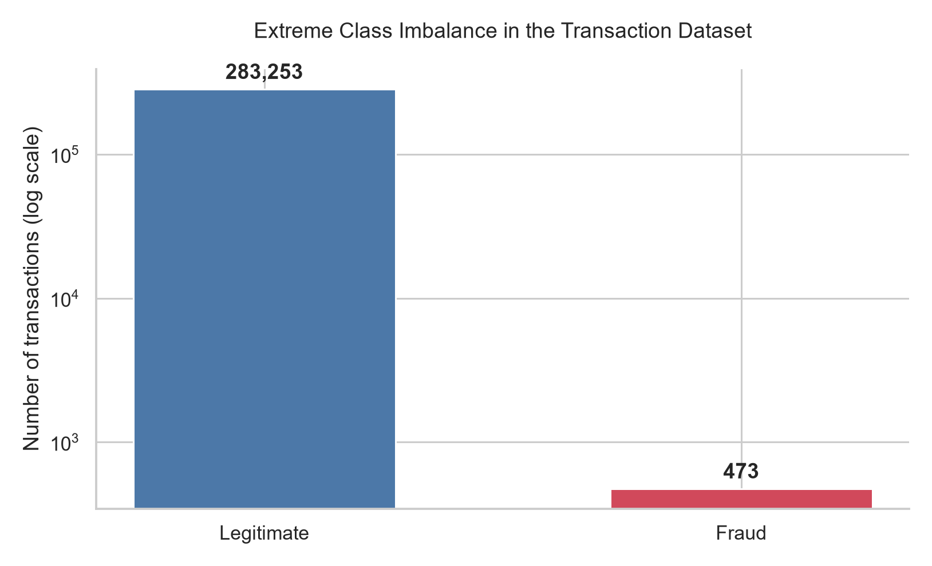
Figure 1. Extreme class imbalance after cleaning; ordinary accuracy would conceal failure.
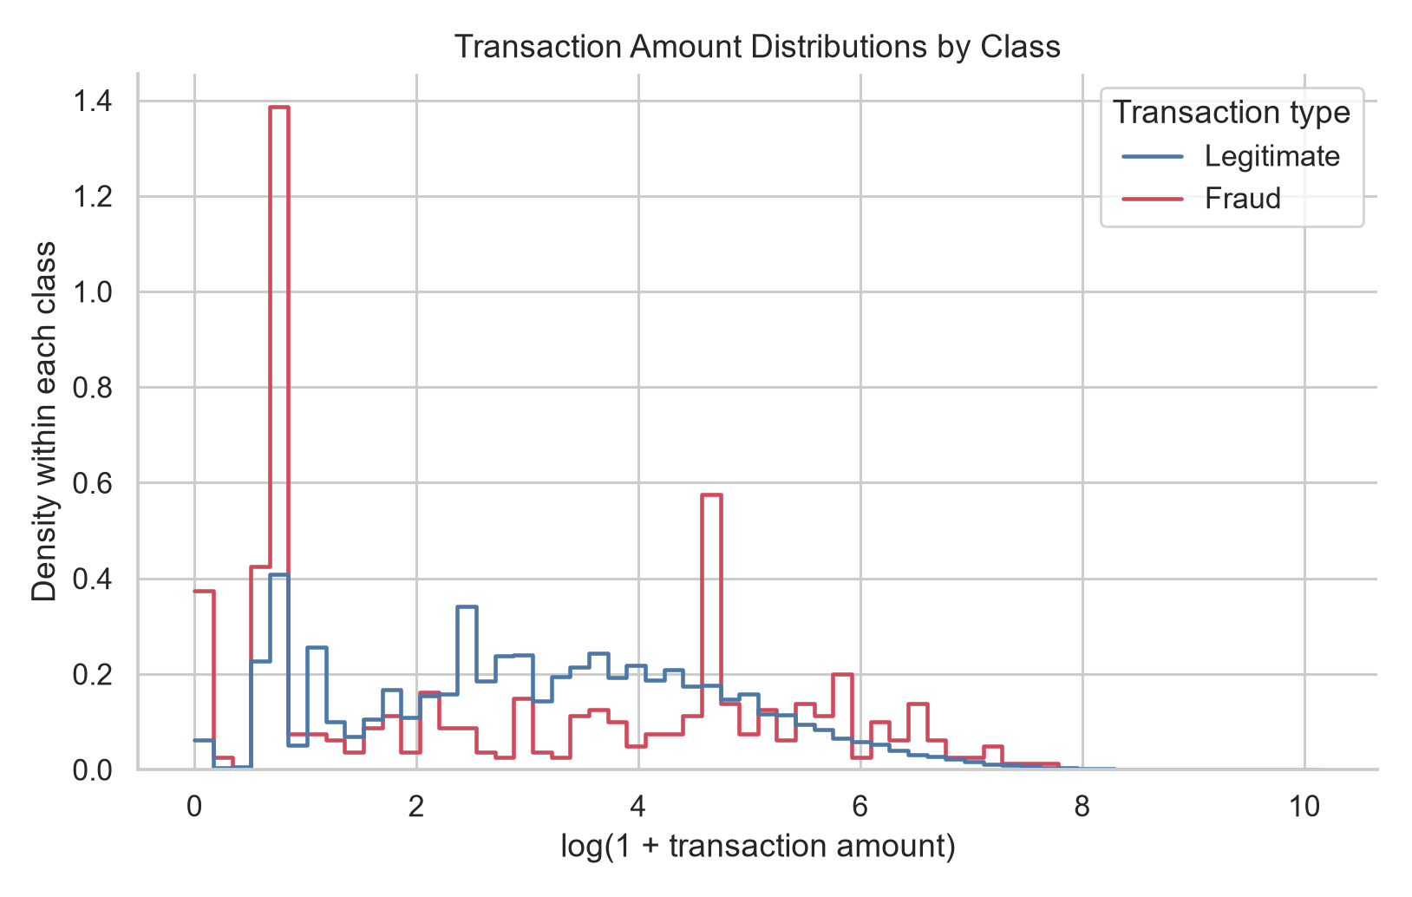
Figure 2. Transaction-amount distributions by class, log-transformed for visualization.
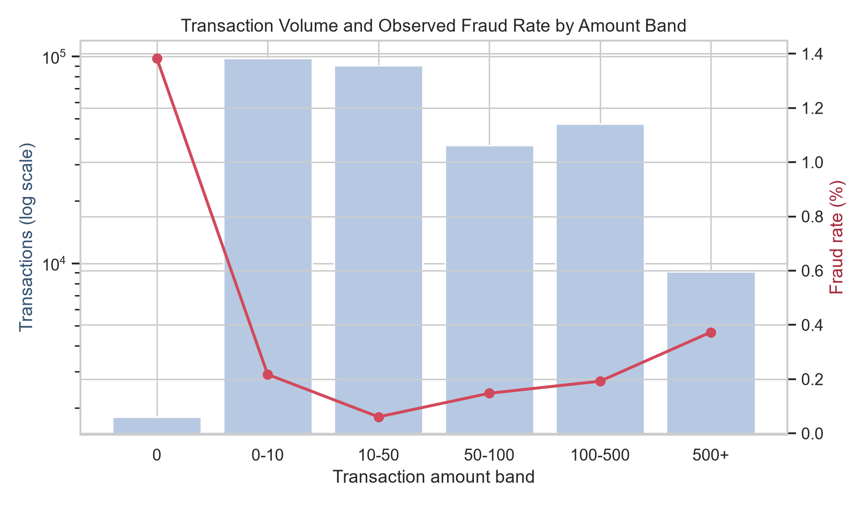
Figure 3. Observed fraud rate by amount band; association does not imply causation.

4.2 Data quality and split design
- Missing values: 0.
- Exact duplicates removed before splitting: 1,081; cleaned rows: 283,726.
- Training: 181,584 rows / 302 fraud.
- Validation: 45,396 rows / 76 fraud.
- Test: 56,746 rows / 95 fraud.
- All index-overlap checks were zero; random state 42 was fixed.

4.3 Models and threshold policy
Dummy Prior supplies a no-skill baseline. Logistic Regression uses standardized inputs and balanced class weights. Random Forest captures nonlinear interactions and uses balanced subsampling. Synthetic oversampling was avoided to keep the baseline auditable and reduce leakage risks.
models = {
"Dummy Prior": DummyClassifier(strategy="prior"),
"Logistic Regression": Pipeline([
("scale", StandardScaler()),
("model", LogisticRegression(class_weight="balanced", max_iter=1000))]),
"Random Forest": RandomForestClassifier(
n_estimators=200, max_depth=12, min_samples_leaf=2,
class_weight="balanced_subsample", random_state=42, n_jobs=1)
}
Model selection used validation AP. The operating policy selected the highest-precision validation threshold reaching at least 80% recall. The Random Forest threshold was 0.6735, with 96.9% validation precision and 81.6% validation recall.

4.4 Test results
Model/policy | AP | Precision | Recall | F1 | TP | FP | FN
Dummy Prior | 0.002 | 0.0% | 0.0% | 0.000 | 0 | 0 | 95
Logistic Regression  validated threshold | 0.687 | 88.5% | 72.6% | 0.798 | 69 | 9 | 26
Random Forest  validated threshold | 0.805 | 95.7% | 69.5% | 0.805 | 66 | 3 | 29
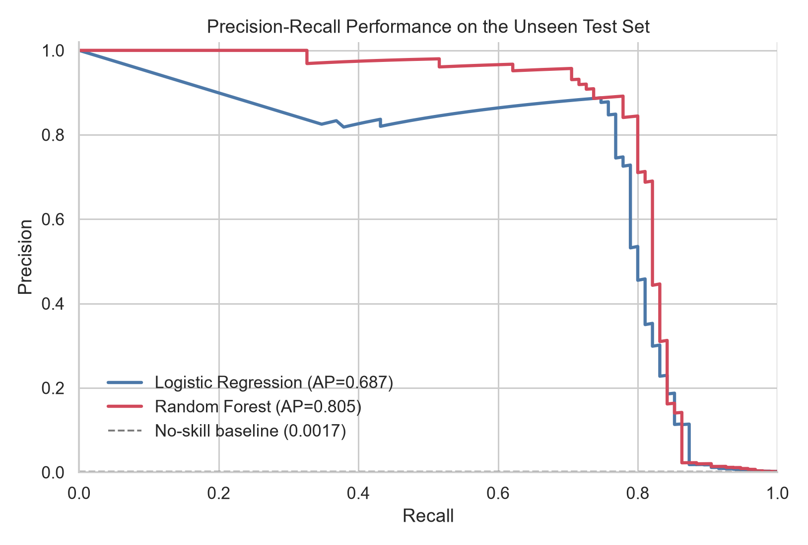
Figure 4. Precision–recall curves on the untouched test set; Random Forest achieved the highest AP.
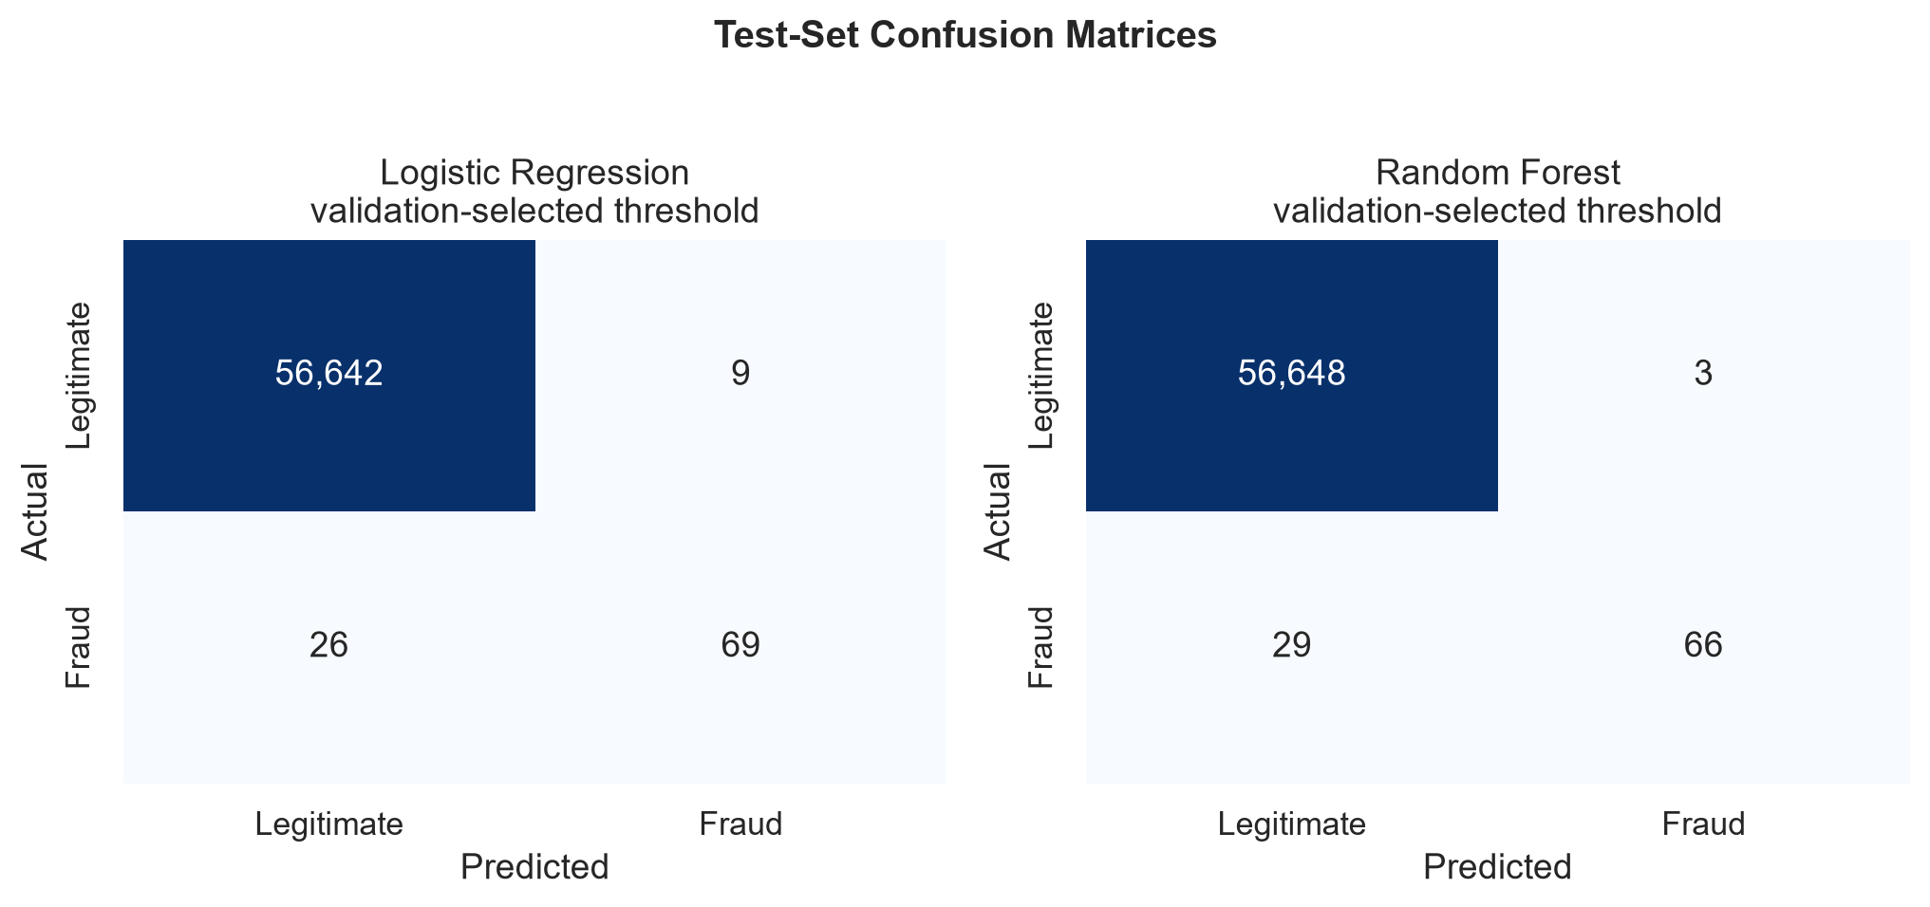
Figure 5. Confusion matrices at validation-selected operating thresholds.
Business interpretation. Among 56,746 test transactions, the selected policy raised 69 alerts: 66 true fraud and 3 legitimate. Precision was 95.7%; alert rate was 0.122%. It missed 29 fraud cases, so it should complement—not replace—rules, identity controls, and analyst review.

4.5 Explainability
The highest-ranked anonymized components were V14 (0.179), V10 (0.117), V4 (0.113), V12 (0.104), V17 (0.096). These rankings indicate predictive contribution, not causality or a customer-facing explanation.
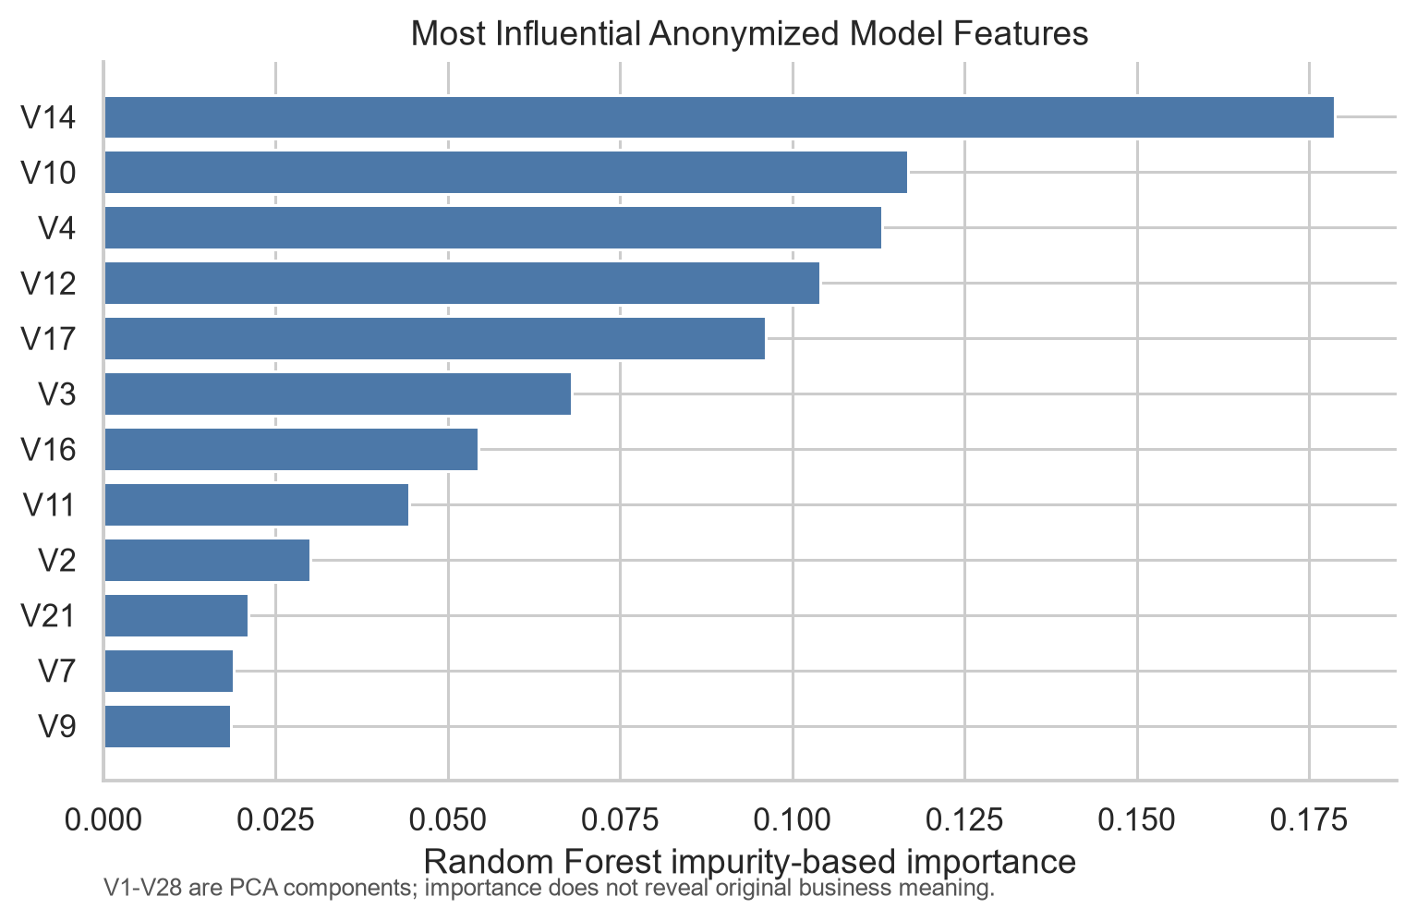
Figure 6. Random Forest impurity-based feature importance; importance does not establish causality.

4.6 Cybersecurity and production controls
- Preventive: strong authentication, device/session risk, velocity rules, limits, and step-up verification.
- Detective: scoring, analyst queues, event correlation, drift monitoring, and dashboards.
- Corrective: case management, account protection, recovery, feedback labels, and post-incident review.
- Governance: least privilege, encryption, retention limits, model/version logs, change approval, bias review, and rollback.

4.7 Limitations and threats to validity
- The transactions cover only two days in September 2013.
- V1-V28 are anonymized PCA components without business-semantic labels.
- Time records elapsed seconds from the first transaction, not calendar timestamps or local time.
- A stratified random split does not simulate future fraud drift.
- The dataset contains no reliable investigation-cost or fraud-loss matrix.
- This is an offline academic prototype, not a production payment control.
- Only 95 fraud examples appear in the test set, so estimates have uncertainty.
- The 81.6% validation recall became 69.5% test recall, showing sampling variation and the need for temporal validation.
- No financial savings are claimed because reliable loss, review-cost, and customer-friction inputs are absent.
- Impurity importance can be biased; SHAP and analyst review are recommended next steps.

5. Conclusion with Remarks
This project shows that fraud detection is a strong bridge between cybersecurity and applied data science. On real, highly imbalanced data, Random Forest achieved 0.805 AP and 95.7% precision at the selected policy, with only 3 false alerts in 56,746 test transactions. However, it recalled 69.5% of fraud and missed 29 cases; it must remain one signal in a layered control system.
The operating threshold is a business and security decision, not merely a model default. Lower thresholds may catch more fraud but create workload and customer friction; higher thresholds improve precision but miss attacks. Production work therefore needs cost-sensitive thresholding, temporal testing, calibration, continuous monitoring, and human accountability.
Final remark. The project is intentionally honest about its boundaries. Its value is the complete reasoning chain: real data, leakage-aware evaluation, rare-event metrics, business thresholding, cybersecurity controls, reproducible code, and a practical roadmap.

References
Machine Learning Group – ULB. (n.d.). Credit Card Fraud Detection [Data set]. Kaggle. Retrieved 15 July 2026 from https://www.kaggle.com/datasets/mlg-ulb/creditcardfraud
Dal Pozzolo, A., Boracchi, G., Caelen, O., Alippi, C., & Bontempi, G. (2015). Credit card fraud detection and concept-drift adaptation with delayed supervised information. IEEE SSCI, 990–997. https://doi.org/10.1109/SSCI.2015.33
Dal Pozzolo, A., Boracchi, G., Caelen, O., Alippi, C., & Bontempi, G. (2018). Credit card fraud detection: A realistic modeling and a novel learning strategy. IEEE TNNLS, 29(8), 3784–3797. https://doi.org/10.1109/TNNLS.2017.2736643
Saito, T., & Rehmsmeier, M. (2015). The precision–recall plot is more informative than the ROC plot when evaluating binary classifiers on imbalanced datasets. PLOS ONE, 10(3), e0118432. https://doi.org/10.1371/journal.pone.0118432
He, H., & Garcia, E. A. (2009). Learning from imbalanced data. IEEE TKDE, 21(9), 1263–1284. https://doi.org/10.1109/TKDE.2008.239
scikit-learn developers. (2026). Model evaluation and threshold tuning documentation: https://scikit-learn.org/stable/

