### ****How to get the most value out of your rent-out property in Seattle?****

*Understand lodging services in Seattle using Airbnb data*

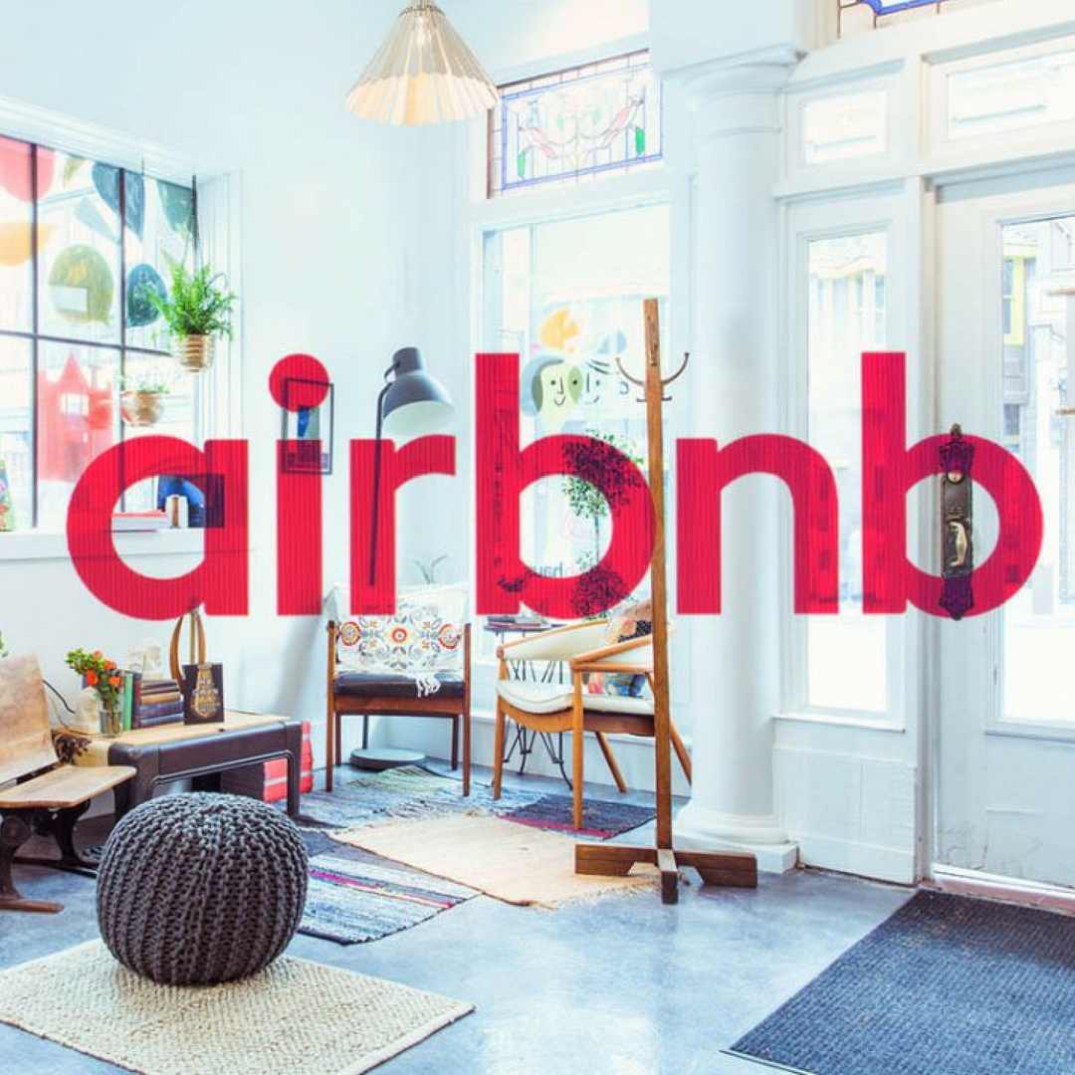

**Introduction**

Airbnb is one of the most popular marketplaces for offering lodging and homestay services. If I’m a homeowner in Seattle, how can I get the most value out of my rent-out property?

I’m interested in answering the following three questions.

1. What are the most important features that estimate the rental price?

2. What top amenities should I offer in my rent-out place?

3. What are the most requested neighbourhoods in Seattle?

I used Airbnb Seattle dataset from Kaggle to investigate and answer these questions.

**Predicting rental price in Seattle**

After performing some data cleaning and feature selection process, I built a machine learning model to predict the price of a listing. I used AdaBoostRegressor as the ML algorithm and Grid Search Cross Validation method to get the best possible parameters for the model. About 80% of data is used for training and the rest is used for testing.

The following analysis is done using the results from the best model chosen in this step.

## **Question 1. What are the most important features that estimate the rental price?**

The top 20 features that have the most significance in estimating the rental price are listed here.

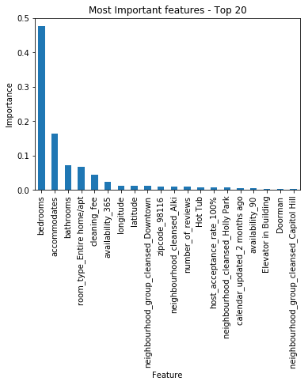

Its not surprising to see that attributes such as number of bedrooms, bathrooms and the number of people the place of stay accommodates are at the top. It is obvious that the rental price will go up when these values increase. Also, if you rent the entire home or apartment, you would be paying higher.

Latitude and Longitude are also listed in the top 20 significant features, as the rental price would vary depending on the location. Cleaning fee is also listed in the top 20 and I suspected that the price would go down if this fee is increased. But looking at this chart, this doesn’t seem to be the case and I think several other factors come into play.

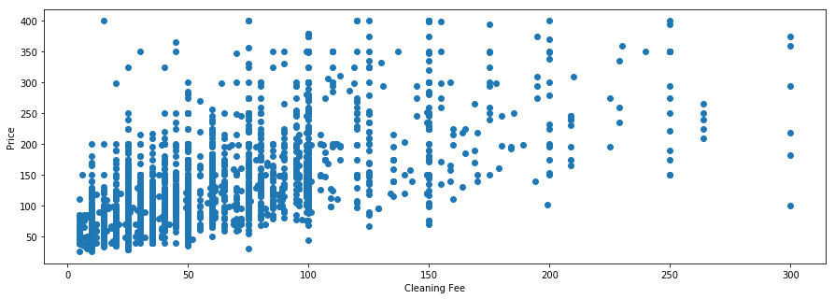

It’s also interesting to see that amenities such as Hot tub and Elevator are part of the top 20 significant features. Let’s look at those in detail.

## **Question 2. What top amenities should I offer in my rent-out place?**

Using the machine learning model, let us look at how important each amenity is.

There were around 40 amenities in total listed in Seattle region. We can see that necessities such as Elevator, Air Conditioning and Breakfast comes at the top. Pool and Gym are also at the top, as expected. I guess if most of the guests are visitors to the city, then they won’t mind the free / paid parking as much.

Hot tub amenity is twice as significant as the other amenities when estimating the price. It’s plausible that the places with a hot tub will be listed with a high rental price and might also include other necessities as well.

If you want to double your profit from Airbnb, then get a hot tub! 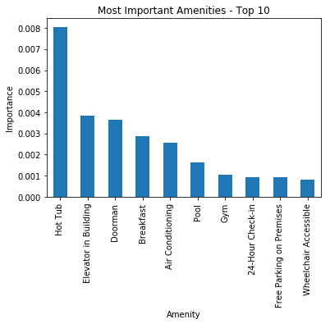

## **Question 3. What are the most requested neighbourhoods in Seattle?**

The proportion of requests related to each neighbourhood in Seattle is shown here. The densely populated, residential district Capitol Hill is the topmost requested neighbourhood with more than 10% of overall requests. We can see that this entertainment district is very popular among visitors and has something to offer to everyone.

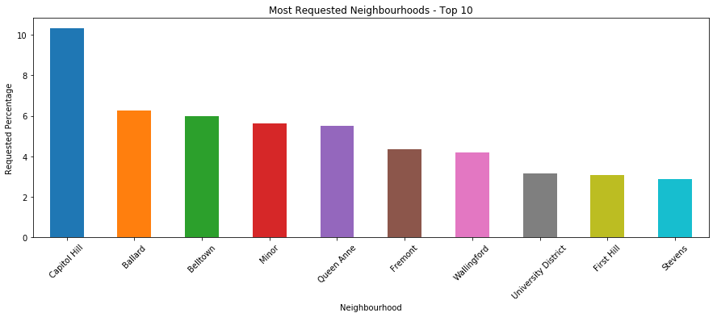

‘Ballard’ and ‘Belltown’ neighbourhoods come in second with approximately 6% of requests each. I believe trendy restaurants and recreation centers are drawing people to these areas.

**Conclusion**

We explored the Seattle Airbnb dataset and built a machine learning model to estimate rental prices.

Then we investigated the top 20 attributes that are most important in estimating the rental prices.

We also found that amenities such as Hot tub, Elevator should be offered to get a high rental price.

Finally, we saw the most requested neighbourhoods in Seattle region.