**NITTE MEENAKSHI INSTITUTE OF TECHNOLOGY**

(AN AUTONOMOUS INSTITUTION)

(AFFILIATED TO VISVESVARAYA TECHNOLOGICAL UNIVERSITY, BELGAUM, APPROVED BY AICTE & GOVT. OF KARNATAKA)



OOP COURSE-PROJECT REPORT

ON

**BIG BAZAR BILLING SYSTEM**

*Submitted by: USN:*

*1. Preethi .H.R (*1NT16CS079*)*

*2. Nayana Reddy .T. (*1NT16CS064)

*3. Sneha (1NT16CS111)*

In partial fulfilment of the requirement for the completion of*Ⅳ Semester Object-*

*Oriented Programming Course-Project work during the academic year 2018-2019.*

Department of Computer Science and Engineering

NitteMeenakshi Institute of Technology,

Yelahanka, Bangalore – 560064

Academic Year 2018 - 19

**NITTE MEENAKSHI INSTITUTE OF TECHNOLOGY**

(AN AUTONOMOUS INSTITUTION)

(AFFILIATED TO VISVESVARAYA TECHNOLOGICAL UNIVERSITY, BELGAUM, APPROVED BY AICTE & GOVT. OF KARNATAKA)



**CERTIFICATE**

**This is to certify that the Project Report**

**BIG BAZAR BILLING SYSTEM**

Is an authentic work carried out by

*1. Preethi .H.R (*1NT16CS079*)*

*2. Nayana Reddy .T. (*1NT16CS064)

*3. Sneha (1NT16CS111)*

In partial fulfilment of the requirement for the completion of*Ⅳ Semester Object-*

*Oriented Programming Course-Project work during the academic year 2018-2019.*

Name & Signature of the Guide Name & Signature of HOD

Prof. VijayaShetty S Dr. M.N Thippeswamy

ACKNOWLEDGEMENT

We would like to express our sincere gratitude to our object oriented programming lecturer Prof.VijayaShetty S for her vital support, guidance and constant supervision as well as for providing necessary information regarding the project without which this course project would not have completed.

We have taken efforts in this project. However, it would not have been possible without the kind support and

help of many individuals. We would like to extend our sincere thanks to all of them.

ABSTRACT

The Project “Big Bazar Billing System” is very helpful for the Big Bazar or super market owners. This system will help the workers to maintain the various information pertaining to their customer. This system will reduce the workload for the workers working in the super markets or Big Bazar.

It is very difficult for the workers to maintain the product details and calculate the amount for the all the products ordered by the customer manually. It requires so much of time and the persons required for the work is also more. Our system will automatethe process where the worker will not require more time and calculations become easier.

The main aim of introducing this project is to increase the efficiency in the work. In manual system, the workers do lot of errors and maintaining a huge data file is very difficult. Our system will reduce the errors done by workers in manual system and makes the work faster. There is also an option in our system to modify the product, delete the product, search for the product and many more, which are very useful for the administrator to maintain the product details.

TABLE OF CONTENTS

|  |  |  |
| --- | --- | --- |
| Sl.No | CONTENTS | Page.No |
| 1. | Introduction | 1 |
| 2. | Literature survey | 2 |
| 3. | Correlating theoretical concept to  practical implementation | 3-4 |
| 4. | Flow diagram | 5 |
| 5. | Results | 6-11 |
| 6. | Conclusions | 12 |
| 7. | Bibliography | 13 |

INTRODUCTION

[2]The project is on Big Bazar Billing System. Big Bazar is the place where customers come to purchase their daily using products and pay for that. Therefore, there is a need to calculate how many products are sold and to generate the bill for the customer.

“Big Bazar Billing System” aims at developing in software that can be used at places like shopping malls, big bazars, supermarkets to easily manoeuvre the daily task of taking the order, calculating the bill etc.

The main advantage of this project is that it converts all the manual work which is time consuming and error prone to fully automated system which helps in eliminating all the paper work, saves time, improves customer services. It also speeds up various processes such as addition of new items to the menu, deletion of items from the menu, modification of details of items and calculation of bills thus providing convenience to the workers as well as customers.

In the development of the project, selection of an appropriate programming language and a platform is of primary importance. The major part of the credit goes to the software environment chosen by the developer.

Selection of a language from the ocean of languages is very difficult, a developer has to consider various features and functionalities that a particular language can provide.

In this language C++ language is used to maintain all the data. It provides many features like file handling, data can be easily maintained and many features that are required while doing a project.

LITERATURE SURVEY

[1]Object oriented programming is a programming approach that provides a way to modularize the program by creating separate memory area for both data and functions that can be used as a template to create copies of such modules on demand. It is mainly designed to overcome the problems of procedure oriented programming.

The prime purpose of C++ programming was to add object orientation to the c programming language, which is in itself one of the most powerful programming languages.

There are a some principle concepts that form the foundation of object-oriented programming-

Class

Object is a user defined data type describes the properties (attributes/data members) and behaviour(member functions/methods) of objects of similar type.

Object

Object is an entity that has its own attributes and behaviour. It is an instance/variable of a class.

Abstraction

Data abstraction means specifying only essential features without showing background details.

Encapsulation

Bundling/wrapping up of data into a single unit called class.

Data hiding

Insulating the data from directly access by the users.

Inheritance

It is the mechanism where an object acquires properties of other objects. Advantages of inheritance are reusability of the code and hierarchical classification of classes.

Operator overloading

It is a process of giving different meaning to the same operator at different situations.

CORRELATING THEORITICAL CONCEPTS TO PRACTICAL IMPLEMENTATION

1. Inline Functions : To make the output of the project more attractive we have used text colors in our project. We have declared constant values for each color and with the help of color() function in each modules we are passing that constant value as a parameter to the inline function so that it expands during compilation and sets the specific color for that module. In our project we used one inline function.

2. Static Variables : In our project we had used static variable for declaring constant variable to each color. We are using color() function in all modules so we made use of static variable so that for each color, numbers are different and do not change their values during runtime . Ex: For blue color, static constant value is 1 and for purple its 5 etc.

3. Class : We had used a class in our project, which includes all the all the data members and member functions used in our project. We had used four datatypes and twenty member functions in our project to implement “Big Bazar Billing System”.

4. Operator Overloading : We had overloaded shorthand(+=) operator to add the final amount(The amount obtained after placing all orders with giving certain discounts for some products) of all orders of the customer.

5. This pointer : When the customer places the order, we made use of overloaded function and this pointer to return the implied object i.e the product after calculating the discount amount of the product.

6. Function Overloading : We made use of a overloaded function display_all() , among which one does not take any parameter and used to display all the products available at big bazar, and another take a single int type parameter, used during clarification of certain product by entering the product number of the product.

7. Default argument : During the deletion of a product , the product number of the product is need to be specified. If the administrator fails to enter the product number of the product to be deleted, then the default product number is taken as zero and no product will be deleted.

8. Friend Function : We had declared an overloaded function as friend to the class known as operator overloading using friend function to overload extraction(<<) operator.

9. Files : We had used two text files in our project one to store the details of the products that are created by the administrator i.e shop.dat and another text file which is used to store the details of the product that were deleted by the administrator , this is useful for temporary storage i.e temp.dat and can also be used for future reference and also data deletion will be more safely done.

We had used seekp() during modification of the product. It moves the put pointer from the current to the required position where we need to modify the product.

We had used seekg() during deletion of the product . It moves the get pointer to the beginning of the temporary file and add the details of the product to it.

The modes of file we used are:

in -> which indicates input mode, it opens the text file used for reading the product from file.

out -> which indicates output mode, it opens the text file used for writing the product into the file.

app-> which indicates append mode, it opens the text file used for adding the details of the product one after the another at end.

10. Headerfiles : We had used the following header files in our project –

<iostream> is used for defining the c++ input and output streams.

<windows.h> is used for setting output text colors using WORD.

<conio.h> is used for system clear in our project to make the display clear before showing the next output.

<fstream> is used for input and output stream for the text files used in our project.

FLOW DIAGRAM

**MAIN PAGE**

CUSTOMER

EXIT

ADMINISTRATOR

BACK TO MENU

VIEW PRODUCT MENU

DISPLAY ALL PRODUCT

PRODUCT NO.

CREATE PRODUCT

PRODUCT

QUANTITY

QUERY

PLACE YOUR ORDER

MODIFY PRODUCT

DELETE PRODUCT

RESULTS

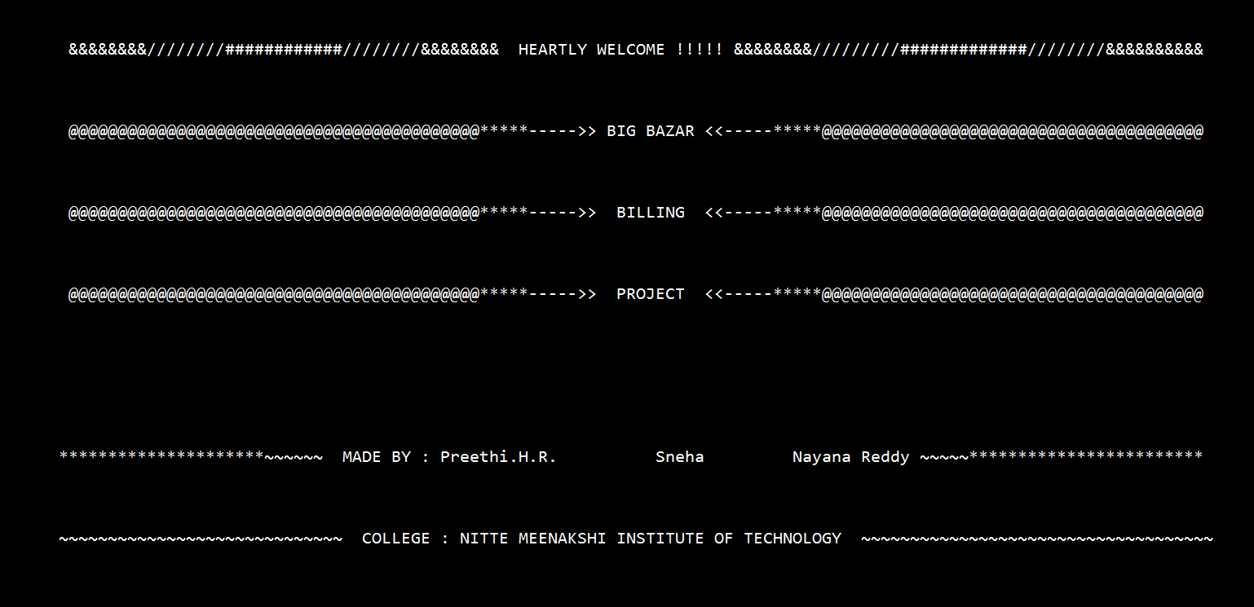

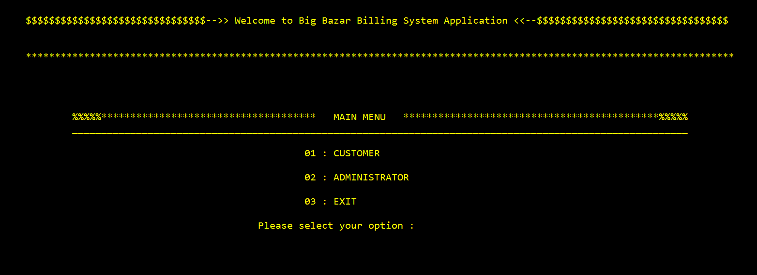

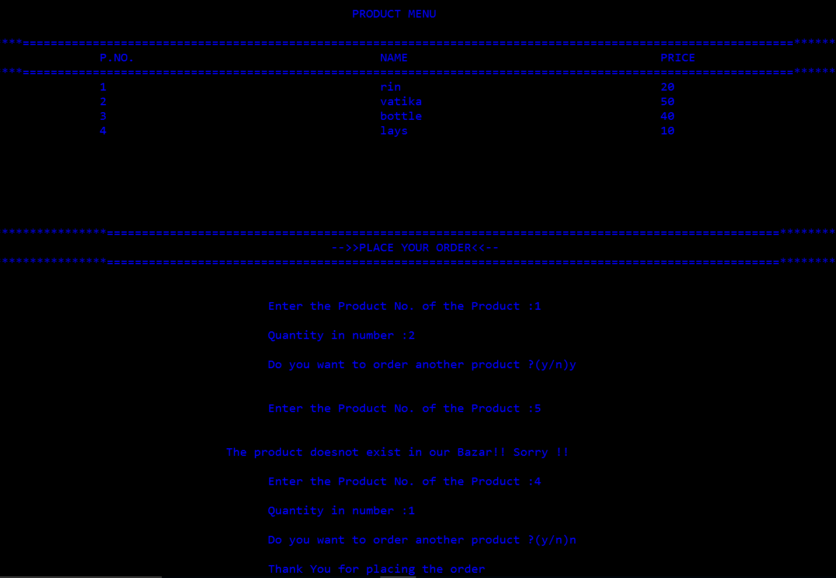

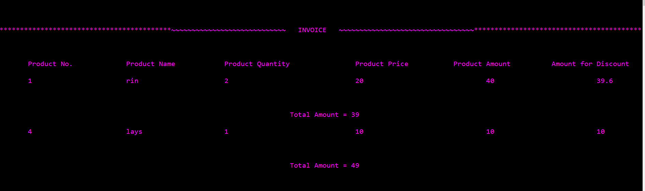

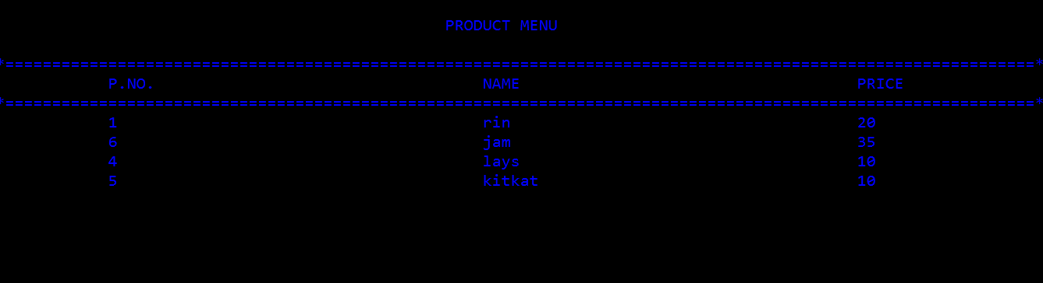

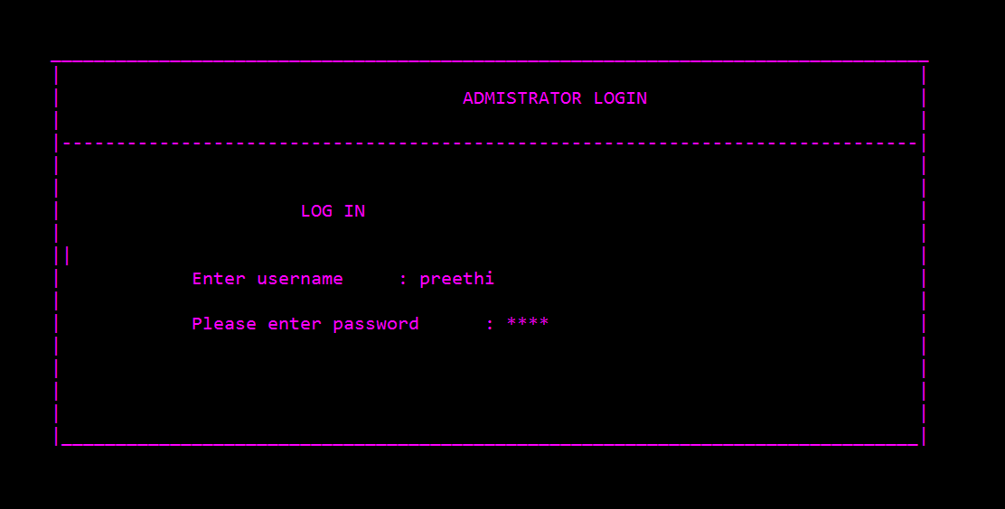

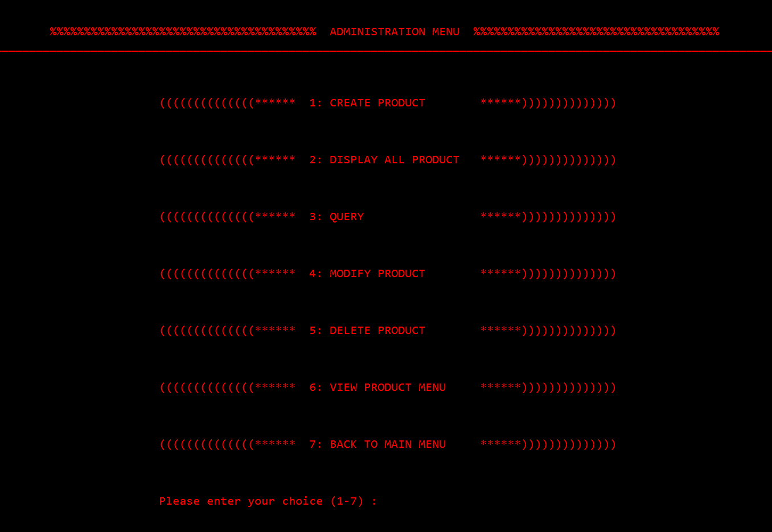





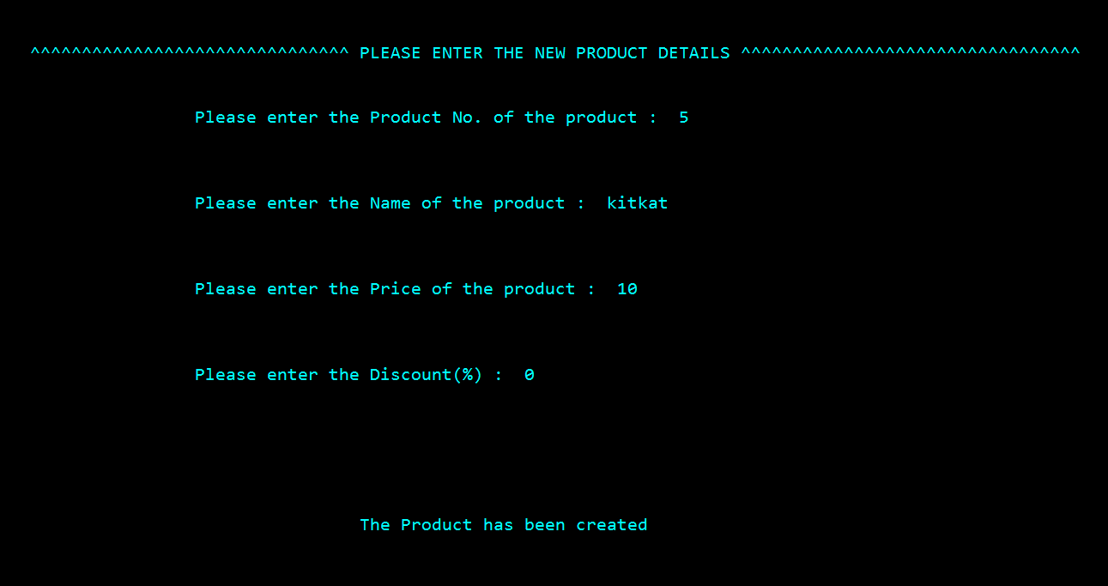

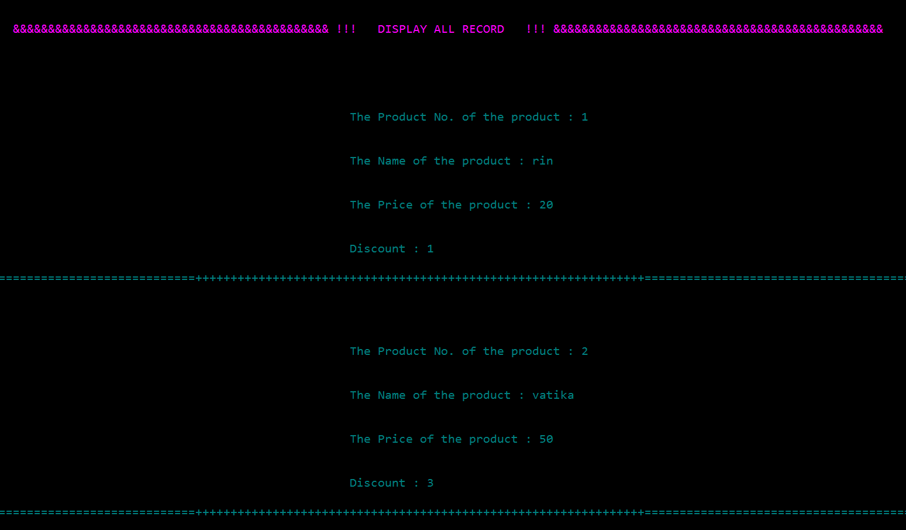

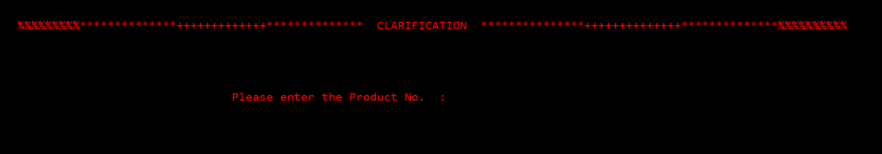

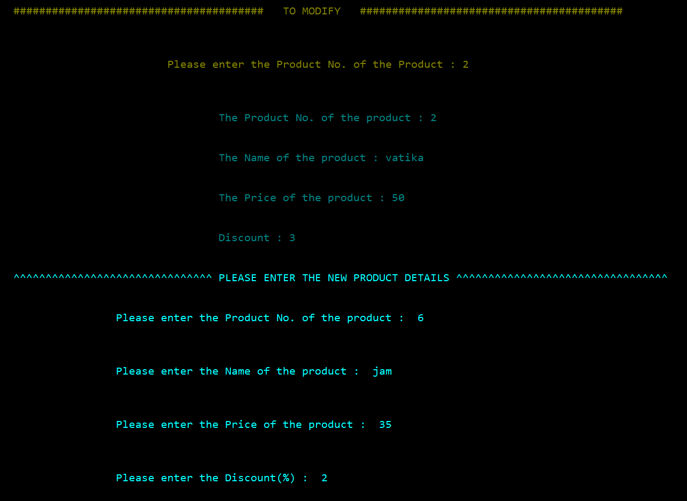

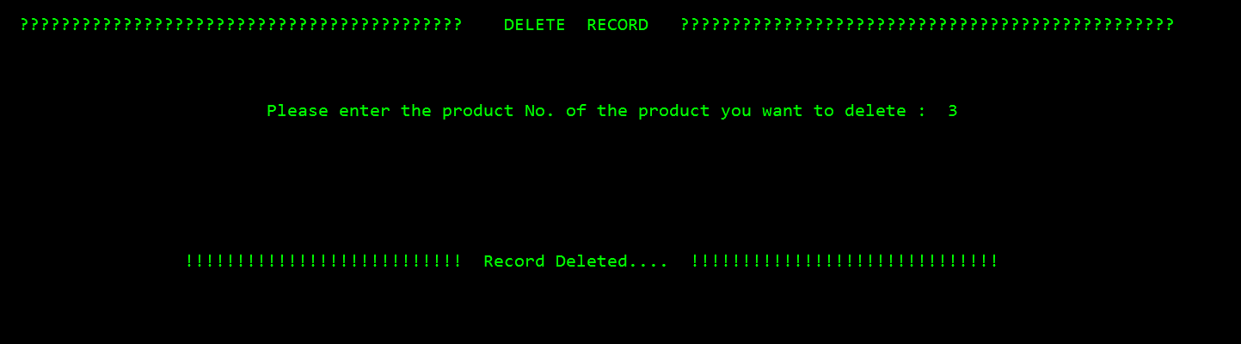

CONCLUSION

We have tried to develop a system that can be great help for the owner of the referred Big Bazar for making bill for the customer. Despite of all our efforts here are some bugs in the system, which are still to be removed. This is possible by testing being done in the system. We have left all the options open so that if there is any other future requirement in the system by the user for the enhancement of the system then it is possible to implement them.

In the end we wish to say that computers should be put to such use where not only their capabilities are fully exploited but, what is more important, serve the society by raising the standard of living of people, thereby making the world better place to live and work in.

BIBLIOGRAPHY

[1] The Complete Reference C++, Fourth Edition by Herbert Schildt .

Web links

[2][www.cplusplus.com](http://www.cplusplus.com)

[www.tutorialspoint.com/cpluscplus/cpp_files_streams.htm](http://www.tutorialspoint.com/cpluscplus/cpp_files_streams.htm)

<https://stackoverflow.com>

[www.scribd.com](http://www.scribd.com)

PLAGIARISM REPORT

1. Plagiarism Report for Code

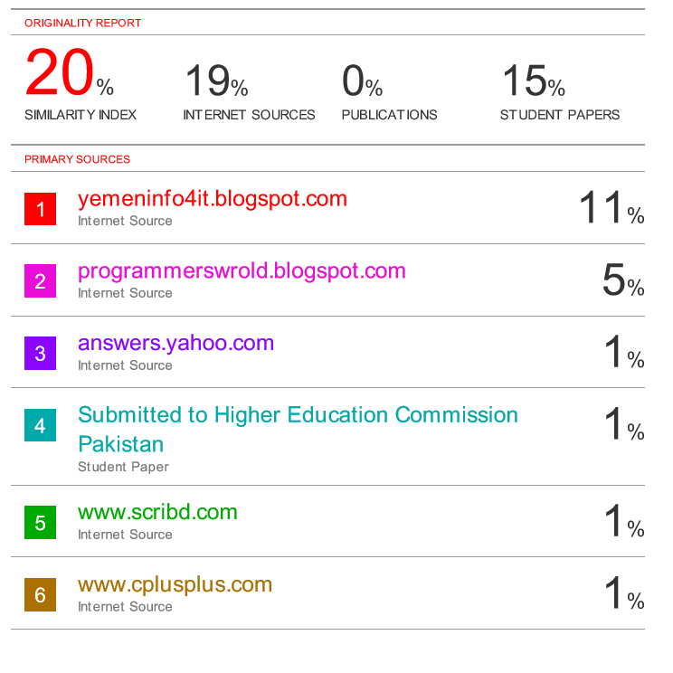

2. Plagiarism Report for report including certificate, header and footers.

