IT - 4th Module

What is E-commerce?
The use of internet and the Web to transact business.More formally digitally enabled commercial transactions between and among organisations and indviduals.

E-business
the digital enabling of transactions and processes within a firm,involving info systems under the control of the firm.

Modes of E-commerce?
Eight Key Elements of a Business Model

Value proposition-how does the product or service fulfill user needs

Revenue model-hw will the company earn money

Market opportunity-area of commercial value in which the company wish to operate

Competitive environment-other companies selling similar products in the intended marketplace

Competitive advantage-superior/cheaper product(special advantage of a firm)

Market strategy-promote your product

Organizational development-

Management team

B2C Business Model

In B2C model, business Website is a place where all transactions take place between a business organization and consumer directly.
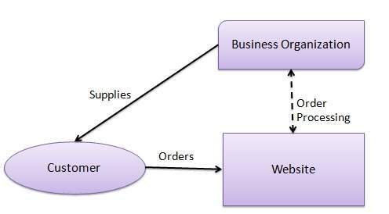
In B2C Model, a consumer goes to the website, selects a catalog, orders the catalog and an email is sent to business organization. After receiving the order, goods would be dispatched to the customer. Following are the key features of a B2C Model
- Heavy advertising required to attract large no. of customers.
- High investment in terms of hardware/software.
- Support or good customer care service

Consumer Shopping Procedure
Following are the steps used in B2C e-commerce −
A consumer
- determines the requirement.
- searches available items on the website meeting the requirment.
- compares similar items for price, delivery date or any other terms.
- gives the order.
- pays the bill.
- receives the delivered item and review/inspect them.
- consults the vendor to get after service support or returns the product if not satisfied with the delivered product.

E-tailer
Community provider (social network)
Content provider
Portal
Transaction broker
Market creator
Service provider

b2b model

Business - to - Business (B2B)
Website following B2B business model sells its product to an intermediate buyer who then sells the product to the final customer. As an example, a wholesaler places an order from a company's website and after receiving the consignment, sells the end product to final customer who comes to buy the product at wholesaler's retail outlet.
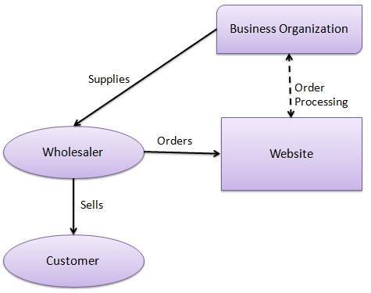

Payment Systems
** Credit Card
Credit card represent an account that extends
credit to consumers, permits consumers to
purchase items while deferring payment, and
allows consumers to make payments to multiple
vendors at one time

**Stored value payments(Debit Cards)
Stored value payments systems are
accounts created by depositing funds into
an account and from which funds are paid
out or withdrawn as needed
ß
Debit cards immediately debit a checking
or other demand deposit account

**Accumulating balance payment
Accumulating balance payment systems
are accounts that accumulate
expenditures and to which consumers
make periodic payments

**Digital Cash
The bank creates a digital bank note by signing a message which specifies the serial number (with a primary or public key) and value of the note, and sends it to Person A. Person A, as he withdraws it, uses Chaum's technique (A Cryptography technique) to alter the serial number so that the bank will not recognize the note as being from this withdrawal. This note is now returned to the bank with the new serial number. The bank now has a note with a new serial number. Person A then pays Person B electronically by sending the bank note to him. Person B checks the note's validity by decrypting using the bank's public key to check its signature (new serial number validity). Person B then sends the note to the bank, which checks the serial number to confirm that this bank note hasn't been spent before. The serial number is now different from that in Person A’s withdrawal, thereby pre- venting the bank from linking the two transactions. The enabling bank merely checks the new serialized key account for the amount of the transaction and transfers the money by sending out a depository notice. Person B using the same encrypting technique returns the depository notice with the new serialize account. The enabling bank does not know who the merchant is only that money is available for payment. In some respects, this is a debit card transaction with no information other than the amount of the transaction. All initial depositor information is in the primary key account not the password account.

**Virtual Currency
Bit coins
Bitcoins are stored in a “digital wallet,” which exists either in the cloud or on a user’s computer. The wallet is a kind of virtual bank account that allows users to send or receive bitcoins, pay for goods or save their money. Unlike bank accounts, bitcoin wallets are not insured by the FDIC
Though each bitcoin transaction is recorded in a public log, names of buyers and sellers are never revealed – only their wallet IDs. While that keeps bitcoin users’ transactions private, it also lets them buy or sell anything without easily tracing it back to them. That’s why it has become the currency of choice for people online buying drugs or other illicit activities.
How an Online Credit Card
Transaction Works
Customer-SSL/TLS->Merchant-Software contcts clearringhouse->Clearhouse-verifies account and balance->Issuing Bank-->>>>>Merchant bank

What is digital cash?

B2B Business Model

