# Phonepe-Pulse -Data-visualization

**Working steps:**

1. First lets extracts data from the files and convert it into csv files

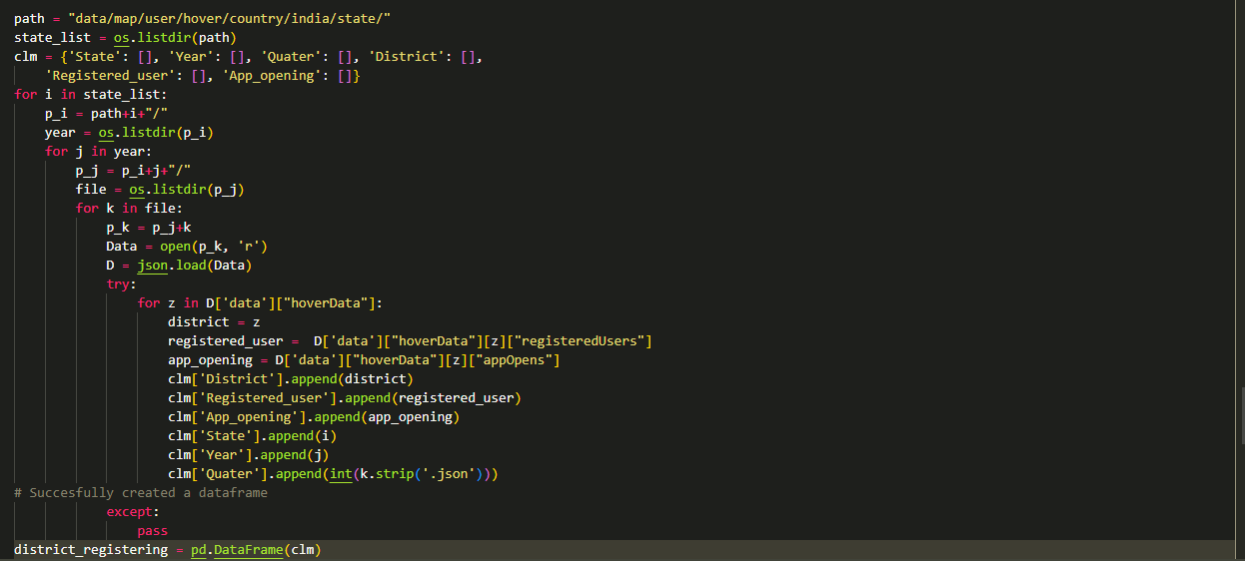

1. In this above code we can see that in each step we go through the folders and we also setting the folder name as a value for dictionary.
2. Now we want to repeat this process for all respective folders then we can get all the data in our desired format of csv.
3. After extracting the data we need to upload it into Mysql
4. To insert datas into Mysql i used sqlalchemy(in order to establish connection you want pymysql also)
5. In order to insert csv to Mysql we need to establish connection to Mysql server

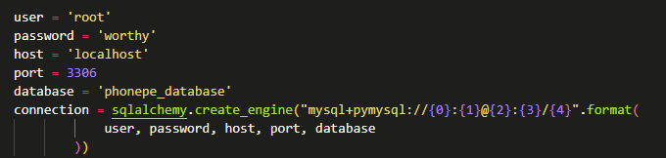

1. After connection we need to create table then we can insert csv files to Mysql database



1. To see full code see in mysqlinsert.ipynb file Repeat the above process for all csv files to insert into your Mysql database
2. Then after inserting all my files to Mysql database. I created a new file named main.py to create a app using streamlit.

**Screenshot:**

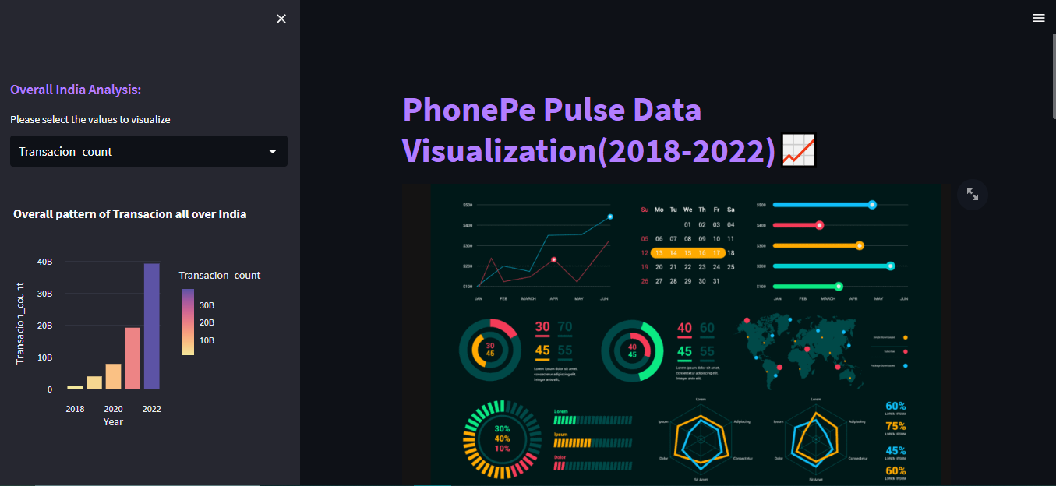

**Geo-visualization of Transaction datas:**

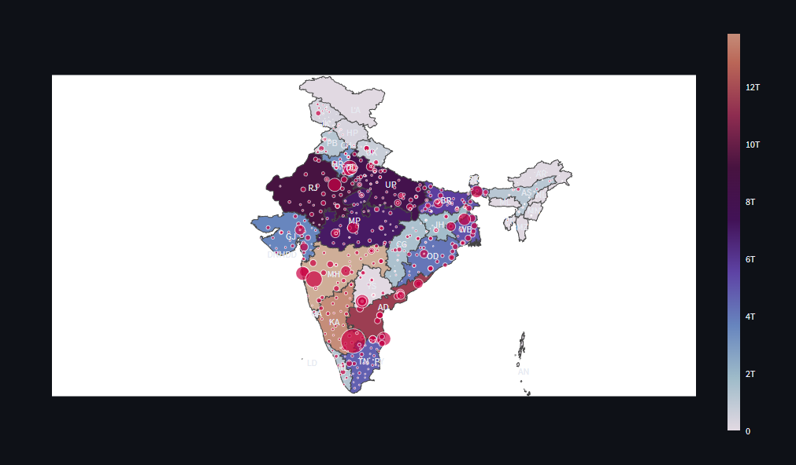

**User device analysis od Phonepe data**

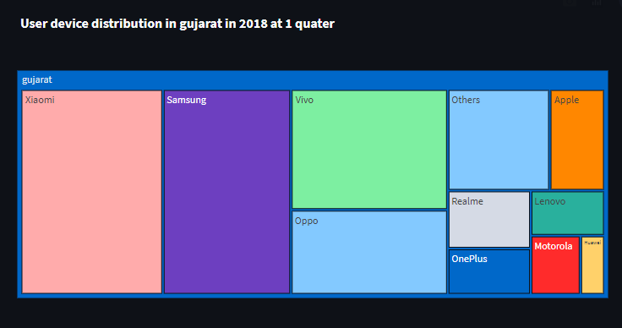

**BAR CHART ANALYSIS**

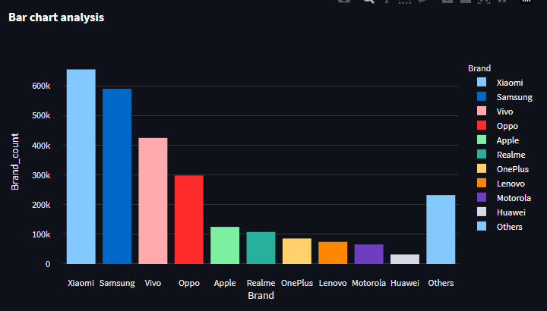

**Payment type analysis**

**PIE CHART ANALYSIS**

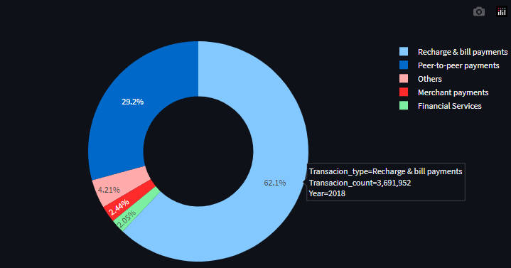

**BAR CHART ANALYSIS**

