Infosys Springboard Virtual Internship 6.0 Completion Report

Team Details
Batch Number 2025-AI-09
Start date: September 4, 2025
Names: Rekhansh Gupta, K.L Perananda, Kushal Sitnoor
Internship Duration: 8 Weeks

1. Project Title
Know map Cross Domain Knowledge Mapping using AI.

2. Project Objective
The primary objective of this internship project was to develop an intelligent knowledge mapping system capable of identifying, extracting, and linking concepts across different domains using Artificial Intelligence. The goal was to bridge domain silos by enabling semantic relationships between related topics, allowing faster knowledge discovery and better contextual understanding.
This project aimed to contribute to the organization by introducing an AI-driven framework that could support smarter search, automated knowledge extraction, and data-driven decision-making across multiple subject areas.

3. Project description in detail
The KnowMap project focuses on cross-domain semantic understanding using AI and Natural Language Processing (NLP). The project leverages knowledge graphs and semantic search models to connect related concepts across domains.
Approach:
- The first phase involved data collection and preprocessing from various text sources.
- In the next phase, entities and relations were extracted using AI-based NLP models.
- A knowledge graph was generated to represent the extracted relationships in a structured, interconnected format.
- Semantic search was implemented to retrieve contextually similar information across domains.
Technologies Used:
- Python, Flask, SPARQL, Google Colab, Docker, and Knowledge Graph APIs.
- AI/ML libraries: Transformers, Sentence-BERT, SpaCy, and NetworkX.
Real-World Impact:
This project can be applied in research, education, and enterprise knowledge systems to automate knowledge linking and assist users in retrieving meaningful insights across disciplines — for example, connecting computer science concepts with healthcare, finance, or education.

4. Timeline Overview
Week | Activities Planned | Activities Completed
Week 1 | Literature review and problem understanding | Completed literature review and finalized project topic
Week 2
  Setup environment, tools, and data sources
  Configured Google Colab and Docker environment
Week 3
  Data preprocessing and knowledge extraction
  Extracted entities and relations using NLP models
Week 4
  Knowledge graph construction
  Built semantic graph and verified entity linking
Week 5
  Implementation of semantic search
  Integrated Sentence-BERT for contextual retrieval
Week 6
  Testing and optimization
  Conducted accuracy and performance testing
Week 7
  UI design and Docker deployment
  Developed and containerized Flask-based web app
Week 8 |  | Prepared final report and presented project outcomes
  Final documentation and presentation

5a. Key Milestones
Milestone | Description | Date Achieved
Project Kickoff |  | Week 1
  Project topic discussion and research plan approval
Prototype/First Draft
  Initial version of entity extraction and graph building
  Week 3
Mid-Term Review
  Partial demo with semantic search functionality
  Week 5
Final Submission |  | Week 8
  Fully functional app and documentation
Presentation |  | Week 8
  Final presentation and discussion of results

5b. Project execution details
The project was executed in multiple phases following an agile methodology. Initial research defined the scope and objectives, followed by technical implementation using Python and AI libraries. Data was processed to identify entities and their relationships, which were visualized in a knowledge graph. Semantic search capabilities were built on top of this structure to enable intelligent query responses. The final deployment was done using Docker, ensuring easy scalability and portability.
Weekly reviews ensured alignment with goals, and feedback from mentors was incorporated for iterative improvement.

6. Snapshots / Screenshots

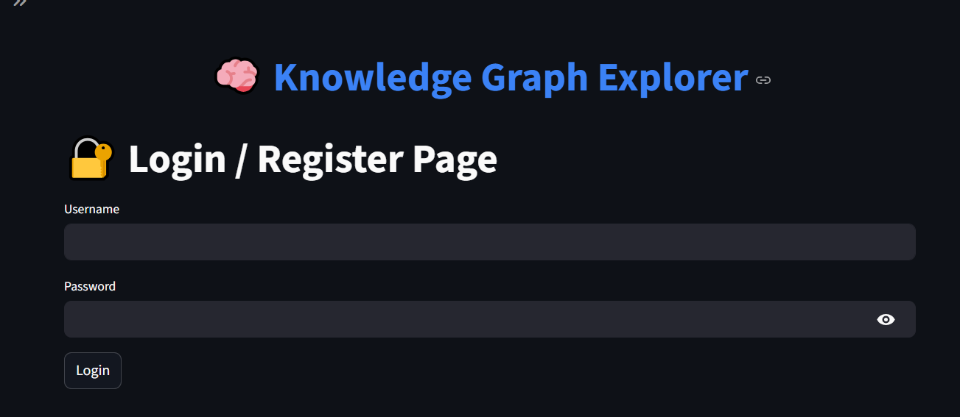

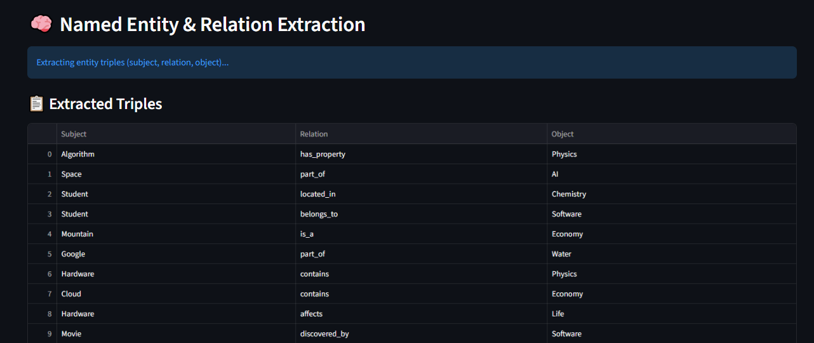
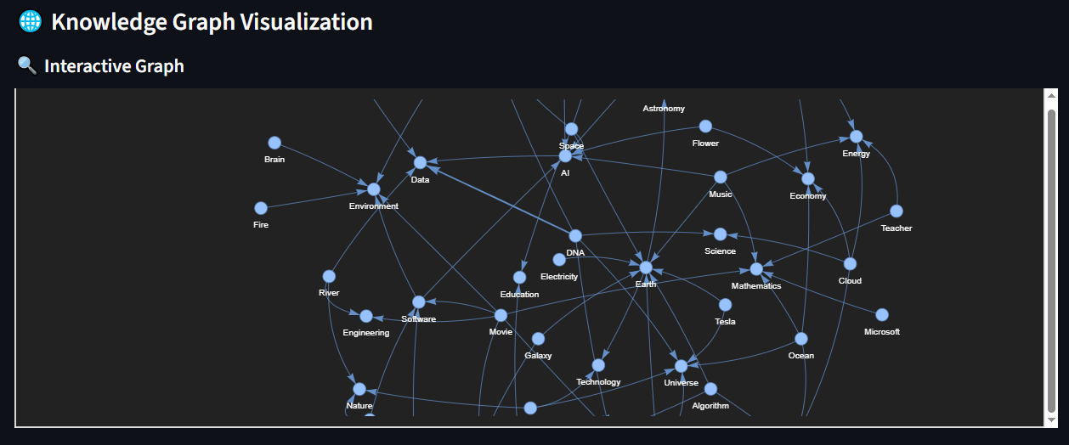

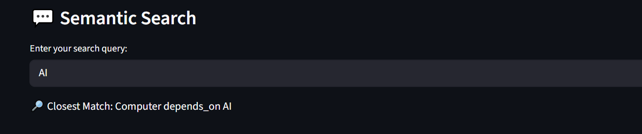

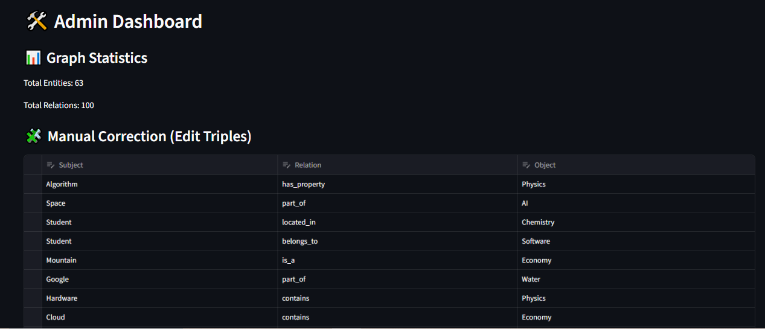

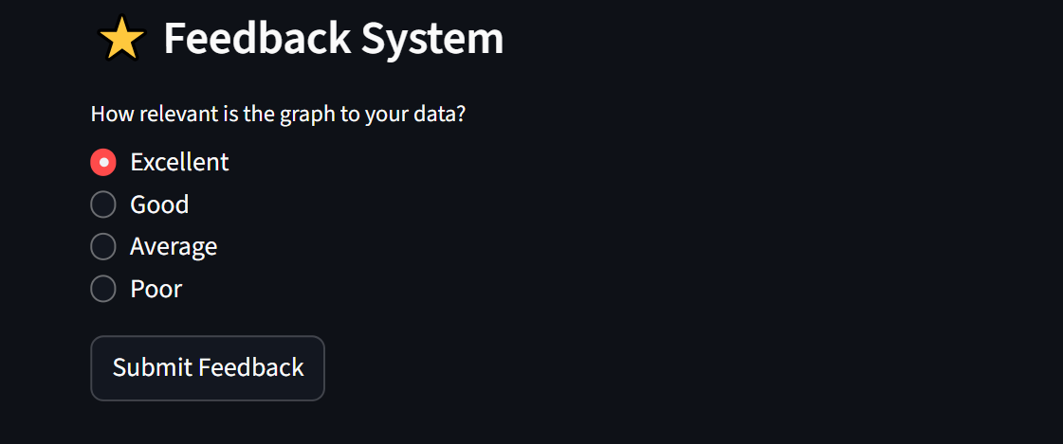

7. Challenges Faced
- Integration issues: Combining NLP models and graph databases required careful data structuring.
- Limited resources: Handling large datasets on Colab caused memory limitations.
- Deployment errors: Docker initially failed to start due to WSL configuration issues, resolved by reinstalling and configuring Docker Desktop.
- Semantic accuracy: Fine-tuning the similarity model to improve cross-domain relevance took extra testing iterations.

8. Learnings & Skills Acquired
- Technical Skills: NLP, Knowledge Graphs, Python, Flask, Docker, and Semantic Search techniques.
- Analytical Skills: Improved understanding of ontology design and cross-domain knowledge representation.
- Soft Skills: Enhanced problem-solving, time management, and technical documentation abilities.
- AI/ML Exposure: Hands-on experience with Sentence-BERT, tokenization, and entity linking.

9. Testimonials from team

This internship provided comprehensive experience in implementing real-world AI solutions. It strengthened my understanding of AI-driven data linking and broadened my perspective on how semantic systems can revolutionize knowledge management. Successfully completing this project has boosted my confidence in handling end-to-end AI-based projects.

10. Conclusion
The Know Map project achieved its objective of building an AI-based cross-domain knowledge mapping system. It demonstrated how semantic search and knowledge graphs can enhance the way data is connected and accessed. The internship has significantly contributed to my technical growth, preparing me for future research and industry roles in Artificial Intelligence and Machine Learning.

11. Acknowledgements
I would like to express my heartfelt gratitude to Springboard Organization for providing me with the opportunity to undertake this project.
A special thanks to my mentor, Ms. Pavithra Venugopal, for her continuous support, valuable feedback, and motivation throughout the internship.
I also extend my appreciation to my teammates and colleagues who provided assistance and collaboration during various stages of the project.

