1. Introduction
For manufacturing, wafer lines run at razor-thin profit margins, and one hiccup with equipment can lead to devastating loss in yield. Within specialized environments like High-Temperature Operating Life (HTOL) or post-silicon validation, an undetected fault doesn’t just stall a single batch. It compromises months of reliability data and risks the delivery of silicon to global supply chains. Each hour of fab downtime can cost tens of thousands of dollars, and legacy monitoring systems often cannot distinguish between signal noise and real hardware faults. As test data is high-dimensional today, traditional maintenance techniques do not keep up with real-time fault detection.
The Artificial Intelligence of Things (AIoT) brings sensing and intelligence together directly on the hardware. In an industrial setting, this allows shifting from the “end-to-end cloud” to an “on-device-thinking” mechanism. By running optimized models on microcontrollers via TinyML, manufacturers can detect premature mechanical fatigue or thermal anomalies without delay or data leakage to an external cloud. Although the real-time diagnostic potential is considerable, current TinyML research is concentrated on low complexity, such as vibration sensing and keyword spotting only. More challenging, high-dimensional industrial application areas remain largely unexplored.
This project develops a TinyML-based predictive maintenance system for high-dimensional fault detection in semiconductor test equipment. The UCI SECOM dataset provides a representative benchmark, comprising 1567 process samples, 590 features, and a challenging 6.6% failure rate. A suitable optimized classification model is first trained offline, followed by deploying the compressed architecture on the ESP32 microcontroller, where it will infer the predictions on the edge. The reliability of the deployment will be investigated using the Wokwi simulation environment (for hardware) and the Blynk IoT platform (for monitoring predictions of failures in the cloud). In essence, this serves as a deployment feasibility study in the field and tests the limits of resource-constrained hardware with complex industrial data.
The remaining part of the report consists of 8 sections. Section 2 reviews the Literature and defines the gap for the research, then followed by the architecture for the hardware and software in Section 3. The AI component is explained in Section 4, which defines the model, how it’s trained and evaluated. Section 5 explains the implementation using Wokwi and Blynk. Section 6 deals with ethics, while Section 7 provides a critical reflection of the results. The final section 8 has the future work of the project.

2.1 Predictive maintenance in semiconductor manufacturing
In semiconductor manufacturing, the largest cost is unplanned machine downtime. When equipment fails during post-silicon validation and reliability testing, the assembly line comes to a halt and significantly reduces yield. Predictive maintenance could fix this issue by diagnosing potential failures before they cause the downtime. Achouch et al. (2022) suggest that an Industry 4.0 solution such as using sensors to monitor the machinery can reduce maintenance costs by 30–50% across general manufacturing. The same approaches extend equipment life and lower maintenance expenses. Research in this area depends on representative benchmark data.
The UCI SECOM dataset has become a standard benchmark for this problem domain (McCann and Johnston, 2008). The dataset consists of 1567 examples and 590 features generated in a real semiconductor manufacturing process. Each example contains values for multiple process parameters and a binary label indicating whether the process passed or failed. This is a highly imbalanced dataset: only about 6.6% of observations are failures (104 failures among 1567 observations). This rate reflects the low defect levels typical in high-volume manufacturing. The defect level is critical for a product test engineer because the misdetection of one failure has far greater cost implications down the line than a single false alarm at the line.
Past approaches used multiple classifiers ensembles to deal with these difficulties. For example, Susto et al. (2015) proposed a method using multiple classifiers to deal with the censored, imbalanced data associated with manufacturing processes in semiconductor manufacturing. Performance has improved more recently as a result of a combination of feature reduction methods with newer algorithms. Salem and Bhuiyan (2025) reported a result of 98.6% accuracy on the SECOM benchmark with the Support Vector Classifier and PCA-based dimensionality reduction but, like most results on SECOM, this performance was achieved on a class-balanced (resampled) test set and doesn’t necessarily reflect real world accuracy. That is, “accuracy” can be misleading on SECOM.
Cloud/workstation-basedsystems have achieved high accuracy on the SECOM benchmark; however, these assume unlimited compute resources and consistent connectivity, assumptions that are no longer true in an edge setting. An edge system that lives on a test piece needs to address memory, power and latency constraints.

2.2 TinyML and Edge AI Foundations
Tiny Machine Learning, or TinyML, allows for machine learning inference directly on ultra-low power microcontrollers which consume power values of less than 1mW (Ooko and Karume, 2024). According to Ooko and Karume (2024) it may be viewed as deploying a miniature machine learning model onto resource constrained embedded systems, meaning rather than intelligence located on remote cloud servers, data can be processed locally. For an industrial context there are four specific benefits. Low latency allows real-time decision making. Enhanced data privacy keeps confidential information on the device, so it never leaves the edge. Low power consumption results from local rather than remote processing. Lower operational costs follow from reduced cloud and bandwidth dependency.
A robust TinyML system has a five-layer stack; according to Njor et al. (2024) these layers are the hardware, toolchain, model, data and application. This review focuses on the model layer which represents where model compression techniques such as quantisation, pruning, clustering, and neuron merging are used to shrink models with controlled trade-offs in predictive performance. This allows large classifiers to run efficiently on low-power microcontroller chips such as the ESP32 which possess relatively limited processing power and memory capacity.
While these advantages are genuine, they involve significant trade-offs, such as a typical degradation in accuracy. This degradation stems from quantization reducing numeric precision in model weights. The variety of available hardware means that deployment across different microcontrollers introduces further complexity. From a deployment perspective, the lack of standardized benchmarks means each project must establish its own evaluation criteria rather than build on shared evidence.

2.3 Applications of TinyML for Predictive Maintenance
Recent work has shown that TinyML is capable of real time predictive maintenance on microcontroller devices. Gupta and Shivhare (2025) developed an edge-based monitoring system using ESP32 with a 1D Convolutional Neural Network for vibration-based fault detection. Their model achieved an accuracy of 91.4%, with an inference time of 13ms for four fault classes while utilizing 172KB flash memory. The model utilizes data derived from rotating machinery and employs a custom collected vibration data set. This serves as a key reference for the present project.
Effective deployment of a TinyML model in a PdM scenario is heavily reliant on efficient data collection and preprocessing. Hymel et al. (2023) report that digital signal processing, rather than inference, often dominates overall system latency on edge devices. Performing DSP in an efficient manner (i.e. using FFT and statistical feature extraction) plays an essential role in ensuring high model performance and low latency. The authors also discuss the benefit ofgit status MLOps platforms such as Edge Impulse for streamlining this end-to-end workflow. However, this project uses pure TensorFlow Lite Micro to ensure complete control over the preprocessing and quantization process.
An additional important aspect of TinyML for PdM is the environmental impact. Prakash et al. (2023) state that although localized inference on the edge lowers the carbon emissions associated with data transmission to the cloud, it introduces additional “hidden” costs such as the manufacturing footprint of microcontrollers, battery consumption, and the problem of waste management. System-wide improvements must factor in environmental sustainability along with accuracy and latency performance.
Within real-time testing environments such as semiconductor post-silicon validation, equipment generates complex high-dimensional data as opposed to simple vibration signals. To date, TinyML has not been successfully adapted for semiconductor testing, where the high-dimensional data complexity exceeds current research applications.

2.4 Research Gap
A clear pattern emerges from the literature reviewed above. Many TinyML approaches toward PdM are concerned with simpler vibration or audio inputs from rotating machinery (Gupta and Shivhare, 2025; Hymel et al., 2023). While several cloud-based approaches successfully used high-dimensional process data such as the SECOM dataset (Susto et al., 2015; Salem and Bhuiyan, 2025; Abdelhafiz et al., 2024) their solutions rely heavily on cloud computing and constant network access.
What remains largely unexplored is the use of TinyML models with complex, multi-feature data from semiconductor processes on resource-limited edge devices. Three challenges combine to make this difficult: severe class imbalance (only 6.6% failures), high feature dimensionality, and the strict memory and power constraints of microcontrollers like the ESP32. Current TinyML PdM research has not addressed this combination.
This project seeks to fill this gap by attempting to train a TinyML model on the SECOM dataset, optimizing it to run on an ESP32, simulating it on Wokwi, and monitoring it on the cloud using Blynk. Closing this gap matters because high-dimensional process telemetry dominates semiconductor test floors, and bringing predictive maintenance to the edge could reduce both cloud dependency and decision latency for fault detection.

3.1 System Overview
The proposed system runs on an ESP32 microcontroller in a Wokwi simulation environment that supports live sensor monitoring and on-device ML inference. The design is purposefully structured into a two-tier system. Tier 1 is an edge IoT layer which transmits sensor data from MEMS and environmental sensors to a Blynk cloud dashboard with anomaly notifications based on thresholds. Tier 2 is an AI inference layer with an XGBoost classifier trained to operate on stored SECOM process samples. The two tiers run in parallel because they operate in distinct data domains, a design choice explained in Section 3.4.

3.2 Hardware Components
This system is based on the ESP32 microcontroller which was chosen for its high performance (4MB of flash and dual cores) and the large overhead for running compressed TinyML models, as well as to accommodate a WIFI stack for cloud-based telemetry. Two sensors model the typical monitoring signals on industrial semiconductor test equipment. An MPU6050 six-axis IMU is included to monitor vibration and mechanical health over I2C, modeling the forces exerted on the unit in a high-speed handler. A DHT22 sensor is included to monitor environmental and thermal stress, such as that experienced within a High-Temperature Operating Life chamber, by outputting digital temperature and humidity values over a single GPIO pin. Local feedback to an operator regarding device state is provided by a Green and a Red LED. Green lights up if the system is operating normally, red lights up when a failure or threshold condition is detected. The MPU6050 connects via I2C (GPIO 21/22), while the DHT22 (GPIO 4) and the red and green LEDs (GPIO 18 and 19) each use individual digital pins.

3.3 Software Architecture
The software stack is built on the Arduino ecosystem with libraries specifically added to handle hardware abstraction and connectivity to the cloud. Data collection from the sensors is performed by the Adafruit MPU6050 library and DHT sensor library, giving us a structured representation of the I2C and digital bit stream of readings. The XGBoost classifier was successfully ported from Python to a standalone C score () function using m2cgen, after the alternative quantised framework (emlearn) caused severe precision loss in initial deployment tests. This double precision output preserves the model’s logic as is, essential as the SECOM features are Z-score standardised. System logic is handled by a BlynkTimer responsible for two asynchronous tasks: polling sensors at two-second intervals and running inference at five-second intervals. The ESP32 maintains a continuous WiFi connection to the cloud through the Wokwi-GUEST where results are pushed to ten virtual pins (V0–V9) in the Blynk web dashboard.

3.4 Two-Tier Architecture: Justification
The two-tier architecture is a deliberate design choice. It mirrors how modern semiconductor manufacturing combines multiple data sources at different layers. The real-time IoT stream on the physical testing apparatus is segmented from the TinyML inference run on high-complexity process telemetry data. The motion and temperature of the system’s hardware is streamed live through the IoT layer but processed through a model operating on standard SECOM process samples. The partitioning is mandated by a core domain mismatch, as the input data consists of exterior physical health on the testing apparatus itself (vibration and ambient temperature), whereas the SECOM data describes interior process behavior (gas flows, pressures, and voltages). In a manufacturing setting, both data types exist side-by-side but represent disparate fault vectors: vibration analysis measures the health of the mechanics in high-speed handlers, and process telemetry detects silicon manufacturing phase drift. The two tiers are thus co-located onto a single ESP32 to form a ‘capability-complete’ edge device. This is evidence that the microcontroller can simultaneously manage high-bandwidth IoT telemetry and high-dimensional AI inference. Simply piping raw vibration signals from the MPU6050 into a trained SECOM chemical process model would result in a technically unsound application of the model; here, the focus is on verifying the ability of the device to handle the resource load of parallel, independent computation with each domain. This creates an accurate testing environment for hardware capabilities with regards to computational load and avoids corrupting the carefully prepared SECOM dataset. The two tiers remain independent in this implementation. Their inter-domain integration via intelligent sensor fusion becomes the primary direction for future research described in Section 8.

3.5 Section Summary
This two-tier approach presents a balance between an illustrative IoT demonstration and a practical implementation study of a high-dimensional ML model. It validates that the ESP32 can fulfill its dual role of streaming raw, real-time environmental telemetry and performing sophisticated process-level inference. The model selection, training procedure, and necessary adjustments to account for the SECOM dataset are described in Section 4, and the full system implementation and verification are described in Section 5. This system has been successfully implemented and tested: real-time sensor data is reliably streaming to the cloud dashboard, and ML inference produces predictions matching the original Python implementation.

4.1 Dataset and Problem Framing
The model is trained on UCI SECOM dataset in the development of the predictive maintenance model. The SECOM dataset is widely used as a benchmark in the process telemetry data of semiconductor manufacturing processes. The dataset contains 1,567 process samples with 590 individual features capturing internal manufacturing variables, such as a gas pressure or flow rates. A key technical issue is that there is a severe class imbalance with only 104 failures present compared to 1,463 passes, a mere 6.6% failure rate. This class imbalance, along with the high dimensional features and high rate of missing values characteristic of actual fab sensor data, adds complexity to the problem. Despite the challenges, the SECOM dataset is a great choice for this work due to the sparsity of defects and data complexity seen in high volume silicon testing and post-silicon validation.

4.2 Preprocessing Pipeline
After collecting, raw SECOM data is extensively preprocessed for the stability and compatibility with the ESP32 resource constraints. Features with over 55% of missing values are discarded and remaining null/missing values are filled using median imputation so as not to add to the distribution of the dataset or insert outliers. After this, a variance-based filter is used to eliminate zero or near-zero variance predictors, removing features with variance below 1e-6, which have negligible predictive value. This filtering is important and decreases the number of features to 440 compared to the 590 used initially. A train/test stratified 80/20 split is performed using a static random state for consistent results during evaluation. This also ensures the results align with the initial class proportions. An important architectural decision was to use min-max scaling to scale all features to fit within the int16 boundaries (-30000, +30000). Standard normalization using Z-scores was avoided as this feature set would fall in the [-3, +3] range, which collapses to near zero integers when cast to int16 in the embedded export pipeline.

4.3 Baseline Model Selection
For the establishment of a performance baseline, three different model families were tested: Random Forest (RF) which is an ensemble bagger, XGBoost (XGB) which uses gradient boosting, and a Multi-Layer Perceptron (MLP) that represents neural networks. To overcome the severe class imbalance of the SECOM dataset during this initial training, class weighting was performed using class_weight= ‘balanced’ for Random Forest, and scale_pos_weight was used in XGBoost to penalize classification error for minority class. Furthermore, in place of the standard threshold of 0.5 classification, a probability sweep ranging from 0.05 to 0.95 was carried out to find the threshold that maximized F1-score for each candidate. Initially, Random Forest yielded F1=0.359 at threshold 0.19, substantially better than XGBoost (F1=0.238) and MLP (F1=0.148) on this preprocessing pipeline. Random Forest was selected as the deployment baseline, both for its superior F1-score and its compatibility with tree-based embedded toolchains, providing a consistent reference for subsequent optimization experiments.
Model | Best Threshold | F1 | Recall | Precision | AUC
Random Forest | 0.19 | 0.359 | 0.333 | 0.389 | 0.743
XGBoost | 0.05 | 0.238 | 0.238 | 0.238 | 0.735

Table 1. Baseline model comparison. *MLP from earlier preprocessing pipeline.

4.4 F1 Improvement Experimentation
With a stable baseline in Random Forest areas of improvement were investigated. The low prediction F1-score of 0.359 was an immediate concern since a poor predictive capacity can reduce the benefit of predictive maintenance in the semiconductor manufacturing environment. A rigorous experimental campaign was conducted: eight experiments across multiple orthogonal axes: oversampling, hyperparameters, and feature selection.
First, SMOTE oversampling was evaluated at several levels. Results showed that although the baseline 0.5 SMOTE oversample significantly increased recall (to nearly 76%) it simultaneously degraded the precision resulting in too many false alarms. Additional experiments evaluated other oversamplers such as ADASYN and SMOTE-Tomek to try to improve the separability of the decision boundary. However, the baseline SMOTE 0.5 sample consistently produced reliable results across multiple model families. Feature selection experiments revealed the highest cause of model instability in this dataset. The full 440-feature space introduced sufficient noise to degrade most models. Selecting the Top 100 features by Gini importance achieved a better complexity/accuracy trade-off.
Finally, multiple model families were tested against the optimised feature set, including Logistic Regression, LightGBM, and XGBoost. The XGBoost classifier paired with Top 100 features and SMOTE sampling_strategy=0.5 emerged as the champion configuration: F1=0.4151 (+15.6% over baseline).
Fields: | Configuration | F1 | Recall | Precision | AUC
1 | RF baseline (440 features) | 0.359 | 0.333 | 0.389 | 0.743
2 | RF + SMOTE 1.0 (440 features) | 0.333 | 0.762 | 0.213 | 0.785
3 | RF + SMOTE 0.5 + GridSearch | 0.343 | 0.571 | 0.245 | 0.801
4 | RF + Top 100 + SMOTE 0.5 | 0.400 | 0.524 | 0.324 | 0.780
5 | RF + Top 100 + GridSearch | 0.400 | 0.524 | 0.324 | 0.800
6 | XGBoost + Top 100 (no SMOTE) | 0.238 | 0.238 | 0.238 | 0.735
7 | XGBoost + Top 100 + SMOTE 0.5 (champion) | 0.415 | 0.524 | 0.344 | 0.760
8 | XGBoost + Top 100 + GridSearch | 0.408 | 0.476 | 0.357 | 0.713

Table 2. Progression of F1 improvement experiments (8 configurations tested). Champion configuration in bold.
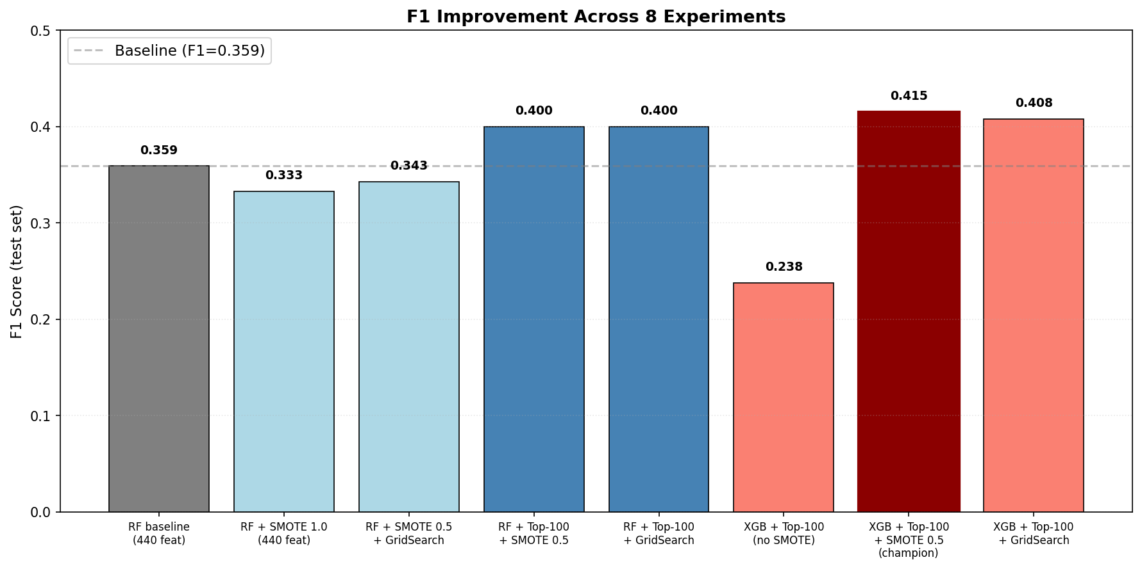
Figure 1. F1 progression across 8 experiments. Champion configuration (XGBoost + Top 100 + SMOTE 0.5) shown in dark red; baseline reference shown as dashed line.

4.5 Champion Model: XGBoost with Top 100 Features
The deployed champion model is an XGBoost gradient boosting classifier, which balances well on predictive accuracy and execution limitations of an ESP32. It has the architecture: n_estimators = 200, max_depth = 6, learning_rate = 0.1. This model only uses the best 100 features selected out of 440 original features in the pipeline using RF Gini importance. To tackle the problem of strong class imbalance, the training is carried out using sampling_strategy=0.5 and k_neighbors=5. The optimal classification threshold that maximized F1-score after probability calibration is 0.07, substantially lower than the RF baseline’s 0.19, reflecting XGBoost’s different probability calibration. The F1 score on the test set is 0.4151 with a recall of 0.524, precision of 0.344, and AUC of 0.7595. This model achieved 15.6% better F1-score than the baseline RF while its embedded memory footprint is approximately 10× smaller than the RF deployment (140 KB vs 1.5 MB).
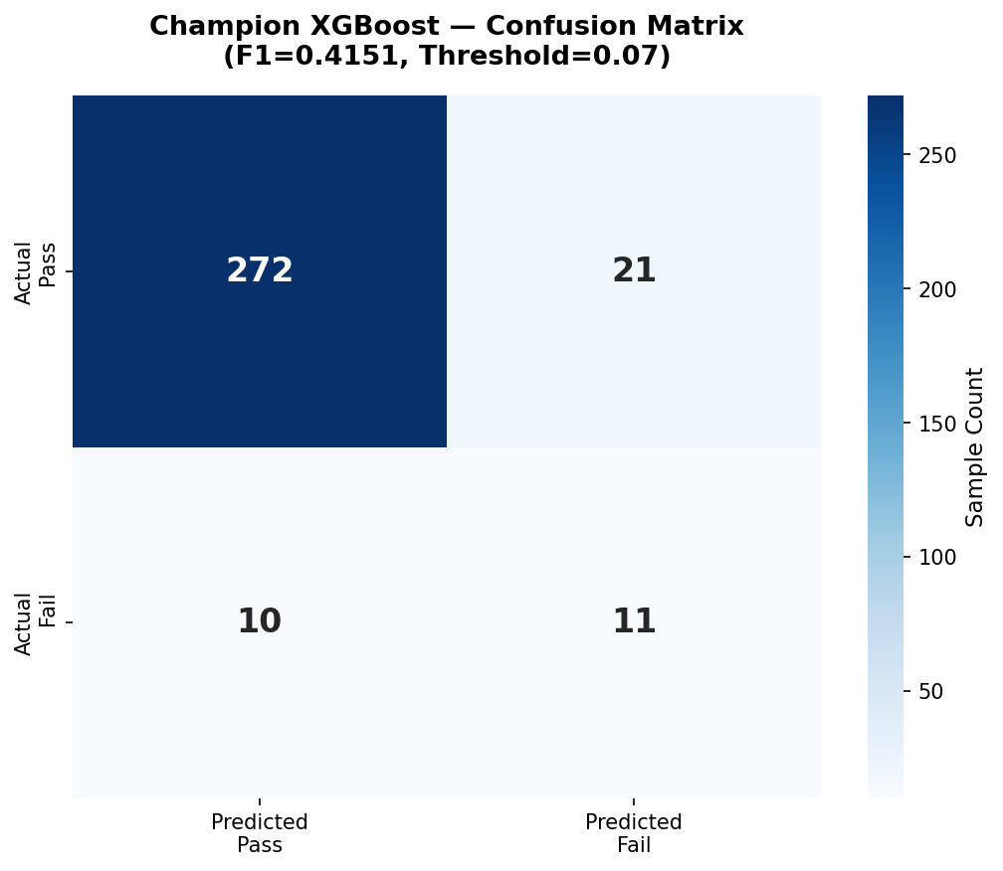
Figure 2. Confusion matrix for the deployed XGBoost classifier on the SECOM test set. The model correctly identifies 11 of 21 failures (TP) at the optimal threshold of 0.07.

4.6 Deployment Considerations
Migrating the winning XGBoost model to the ESP32 presented several challenges due to the aggressive embedded resource constraints, such as limited flash storage, lack of dedicated FPU support for complex ensemble structures, etc. A crucial step during the transition was selecting a toolchain. Initially, emlearn was evaluated; however, it was eventually replaced by m2cgen. The primary reason for selecting m2cgen was its native support of XGBoost combined with double precision numbers to prevent loss of information from the standardised features. This precision issue with other quantization export pathways resulted in a substantial loss of accuracy; this loss is discussed further in Section 7. In the end, m2cgen generated a 140KB independent C function with bit-exact parity with the Python model. The bit-exact C code became the core engine of the AI tier, and the deployed inference performance is detailed in Section 5.
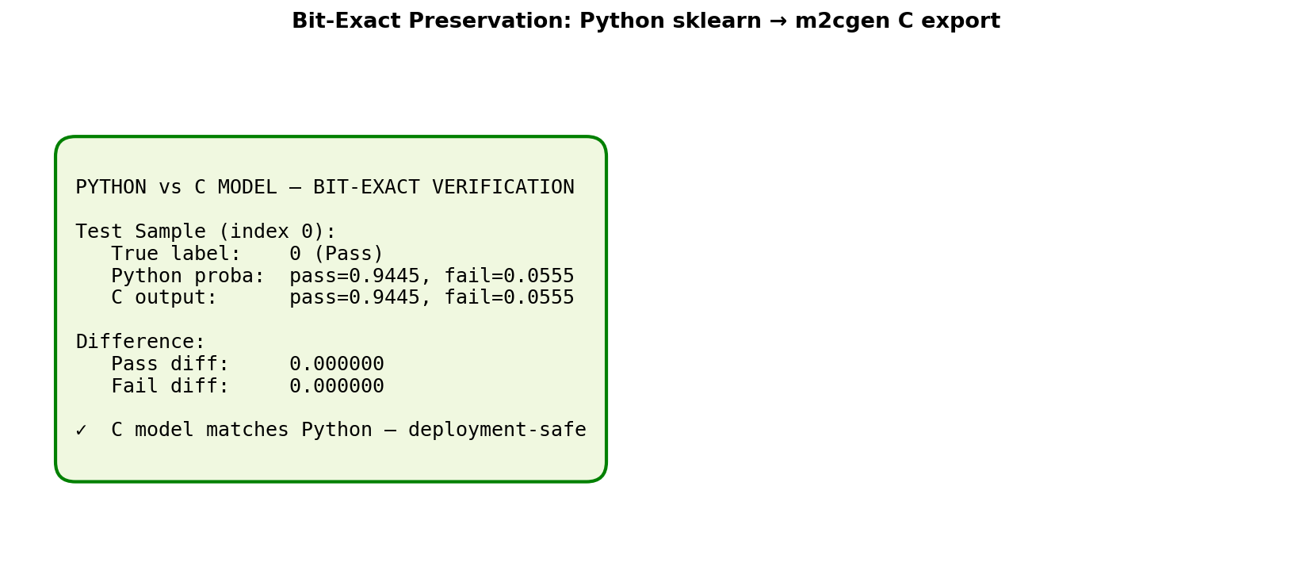
Figure 3. Verification that the m2cgen-generated C code produces identical predictions to the Python reference model. The bit-exact preservation guarantees deployment fidelity.

4.7 Section Summary
This section outlines the transformation of raw SECOM process telemetry into a validated, ready-for-deployment TinyML model. Through a structured pipeline of variance-based feature selection, stratified resampling, and orthogonal experimentation, this work developed a more efficient XGBoost model which outperformed our initial Random Forest baseline. The chosen champion (with the 100 best features and SMOTE oversampling) has achieved an F1-score of 0.4151, an increase in predictive performance of 15.6%. Having successfully transformed the model into a bit-exact C function, Section 5 outlines its deployment on the ESP32 and verification of the overall AIoT system.

5.1 Hardware Setup in Wokwi
This system is modeled physically using the Wokwi simulator; this simulates a cycle-accurate version of the ESP32 DevKit V1, its peripheral interaction and the relevant logic. The MPU6050 connects via I2C (GPIO 21/22), the DHT22 via a digital pin (GPIO 4), and two status LEDs (red and green) on GPIO 18 and 19 for local status indication. Wiring is in accordance with the wiring schematic set out in Section 3.2. Cloud-based simulation provides a readily available and repeatable testing platform for performing hardware-in-the-loop testing of the AI inference engine quickly without requiring physical hardware access. This also accurately simulates the timing and signal semantics that are needed for verification of the end-to-end AIoT system.

5.2 Software Stack & Build Process
This firmware was programmed using the Arduino framework where it utilizes the Adafruit MPU6050, DHT, and Blynk libraries in order to interact with the peripheral sensors and communicate to the cloud. The Arduino CLI was used to compile firmware locally via VS Code (using the Wokwi VS Code extension), rather than the Wokwi web cloud build service. The choice to compile locally was made to avoid build queue backlogs and timeout issues with the large firmware (the RF model alone exceeded 1.5 MB before the m2cgen pivot reduced the model to 140 KB). The total binary is roughly 77% of the ESP32’s total flash memory, which is a slight decrease from the 81% with the Random Forest baseline model. WiFi credentials and Blynk authentication token are defined as preprocessor macros at the top of the sketch file.

5.3 ML Inference Deployment
After validation, the XGBoost model is converted into a standalone C function using m2cgen and placed into xgb_model.h The resulting function is called score (double *input, double *output) and takes a 100 double feature array and returns a two-element output vector, where each element contains the probability of a state being either “pass” or “fail.” Since the physical sensors cannot produce SECOM-domain features (Section 3.4), five example samples are hardcoded into secom_samples_xgb.h. This allows for testing the inference engine without using the actual sensor streams. Inference is invoked every 5 seconds via a BlynkTimer task; the optimal classification threshold of 0.07 (from training, see Section 4) is applied to the model output to determine the predicted class. When the failure probability crosses the threshold, the local LEDs and Blynk dashboard widgets are updated to reflect the predicted state.

5.4 Cloud Dashboard
An interactive interface allows users to observe sensor data in real-time via the Blynk IoT platform which manages 10 separate datastreams associated with virtual pins V0-V9. Datastreams V0-V5 correspond to sensor telemetry and encompass the 3-axis acceleration values, the current temperature and humidity, and a threshold-based fault indicator (1 = fault detected, 0 = normal). The ML inference tier outputs are presented across four widgets: predicted class (V6), actual class (V7), current sample index (V8), and a binary match indicator (V9). These datastreams are visualized in the system using several different widgets such as the temperature and humidity gauges and the failure LED display. The datastreams are updated asynchronously at 2-second intervals for sensor telemetry and 5-second intervals for ML inference results, providing the operator with near real-time visibility.

5.5 Testing & Verification
System performance was verified through both ML inference testing and live sensor pipeline validation. A validation test of the ML inference engine was conducted using five pre-loaded hardcoded SECOM samples. When the 5 samples were input into the ESP32 at 5 second intervals it was discovered that all 5 out of 5 inferences returned the correct outcome. A representative ‘Pass’ sample produced a failure probability of 0.0004 (effectively zero). A ‘Fail’ sample triggered the correct fault detection with a failure probability between 0.58 and 0.64. This is much higher than the optimized threshold of 0.07. The sensor pipeline was tested using a live feed of MEMS and thermal data to the Blynk dashboard within 2 seconds of polling. Local threshold-based fault detection was also verified: a simulated sensor breach caused the red LED to illuminate immediately.

5.6 Section Summary
This section’s implementation verifies that both the IoT monitoring tier and the AI inference tier operate concurrently on the ESP32 within a simulated industrial environment: live sensor data streams with full fidelity, and embedded SECOM samples are classified with 100% parity to the host machine learning model. Having proved the end-to-end data flow and system functionality, Section 6 reflects on the obtained results and the ethical considerations regarding edge-based predictive maintenance.

6.1 Achievements and Limitations
Among the successes were systematically improving the F1-score from 0.36 to 0.42 (+15.6%) and deploying the XGBoost classifier via m2cgen. 5/5 prediction success on the embedded SECOM samples was verified through validation cycles, demonstrating that the hardware can achieve bit-exact parity to Python-based reference models. The limitations are also clear. Even with the 15.6% increase, an F1-score of 0.42 remains fairly low compared to literature results on resampled, balanced datasets. The clear boundary and physical distance between the physical sensors and ML tier, though the intended result, does not lend to direct, immediate sensor-driven fault detection in its current form. Relying on a Wokwi simulation and 5 hardcoded test samples is appropriate for the feasibility study but indicates that future work will require validation on a physical platform and with a wider variety of samples. All of these aspects serve as building blocks for the technical reflections discussed in the following subsections.

6.2 Engineering Lessons: The Deployment Toolchain Pivot
The most significant engineering hurdle was a failure in the initial deployment pipeline. Emlearn was chosen as it converted tree-based models efficiently, but the early testing showed that the Random Forest baseline was breaking completely-it predicted the majority ‘pass’ class for all inputs. The issue was found by looking through the produced C code: an (int16_t) cast was applied to the inputs without an internal scaling factor in the toolchain. Since the inputs were Z-scored (around -3 to +3) nearly every feature was effectively becoming 0 after truncation completely removing predictive information.
This identified three crucial changes to the project’s approach. First, the preprocessing pipeline was redeveloped to use a MinMaxScaler with int16 safe boundaries of [-30000, +30000] in order to maintain fidelity. Secondly, as optimizations improved the model was changed from a Random Forest to an XGBoost modelThe toolchain was then changed to m2cgen, which natively supports XGBoost and uses double-precision arithmetic, avoiding the quantisation problem entirely. The major lesson was the implicit assumption made by toolchains about data scaling; it is crucial to examine the generated C code relative to the Python model to confirm it functions correctly when it is deployed from desktop to the edge.

6.3 Honest Discussion of F1 = 0.42
While F1=0.4151 is modest in absolute terms, it represents a 15.6% improvement over the baseline, and the performance can be attributed to the inherent difficulties of the SECOM dataset. Many F1 scores reported in the SECOM literature use resampled or balanced test sets, which may not reflect production-realistic distributions. For predictive maintenance applications, a high recall (0.524) is often preferable to high precision to minimise the probability that catastrophic failures occur without detection. The AUC of 0.76 indicates meaningful class separability and provides an adequate basis for risk-informed decision-making at the edge.

6.4 Ethical Considerations
Several domain-specific ethical considerations emerge from the deployment of edge-based predictive maintenance. Running the model inferences locally on the ESP32 increases data sovereignty and IP protection, avoiding exposure of sensitive manufacturing telemetry to potentially vulnerable third-party cloud platforms and keeping it within the fab’s local network. However, model performance concerns, in particular the problem of false negatives, have critical ethical implications undetected failures in the semiconductor fabrication process may lead to defects entering key sectors like medical and automotive. The question of model bias is also significant; the XGBoost classifier built on the SECOM process parameters will likely not translate to a new fabrication environment, yielding unreliable safety signaling when applied outside the training domain. Lastly, despite potential labour-replacement implications, transparency in tree-based models offers an interpretability gain, allowing human operators to verify the system’s decisions and shift from hands-on inspection to higher-value supervisory tasks.

6.5 Section Summary
This section has reflected on the successful delivery of the AIoT pipeline and the critical engineering pivots required to maintain model integrity at the edge. The transition from int16 quantization to double-precision inference underscores the necessity of toolchain verification in embedded ML. With the technical and ethical dimensions of the project fully evaluated, the report concludes in Section 7 with a summary of findings and proposed directions for future work.

7.1 Project Summary
This project developed an integrated AIoT predictive maintenance system on an ESP32 microcontroller, showing that high-dimensional inference is possible at the edge. The system uses a two-tier architecture to process real-time data from MEMS sensors and run machine learning classifications simultaneously. A key achievement was improving the predictive model’s F1-score from 0.36 to 0.42 by refining features and switching to an XGBoost model. The model was migrated from Python to embedded C using m2cgen, preserving the model weights and logic exactly. Final tests showed the system streams sensor data quickly to a Blynk cloud dashboard and correctly classifies all SECOM test samples. This work shows that tree-based ensemble models can be made sufficiently small for industrial monitoring without sacrificing accuracy.

7.2 Key Findings
Several key findings emerge from the development and testing of this system:
- Reducing the number of features had the biggest impact on performance. Using only the top 100 features performed much better than using all 440 features, regardless of the model used.
- Standard int16 quantisation is incompatible with z-score standardised features, as demonstrated by the emlearn deployment failure in this project. For reliable results on embedded systems, double-precision arithmetic or careful range scaling is needed.
- m2cgen provides a reliable way to deploy XGBoost models, ensuring predictions remain identical across Python and C.
- The two-tier architecture provides a strong framework for AIoT systems, especially when physical sensor data and process telemetry do not align well.

7.3 Future Work
The current system demonstrates that edge-based predictive maintenance is possible, but there is still room for improvement. The main goal should be to move from the current two-tier setup to real sensor fusion. Future versions should train a second machine learning model directly on the high-frequency vibration and thermal data from the MPU6050 and DHT22 sensors. Migrating from the Wokwi simulation to actual ESP32 hardware to test the system in real-world conditions, including electromagnetic interference and changing environments.
To make the verification process stronger, the system could stream more of the SECOM test set through the serial interface instead of just using five fixed samples. Measuring latency and power use on real hardware would also help show how model complexity affects battery life, which is important for wireless industrial use. For a more advanced upgrade, adding federated learning could let several manufacturing sites work together to improve the model without sharing sensitive or restricted data. These changes would help turn the current prototype into a reliable, production-ready solution for the semiconductor industry.

7.4 Closing Remarks
This project demonstrates that high-dimensional ensemble models can run effectively on low power edge devices, enabling real-time industrial intelligence. By solving key toolchain and data scaling problems, it provides a viable pathway for implementing predictive maintenance in the semiconductor industry and lays a strong foundation for future AIoT advances.

References
- Abdelhafiz, A., Soliman, A. and Mahgoub, I., 2024. Rare Class Prediction Model for Smart Industry in Semiconductor Manufacturing. arXiv preprint, 2406.04533. Available at: https://arxiv.org/abs/2406.04533
- Achouch, M., Dimitrova, M., Ziane, K., Sattarpanah Karganroudi, S., Dhouib, R., Ibrahim, H. and Adda, M., 2022. On Predictive Maintenance in Industry 4.0: Overview, Models, and Challenges. Applied Sciences, 12(16), p.8081. https://doi.org/10.3390/app12168081
- EpiSensor, 2024. IoT Data Privacy: Ensuring Compliance with GDPR and Other Regulations. EpiSensor Knowledge Base. Available at: https://episensor.com/knowledge-base/iot-data-privacy-ensuring-compliance-with-gdpr-and-other-regulations/
- Gupta, S. and Shivhare, S.N., 2025. Embedded TinyML for Predictive Maintenance: Vibration Analysis on ESP32 with Real-Time Fault Detection in Industrial Equipment. International Journal on Computational Modelling Applications, 2(2), pp.1–17. https://doi.org/10.63503/j.ijcma.2025.114
- Hymel, S., Banbury, C., Situnayake, D., Elium, A., Ward, C., Kelcey, M., Baaijens, M., Majchrzycki, M., Plunkett, J., Tischler, D., Grande, A., Moreau, L., Maslov, D., Beavis, A., Jongboom, J. and Reddi, V.J., 2023. Edge Impulse: An MLOps Platform for Tiny Machine Learning. In: Proceedings of Machine Learning and Systems (MLSys), Vol. 5. Available at: https://proceedings.mlsys.org/paper_files/paper/2023/hash/49fe55f5e9574714dda575bfb2177662-Abstract-mlsys2023.html
- McCann, M. and Johnston, A., 2008. SECOM Data Set. UCI Machine Learning Repository. Available at: https://archive.ics.uci.edu/dataset/179/secom
- Njor, E., Hasanpour, M.A., Madsen, J. and Fafoutis, X., 2024. A Holistic Review of the TinyML Stack for Predictive Maintenance. IEEE Access, 12, pp.184861–184882. https://doi.org/10.1109/ACCESS.2024.3512860
- Ooko, S.O. and Karume, S.M., 2024. Application of Tiny Machine Learning in Predictive Maintenance in Industries. Journal of Computing Theories and Applications, 2(1), pp.131–150. Available at: https://dl.futuretechsci.org/id/eprint/17/
- Prakash, S., Stewart, M., Banbury, C., Mazumder, M., Warden, P., Plancher, B. and Reddi, V.J., 2023. Is TinyML sustainable? Assessing the environmental impacts of machine learning on microcontrollers. Communications of the ACM, 66(11), pp.68–77. https://doi.org/10.1145/3608473
- Salem, A. and Bhuiyan, M.A.N., 2025. Predictive Maintenance in Semiconductor Manufacturing Using Machine Learning on Imbalanced Dataset. International Journal of Research and Scientific Innovation, 12(10), pp.170–176. Available at: https://rsisinternational.org/journals/ijrsi/view/predictive-maintenance-in-semiconductor-manufacturing-using-machine-learning-on-imbalanced-dataset
- Susto, G.A., Schirru, A., Pampuri, S., McLoone, S. and Beghi, A., 2015. Machine Learning for Predictive Maintenance: A Multiple Classifier Approach. IEEE Transactions on Industrial Informatics, 11(3), pp.812–820. https://doi.org/10.1109/TII.2014.2349359

