

COURSEWORK COVER PAGE
Module Code/Title: | LD7182FLZ01 - Artificial Intelligence for Internet of Things (IoT)
Module Tutor Name: | Saber Farag
Student Name (ID): | Rekhanth Reddy Obireddy (25034464)
Programme of Study: | MSc Artificial Intelligence Technology
Coursework Title: | Artificial Intelligence for Internet of Things (IoT)
Word count: | 4255
Submission Instructions:
- Name your submission using the name convention, LDXXXX_<your tutor initial>_<your programme> <intakes>_<your id><name>.docx, eg LD7091_NT_CT9_w24012345John.docx is a submission for the student of MSc Computing & Technology (Sep Intakes) attending Ning Tse’s session.
- Submit to Bb on or before 16:00, dd MMM YYYY

Declaration of that the submission is your own work
I confirm that:
☒ This assignment submission is my own, independent work.
☒ I have referenced the sources of information, ideas, and quotations that I have used in this submission and listed my sources in a bibliography.
☒ I have submitted the supporting documentation I have been asked for (e.g., notes, plans, etc - refer to your assessment brief).

Declaration of the Use of AI tool:
EITHER
☐ I have not used AI at any point in preparing this assignment.
OR
☒ I have used AI tools (including, but not limited to ChatGPT) to help me (select all that apply):
☐ Generate initial ideas in response to the question.
☒ Develop my structure.
☐ Generate ideas for examples / sources.
☒ Provide feedback and suggestions for improvement on my content.
☒ Edit and improve my spelling and grammar.
☐ Other: please explain: _________________________________________________________

☒ I have NOT used AI to generate whole sentences, paragraphs, sections, or the whole of this assignment and I understand that this would be considered academic misconduct.

Your signature: | Rekhanth Reddy Obireddy | Date: | 19/05/2026

Table of Contents
1. Introduction 4
2.1 Predictive maintenance in semiconductor manufacturing 5
2.2 TinyML and Edge AI Foundations 5
2.3 Applications of TinyML for Predictive Maintenance 6
2.4 Research Gap 6
3.1 System Overview 7
3.2 Hardware Components 7
3.3 Software Architecture 7
3.4 Two-Tier Architecture: Justification 8
4.1 Dataset and Problem Framing 8
4.2 Preprocessing Pipeline 9
4.3 Baseline Model Selection 9
Table 1 9
4.4 F1 Improvement Experimentation 9
Table 2. 10
Figure 1. 11
4.5 Champion Model: XGBoost with Top 100 Features 11
Figure 2. 11
4.6 Deployment Considerations 11
5.1 Hardware Setup in Wokwi 12
Figure 4. 13
5.2 Software Stack & Build Process 13
5.3 ML Inference Deployment 13
5.4 Cloud Dashboard 14
Figure 5. 14
5.5 Testing & Verification 14
Figure 6. 15
6.1 Achievements and Limitations 15
6.2 Engineering Lessons: The Deployment Toolchain Pivot 16
Figure 7. 16
6.3 Honest Discussion of F1 = 0.42 16
6.4 Ethical Considerations 17
6.5 Section Summary 17
7.1 Project Summary 17
7.2 Key Findings 17
7.3 Future Work 18
7.4 Closing Remarks 18
References 18
Appendix A: User Guide 19
A.1 Repository and Code 19
Repository structure: 20
A.2 Running the Wokwi Simulation 20
A.3 Accessing the Blynk Dashboard 20
A.4 Interpreting the Outputs 20
A.5 Re-Training the Model (Optional) 21
A.6 System Requirements 21

1. Introduction
Equipment failure can lead to costly downtime for organizations. It severely affects the yields of silicon which costs thousands of dollars as well as supply chain disruptions globally. In 2021, Amazon lost 13 million dollars from a 13 min downtime. There are 3 types of maintenance methods: Reactive Maintenance, Preventive Maintenance and Predictive Maintenance. Most of the organizations use preventive maintenance (predefined schedule maintenance) currently. In general, the current methods cannot tell the difference between real faults and white noise. Advancements in AIoT and TinyML can enable intelligence to the edge devices to detect mechanical or thermal issues without relying on the cloud. However most related research mainly focuses on simple tasks like using vibration telemetry or keyword spotting. Organizations have incentives to predict or prevent the costs rendered by unplanned downtime.
Here comes my solution to this problem - a TinyML-based predictive maintenance approach is introduced that can detect failures using high dimensional data. The UCI SECOM dataset (imbalanced) is used as the standard. System is optimized offline and the compressed architecture is executed on an ESP32 microcontroller. In this design I deliberately choose 2 tier architecture, Tier 1 gathers equipment vibration and temperature using MPU6050 and DHT22 sensors. Tier 2 performs machine learning inference on internal silicon process logs like voltage, pressure and gas flow. Here I’m trying to address 2 problems (equipment External data + Internal data) within one integrated solution. This can prove that edge devices can handle multiple tasks at the same time.
2.1 Predictive maintenance in semiconductor manufacturing
In semiconductor manufacturing, unplanned machine downtime is the biggest cost driver. Equipment failures during post-silicon validation stop production and lower yield. Predictive maintenance solves this problem by identifying failures before they lead to downtime. Achouch et al. (2022) suggest that an Industry 4.0 solution such as using sensors to monitor the machinery can reduce maintenance costs by 30–50% across general manufacturing.
For this problem domain, SECOM dataset became a standard benchmark (McCann and Johnston, 2008). The defect level is critical for a product test engineer because the misdetection of one failure has far greater cost implications down the line than a single false alarm at the line.
Susto et al. (2015) proposed a method using multiple classifiers to deal with the censored, imbalanced data associated with manufacturing processes in semiconductor manufacturing. Performance has improved more recently because of a combination of feature reduction methods with newer algorithms. Salem and Bhuiyan (2025) reported a result of 98.6% accuracy with the Support Vector Classifier and PCA-based dimensionality reduction but like most results on SECOM, this performance was achieved on a class-balanced (resampled) test set which inflates performance.

2.2 TinyML and Edge AI Foundations
Tiny Machine Learning, or TinyML, allows for machine learning inference directly on ultra-low power microcontrollers which consume power values of less than 1mW (Ooko and Karume, 2024).
Four industrial benefits: low latency for real time decisions, enhanced privacy, low power, and reduced cloud cost. A robust TinyML system has a five-layer stack; according to Njor et al. (2024) these layers are the hardware, toolchain, model, data and application.
The focus is on model layer where compression techniques like quantization, pruning, clustering and neuron merging are used to reduce the model size with controlled tradeoffs. It’s helpful in PdM as it involves large classifiers to run efficiently on low power microcontrollers like ESP32 which are limited by resources constraint.
2.3 Applications of TinyML for Predictive Maintenance
Existing research evidently shows that TinyML can process data on devices near the sensors enhancing responsiveness and privacy for a real time PdM on microcontrollers. Gupta and Shivhare (2025) developed an edge-based monitoring system for real-time predictive maintenance using Tiny ML model on ESP32 controller within its memory and processing limitations for vibration-based fault classification. They used 1D convolutional neural networks to accuracy of 91.4% with inference time 13ms using only 172kb flash memory. The model uses data from rotating machinery and a custom collected vibration data set. It is major reference for this project.
TinyML model deployment in a PdM environment is highly dependent on data acquisition and preprocessing stages. Hymel et al. (2023) report that digital signal processing, rather than inference, often dominates edge-device latency. Efficient DSP (i.e. using FFT and statistical feature extraction) plays an essential role for high model performance and low latency. The authors also state that MLOps platforms such as Edge Impulse simplify the end-to-end process, but pure TensorFlow Lite Micro is being used on this project, so full control over the pre-processing and quantization is maintained.
An additional important aspect of TinyML for PdM is the environmental impact. Prakash et al. (2023) state that although localized inference on the edge lowers the carbon emissions associated with data transmission to the cloud, it introduces additional “hidden” costs such as the manufacturing footprint of microcontrollers, battery consumption, and the problem of waste management. Overall improvements to the system need to account for environmental sustainability in addition to accuracy and latency.
Real-time semiconductor testing environments generates a complex, high-dimensional data, not just simple vibration signals. TinyML is not yet used in this domain as data is complex for current research.
2.4 Research Gap
A clear pattern emerges from the literature reviewed above. Many TinyML approaches toward PdM are concerned with simpler vibration or audio inputs from rotating machinery (Gupta and Shivhare, 2025; Hymel et al., 2023). Cloud-based approaches successfully used high-dimensional process data such as the SECOM dataset (Susto et al., 2015; Salem and Bhuiyan, 2025; Abdelhafiz et al., 2024) rely heavily on cloud computing and constant network access.
What remains largely unexplored is the use of TinyML models with complex, multi-feature data from semiconductor processes on resource-limited edge devices. It’s difficult due to the class imbalance (6.6% failures) and high dimensionality of features on microcontrollers with extreme memory and power limitations (ESP32). So far, there are no known TinyML works concerning PdM with these types of data.
This project seeks to fill this gap by attempting to train a TinyML model on the SECOM dataset, optimizing it to run on an ESP32, simulating it on Wokwi, and monitoring it on the cloud using Blynk. The importance of bridging this gap is that most semiconductor test floors are driven by high-dimensional process telemetry and moving predictive maintenance to the edge would minimize cloud dependence and fault detection decision latency.

3.1 System Overview
This project operates on an ESP32 microcontroller in a Wokwi simulation environment allowing live sensor reading and onboard ML inference. The architecture is designed deliberately as a two-tier architecture. Tier 1 is an edge IoT layer that sends data from the MEMS and environmental sensors to a Blynk cloud dashboard with anomaly alerts using thresholding. Tier 2 is an AI inference layer with an XGBoost classifier trained to operate on stored SECOM process samples. The two tiers run in parallel because they operate in distinct data domains, a design choice explained in Section 3.4.

3.2 Hardware Components
This project is based on the ESP32 microcontroller which was chosen for its high performance (4MB of flash and dual cores) and the large overhead for running compressed TinyML models, and built-in WiFi stack for cloud-based telemetry. Two sensors model the typical monitoring signals on industrial semiconductor test equipment. A 6-axis IMU is included for the MPU6050 which monitors mechanical state and vibrations through I2C, with the physical forces within a High-Speed Handler. A DHT22 sensor measures thermal and environmental stress such as High Temperature Operating Life chambers. Local feedback to an engineer regarding device state is provided by a Green and a Red LED. Green lights up if the system is operating normally, red lights up when a failure or threshold condition is detected. The MPU6050 is connected using I2C (GPIO 21/22). The assignments of the digital pins are straightforward. GPIO 4 is assigned to the DHT22, GPIO 18 is assigned to the red LED and GPIO 19 is assigned to the green LED.

3.3 Software Architecture
Built on Arduino using hardware-abstraction and cloud libraries; Adafruit MPU6050 and DHT libraries process peripheral data into I2C and digital bit-streams. The XGBoost classifier was ported from Python and converted into an C score () function using m2cgen. Earlier experiments with quantized framework (emlearn) caused severe precision loss during an initial deployment. This output provides double-precision probability results preserving the model logic which was necessary given that SECOM features were Z-score standardized. The BlynkTimer manages two processes: fetching the sensor values every 2 seconds and running the model inference every 5 seconds. Continuous connection to the cloud via WiFi is provided by the ESP32 via the Wokwi-GUEST and results pushed to ten virtual pins (V0-V9) on the Blynk web interface.

3.4 Two-Tier Architecture: Justification
The two-tier architecture is an intentional design decision. It mirrors the way semiconductor fabrication uses different sources of data at various levels. The real-time physical data from IoT is separated from the high complexity process telemetry data used by ML inference. The motion and temperature of the system's hardware is streamed live through the IoT layer but processed through a model operating on standard SECOM process samples. The partitioning is required due to a "fundamental domain mismatch", because input data is external physical health (vibration and ambient temperature) at the test apparatus and the SECOM data is internal process health (gas flow and pressures, and voltages). Within manufacturing both types are found adjacent but represent independent fault vectors: vibration analysis addresses mechanics health within high-speed handlers, and process telemetry identifies silicon manufacturing phase drift. They reside together on one ESP32 'capability complete' edge device. This is evidence that the microcontroller can simultaneously manage high-bandwidth IoT telemetry and high-dimensional AI inference. Simply piping raw vibration signals from the MPU6050 into a trained SECOM chemical process model would result in a technically unsound application of the model; here, the focus is on verifying the ability of the device to handle the resource load of parallel, independent computation with each domain. This creates an accurate testing environment for hardware capabilities with regards to computational load and avoids corrupting the carefully prepared SECOM dataset.

4.1 Dataset and Problem Framing
The model is trained on UCI SECOM dataset in the development of the predictive maintenance model. The SECOM dataset is widely used as a benchmark in the process telemetry data of semiconductor manufacturing processes. This is a production process dataset with 1,567 samples on 590 features from sensors on a production line (Labels: -1 is success; +1 is a failure). The primary problem is extreme class imbalance as there are only 104 samples which are a failure (failure rate = 6.6%). Most common ML methods will overfit to the majority class. This leads to very high accuracy but no detection of failures.

4.2 Preprocessing Pipeline
The raw SECOM data needs to be highly preprocessed due to stability issues and ESP32 limitations. All features with missing values above 55% are dropped. The other missing values are filled using median imputation to preserve distribution. After that, a variance filter is used to remove predictors with a variance of 0 or very small values. Predictors with variances less than 1e-6, which do not contribute to predictions, have been eliminated. It is essential and has removed the predictors count from 590 to 440. A stratified 80/20 train/test split with a fixed random state keeps the original class proportions and ensures that results can be reproduced. Min-max scaling was used to scale all features to fit within the int16 boundaries (-30000, +30000). Didn’t use Z-score standard normalization as the feature set falls in [-3, +3] range, when cast into int16 in embedded export pipeline it rounded almost all values to {-3, -2, -1, 0, 1, 2, 3} removing predictive information.

4.3 Baseline Model Selection
To establish a baseline, three different model families were tested: Random Forest (RF) which is an ensemble bagger, XGBoost (XGB) which uses gradient boosting, and a Multi-Layer Perceptron (MLP) that represents neural networks. To overcome the severe class imbalance of the SECOM dataset during this initial training, class weighting was performed using class_weight='balanced' for Random Forest, and scale_pos_weight was used in XGBoost to penalize classification error for minority class. Furthermore, in place of the standard threshold of 0.5 classification, a probability sweep ranging from 0.05 to 0.95 was carried out to find the threshold that maximized F1-score for each candidate. Initially, Random Forest yielded F1=0.359 at threshold 0.19, substantially better than XGBoost (F1=0.238) and MLP (F1=0.148) on this preprocessing pipeline. Random Forest was chosen as the baseline for deployment, due to both its higher F1-score, and its use of a tree based embedded toolchains as a steady benchmark against future optimization attempts.
Model | Best Threshold | F1 | Recall | Precision | AUC
Random Forest | 0.19 | 0.359 | 0.333 | 0.389 | 0.743
XGBoost | 0.05 | 0.238 | 0.238 | 0.238 | 0.735
Table 1. Baseline model comparison. *MLP from earlier preprocessing pipeline.

4.4 F1 Improvement Experimentation
With a stable baseline in Random Forest areas of improvement were investigated. The low prediction F1-score of 0.359 was an immediate concern since a poor predictive capacity can reduce the benefit of predictive maintenance in the semiconductor manufacturing environment. Total eight experiments were conducted, spanning a few orthogonal axes: oversampling, hyperparameters and feature selection. First, SMOTE oversampling was evaluated at several levels. Results showed that although the baseline 0.5 SMOTE oversample significantly increased recall (to nearly 76%) it simultaneously degraded the precision resulting in too many false alarms. Additional experiments evaluated other over samplers such as ADASYN and SMOTE-Tomek to try to improve the separability of the decision boundary. Despite these issues the baseline SMOTE 0.5 sample consistently performed consistently well across several different model families. Feature selection experiments showed that the main cause of instability in this data was the complete 440-feature space. This added a significant amount of noise and reduced the performance of many models. Top 100 by Gini importance offered a good complexity/accuracy trade-off. Lastly, many models were tried on top of the optimized features: LR, LightGBM, and XGBoost. Best of all, is the combination of XGBoost classifier and Top 100 features, sample_strategy=0.5 and SMOTE with F1=0.4151 (+15.6% to baseline).
Fields: | Configuration | F1 | Recall | Precision | AUC
1 | RF baseline (440 features) | 0.359 | 0.333 | 0.389 | 0.743
2 | RF + SMOTE 1.0 (440 features) | 0.333 | 0.762 | 0.213 | 0.785
3 | RF + SMOTE 0.5 + GridSearch | 0.343 | 0.571 | 0.245 | 0.801
4 | RF + Top 100 + SMOTE 0.5 | 0.400 | 0.524 | 0.324 | 0.780
5 | RF + Top 100 + GridSearch | 0.400 | 0.524 | 0.324 | 0.800
6 | XGBoost + Top 100 (no SMOTE) | 0.238 | 0.238 | 0.238 | 0.735
7 | XGBoost + Top 100 + SMOTE 0.5 (champion) | 0.415 | 0.524 | 0.344 | 0.760
8 | XGBoost + Top 100 + GridSearch | 0.408 | 0.476 | 0.357 | 0.713
Table 2. Progression of F1 improvement experiments (8 configurations tested). Champion configuration in bold. 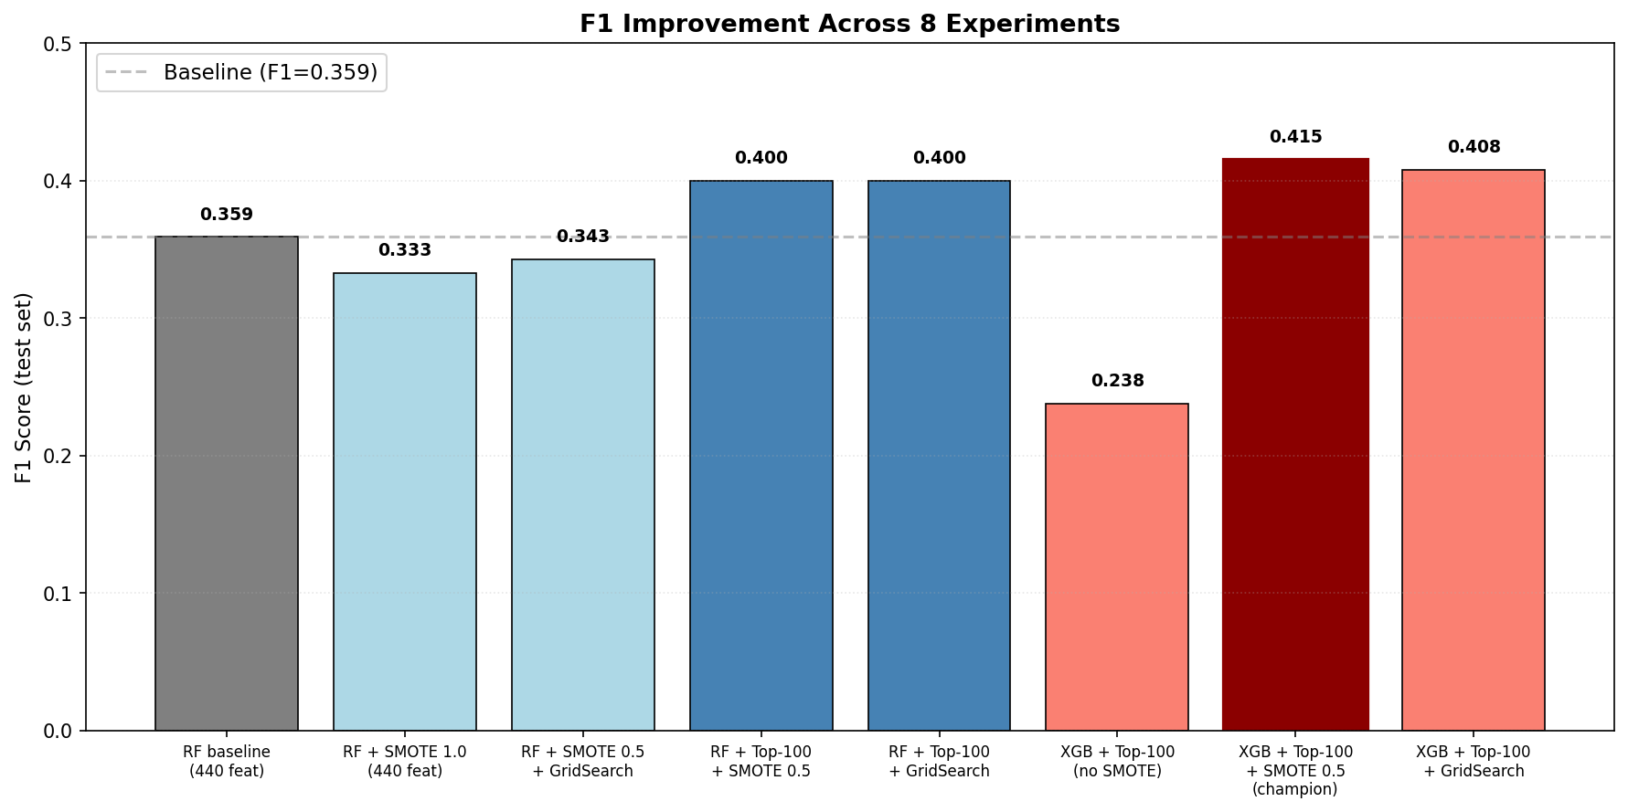
Figure 1. F1 progression across 8 experiments. Champion configuration (XGBoost + Top 100 + SMOTE 0.5) shown in dark red; baseline reference shown as dashed line.

4.5 Champion Model: XGBoost with Top 100 Features
The trained champion model is an XGBoost gradient boosting classifier, where accuracy of prediction and resource limits in ESP32 is a trade-off. It has the architecture: n_estimators = 200, max_depth = 6, learning_rate = 0.1. This model only uses the best 100 features selected out of 440 original features in the pipeline using RF Gini importance. To tackle the problem of strong class imbalance, the training is carried out using sampling_strategy=0.5 and k_neighbors=5. F1 was maximized when threshold=0.07 for classification, whereas RF threshold=0.19. This shows XGBoost's unique probability calibration process. F1 score of the test set is 0.4151 where the recall is 0.524 and the precision is 0.344, AUC of the test set is 0.7595. This model was 15.6% better than baseline RF in F1-score but with a comparable embedded memory footprint around 10x smaller than the RF deployment (140 KB vs 1.5 MB).
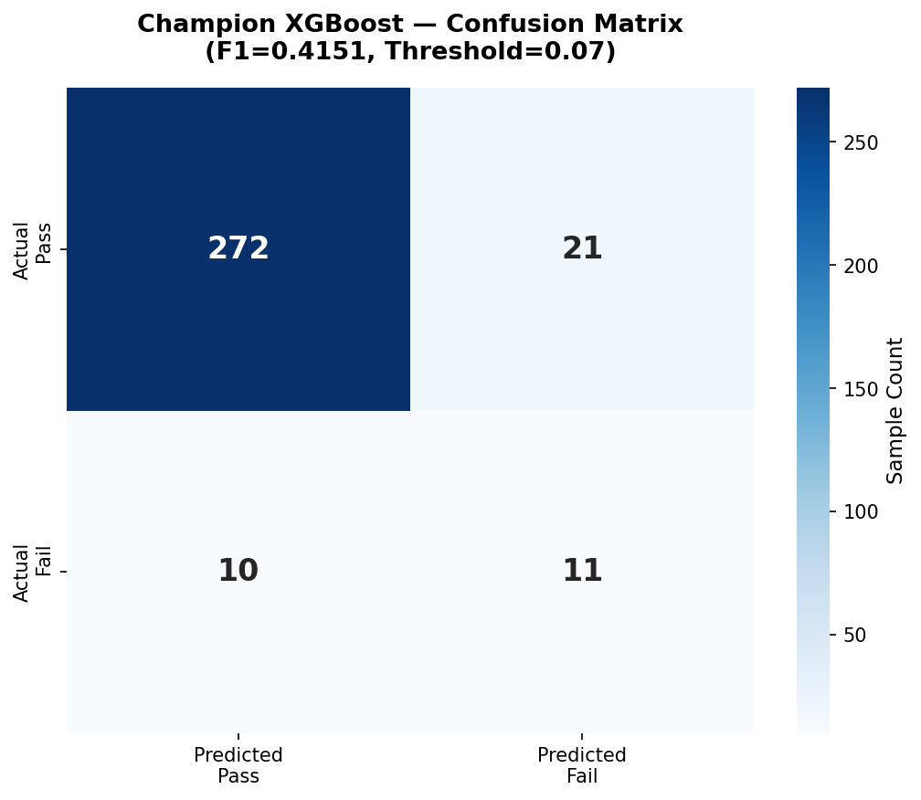
Figure 2. Confusion matrix for the deployed XGBoost classifier on the SECOM test set. The model correctly identifies 11 of 21 failures (TP) at the optimal threshold of 0.07.

4.6 Deployment Considerations
Migrating the optimal XGBoost model onto the ESP32 was problematic due to the tight embedded resource constraints (e.g. Flash size limits, no FPU for such complex ensemble models, ...). The selection of a toolchain was key in this migration. Initially emlearn was tested and subsequently discarded in favor of m2cgen. M2cgen was selected because of its native support of XGBoost combined with double precision numbers to prevent loss of information from the standardized features. This lack of precision on the other quantization export methods resulted in a big loss of accuracy, described in section 6.2. In the end, m2cgen generated a 140KB independent C function with bit-exact parity with the Python model. This bit-exact C-code formed the basis for the AI tier, and the inference performance is described in Section 5.
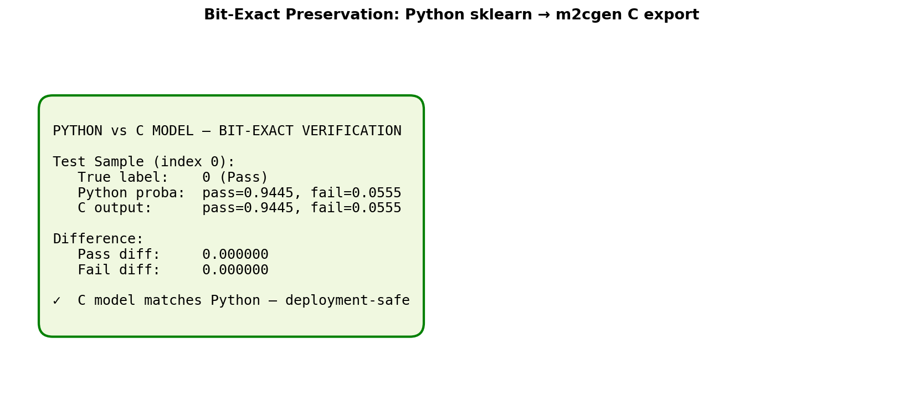Figure 3. Verification that the m2cgen-generated C code produces identical predictions to the Python reference model. The bit-exact preservation guarantees deployment fidelity.
Finally, this reduction of features, stratified resampling and deployment pipeline resulted in a better performing XGBoost model with a maximum F1-score of 0.4151. This represents a 15.6% improvement on the Random Forest baseline.

5.1 Hardware Setup in Wokwi
The hardware implementation is done in Wokwi using ESP32 Devkit. The MPU6050 is connected to GPIO 21 and 22 using I2C interface. DHT22 sensor is connected to GPIO4. Two LEDS for local indication are connected to GPIO 18 and 19. Wokwi provides a good simulation platform for hardware in loop validation and system testing.
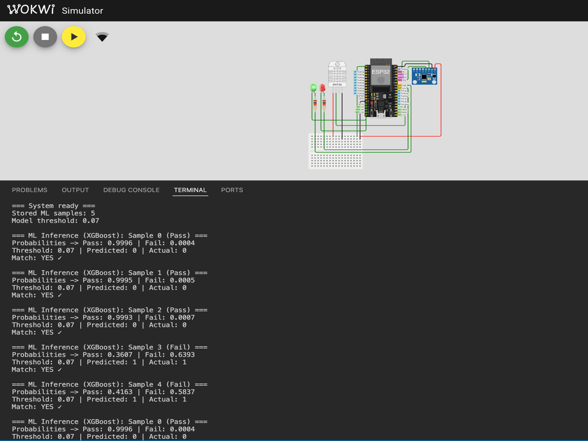
Figure 4. Wokwi simulation of the ESP32 hardware setup.

5.2 Software Stack & Build Process
The hardware was programmed using the Arduino framework which supports Adafruit and Blynk libraries. I switched to compilation locally with Arduino CLI inside VS Code because web builder times out very often (RF model was 1.5 MB). Since model has been changed to use m2cgen, model size became 140KB and total size of firmware was kept around 77% of flash size on ESP32.

5.3 ML Inference Deployment
The trained and validated XGBoost model was then exported into a simple, standalone C function and saved to xgb_model.h via m2cgen. This C function (named score) took in an array of 100 doubles (the features) and outputted the prediction probabilities for the two classes, "pass" and "fail". Since the physical sensors do not generate the SECOM-domain features (Section 3.4), five sample data are hard-coded in the secom_samples_xgb.h, to test the inference engine without using sensor streams. The inference function is called every 5s through a BlynkTimer task; with the 0.07 threshold optimized during the training (Section 4), the output probability is classified and predicted class is achieved. When failure probability reaches the threshold, the local LEDs as well as Blynk widgets are updated accordingly.

5.4 Cloud Dashboard
An interactive interface is presented so that sensors can be monitored in real time by using the Blynk IoT interface which controls ten separate datastreams connected to virtual pins V0-V9. Datastreams V0-V5 correspond to sensor telemetry, consisting of the three components for 3-axis acceleration, the measured temperature and humidity, and an indicator for fault conditions (1=fault, 0=normal) dependent on thresholds. The four widgets correspond to outputs of the ML inference tier (predicted class, actual class, index of sample taken, and binary match indicator): V6, V7, V8 and V9 respectively. These datastreams are visualized in the system using several different widgets such as the temperature and humidity gauges and the failure LED display. Datastream updates for sensor telemetry occur with 2 second intervals asynchronously; and for ML inference results with 5 second intervals. This presents near real time information to the operator.
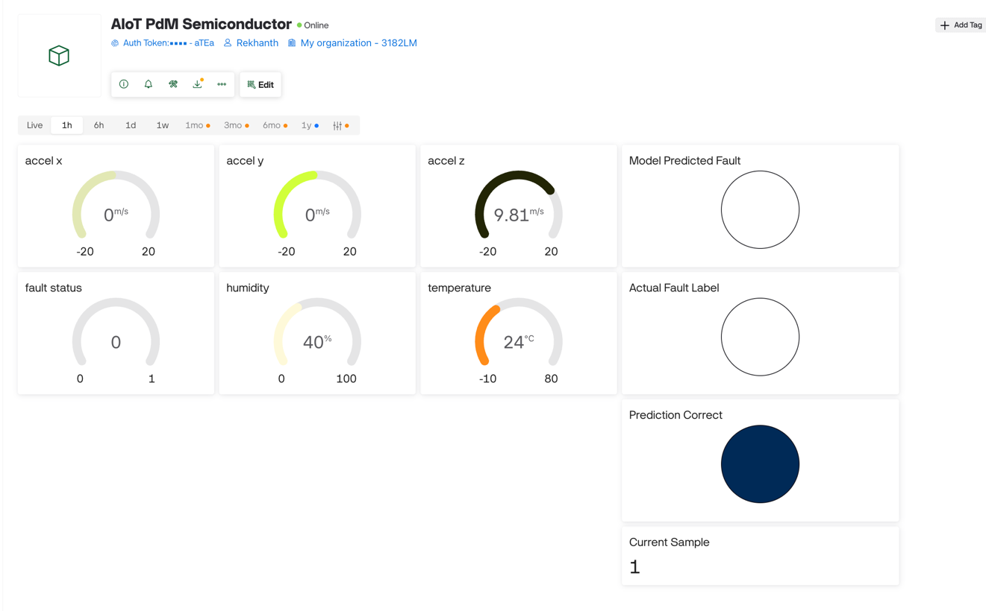
Figure 5. Blynk cloud dashboard with live telemetry and inference.

5.5 Testing & Verification
System performance was tested through both ML inference testing and a live sensor pipeline check. A validation test of the ML inference engine was conducted using five pre-loaded hardcoded SECOM samples. When the 5 samples were input into the ESP32 at 5 second intervals it was discovered that all 5 out of 5 inferences returned the correct outcome. For the typical 'Pass' sample we observed a failure probability of 0.0004 which is negligible. A ‘Fail’ sample triggered the correct fault detection with a failure probability between 0.58 and 0.64. The sensor pipeline was also tested by providing live feed of MEMS and thermal data to Blynk dashboard within 2 sec after polling.
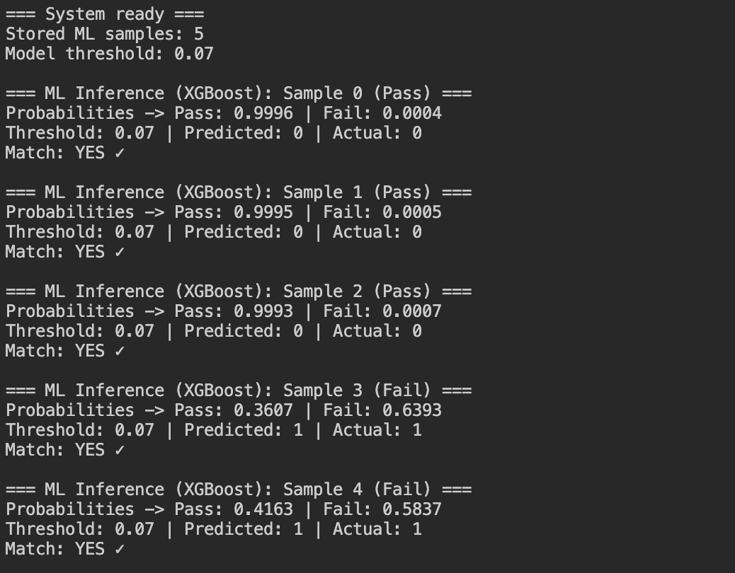
Figure 6. ESP32 serial monitor output showing inference predictions.

6.1 Achievements and Limitations
The successes include the systematic increase in the F1-score by 15.6%, from 0.36 to 0.42. They also include deploying the XGBoost classifier using m2cgen. I tested the system and got 5/5 predictions correctly on SECOM samples. It means the bit exact parity generated by ESP32 matches with the python reference. The limitations are also clear. Even with the 15.6% increase, an F1-score of 0.42 remains low compared to literature results on resampled, balanced datasets. The sensors can't trigger the TinyML predictions right now as I deliberately separated physical data and equipment internal data. I'm trying to prove the concept of PdM with the use of 5 hardcoded samples in Wokwi. It's far from real time data predictions. Here I'm following famous 'I'm trying to walk before I run' scenario.

6.2 Engineering Lessons: The Deployment Toolchain Pivot
The main engineering challenge was a failure in the initial deployment pipeline. The emlearn library applied an int16 casting to standard normalization which removed useful data. As shown in fig 7, this problem led to 3 major advancements: Using MinMaxScaler with [-30000, +30000] range, replacing Random Forest to an XGBoost model and m2cgen library instead of emlearn. The main learning is the need to verify the generated C code against the original Python reference.

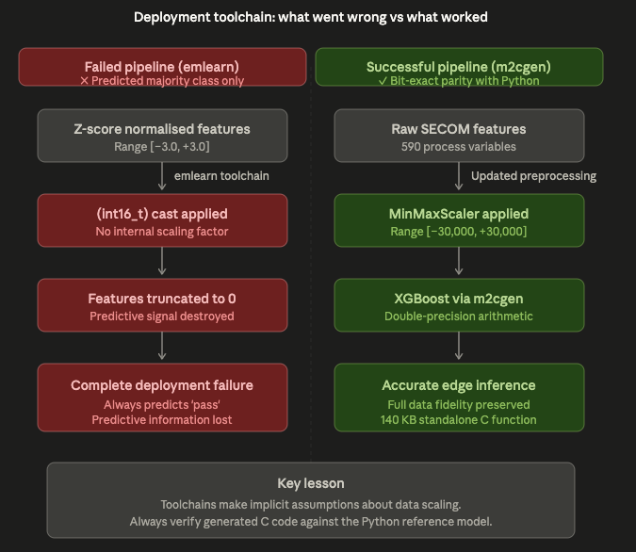
Figure 7. Deployment Toolchain Pivot from emlearn to m2cgen.
6.3 Honest Discussion of F1 = 0.42
Although 0.4151 is rather small, it reflects a 15.6% gain over the baseline. F1 score is low but it's because of SECOM dataset resembles real time data. Therefore, it's respectable compared to high F1 on custom datasets. The F1 scores presented in the lit review are resampled balanced test sets which does not reflect real world distributions. In a context of predictive maintenance, recall (0.524) may be preferred to precision. This minimizes unexpected downtime. From the AUC score 0.76 I can say model can detect pass/fail decently which is worth for making risk informed decisions on the edge device.

6.4 Ethical Considerations
When I think about the edge based PdM, the question is how to keep this ethically and morally clean. Local inference on the ESP32 improves data sovereignty and protects intellectual property. It keeps manufacturing telemetry within the factory and off third-party cloud platforms. On the other hand, not detecting hardware issues leads to serious ethical problems. If there are too many false negatives, it could result in defects in important manufacturing areas like automotive or medical equipment. Moreover, due to the model bias the XGBoost classifier might generate faulty results on other datasets apart from the SECOM set. Automation does not replace humans. It helps humans to make precise decisions. From the tree-based models’ operators can see why it’s making such decisions and decide whether to act on it or not. Nvidia’s CEO also mentioned in a podcast that AI won’t replace humans but can help humans to work better (Huang, 2026).

6.5 Section Summary
When using the libraries to convert from int16 to double precision inference the verification is must. Overall, the AIoT pipeline execution and the necessary engineering steps to improve the model performance at the edge are discussed.

7.1 Project Summary
This project develops an AIoT predictive maintenance system on ESP32 on the edge. The system uses 2 tiers: one for external sensors, one for ML inference. Feature extraction and model change from the ML model used initially to the XGBoost model have increased the F1 score for prediction from 0.36 to 0.42. m2cgen converted my python XGBoost to C code preserving the logic. Test results showed system streaming sensor readings to Blynk cloud dashboard rapidly and correctly classifies the SECOM dataset.

7.2 Key Findings
· Reducing the number of features had the greatest effect on performance. The 100 top performing features far outweighed performance over the 440 features, across all models used.
· Standard int16 quantisation doesn't play nicely with z-score standardized features, as demonstrated by this project failing in terms of emlearn deployment. To get reliable data, double-precision arithmetic or appropriate range scaling, is required to achieve good results on an embedded system.
· m2cgen offers a way to securely and successfully deploy models such as XGBoost, without changing the predictions between Python and C.
· This two-tier architecture provides a very robust framework in an AIoT application, specifically where the sensor data and process telemetry are different domains.

7.3 Future Work
TinyML based edge device PdM is a promising technology that can enable many applications. This project is a live example of PdM. For future work, a second ML model can be trained on vibration and temperature data from MPU6050 and DHT22 sensors. Working on real hardware controllers rather than the simulations (Wokwi) to test real-world conditions such as electromagnetic interference and environmental changes. For better validation need to stream a greater number of samples through serial interface. All these leads to measure actual power usage and latency.

7.4 Closing Remarks
In summary, the project has successfully shown that a high-dimension ensemble model can run well on low power edge devices. Addressing two major challenges, toolchain scaling and data scaling, the project has proposed an efficient and simple approach to predictive maintenance for today's semiconductor factories.

References
- Abdelhafiz, A., Soliman, A. and Mahgoub, I., 2024. Rare Class Prediction Model for Smart Industry in Semiconductor Manufacturing. arXiv preprint, 2406.04533. Available at: https://arxiv.org/abs/2406.04533
- Achouch, M., Dimitrova, M., Ziane, K., Sattarpanah Karganroudi, S., Dhouib, R., Ibrahim, H. and Adda, M., 2022. On Predictive Maintenance in Industry 4.0: Overview, Models, and Challenges. Applied Sciences, 12(16), p.8081. https://doi.org/10.3390/app12168081
- EpiSensor, 2024. IoT Data Privacy: Ensuring Compliance with GDPR and Other Regulations. EpiSensor Knowledge Base. Available at: https://episensor.com/knowledge-base/iot-data-privacy-ensuring-compliance-with-gdpr-and-other-regulations/
- Gupta, S. and Shivhare, S.N., 2025. Embedded TinyML for Predictive Maintenance: Vibration Analysis on ESP32 with Real-Time Fault Detection in Industrial Equipment. International Journal on Computational Modelling Applications, 2(2), pp.1–17. https://doi.org/10.63503/j.ijcma.2025.114
- Hymel, S., Banbury, C., Situnayake, D., Elium, A., Ward, C., Kelcey, M., Baaijens, M., Majchrzycki, M., Plunkett, J., Tischler, D., Grande, A., Moreau, L., Maslov, D., Beavis, A., Jongboom, J. and Reddi, V.J., 2023. Edge Impulse: An MLOps Platform for Tiny Machine Learning. In: Proceedings of Machine Learning and Systems (MLSys), Vol. 5. Available at: https://proceedings.mlsys.org/paper_files/paper/2023/hash/49fe55f5e9574714dda575bfb2177662-Abstract-mlsys2023.html
- Huang, J., 2026. Will AI replace programmers? NVIDIA CEO Jensen Huang on AI and human collaboration. Lex Fridman Podcast, YouTube, 24 March. Available at: https://www.youtube.com/watch?v=N_wq9OV4T4c.
- McCann, M. and Johnston, A., 2008. SECOM Data Set. UCI Machine Learning Repository. Available at: https://archive.ics.uci.edu/dataset/179/secom
- Njor, E., Hasanpour, M.A., Madsen, J. and Fafoutis, X., 2024. A Holistic Review of the TinyML Stack for Predictive Maintenance. IEEE Access, 12, pp.184861–184882. https://doi.org/10.1109/ACCESS.2024.3512860
- Ooko, S.O. and Karume, S.M., 2024. Application of Tiny Machine Learning in Predictive Maintenance in Industries. Journal of Computing Theories and Applications, 2(1), pp.131–150. Available at: https://dl.futuretechsci.org/id/eprint/17/
- Prakash, S., Stewart, M., Banbury, C., Mazumder, M., Warden, P., Plancher, B. and Reddi, V.J., 2023. Is TinyML sustainable? Assessing the environmental impacts of machine learning on microcontrollers. Communications of the ACM, 66(11), pp.68–77. https://doi.org/10.1145/3608473
- Salem, A. and Bhuiyan, M.A.N., 2025. Predictive Maintenance in Semiconductor Manufacturing Using Machine Learning on Imbalanced Dataset. International Journal of Research and Scientific Innovation, 12(10), pp.170–176. Available at: https://rsisinternational.org/journals/ijrsi/view/predictive-maintenance-in-semiconductor-manufacturing-using-machine-learning-on-imbalanced-dataset
- Susto, G.A., Schirru, A., Pampuri, S., McLoone, S. and Beghi, A., 2015. Machine Learning for Predictive Maintenance: A Multiple Classifier Approach. IEEE Transactions on Industrial Informatics, 11(3), pp.812–820. https://doi.org/10.1109/TII.2014.2349359

Appendix A: User Guide
This appendix provides instructions for setting up, running, and verifying the AIoT predictive maintenance system.

A.1 Repository and Code
All source code, model files, and simulation assets are available at:
https://github.com/RekhanthReddy/aiot-semiconductor-pdm-ld7182

Repository structure:
- /wokwi/ — Wokwi simulation files (sketch.ino, diagram.json, libraries)
- /colab/ — Jupyter notebooks for model training and SECOM analysis
- /docs/ — Report drafts and supporting documentation
- /references/ — Bibliography file (references.bib)

A.2 Running the Wokwi Simulation
1. Visit https://wokwi.com/projects/462262259358425089 in any browser
2. Click the green "Start Simulation" button
3. The simulated ESP32 will boot, connect to Wokwi-GUEST WiFi, and begin polling sensors
4. The serial monitor (bottom panel) shows real-time sensor readings and ML inference outputs every 5 seconds

A.3 Accessing the Blynk Dashboard
1. The Blynk authentication token is embedded in the Wokwi sketch (preprocessor macro at the top of sketch.ino)
2. Once the simulation is running, the ESP32 streams data to the Blynk cloud
3. The Blynk web dashboard displays:
- V0–V5: Sensor telemetry (3-axis acceleration, temperature, humidity, fault indicator)
- V6–V9: ML inference outputs (predicted class, actual class, sample index, match indicator)
4. Updates occur every 2 seconds (sensors) and 5 seconds (ML inference)

A.4 Interpreting the Outputs
- Green LED on, no Blynk fault flag: System operating normally
- Red LED on, V5 = 1 (sensor breach): Sensor threshold exceeded
- V6 (predicted class) matches V7 (actual class): ML inference correct
- V9 = 1: Binary match between prediction and ground truth

A.5 Re-Training the Model (Optional)
To re-train the XGBoost champion model:
1. Open /colab/06_f1_improvement.ipynb in Google Colab
2. Run all cells (training takes approximately 5 minutes)
3. The final cell exports the trained model via m2cgen as xgb_model.h
4. Replace the corresponding file in /wokwi/ and re-run the simulation

A.6 System Requirements
- Browser with internet connection (for Wokwi and Blynk)
- Google account (for Colab, if re-training)
- No physical hardware required for simulation
- Wokwi VS Code extension (optional, for local compilation)

