

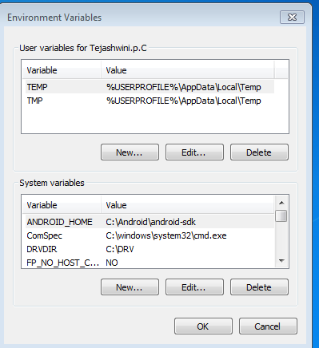
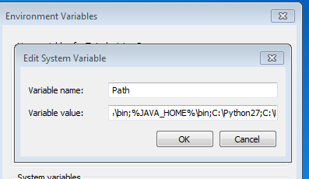
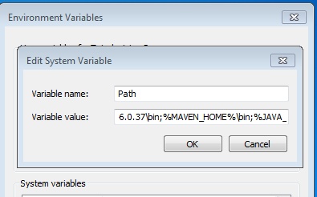
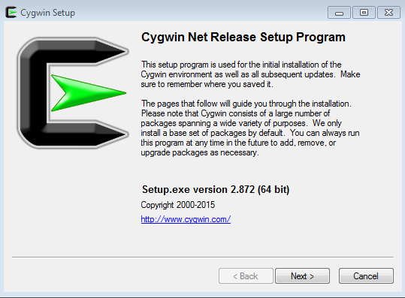
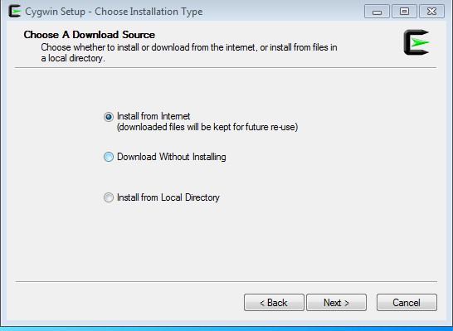
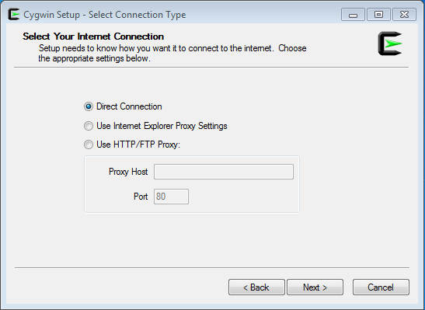
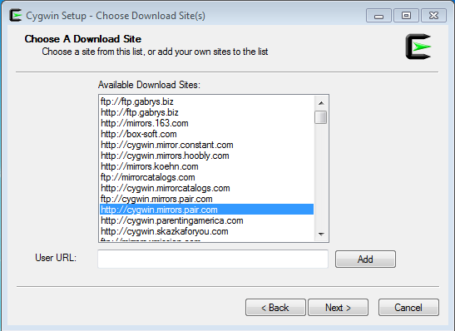
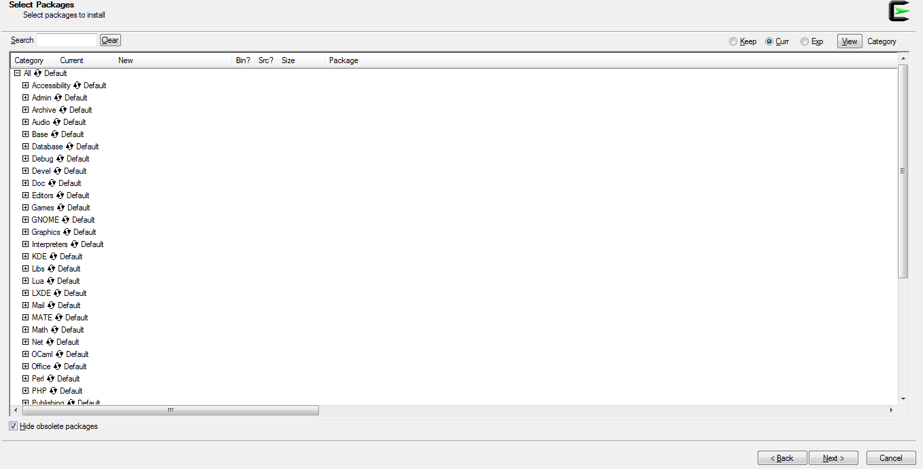
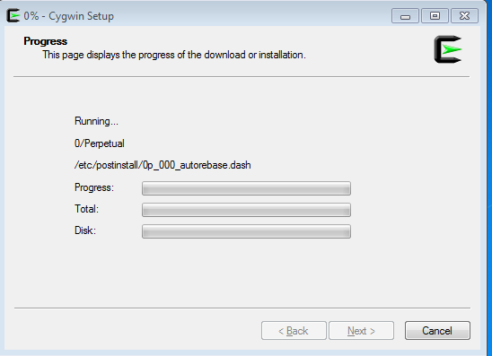
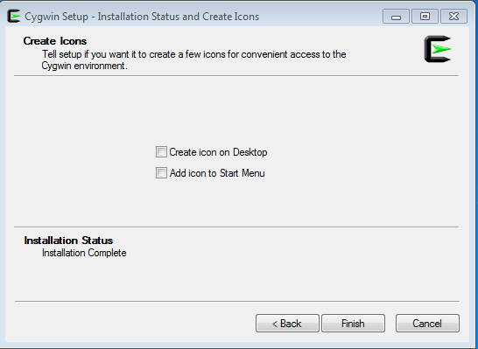
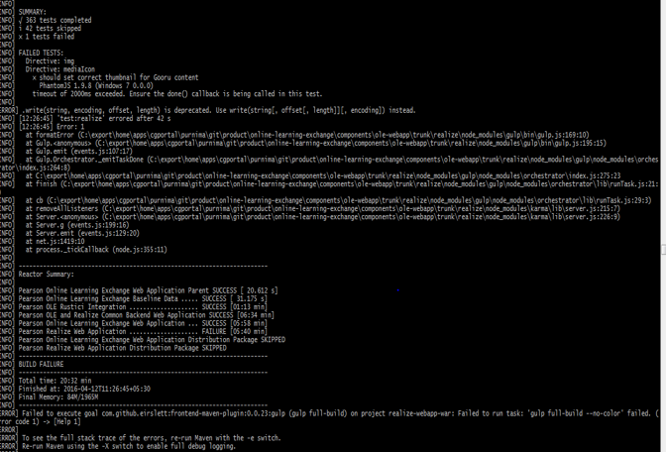
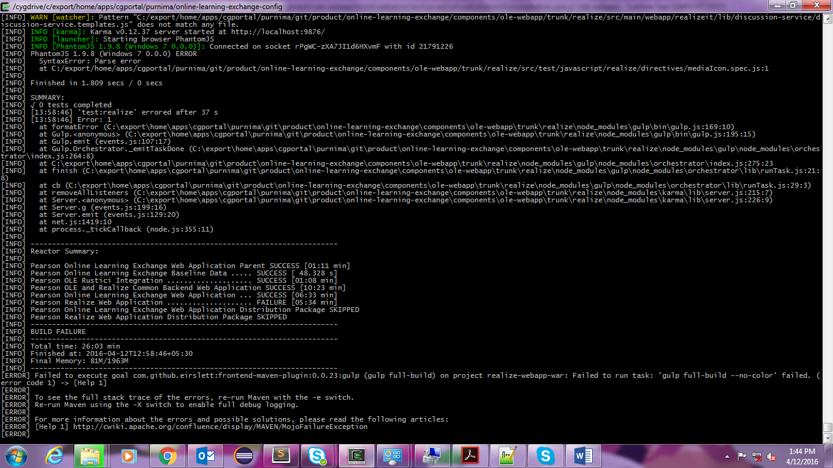

Pearson Schools Realize Project setup instructions

Index

- Revision History
- Technology Stack
- Setup requirements
- Installation steps
- Set up development environment
- Troubleshooting possible errors.

- Revision History

Revision No. | Revision Date | Changes Made | Changed By
1 | 19/04/2016 | Document Draft | Purnima
2 |  | Revised

2. Technology stack
- IDE: Eclipse or STS or sublime text – for coding and debugging.
- Java : 8
- Build Tool : Apache Maven 3.0.5 *(for building and packaging) and
: Apache Ant 1.9.6 or above version.
- Cygwin : provides LINUX virtual platform to run an application

*If using different version have to change plugin at many places.

3. Setup Requirements
This folders can reside wherever is most desirable for you. The path below is merely an example.

Step 1: Create Cygwin folder in c drive and give this path while installing Cygwin.
Step 2: Download and copy Cygwin setup in Cygwin folder.
Step 3: Create a folder in C drive for all software (ex.: tools).
Step 4: Download and copy Java to tools. i.e. C:\tools\jdk1.8.0_65,
Step 5: Download and copy apache-maven-3.0.5 to tools. i.e. C:\tools\apache-maven-3.0.5,
Step 6: Download and copy apache-ant-1.9.6 to tools. i.e. C:\tools\apache-ant-1.9.6,

4. Installation Steps
- JAVA8:
- Set environment variable for Java
- Right click on my computer->properties->Advanced System settings->Go to Advance Tab
- Click on environment variables

Click on “New” button from system variables section.

- Add JAVA_HOME as variable name and path C:\tools\ jdk1.8.0_65 as variable value and click OK.
- Double click on path variable to JAVA_HOME variable as shown below.

(%JAVA_HOME%\bin;)

- Click OK.
- We also need to add the JCE Unlimited Strength Jurisdiction Policy Files Open the archive and move the .jar files into / jdk1.8.0_65/jre/lib/security
Here is the file to replace -

- Apache Maven 3.0.4
- Set up environment variable for apache-maven.3.0.5

- Right click on my computer->properties->Advanced System settings->Go to Advance Tab
- Click on environment variables

- Click on New button from “System variables” to add variable for apache-maven
- Add MAVEN_HOME as variable name and path C:\tools\apache-maven-3.0.5 as variable value and click Ok
- Edit path variable to add MAVEN_HOME as shown below
- Click OK

- Apache ANT 1.9.6
Set up environment variable (ANT_HOME) for apache-ant.1.9.6 and add ANT_HOME in path similarly.

- Cygwin

- Cygwin folder should be created inside the C:\cygwin as mentioned before

- Install Cygwin from the internet

Go to https://cygwin.com/install.html. Check your system’s windows version and download the respective .exe file. For ex if it is 64 bit system, click on setup-x86_64.exe from Installing and Updating Cygwin for 64-bit versions of Windows

- Give root directory path as c:\cygwin, and select ALL Users.
- Give local package directory path also as c:\cygwin

- Select any one site with http:

- Click on Next

- Click on Next

- Check create icon on Desktop and click on finish

- Install the default and the latest versions of the recommended packages below
Archive: zip | unzip
Devel: git | git-completion | gitk | make | patch | subversion
Editors: vim
Interpreters: python | python3 | ruby
Utils: dos2unix | md5deep | ncurses
Net: rsync | curl | openssh
Web: wget
System: procps
Open cygwin terminal in administrator mode and run the command to install packages :
/cygdrive/c/cygwin/setup-x86_64.exe -q –P zip,unzip,git,git-completion,gitk,make,patch, subversion,vim,python,python3,ruby,dos2unix,md5deep,ncurses,rsync,curl,openssh,wget,procps
(make sure you have Cygwin setup in Cygwin folder in c drive , check the name of setup in path here )
10. Open new terminal of Cygwin.
*Edit .bashrc in home folder of Cygwin to make sure all the paths point to the right location of the folder if required.
For example,
LIBS=/xncpkgs
export M2_HOME=/cygdrive/c/Softwares/apache-maven-3.5.0-bin/apache-maven-3.5.0
export ANT_HOME=/cygdrive/c/Softwares/apache-ant-1.10.1-bin/apache-ant-1.10.1
export M2=$M2_HOME/bin
export GRADLE_HOME=$LIBS/gradle-3.2.1
#export GRADLE_HOME=$LIBS/gradle-2.12
export GRADLE=$GRADLE_HOME/bin
export JAVA_HOME=$LIBS/jdk1.8.0_131
#export JAVA_HOME=$LIBS/jdk1.7.0_80
#export GIT_HOME=$LIBS/gitlocal/cmd
export AWS_ACCESS_KEY_ID=local
export AWS_SECRET_ACCESS_KEY=local
PATH=$GIT_HOME:$PATH:$JAVA_HOME/bin:$M2_HOME/bin:$ANT_HOME/bin:$GRADLE_HOME/bin:$AWS_ACCESS_KEY_ID:$AWS_SECRET_ACCESS_KEY
CATALINA_OPTS="-Xms512M -Xmx8192M"

- Check prerequisites

In Cygwin run these commands:
Prerequisite: Ant installed
$ ant –version
If you have issues with ant installation, you can follow the below steps
$ export ANT_HOME=/cygdrive/c/apache-ant-1.7.1 (assumes you've unzipped Ant into C:\apache-ant-1.7.1)
$ export PATH=$ANT_HOME/bin:$PATH
$ ant -version
Apache Ant version 1.7.1 compiled on June 27 2008

Prerequisite: Maven 3.0.4 or newer installed
$ mvn --version
Prerequisite: Java jdk1.8.0_65 or newer installed
$ java -version
Prerequisite: Git 1.7.* or newer installed
$ git –version

- Public and private key generation and add them to bitbucket

$ ssh-keygen -t rsa -C {prootid}@bitbucket.pearson.com
Be sure to add the public key to your account on Stash (bitbucket.pearson.com). After logging in, choose 'Manage Account' from the user dropdown in the upper right corner add SSH keys.
Copy from cygwin home folder “id_rsa.pub” file content to SSH keys in BitBucket
Create soft link for GIT and Java in cygwin,
Traverse to home folder and run below commands
ln -s 'C:\Program Files\Git' /xncpkgs/gitlocal
ln -s 'C:\Program Files\Java' /xncpkgs/
read-write permission to ssh key:
chmod 600 /home/Meghana.d/.ssh/id_rsa

5. Set up development environment

1. Clone this project onto your machine

To clone the code in your local make a directory structure wherever you want to clone

mkdir -p export/home/apps/cgportal/{username}
Create symbolic link for working folder
Ln –s ‘/cygdrive/c/export’ ‘/export’

Go to location where you want to clone in Cygwin:

cd /export/home/apps/cgportal/{ username }
*As with SVN, this config project can reside wherever is most desirable for you. The path above is merely an example.

git clone –b develop ssh://git@bitbucket.pearson.com/real/online-learning-exchange-config.git

After complete run this command

cd online-learning-exchange-config

Create a soft link to the dev1-env/configs
The ce-tools-scripts expect a configs directory inside of the top level directory of this repository.
ln -s dev1-env/configs

2. Initialize

ce-tools-scripts/project.sh init
Set the appropriate values for the properties that init will prompt for. The result should be a message like this
Detected existing configuration:

environment_type: full-source
os_owner: {USERNAME}
os_group: cgportal
svn_base_url: http://subversion.pearsoncmg.com/data/portal
git_base_url: ssh://git@bitbucket.pearson.com/real
svn_wc_root: /export/home/apps/cgportal/username/git
system_ant_home: /cygdrive/c/tools/apache-ant-1.9.6
system_java_home: /cygdrive/c/tools /jdk1.8.0_25/jre
system_maven_home: /cygdrive/c/tools /apache-maven-3.0.5
packages_dir: /export/home/apps/cgportal/username/git/product/online-learning-exchange/server-install-package/trunk/target/packages

NOTE: Prompting uses your current settings (if they exist) as defaults. Is this correct (y) , would you like to edit (e), or to be prompted (p)? y

you can now run `./project.sh` with more interesting operations
If you need to correct a value, just enter the prompt mode again by pressing p.
Pay special attention to the location of the ANT, MAVEN, and JAVA home.

3. Update the working copies

ce-tools-scripts/project.sh svnupdate

When prompted
Is this correct (y), or do you need to edit (e)?
Press y .
Make sure all projects are selected . The initial checkout will take ~20 minutes.

- For two

4. Build

- Paste these file at /export/home/apps/cgportal/username/wc/common/common-installer/deployment-tool/branches/1.x

2 .select project to build ---------------
Open /export/home/apps/cgportal/username/online-learning-exchange-config/dev1- env/configs/projects.build.env" and
uncomment (remove prepending #) all the build projects. Comment the last one
"ONLINE_LEARNING_EXCHANGE_FEATURES"

After that run the command:
ce-tools-scripts/project.sh build --auto
3. Download latest version of GIT for windows and install it .
Get the install location
for me it is C:\Program Files\Git\cmd

Create a soft link in xncp

use command ln -s 'C:\Program Files\Git\cmd' /xncpkgs/cmdgit , here I am naming cmdgit , you can name any thing.

Goto .bashrc file and add the below lines
LIBS=/xncpkgs
export CMD_HOME=$LIBS/cmdgit

When ever you want to run the build , open a new cygwinfolder and run the below command

export PATH=$CMD_HOME:$PATH

Then check the git --version , it should show
git version 2.13.3.windows.1 (I installed 2.13.3 mainly what ever the version is it should show .window.1).

After that remove node, node_modules folders in realize folders
Also remove npm and npm_cache folders in C:\Users\ramesh.babu2\AppData\Roaming.

Also copy the RSA files from cygwin to c:\users\<user>\.ssh
Remove early learner(build:earlyLearner & clean:earlyLearner), but keep componentArchitecture project in default-build.js file.
Finally run the build .

5. Installation

After build successful
Update file - dev1-env/configs/install.env.properties as:
global.env.os.owner={LOGIN_USERNAME}
global.env.os.dir.base=/export/home/apps/cgportal/username/inst_9080

global.env.os.dir.logs=/export/home/apps/cgportal/username/logs

global.env.database.url=jdbc:oracle:thin:@10.101.78.21:1521:XE

global.env.database.username={YOUR_SCHEMA}

global.env.database.password={YOUR_SCHEMA_PW}

global.env.nfs.shared.directory=/export/home/apps/cgportal/username/wc/product/online-learning-exchange/components/olewebapp/trunk/webapp/src/main/webapp/nfs_shared
Than run install command:
ce-tools-scripts/project.sh install --auto

6. Start Server

After successful install start the server
ce-tools-scripts/project.sh start
After all these steps once the server is started open in your web browser http://localhost:9080/community

6. Troubleshooting
- Out of memory exception in assessment-services or Rumba project :
In global.env ( /export/home/apps/cgportal/username /online-learning-exchange-config\dev1-env\configs)
Change memory size :
export MAVEN_OPTS="-Xmx2048m -Xms2048m -XX:MaxPermSize=2048m - XX:PermSize=2048m"
2. Realize webapp build fail

: comment the test case in mediaicon.spec.js(/export/home/apps/cgportal/username/wc/product/online-learning-exchange/components/ole-webapp/trunk/realize/src/test/javascript/realize/directives/mediaIcon.spec.js )
/*
it('should set correct thumbnail for Gooru content', function() {
var content, element, thumbnailSrc, fallbackSrc;
content = {
'assetURI': 'http://stca-we-01.goorulearning.org/prod1/',
'category': 'Slide',
'contentType': null,
"description": "Highlighting the work of Bil Johnson, \"Student Centered Classroom\" and Mike Schmoker \"Focus\" to discuss the importance of teaching reading and writing across all content.",
'gooruOid': '1780b3f7-382b-4028-a56a-98e12f393ccc',
'mediaType': null,
'recordSource': 'useradded',
'resourceType': {
'description': null,
'name': 'ppt/pptx'
},
'thumbnail': '1780b3f7-382b-4028-a56a-98e12f393ccc-80x60.png',
'thumbnails': {
'defaultImage': false,
'dimensions': '80x60,160x120',
'url': 'http://stca-we-01.goorulearning.org/prod1/0015/4539/1780b3f7-382b-4028-a56a-98e12f393ccc-80x60.png'
},
'title': 'Teaching Social Studies',
};
$scope.content = new GooruItem(content);
element = $compile(template)($scope);
$scope.$digest();
thumbnailSrc = element.find('img').attr('src');
expect(thumbnailSrc).to.contain(content.thumbnail);
});
*/
3. If getting error because of failure of test cases :
To disable testcases add below in between <servers> and <mirrors> in /export/home/apps/cgportal/username/online-learning-exchange/shared-configs/maven_settings.xml
<profiles>
<profile>
<id>skip.tests.by.default</id>
<activation>
<activeByDefault>true</activeByDefault>
</activation>
<properties>
<maven.test.skip>true</maven.test.skip>
</properties>
</profile>
</profiles>

4. If you encounter errors like the following during start
.../inst_9080/tomcat/bin/catalina.sh: line 2: $'\r': command not found
.../inst_9080/tomcat/bin/catalina.sh: line 91: syntax error near unexpected token `$'in\r''

...\ inst_9080\tomcat/bin/envvars/tomcat.env: line 7: $'\r': command not found
...\ inst_9080\tomcat/bin/envvars/tomcat.env: line 49: syntax error: unexpected end of file
That's due to windows using \n\r as a line seperator
Run 'dos2unix' command on the files listed will fix it
$ cd /export/home/apps/cgportal/username/inst_9080/tomcat/bin
$ dos2unix catalina.sh
dos2unix: converting file catalina.sh to Unix format ...
$ cd envvars/
$ dos2unix tomcat.env
dos2unix: converting file tomcat.env to Unix format ...
5. Fixing maven frontend plugin issue

This error occurs when we have latest maven version
Fix:
Change the version of 'frontend-maven-plugin' from '0.0.16' to '0.0.23' in the following files

"C:\export\home\apps\cgportal\username\wc\product\realize-common\assessment-service\trunk\assessment-ui\pom.xml"

" C:\export\home\apps\cgportal\username\wc \product\online-learning-exchange\components\ole-webapp\trunk\realize\pom.xml"

- Common-intsaller : Build error
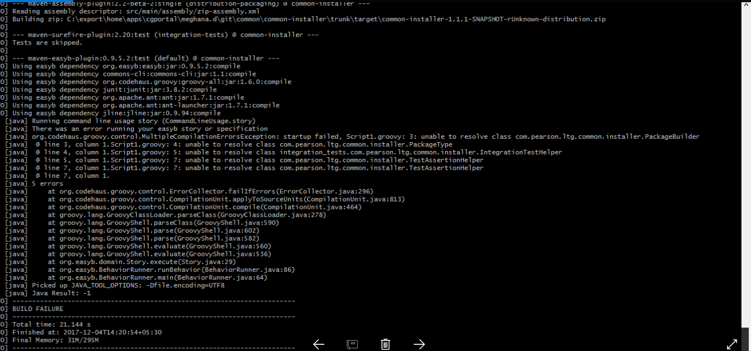
Copy the patch to C:\export\home\apps\cgportal\{username}\git\common\common-installer\trunk

Apply the patch “patch -p0 < common-installer.patch” using cygwin cmd prompt
or using eclipse,
1. Import the common-installer project into Eclipse - Running a patch is easiest through the Eclipse UI
1. Open Eclipse
2. Navigate to the File Menut and select Import...
3. Choose the Existing Maven Projects item under the Maven group
4. Select the C:\export\home\apps\{ U42 }\git\common\common-installer\trunk folder
2. Patch the common-installer project
1. Download the common-installer.patch file. It's attached to this Confluence page: common-installer.patch
2. Right-click on the common-installer project and select Team → Apply patch
3. Select "File" and browse for the common-installer.patch file you just downloaded.
4. Click Finish to apply the patch

7. Assessment service project Fails,
Reason : GC overhead
Edit pom.xml from “D:\export\home\apps\cgportal\meghana.d\git\product\realize-common\assessment-service\trunk\assessment-ui”
Change the jasmine version to 2.2
and below line inside configuration tag,
<webDriverClassName>org.openqa.selenium.phantomjs.PhantomJSDriver</webDriverClassName>

- Realize-webapp project Fails
Reason : ege.git
Turn on Windows Git and Execute npm install in below paths ”D:\export\username\git\product\online-learning-exchange\components\ole-webapp\trunk\realize\src\main\webapp\realizeit\componentArchitecture” and “D:\export\meghana.d\git\product\online-learning-exchange\components\ole-webapp\trunk\realize”

In (D:\export\home\apps\cgportal\username\git\product\online-learning-exchange\components\ole-webapp\trunk\realize\src\main\webapp\realizeit\js\app\classes\calendar\calendar.svc.spec.js) calendar.svc.spec.js file, line no 52 =>utcOffset = '[+-]([01]\\d|2[0-9]):([0-5]\\d)';

In (D:\export\home\apps\cgportal\meghana.d\git\product\online-learning-exchange\components\ole-webapp\trunk\realize\gulp\tasks\default-build.js) default-build.js file, make the changes
return runSequence('build:componentArchitecture',
'clean:componentArchitecture', [
'build:realize',
'devIncludes:realize',
'build:studentCenters',
'devIncludes:studentCenters',
'build:lti',
'build:elContentViewer',
'devIncludes:elContentViewer',
'less',
'less:lti',
'jsCodeQuality',
'jsonlint',
'concat-libs',
'concat:js-e2e-mocks'
], callback);

- To solve bare repository, copy the .ssh folder from cygwin to AppData folder

DB set up
- Download and install Oracle
- Download and run SQL Developer
- Create new connection “system” and execute the below lines
- Restart the system
- In SQL Developer, execute realize.sql file with seed=true for the first time
- To execute “install” for the second cmd change seed=false

