COURSEWORK SUBMISSION FORM
STUDENT USE |  | STAFF USE
Module Name | Web Technologies | First Marker’s  (acts as signature)
Module Code | 4BUIS011C | Second Marker’s  (acts as signature)
Lecturer Name | Iskandar Anvarov | Agreed Mark
UoW Student IDs |  | For Registrar’s office use only (hard copy submission)
WIUT Student IDs | 00005989
Deadline date | November 15
Assignment Type | GroupIndividual

SUBMISSION INSTRUCTIONS

COURSEWORKS must be submitted in both HARD COPY (to the Registrar’s Office) and ELECTRONIC unless instructed otherwise.
For hardcopy submission instructions refer to: http://intranet.wiut.uz/Shared%20Documents/Forms/AllItems.aspx - Coursework hard copy submission instructions.doc
For online submission instructions refer to: http://intranet.wiut.uz/Shared%20Documents/Forms/AllItems.aspx - Coursework online submission instructions.doc

MARKERS FEEDBACK (Continued on the next page)

Report
- Site plan
Audience Profile. The target audience of the website Avicenna School of Science and Medicine is the children between the age of 11 and 16 who wants to have a quality education with a particular attention and depth in the sphere of Medicine and Science. Although not clearly stated on the website the Avicenna School is an international one, which means, students from abroad are welcome to secure a place at this science and medicine school.
Goals and Objectives. The main purpose of the website would be to represent and promote the Avicenna School of Science and Medicine on a wider scope. In addition, it would serve to communicate to the interested parties such as parents and clients what is happening at the school to where they are bringing their children every day. This would eventually result in better communication between the school and client, which leads to the satisfaction of both concerning parties.
Functions and Features. The website which has been created is not the best example of a Private Secondary School but that does not necessarily mean it lacks some user friendly functions and features. One of the main features of the website is its responsiveness to fit to the screen of a user, be it a mobile phone or a tablet. However, it still has some room for improvement in this section, as some of the elements on the website may not resize, as you would want them to. Secondly, the creator of the website tried to make the design as simple as possible as if it is otherwise, viewers of the website might get intimidated and distracted from their purpose of visiting. Moreover, the School website is quite clean and has some good color combinations, which may help to console the mood of a user. Furthermore, automatic and manually controlling sliders which contain some quality pictures is also one of the properties of the website which somehow makes it attention grabbing. Lastly, it has a footer that indicates where the user is at a current time and that can help a user to navigate to other pages of the website. This would be helpful when the page content is too long, and the user would not have to go all the way up to the top navigation bar to go to the other pages.
Navigation. The navigation type of the Avicenna School of Science and Medicine Website is linear Global Website Navigation, which means it exists on each page of the website. Its creator preferred to make it the typical way, which is making the navigation bar fixed at the top as it is much easier for any user to utilize even if it is their first time visiting it. Moreover, any user can easily remember which navigation link leads where. Furthermore, the active list item has a border-bottom, which is a thin red line and the name has a red color, which somehow creates a delicate design on the white colored navigation bar.

- Evaluation
Evaluation of Competitors’ Websites.
Screenshot 1. Vosiq International School and Kindergarten.
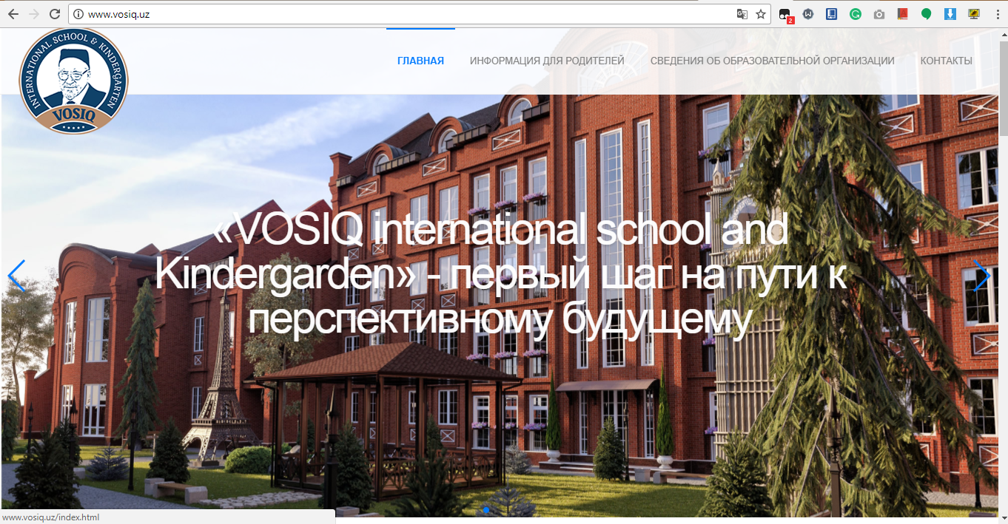

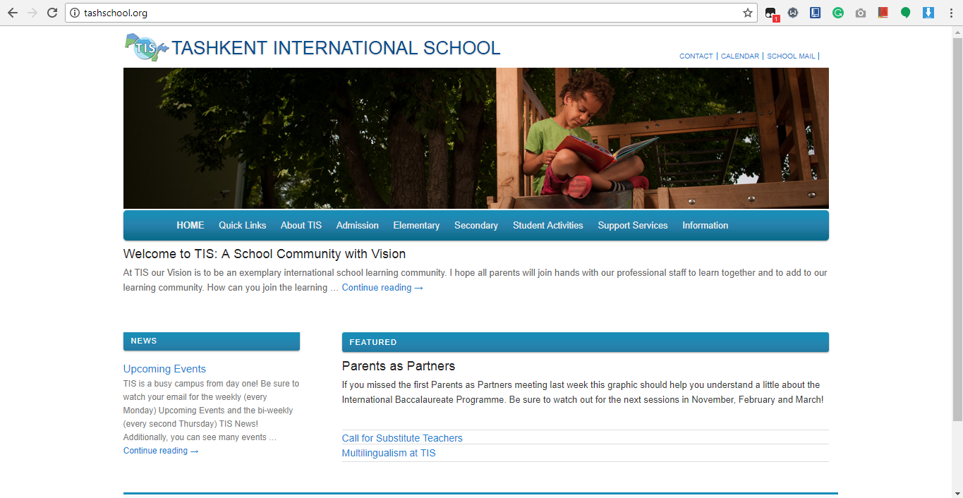
Screenshot 2. Tashkent International School.

The first competitor is Vosiq International School and Kindergarten in Tashkent and the second one is Tashkent International School (Screenshot 1 and Screenshot 2 respectively). Both of the abovementioned schools have generally competitive websites, which have some nice features and functions as well as some room for improvement.
The website of Vosiq International School and Kindergarten is generally good. Especially, the Home page is quite attractive and attention grabbing due to its automatic slideshow that embeds well-chosen high resolution photos of the school and its campus. Its navigation also has a linear style, fixed at the top and transparent. It also holds the school logo on the left corner that is a link to the home page. In addition, the parallax effect it has on its home page makes viewing the page quite enjoyable. Nevertheless, the other pages of the website have relatively too simple design. Moreover, pictures on the website lack proper sizing and position relative to the paragraphs and footer of the website does not show any information or link expect for the only Facebook and Contacts link. Finally, they should consider adding more info about the events and study programs as well as teacher profiles in the school as it would increase the awareness of its clients.

Tashkent International School on the other hand, has quite a competitive and well-informed website that has a global navigation, which has multiple dropdown menus. The website has almost all the necessary information about the school, events, teacher profiles, vision, mission, teaching systems, study programs and many more. It is quite a clean website, which is very easy to navigate through and remember. However, they should consider font-sizing, as it could be difficult for vision impaired to read the small sized texts.

Reference list

Ealing Independent College (2017). Photo Gallery | Ealing Independent College London. Available from http://www.ealingindependentcollege.com/student-life/photo-gallery/ [Accessed 12 November 2017].

Kings Education (2017). International High School for international students | Kings Education. Available from https://www.kingseducation.com/university-pathways/undergraduate-uk/our-courses/international-high-school-programme.html [Accessed 14 November 2017].

Tashkent International School (2017). Director’s Welcome | Tashkent International School. [online] Available at: http://tashschool.org/about-tis/directors-welcome/# [Accessed 12 November 2017].

Vosiq International School and Kindergarten (2017). VOSIQ International School and Kindergarten. Available from http://www.vosiq.uz/ [Accessed 12 November 2017].

Appendix

