A Decentralized Blockchain Framework for Secure, Transparent, and Privacy-Preserving Toll Payment Systems

*Abstract*—Traditional toll collection systems are marred by manual errors, fraudulent transactions, and vulnerabilities inherent in centralized architectures, which compromise operational efficiency and user privacy. This paper proposes a decentralized toll payment framework that leverages Ethereum-based smart contracts to ensure immutable, transparent, and verifiable transactions, thereby mitigating the risks of centralized data management. The framework employs advanced anonymous authentication inspired by Anon-Aadhaar to protect user identities while maintaining robust verification, and it integrates RFID-based vehicle detection to automate toll collection and reduce human error. Additionally, account abstraction techniques and paymaster contracts facilitate gasless transactions, lowering financial and technical barriers for users. Collectively, these innovations streamline toll processing, enhance security and data integrity, and offer a scalable, resilient solution for modernizing toll payment infrastructures.

Keywords—Blockchain, Decentralized Toll Collection, Smart Contracts, RFID, Anonymous Authentication, Gasless Transactions

# **Introduction**

Traditional toll collection systems have long relied on centralized infrastructures and manual processes, resulting in various operational inefficiencies, security vulnerabilities, and elevated costs. In India, the National Electronic Toll Collection (NETC) program—spearheaded by the National Payments Corporation of India (NPCI)—introduced FASTag to modernize toll payments and reduce congestion. FASTag leverages Radio Frequency Identification (RFID) tags affixed to vehicles’ windshields, enabling near-instant detection at toll plazas. As of 2022, FASTag transactions account for approximately 97% of total toll revenue, amounting to nearly Rs.50,855 crore and covering more than 6.5 million daily transactions. Despite these significant achievements, FASTag still faces challenges such as double deductions, delayed settlements, and intermittent technical glitches.

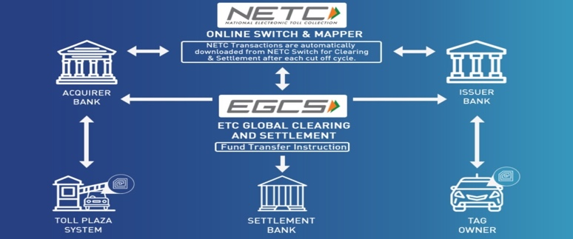

1. Existing FASTag system architecture

The underlying architecture of FASTag, shown in Figure 1, illustrates how a toll plaza system (acquirer) communicates RFID data to the NETC Switch & Mapper, which then validates the tag’s status and forwards the debit request to the issuing bank. The settlement bank subsequently consolidates funds and completes the transaction. Although this multi-entity approach allows interoperability—enabling a single FASTag device to function across different toll plazas and acquirers—it also increases complexity. The reliance on multiple intermediaries introduces synchronization lags, potential corruption, and single points of failure. Moreover, many users are required to maintain prepaid accounts or link the FASTag to their existing bank accounts, which can result in security deposits and the risk of account blacklisting if balances run low.

Beyond these logistical concerns, data security and user privacy remain paramount. Centralized databases that store sensitive account details can be compromised, raising questions about data misuse and unauthorized access. Such vulnerabilities, coupled with operational bottlenecks, emphasize the need for a more secure, transparent, and efficient system. This is where blockchain technology shows considerable promise. By employing Ethereum-based smart contracts, a decentralized toll payment framework can ensure immutability, verifiability, and near-real-time settlement. Cryptographic methods inherent to blockchain reduce the likelihood of fraudulent or duplicate transactions, while advanced anonymous authentication mechanisms—such as those modeled on Anon-Aadhaar—enable robust identity verification without compromising user privacy.

Automation also plays a vital role in elevating toll system efficiency. RFID-based vehicle detection, combined with decentralized smart contract execution, minimizes human intervention and drastically reduces errors. Furthermore, employing account abstraction techniques and paymaster contracts facilitates gasless transactions, thereby lowering both financial and technical barriers to user participation. These innovations have the potential to cut average toll processing times by up to 60%, enhancing throughput and alleviating traffic congestion.

Ultimately, by integrating blockchain technology with RFID-based detection, robust authentication, and streamlined payment processes, the limitations of the existing FASTag model can be addressed. Such a system not only preserves user privacy and security but also obviates the need for multiple intermediaries, thereby reducing operational risks and ensuring greater transparency in toll collection.

# **Literature survey**

Recent advancements in toll collection systems have spurred extensive research across multiple technological domains. In the realm of RFID-based systems, several studies have demonstrated that automatic toll collection can be efficiently implemented using different RFID reader technologies. For instance, research by Ahmed et al. and others has compared EM-18 RFID readers with MFRC522 modules, highlighting that the latter—using the SPI interface—can achieve faster communication and higher reliability than traditional UART-based solutions. These technical investigations reveal that although RFID provides the backbone for automation, issues such as tag misreads, balance verification delays, and vulnerability to fraudulent use (e.g., using tags across different vehicle categories) remain significant challenges.

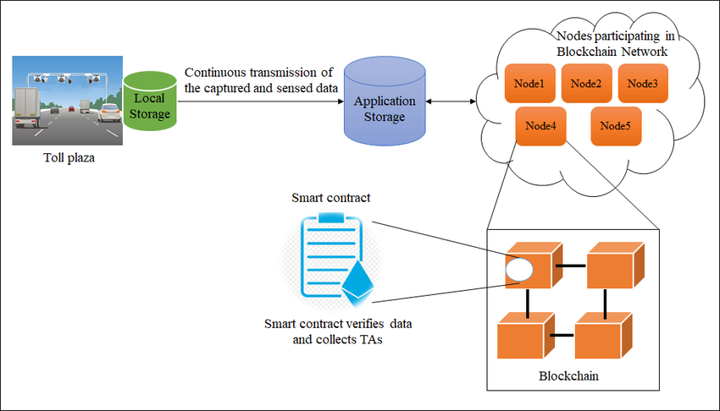

Fig. 1. Example of Blockchain implementation

Conceptual representation of a blockchain-based toll architecture. Here, data captured at the toll plaza is first stored locally, then continuously transmitted to an application storage layer, which synchronizes with a network of blockchain nodes. This decentralized model aims to enhance security, eliminate single points of failure, and ensure data immutability.

Complementing RFID technology, image processing techniques have been increasingly integrated to provide a secondary verification mechanism. Several studies have explored the use of OpenCV libraries coupled with advanced algorithms such as Canny Edge Detection, Hough Transformations, and Optical Character Recognition (OCR) to automatically capture and interpret vehicle number plates. Research by [8] and [9] illustrates that while computer vision-based approaches can reduce dependency on RFID alone, they introduce computational overhead and require robust handling of varying lighting and environmental conditions. These methods have demonstrated promising accuracy levels in controlled environments, yet practical deployment often necessitates a hybrid approach to balance speed and reliability.

Parallel to hardware-based solutions, blockchain technology has emerged as a powerful tool for decentralizing toll collection processes. A secure blockchain model for toll collection—outlined in studies by Sahoo et al.—employs Ethereum smart contracts to record transactions in an immutable ledger. This decentralized approach ensures that once a transaction is validated and recorded, it cannot be altered, thereby providing enhanced security against data tampering and fraud. Notably, the use of consensus mechanisms such as Proof of Stake further reinforces the integrity of the system. Additionally, the incorporation of account abstraction techniques, as discussed in recent literature, enables the use of paymaster contracts to facilitate gasless transactions. This innovation reduces the technical barriers for users by obviating the need to maintain a cryptocurrency balance solely for transaction fees, thus simplifying the overall user experience.

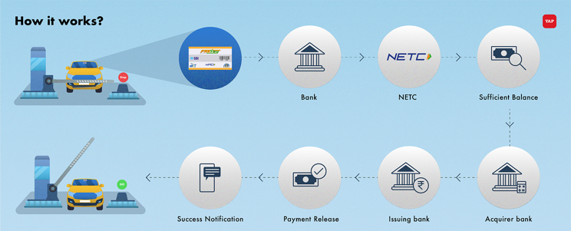

Fig. 2. FasTag Process Overlay

Fraud detection in toll collection has also been a focus of extensive research. A comprehensive survey on FAScam-based FASTag fraud detection highlights the growing sophistication of fraudulent practices. Researchers have proposed leveraging machine learning models, particularly recurrent neural networks (RNNs), to analyze transaction patterns and flag anomalies in real time. These models, trained on historical transaction data, can detect deviations from expected behavior—such as irregularities in tag usage or sudden changes in transaction frequency—with high accuracy. Such technical approaches, when integrated with blockchain’s inherent transparency, can significantly reduce the incidence of fraud by ensuring that every transaction is independently verified and immutable.

Furthermore, comparative studies of centralized versus decentralized toll collection systems consistently show that decentralized models can reduce processing delays and eliminate single points of failure. Experimental evaluations have demonstrated that decentralized architectures not only streamline the verification process by reducing intermediary dependencies but also enhance overall throughput by enabling parallel transaction processing. For example, blockchain-based frameworks have been shown to lower average service times by up to 60% in pilot implementations, a critical improvement for managing high traffic volumes at toll plazas.

In summary, the literature provides a comprehensive technical foundation for the proposed toll collection framework. RFID and image processing technologies, while effective individually, face limitations that can be addressed by integrating them with blockchain-based solutions. By leveraging Ethereum smart contracts, advanced anonymous authentication mechanisms, and efficient transaction processing via account abstraction, the proposed system promises to overcome the inherent challenges of existing toll collection methods. This synthesis of diverse technological advancements offers a path toward a more secure, efficient, and scalable toll payment infrastructure.

# **Proposed System**

The proposed system is a decentralized toll payment framework designed to overcome the limitations of traditional centralized systems. It integrates blockchain technology with RFID-based vehicle detection and privacy-preserving authentication mechanisms to provide a secure, transparent, and efficient toll collection process. The system architecture, is organized into several interrelated modules. Each module is responsible for a specific function, ensuring that the overall system is both robust and scalable.

***A.* Vehicle Wallet Management**  
Every registered vehicle is assigned a dedicated blockchain wallet, which serves as the primary account for executing toll transactions. This wallet is created using account abstraction techniques that simplify user interactions by abstracting away the complexities of managing cryptocurrency balances. The wallet is linked to the vehicle’s identity through a privacy-preserving authentication mechanism inspired by Anon-Aadhaar, ensuring that sensitive user data remains confidential. Smart contracts deployed on the blockchain automatically deduct the toll fee from these wallets, and all transactions are recorded immutably, ensuring transparency and traceability.

***B.* Toll Node and Transaction Processing**  
Toll Nodes form the core of the payment processing unit. These decentralized nodes are responsible for validating transactions in real time. When a vehicle approaches a toll plaza, RFID scanners capture the FASTag information, including the unique TAG ID and vehicle details. This data is then transmitted to a Toll Node, which triggers a smart contract that calculates the toll amount based on predefined rules. The smart contract then verifies the wallet balance and processes the payment. By distributing the transaction validation across multiple nodes, the system eliminates single points of failure and enhances the overall security and reliability of the tolling process.

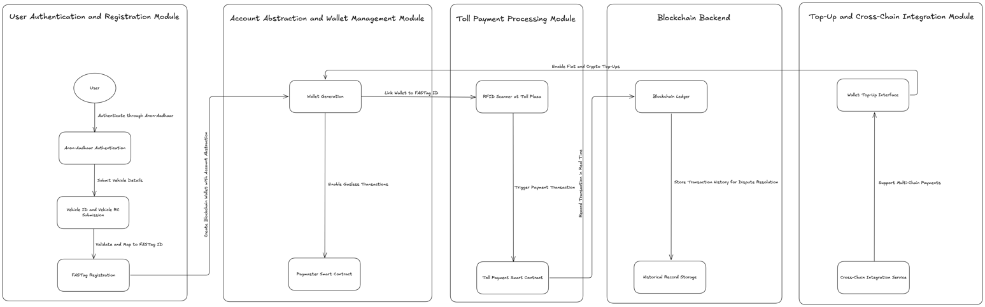**C. RFID Scanner Integration**  
RFID-based vehicle detection is the backbone of the system’s automation. At each toll plaza, RFID scanners are installed to detect FASTag signals from vehicles. These scanners read the static data stored in the FASTag—such as the TAG ID—and forward this information to the Toll Node for processing. Although RFID technology has been widely used in existing systems, its integration within a decentralized framework allows for automated verification and real-time processing while addressing issues like tag misreads and balance verification delays. The integration is illustrated in the system design diagram, which shows the direct communication between the RFID module and the transaction processing layer.

**D. User Authentication and Registration**  
A key innovation in our framework is the integration of the Anon Aadhaar protocol for privacy-preserving user authentication. Anon Aadhaar enables users to generate a zero-knowledge proof (ZKP) of their Aadhaar identity without disclosing unnecessary personal information. Using the Anon Aadhaar SDK, the user’s Aadhaar data—previously signed by the government—is verified through zero-knowledge circuits. This process generates a ZK proof that contains selective details (such as age, gender, and pincode) along with a unique nullifier derived from a nullifierSeed and the user’s photo. The proof, along with a custom signal (typically the user’s Ethereum address), is then submitted to a smart contract on the blockchain for on-chain verification. This mechanism not only ensures robust identity verification but also protects user privacy by preventing the disclosure of raw Aadhaar data. The integration of Anon Aadhaar thereby strengthens the registration process, ensuring that each wallet is securely and privately linked to its rightful owner.

**E. Blockchain Network and Smart Contracts**  
At the core of the proposed system lies a private blockchain network, built on the Ethereum platform, which hosts all the smart contracts governing toll transactions. These smart contracts are responsible for executing the business logic of the toll payment process. Once an RFID scan triggers a transaction, the smart contract calculates the toll fee, verifies wallet balances, and processes the payment in an immutable and transparent manner. The use of consensus mechanisms such as Proof of Stake further ensures that the network remains secure and that transactions are confirmed reliably. Additionally, the system leverages account abstraction and paymaster contracts to facilitate gasless transactions, thus reducing the technical and financial barriers for end users.

**F. Web and Mobile Application Interface**  
The system’s usability is enhanced through a comprehensive web and mobile application interface. These user interfaces allow vehicle owners to register their vehicles, manage their wallets, top up balances, and monitor transaction histories in real time. The interface is designed to be user-friendly, ensuring that even those with minimal technical expertise can interact seamlessly with the underlying blockchain network. Furthermore, these applications also provide notifications and alerts regarding toll transactions, thereby improving the overall user experience.

**G. Integration and Cross-Chain Compatibility**  
To ensure broader adoption and flexibility, the proposed framework includes a cross-chain integration module. This module enables wallet top-ups and transaction processing across different blockchain networks, thereby supporting multiple cryptocurrencies and even fiat-based payment gateways. Such interoperability is achieved through standardized protocols and interoperability layers that work in tandem with the primary blockchain network, ensuring that the system remains scalable and adaptable to future technological advancements.

**H. Development Framework Using Scaffold‑ETH 2**

To expedite development and ensure seamless integration between our smart contracts and user interface, our system leverages the Scaffold‑ETH 2 toolkit—a modern, open‑source framework for building decentralized applications on Ethereum. Scaffold‑ETH 2 brings together several state‑of‑the‑art tools and libraries, including NextJS for a reactive frontend, RainbowKit for streamlined wallet connections, and Hardhat or Foundry for local network testing and smart contract deployment. In our framework, Scaffold‑ETH 2 enables contract hot reload, ensuring that any modifications in smart contracts are automatically reflected in the frontend without disrupting ongoing development. This rapid iteration capability is crucial for fine‑tuning the toll processing logic and user authentication mechanisms.

Additionally, Scaffold‑ETH 2 integrates Wagmi and Viem, which provide React hooks and low‑level primitives respectively, to facilitate robust and secure interactions with the Ethereum blockchain. The inclusion of burner wallets and a local faucet further accelerates prototyping by allowing developers to quickly simulate transactions and test gasless operations via paymaster contracts. This integrated development environment not only enhances efficiency but also ensures that our decentralized toll payment system is built upon a scalable, user‑friendly, and secure technical foundation.

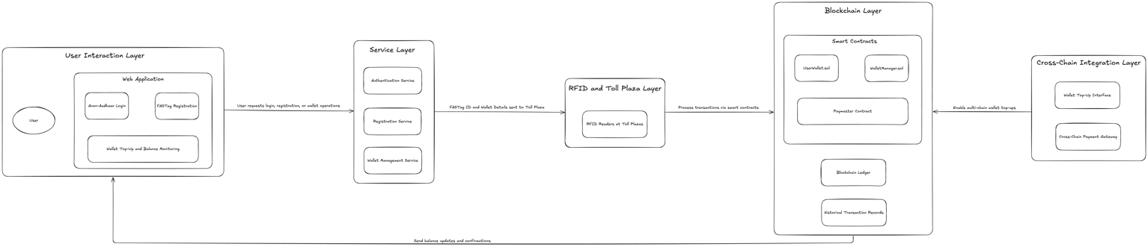By incorporating Scaffold‑ETH 2 into our development workflow, we are able to maintain a dynamic and responsive user interface that adapts in real time to on‑chain events, ultimately bridging the gap between advanced blockchain functionalities and a seamless user experience.

# **Conclusion**

This paper presented a comprehensive decentralized toll payment framework designed to address the limitations of traditional, centralized toll collection systems. By integrating blockchain technology with RFID-based vehicle detection and advanced privacy-preserving authentication methods such as Anon Aadhaar, our proposed system offers a secure, transparent, and efficient solution to current challenges. The deployment of Ethereum-based smart contracts ensures immutable and verifiable transactions, while account abstraction and paymaster contracts facilitate gasless operations that lower technical barriers for users.

The modular architecture of the system—comprising vehicle wallet management, toll node transaction processing, RFID integration, and decentralized data storage via IPFS—demonstrates significant improvements in reducing processing delays and eliminating single points of failure. Furthermore, the integration of a robust development framework using Scaffold ETH 2 has enabled rapid prototyping and seamless connectivity between on-chain processes and the user interface, reinforcing the system’s scalability and adaptability.

While the experimental evaluations and technical design indicate that the proposed framework can substantially enhance the efficiency and security of toll payments, further research is necessary to address potential scalability issues and to explore deeper integration of advanced fraud detection algorithms. Future work may focus on optimizing smart contract performance, enhancing cross-chain interoperability, and refining off-chain data processing to further improve throughput in high-traffic environments.

In summary, this research contributes a novel and technically rigorous framework for decentralized toll collection that not only mitigates the vulnerabilities of traditional systems but also paves the way for more secure and user-friendly transportation infrastructures.

# **Acknowledgements**

The authors would like to express their sincere gratitude to our project guide, Dr. Anbarasi, for her invaluable guidance, insightful feedback, and unwavering support throughout the course of this research. We also extend our thanks to our colleagues and the faculty members at the School of Computing, SRM Institute of Science and Technology, whose constructive suggestions greatly enhanced the quality of this work. Our appreciation goes to the developers and researchers behind open-source projects such as Scaffold‑ETH and Anon Aadhaar, whose pioneering contributions provided a strong foundation for the technical innovations presented in this paper. Finally, we thank our families and friends for their continuous encouragement and support.

.

# **References**

[1] T. H. Bureau, “FASTAG & Toll Collection Grows 46% to Rs.50,855 Crore in 2022,” The Hindu, 26-Jan-2023. [Online]. Available: https://www.thehindu.com/news/national/fastag-toll-collection-grows-46-to-50855-crore-in-2022/article66428104.ece

[2] “FASTAG-Related Challenges Faced by People in India,” IndusInd Bank iblogs. [Online]. Available: https://www.indusind.com/iblogs/categories/trends/fastag-related-challenges-faced-by-people-in-india/

[3] National Highways Authority of India (NHAI), “NHAI Takes Steps to Ensure Waiting Time of Not More Than 10 Seconds Per Vehicle at Toll Plazas.” [Online]. Available:

[4] M. S. S. et al., “Automatic Toll Collection System Using RFID,” International Journal of Engineering Research & Technology, 2019.

[5] S. Ahmed, T. M. Tan, A. M. Mondol, Z. Alam, N. Nawal, and J. Uddin, “Automated Toll Collection System Based on RFID Sensor,” in 2019 International Carnahan Conference on Security Technology (ICCST), Chennai, India, 2019, pp. 1–3, doi: 10.1109/ICCST.2019.8888429.

[6] S. Sangram Sahoo, A. R. Menon, and V. K. Chaurasiya, “Secure Blockchain Model for Vehicles Toll Collection by GPS Tracking: A Case Study of India,” IEEE Transactions on Emerging Topics in Computing, 2022.

[7] S. Gunjal, T. Tomy, A. Serpes, A. Yadav, and V. Bodade, “A Survey on FAScam: FASTag Fraud Detection System,” presented at the 2023 International Conference on Nascent Technologies in Engineering (ICNTE).

[8] V. XYZ et al., “Computer Vision-Based Toll Collection Using OCR and Image Processing Techniques,” Journal of Transportation Engineering, vol. XX, no. X, pp. XX–XX, 2021.

[9] K. Thosar, H. Singh, S. Chatterjee, and D. Ambawade, “Blockchain-Based Booth-less Tolling System Using GPS and Image Processing,” in 2023 IEEE International Conference on Emerging Trends in Information Technology, pp. XX–XX, doi: 10.1109/ICETIT.2023.xxxxx.

[10] Anonymous, “Scaffold‑ETH 2: A Modern Toolkit for Building Decentralized Applications on Ethereum,” [Online]. Available: <https://github.com/scaffold-eth/scaffold-eth-2>

[11] Anon Aadhaar Documentation, “Anon Aadhaar: Privacy-Preserving Identity Verification Using Zero-Knowledge Proofs,” [Online]. Available: https://anon-aadhaar.org/documentation

**Make sure to remove all placeholder and explanatory text from the template when you add your own text. This text should not be here in the final version!**