**Interactive Computer Graphics 2023 Spring, Term Project Report**

**Color Harmonization**

Chin-Chieh Hsu 許晉捷 F09922184

# Abstract

An image can be considered harmonious if we feel comfortable based on our individual perspective. Conventionally, artists and visual designers have been relying on their own instincts and artistic feelings to create impressive harmonic artworks. Color harmonization, on the other hand, is a computerized technique that applies a statistical algorithm to alter a digital image into a harmonized one. In this report, I will provide a detailed explanation of the methodology behind color harmonization, along with my own comprehensive implementation with a Graphical User Interface (GUI) using Python. Additionally, to elevate the performance in terms of time cost, some additional features not included in the original paper have been implemented.

# Contributions (貢獻)

The main contributions in my implementation can be categorized into two areas: GUI-related and algorithm-related, and are summarized as follows:

* + Algorithm-related contributions
    1. The first full implementation of the original paper (Cohen-Or et al., 2006) thus far, including all details of the algorithm, with additional features as undermentioned, among resource that can be found on public Internet, to the best of my knowledge.
    2. The harmonic scheme of the harmonization process can be either based on the target image itself, or on an optional reference image.
    3. In conjunction with a Super Resolution (SR) technique (Wang et al., 2021), an enhancement has been made to improve the efficiency of the algorithm. This enhancement enables the use of smaller-sized inputs for the main process without sacrificing quality. Further details are described in Section 4.
    4. In conjunction with GrabCut (Rother et al., 2004), a foreground-background image segmentation technique, a high-level application has been developed to let users selectively apply the color harmonization process on background (and the color harmony is based on the foreground), or vice-versa. This was also mentioned in the original paper. Further details are described in Section 4.
    5. Users have the option to choose between selecting a specific template type or allowing the program to automatically search for the best template type. The concept of template types will be discussed in greater detail in Section 3.
  + GUI-related contributions
    1. The first implementation along with a stand-alone GUI, including several extensive and user-friendly features, listed undermentionedly.
    2. Four ways to load image: 1) from local 2) drag-and-drop 3) from URL 4) from clipboard. This enables the ample flexibility for individual users.
    3. A specific GUI panel for algorithm settings for each single loaded image individually. The settings incorporate the template type of the harmonic schemes, the resize-ratio, and an optional reference image. These terms will be further explained in Section 3.
    4. All algorithms run on other threads. The user-interface is not frozen; thus, users can continue operating (e.g., load another image) while the harmonization process is concurrently running.
    5. An immediate and clear comparison will be displayed right after a process is done. This further enhances the user experience in terms of convenience and practicality.

# Introduction

The research of the color harmony has been elapsed a long time, intertwined with the some modern color model and color theory with respect to the human perception. Among those previous works, Matsuda introduced a comprehensive set of harmonic templates for color design (Matsuda, Y. 1995) that we leverage for harmonious evaluation and a further calculation, shown in *Figure 1*.

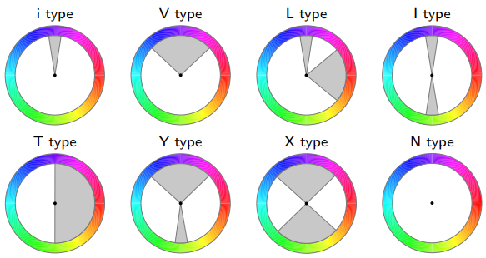

Figure . The eight harmonic templates as hue wheels, represented in HSV color space, developed by Matsuda (The figure originates from the paper (Cohen-Or et al., 2006)).

As Figure 1 shown, there exist eight types of harmonic templates: i-type, V-type, L-type, I-type, T-type, Y-type, X-type, and N-type. Each template is represented as a ring with hues in the HSV (hue, saturation, and value) color space and one or two sectors, except the N-type. The sectors in each template signify each type of color harmony, i.e., if all pixels’ hues of an image are located inside that one or two sectors in any one of the templates, the image is considered harmonious. Note that here we do not incorporate the N-type template into consideration, since it was proposed for grayscale images.

The goal of this computerized color harmonization algorithm is to alter a digital image by “shifting” the hues of all pixels along with a ring (a template) in order to make them be inside the sectors. This is depicted in Figure 2, which shows the goal of the algorithm. The upper row is the raw hues in a ring-shaped histogram and the raw image; the second row is the eventual result after the algorithm. As the figure shows, we “pushed” the raw hues on the ring and enforcedly “shifted” them into sectors of the chosen I-type template in a statistical way.

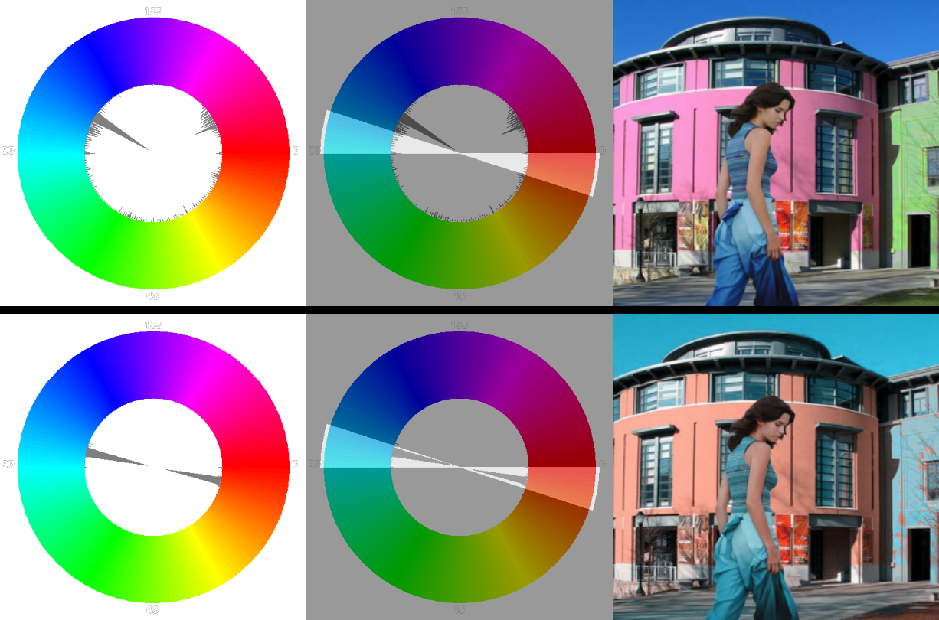

Figure . The goal of the color harmonization algorithm: the upper row is the raw hues in a ring-shaped histogram and the raw image; the second row is the eventual result after the algorithm. As the figure shows, we “pushed” the raw hues on the ring and enforcedly “shifted” them into sectors of the I-type template (This figure with ring-shaped histograms is drawn and generated by my own program; the raw image originates from the paper; the harmonized image is the result of my program).

In details, algorithmically speaking, in this project, I have implemented the full content of the original paper, including 1) harmonic scheme selection for the best one, 2) Graph-cut optimization (Boykov & Jolly, 2001) based on the selected best harmonic scheme, and 3) the color-shifting in conjunction with a normalized Gaussian function, as well as 4) some high-level application such like foreground-only or background-only harmonization with the help of image segmentation. Furthermore, 5) the option for users to apply the harmonization process based on either the target image itself or an optional reference image. These all result in a satisfied completeness and accomplishment implementation, which is the first one that implemented the full process and features of the original paper among the resource that can be found on public Internet, to the best of my knowledge. Further details will be illustrated in the following sections.

On the GUI side, I have developed an abundant amount of user-friendly features to attain better-to-best user experience. Regarding the file input, the program provides up to four different ways for users to load images: 1) from local storage via OS-native file dialogue 2) by dragging an image and dropping within the interface of the program 3) from a Uniform Resource Locator (URL) to let users conveniently load the image through Internet without explicitly downloading it 4) from the OS-native clipboard: the user can copy an image and it will be stored in the clipboard provided by OS. Once the user clicks the button that activates the image-loading “from clipboard”, the program will automatically read the stored image from the clipboard. This is the most convenient feature for image loading, in my personal opinion. As for the file output, the process results and visualizations will automatically be saved to a pair of pre-determined paths, respectively. These paths could be altered by users via a dedicated global preference panel. Moreover, the results could also be saved to arbitrary local storage explicitly by user, if intended.

# Method

In this section, the entire color harmonization algorithm (Cohen-Or et al., 2006) is elaborated in details. The algorithm can be subdivided into three stages: 1) Harmonic scheme selection. 2) Graph-cut optimization. 3) Color shifting.

1. Harmonic scheme selection

A harmonic scheme is defined as , where is the “index” of a template () and is defined as an orientation (offset) of a template. In this stage, we aim to select a best harmonic scheme along with the , the template indexed by , that minimizes the following objective function



, where *X* is the input image, is the harmonic scheme, *p* belonging to *X* represents all pixels in *X*, *H* and *S* refers respectively to the hue and saturation, and *E* denotes the closest sector’s border from *p*. In particular,



represents that given a specific harmonic scheme , the closest border of the sector in the , which is “rotated-by-“, from a pixel *p*. Finally, denotes the arc-distance on the ring.

This objective function *F* measures the color harmony of an image *X*, given an arbitrary harmonic scheme . The author also considered the saturation channel to mitigate the overestimated effect caused by the hue channel. We aim to minimize *F* to search for the best harmonic scheme , such that



In practical, in order to save the time cost to do optimization, instead of applying Brent’s method seven times to find out seven different -values for each template type, we can let the user to choose a designated template type and apply merely once Brent’s method. This may lead to a suboptimal result, since the chosen-by-user template type may not be the best one that can actually minimize *F*; however, it will be much more efficient by doing this.

The visualized process finding the best harmonic scheme can be depicted in Figure 3, as the red arrow represents. The “rotated” I-type template at the lower-right corner in Figure 3 can now be construed as the result of the first stage, i.e., the best harmonic scheme that we have found out.

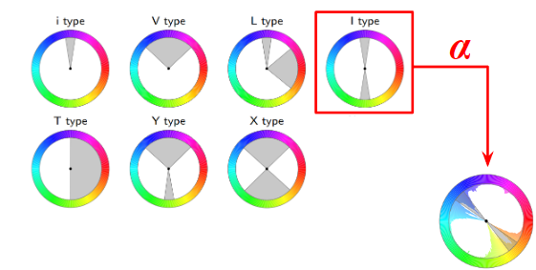

Figure . The visualization of the goal of searching for the best harmonic scheme . In this particular case, is I (thus is the I-type template). The “rotated” I-type template at the lower-right corner can now be construed as the result of the first stage, i.e., the best harmonic scheme that we have found out.

1. Graph-cut optimization

Now we have the best harmonic scheme, as shown as the “rotated” template at the lower-right corner in Figure 3. The problem now we possess is that: can we shift the hues on the ring-shaped histogram along with the template directly and coerce them be located inside the sectors, e.g., the nearest sector? Unfortunately, the answer is NO.

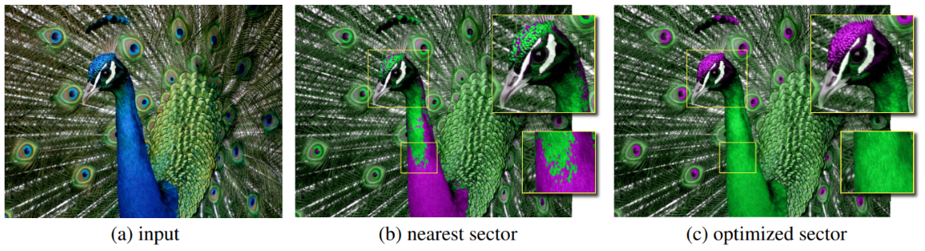

Figure . (a) the raw image (b) the result if we directly move each hue which are originally outside any sectors to the border of its nearest sector (c) the result after applying the Graph-cut optimization (The figure originates from the paper (Cohen-Or et al., 2006)).

As shown in Figure 4, If we simply coerce and shift each hue toward the border of its nearest sector, the unpleasant visual artifacts will be clearly generated.

1. Color shifting

s

# Implementation and Results

s

# Discussion

# Conclusion

# Implementation-Related Acknowledgements

# Reference

Boykov, Y. Y., & Jolly, M.-P. (2001). Interactive graph cuts for optimal boundary & region segmentation of objects in ND images. Proceedings eighth IEEE international conference on computer vision. ICCV 2001,

Cohen-Or, D., Sorkine, O., Gal, R., Leyvand, T., & Xu, Y.-Q. (2006). Color harmonization. In *ACM SIGGRAPH 2006 Papers* (pp. 624-630).

Rother, C., Kolmogorov, V., & Blake, A. (2004). " GrabCut" interactive foreground extraction using iterated graph cuts. *ACM transactions on graphics (TOG)*, *23*(3), 309-314.

Wang, X., Xie, L., Dong, C., & Shan, Y. (2021). Real-esrgan: Training real-world blind super-resolution with pure synthetic data. Proceedings of the IEEE/CVF International Conference on Computer Vision,