BMW_Sales_Detail.R

Mareko

2025-10-15

library(readxl)  
library(tidyverse)

## ── Attaching core tidyverse packages ──────────────────────── tidyverse 2.0.0 ──  
## ✔ dplyr 1.1.4 ✔ readr 2.1.5  
## ✔ forcats 1.0.1 ✔ stringr 1.5.2  
## ✔ ggplot2 4.0.0 ✔ tibble 3.3.0  
## ✔ lubridate 1.9.4 ✔ tidyr 1.3.1  
## ✔ purrr 1.1.0   
## ── Conflicts ────────────────────────────────────────── tidyverse_conflicts() ──  
## ✖ dplyr::filter() masks stats::filter()  
## ✖ dplyr::lag() masks stats::lag()  
## ℹ Use the conflicted package (<http://conflicted.r-lib.org/>) to force all conflicts to become errors

BMW_sales_data_2010_2024_ <- read_excel("C:/Users/Mareko/Downloads/archive (7)/BMW sales data (2010-2024).xlsx")  
View(BMW_sales_data_2010_2024_)  
  
print(BMW_sales_data_2010_2024_)

## # A tibble: 50,000 × 12  
## Model Year Region Color Fuel_Type Transmission Engine_Size_L Mileage_KM  
## <chr> <dbl> <chr> <chr> <chr> <chr> <chr> <dbl>  
## 1 i8 2010 South A… Black Hybrid Automatic 4.7 16020  
## 2 i8 2010 Middle … Grey Petrol Automatic 4.0 98514  
## 3 X6 2010 Europe Red Hybrid Manual 3.8 128477  
## 4 i8 2010 North A… White Electric Automatic 2.5 75457  
## 5 X6 2010 Africa Silv… Petrol Manual 1.7 176650  
## 6 M5 2010 South A… White Diesel Manual 2.8 121393  
## 7 3 Series 2010 Asia Black Petrol Manual 2.1 107572  
## 8 5 Series 2010 Europe Red Petrol Manual 1.8 194101  
## 9 i3 2010 Africa Blue Petrol Manual 3.6 91061  
## 10 i3 2010 Africa Blue Diesel Manual 1.8 120482  
## # ℹ 49,990 more rows  
## # ℹ 4 more variables: Price_USD <dbl>, Sales_Volume <dbl>,  
## # Sales_Classification <chr>, New_Count <dbl>

BMWSD = head(BMW_sales_data_2010_2024_, 100)  
  
summary(BMWSD$Mileage_KM)

## Min. 1st Qu. Median Mean 3rd Qu. Max.   
## 3514 46205 105041 103430 152912 199290

names(sort(-table(BMWSD$Mileage_KM)))[1]

## [1] "191728"

summary(BMWSD$Price_USD)

## Min. 1st Qu. Median Mean 3rd Qu. Max.   
## 30946 48255 67198 72359 99819 117253

names(sort(-table(BMWSD$Price_USD)))[1]

## [1] "30946"

summary(BMWSD$Sales_Volume)

## Min. 1st Qu. Median Mean 3rd Qu. Max.   
## 184 2706 5824 5499 8095 9996

names(sort(-table(BMWSD$Sales_Volume)))[1]

## [1] "184"

price_car <- c(BMWSD$Price_USD)  
cars <- c(BMWSD$Model)  
mileage <- c(BMWSD$Mileage_KM)  
  
barplot(price_car, names.arg = cars)

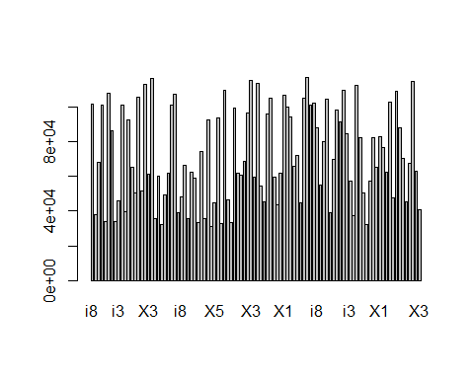

plot(mileage, price_car)  
  
model <- lm(price_car ~ mileage)  
abline(model, col = "red", lwd = 2)

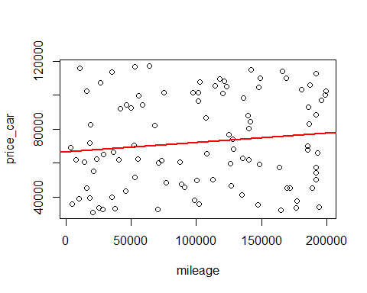

library(pivottabler)  
  
pivot <- qpvt(BMWSD,"Model","Transmission","sum(New_Count)")  
print(pivot)

## Automatic Manual Total   
## 3 Series 3 2 5   
## 5 Series 4 7 11   
## 7 Series 6 4 10   
## M3 6 4 10   
## M5 5 5 10   
## X1 5 9 14   
## X3 5 2 7   
## X5 6 4 10   
## X6 2 5 7   
## i3 2 4 6   
## i8 9 1 10   
## Total 53 47 100

Automatic = c(3,4,6,2,9,6,5,5,5,6,2)  
Model_Series = c("3 Series","5 Series","7 Series","i3","i8","M3","M5","X1","X3","X5","X6")  
pct <- round(Automatic/sum(Automatic)*100)  
Model_Series <- paste(Model_Series,"=", pct)  
  
Model_Series <- paste(Model_Series, "%",sep = "")  
pie(Automatic, labels = Model_Series,col = rainbow(length(Model_Series)), main = "Presentase Automatic/Matic")

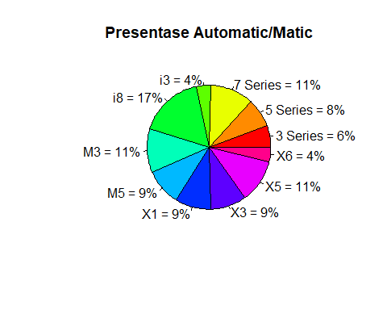

Automatic = c(2,7,4,4,1,4,5,9,2,4,5)  
Model_Series = c("3 Series","5 Series","7 Series","i3","i8","M3","M5","X1","X3","X5","X6")  
pct <- round(Automatic/sum(Automatic)*100)  
Model_Series <- paste(Model_Series,"=", pct)  
  
Model_Series <- paste(Model_Series, "%",sep = "")  
pie(Automatic, labels = Model_Series,col = rainbow(length(Model_Series)), main = "Presentase Manual")

