# **Abstract**

1. Trait-based ecology is becoming widespread, with many studies defining multidimensional trait spaces. This trend encourages the use of multidimensional functional diversity metrics to relate trait diversity to environmental gradients. However, the effect of the use of many related traits to draw functional diversity-environment relationships is not well known, especially if many traits vary in a non deterministic way along environmental gradients.
2. We used simulated virtual communities along an environmental gradient, experiencing increasingly strong environmental filtering on a single trait. We measured Functional Richness (FRic) and Functional Dispersion (FDis) along the gradient with combinations of traits either with or without the filtered trait. We also considered the effect of neutral processes on FD-environment trends by changing the migration rate as well as the regional pool size. We tested two scenarios: (i) only one trait affected by environmental filtering, (ii) two traits affected by environmental filtering in opposite manner along the environmental gradient. We estimated the statistical power of using the FD-environment trend to infer environmental filtering.
3. We found that the decrease in both FRic and FDis along the environmental gradient was weaker when considering additional traits, than when focusing on the filtered trait. Additional traits “dilute” the single expected trait-environment relationship. When neutral processes were stronger (with low immigration rate and/or smaller regional pool), the relationships were weaker. FDis was more susceptible to this “dilution effect” than FRic. Statistical power to detect a trend in FD-environment relationships dropped when adding traits.
4. Our findings underline the importance of carefully selecting the traits to detect trait-environment relationships. When no a priori knowledge is available to select potential traits related to environmental gradients, we suggest adjusting the significance standard effect size threshold to avoid the drop in statistical power.

# **Keywords**

functional diversity; virtual ecology; trait-environment relationship; trait-environment linkages; functional diversity-environment relationship; functional trait space

# **Introduction**

Organismal phenotypes are multidimensional by nature [(Hutchinson, 1957; Laughlin & Messier, 2015)](https://www.zotero.org/google-docs/?B4oZdw). This is the reason why trait-based ecology has been interested in studying the nature and shape of species’ multidimensional functional space [(Céréghino et al., 2018; Díaz et al., 2016; Mouillot et al., 2021; Winemiller et al., 2015)](https://www.zotero.org/google-docs/?CLM6xE). In this perspective, major axes of trait variation have been identified for many taxa [(Carmona et al., n.d., 2021; Céréghino et al., 2018; Díaz et al., 2016; Madin et al., 2016; Mouillot et al., 2021; Pianka et al., 2017; Pigot et al., 2020)](https://www.zotero.org/google-docs/?78GnTF). However, whether and how these axes are associated with environmental gradients remains an unsolved question, partly due to the joint effects of myriad local and global factors at play [(Bruelheide et al., 2018)](https://www.zotero.org/google-docs/?jQE8Zw). Despite this complexity, multi-trait distance-based indices (functional diversity indices *sensu lato*) have been popularized for the last two decades [(Mammola et al., 2021; Mason et al., 2013; Mouchet et al., 2010; Schleuter et al., 2010)](https://www.zotero.org/google-docs/?b4bNwY) for at least three reasons: (i) they capture the multidimensional nature of organismal phenotypes using single synthetic metrics [(Dalerum, 2013; Maire et al., 2015; Mouillot et al., 2021)](https://www.zotero.org/google-docs/?EBG4BH) and (ii) they identify multiple niche-based processes (e.g. biotic and abiotic process) that simultaneously act on several facets of organismal phenotypes [(Floury et al., 2017; Mason et al., 2013; Mouillot et al., 2013)](https://www.zotero.org/google-docs/?qLWsfb). This led to a growing number of studies that examined the changes in functional diversity along local and regional gradients, without a prior hypothesis regarding the influence of particular environmental factors on particular traits. In the meantime, the huge efforts of trait measurement standardization and more recently of database aggregations [(Brosse et al., n.d.; Chapman et al., 2019; Falster et al., 2021; Iversen et al., 2017; Jones et al., 2009; Kattge et al., 2011, 2020; Madin et al., 2016; Oliveira et al., 2017)](https://www.zotero.org/google-docs/?dpJ40x), notably in plants, have catalyzed the computation of functional diversity indices with more and more trait dimensions. Establishing functional diversity-environment relationships is critical today since it helps reveal the ecophysiological meaning of functional traits and it contributes to the prediction of ecosystem functions under varying environmental conditions at both local and global scales [(Shipley et al., 2016; Violle et al., 2014)](https://www.zotero.org/google-docs/?LZ6G8i). However, the evaluation of the robustness of these relationships is still at its infancy,

Multiple indices are needed to estimate differentacets of the variability of multi-dimensional organismal phenotypes [(Laughlin & Messier, 2015; Mason et al., 2013; Mouchet et al., 2010; Villéger et al., 2008)](https://www.zotero.org/google-docs/?BMIxoI). For example, Functional Richness (FRic) estimates the total extent of trait variation in a multi-dimensional space, while Functional Dispersion (FDis) describes the abundance-weighted variance of traits in the functional space [(Villéger et al., 2008)](https://www.zotero.org/google-docs/?k41EGJ). These two indices describe independent facets of the functional space and are the most commonly used when describing trait spaces [(Mammola et al., 2021)](https://www.zotero.org/google-docs/?8rcscj).

Community assembly processes affect which species occur in ecological communities [(Keddy, 1992)](https://www.zotero.org/google-docs/?YtXIXz). On the one hand, niche processes can influence one or several traits of multidimensional trait space, without playing on other traits. We expect that, if a single trait is affected by a given process, the use of additional unaffected traits to compute functional diversity should dilute the expected influence of the given process on functional diversity. With additional traits the relationship between functional diversity and the given process should be weaker. In addition, different community assembly processes can affect distinct facets of functional diversity. For example, environmental filtering tends to reduce functional richness [(Keddy, 1992; Kraft, Godoy, et al., 2015)](https://www.zotero.org/google-docs/?v1Y8Yh). A reduction of functional richness along an environmental gradient compared to a null expectation is thus generally interpreted as changing environmental filtering varying along the gradient [(Kraft, Godoy, et al., 2015)](https://www.zotero.org/google-docs/?srALDn). Neutral processes, on the other hand, affect species abundances irrespective of their traits [(Schwilk & Ackerly, 2005)](https://www.zotero.org/google-docs/?qVWdNN). They tend to increase variation in functional diversity [(Schwilk & Ackerly, 2005)](https://www.zotero.org/google-docs/?GOkvvS). If environmental filtering only affects a few traits, neutral processes would greatly increase the variance observed in non-filtered traits. The migration rate between the regional species pool and the local community also affects community composition irrespective of the species trait values. A low migration rate would mean that not all species can reach all communities, which in turn would blur the relationships between trait value and the environment. A migration rate close to one would mean that all species can reach the local communities, and can be filtered by the environment. Both niche-based and neutral community assembly processes should thus shape the expected dilution effect.

One factor that influences estimated functional diversity is the number of traits [(Legras et al., 2019; Maire et al., 2015)](https://www.zotero.org/google-docs/?sSIXWF). For example, depending on the indices used, increasing the number of traits can increase functional diversity for mathematical reasons [(Legras et al., 2019)](https://www.zotero.org/google-docs/?greaN8). Functional diversity is traditionally computed based on species trait dissimilarity [(Maire et al., 2015)](https://www.zotero.org/google-docs/?AkU6wt). The estimated dissimilarities between species can be highly driven by the number of traits (or PCA axes) used to compute functional diversity indices [(Maire et al., 2015)](https://www.zotero.org/google-docs/?LBq0rh). Using more traits in functional diversity should thus better detect niche-based processes, such as environmental filtering, and lead to stronger diversity-environment relationships. However, because a process may affect traits non-linearly and some traits may be affected by different processes, we expect a dilution effect when adding unaffected traits. Because of the dilution effect, an absence of relationship between functional diversity and the environment using multi-dimensional functional diversity indices does not necessarily mean the absence of environmental filtering [(Spasojevic & Suding, 2013)](https://www.zotero.org/google-docs/?oBWLNV). Antagonistic environmental filters affecting distinct traits added to the dilution effect when considering multiple traits entail a loss of statistical power when using multidimensional metrics to infer environmental filtering [(Bernard-Verdier et al., 2012)](https://www.zotero.org/google-docs/?TCVEzA). For example, using two distinct traits, one trait could converge while the other trait would diverge along the environmental gradient. In this case, uni-dimensional functional diversity indices based on these two traits would show opposed trends. Two-dimensional functional diversity indices using the two traits would on the contrary be constant along the gradient, obscuring the processes affecting single traits. Linking functional diversity patterns to specific community assembly processes from observed data can be difficult as both the number of traits and the number of processes affecting them can obscure the expected patterns [(Cornwell & Ackerly, 2009; McPherson et al., 2018)](https://www.zotero.org/google-docs/?qVVWpo).

Numerical simulations, as virtual experiments, can be used to measure the influence of ecological processes [(Peck, 2004; Zurell et al., 2010)](https://www.zotero.org/google-docs/?DvpqtU). Virtual ecology has indeed helped better calibrate species distribution models [(Hirzel et al., 2001; Meynard et al., 2019)](https://www.zotero.org/google-docs/?n2XQiV), design sampling scheme to best represent biodiversity [(Thomas et al., 2018)](https://www.zotero.org/google-docs/?U0yDkJ), and disentangle community assembly processes [(Botta-Dukát & Czúcz, 2015; Münkemüller & Gallien, 2015; Munoz et al., 2017)](https://www.zotero.org/google-docs/?xjT8Wb). Through simulation, we can manipulate the strength of neutral processes and environmental filtering independently [(Kraft et al., 2007)](https://www.zotero.org/google-docs/?wiMq8L). Simulations also let us simulate species with independent traits, and generate environmental filtering affecting single or multiple trait(s). With these simulations we can quantify the expected dilution effect due to additional traits in the functional diversity-environment. Simulations also let us measure the statistical power of using functional diversity-environment relationships to infer environmental filters, while it would be impossible to do so with observed data.

This study aims to estimate the dilution effect when using additional traits that can fade away a functional diversity-environment relationship. We used a simulation framework to test the effect of both environmental filtering and neutral dynamics on the relationship between environment and functional diversity metrics. We tested three scenarios: (i) a single trait was filtered along an environmental gradient, and additional traits were not affected by environmental filtering; (ii) similar to scenario (i) but we modified tested both low and high migration rates; (iii) we used two traits affected by environmental filtering in opposed ways along the environmental gradient, the first trait converged while the second one diverged, and other simulated traits were not affected by environmental filtering.

# **Material and Methods**

## Simulations

### Community Assembly

*Theoretical model*. To test the dilution effect of traits on the functional diversity-environment relationship, we simulated communities using a community assembly model. In our framework, each individual immigrates from a species pool in the local community. The immigration probability of each individual depends on the local environment and the trait value of the species. We used a Gaussian function with parameters and to characterize local environmental filtering. represents the optimal trait value in the local environment such that a species with has a maximum probability of establishing itself in the local environment. While represents the width of environmental filtering, the smaller the narrower the environmental filtering, and the closer the species have to be to to immigrate and maintain in the local community. In addition, the smaller the less functionally diverse a community (for this particular trait). Before establishing, the species have to migrate from the regional pool to the local community following the migration rate *m*.

*Simulations*. We simulated community assembly using ecolottery [(Munoz et al., 2017)](https://www.zotero.org/google-docs/?BkPdLN) (function coalesc()), a fast coalescent-based model which considers both neutral dynamics and environmental filtering. We generated 11 uncorrelated, uniformly distributed traits between 0 and 1 for 200 species. The regional species pool included 500 individuals per species with identical trait values (i.e., without considering their intraspecific trait variation).

*Scenario 1: Single trait, fixed migration rate*. We used a Gaussian environmental filter that affected species establishment probability from the pool in the community as follows: with the probability of successful immigration by species in environment , its associated trait, the optimal trait values in environment and the variance of the environmental filter in this environment. We created a gradient of 10 environments with corresponding optimal traits values ranging from 0.1 to 0.9, thus shifts from 0.1 to 0.9 along the environmental gradient. Along the same gradient we assigned decreasing from 0.2 to 0.03. At the beginning of the gradient, the filter is thereby weak and we expect a high functional diversity for the filtered trait (many species away from the optimum can maintain themselves), while it is harsh at the end of the gradient (only species close to the optimum can maintain themselves). For each environment, we simulated independently 10 communities of 500 individuals using coalesc() with the migration parameter m set to 1.

*Scenario 2: Single trait, variable migration rate*. In order to test to what extent neutral dynamics would affect the functional diversity-environment relationship, we additionally simulated communities with the migration rate m = 0.1. We considered an alternative, smaller regional pool including only 20 individuals of each species, i.e. 4000 individuals total, so as to examine the influence of pool size on the results.

*Scenario 3: Two traits, diverging relationships with the environment*. To test the effect of traits being affected in opposite directions, we simulated 10 communities with a first environmental filter set up as above, and a second environmental filter taking into account a second filtered trait with a variance linearly increasing in the opposite direction as the first environmental filter (Supplementary Figure S1). Both environmental filters had the same optimal trait value .

### **Functional Diversity Indices**

In each simulated community, for each n-uplets of traits, we computed two indices of functional diversity: Functional Richness (FRic) and Functional Dispersion (FDis). Functional Richness quantifies the proportion of the trait space occupied by all the species in the assemblage. It is the volume of the minimum convex hull encompassing all the species in the assemblage [(Villéger et al., 2008)](https://www.zotero.org/google-docs/?BoxpyE). Because FRic is linked to the number of traits used to compute it [(Legras et al., 2019)](https://www.zotero.org/google-docs/?3ZwnLr), we standardized FRic between 0 and 1, where 1 corresponds to the volume of all the species in the species pool. Functional Dispersion quantifies the variance of trait distributions along multiple dimensions [(Laliberté & Legendre, 2010)](https://www.zotero.org/google-docs/?15Xr6a): if all species are close together FDis will be low, while it will be high if species are further apart. Using presence-absence data, FDis is computed as follows:

where is the Functional Dispersion of site , the total number of species in site , the abundance of species in site and the distance between species traits and the weighted centroid of traits of all species present at this site in the trait space. The two indices were computed using the function fdisp() in the FD R package v1.0-12 [(Laliberté et al., 2014)](https://www.zotero.org/google-docs/?aC36Uh) and using the function convhulln() in the geometry package v0.4.5 [(Habel et al., 2019)](https://www.zotero.org/google-docs/?KmQdQd). All simulations, diversity measures and subsequent analyses were made using R [(R Core Team, 2021)](https://www.zotero.org/google-docs/?3AJin4).

## **Statistical Analyses**

### **Null models**

To test to what extent the observed functional diversity patterns were due to the effect of environmental filtering playing on tg and/or sigmag, we used null models to compare observed communities to null communities [(Gotelli & Graves, 1996)](https://www.zotero.org/google-docs/?40Q57P). We shuffled 100 times the trait combinations among all species. We recomputed functional diversity indices using shuffled traits.

We computed Standard Effect Size (SES) as follows:

where is the observed functional diversity of a site, the average of null functional diversity at this site and the standard deviation of null functional diversity at the same site. If the null functional diversity distribution is approximately normal, we can use SES values of -1.96 and 1.96 as significance thresholds [(Gotelli & Graves, 1996)](https://www.zotero.org/google-docs/?yy4n1U) (Figure S2, Figure S3).

### **Statistical power computation**

We wanted to distinguish trends of functional diversity indices along the environment when they were computed using combinations of traits that contained vs that did not contain the filtered trait. To avoid accepting the null hypothesis when the combination contains the filtered trait, we computed the statistical power when varying the SES thresholds. We computed statistical power as follows: for a fixed SES threshold and a fixed number of traits, we counted the proportions of sites along the gradient with an SES above the threshold (significantly different from null models) when the traits used to compute functional diversity included the filtered trait. Statistical power is the probability to correctly reject the null hypothesis ( = functional diversity is not different from random), i.e. detecting a trend in the functional diversity-environment relationship when there is one. We computed power for all functional diversity indices and all combinations of traits with various SES thresholds. We then used these power estimates to adjust the SES threshold depending on the number of traits and the index used to reach a fixed power level.

# **Results**

FRic decreased along the environmental gradient when using the filtered trait (Figure 1). With additional traits, including the filtered trait, FRic still showed a decrease along the environmental gradient, but the decrease was less pronounced as the number of traits increased. When using a single non-filtered trait, FRic did not change along the environmental gradient. However, when considering two or more non-filtered traits, FRic decreased with increasing environmental filtering, even though the filtered trait was not among the considered traits. This decrease in FRic was due to the increase in dimensionality, because we standardized FRic to its maximum theoretical value if all traits varied independently, and the higher dimensionality, the emptier the functional space. Still, the combinations of non-filtered traits showed higher FRic at all environments than combinations including the filtered trait.

The Standard Effect Sizes (SES) that quantify departures from the null expectations were within -1.96 and 1.96 significance limits for all trait combinations that did not contain the filtered trait, while they were all under -1.96 for trait combinations containing the filtered trait, whatever the number of traits considered. This means that FRic was lower than expected by the null model when including the filtered trait. Even if much lower than the significance threshold -1.96, the SES values for the combination of 11 traits were on average -3.4.

FDis decreased along the environmental gradient when using the filtered trait (Figure 1), while it shows no trend when using non-filtered traits. When using combinations of two traits including the filtered trait, there was still a decrease in FDis, while there was no more decrease when using combinations of 3 or more traits. The greater the number of traits used, the closer the FDis values between combinations with and without the filtered trait. The SES for FDis remained between -1.96 and 1.96 for all combinations of non-filtered traits, while it was well below -1.96 for almost all combinations containing the filtered trait; except at the extreme of the gradient, environment 0.9, for five, six and seven traits.

Simulations with low migration rate showed higher variability in both FRic and FDis observed values (Figure 2), with smaller differences between combinations with and without the filtered trait than cases with higher migration rate. For SESs, the effect of a decrease in migration rate was similar, lower migration rate simulations show higher variability in SES and smaller differences between combinations containing only non-filtered traits and with the filtered trait.

At a fixed SES threshold, the statistical power decreased with increasing number of traits (Figure 3) at a high immigration rate. However, the power decreased more for FDis reaching about 80% for 7 traits at 1.96 SES, than for FRic where the power did not decrease when using the 1.96 SES threshold. FRic showed almost no change in power whatever the SES threshold used and the number of traits, except with the six or seven traits with more stringent threshold around 2.5.

When considering two traits with opposed variations in filtering strength along the gradient, both FRic and FDis showed no trend along the environment when considering a non-filtered trait (Figure 4 **A** and **B**, respectively green and blue lines). For FRic, all combinations of two or more traits without filtered traits showed a humped-shaped relationship with the environment. FRic was lower on the margins of the environment and higher in the center. FRic decreased as the number of traits increased. All combinations containing either filtered traits showed trends similar to the single trait case with decreasing (respectively increasing) trend of FRic along the environment. Combinations of traits comprising both filtering traits showed lower FRic than any other combination for all environments, with a humped shape of higher FRic at the middle of the environmental gradient and lower FRic at the extremes. FRic SES showed similar trends, with combinations containing either filtered traits showing opposing trends along the environment well below -1.96, combinations without any filtered trait being between -1.96 and 1.96 and combinations containing both filtered traits showing lower FRic SES than combinations with either ones below -1.96.

FDis showed trends similar to FRic. Combinations of non-filtered traits showed no trend along the environment. Combinations with either filtered traits showed decreasing (respectively increasing) trends along the environment. Combinations with both filtered traits showed no trend in FDis, but consistently lower values than other trait combinations. FDis increased with an increasing number of traits. FDis SESs were similar to FDis trends along the environment. All combinations of non-filtered traits had SES values between -1.96 and 1.96, while combinations with either filtered traits showed gradients with SES values lower than -1.96. Combinations with both traits showed lower SES than other combinations for all traits.

# **Discussion**

Through a simulation approach, we have shown that increasing the number of traits not affected by the community assembly process can blur the functional diversity-environment relationship. We tested various situations with different migration rates and different traits with opposed filtering along the environmental variables. We proposed a method to compute the statistical power of each functional diversity metric. The decrease in power with an increasing number of traits indicate the need of tuning the SES threshold to adjust detection in the different cases examined here. This threshold adjustment should be dependent on the functional diversity index used. Our results show that adding non-filtered traits in trait diversity analyses weakens the linkage between functional diversity and the environment.

Our simulations underline the importance of trait selection when computing functional diversity to avoid the dilution effect seen when adding unaffected traits. Among all the possible measured traits, the recommendation is to focus on the traits that are the most linked to the studied process [(Shipley et al., 2016; Violle et al., 2007)](https://www.zotero.org/google-docs/?DJg5Hh). This is an opposite approach to the current practices of drawing phenotypic spaces with as many traits as possible at global scales [(Carmona et al., 2021; Díaz et al., 2016; Mouillot et al., 2021; Pianka et al., 2017)](https://www.zotero.org/google-docs/?YE9BkN), and using all these traits to infer possible processes. The knowledge of the main community assembly drivers instead helps selecting the most relevant traits to detect this effect [(Shipley et al., 2016)](https://www.zotero.org/google-docs/?qrKWI6). At broader biogeographical scales, however, the knowledge of both traits, the environment, and their linkage is coarser. This means that the risk of dilution effect of considering many traits together should be greater at broader scales [(Shipley et al., 2016; Swenson et al., 2012)](https://www.zotero.org/google-docs/?qgHQ7E). The context-dependency of traits increases the risk for dilution. To account for the dilution effect, we propose to compute statistical power when testing trends in functional diversity-environment relationships. The dilution effect should be more pronounced at biogeographical scales when using many traits simultaneously. At these scales, we recommend adjusting the significance of the SES threshold to avoid losing statistical power.

We showed how different facets of functional diversity show different sensitivity to the dilution effect of additional traits. For example Functional Richness (FRic), being defined as the convex hull of species present in the functional space, is particularly sensitive to the presence of outliers and represents the trait space occupied by all species present [(Villéger et al., 2008)](https://www.zotero.org/google-docs/?CsSKfU). Functional Dispersion (FDis), on the other hand, is the abundance-weighted centroid in trait space. FDis reflects to what extent most abundant species are at the border or in the center of trait space. It is used to detect limiting similarity [(Villéger et al., 2008)](https://www.zotero.org/google-docs/?mzudEH). The decrease in power with additional traits was stronger in FDis than in FRic in our simulations. It suggests that adjusting the SES threshold to get a fixed statistical power may be index-specific. Our method has to be adapted to additional combinations of functional diversity indices and community assembly processes to further characterize power reduction associated with increasing number of traits in a broader context.

Neutral processes increase functional diversity variability along the environment. We showed in our simulation how lower migration rate made observed functional diversity more variable and lower—in absolute—SESs. Indeed, low migration rate implies that less individuals and, in turn, less species can reach the observed communities from the species pool, making functional diversity more variable [(Münkemüller et al., 2012)](https://www.zotero.org/google-docs/?mp1p7K). This can hinder our ability to correctly identify a functional diversity-environment relationship with more than one trait. Dispersal limitation can also decrease observed functional diversity along the environment because of low migration rate [(Spasojevic et al., 2014)](https://www.zotero.org/google-docs/?s4tIml).

Our simulation framework only considered environmental filtering and neutral dynamics, while many other assembly processes can affect functional diversity-environment relationships [(Mason et al., 2013; Münkemüller et al., 2012)](https://www.zotero.org/google-docs/?gm23Y5). For example, limiting similarity also affects trait-environment distribution and thus functional diversity-environment relationships, so that it increases the expected functional diversity and counteracts environmental filtering [(Diamond, 1975; Götzenberger et al., 2012)](https://www.zotero.org/google-docs/?9uJ0ho). Limiting similarity is expected to spread and increase the evenness of species in the trait space and thus to increase FRic and FDis along the environment [(Cornwell & Ackerly, 2009)](https://www.zotero.org/google-docs/?MnpgT4). But it has been recently shown that competitive hierarchy could lead to patterns similar to environmental filtering [(Bernard-Verdier et al., 2012; HilleRisLambers et al., 2012; Mayfield & Levine, 2010; Perronne et al., 2017)](https://www.zotero.org/google-docs/?vnAAIU). Furthermore, depending on the scale at which we consider functional diversity, distinct processes can affect different functional diversity facets [(de Bello et al., 2013)](https://www.zotero.org/google-docs/?orLTbB). For instance, de Bello et al. [(2013)](https://www.zotero.org/google-docs/?yDt5MH) found that environmental filtering at large scales mainly affected FRic while at finer-scale it affected FDis and FDiv. Our simulation approach could be completed by the integration of additional community assembly processes that also affect functional diversity-environment relationships, similarly to what has been done on phylogenetic diversity indices [(Kraft et al., 2007)](https://www.zotero.org/google-docs/?Qa5msd).

When considering functional diversity-environment relationships for a single trait, our simulations distinguished well between the filtered trait and all the other traits, while the distinction gets more difficult with additional traits. Indeed, single-trait approaches have been suggested to delve into the details of community assembly, while multi-trait approaches aggregate many processes [(Butterfield & Suding, 2013; Lefcheck et al., 2015; Spasojevic & Suding, 2013)](https://www.zotero.org/google-docs/?cvrdbL). From our simulations, we estimated the dilution effect due to the use of unaffected traits in functional diversity. If a trait is singled out by showing a distinct relationship than the other traits with the environment, then it may be filtered. However, our simulation setup is a simplified situation where a single trait responds to the environment while others are uncorrelated to it, while trait correlations are widespread in real datasets [(Westoby et al., 2002)](https://www.zotero.org/google-docs/?5NxZ9X). Trait correlation can cause multiple traits to have similar relationships with the environment while only one is affected by the process [(Dwyer & Laughlin, 2017; Laughlin & Messier, 2015)](https://www.zotero.org/google-docs/?fLicxL). Different trait combinations can also exhibit similar fitness along the environment if environmental filtering is not uni-modal without any trait correlations [(Corrêa Dias et al., 2019; Laughlin & Messier, 2015; Marks & Lechowicz, 2006)](https://www.zotero.org/google-docs/?3d0Ths). Single traits can also be influenced by multiple processes simultaneously and thus reach far from the optimum value when considering a single process [(Sack & Buckley, 2019)](https://www.zotero.org/google-docs/?9noxho).

Multi-traits functional diversity indices can however unravel patterns that cannot be found using single-trait indices [(Cornwell & Ackerly, 2009; Kraft, Adler, et al., 2015; Kraft, Godoy, et al., 2015)](https://www.zotero.org/google-docs/?huN4gN). For example, disturbances can have effects that cannot be resumed looking at single trait indices [(Mouillot et al., 2013)](https://www.zotero.org/google-docs/?V7nJC8), but revealed by multi-traits metrics [(Villéger et al., 2011)](https://www.zotero.org/google-docs/?ThMD19). Similarly, ecosystem multifunctionality is better predicted when accounting for multiple traits than using single traits [(Mouillot et al., 2011)](https://www.zotero.org/google-docs/?InNClf). Multiple traits need to be taken into account when explaining multiple species stable coexistence [(Kraft, Godoy, et al., 2015)](https://www.zotero.org/google-docs/?l7AgvG). Indeed, using only single-trait indices can be informative as stated above, but multiple independent functional dimensions cannot be reduced by uni-dimensional indices. Furthermore, in the absence of a priori knowledge of trait importance for community assembly, multidimensional functional diversity indices can help test broad patterns [(Lefcheck et al., 2015)](https://www.zotero.org/google-docs/?I4muMl).

# **References**

[Bernard-Verdier, M., Navas, M.-L., Vellend, M., Violle, C., Fayolle, A., & Garnier, E. (2012). Community assembly along a soil depth gradient: Contrasting patterns of plant trait convergence and divergence in a Mediterranean rangeland. *Journal of Ecology*, *100*(6), 1422–1433. https://doi.org/10.1111/1365-2745.12003](https://www.zotero.org/google-docs/?ngCVE2)

[Botta-Dukát, Z., & Czúcz, B. (2015). Testing the ability of functional diversity indices to detect trait convergence and divergence using individual-based simulation. *Methods in Ecology and Evolution*, n/a-n/a. https://doi.org/10.1111/2041-210X.12450](https://www.zotero.org/google-docs/?ngCVE2)

[Brosse, S., Charpin, N., Su, G., Toussaint, A., Herrera-R, G. A., Tedesco, P. A., & Villéger, S. (n.d.). FISHMORPH: A global database on morphological traits of freshwater fishes. *Global Ecology and Biogeography*, *n/a*(n/a). https://doi.org/10.1111/geb.13395](https://www.zotero.org/google-docs/?ngCVE2)

[Bruelheide, H., Dengler, J., Purschke, O., Lenoir, J., Jiménez-Alfaro, B., Hennekens, S. M., Botta-Dukát, Z., Chytrý, M., Field, R., Jansen, F., Kattge, J., Pillar, V. D., Schrodt, F., Mahecha, M. D., Peet, R. K., Sandel, B., Bodegom, P. van, Altman, J., Alvarez-Dávila, E., … Jandt, U. (2018). Global trait–environment relationships of plant communities. *Nature Ecology & Evolution*, *2*(12), 1906. https://doi.org/10.1038/s41559-018-0699-8](https://www.zotero.org/google-docs/?ngCVE2)

[Butterfield, B. J., & Suding, K. N. (2013). Single-trait functional indices outperform multi-trait indices in linking environmental gradients and ecosystem services in a complex landscape. *Journal of Ecology*, *101*(1), 9–17. https://doi.org/10.1111/1365-2745.12013](https://www.zotero.org/google-docs/?ngCVE2)

[Carmona, C. P., Bueno, C. G., Toussaint, A., Träger, S., Díaz, S., Moora, M., Munson, A. D., Pärtel, M., Zobel, M., & Tamme, R. (2021). Fine-root traits in the global spectrum of plant form and function. *Nature*, *597*(7878), 683–687. https://doi.org/10.1038/s41586-021-03871-y](https://www.zotero.org/google-docs/?ngCVE2)

[Carmona, C. P., Tamme, R., Pärtel, M., de Bello, F., Brosse, S., Capdevila, P., González-M., R., González-Suárez, M., Salguero-Gómez, R., Vásquez-Valderrama, M., & Toussaint, A. (n.d.). Erosion of global functional diversity across the tree of life. *Science Advances*, *7*(13), eabf2675. https://doi.org/10.1126/sciadv.abf2675](https://www.zotero.org/google-docs/?ngCVE2)

[Céréghino, R., Pillar, V. D., Srivastava, D. S., Omena, P. M. de, MacDonald, A. A. M., Barberis, I. M., Corbara, B., Guzman, L. M., Leroy, C., Bautista, F. O., Romero, G. Q., Trzcinski, M. K., Kratina, P., Debastiani, V. J., Gonçalves, A. Z., Marino, N. A. C., Farjalla, V. F., Richardson, B. A., Richardson, M. J., … Montero, G. (2018). Constraints on the functional trait space of aquatic invertebrates in bromeliads. *Functional Ecology*, *32*(10), 2435–2447. https://doi.org/10.1111/1365-2435.13141](https://www.zotero.org/google-docs/?ngCVE2)

[Chapman, A. S. A., Beaulieu, S. E., Colaço, A., Gebruk, A. V., Hilario, A., Kihara, T. C., Ramirez‐Llodra, E., Sarrazin, J., Tunnicliffe, V., Amon, D. J., Baker, M. C., Boschen‐Rose, R. E., Chen, C., Cooper, I. J., Copley, J. T., Corbari, L., Cordes, E. E., Cuvelier, D., Duperron, S., … Bates, A. E. (2019). sFDvent: A global trait database for deep‐sea hydrothermal‐vent fauna. *Global Ecology and Biogeography*, *28*(11), 1538–1551. https://doi.org/10.1111/geb.12975](https://www.zotero.org/google-docs/?ngCVE2)

[Cornwell, W. K., & Ackerly, D. D. (2009). Community assembly and shifts in plant trait distributions across an environmental gradient in coastal California. *Ecological Monographs*, *79*(1), 109–126.](https://www.zotero.org/google-docs/?ngCVE2)

[Corrêa Dias, A. T., Rosado, B. H. P., Bello, F. de, Pistón, N., & Mattos, E. A. de. (2019). Alternative plant designs: Consequences for community assembly and ecosystem functioning. *Annals of Botany*, mcz180. https://doi.org/10.1093/aob/mcz180](https://www.zotero.org/google-docs/?ngCVE2)

[Dalerum, F. (2013). Phylogenetic and functional diversity in large carnivore assemblages. *Proceedings of the Royal Society of London B: Biological Sciences*, *280*(1760), 20130049. https://doi.org/10.1098/rspb.2013.0049](https://www.zotero.org/google-docs/?ngCVE2)

[de Bello, F., Lavorel, S., Lavergne, S., Albert, C. H., Boulangeat, I., Mazel, F., & Thuiller, W. (2013). Hierarchical effects of environmental filters on the functional structure of plant communities: A case study in the French Alps. *Ecography*, *36*(3), 393–402. https://doi.org/10.1111/j.1600-0587.2012.07438.x](https://www.zotero.org/google-docs/?ngCVE2)

[Diamond, J. M. (1975). Assembly of species communities. *Ecology and Evolution of Communities*, *342*, 444.](https://www.zotero.org/google-docs/?ngCVE2)

[Díaz, S., Kattge, J., Cornelissen, J. H. C., Wright, I. J., Lavorel, S., Dray, S., Reu, B., Kleyer, M., Wirth, C., Prentice, I. C., Garnier, E., Bönisch, G., Westoby, M., Poorter, H., Reich, P. B., Moles, A. T., Dickie, J., Gillison, A. N., Zanne, A. E., … Gorné, L. D. (2016). The global spectrum of plant form and function. *Nature*, *529*(7585), 167–171. https://doi.org/10.1038/nature16489](https://www.zotero.org/google-docs/?ngCVE2)

[Dwyer, J. M., & Laughlin, D. C. (2017). Constraints on trait combinations explain climatic drivers of biodiversity: The importance of trait covariance in community assembly. *Ecology Letters*, *20*(7), 872–882. https://doi.org/10.1111/ele.12781](https://www.zotero.org/google-docs/?ngCVE2)

[Falster, D., Gallagher, R., Wenk, E. H., Wright, I. J., Indiarto, D., Andrew, S. C., Baxter, C., Lawson, J., Allen, S., Fuchs, A., Monro, A., Kar, F., Adams, M. A., Ahrens, C. W., Alfonzetti, M., Angevin, T., Apgaua, D. M. G., Arndt, S., Atkin, O. K., … Ziemińska, K. (2021). AusTraits, a curated plant trait database for the Australian flora. *Scientific Data*, *8*(1), 254. https://doi.org/10.1038/s41597-021-01006-6](https://www.zotero.org/google-docs/?ngCVE2)

[Floury, M., Souchon, Y., & Looy, K. V. (2017). Climatic and trophic processes drive long-term changes in functional diversity of freshwater invertebrate communities. *Ecography*, n/a-n/a. https://doi.org/10.1111/ecog.02701](https://www.zotero.org/google-docs/?ngCVE2)

[Gotelli, N. J., & Graves, G. R. (1996). *Null models in ecology*. Smithsonian Institution Press.](https://www.zotero.org/google-docs/?ngCVE2)

[Götzenberger, L., Bello, F. de, Bråthen, K. A., Davison, J., Dubuis, A., Guisan, A., Lepš, J., Lindborg, R., Moora, M., Pärtel, M., Pellissier, L., Pottier, J., Vittoz, P., Zobel, K., & Zobel, M. (2012). Ecological assembly rules in plant communities—Approaches, patterns and prospects. *Biological Reviews*, *87*(1), 111–127. https://doi.org/10.1111/j.1469-185X.2011.00187.x](https://www.zotero.org/google-docs/?ngCVE2)

[Habel, K., Grasman, R., Gramacy, R. B., Mozharovskyi, P., & Sterratt, D. C. (2019). *geometry: Mesh generation and surface tessellation*. https://CRAN.R-project.org/package=geometry](https://www.zotero.org/google-docs/?ngCVE2)

[HilleRisLambers, J., Adler, P. B., Harpole, W. S., Levine, J. M., & Mayfield, M. M. (2012). Rethinking Community Assembly through the Lens of Coexistence Theory. *Annual Review of Ecology, Evolution, and Systematics*, *43*(1), 227–248. https://doi.org/10.1146/annurev-ecolsys-110411-160411](https://www.zotero.org/google-docs/?ngCVE2)

[Hirzel, A. H., Helfer, V., & Metral, F. (2001). Assessing habitat-suitability models with a virtual species. *Ecological Modelling*, *145*(2), 111–121. https://doi.org/10.1016/S0304-3800(01)00396-9](https://www.zotero.org/google-docs/?ngCVE2)

[Hutchinson, G. E. (1957). Concluding Remarks. *Cold Spring Harbor Symposia on Quantitative Biology*, *22*, 415–427. https://doi.org/10.1101/SQB.1957.022.01.039](https://www.zotero.org/google-docs/?ngCVE2)

[Iversen, C. M., McCormack, M. L., Powell, A. S., Blackwood, C. B., Freschet, G. T., Kattge, J., Roumet, C., Stover, D. B., Soudzilovskaia, N. A., Valverde‐Barrantes, O. J., Bodegom, P. M. van, & Violle, C. (2017). A global Fine-Root Ecology Database to address below-ground challenges in plant ecology. *New Phytologist*, *215*(1), 15–26. https://doi.org/10.1111/nph.14486](https://www.zotero.org/google-docs/?ngCVE2)

[Jones, K. E., Bielby, J., Cardillo, M., Fritz, S. A., O’Dell, J., Orme, C. D. L., Safi, K., Sechrest, W., Boakes, E. H., Carbone, C., Connolly, C., Cutts, M. J., Foster, J. K., Grenyer, R., Habib, M., Plaster, C. A., Price, S. A., Rigby, E. A., Rist, J., … Purvis, A. (2009). PanTHERIA: A species-level database of life history, ecology, and geography of extant and recently extinct mammals. *Ecology*, *90*(9), 2648–2648. https://doi.org/10.1890/08-1494.1](https://www.zotero.org/google-docs/?ngCVE2)

[Kattge, J., Bönisch, G., Díaz, S., Lavorel, S., Prentice, I. C., Leadley, P., Tautenhahn, S., Werner, G. D. A., Aakala, T., Abedi, M., Acosta, A. T. R., Adamidis, G. C., Adamson, K., Aiba, M., Albert, C. H., Alcántara, J. M., Alcázar C, C., Aleixo, I., Ali, H., … Wirth, C. (2020). TRY plant trait database – enhanced coverage and open access. *Global Change Biology*, *26*(1), 119–188. https://doi.org/10.1111/gcb.14904](https://www.zotero.org/google-docs/?ngCVE2)

[Kattge, J., Díaz, S., Lavorel, S., Prentice, I. C., Leadley, P., Bönisch, G., Garnier, E., Westoby, M., Reich, P. B., Wright, I. J., Cornelissen, J. H. C., Violle, C., Harrison, S. P., Van BODEGOM, P. M., Reichstein, M., Enquist, B. J., Soudzilovskaia, N. A., Ackerly, D. D., Anand, M., … Wirth, C. (2011). TRY – a global database of plant traits. *Global Change Biology*, *17*(9), 2905–2935. https://doi.org/10.1111/j.1365-2486.2011.02451.x](https://www.zotero.org/google-docs/?ngCVE2)

[Keddy, P. A. (1992). Assembly and response rules: Two goals for predictive community ecology. *Journal of Vegetation Science*, *3*(2), 157–164. https://doi.org/10.2307/3235676](https://www.zotero.org/google-docs/?ngCVE2)

[Kraft, N. J. B., Adler, P. B., Godoy, O., James, E. C., Fuller, S., & Levine, J. M. (2015). Community assembly, coexistence and the environmental filtering metaphor. *Functional Ecology*, *29*(5), 592–599. https://doi.org/10.1111/1365-2435.12345](https://www.zotero.org/google-docs/?ngCVE2)

[Kraft, N. J. B., Cornwell, W. K., Webb, C. O., & Ackerly, D. D. (2007). Trait Evolution, Community Assembly, and the Phylogenetic Structure of Ecological Communities. *The American Naturalist*, *170*(2), 271–283. https://doi.org/10.1086/519400](https://www.zotero.org/google-docs/?ngCVE2)

[Kraft, N. J. B., Godoy, O., & Levine, J. M. (2015). Plant functional traits and the multidimensional nature of species coexistence. *Proceedings of the National Academy of Sciences*, *112*(3), 797–802. https://doi.org/10.1073/pnas.1413650112](https://www.zotero.org/google-docs/?ngCVE2)

[Laliberté, E., & Legendre, P. (2010). A distance-based framework for measuring functional diversity from multiple traits. *Ecology*, *91*(1), 299–305. https://doi.org/10.1890/08-2244.1](https://www.zotero.org/google-docs/?ngCVE2)

[Laliberté, E., Legendre, P., & Shipley, B. (2014). *FD: measuring functional diversity from multiple traits, and other tools for functional ecology*.](https://www.zotero.org/google-docs/?ngCVE2)

[Laughlin, D. C., & Messier, J. (2015). Fitness of multidimensional phenotypes in dynamic adaptive landscapes. *Trends in Ecology & Evolution*, *30*(8), 487–496. https://doi.org/10.1016/j.tree.2015.06.003](https://www.zotero.org/google-docs/?ngCVE2)

[Lefcheck, J. S., Bastazini, V. A. G., & Griffin, J. N. (2015). Choosing and using multiple traits in functional diversity research. *Environmental Conservation*, *42*(02), 104–107. https://doi.org/10.1017/S0376892914000307](https://www.zotero.org/google-docs/?ngCVE2)

[Legras, G., Loiseau, N., Gaertner, J.-C., Poggiale, J.-C., & Gaertner-Mazouni, N. (2019). Assessing functional diversity: The influence of the number of the functional traits. *Theoretical Ecology*. https://doi.org/10.1007/s12080-019-00433-x](https://www.zotero.org/google-docs/?ngCVE2)

[Madin, J. S., Anderson, K. D., Andreasen, M. H., Bridge, T. C. L., Cairns, S. D., Connolly, S. R., Darling, E. S., Diaz, M., Falster, D. S., Franklin, E. C., Gates, R. D., Hoogenboom, M. O., Huang, D., Keith, S. A., Kosnik, M. A., Kuo, C.-Y., Lough, J. M., Lovelock, C. E., Luiz, O., … Baird, A. H. (2016). The Coral Trait Database, a curated database of trait information for coral species from the global oceans. *Scientific Data*, *3*, sdata201617. https://doi.org/10.1038/sdata.2016.17](https://www.zotero.org/google-docs/?ngCVE2)

[Maire, E., Grenouillet, G., Brosse, S., & Villéger, S. (2015). How many dimensions are needed to accurately assess functional diversity? A pragmatic approach for assessing the quality of functional spaces. *Global Ecology and Biogeography*, *24*(6), 728–740. https://doi.org/10.1111/geb.12299](https://www.zotero.org/google-docs/?ngCVE2)

[Mammola, S., Carmona, C. P., Guillerme, T., & Cardoso, P. (2021). Concepts and applications in functional diversity. *Functional Ecology*, *35*(9), 1869–1885. https://doi.org/10.1111/1365-2435.13882](https://www.zotero.org/google-docs/?ngCVE2)

[Marks, C. O., & Lechowicz, M. J. (2006). Alternative Designs and the Evolution of Functional Diversity. *The American Naturalist*, *167*(1), 55–66. https://doi.org/10.1086/498276](https://www.zotero.org/google-docs/?ngCVE2)

[Mason, N. W. H., de Bello, F., Mouillot, D., Pavoine, S., & Dray, S. (2013). A guide for using functional diversity indices to reveal changes in assembly processes along ecological gradients. *Journal of Vegetation Science*, *24*(5), 794–806. https://doi.org/10.1111/jvs.12013](https://www.zotero.org/google-docs/?ngCVE2)

[Mayfield, M. M., & Levine, J. M. (2010). Opposing effects of competitive exclusion on the phylogenetic structure of communities. *Ecology Letters*, *13*(9), 1085–1093. https://doi.org/10.1111/j.1461-0248.2010.01509.x](https://www.zotero.org/google-docs/?ngCVE2)

[McPherson, J. M., Yeager, L. A., & Baum, J. K. (2018). A simulation tool to scrutinise the behaviour of functional diversity metrics. *Methods in Ecology and Evolution*, *9*(1), 200–206. https://doi.org/10.1111/2041-210X.12855](https://www.zotero.org/google-docs/?ngCVE2)

[Meynard, C. N., Leroy, B., & Kaplan, D. M. (2019). Testing methods in species distribution modelling using virtual species: What have we learnt and what are we missing? *Ecography*, *42*(12), 2021–2036. https://doi.org/10.1111/ecog.04385](https://www.zotero.org/google-docs/?ngCVE2)

[Mouchet, M. A., Villéger, S., Mason, N. W. H., & Mouillot, D. (2010). Functional diversity measures: An overview of their redundancy and their ability to discriminate community assembly rules: Functional diversity measures. *Functional Ecology*, *24*(4), 867–876. https://doi.org/10.1111/j.1365-2435.2010.01695.x](https://www.zotero.org/google-docs/?ngCVE2)

[Mouillot, D., Graham, N. A. J., Villéger, S., Mason, N. W. H., & Bellwood, D. R. (2013). A functional approach reveals community responses to disturbances. *Trends in Ecology & Evolution*, *28*(3), 167–177. https://doi.org/10.1016/j.tree.2012.10.004](https://www.zotero.org/google-docs/?ngCVE2)

[Mouillot, D., Loiseau, N., Grenié, M., Algar, A. C., Allegra, M., Cadotte, M. W., Casajus, N., Denelle, P., Guéguen, M., Maire, A., Maitner, B., McGill, B. J., McLean, M., Mouquet, N., Munoz, F., Thuiller, W., Villéger, S., Violle, C., & Auber, A. (2021). The dimensionality and structure of species trait spaces. *Ecology Letters*, *24*(9), 1988–2009. https://doi.org/10.1111/ele.13778](https://www.zotero.org/google-docs/?ngCVE2)

[Mouillot, D., Villéger, S., Scherer-Lorenzen, M., & Mason, N. W. H. (2011). Functional Structure of Biological Communities Predicts Ecosystem Multifunctionality. *PLoS ONE*, *6*(3). https://doi.org/10.1371/journal.pone.0017476](https://www.zotero.org/google-docs/?ngCVE2)

[Münkemüller, T., Bello, F. de, Meynard, C. N., Gravel, D., Lavergne, S., Mouillot, D., Mouquet, N., & Thuiller, W. (2012). From diversity indices to community assembly processes: A test with simulated data. *Ecography*, *35*(5), 468–480. https://doi.org/10.1111/j.1600-0587.2011.07259.x](https://www.zotero.org/google-docs/?ngCVE2)

[Münkemüller, T., & Gallien, L. (2015). VirtualCom: A simulation model for eco-evolutionary community assembly and invasion. *Methods in Ecology and Evolution*, *6*(6), 735–743. https://doi.org/10.1111/2041-210X.12364](https://www.zotero.org/google-docs/?ngCVE2)

[Munoz, F., Grenié, M., Denelle, P., Taudiere, A., Laroche, F., Tucker, C., & Violle, C. (2017). ecolottery: Simulating and assessing community assembly with environmental filtering and neutral dynamics in R. *Methods in Ecology and Evolution*, *in press*.](https://www.zotero.org/google-docs/?ngCVE2)

[Oliveira, B. F., São-Pedro, V. A., Santos-Barrera, G., Penone, C., & Costa, G. C. (2017). AmphiBIO, a global database for amphibian ecological traits. *Scientific Data*, *4*(1), 170123. https://doi.org/10.1038/sdata.2017.123](https://www.zotero.org/google-docs/?ngCVE2)

[Peck, S. L. (2004). Simulation as experiment: A philosophical reassessment for biological modeling. *Trends in Ecology & Evolution*, *19*(10), 530–534. https://doi.org/10.1016/j.tree.2004.07.019](https://www.zotero.org/google-docs/?ngCVE2)

[Perronne, R., Munoz, F., Borgy, B., Reboud, X., & Gaba, S. (2017). How to design trait-based analyses of community assembly mechanisms: Insights and guidelines from a literature review. *Perspectives in Plant Ecology, Evolution and Systematics*, *25*, 29–44. https://doi.org/10.1016/j.ppees.2017.01.004](https://www.zotero.org/google-docs/?ngCVE2)

[Pianka, E. R., Vitt, L. J., Pelegrin, N., Fitzgerald, D. B., & Winemiller, K. O. (2017). Toward a Periodic Table of Niches, or Exploring the Lizard Niche Hypervolume. *The American Naturalist*, *190*(5), 601–616. https://doi.org/10.1086/693781](https://www.zotero.org/google-docs/?ngCVE2)

[Pigot, A. L., Sheard, C., Miller, E. T., Bregman, T. P., Freeman, B. G., Roll, U., Seddon, N., Trisos, C. H., Weeks, B. C., & Tobias, J. A. (2020). Macroevolutionary convergence connects morphological form to ecological function in birds. *Nature Ecology & Evolution*, *4*(2), 230–239. https://doi.org/10.1038/s41559-019-1070-4](https://www.zotero.org/google-docs/?ngCVE2)

[R Core Team. (2021). *R: A language and environment for statistical computing* [Manual]. https://www.R-project.org/](https://www.zotero.org/google-docs/?ngCVE2)

[Sack, L., & Buckley, T. N. (2019). Trait multi-functionality in plant stress response. *Integrative and Comparative Biology*, icz152. https://doi.org/10.1093/icb/icz152](https://www.zotero.org/google-docs/?ngCVE2)

[Schleuter, D., Daufresne, M., Massol, F., & Argillier, C. (2010). A user’s guide to functional diversity indices. *Ecological Monographs*, *80*(3), 469–484. https://doi.org/10.1890/08-2225.1](https://www.zotero.org/google-docs/?ngCVE2)

[Schwilk, D. W., & Ackerly, D. D. (2005). Limiting similarity and functional diversity along environmental gradients. *Ecology Letters*, *8*(3), 272–281. https://doi.org/10.1111/j.1461-0248.2004.00720.x](https://www.zotero.org/google-docs/?ngCVE2)

[Shipley, B., Bello, F. D., Cornelissen, J. H. C., Laliberté, E., Laughlin, D. C., & Reich, P. B. (2016). Reinforcing loose foundation stones in trait-based plant ecology. *Oecologia*, 1–9. https://doi.org/10.1007/s00442-016-3549-x](https://www.zotero.org/google-docs/?ngCVE2)

[Spasojevic, M. J., Copeland, S., & Suding, K. N. (2014). Using functional diversity patterns to explore metacommunity dynamics: A framework for understanding local and regional influences on community structure. *Ecography*, *37*(10), 939–949. https://doi.org/10.1111/ecog.00711](https://www.zotero.org/google-docs/?ngCVE2)

[Spasojevic, M. J., & Suding, K. N. (2013). Inferring community assembly mechanisms from functional diversity patterns: The importance of multiple assembly processes. *Journal of Ecology*, 652–661. https://doi.org/10.1111/j.1365-2745.2011.01945.x@10.1111/(ISSN)1365-2745.FACANDSC_JEC13](https://www.zotero.org/google-docs/?ngCVE2)

[Swenson, N. G., Enquist, B. J., Pither, J., Kerkhoff, A. J., Boyle, B., Weiser, M. D., Elser, J. J., Fagan, W. F., Forero‐Montaña, J., Fyllas, N., Kraft, N. J. B., Lake, J. K., Moles, A. T., Patiño, S., Phillips, O. L., Price, C. A., Reich, P. B., Quesada, C. A., Stegen, J. C., … Nolting, K. M. (2012). The biogeography and filtering of woody plant functional diversity in North and South America. *Global Ecology and Biogeography*, *21*(8), 798–808. https://doi.org/10.1111/j.1466-8238.2011.00727.x](https://www.zotero.org/google-docs/?ngCVE2)

[Thomas, F. M., Vesk, P. A., & Hauser, C. E. (2018). A field ecologist’s adventures in the virtual world: Using simulations to design data collection for complex models. *Ecological Applications*, *28*(8), 2130–2141. https://doi.org/10.1002/eap.1801](https://www.zotero.org/google-docs/?ngCVE2)

[Villéger, S., Mason, N. W. H., & Mouillot, D. (2008). New Multidimensional Functional Diversity Indices for a Multifaceted Framework in Functional Ecology. *Ecology*, *89*(8), 2290–2301. https://doi.org/10.1890/07-1206.1](https://www.zotero.org/google-docs/?ngCVE2)

[Villéger, S., Novack‐Gottshall, P. M., & Mouillot, D. (2011). The multidimensionality of the niche reveals functional diversity changes in benthic marine biotas across geological time. *Ecology Letters*, *14*(6), 561–568. https://doi.org/10.1111/j.1461-0248.2011.01618.x](https://www.zotero.org/google-docs/?ngCVE2)

[Violle, C., Navas, M.-L., Vile, D., Kazakou, E., Fortunel, C., Hummel, I., & Garnier, E. (2007). Let the concept of trait be functional! *Oikos*, *116*(5), 882–892. https://doi.org/10.1111/j.0030-1299.2007.15559.x](https://www.zotero.org/google-docs/?ngCVE2)

[Violle, C., Reich, P. B., Pacala, S. W., Enquist, B. J., & Kattge, J. (2014). The emergence and promise of functional biogeography. *Proceedings of the National Academy of Sciences*, *111*(38), 13690–13696. https://doi.org/10.1073/pnas.1415442111](https://www.zotero.org/google-docs/?ngCVE2)

[Westoby, M., Falster, D. S., Moles, A. T., Vesk, P. A., & Wright, I. J. (2002). PLANT ECOLOGICAL STRATEGIES: Some Leading Dimensions of Variation Between Species. *Annual Review of Ecology and Systematics*, *33*(1), 125–159. https://doi.org/10.1146/annurev.ecolsys.33.010802.150452](https://www.zotero.org/google-docs/?ngCVE2)

[Winemiller, K. O., Fitzgerald, D. B., Bower, L. M., & Pianka, E. R. (2015). Functional traits, convergent evolution, and periodic tables of niches. *Ecology Letters*, *18*(8), 737–751. https://doi.org/10.1111/ele.12462](https://www.zotero.org/google-docs/?ngCVE2)

[Zurell, D., Berger, U., Cabral, J. S., Jeltsch, F., Meynard, C. N., Münkemüller, T., Nehrbass, N., Pagel, J., Reineking, B., Schröder, B., & Grimm, V. (2010). The virtual ecologist approach: Simulating data and observers. *Oikos*, *119*(4), 622–635. https://doi.org/10.1111/j.1600-0706.2009.18284.x](https://www.zotero.org/google-docs/?ngCVE2)

# **Figures**

**Figure 1: Functional diversity vs. environmental filtering strength (*σg*) in the case of a single filtered trait in function of the number of traits included to compute functional dissimilarities**. In each panel, the top row is the observed value and the bottom row is the Standard Effect Size (SES) from null models. **A**: Functional Richness. **B**: Functional Dispersion. Each point represents the functional diversity metric computed for a single community. **red** points show combinations which did not contain the filtered trait, **blue** points show combinations that contained the filtered trait. Solid lines are significant linear regressions. The dashed lines represent the threshold at which the SES equals zero. Above it, it means that the observed functional diversity exceeds the functional diversity in null models. Under it, observed functional diversity is below functional diversity in null models. Dotted lines show lines of -1.96 and 1.96 SES values representing quantiles 2.5% and 97.5% assuming a normal distribution.

**Figure 2: Functional Diversity vs. environment with varying immigration rate (*m*) from the same species pool**. **A**: Functional Richness (FRic), **B**: Functional Dispersion (FDis). Each point represents the functional diversity computed for a single community. **red** points show combinations that did not contain the filtered trait, **blue** points show combinations that contained the filtered trait. Solid lines are significant linear regressions. The dashed lines represent the threshold at which the SES equals zero. Above it, it means that the observed functional diversity exceeds the functional diversity in null models. Under it, observed functional diversity is below functional diversity in null models. Dotted lines show lines of -1.96 and 1.96 SES values representing quantiles 2.5% and 97.5% assuming a normal distribution. The panels differentiate between **observed** values of functional diversity and **Standard Effect Sizes** (**SESs**), with migration rate of 0.1 (**m = 0.1**) or of 1 (**m = 1**).

**Figure 3: Power analyses of functional diversity with varying SES thresholds**. Variation statistical power with varying SES threshold for (left) Functional Dispersion and (right) Functional Richness. The colored lines showed the relationship for different trait numbers. The dashed line shows the “classical” threshold of 1.96.

**Figure 4: Functional diversity vs. environmental filtering strength in the case of a two filtered traits, for increasing number of traits**. In each panel the top row is the observed value and the bottom row is the Standard Effect Size (SES) from null models. **A**: Functional Richness. **B**: Functional Dispersion. **red** points shows combinations that did not contain either of the filtered traits, **green** points combinations that contained trait 1, **blue** points combinations that contained trait 2, **purple** points combinations that contained both filtered traits. The dashed lines represents the line where the SES equals zero. Above it, it means that the observed functional diversity exceeds the functional diversity in null models. Under it, observed functional diversity is below functional diversity in null models. Dotted lines show lines of -1.96 and 1.96 SES values representing quantiles 2.5% and 97.5% assuming a normal distribution.

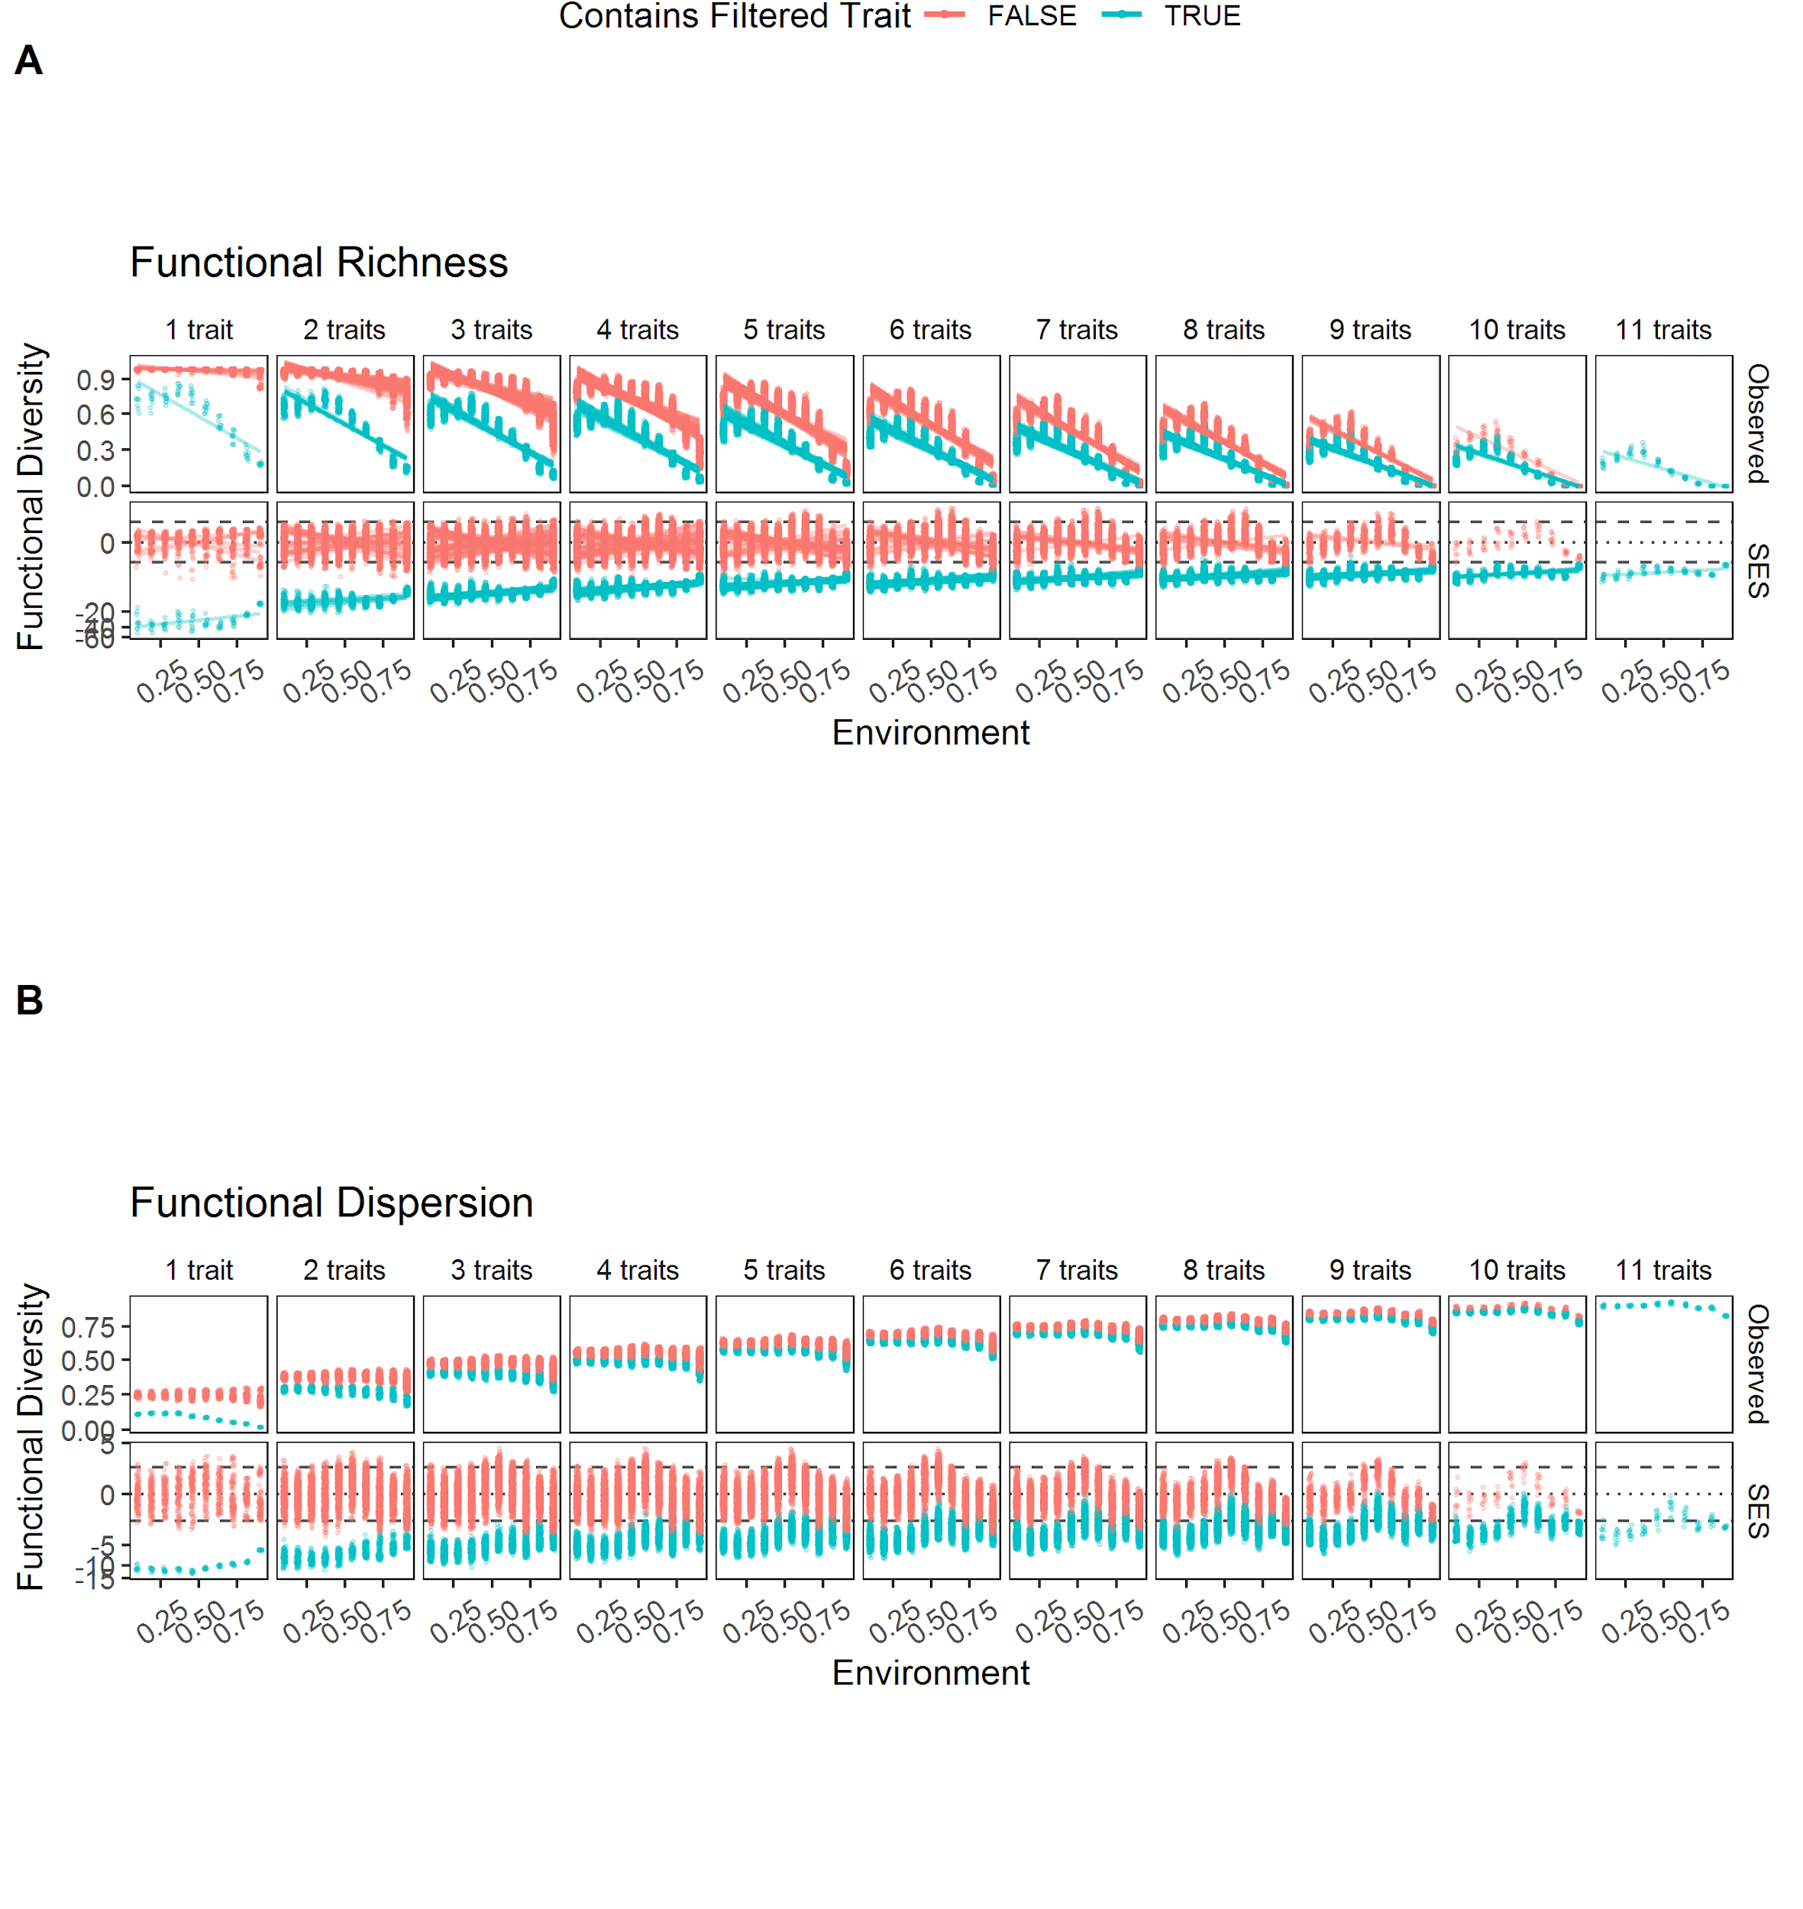

*Figure 1*

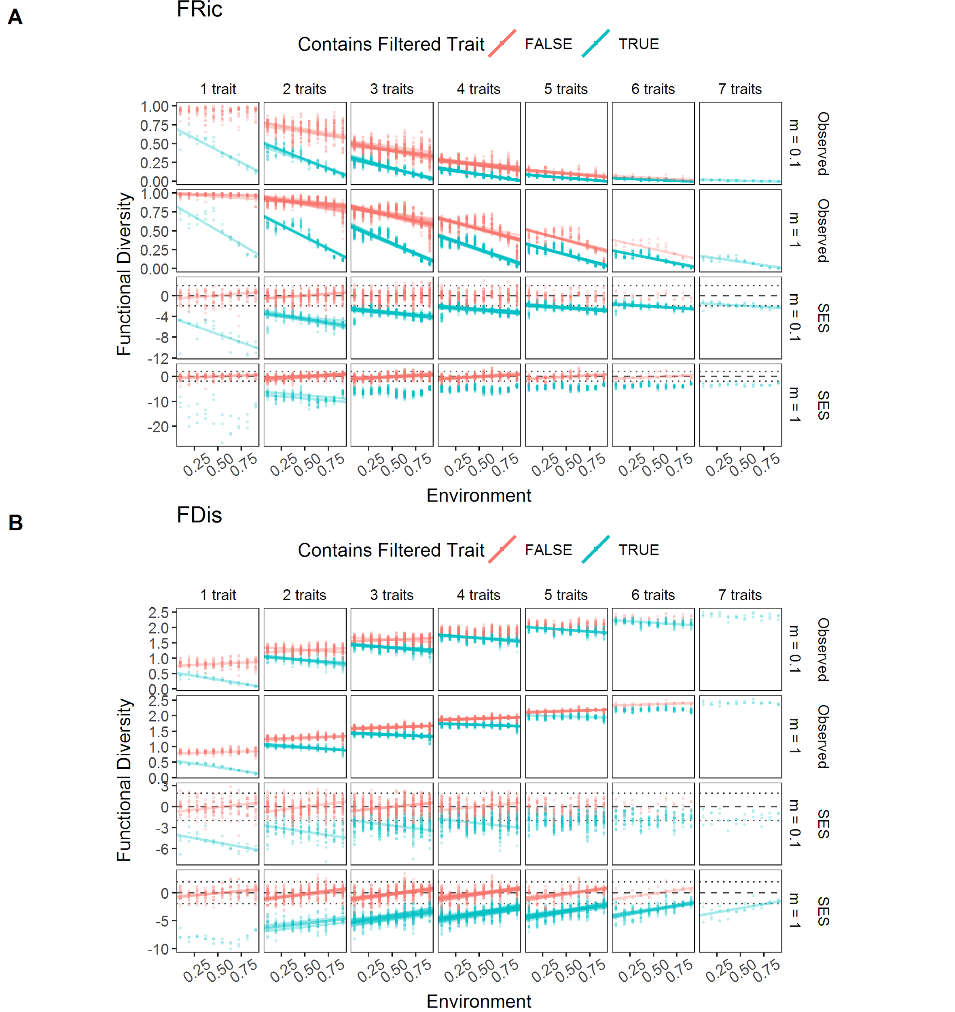

*Figure 2*

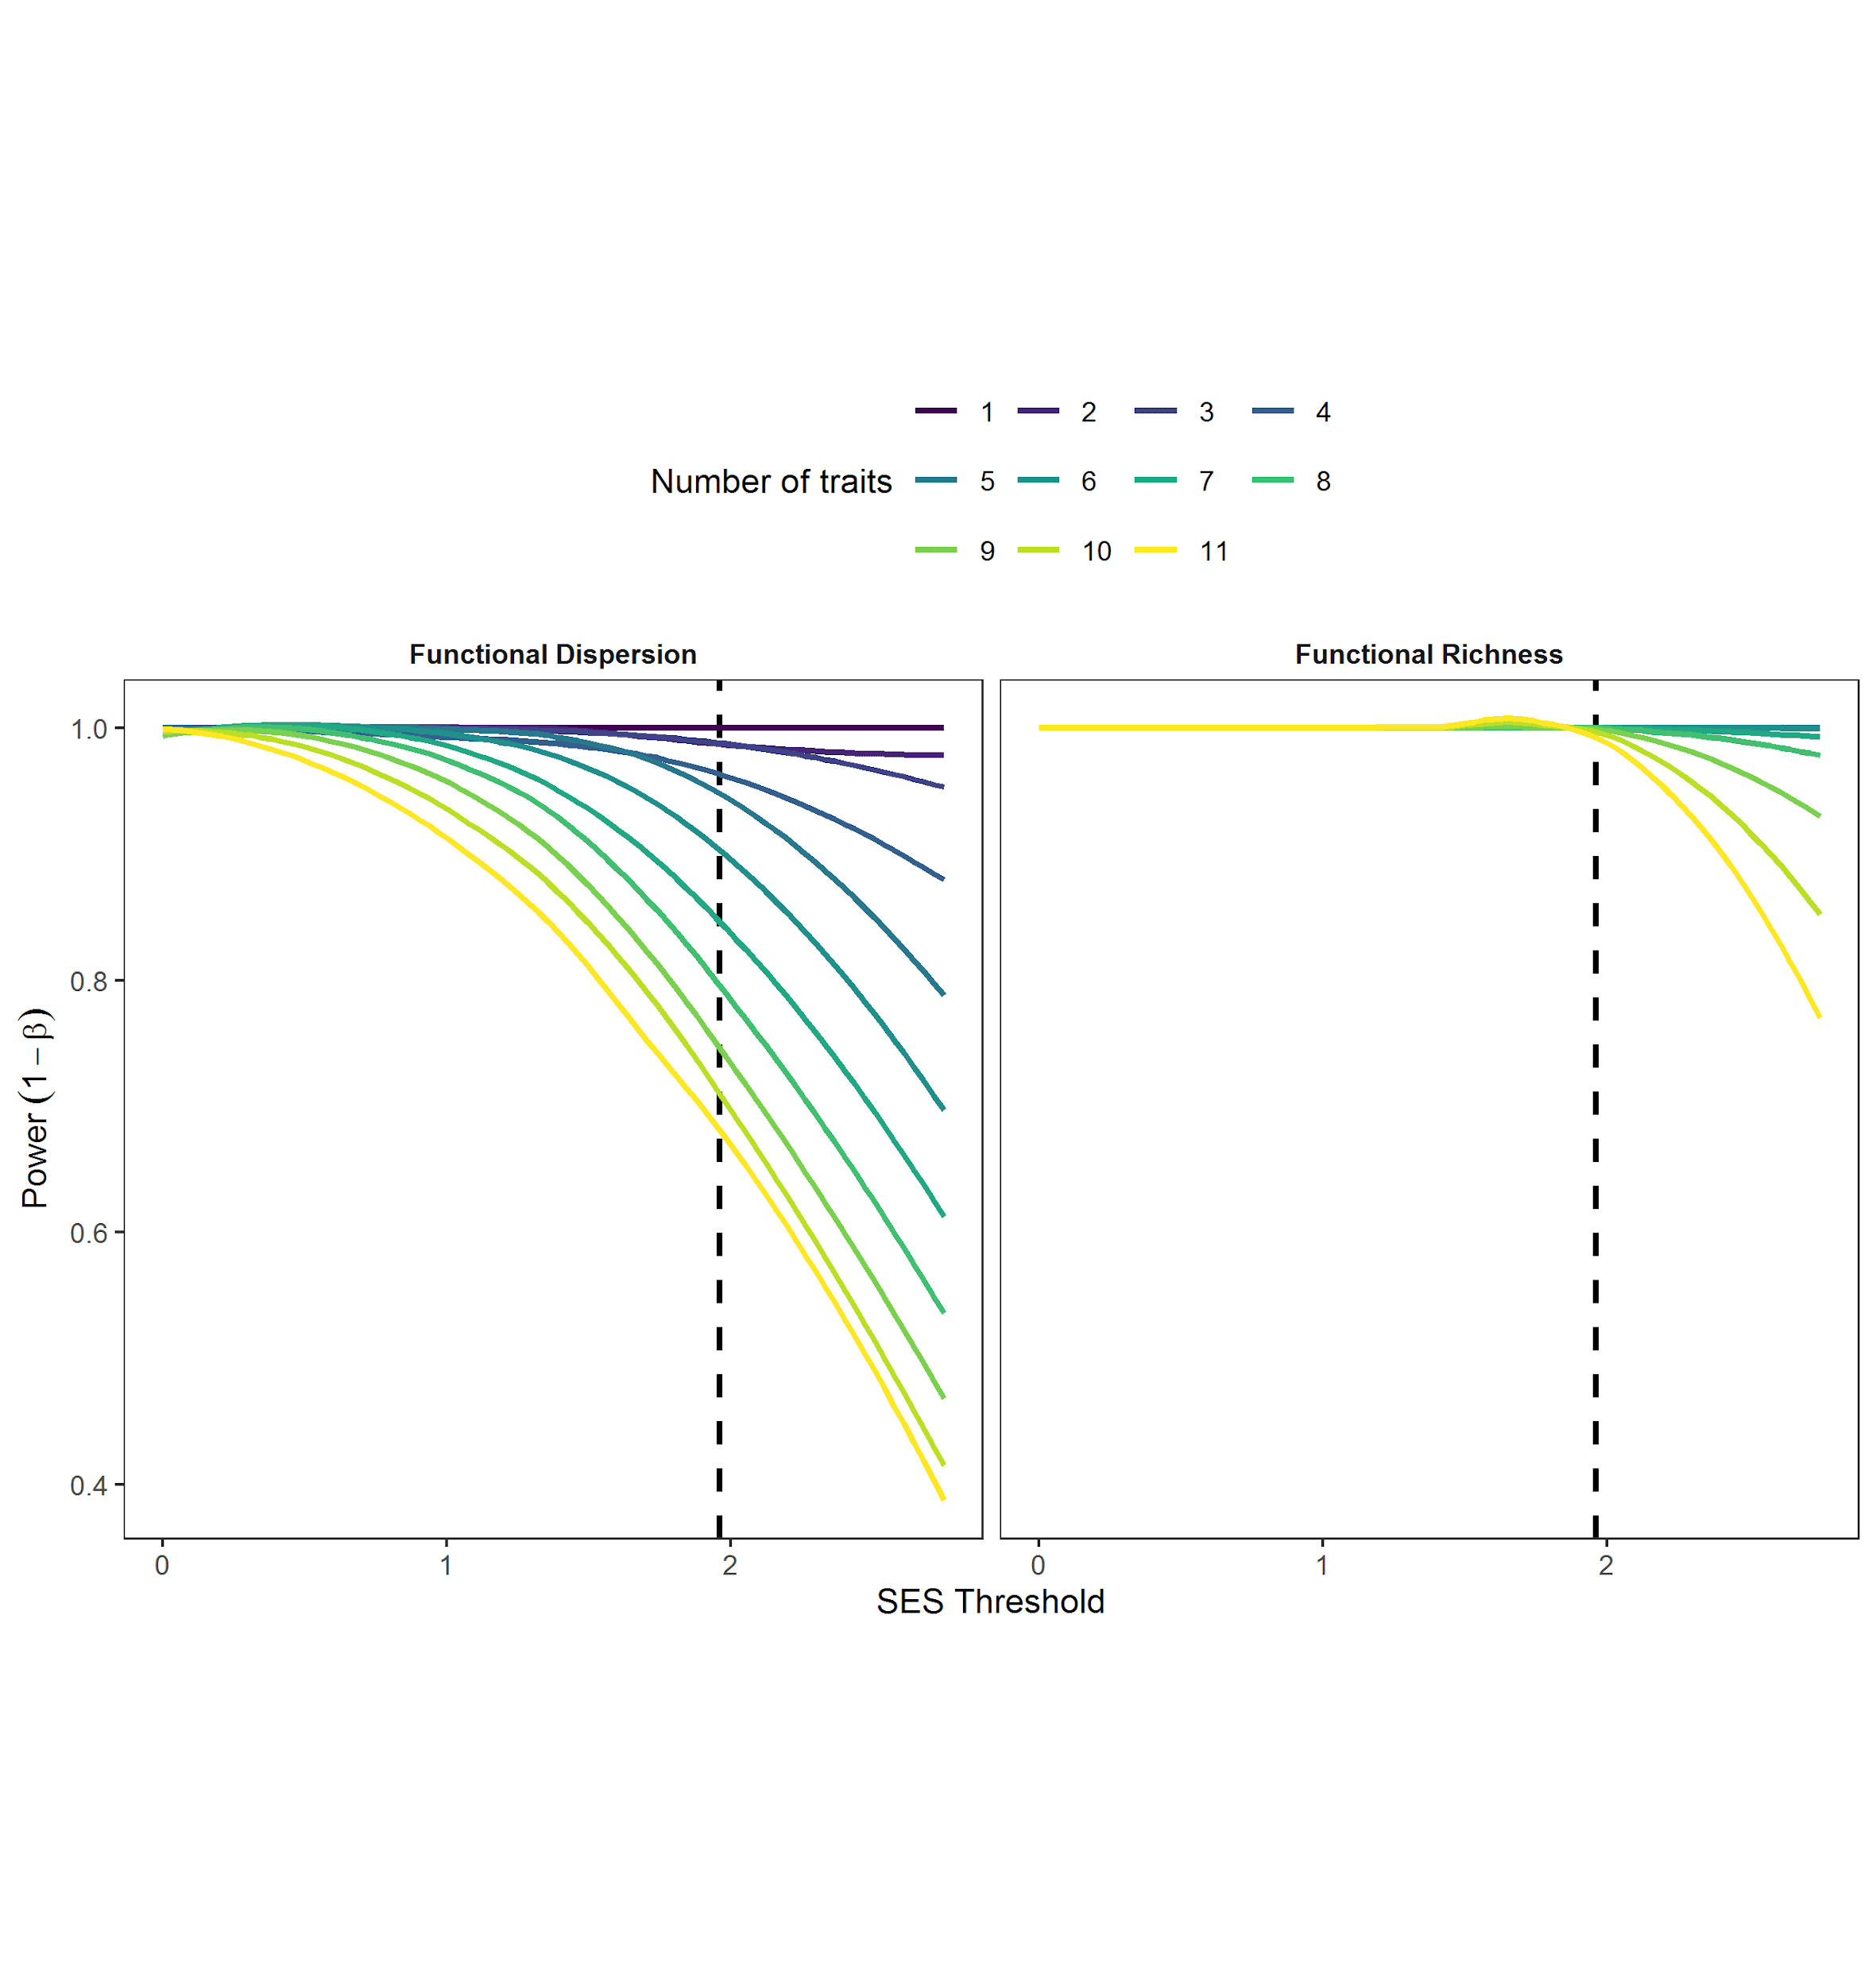

*Figure 3*

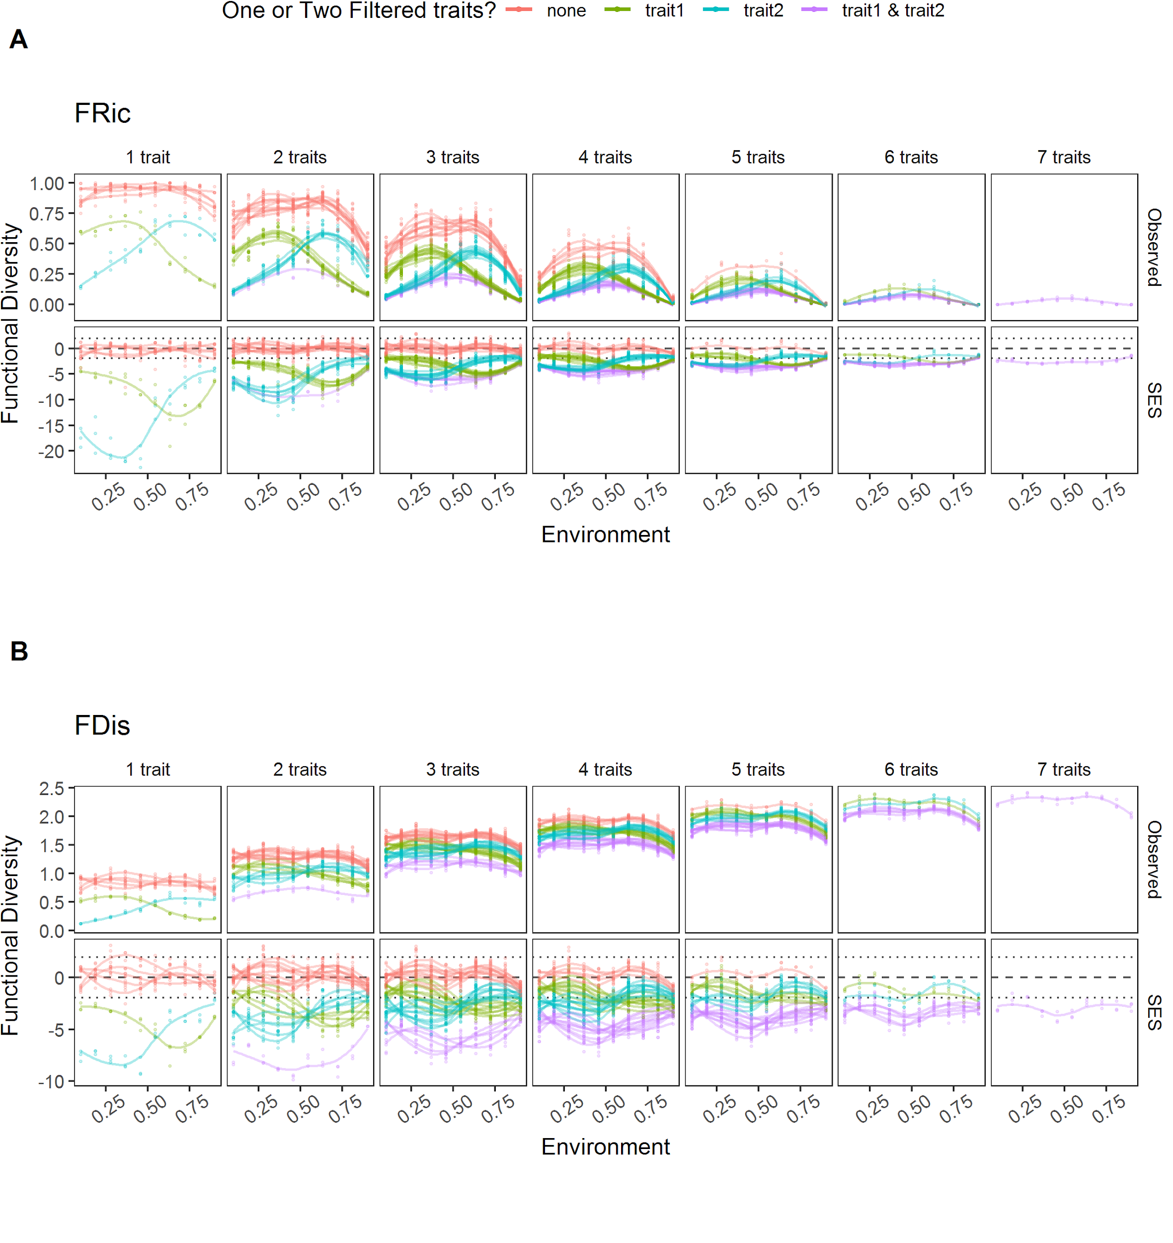

*Figure 4*