# **Supporting Information**

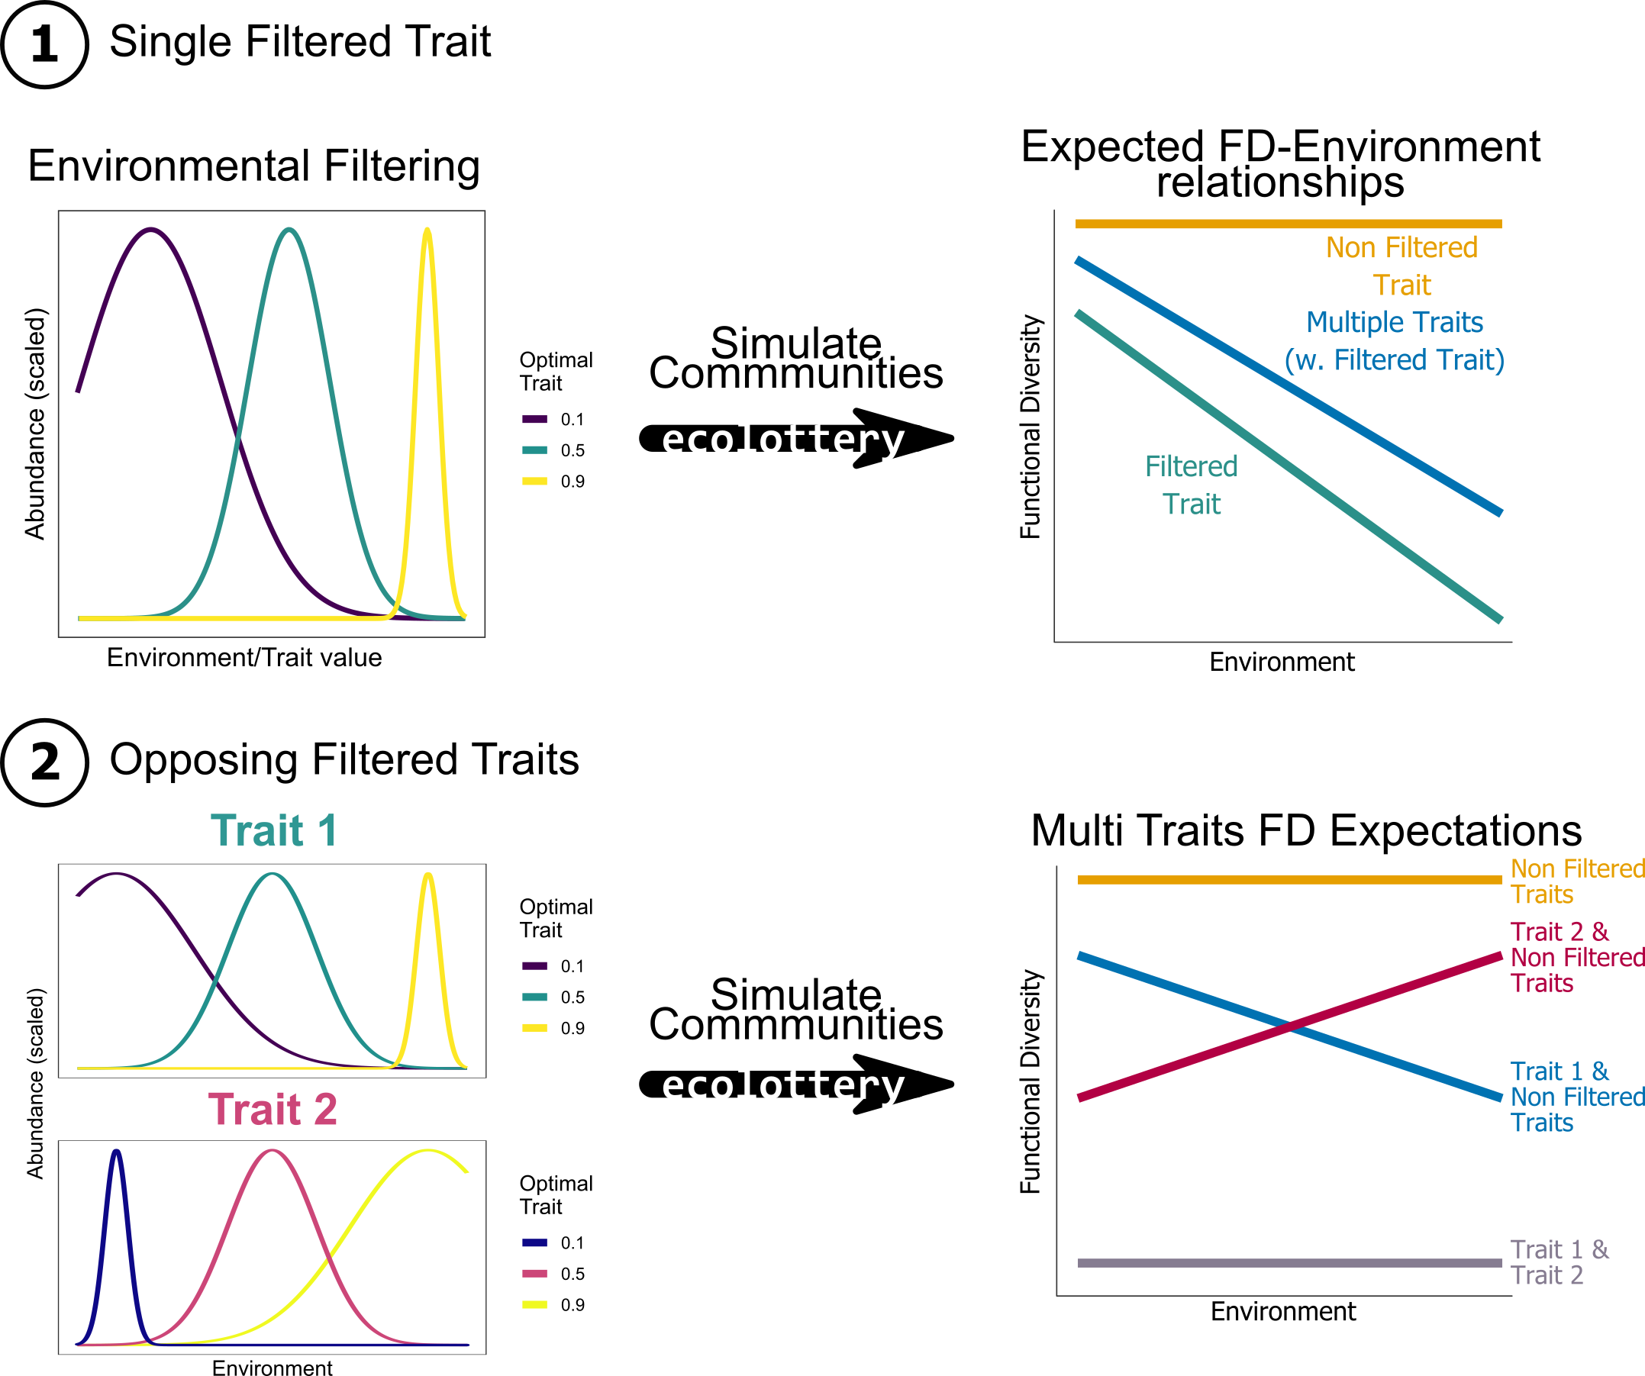

*Supplementary Figure S1*

**Supplementary Figure S1: Conceptual Figure showing the simulation process**. **(1)** We first define a Gaussian environmental filter for a single trait along a gradient that increases in mean regularly and decreases in variance. The environmental filter only applies to a single trait. With these filters and a uniform pool of species, we simulate communities along the environmental gradient using ecolottery (Munoz *et al.*, 2017). We then compute functional diversity indices for each community and all combinations of one to seven traits. We expect functional diversity to decrease along the gradient when computed using the filtered trait (green line) while it should be constant without (orange line); any combination of traits containing the filtered trait should also exhibit decreasing functional diversity along the environment (blue line). **(2)** For our second simulation setup we use the same environmental filters, with one in a similar direction on a first trait while the other one is in the opposite direction on a second trait. We do similarly by simulating communities then computing functional diversity indices with all possible combinations of traits. We expect opposing functional diversity-environment relationships when considering each filtered trait (blue and red lines), while there should be no trend in functional diversity when considering both traits at the same time (gray line). However we expect a lower functional diversity when considering both traits (gray line) than random combinations of non-filtered traits (orange line).

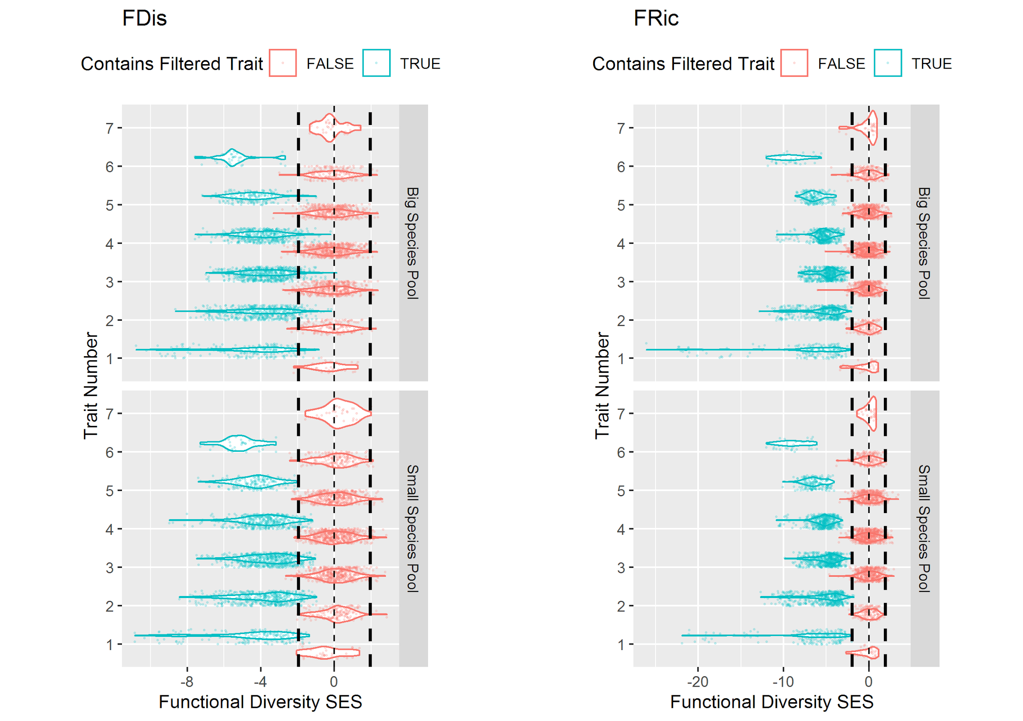

*Supplementary Figure S2:* ***Functional diversity SES distributions with varying pool sizes***

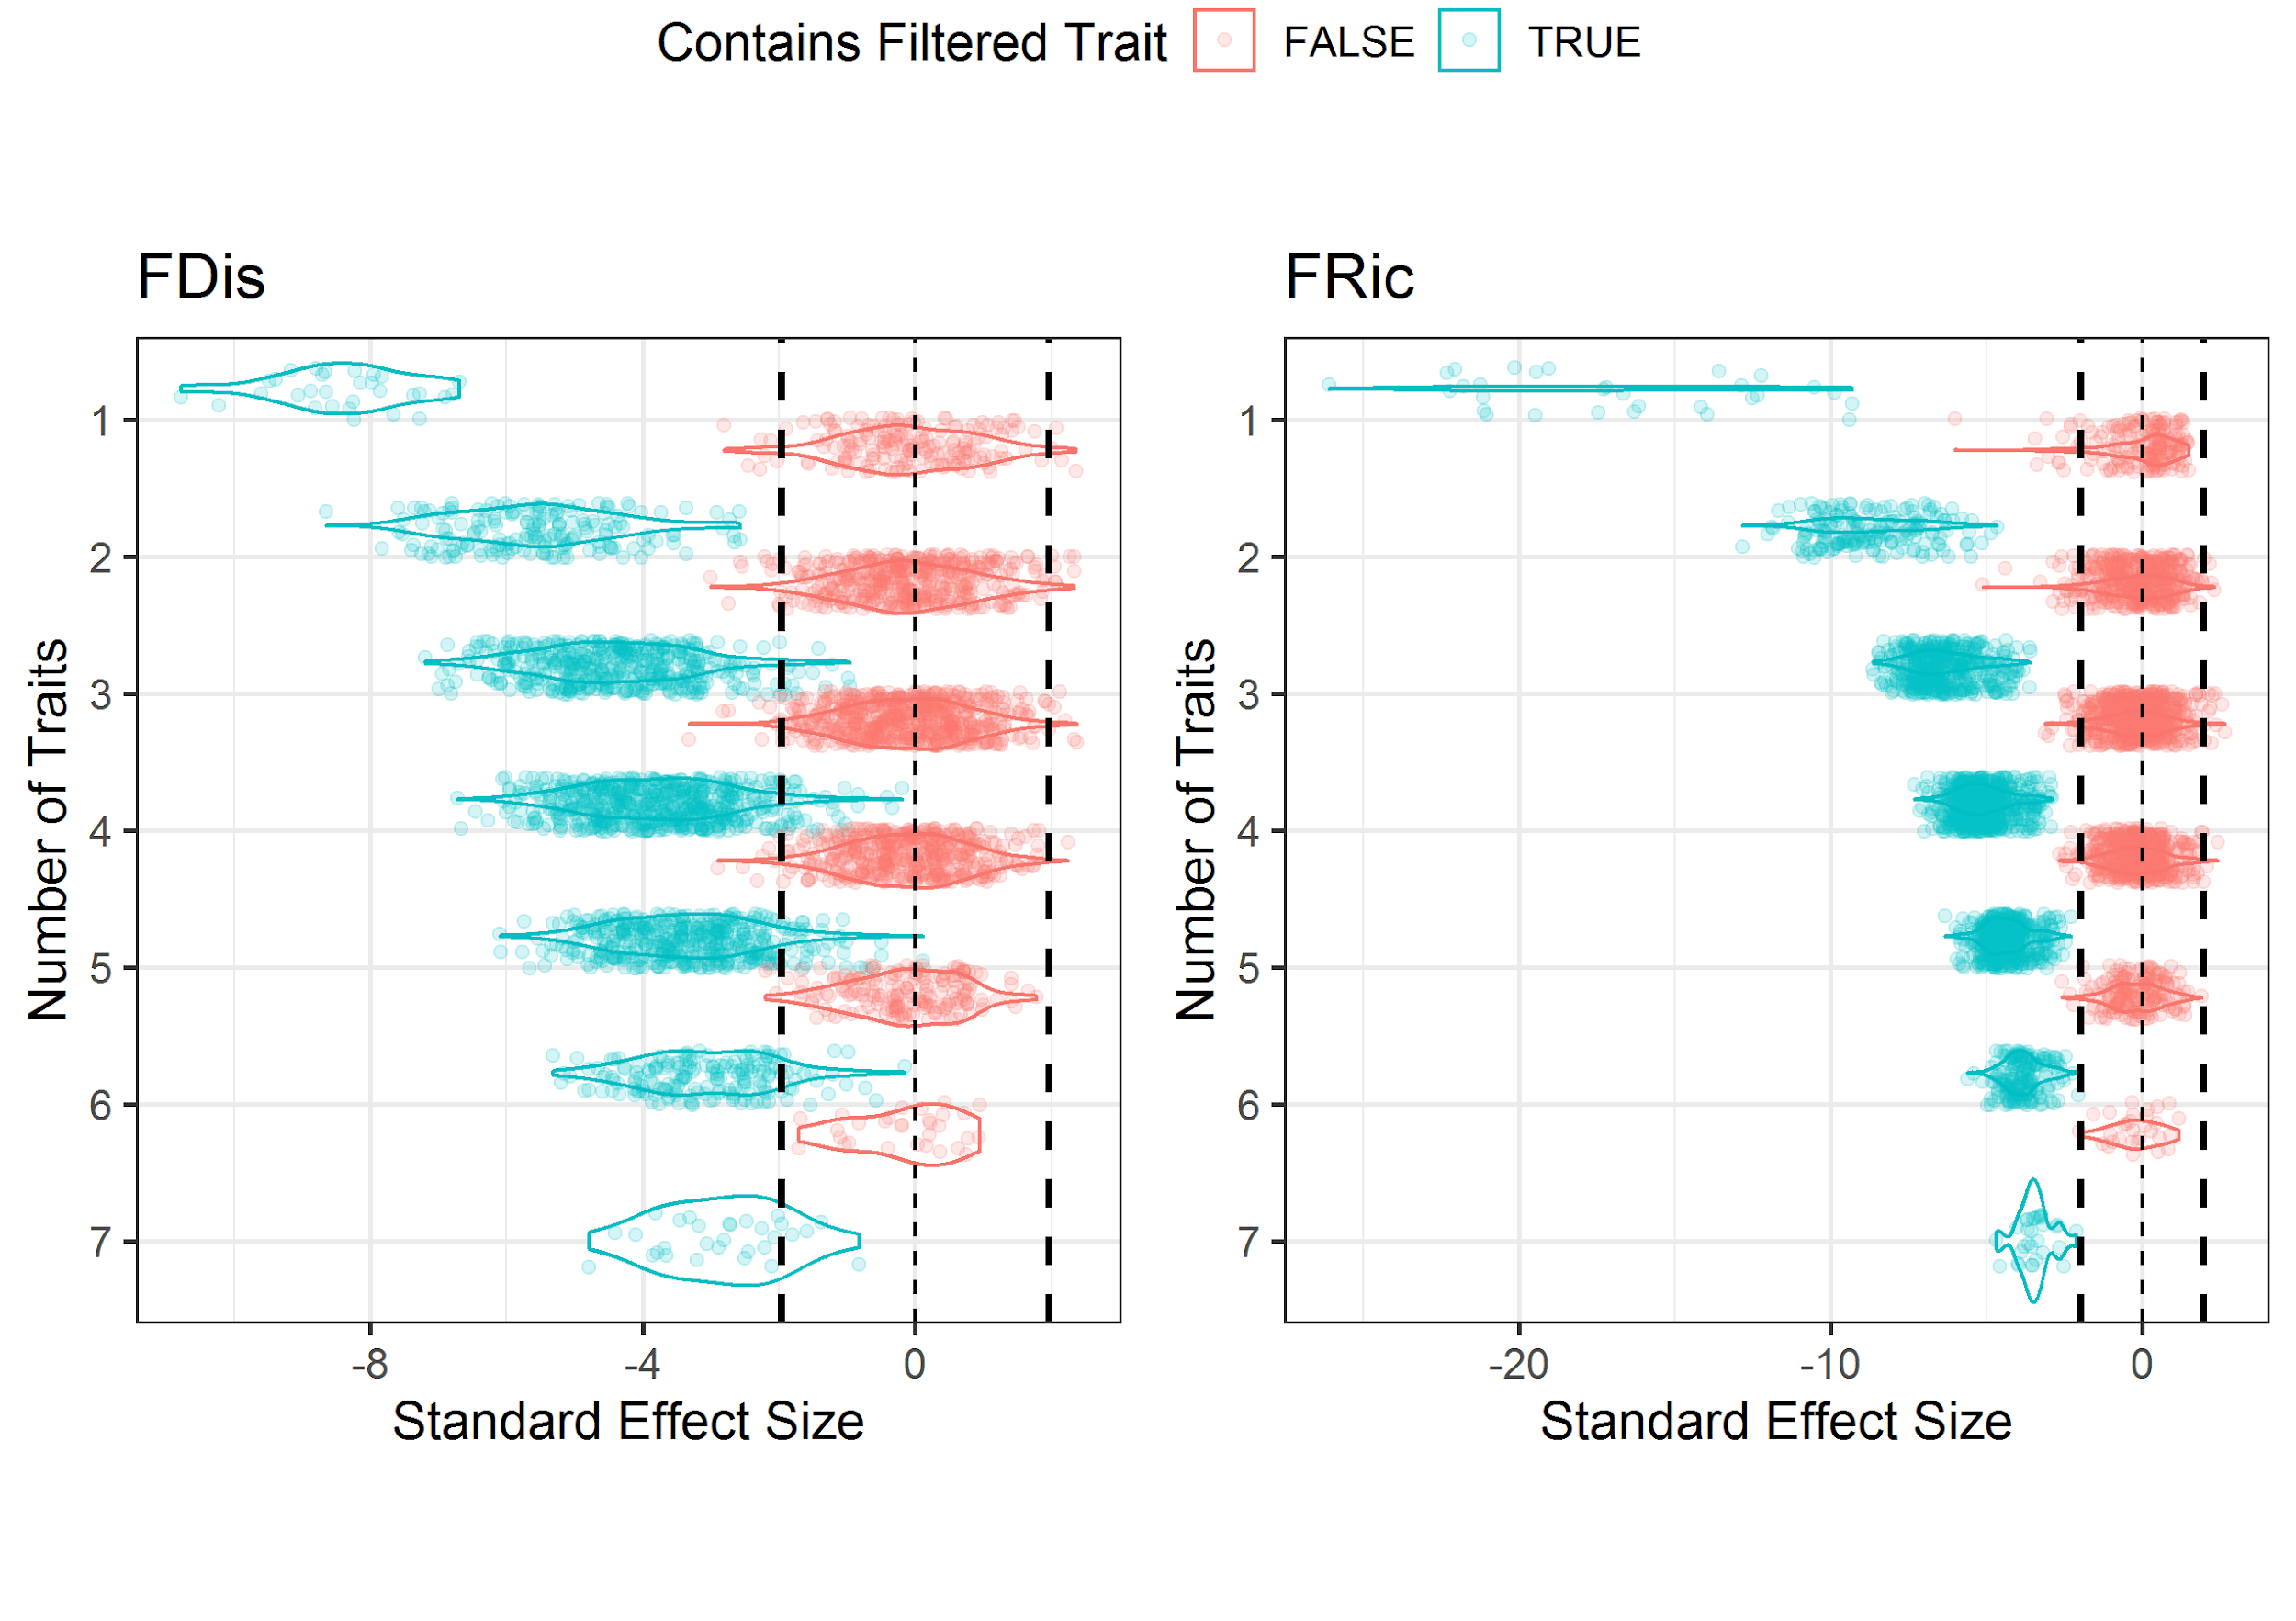

*Supplementary Figure S3:* ***Functional Diversity Standard Effect Size (SES) distribution in function of the number of traits for trait combinations that contained and did not contain the filtered trait.*** *(left) SES of Functional dispersion (right) SES of Functional Richness. The SES distribution corresponds to a standardized difference between null models and observed distribution. Vertical dashed lines show SES of 0 (thin dashed line) and -1.96 & 1.96 SES values (thick dashed lines) which is a classically used threshold value to define significant deviation from null models.*