

IT342-Section SYSTEMS INTEGRATION AND

ARCHITECTURE 1

FUNCTIONAL REQUIREMENTS SPECIFICATION (FRS)

Project Title: AccessHub
Prepared By: Reden Misael Relacion Date of Submission: 02/02/2026 Version: version 1.0

Table of Contents
- Introduction 3
  - Purpose 3
  - Scope 3
  - Definitions, Acronyms, and Abbreviations 3
- Overall Description 3
  - System Perspective 3
  - User Classes and Characteristics 4
  - Operating Environment 4
  - Assumptions and Dependencies 4
- System Features and Functional Requirements 4
  - Feature 1: 4
  - Feature 2: 5
- Non-Functional Requirements 5
- System Models (Diagrams) 6
  - ERD 6
  - Use Case Diagram 6
  - Activity Diagram 7
  - Class Diagram 8
  - Sequence Diagram 9
- Appendices 9

Introduction

Purpose
The purpose of this document is to define the functional and non-functional requirements for the "Mini App – User Registration & Authentication" system. This document serves as a blueprint for the implementation phase, detailing the system flow for user registration, secure login, and session management.

Scope
The system is a web-based application designed to demonstrate secure identity management. The boundaries of the system include:
    - User Registration: Allowing new users to create an account by providing personal details.
    - Authentication: Verifying user identity via email and password (Login).
    - Authorization: Granting access to the protected Dashboard only to logged-in users.
    - Session Management: Securely logging out and clearing user sessions.

Definitions, Acronyms, and Abbreviations

    - FRS: Functional Requirements Specification.

    - JWT (JSON Web Token): A standard method for securely transmitting information between parties as a JSON object, used here for maintaining user sessions.

    - BCrypt: A password-hashing algorithm used to encrypt passwords before storage.

    - API: Application Programming Interface.

Overall Description

System Perspective
This system operates as a standalone web application utilizing a Client-Server architecture.
    - Frontend: React.js application serving as the User Interface.
    - Backend: Spring Boot API handling business logic and security.

    - Database: Relational database (MySQL) for storing user credentials.

User Classes and Characteristics

    - Guest User: An unauthenticated user. They have limited access permissions and can only view the Login and Registration pages.

    - Authenticated User: A user who has successfully logged in. They have full access permissions to view the Dashboard and use the Logout function.

Operating Environment

    - Client Side: Modern Web Browser (Chrome, Edge, Firefox).

    - Server Side: Java Development Kit (JDK) 17+, Spring Boot Framework.

    - Database: MySQL.

    - Tools: Draw.io (Diagramming), Postman (API Testing).

Assumptions and Dependencies

    - It is assumed that the database server is running and accessible by the API.

    - The system depends on the Spring Security library for handling authentication protocols.

    - Passwords must be hashed before storage; plain text storage is prohibited.

System Features and Functional Requirements
Describe each major feature of the system and its functional requirements.

Feature 1:
User Registration Description: This feature allows a Guest User to create a new account by providing their personal details. The system validates the input and stores the password securely.
Functional Requirements:

    - REQ-1.1: The system shall accept First Name, Last Name, Email, and Password as input.
    - REQ-1.2: The system shall verify that the email address is not already registered in the database.
    - REQ-1.3: The system must encrypt the user's password using BCrypt before saving it.
    - REQ-1.4: Upon successful registration, the system shall redirect the user to the Login page.

Feature 2:
Authentication & Session Management Description: This feature handles the secure login process, dashboard access, and logout capabilities.
Functional Requirements:
    - REQ-2.1: The system shall validate the entered email and password against the database records.
    - REQ-2.2: If credentials are valid, the system shall generate a session token (JWT) and grant access.
    - REQ-2.3: The system shall restrict access to the "Dashboard" page; if a user is not logged in, they are redirected to Login.
    - REQ-2.4: The system shall provide a "Logout" button that clears the stored session/token and redirects the user to the Login page.

Non-Functional Requirements

- Security: User passwords must never be stored in plain text. API endpoints for the dashboard must be protected by an authentication filter.

- Performance: Login and Registration transactions should complete within 2 seconds.

- Usability: The UI must be intuitive, clearly distinguishing between the "Register" and "Login" forms. Error messages (e.g., "Invalid Credentials") must be displayed clearly.

- Reliability: The system should handle database connection errors gracefully without crashing.

System Models (Diagrams)

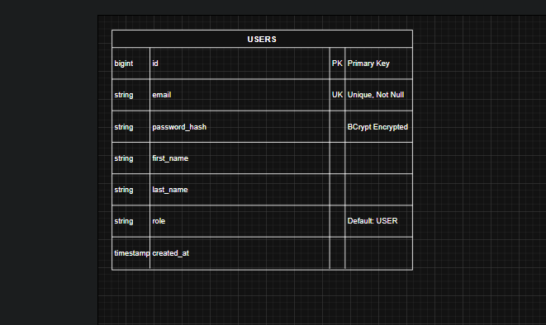
ERD

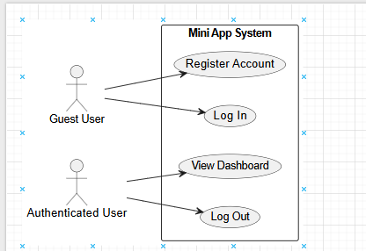
Use Case Diagram

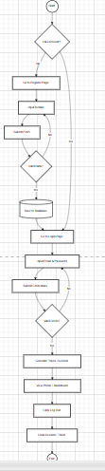
Activity Diagram

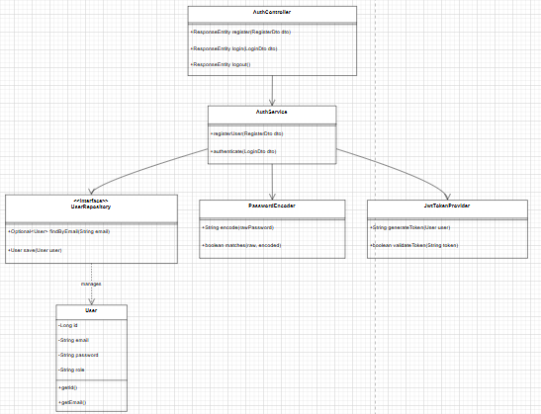
Class Diagram

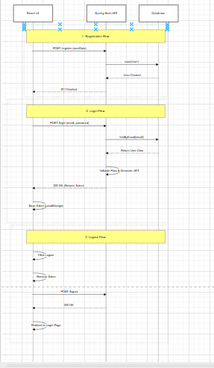
Sequence Diagram

Appendices

- Appendix A: Laboratory Instruction Sheet (Mini App – User Registration & Authentication).

- Appendix B: Spring Security Documentation Reference

.

Dashboard

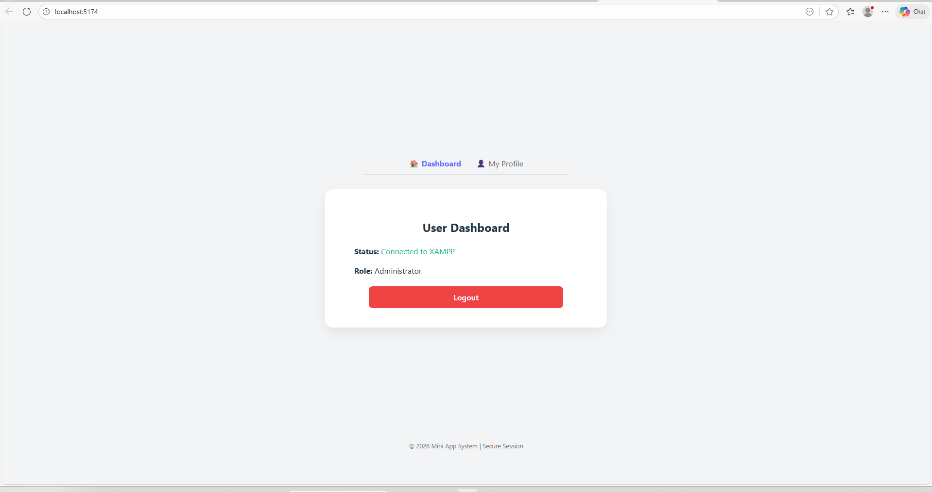

Log in page

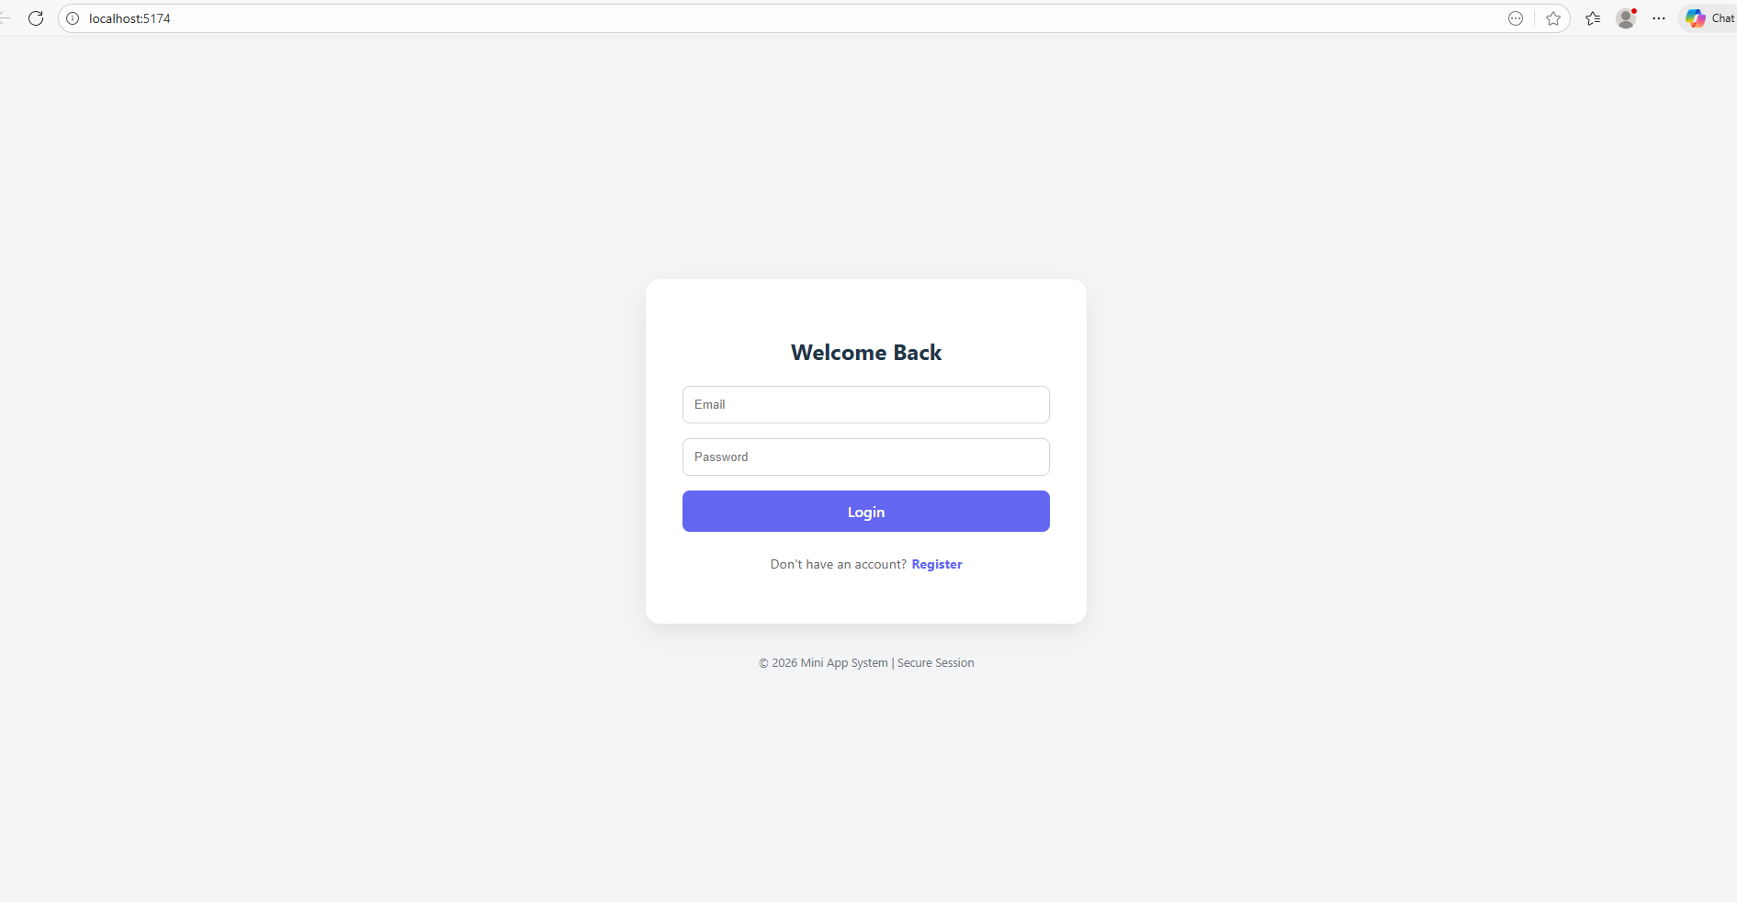

Registration

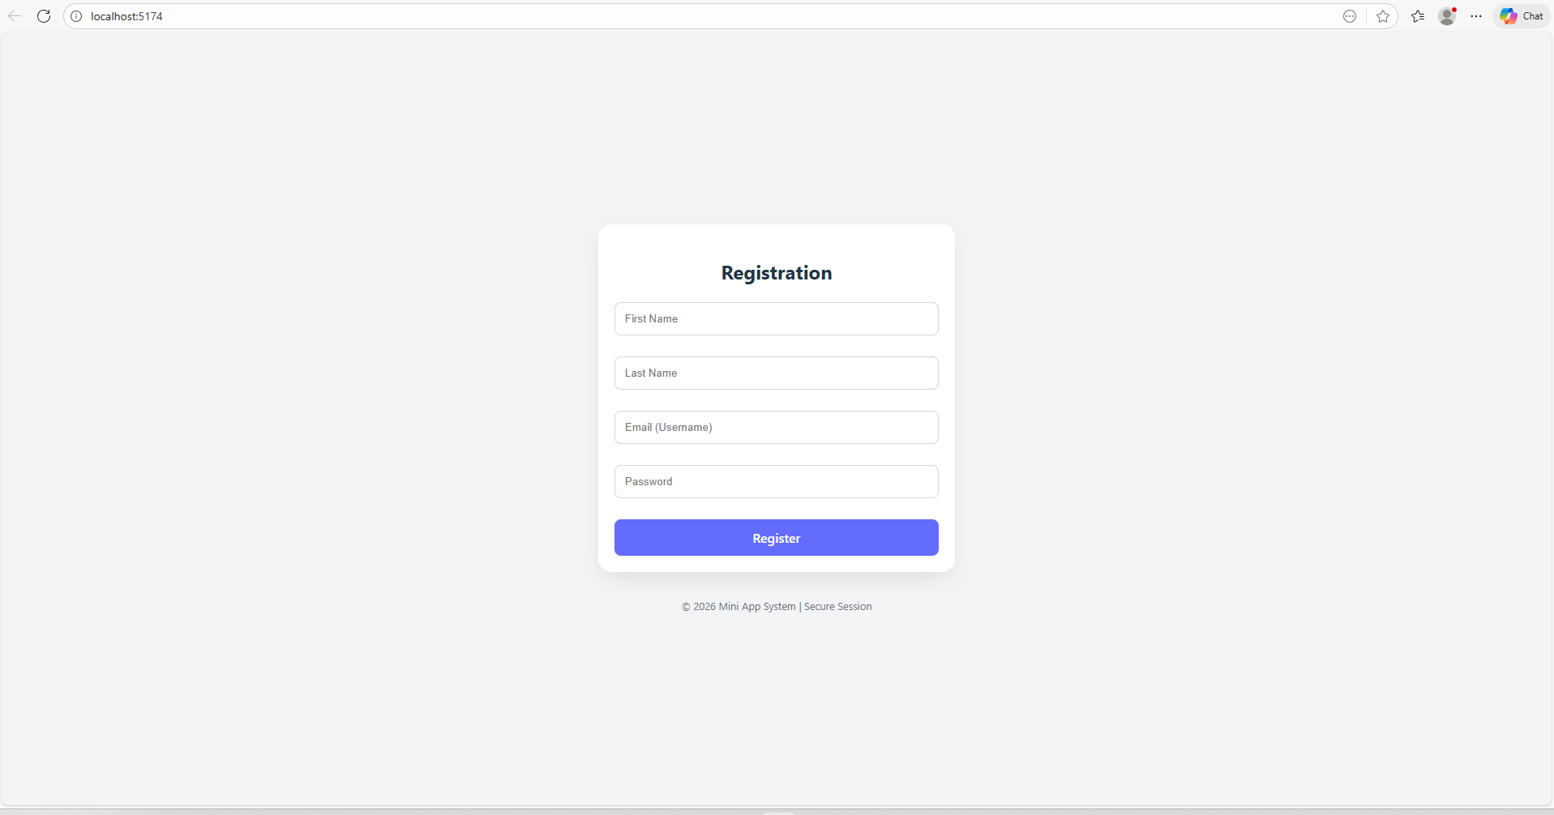

My Profile

