



Software Engineering Project – First Semester 2025
Dr.Eman Almadhoun
Section: IBR

Relam AlOrri

Table of Contents
- Project Description & Definition 4
  - Introduction: 4
  - Project Description: 4
  - Problem Objectives: 5
  - Project goals: 5
  - Project Organization: 5
    - SMART project goals & scope: 6
  - Features: 7
    - Included Features 7
1.6.2 8
  - Comparable software: 9
    - Similar Apps: 9
    - Feature by Feature: 10
- Business Requirements Specifications 11
  - Domain Analysis: Systems Stakeholder, Actor, Participants 11
  - Techniques for Gathering Data 12
  - Requirements 13
    - Functional Requirements (FRs) 13
    - Non Functional Requirements 14
  - Use Case Model 15
  - Use Case Discraption 17
  - Difficulties and Risk Analysis 21
    - Difficulties 21
    - Risk Analysis 22
    - Summary 23

List of Figures
Figure 1Analyzing Neighborhood Data 15
Figure 2 Search for Commercial Rental Spaces 16
Figure 3 Generating Service Gap Report 16
Figure 4 Send Business Recommendation Notification 17
Figure 5 Maqsad UML Design Structure 22
Figure 6 Percentage of participants who faced difficulty choosing a business location 25
Figure 7 Main reasons behind the difficulty in selecting a business location 26
Figure 8 Common tools used by participants to search for business locations 27
Figure 9 Participants’ opinion about the usefulness of Maqsad 28
Figure 10 Percentage of participants who believe their area lacks certain business types 29 Figure 11 Services that participants believe are missing in their neighborhoods 30
Figure 12 Participants’ likelihood to use Maqsad in the future 31
Figure13 Participants’ open-ended suggestions to improve Maqsad’s features and usability 32

List of Tables
Table 1: Analyzing Neighborhood Data 18
Table 2: Searching for Commercial Rental Spaces 19
Table 3: Generating Service Gap Report 20
Table 4: Sending Business Recommendation Notification 21
Table 5: Risk Analysis 24

Project Description & Definition

Introduction:
The success or failure of commercial projects depends heavily on choosing the right location. In many cities, services are not distributed equally between neighborhoods. In certain neighborhoods, the same type of businesses is repeated, for example several cafés or restaurants close to one another, while in other neighborhoods essential services such as pharmacies, nurseries, grocery stores, and women’s fitness centers are missing. As a result, investors may face financial losses when opening projects in saturated areas, while residents experience a lower quality of life when they do not have access to the services they need.

Such problems point to the importance of having a system that guides investors toward better choices. By identifying service shortages and highlighting real opportunities, such a system can reduce unnecessary competition, support balanced business growth, and improve how services are spread across neighborhoods. The project also supports the objectives of Saudi Vision 2030, which focus on improving quality of life, supporting private investment, and promoting sustainable urban development. This project aims to deliver a software-based solution that analyzes neighborhood needs and provides data-driven recommendations to help investors make informed decisions.

Project Description:
Current real estate platforms mainly show available rental properties but do not explain whether these locations match the actual needs of the community. This gap often results in repeated services in some places and missing services in others. The proposed system, Maqsad, is designed to close this gap by studying neighborhoods, finding where services are missing, and using input from residents to make sure that investment decisions reflect real community needs. Maqsad will combine location data and community feedback into an interactive platform, offering investors clear insights for decision-making. The goal of the system is to make services more balanced, lower the risk of failed projects, and create better chances for steady growth in the future.

Problem Objectives:
The primary goal of Maqsad is to reduce the number of problems entrepreneurs face when selecting optimal business locations using data-driven insights, this involves:
- Analyzing commercial activity and identifying service gaps within neighborhoods to avoid market saturation and reduce the risk of business failure.
- Providing new firms with improved decision-making information through real-time data on available rentals and the types of services that are in short supply in specific locations.
- Minimizing entrepreneurship risks by transforming location selection into a structured process guided by detailed data analysis.

Project goals:
Maqsad aims to revolutionize the real estate industry for business owners using advanced AI technology that supports data-driven business decisions. The app will allow users to be updated with personalized alerts for rental leads, service gap analysis, and forecasts of upcoming commercial needs. With a user-friendly dashboard containing interactive maps and graphics, Maqsad enhances the overall user experience, which helps entrepreneurs identify high-potential spots without having to face high risks. Finally, the project is expected to establish a good-balanced commercial climate by encouraging several business opportunities and hence increasing economic growth and sustainability in cities.

Project Organization:
The work has been equally divided among the group members, ensuring that each student fully understands the concept of this project while applying the course’s principles to strengthen our knowledge. The division of tasks for this phase is shown below and will be regularly updated in future phases. This organization ensures teamwork, equal contribution, and clarity of responsibilities throughout the project.

SMART project goals & scope:
The Maqsad project is a real estate support system designed to help small business owners and entrepreneurs choose suitable locations. These goals define the key outcomes that Maqsad aims to achieve, ensuring the project stays focused and practical.

Project Goals (SMART):
        - Specific: The system focuses only on commercial rental properties, providing detailed property information and map locations, while excluding residential properties or sales transactions.
        - Measurable: The system includes core features such as rental listings, personalized alerts, service gap analysis, resident surveys, and a shared rental option. Success can be measured by the system’s ability to display property data accurately and send alerts effectively.
        - Achievable: All main features can be built using available technologies such as databases and interactive maps, without requiring complex tools or resources.
        - Relevant: The features address the problem of repeated or missing services in neighborhoods, supporting small investors in making better location decisions.
        - Time-bound: A functional first version of the system will be ready by the end of the current semester.

Project Scope:
The scope of this project is to develop Maqsad as a real estate support system that provides rental property listings with detailed information and map access, sends personalized alerts about new opportunities, and analyzes neighborhoods to identify service gaps such as the lack of pharmacies, supermarkets, nurseries, or women’s fitness centers. It will also include surveys for residents to record which services are missing in their area and provide simple forecasts about future growth needs. Additionally, the system offers a shared rental option that allows users to rent only part of a property, such as a booth or corner, making it easier for small businesses to enter the market.
The project will not include advanced AI models for sales forecasting, complex GIS tools that require technical expertise, contractor or renovation services, or tools designed for large retail chains. By focusing on these specific functions, Maqsad remains aligned with its main goal of helping entrepreneurs make better decisions while keeping the system simple and practical to use.

Features:
Maqsad offers a set of features tailored to support small business investors while keeping the system simple and practical. The following outlines the included and excluded features:

Included Features

Rental Availability
Displays are available at shops and rental spaces with detailed information and direct access to location data.

Personalized Alerts
Sends notifications when new rental spaces match the investor’s business type and preferred area.

Service Gap Analysis
Identifies missing services such as pharmacies, supermarkets, nurseries, and plumbing shops to highlight real opportunities.

Contact Agent Button
Provides quick communication with property agents to simplify rental negotiations.

User-friendly Dashboard
Offers charts and key performance indicators to support data-driven decision-making.

Future Growth Forecasting
Predicts commercial needs by analyzing demographic and city expansion data (e.g., “This district will need a new supermarket within three years”).

Push Notifications
Updates users on new listings or price changes for saved properties.

Resident Surveys
Engage residents through structured surveys to indicate which services are missing in their neighborhoods, ensuring decisions reflect community needs.

Shared Rental Option
Introduces the ability for multiple small businesses to share the same rental space, reducing entry costs and encouraging entrepreneurship.

Excluded features

Residential property listings
The application is limited to commercial rentals and excludes apartments, villas, or other housing units.

Property sales and ownership transactions
Buying, mortgages, or transfer of ownership are not supported.

Comprehensive financial modelling
Advanced ROI calculations, tax estimators, and loan simulators are excluded beyond basic KPIs.

Property management functions
Features such as rent collection, lease management, and maintenance requests are outside the project scope.

Immersive visualization tools
Virtual tours, AR-based design previews, or 3D walkthroughs are not included.

Legal and regulatory integration
Business license applications, government permit processing, and contract drafting are excluded.

Cross-border coverage
The system is intended for local or regional markets only; international property searches are not supported.

Comparable software:
The following software solutions provide some similar functionality to Maqsad, but none fully address the needs of small business investors in a comprehensive way.

Similar Apps:

Placer.ai (Void Analysis)
Capabilities: Identifies gaps in retail services and supports landlords in determining which tenants are missing in a trade area.
Limitations: Designed primarily for landlords, developers, and enterprise clients. Does not integrate live rental listings or provide recommendations targeted at small business entrepreneurs.

SiteZeus
Capabilities: AI-driven sales forecasting and location planning for large retail chains. Limitations: Focuses on multi-unit brands rather than small businesses. Does not include service-gap analysis, shared rental options, or direct agent communication.

Esri ArcGIS Business Analyst
Capabilities: Provides geographic information system (GIS) tools, including retail gap and surplus studies, demographic insights, and trade area analysis.
Limitations: Requires technical expertise and is oriented toward government and enterprise users rather than individual entrepreneurs.

Regional Portals (e.g., Bayut, Property Finder, Wasalt, Aqarmap)
Capabilities: Offer commercial property rental listings, saved searches, push notifications, and direct agent contact.
Limitations: Function as property marketplaces only. They do not analyze service gaps, forecast neighborhood needs, or evaluate business saturation.

Feature by Feature:
Maqsad differs from other platforms in the following ways:
Service Gap Analysis: Can identify underserved business types for a region (e.g., a lack of supermarkets or pharmacies). Other platforms analyze property availability or general demographic analysis, but do not usually provide actionable business-type recommendations.
Interactive Smart Map: Utilizes easy-to-use visual indicators (green = high potential, yellow = medium, red = saturated) to enable entrepreneurs to quickly assess opportunities. Even though GIS programs create detailed layers, they are not easy to use.
Future Growth Projection: Projects future commercial demand by merging demographic and city expansion data. It is rare for sites to provide such future estimates at the neighborhood level.
Shared Rental Option: Introduces a new capability that allows multiple small businesses to operate from a single store space, reducing entry barriers. This is not a feature available in mass market solutions today.
Entrepreneur-Centric Design: Unlike enterprise software designed for landlords, municipalities, or large brands, Maqsad is created for solo entrepreneurs and small business owners.

Business Requirements Specifications

Domain Analysis: Systems Stakeholder, Actor, Participants
All parties involved in this project are considered stakeholders, including entrepreneurs, residents, property agents, city planners, and the system itself.

Entrepreneurs & Small Business Owners
They benefit from the system by identifying the best locations to open new businesses or expand existing ones. In addition to identifying service gaps (such as a lack of pharmacies or gyms), the platform assists users in avoiding places that are too crowded and competitive. This lowers the chance of unsuccessful investments. Smarter decision-making is further supported by data-driven forecasts and personalized warnings.

Residents
By using surveys to identify the services that are lacking in their communities, locals play a crucial role. Their input guarantees that suggestions represent actual community needs, enhancing living standards and encouraging service distribution throughout the city. Additionally, their contributions aid investors and entrepreneurs in comprehending the possible size of target client groups and the levels of demand.

Property Agents & Landlords
Agents and landlords use the system to advertise available commercial rental spaces. The platform improves the exposure of their postings, speeds up communication, and puts them in direct contact with possible tenants. Both businesses and property owners benefit from this mutually beneficial arrangement.

City Planners & Local Authorities
The system's service gap analysis and forecasts are useful to local authorities and city planners, even though they are not its main customers. They can better plan infrastructure and comprehend urban development trends thanks to this data, which supports the objectives of Saudi Vision 2030.

The System (Maqsad Platform)
The system itself serves as the focal point for bringing all parties together. To give service gap insights, future growth forecasts, and interactive dashboards, it gathers data from rental listings and resident surveys. All users can make well-informed decisions with the help of these tools.

Techniques for Gathering Data
To learn more about the real problems people face when choosing business locations, the team prepared an online survey for both entrepreneurs and residents. It was designed to find out what makes it difficult for them to select the right place and to understand what they expect from Maqsad and the kind of features they would like to see in it. This method helped the team collect honest opinions from people who might use the system and use their feedback to shape the design and main requirements.
The survey showed that about 80% of participants had trouble finding the right location for their businesses (Figure 6). The most common reasons were too many similar projects (60%) and high rental prices (53.3%) (Figure 7), while 26.7% mentioned lack of accurate information about different areas or unclear community needs. These answers showed that many people still rely on simple and personal ways when picking business locations. It became clear that they need something easier that can guide them with real information instead of random guessing.
Most participants mentioned that they often use Google Maps (46.7%), friends’ suggestions (40%), or real estate websites (20%) when looking for business locations (Figure 8). From what people said, it was clear that they prefer having one simple platform instead of searching through many different apps or websites.
When they were asked which features would help the most, about half of them chose the interactive map (46.7%) and the service-gap analysis (46.7%), while 33.3% liked getting automatic alerts when new rental options appear. About 73.3% of the people in the survey said that the idea behind Maqsad could really help business owners choose better locations (Figure 9), and nearly half of them also mentioned that they would like to try the app once it becomes available (Figure 12).
A few participants added extra notes, saying it would be useful if Maqsad included small but important local details like how busy the area usually is, whether there’s enough parking, and roughly how many people live nearby (Figure 10). They believed that these details would make the results easier to understand and more realistic for everyday use.
The team used this feedback to improve the project plan and adjust the design so that Maqsad better matches what users really need (Figure 13).

Requirements

Functional Requirements
- The system shall provide a secure way for users to sign up and log in using their mobile number or email, so that only verified accounts can reach the platform’s features. By using OTP, the system validates the log-in request upon the user.
- The system shall let users search within a city, district, or neighborhood to explore business opportunities and view key data, including population, existing services, and service availability.
- The system shall display the analysis results on an interactive map with color indicators - green for high potential, orange for medium, and red for low potential, and shall allow users to click on an area to view summary information.
- The system shall generate a comprehensive service gap report that identifies existing business types, missing services, and the population-to-service ratio within the selected area.
- The system shall provide at least three ranked business recommendations for each area, based on population data, available services, detected market gaps, and residents’ demand.
- The system shall allow users to save and label preferred areas, making it easier to identify and compare them later during decision-making.
- The system shall send automatic notifications when new business opportunities or uncovered service categories are detected, including basic details such as location, size, and estimated demand level.
- The system shall allow residents to fill online surveys highlighting services their neighborhood lacks, ensuring community feedback is considered in the analysis.
- The system shall integrate with trusted map services (such as Google Maps) to display accurate property and area locations.
- The system shall allow property owners to register and upload their rental listings, thus keeping the platform updated with newer opportunities for users.
- The system shall include a “Contact Agent” feature that allows users to directly communicate with property agents for inquiries, clarifications, or negotiations regarding available spaces.
- The system shall support shared rental options, allowing multiple small businesses to co-rent a single commercial property to reduce costs and improve utilization

Non-Functional Requirements
- The interface should be straightforward and simple to use so that users can search and read results without difficulty.
- The system must load maps and analysis findings in under 5 seconds.
- User data and location searches must be protected from unauthorized access.
- The system should be available around the clock, with minimal downtime.
- The platform should have the ability to add new cities, services, and users in the future.
- The system must include both Arabic and English interfaces.
- The system should run smoothly with no problems or crashes.
- Developers should be able to easily upgrade and fix the system as needed.
- To be credible, the results must be based on accurate and timely data.
- The system should be able to manage many users simultaneously without slowing down.

Use Case Model

Analyze Neighborhood Data
Suggest Nearby Areas
Register I Login
etrieve Demographic & 1-------..! Analyze Neighborhood ----��i��_u_d_e_�_=: .,,._ Commercial Data
Data
Entrepreneur
<<int.l_ude=->
Compare Services with Demographic Needs
Display Analysls Report
,� Collect Resident Surveys
Resident

Collect Resident Surveys (note):
- Residents can fill out suiveys about local service needs.
- Collected suiveys will inform the analysis and recommendations.

Preconditions:
- Entrepreneur must be logged in (UC-01).
- Neighborhood and business data must be up-to-date.

PostcondiUons:
- Analysis report stored in user profile.
- Usage statistics updated for recommendations.

Alternative Path (extends):
- If data is insufficient, system executes
·suggest Nearby Areas.·

Figure 1Analyzing Neighborhood Data

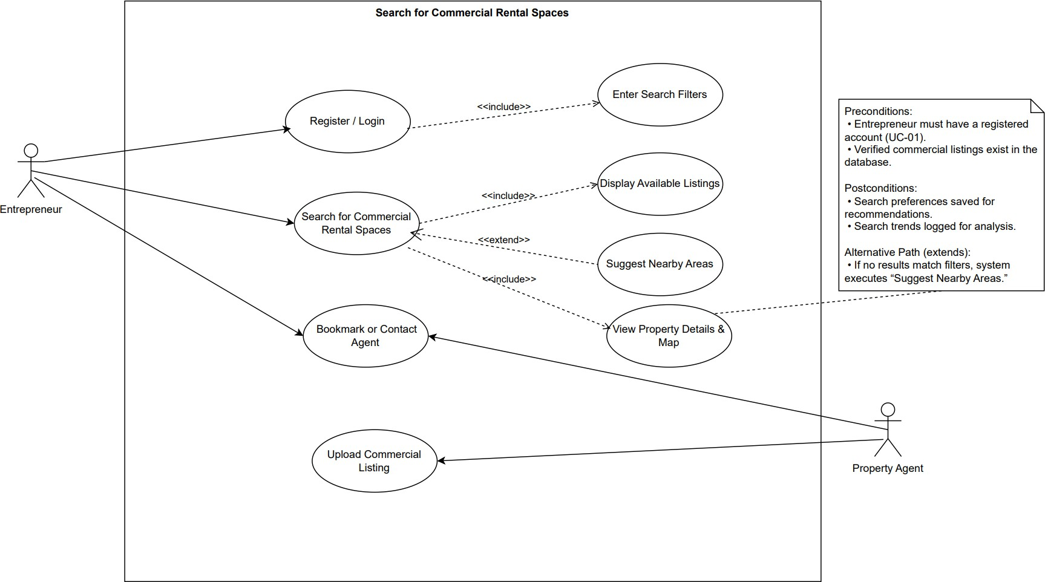

Figure 2 Search for Commercial Rental Spaces
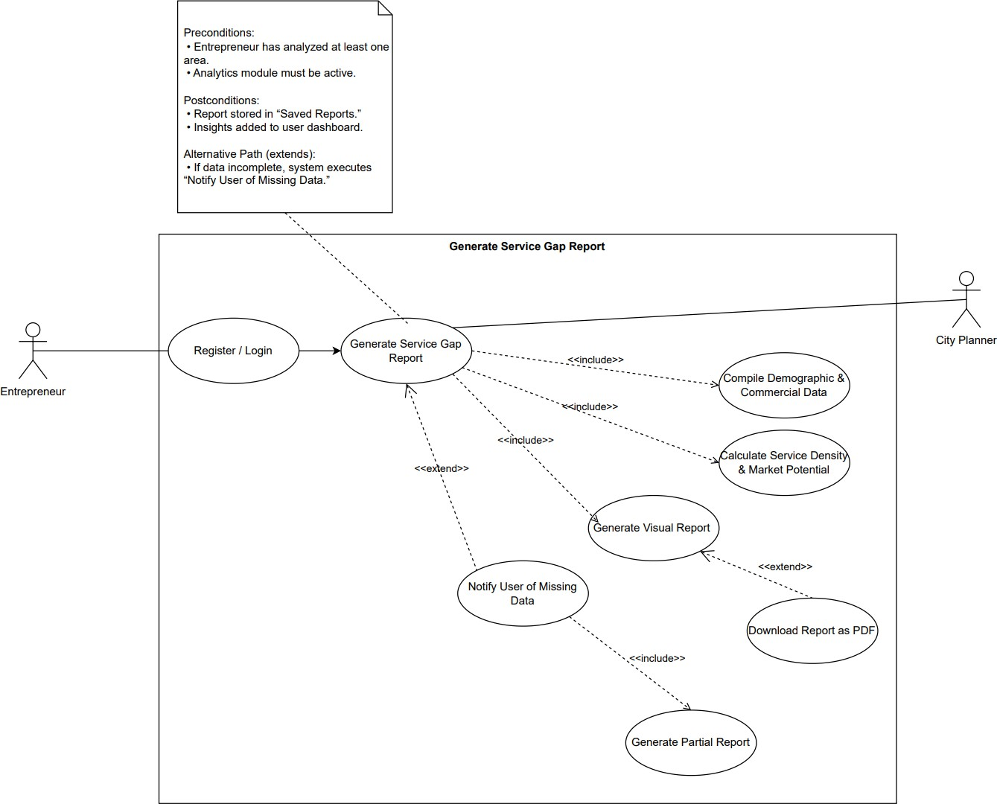
Figure 3 Generating Service Gap Report 16

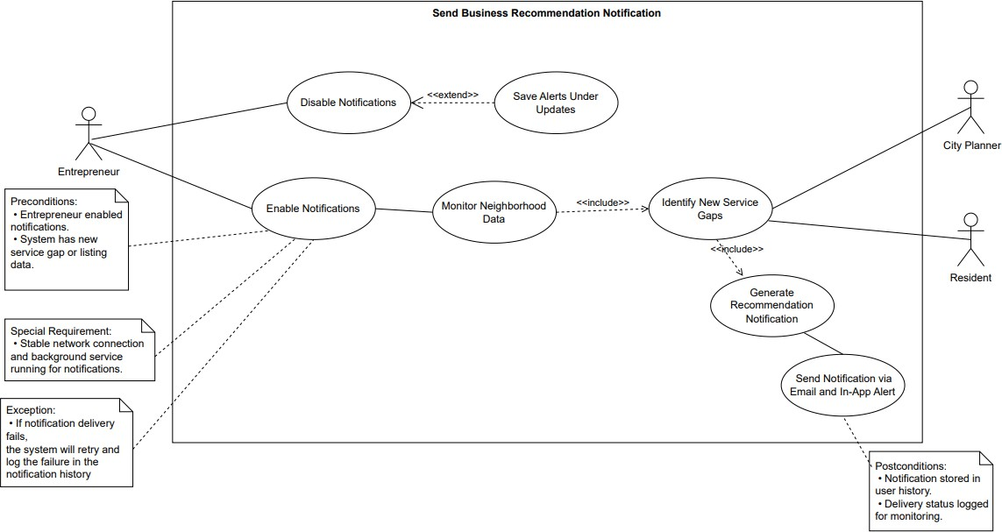
Figure 4 Send Business Recommendation Notification

Use Case Description

Analyzing Neighborhood Data
Brief description: The process of collecting and analyzing neighborhood data to identify service gaps and suggest profitable business opportunities for entrepreneurs.
Actors: Entrepreneur, System
Preconditions:
- The entrepreneur must be logged into the system.
- The database must contain up-to-date neighborhood and business data.
Basic flow:
- The entrepreneur logs into the system.
- The entrepreneur navigates to the “Analyze Area” section.
- The entrepreneur selects a district or area for analysis.
- The system retrieves the area’s demographic and commercial data.
- The system compares existing services against demographic needs.
- The system displays a report highlighting missing business types and potential opportunities.
Alternative flow:
If the selected area has insufficient data:
- The system displays a message notifying the user of limited data availability.
- The system recommends nearby areas with richer datasets for analysis.
Postconditions:
- The analysis report is stored in the user’s profile.
- The system updates usage statistics to refine recommendation accuracy.
Special requirements: The system must have a stable internet connection to fetch external data (e.g., map and business APIs).
Exceptions: If the analysis process fails due to a network or API issue, an error message will be displayed prompting the user to retry.
Table 1: Analyzing Neighborhood Data

Searching for Commercial Rental Spaces
Brief description: Allow entrepreneurs to search for commercial rental listings based on location, budget, and business category.
Actors: Entrepreneur
Preconditions:
- The entrepreneur must have a registered account.
- The database must contain verified commercial listings.
Basic flow:
- The entrepreneur opens the “Search Spaces” page.
- The entrepreneur enters search for filters (location, price range, size, category).
- The system displays a list of available commercial rentals.
- The entrepreneur clicks on a property to view detailed information and location on the map.
- The entrepreneur can bookmark or contact the agent directly.
Alternative flow:
If no results match the filters:
- The system displays a message indicating that no rentals match the criteria.
- The system suggests nearby areas with similar price ranges.
Postconditions:
- The entrepreneur’s search preferences are saved for future recommendations.
- The system logs search trends for data analysis.
Special requirements: Active internet connection required for map rendering.
Exceptions: If listing retrieval fails due to server or database error, a message is displayed informing the user to try again later.
Table 2: Searching for Commercial Rental Spaces

Generating Service Gap Report
Brief description: Generates a comprehensive report showing missing or underrepresented business sectors within a selected area.
Actors: System, Entrepreneur.
Preconditions:
- The entrepreneur must have analyzed at least one area.
- The system’s analytics module must be active.
Basic flow:
- The entrepreneur selects “Generate Report” after completing an area analysis.
- The system compiles demographic, commercial, and survey data.
- The system calculates service density and market potential.
- The system generates a visual report (graphs and tables).
- The entrepreneur can download or export the report as a PDF.
Alternative flow: If data is incomplete, the system generates a partial report and alerts the user to missing data sources.
Postconditions:
- The report is stored in the user’s “Saved Reports” section.
- Insights are added to the user’s personalized dashboard.
Special requirements: Access to a data-visualization API.
Exceptions: If report generation fails due to insufficient data, an error notification is displayed.
Table 3: Generating Service Gap Report

Sending Business Recommendation Notification
Brief description: Automatically notify entrepreneurs when a new business opportunity appears in an area they have previously analyzed.
Actors: System
Preconditions:
- The entrepreneur must have enabled notifications.
- A new listing or service gap change must be detected.
Basic flow:
- The system monitors neighborhood data updates.
- The system identifies new service gaps matching user preferences.
- The system generates recommendation notification.
- The system sends the notification via email and in-app alert.
Alternative flow: If the user has disabled notifications, the system saves the alert under the “Updates” tab without sending a push notification.
Postconditions:
- The notification status is logged in the system.
- The entrepreneur can view the recommended opportunity later.
Special requirements: Stable network connection and background service running for notifications.
Exceptions: If notification delivery fails, the system will retry and log the failure in the notification history.
Table 4: Sending Business Recommendation Notification

UML Class Diagram

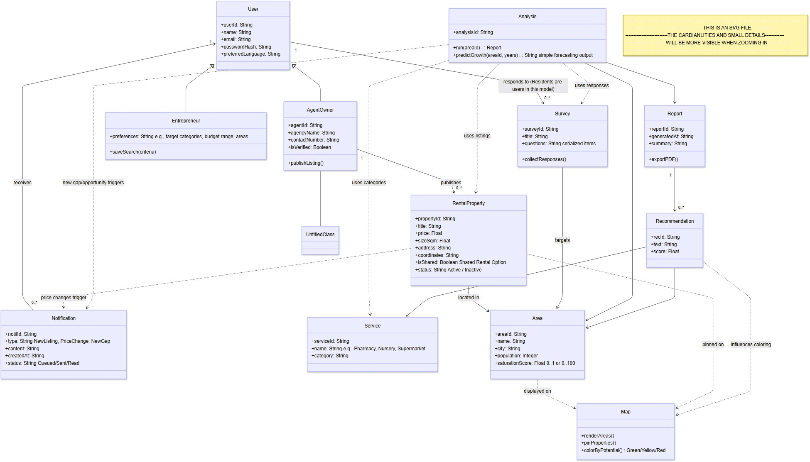
Figure 5 Maqsad UML Design Structure

Difficulties and Risk Analysis
Developing Maqsad comes with several technical and operational challenges that could impact the project's success if not handled correctly. The following points highlight the main difficulties encountered during the design and implementation stages. This is followed by a look at potential risks and strategies to reduce them.

Difficulties

Data Collection and Accuracy
Obtaining accurate and up-to-date data about commercial activities and available rentals was challenging.
Publicly available datasets are often limited, which required careful validation and the use of trusted open-data sources.

Integration with Map and External APIs
Connecting the system to mapping services and APIs for real-time location data presented technical difficulties such as coordinate mismatches, slow loading times, and authentication errors.

Data Analysis Complexity
Implementing the Service Gap Analysis and Future Forecasting features required handling multiple variables (demographics, existing services, and survey responses), which increased algorithmic complexity.

Survey Participation
Encouraging residents to complete surveys was another challenge, as low participation could reduce the reliability of the analysis and lead to biased results.

Interface Design and Usability
Designing a bilingual (Arabic / English) interface that remained simple and intuitive required several layout revisions to ensure clarity across different screen sizes.

Performance Optimization
Handling multiple user requests simultaneously, especially when loading maps and analytical results, sometimes slowed down the prototype during testing.

Risk Analysis

Risk Type | Description | Impact | Likelihoo d | Mitigation Strategy
Data Reliability | Inaccurate or incomplete datasets may lead to misleading recommendations. | High | Medium | Validate all data sources and schedule regular updates.
API  Integration Failure | External maps or data services may become temporarily unavailable. | High | Medium | Use backup APIs and implement error-handling mechanisms.
User Privacy Breach | Unauthorized access to user or location data. | High | Low | Encrypt sensitive data and enforce secure login protocols.
Low User Engagement | Entrepreneurs or residents may not interact consistently with surveys and alerts. | Mediu m | Medium | Add incentive messages, visual feedback, and user reminders.
System Downtime | Unexpected server or network failures interrupting service. | High | Low | Deploy regular backups and monitoring tools to ensure availability.
Scalability Issues | System may slow under heavy load or expansion to new cities. | Mediu m | Medium | Optimize database queries and use scalable cloud hosting.
Maintenance Risk | Lack of updates could cause obsolete listings or features. | Mediu m | Medium | Assign maintenance schedules and version control documentation.
Table 5: Risk Analysis

3.Phase 4: Modeling, Interaction and Behavior
Diagrams and Testing

3.1Activity Diagram:
3.1.1Analyze Area and Generate Report
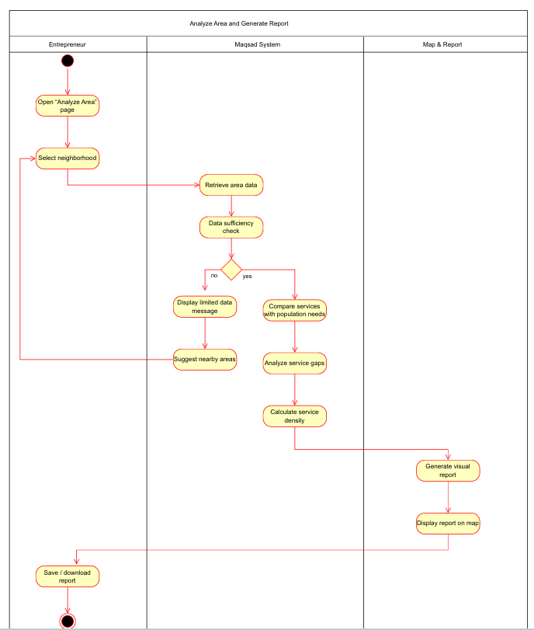

3.1.2 Send Business Recommendation Notification

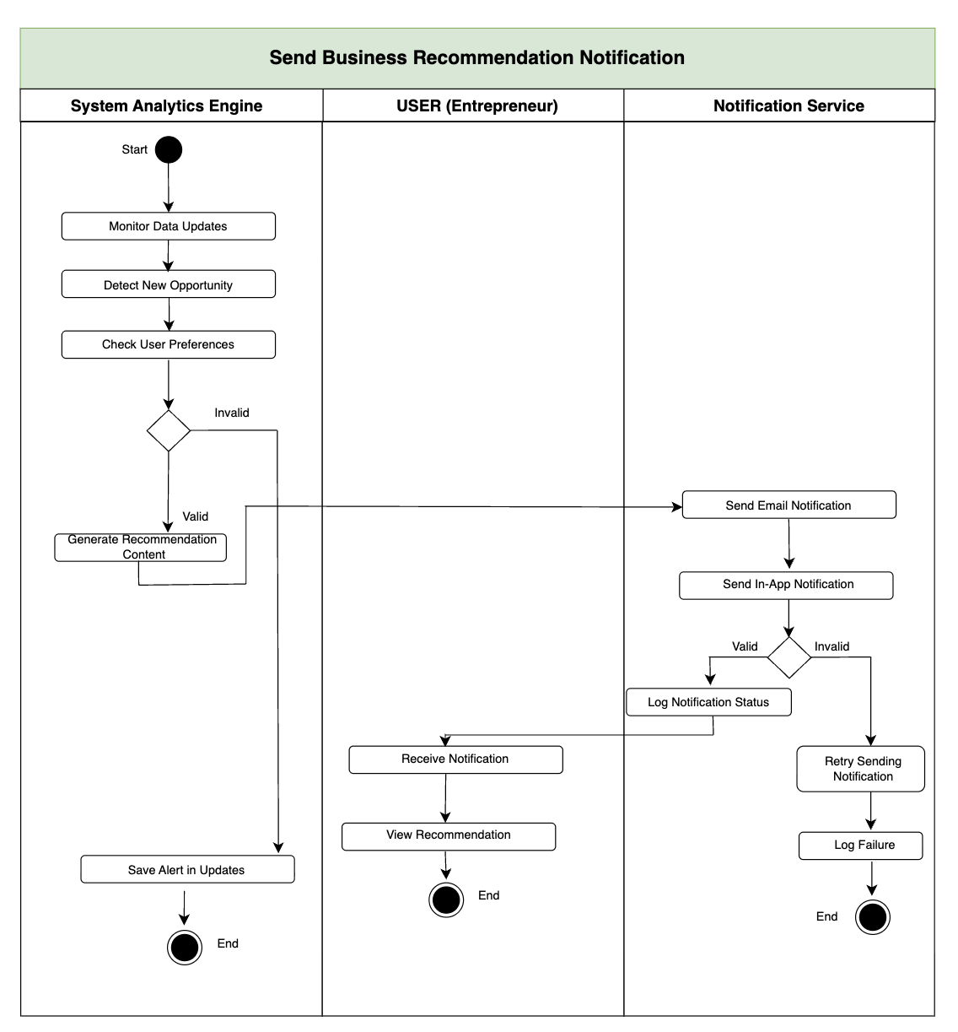

3.1.3 Save Rental Listing to Favorites

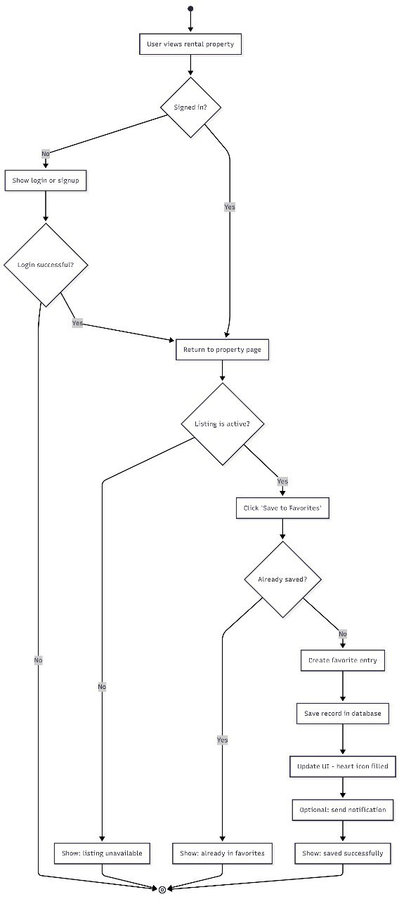
3.2 State Diagram:
3.2.1 Rental Listing State
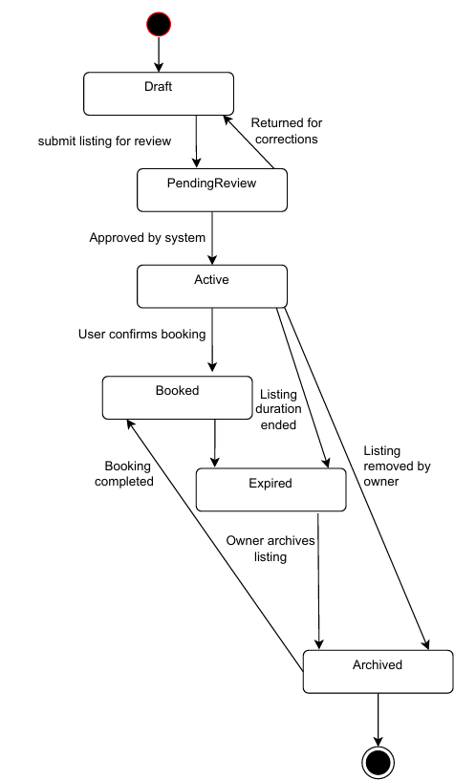

3.2.2 Service Gap Report and Analysis State


3.3 Sequence Diagram:
3.3.1 View Business Recommendations

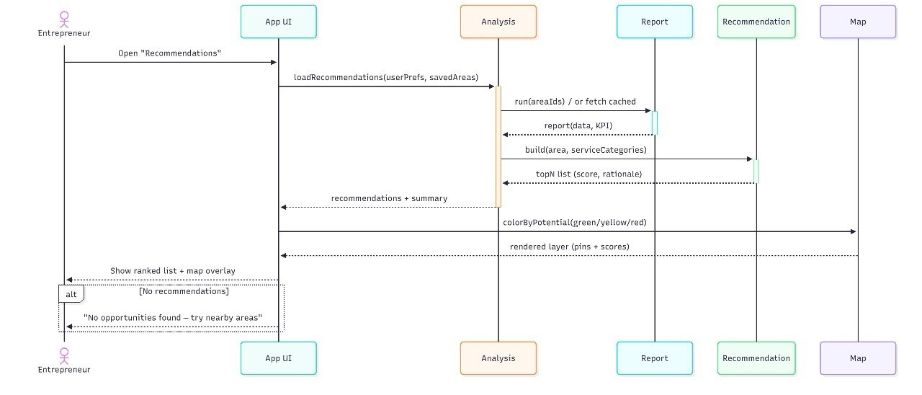

3.3.2 Analyze Area and Show Service Gaps
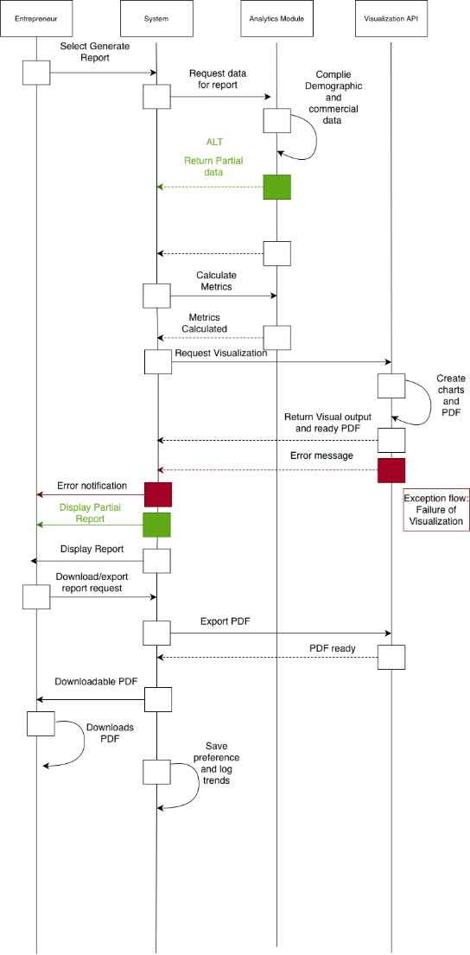

3.4 System Architecture Diagram

3.4.1 Type of the System

The Maqsad Real Estate Support System is an interactive, data-driven decision support system that helps entrepreneurs evaluate business opportunities using real-time neighborhood analytics. Users can explore commercial rental spaces, view interactive maps, analyze service gaps, receive automated business recommendations, and submit resident surveys that influence future analysis. The system provides a seamless and dynamic experience through dashboards, notifications, and location-based insights, making it highly interactive and user-centric.

3.4.2 System Design
1- Determine Design Objectives

The design objective of Maqsad is to deliver a smart, easy-to-use platform that assists entrepreneurs in selecting optimal business locations.
The system aims to:
- Provide accurate service gap analysis.
- Offer data-driven recommendations.
- Combine map visualizations annd demographic data.
- Allow property agents to publish commercial spaces
- Support residents in reporting missing services in their neighborhoods.
The overall goal is to enhance user decision-making, reduce investment risks, and support balanced urban development.

2- Determine Type of the System

Maqsad is an interactive system.It continuously responds to user inputs, updates maps in real time, sends instant notifications, and processes analytics dynamically based on user-selected areas and preferences.

3- Apply an Architectural Design

Maqsad uses a Three-Tier Architecture (N-tier style) consisting of:
- Presentation Layer – Mobile interface, maps, dashboards, surveys
- Application Layer – Business logic, notification service, analytics and recommendation engine
- Data Layer – Databases, listings data, survey data, demographic datasets, and external map APIs
This architecture supports scalability, efficient data processing, and flexible integration with external services.

4- Specify Subsystem Functions, Interfaces, and Interaction Behavior

The main subsystems in Maqsad are:
- Entrepreneur Subsystem: explore areas, analyze service gaps, receive recommendations
- Resident Subsystem: submit surveys and provide feedback
- Property Agent Subsystem: publish and update rental listings
- Analytics Subsystem: perform neighborhood analysis, generate reports
- Notification Subsystem: send personalized alerts
- Map Integration Subsystem: retrieve and display geographic and service data

All subsystem interfaces and functions are described in the functional requirements, while behavior and interactions are modeled in the UML sequence, activity, and state diagrams included in Phase 4.

5- Review the Architectural Design

All design requirements, constraints, and objectives are met.
The Maqsad system architecture follows standard software design principles, ensuring:
- Clear separation of layers
- High scalability
- Maintainability
- Efficient integration with external APIs
- Smooth user interaction
Therefore, the chosen three-tier architectural design aligns fully with Maqsad’s functional and non-functional requirements.
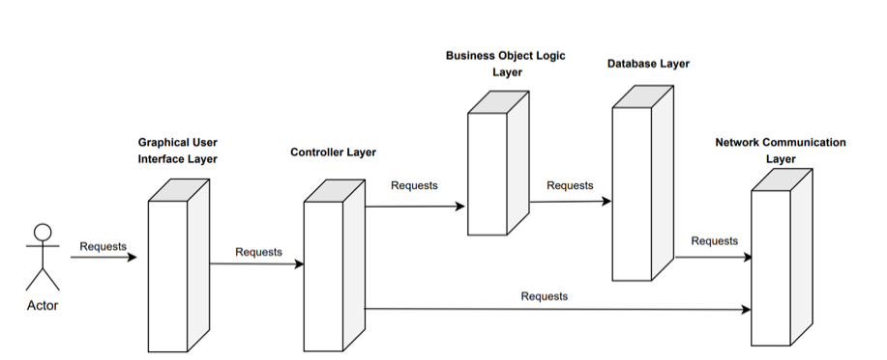

3.5 Testing

3.51 Objectives
The goal of testing in Maqsad is to check if the main features work the way they should. We tried different types of inputs to see how the system reacts. This helps us make sure that the login, search, and recommendation features work correctly before completing the project.

3.5.2 Testing Strategy
We used different testing levels and techniques to check the system.

• Unit Testing: Each feature was tested alone, like login and search.
• Integration Testing: We tested how features work together, such as preferences leading to recommendations.
• System Testing: The whole app was tested from start to finish.

Techniques used include:

• Black-box testing
• Equivalence Partitioning
• Boundary Value Analysis
• Decision Table testing

Pass/Fail Criteria:

• Pass: The result matches what we expected.
• Fail: The result is wrong or the system does not respond correctly.

3.5.3 Approach
We tested the system in a simple way, similar to how a normal user would use it. We tried correct inputs, wrong inputs, and empty inputs. After each test, we compared what we expected with the actual result to mark it as pass or fail.

3.5.4 Test Plans

3.5.4.1 Test Plan 1 – Login

System: Maqsad
Test Case Name: Login
Description: This test checks how the login feature reacts to different inputs.
Test Scenario: Check if the user can log in or see the correct message.
Precondition: User already has an account.

Test Case ID | Test Scenario | Test Steps | Test Data | Expected Results | Actual Results Pass/Fail
TC01 | Login with correct information | 1. Open app.  2. Go to login.  3. Enter correct email & password.  4. Click login. | Correct email + password | User logs in | Same result | Pass
TC02 | Login with wrong password | 1. Open app.  2. Go to login.  3. Enter correct email + wrong password.  4. Click login. | Wrong password | App shows an error message | Same result | Pass
Postcondition: The user logs in or sees a message explaining the issue.

3.5.4.2 Test Plan 2 – Search

System: Maqsad
Test Case Name: Search for commercial Rental Spaces
Description: This test checks how the Search feature reacts to different filters/inputs.
Test Scenario: Check if the user can log in or see the correct message.
Precondition:
User must be registered and logged in
Database must contain verified commercial listings

Test Case ID | Test Scenario | Test Steps | Test Data | Expected Results | Actual Results | Pass/Fail
TC01 | Search with valid filters | 1.Open Search page  2. Enter a valid location, category, price range and size  3.Click Search | Location:” Al-Jamiah”  Price:25,000-47,000  Category: Retail | Verified rental listing that match | Actual | Pass
TC02 | Search with no filters | 1.Open search Area  2.Leave filter fields empty  3.Click Search | Empty | Prompt user to enter Atleast one filter | Actual | Pass
TC03 | Search returns no results | 1.Open search page  2.Enter filters that will match no listings  3.ClickSearch | Location:”Unknown”  Price:0  Category: Retail | “No rentals match”+ suggests nearby areas | Actual | Pass
TC04 | Invalid filter format | 1.Open search page  2.Enter invalid filters  3.Click search | Location:””  Price: yz  Category:Castle | Displays Error and doesn’t proceed with search | Actual | Pass
TC05 | View property details | 1.Perform a valid search  2.Choose a listing from list | Valid Listing | Full property data and map view | Actual | Pass
TC06 | Bookmark property | 1.Perform a valid search  2.Choose a listing from the list  3.Click on “bookmark” | Valid listing | Listing added to user’s bookmarks list | Actual | Pass
TC07 | Contact agent | 1.Open chosen listing details  2.Click on “Contact Agent” | Valid listing | System opens contact option | Actual | Pass
TC08 | Server error | 1.Perform a search while the server is offline  2.Click search | N/A | “System retrieval failed, try again later” | Actual | Pass
Postcondition:
User’s search preferences are saved by the system
System updates analytics logs for search trends

3.5.5 Test Design Technique

3.5.5.1 Equivalence Partitioning
Equivalence Partitioning divides the input domain into logical classes where each input in the class is expected to produce similar behavior. This reduces redundancy in testing while ensuring meaningful coverage.
For the Search for Commercial Rental Spaces feature

Input Field | Equivalence Class | Description | Example | Related TC
Location | Valid | Existing area in system | “Al-Jamiah” | TC01
Location | Invalid | Area not stored in DB | “Unknown Area” | TC03
Location | Empty | No location selected | "" | TC02
Price | Valid | Within allowed numeric range | 25,000–47,000 | TC01
Price | Invalid Format | Non-numeric or malformed | “yz” | TC04
Category | Valid | Supported business category | “Retail” | TC01
Category | Invalid | Not defined in system | “Castle” | TC04
All Filters | Empty | User submits with no filters |  | TC02
Using these partitions ensured that the feature was tested for valid, invalid, and empty input scenarios with minimal but effective test cases.

3.5.5.2 Boundary Value Analysis
Boundary Value Analysis (BVA) focuses on values at the edge of valid input ranges, where errors are most likely to occur. This technique was applied to the price range and property size fields, which have defined numeric limits.

boundaries are:
- Price Range: minimum = 0, maximum = system-defined upper limit
- Property Size: minimum = >0 sqm, maximum = landlord-defined upper limit

Field | Lower Boundary | Just Below | Exact | Just Above | Related TC
Price | 0 | -1 (invalid) | 0 | 1 | TC04
Price | Upper Limit | UpperLimit-1 | UpperLimit | UpperLimit+1 (invalid) | TC01/TC04
Size | 1 sqm | 0 (invalid) | 1 sqm | 2 sqm | TC01
Testing these boundaries validated that the system correctly processes numeric input, rejects out-of-range values, and handles the transition between acceptable and unacceptable inputs

3.5.5.3 Decision Table Testing
Decision Table Testing was used to evaluate how the system behaves when multiple filter conditions are combined. This technique ensures that all important rule combinations are covered.
The feature “Search for Commercial Rental Spaces” supports four key conditions:
- Valid location
- Valid price
- Valid category
- Non-empty filters
Rule | Location | Price | Category | Expected Outcome | Related TC
R1 | Valid | Valid | Valid | Successful search with results | TC01
R2 | Empty | Empty | Empty | Show all listings (no filters applied) | TC02
R3 | Valid | Valid | Valid but unmatched | No results found | TC03
R4 | Invalid | Invalid | Invalid | Input error message / validation failure | TC04
This technique confirmed that the system behaves correctly for all critical combinations of filter inputs, including fully valid, fully empty, unmatched, and invalid cases.

Appendix

Survey Questions and Results

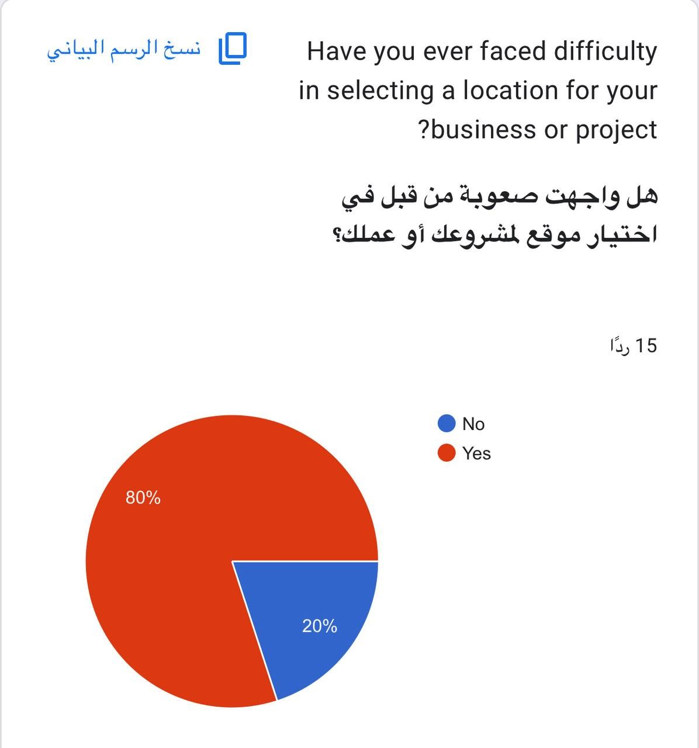
Figure 6 Percentage of participants who faced difficulty choosing a business location


What is the main reason that makes location selection
?difficult for you





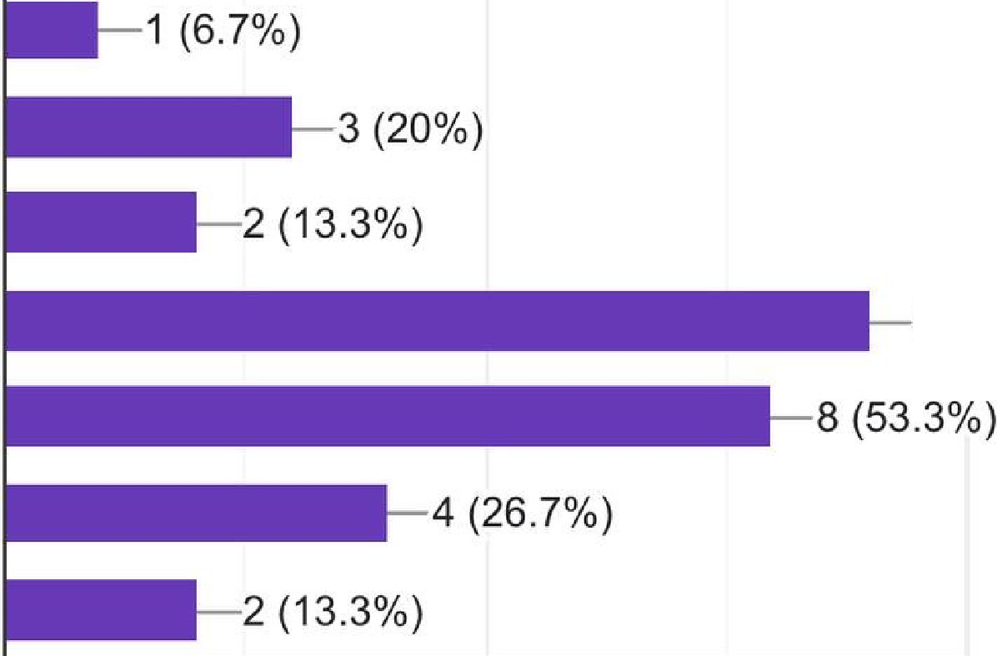
Lack of accurate... 0 (0%)

Too many similar.. . Unclear commun.. . High rental costs.. .

Too many similar.. . High rental costs Lack of accurate .. . Unclear commun.. .
9 (60%)

0 5 10

Figure 7 Main reasons behind the difficulty in selecting a business location

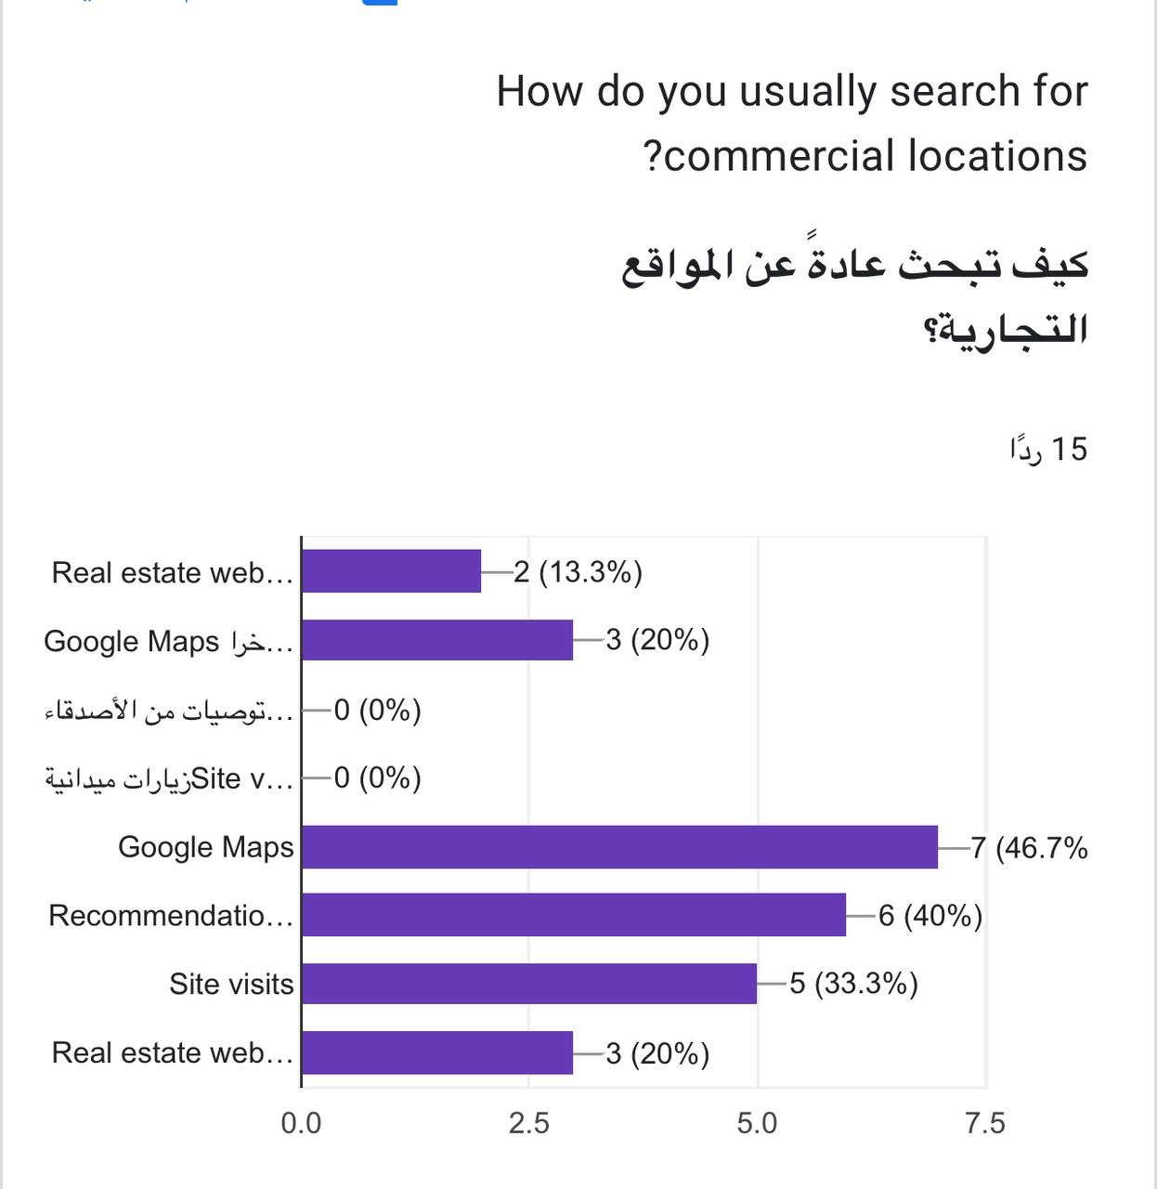

Figure 8 Common tools used by participants to search for business locations

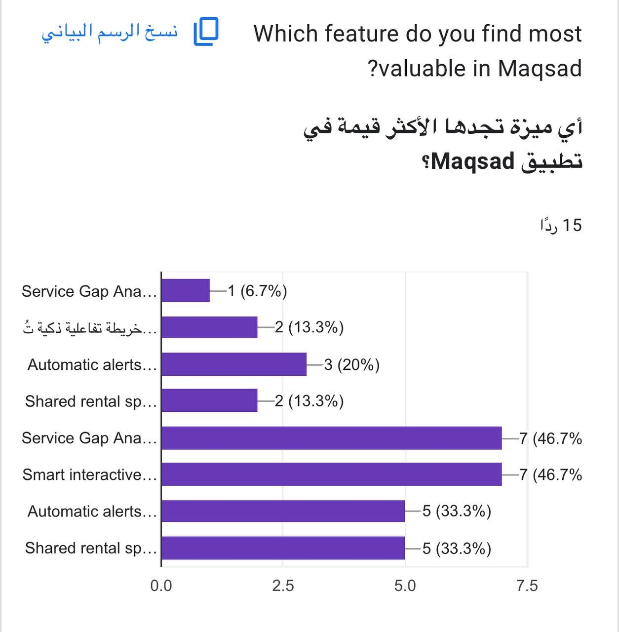
Figure 9 Participants’ opinion about the usefulness of Maqsad

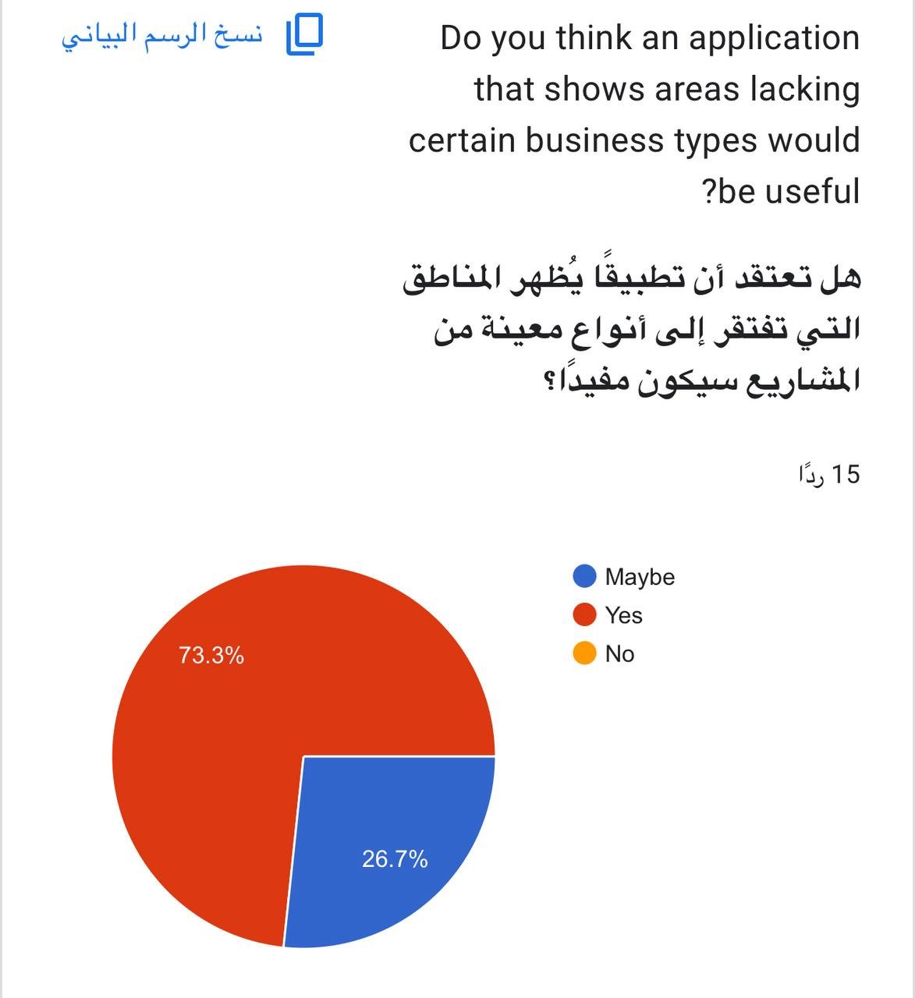

Figure 10 Percentage of participants who believe their area lacks certain business types

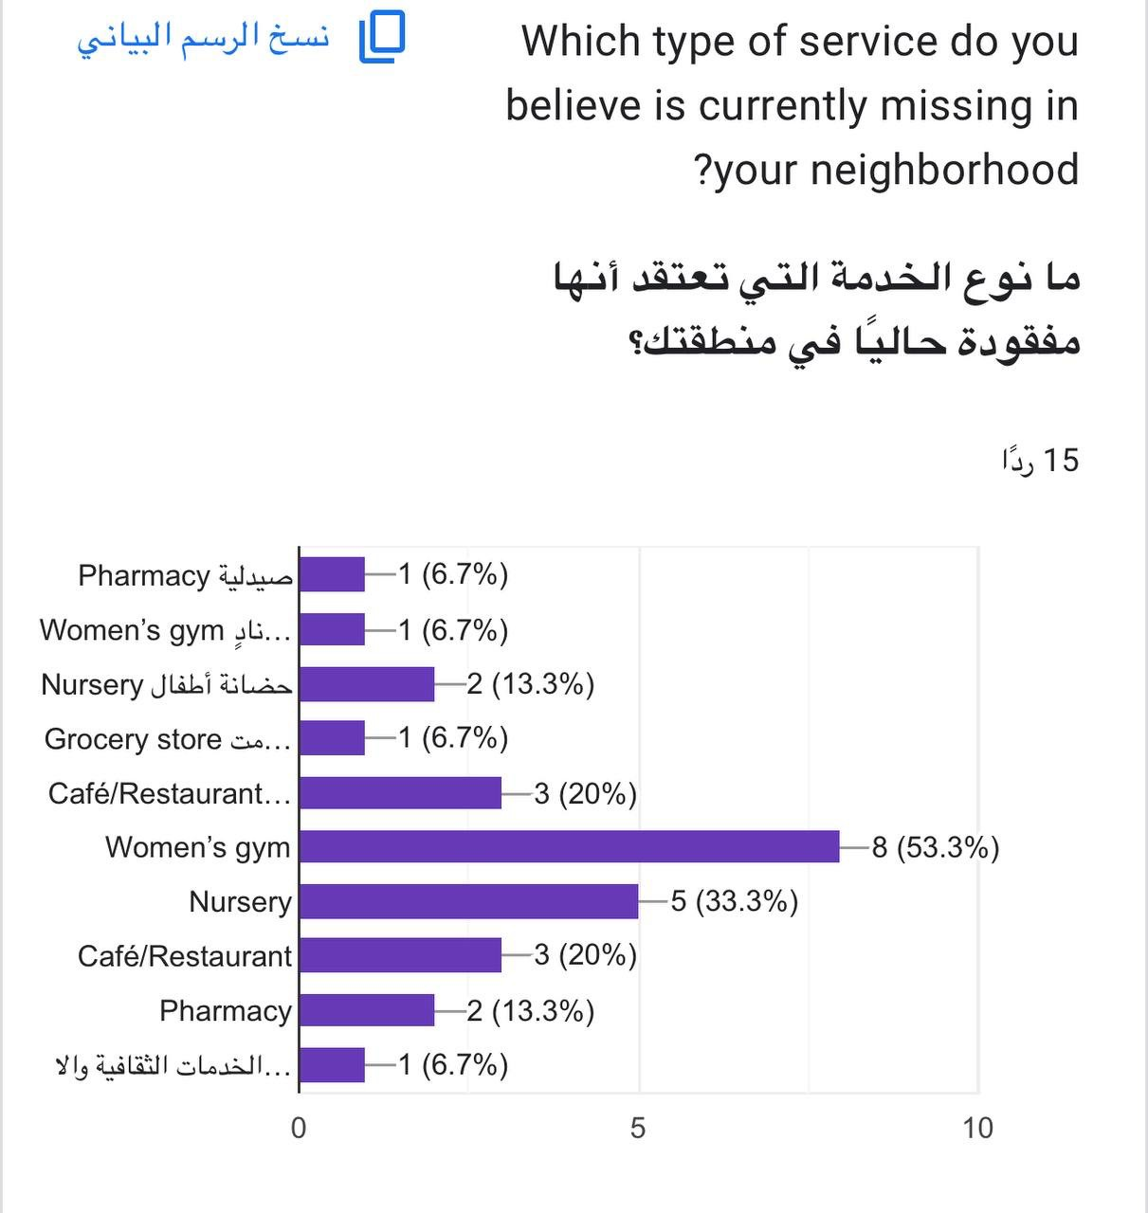
Figure 11 Services that participants believe are missing in their neighborhoods

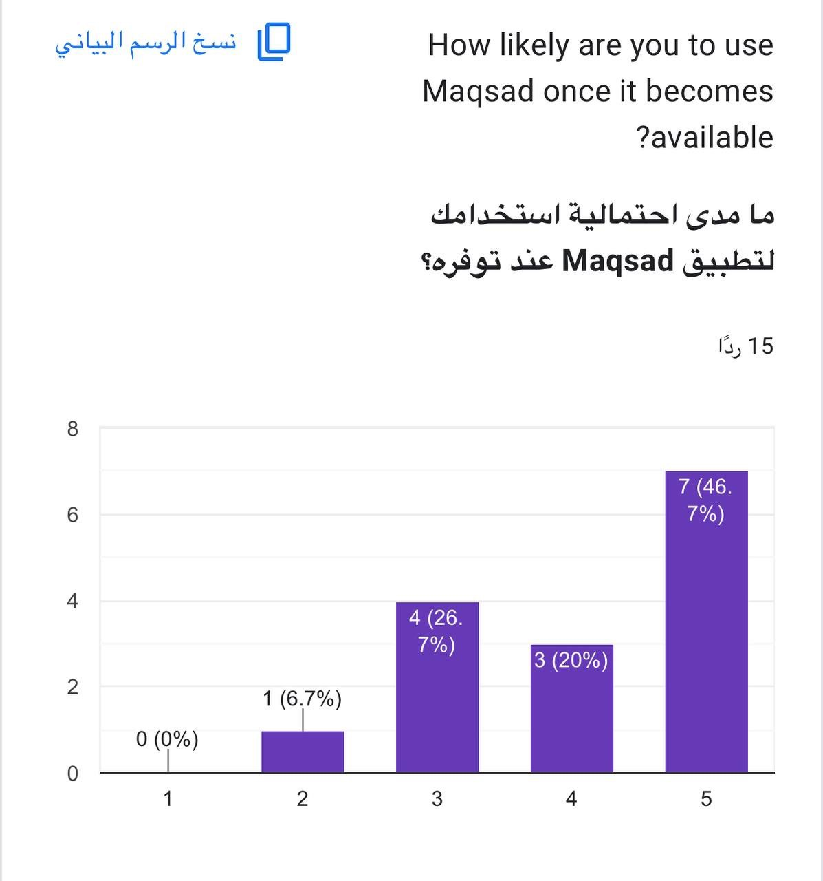

Figure 12 Participants’ likelihood to use Maqsad in the future

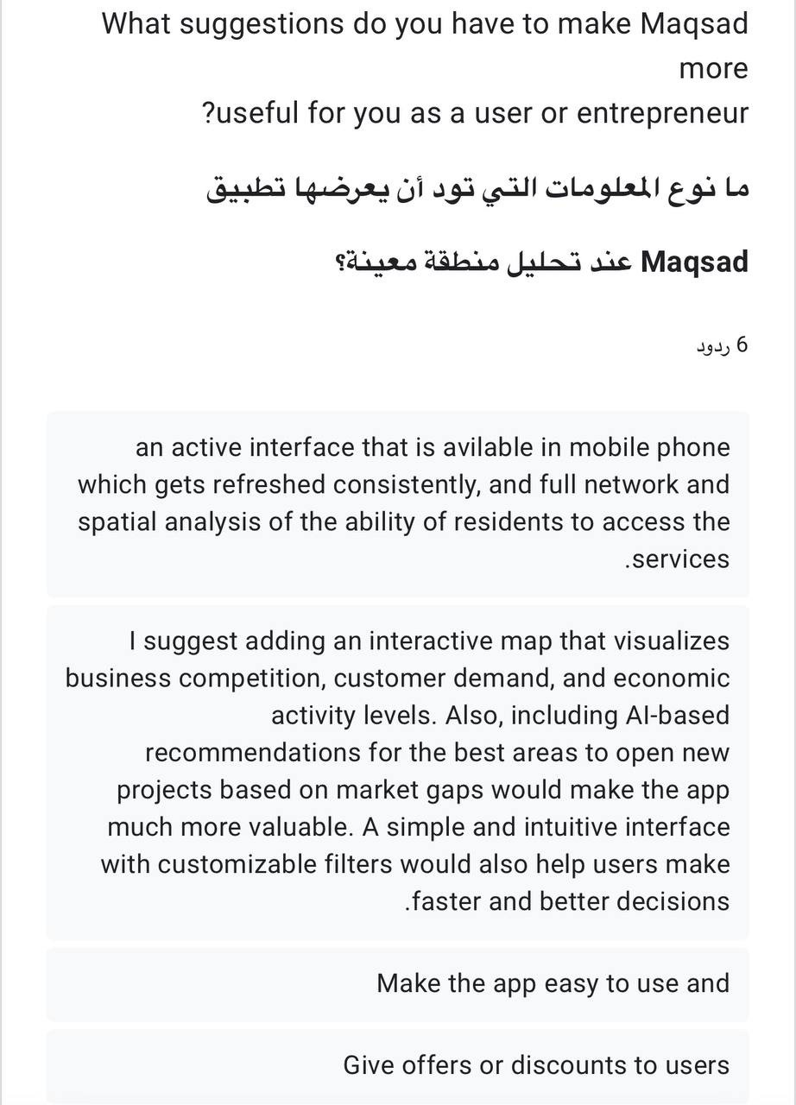
Figure13 Participants’ open-ended suggestions to improve Maqsad’s features and usability

      - Survey link https://docs.google.com/forms/d/e/1FAIpQLSdWaLptxgbk9ew8OwZ0z0yvRIAXNp7TWT5p G_0dr66lTMwW9A/viewform?usp=header

Summary
The success of Maqsad relies on having reliable data sources, keeping the system secure, and encouraging active user participation. While technical integration and data quality pose the greatest risks, these can be reduced through regular data validation, strong API management, and ongoing testing. By identifying these problems early, the project can uphold stability, ensure accuracy, and support long-term usability in future development phases.

