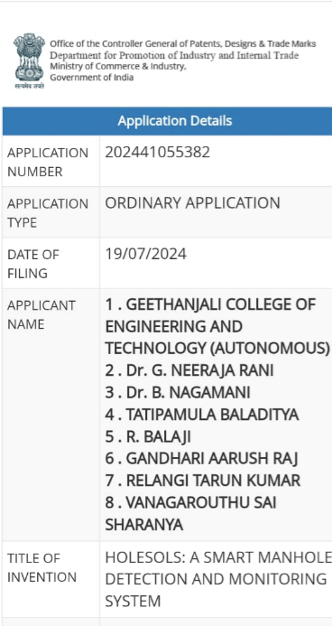

**HoleSols: Manhole Monitoring and Detection System**

**Developed during my first year of BTech, HoleSols is an advanced system designed to improve urban infrastructure safety by providing real-time monitoring and detection of manholes. The project has received considerable recognition, including:**

* **Winner of AICTE's The Inventors Challenge 2023**
* **Champion in multiple hackathons**

**You can view the detailed implementation video and prototype on my GitHub account.**

**Handover and Patent**

**After completing this project and shifting my focus to academics and coding, I handed over the project to my juniors for continued development. Additionally, a patent application has been filed for this innovative solution.**