PSYC

Negotiation Capstone 6

07/09/2021

library(car)

## Loading required package: carData

# Read in the csv file

Nego_data <- read.csv(file = "Data with Bio culture and Average Score.csv")

# General significant test with linear model and stepwise selection

Culture <- Nego_data$Bio_Culture  
Dignity <- Nego_data$Dignity  
Face <- Nego_data$Face  
  
# linear model and test significance of factors  
model <- lm(Culture ~ (Dignity + Face)^2)  
  
# Stepwise selection process and figure out the significant factor(s)  
# Only intercept and Dignity factor are significant in this model  
model <- step(model)

## Start: AIC=-212.47  
## Culture ~ (Dignity + Face)^2  
##   
## Df Sum of Sq RSS AIC  
## - Dignity:Face 1 0.0026338 32.809 -214.46  
## <none> 32.807 -212.47  
##   
## Step: AIC=-214.46  
## Culture ~ Dignity + Face  
##   
## Df Sum of Sq RSS AIC  
## - Face 1 0.12367 32.933 -215.91  
## <none> 32.809 -214.46  
## - Dignity 1 2.82536 35.635 -204.31  
##   
## Step: AIC=-215.91  
## Culture ~ Dignity  
##   
## Df Sum of Sq RSS AIC  
## <none> 32.933 -215.91  
## - Dignity 1 3.0669 36.000 -204.82

# Only dignity factor is significant

# print out the summary table of the reduced model  
summary(model)

##   
## Call:  
## lm(formula = Culture ~ Dignity)  
##   
## Residuals:  
## Min 1Q Median 3Q Max   
## -0.6998 -0.4029 -0.2887 0.5285 0.7798   
##   
## Coefficients:  
## Estimate Std. Error t value Pr(>|t|)   
## (Intercept) 2.15661 0.20199 10.677 < 2e-16 ***  
## Dignity -0.13703 0.03729 -3.675 0.000334 ***  
## ---  
## Signif. codes: 0 '***' 0.001 '**' 0.01 '*' 0.05 '.' 0.1 ' ' 1  
##   
## Residual standard error: 0.4766 on 145 degrees of freedom  
## Multiple R-squared: 0.08519, Adjusted R-squared: 0.07888   
## F-statistic: 13.5 on 1 and 145 DF, p-value: 0.0003345

# Assumption test

# Done the assumption test  
Culture <- as.factor(Culture)  
leveneTest(Dignity ~ Culture)

## Levene's Test for Homogeneity of Variance (center = median)  
## Df F value Pr(>F)   
## group 1 9.5222 0.002432 **  
## 145   
## ---  
## Signif. codes: 0 '***' 0.001 '**' 0.01 '*' 0.05 '.' 0.1 ' ' 1

leveneTest(Face ~ Culture)

## Levene's Test for Homogeneity of Variance (center = median)  
## Df F value Pr(>F)  
## group 1 1.0941 0.2973  
## 145

# Descriptive data of face and dignity score for mono & bio culture

# Record data into list for mean and SD descriptive data  
mono_face_culture <- c()  
mono_dig_culture <- c()  
bio_face_culture <- c()  
bio_dig_culture <- c()  
  
for (i in 1:length(Culture)){  
 if (Culture[i] == "1"){  
 mono_face_culture <- c(mono_face_culture, Face[i])  
 mono_dig_culture <- c(mono_dig_culture, Dignity[i])  
 } else{  
 bio_face_culture <- c(bio_face_culture, Face[i])  
 bio_dig_culture <- c(bio_dig_culture, Dignity[i])  
 }  
}

# SD values

# SD value for mono-culture of in face score  
sd(mono_face_culture)

## [1] 0.8261746

# SD value for mono-culture of in dignity score  
sd(mono_dig_culture)

## [1] 0.7646281

# SD value for bio-culture of in face score  
sd(bio_face_culture)

## [1] 0.9952884

# SD value for bio-culture of in dignity score  
sd(bio_dig_culture)

## [1] 1.275622

# Mean values

# Mean value for mono-culture of in face score  
mean(mono_face_culture)

## [1] 4.864286

# Mean value for mono-culture of in dignity score  
mean(mono_dig_culture)

## [1] 5.579365

# Mean value for bio-culture of in face score  
mean(bio_face_culture)

## [1] 5.047619

# Mean value for bio-culture of in dignity score  
mean(bio_dig_culture)

## [1] 4.957672

# (Ignore this block if not needed)

info_ave <- Nego_data$Info_AVE  
emo_ave <- Nego_data$Emotion_AVE  
  
bio_info_ave <- c()  
bio_emo_ave <- c()  
mono_info_ave <- c()  
mono_emo_ave <- c()  
  
for (i in 1:length(Culture)){  
 if (Culture[i] == "1"){  
 mono_info_ave <- c(mono_info_ave, info_ave[i])  
 mono_emo_ave <- c(mono_emo_ave, emo_ave[i])  
 } else{  
 bio_info_ave <- c(bio_info_ave, info_ave[i])  
 bio_emo_ave <- c(bio_emo_ave, emo_ave[i])  
 }  
}  
  
# Drop NA value from list  
mono_emo_ave <- mono_emo_ave[-c(49, 50, 52)]  
mono_info_ave <- mono_info_ave[-c(49, 50, 52)]

# One-way ANOVA test on informational value for 2 mono & bio groups

# One-way ANOVA test on emotional value for 2 mono & bio groups

# one-way ANOVA info  
one_way_info <- aov(info_ave ~ Culture)  
summary(one_way_info)

## Df Sum Sq Mean Sq F value Pr(>F)   
## Culture 1 14.08 14.09 16.01 1e-04 ***  
## Residuals 145 127.55 0.88   
## ---  
## Signif. codes: 0 '***' 0.001 '**' 0.01 '*' 0.05 '.' 0.1 ' ' 1

# one-way ANOVA emo  
one_way_emo <- aov(emo_ave ~ Culture)  
summary(one_way_emo)

## Df Sum Sq Mean Sq F value Pr(>F)   
## Culture 1 6.48 6.479 5.306 0.0227 *  
## Residuals 142 173.40 1.221   
## ---  
## Signif. codes: 0 '***' 0.001 '**' 0.01 '*' 0.05 '.' 0.1 ' ' 1  
## 3 observations deleted due to missingness

# Some hist plots for participants’s age and gender distribution

dignity <- c()  
bio <- c()  
info_dignity <- c()  
info_bio <- c()  
emo_dignity <- c()  
emo_bio <- c()  
  
par(mfrow = c(1, 2))  
for (i in 1:length(Nego_data$ResponseId)){  
 if (Nego_data$Bio_Culture[i] < 2){  
 dignity <- c(dignity, Nego_data$Age[i])  
 info_dignity <- c(info_dignity, Nego_data$Info_AVE[i])  
 emo_dignity <- c(emo_dignity, Nego_data$Emotion_AVE[i])  
 }  
 else{  
 bio <- c(bio, Nego_data$Age[i])  
 info_bio <- c(info_bio, Nego_data$Info_AVE[i])  
 emo_bio <- c(emo_bio, Nego_data$Emotion_AVE[i])  
 }  
}  
  
hist(dignity)  
hist(bio)

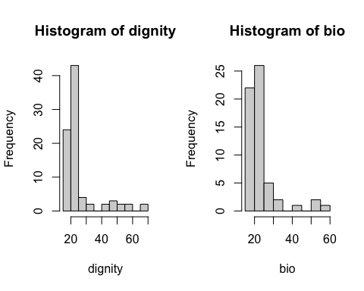

hist(info_dignity)  
hist(info_bio)

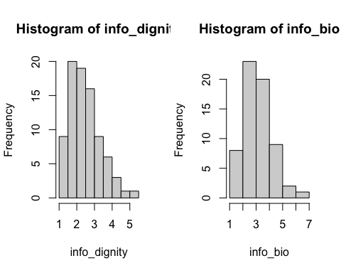

hist(emo_dignity)  
hist(emo_bio)

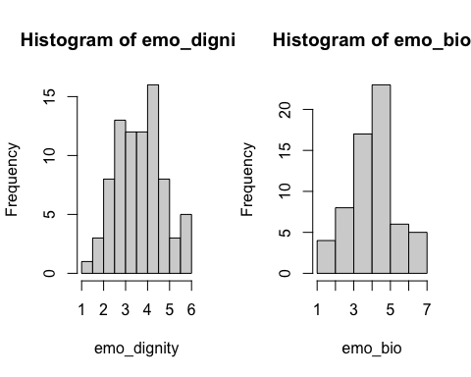

hist(Nego_data$Gender)

