# CSC8503

This document will go through the features present in my submission while also explaining any key/mouse presses the perform actions.

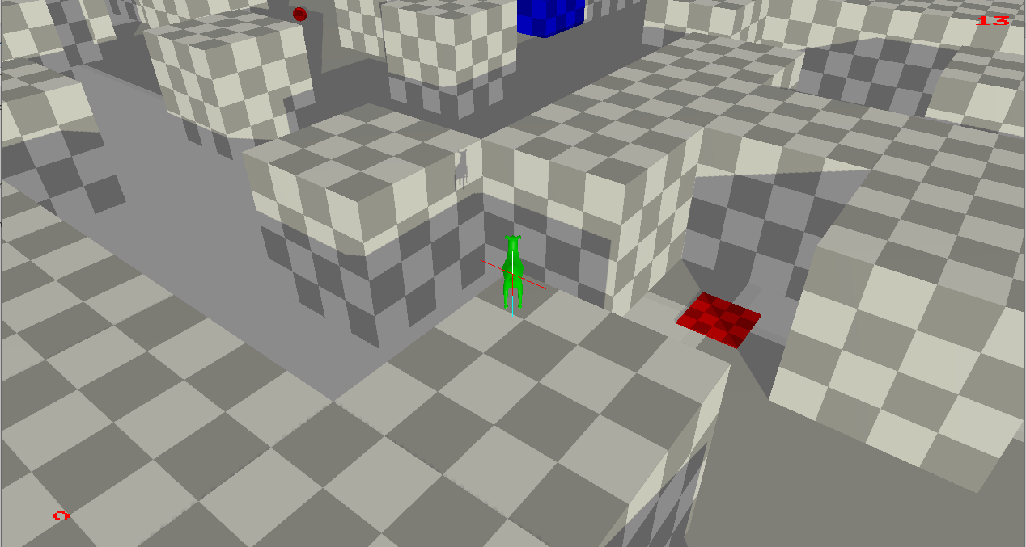

The game world is Navigation grid generated consisting of spherical points to be collected, regular static blocks and a key (the red platform in the screenshot) that is linked to a door (the blue block in the screenshot). The player moves around this game world using forces and torque. Raycasting has been used in the jump component to detect the players proximity to the ground.

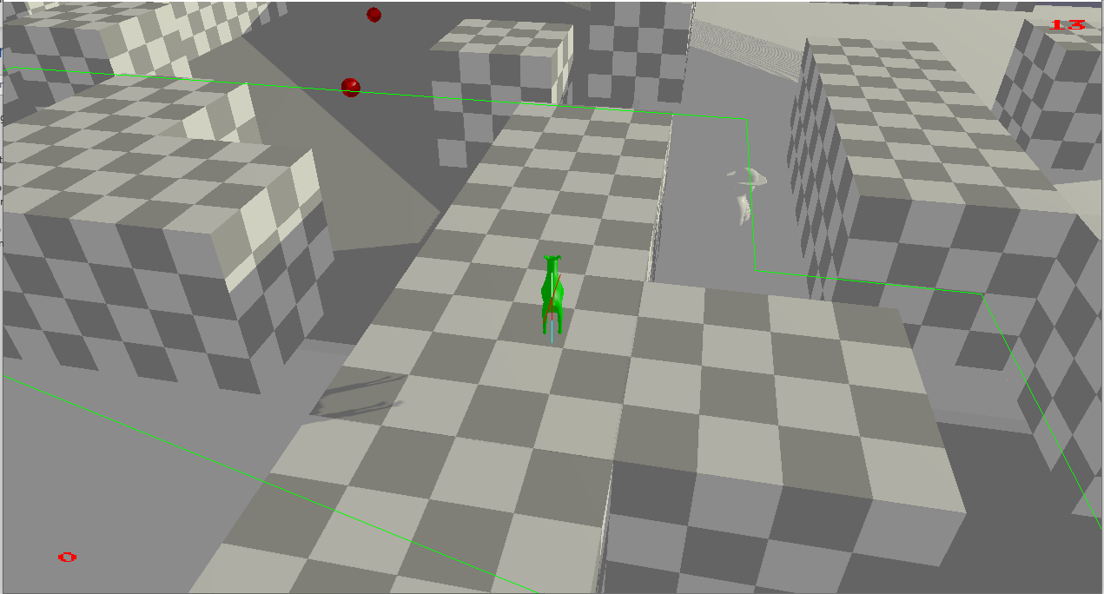

The game world also has an AI object that utilises a state machine to traverse through the world and perform various actions. The zoo-keeper object displayed in the screenshot utilises a state machine to patrol the game world, following an assigned navigation grid. Proximity to the goat will cause this character to turn and proceed to run in the opposite direction. Points interacted with this character while running away will be attributed to the player’s score. When chased too far from the original path, this character will teleport back to it. Objects left to be broken in the world is displayed at the top right of the screen while the current players score is displayed at the bottom left.

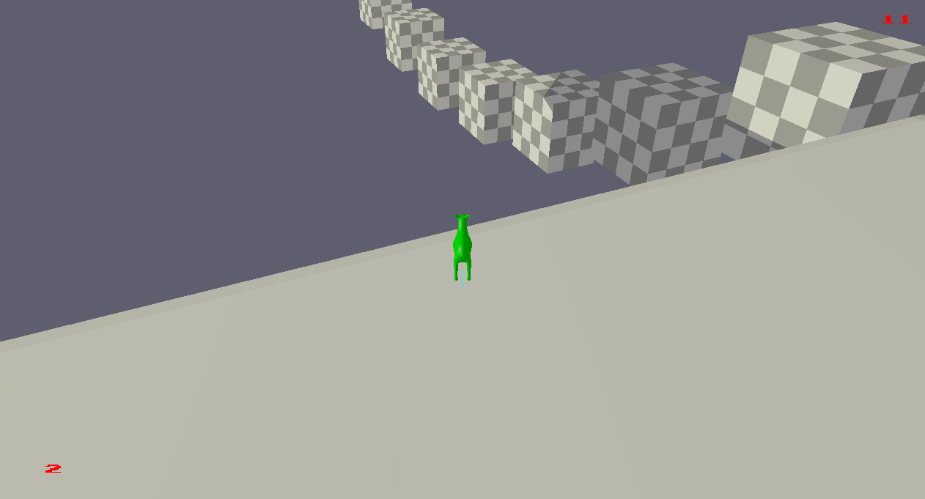

The game world also has a bridge connecting the two platforms for the game. This bridge displays the use of constraints. Other notable features of the submitted game, are the menu system which uses push down automata which can be observed on the terminal, alongside allowing for the highest score to be displayed on the terminal with a button press. This high score is updated on a txt file.

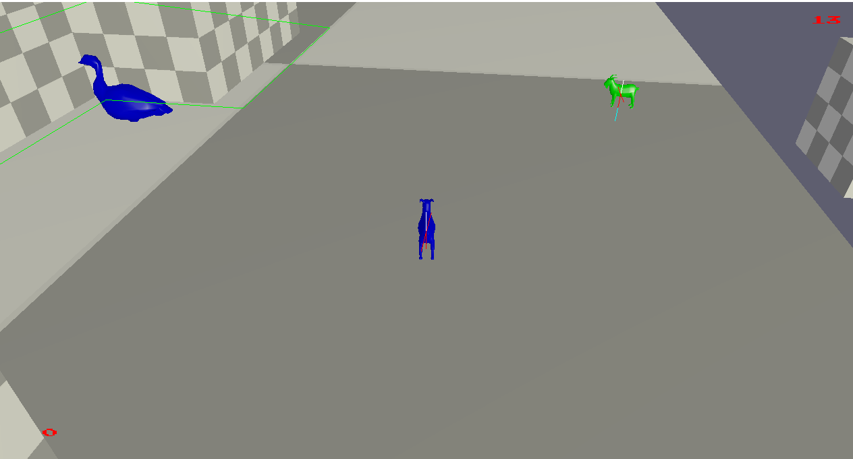

The game allows for a client to join a server, allowing for cooperative play. This second player can collect points and view the highest score, just like the first player. A goose patrolling a hedge maze like area is also present in the submitted game world. This goose entity utilizes a behaviour tree alongside a navigation grid to patrol the maze and perform actions. Players in close proximity to the goose will cause it to chase after them, which on contact will teleport the player outside the maze.

The game concludes when either time runs out, or when all the breakable objects have been collected/broken. In the presence of another player, the player with the most points is the victor.

# Keyboard/ Mouse Actions

* The arrow keys are used to move around the game world.
* Space is used to jump.
* To allow for easy viewing of the game world, gravity has been initially switched off. The “G” key is used to toggle gravity. When two players are active, the “G” key for the server must be pressed to toggle it.
* The “F1” is used to exit back to the main menu, as can be read on the terminal.
* “P” allows for the game to be paused while “U” is used to unpause.
* While in the menu, “ESC” will exit the user from the game.
* The highest score recorded can be observed on the terminal with the “H” key. Both players have access to this information.