**Create Software Packs**

# Introductions

A Software Pack is a zip file containing a single Pack Description file that describes dependencies to devices, processors, tool chains, or other software components.

## *.pack file

All files that belong to a [**Software Pack**](http://www.keil.com/pack/doc/CMSIS/Pack/html/_c_p__s_w_components.html) are compressed into a *.PACK file using a standard [ZIP file format](http://en.wikipedia.org/wiki/Zip_%28file_format%29).

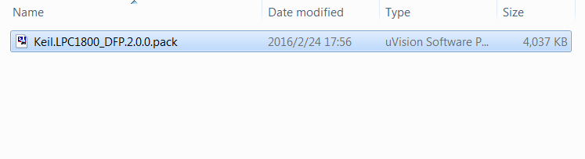

**Figure 1-1. iar_startup_qn9080t.s**

After install the *.pack file, its contents is uncompressed to the directory keil_v5 installation path\ARM\Pack.

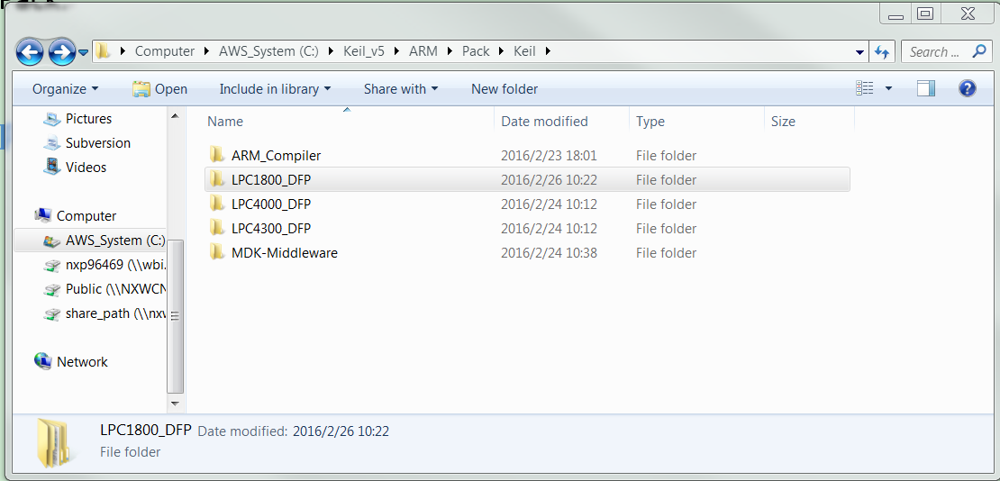

**Figure 1-2. Pack path**

## Components

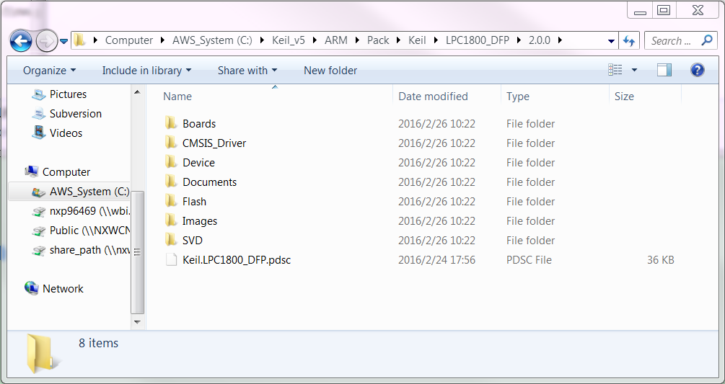

**Figure 1-3. Pack components**

**\*pdsc file:** The content of each [**Software Pack**](http://www.keil.com/pack/doc/CMSIS/Pack/html/_c_p__s_w_components.html) is described in the Pack Description (*.PDSC) file that is part of each **Pack**.

**Device:**

**Include:** [**device header files**](http://www.keil.com/pack/doc/CMSIS/Core/html/device_h_pg.html)

qn9080t.h, system.h

**Source:** [**system configuration files**](http://www.keil.com/pack/doc/CMSIS/Core/html/system_c_pg.html)

sysinit_qn9080t.c

**ARM:** [**startup files**](http://www.keil.com/pack/doc/CMSIS/Core/html/startup_s_pg.html)

keil_startup_qn9080t.s

**Flash:** [**Programming algorithms**](http://www.keil.com/pack/doc/CMSIS/Pack/html/_flash_algorithm.html) for microcontroller devices.

QN9080T.FLM

**CMSIS_Driver:** Examples of driver implementations adhering to [**CMSIS-Driver**](http://www.keil.com/pack/doc/CMSIS/Driver/html/index.html).

**Config:** Driver configuration file

RTE_Device.h

**SVD directory:** .svd file.

QN90xx.svd

**RTE_Components.h**

Sometimes, software components need to know of other components. Depending on the availability or configuration of another component, certain settings may be required. A distinct header file is available to make components aware of each other: **RTE_Components.h**. To add a line of C code to this header file, simply add this to your component:

The #define can be checked by other components in a project.

<RTE_Components_h>

#define RTE_MyVariant_Debug /* MyVariant Debug Version */

</RTE_Components_h>

The #define can be checked by other components in a project.

Note

The RTE_components.h file needs to be included somewhere in your source files.

## .pdsc file

The [**Pack Description (*.PDSC) Format**](http://www.keil.com/pack/doc/CMSIS/Pack/html/_pack_format.html) uses standard XML annotations and is defined in the schema file **PACK.xsd**.

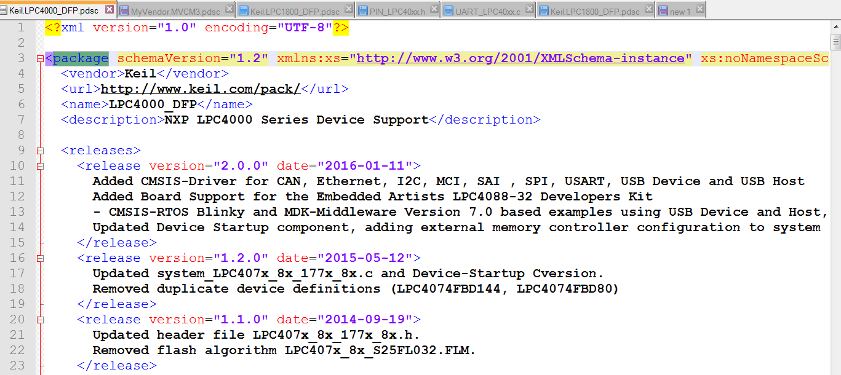

**Figure 1-4. Contents of .pdsc file**

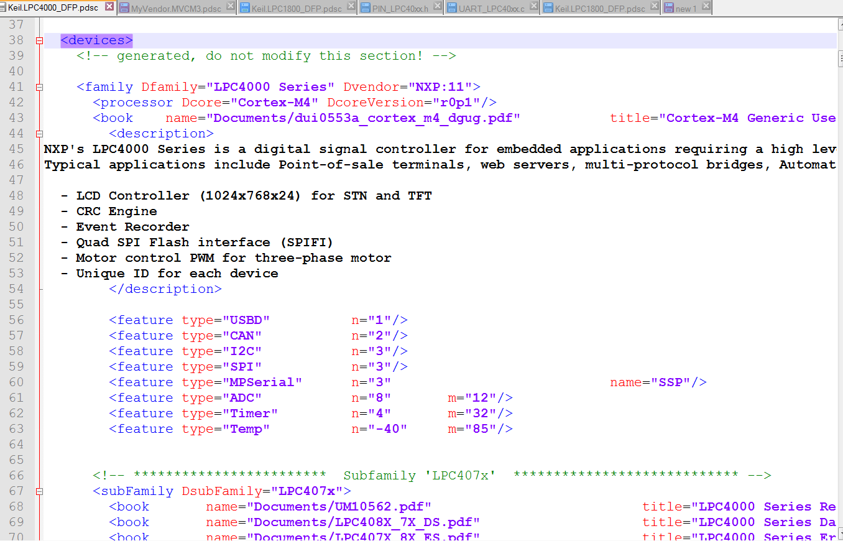

**Figure 1-5. Contents of .pdsc file**

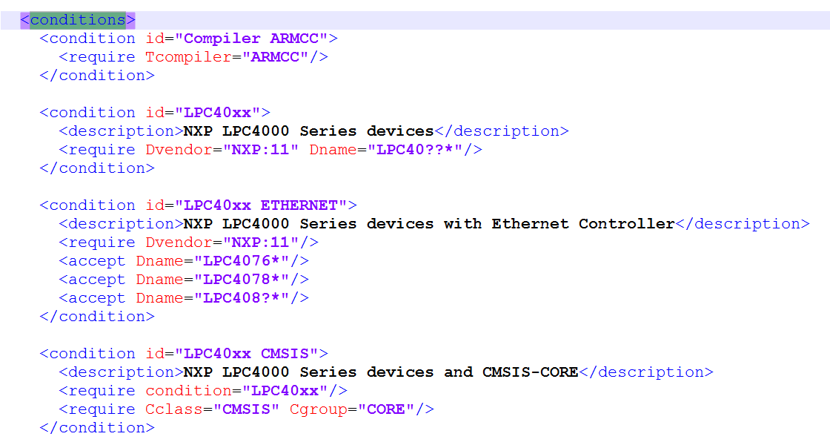

**Figure 1-6. Contents of .pdsc file**

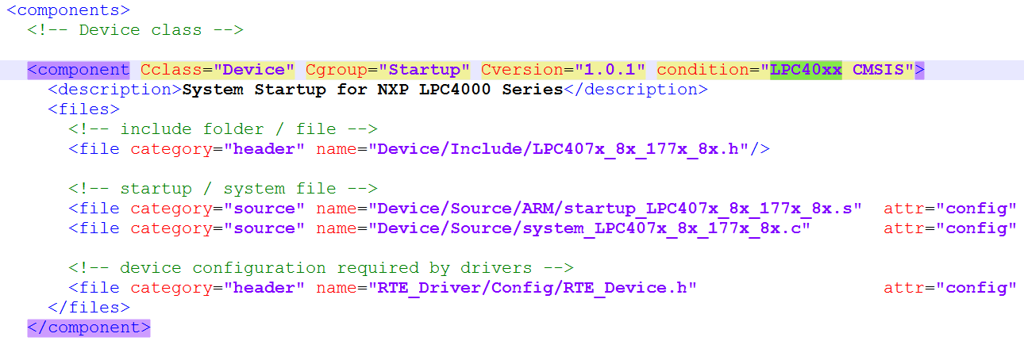

**Figure 1-7. Contents of .pdsc file**

More information, please reference the website page<< **Pack Description (*.PDSC) Format** >>,

<http://www.keil.com/pack/doc/CMSIS/Pack/html/_pack_format.html>

## .svd file

The CMSIS-SVD format is based on XML.

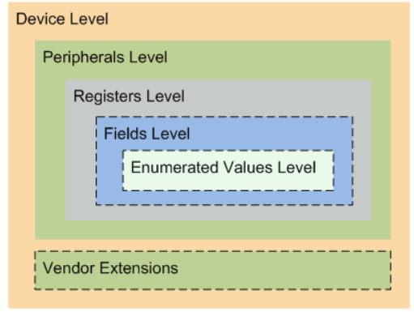

**Figure 1-8 .svd file**

One CMSIS-SVD file contains the description of a single device. A device consists of a processor and at least one peripheral. Each peripheral contains at least one register. A register may consist of one or more fields. The range of values for a field may be further described with enumerated values.

More Information please reference the website page << **SVD File Format** >>. <http://www.keil.com/pack/doc/CMSIS/SVD/html/svd__outline_pg.html>

# Create software packs

## Preparations

Install a 7zip on your PC.

## Steps to create a software pack

1. Create a working directory on you PC, for example **C:\LocalData\keil_pack_example**. And create a **Files** directory under it.
2. Copy the files under the directory Keil installation path\ARM\Pack\ARM\CMSIS\4.5.0\CMSIS\Pack\Example to the **Files** directory.

Rename the file “Keil.LPC1800_DFP.pdsc.txt” to “Keil.LPC1800_DFP.pdsc ”.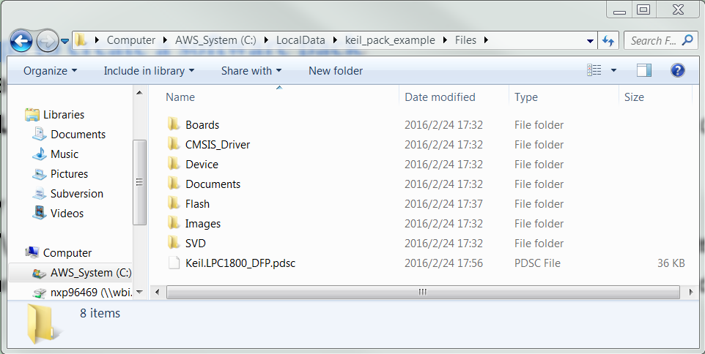

**Figure 2-1 Files directory**

1. Copy the file named “Keil.LPC1800_DFP.pdsc” to your work directory.

Copy the contents of the directory Keil installation path\ ARM\Pack\ARM\CMSIS\4.5.0\CMSIS\Utilities to your work directory.

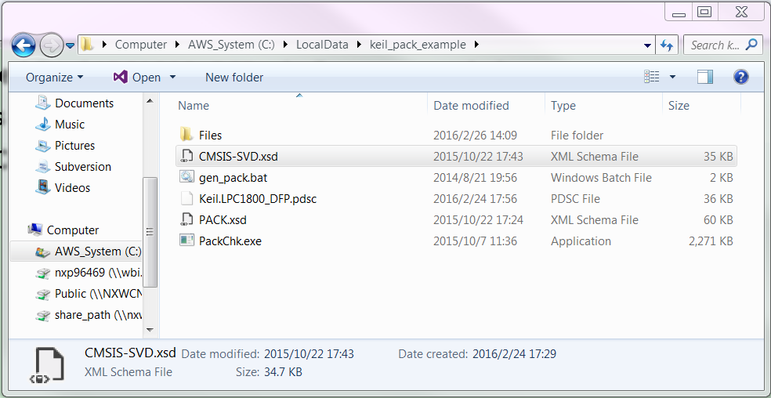

**Figure 2-2 Work directory**

1. Double click the gen_pack.bat file.

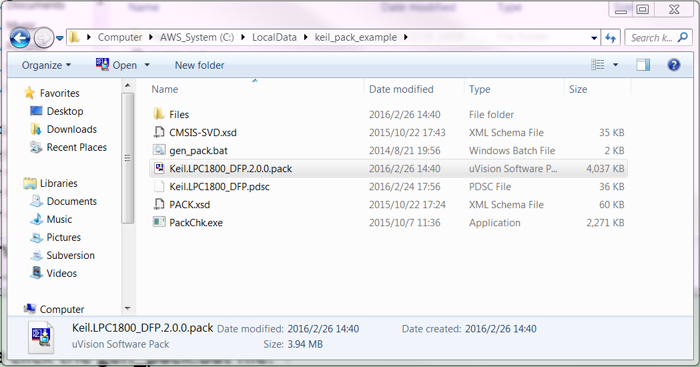

**Figure 2-2 Create packs**

More informations, please reference the website page << **Create Software Packs** >>.

http://www.keil.com/pack/doc/CMSIS/Pack/html/_c_p__packs.html