EMPLOYEE ATTRITION PREDICTION
USING AN ARTIFICIAL NEURAL NETWORK
A Mini Project Report
Neural Networks and Deep Learning
Submitted by:
Relebohile Irene Lesitsi
25MDA10001
in partial fulfillment for the award of the degree of
MASTER OF BUSINESS ADMINISTRATION
IN
(DATA SCIENCE AND ARTIFICIAL INTELLIGENCE)

Chandigarh University
Academic Year 2026–2027

ABSTRACT
Employee attrition is costly, and identifying employees at risk of leaving could help organisations act early. This project extends the Artificial Neural Network (ANN) built in Experiment 4 of the Neural Networks and Deep Learning laboratory into a complete attrition-prediction study using the IBM HR Analytics dataset (1,470 employees, of whom 16.1% left). The data was stored in and retrieved from an SQLite database, explored, cleaned and one-hot encoded into 44 input features, and split into 940 training, 236 validation and 294 test records, with scaling fitted on training data only to prevent leakage.
The Experiment 4 network over-fitted strongly (training AUC 1.00, validation AUC 0.79). It was improved with dropout, L2 regularisation, early stopping, class weights and a validation-selected decision threshold, with hyper-parameters chosen by a 27-configuration grid search on the validation set. An ablation study over 10 random seeds showed that the test ROC-AUC rose from 0.724 ± 0.030 to 0.758 ± 0.012 and the F1-score for leavers from 0.435 ± 0.044 to 0.497 ± 0.036.
The ANN was compared with Logistic Regression and Random Forest. Logistic Regression achieved the highest ROC-AUC (0.789), and bootstrap confidence intervals showed that its difference from the final ANN lies within sampling uncertainty, so no claim of ANN superiority is made. Permutation importance identified overtime, job level and job satisfaction as the most influential features. The report discusses limitations, including the small and simulated dataset, and outlines future work.
Keywords: artificial neural network, employee attrition, imbalanced classification, regularisation, dropout, early stopping, ROC-AUC, bootstrap

CONTENTS
CHAPTER 1 — INTRODUCTION 4
1.1 Background and Motivation 4
1.2 Problem Statement 4
1.3 Project Objectives 4
1.4 Scope of the Project 5
CHAPTER 2 — DATASET AND METHODOLOGY 6
2.1 Dataset Source and Description 6
2.2 Features and Target Variable 6
2.3 Exploratory Data Analysis 7
2.4 Data Preprocessing 9
2.5 Encoding and Scaling 10
2.6 Train, Validation and Test Split 10
2.7 ANN Architecture and Training Configuration 10
2.8 Comparison Models 12
2.9 Evaluation Metrics 12
CHAPTER 3 — IMPLEMENTATION 14
3.1 Tools and Technologies 14
3.2 Project Workflow 14
3.3 Model Training and Saving 15
3.4 Project Components 15
3.5 Prediction Process 15
3.6 Reproducibility and Testing 16
CHAPTER 4 — RESULTS AND DISCUSSION 17
4.1 Overview of Model Evaluation 17
4.2 Behaviour of the Baseline ANN 17
4.3 Ablation Study 18
4.4 Comparison of Model Performance 19
4.5 The Final ANN in Detail (Representative Run, Seed 42) 20
4.6 Statistical Uncertainty 22
4.7 Feature Importance 22
4.8 Error Analysis 23
4.9 Selection of the Final Model 23
4.10 Summary of Results 23
CHAPTER 5 — CONCLUSION AND FUTURE SCOPE 24
5.1 Conclusion 24
5.2 Limitations 24
5.3 Future Scope 25
5.4 Final Remarks 25
REFERENCES 26

CHAPTER 1

INTRODUCTION

1.1 Background and Motivation
Employee attrition, the loss of employees who choose to leave an organisation, is costly. Recruiting, onboarding and training a replacement takes time and money, and the departure of experienced staff can disrupt teams and projects. If human-resources (HR) teams could identify which employees are most at risk of leaving, they could investigate working conditions and offer support before the resignation happens.
Machine learning offers a data-driven way to do this. By learning from historical HR records, a classification model can estimate the probability that an employee will leave. Artificial Neural Networks (ANNs) are attractive because they can learn non-linear relationships and interactions between many employee attributes, such as overtime, job level, satisfaction scores and marital status, without these relationships being specified in advance.
This project builds directly on Experiment 4 of the Neural Networks and Deep Learning laboratory, in which employee data was stored in an SQLite database, retrieved with SQL, pre-processed and used to train a basic ANN. That baseline network reached an accuracy of 83.3% but detected only 30% of the employees who actually left, and its validation behaviour showed clear over-fitting. The present mini project investigates how far a carefully designed and regularised ANN can improve on that baseline, and how it compares with simpler models.

1.2 Problem Statement
Employee attrition is rare relative to retention (about one employee in six leaves in the dataset used here), depends on many interacting factors, and is difficult to predict from structured HR data. A naive classifier can reach a high accuracy simply by predicting that everybody stays, while failing to identify the employees who matter. This project addresses the problem of designing, training and rigorously evaluating an ANN for binary attrition prediction on imbalanced tabular data, quantifying the effect of each design decision, and comparing the ANN honestly against Logistic Regression and Random Forest.

1.3 Project Objectives
- Retrieve the IBM HR attrition data through SQLite and SQL, as practised in Experiment 4, and explore it to identify data-quality issues and the main drivers of attrition.
- Prepare numerical and categorical features correctly, avoiding data leakage by fitting the scaler on training data only.
- Implement the Experiment 4 ANN as a baseline and diagnose its over-fitting.
- Improve the network with dropout, L2 regularisation, early stopping, class weights and a validation-selected decision threshold, and measure each step in an ablation study repeated over 10 random seeds.
- Select hyper-parameters using a validation set only, keeping the test set untouched until the final evaluation.
- Compare the ANN with Logistic Regression and Random Forest using accuracy, precision, recall, F1-score, ROC-AUC and PR-AUC, and quantify uncertainty with bootstrap confidence intervals.
- Interpret the trained network using permutation feature importance and error analysis.

1.4 Scope of the Project
The project covers structured HR data, SQL-based data retrieval, exploratory analysis, pre-processing, ANN design and training, hyper-parameter selection, model comparison, interpretation and error analysis. The ANN is the central analytical component; Logistic Regression and Random Forest are used as reference models.
The work is an academic prototype carried out on a public, simulated dataset. Its predictions are probabilities that indicate relative risk and must not be used to make decisions about individual employees. No web application was built; a prediction function is demonstrated inside the notebook, and deployment is listed as future scope rather than as an implemented feature.

CHAPTER 2

DATASET AND METHODOLOGY

2.1 Dataset Source and Description
The project uses the IBM HR Analytics Employee Attrition and Performance dataset, available on Kaggle (https://www.kaggle.com/datasets/pavansubhasht/ibm-hr-analytics-attrition-dataset) and used in Experiment 4. The dataset is described by its publisher as a fictional dataset created by IBM data scientists; it is therefore suitable for learning and experimentation but does not describe the employees of any real organisation. For this report, an identical copy of the file (1,470 rows, 35 columns, 237 employees who left) was obtained from the IBM employee-attrition-aif360 repository on GitHub, and every figure in the report was produced by running the accompanying notebook on that copy.
Table 2.1 — Dataset characteristics
Characteristic | Description
Number of records | 1,470 employees
Number of columns | 35 (34 attributes plus the target)
Target variable | Attrition (Yes = left the company, No = stayed)
Class distribution | 1,233 stayed (83.9%); 237 left (16.1%)
Missing values | 0
Duplicate records | 0
Raw column types | 26 numeric columns; 9 text columns (including the target)
Task | Binary classification on structured tabular data

2.2 Features and Target Variable
Each record describes one employee through demographic information, job characteristics, compensation, satisfaction ratings and career history. The target variable is Attrition. The network learns to output the probability that an employee has left.
Table 2.2 — Feature groups
Feature group | Examples
Demographics | Age, Gender, MaritalStatus, Education, EducationField
Job characteristics | Department, JobRole, JobLevel, BusinessTravel, OverTime, DistanceFromHome
Compensation | MonthlyIncome, DailyRate, HourlyRate, MonthlyRate, PercentSalaryHike, StockOptionLevel
Satisfaction and engagement | JobSatisfaction, EnvironmentSatisfaction, RelationshipSatisfaction, JobInvolvement, WorkLifeBalance
Career history | TotalWorkingYears, YearsAtCompany, YearsInCurrentRole, YearsSinceLastPromotion, YearsWithCurrManager, NumCompaniesWorked, TrainingTimesLastYear
Removed columns | EmployeeCount, Over18, StandardHours (constant); EmployeeNumber (identifier)

2.3 Exploratory Data Analysis
Exploratory Data Analysis (EDA) was carried out on the data retrieved from the SQLite database. The dataset has no missing values and no duplicate records. Three columns (EmployeeCount, Over18 and StandardHours) contain a single value for all employees and therefore carry no information.
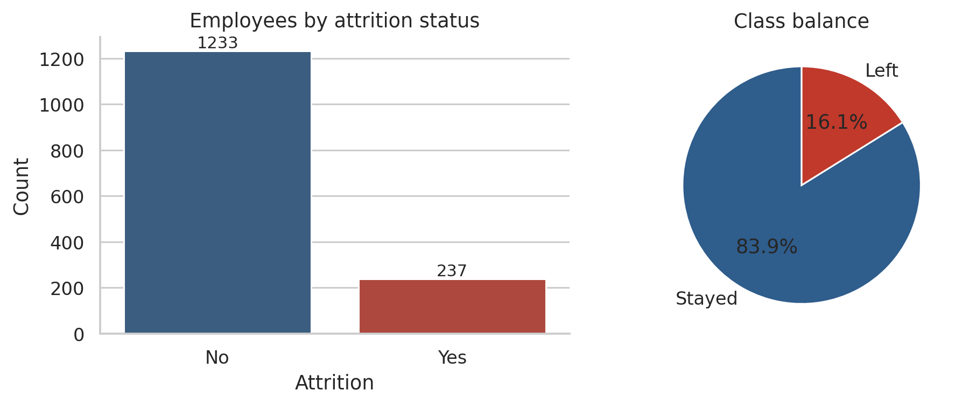
Figure 2.1 — Class distribution of the target variable
Only 16.1% of employees left, so the classes are imbalanced. A model that always predicts “stay” would be correct for about 84% of employees while detecting none of the leavers. Accuracy alone is therefore a misleading metric for this problem, and recall, precision, F1-score and the area-under-curve measures are used throughout.
An SQL aggregate query on the database gave the attrition rate for each department:
Table 2.3 — Attrition by department (SQL query result)
Department | Employees | Leavers | Attrition rate (%)
Sales | 446 | 92 | 20.63
Human Resources | 63 | 12 | 19.05
Research & Development | 961 | 133 | 13.84

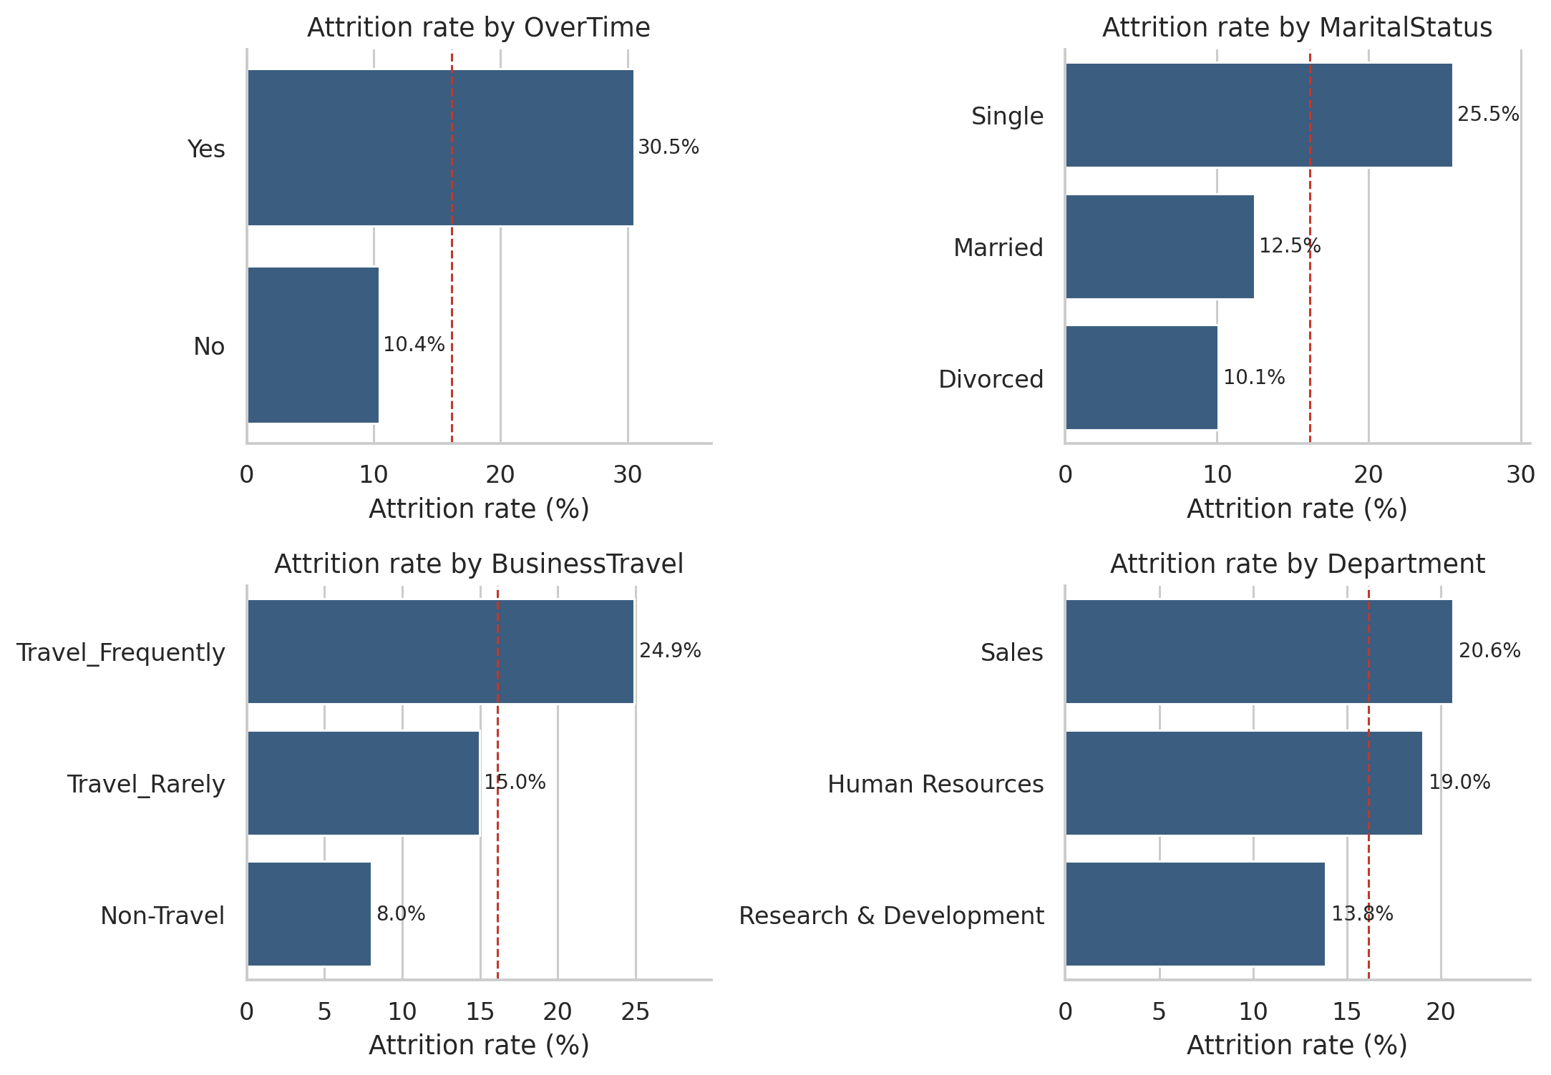
Figure 2.2 — Attrition rate by overtime, marital status, business travel and department
Overtime shows the strongest separation: 30.5% of employees who work overtime left, compared with 10.4% of those who do not. Single employees (25.5%) and employees who travel frequently (24.9%) also leave more often, and the Sales department has the highest attrition rate (20.6%).
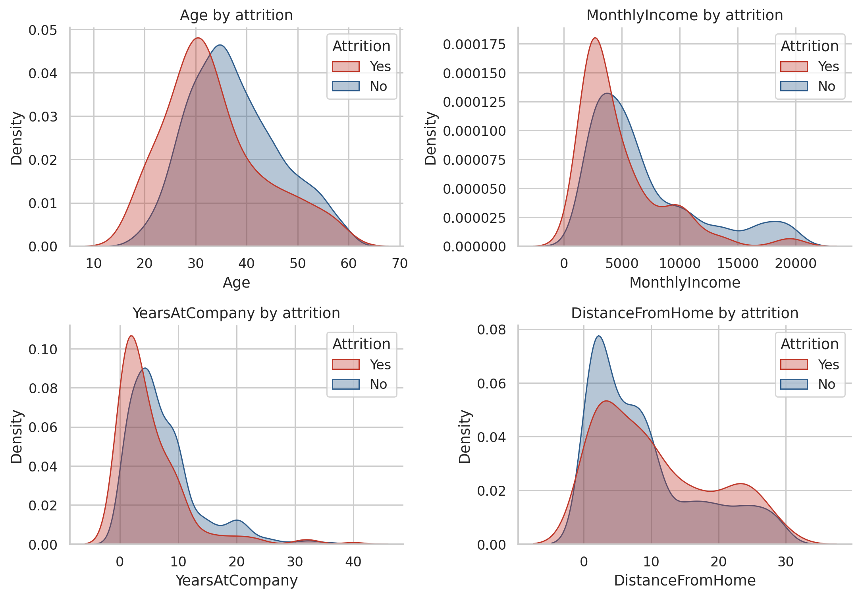
Figure 2.3 — Distributions of selected numeric variables by attrition status
Employees who left tended to be younger (median age 32 against 36 years), earned less (median monthly income 3,202 against 5,204), had shorter tenure (3 against 6 years at the company) and lived slightly further from work (9 against 7 km).
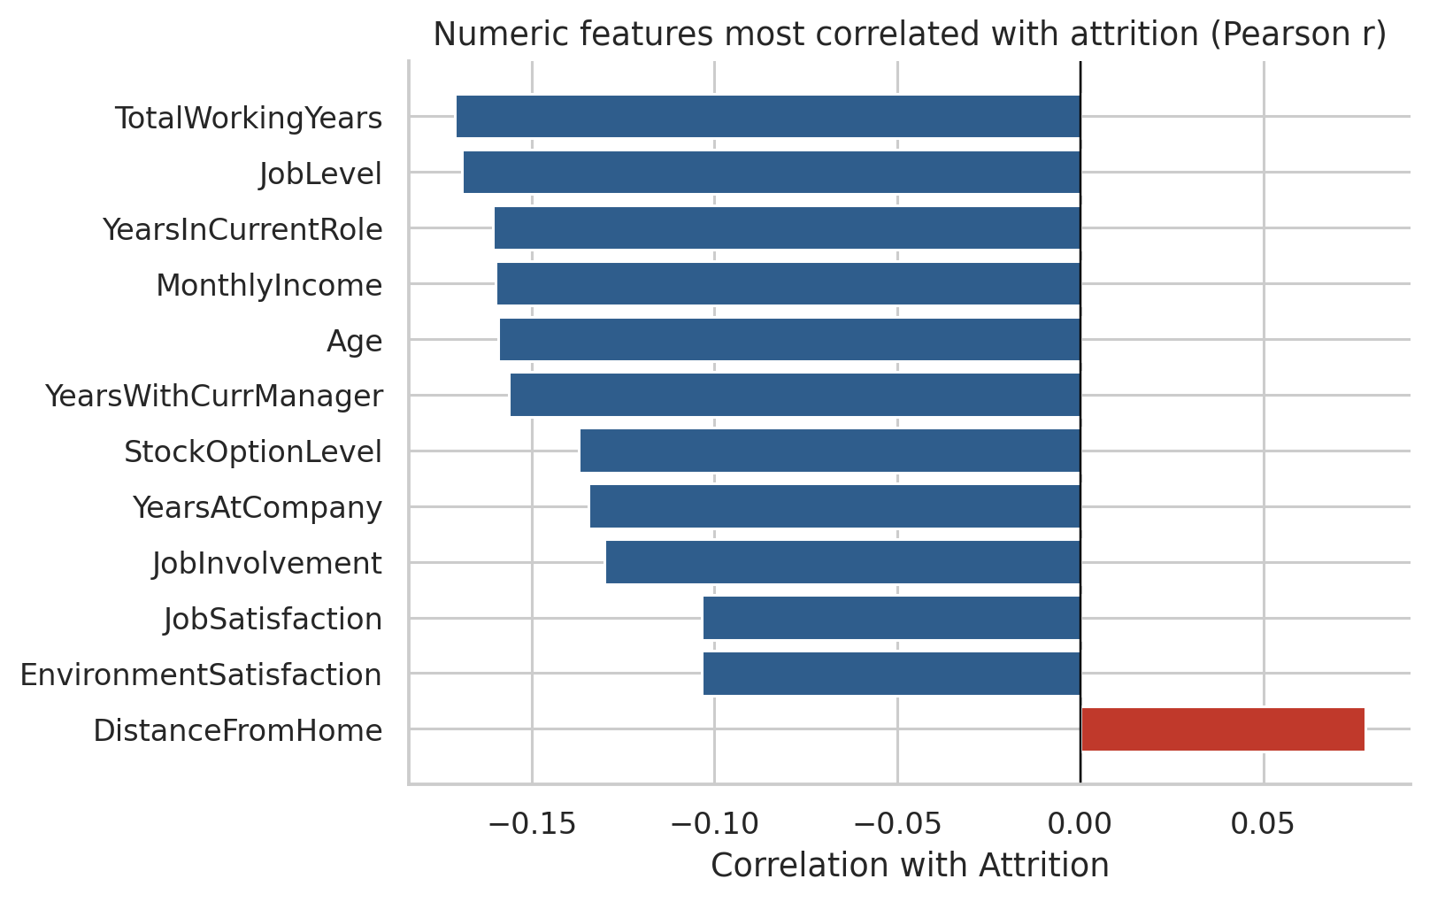
Figure 2.4 — Numeric features most correlated with attrition
No single numeric feature is strongly correlated with attrition (the largest absolute Pearson correlation is about 0.17). Experience, job level, tenure and income are all negatively correlated with leaving. The weak individual correlations suggest that attrition depends on combinations of factors, which is a reason to test a non-linear model such as an ANN, but also warns that the achievable predictive performance is limited.

2.4 Data Preprocessing
Pre-processing follows Experiment 4, with corrections that make the evaluation more reliable.
- Database retrieval. The CSV file is written to an SQLite database (employee_attrition.db, table EmployeeData) and read back with an SQL SELECT query.
- Column removal. The three constant columns and the identifier EmployeeNumber were dropped. An identifier can allow a network to memorise individuals instead of learning general patterns. Experiment 4 retained these columns (47 inputs); this project uses 44.
- Data quality checks. Missing values and duplicates were checked. None were found, so no imputation or row removal was required. (The median and mode imputation of Experiment 4 is kept in the notebook as a safeguard but changed nothing.)
- Target encoding. Attrition was mapped to 1 for “Yes” (left) and 0 for “No” (stayed).

2.5 Encoding and Scaling

2.5.1 Categorical Features
The 7 categorical features (BusinessTravel, Department, EducationField, Gender, JobRole, MaritalStatus and OverTime) were one-hot encoded with the first category dropped to avoid redundant columns. Together with the 23 numeric features this produces 44 input features for the network.

2.5.2 Numerical Features and Prevention of Data Leakage
Neural networks trained by gradient descent are sensitive to feature scale, so all inputs were standardised to zero mean and unit variance with StandardScaler. Importantly, the scaler was fitted on the training rows only and then applied unchanged to the validation and test rows. Fitting it on the whole dataset before splitting, as in Experiment 4, lets information about the test rows influence training, which can make results look slightly better than they really are.

2.6 Train, Validation and Test Split
The data was first divided 80:20 into training and test portions using stratified sampling and random_state = 42 (as in Experiment 4). The training portion was then divided 80:20 again into the final training set and a validation set. Stratification keeps the proportion of leavers (about 16%) the same in all three subsets. The validation set is used for early stopping, hyper-parameter selection and choosing the decision threshold; the test set is used only for the final evaluation.
Table 2.4 — Data split
Subset | Records | Leavers | Purpose
Training set | 940 | 152 | Fit model weights
Validation set | 236 | 38 | Early stopping, hyper-parameters, threshold
Test set | 294 | 47 | Final, unbiased evaluation
Total | 1470 | 237 | Complete dataset

The test set contains only 47 leavers. Conclusions drawn from it carry noticeable statistical uncertainty, which is quantified in Section 4.6.

2.7 ANN Architecture and Training Configuration
The ANN was implemented with TensorFlow/Keras as a fully connected feed-forward network for binary classification. Two networks are used.
- Baseline ANN (Experiment 4 setup). Dense layers of 64, 32, 8 and 16 ReLU units followed by a single sigmoid output; no regularisation; Adam optimiser; binary cross-entropy loss; 30 epochs; batch size 32. It has 5,385 trainable parameters.
- Final ANN. Three hidden layers of 64, 32, 16 ReLU units, each with L2 weight regularisation (λ = 0.01) followed by dropout (rate 0.5), and a sigmoid output. It has 5,505 trainable parameters.
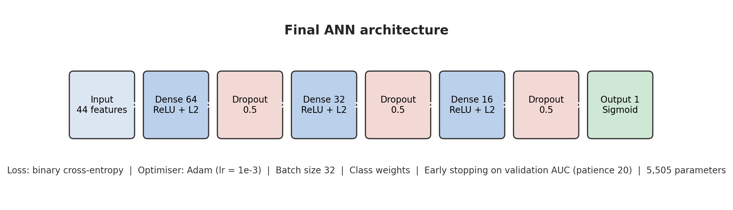
Figure 2.5 — Architecture of the final ANN
Table 2.5 — Training configuration of the final ANN
Parameter | Configuration
Input features | 44
Hidden layers | 64 → 32 → 16 neurons, ReLU activation
Output layer | 1 neuron, sigmoid activation (probability of leaving)
Regularisation | L2 = 0.01 on all hidden layers; dropout = 0.5
Loss function | Binary cross-entropy
Optimiser | Adam, learning rate 0.001
Batch size / maximum epochs | 32 / 200
Early stopping | Monitor validation AUC, patience 20 epochs, restore best weights
Class weights | Stayed = 0.596, Left = 3.092
Random seeds | 42 (representative run) and 1–9 (repeats)

2.7.1 Handling Class Imbalance
Because leavers are a minority, errors on them contribute little to the unweighted loss, and the network can achieve a low loss by favouring “stay”. Class weights inversely proportional to class frequency (0.596 for stayers and 3.092 for leavers) make an error on a leaver about five times as costly during training.

2.7.2 Regularisation and Early Stopping
Dropout randomly disables a fraction of neurons in each training step so the network cannot depend on any single neuron; L2 regularisation penalises large weights. Early stopping halts training when the validation ROC-AUC has not improved for 20 epochs and restores the weights from the best epoch. Together they address the over-fitting visible in the baseline network.

2.7.3 Hyper-parameter Selection
A grid of 27 configurations was evaluated: three network widths (32-16, 64-32-16 and 128-64-32), three dropout rates (0.2, 0.3, 0.5) and three L2 strengths (0.0001, 0.001, 0.01). Each configuration was trained with three seeds and ranked by mean validation ROC-AUC; the test set was not used. The best configuration (64-32-16, dropout 0.5, L2 0.01) reached a mean validation AUC of 0.8324.
Table 2.6 — Five best configurations in the grid search (validation ROC-AUC, mean of 3 seeds)
Rank | Hidden units | Dropout | L2 | Validation AUC
1 | 64-32-16 | 0.5 | 0.01 | 0.8324 ± 0.0086
2 | 64-32-16 | 0.3 | 0.0001 | 0.8315 ± 0.0060
3 | 64-32-16 | 0.3 | 0.001 | 0.8314 ± 0.0038
4 | 64-32-16 | 0.3 | 0.01 | 0.8302 ± 0.0046
5 | 64-32-16 | 0.5 | 0.0001 | 0.8293 ± 0.0019

The 27 configurations span a narrow range of validation AUC (0.810 to 0.832), so the model is not very sensitive to these settings and the top-ranked configurations are practically equivalent.

2.7.4 Decision Threshold
The network outputs a probability. By default a probability of at least 0.5 is classified as “leave”, but with imbalanced classes 0.5 is rarely the best operating point. The final decision threshold was chosen as the value between 0.05 and 0.95 that maximises the F1-score for leavers on the validation set, never on the test set.

2.8 Comparison Models
Logistic Regression (maximum 2,000 iterations, balanced class weights) was used as a linear baseline. Random Forest (300 trees, minimum 2 samples per leaf, balanced class weights) was used as a non-linear tree-ensemble reference, repeated over the same 10 random seeds as the ANN. All models were trained on the same training rows and evaluated on the same test rows.

2.9 Evaluation Metrics
For a binary classifier, TP, TN, FP and FN denote true positives (leavers correctly identified), true negatives, false positives (false alarms) and false negatives (leavers missed).

2.9.1 Accuracy
The proportion of all predictions that are correct. It can be misleading with imbalanced classes.
Accuracy = (TP + TN) / (TP + TN + FP + FN)

2.9.2 Precision and Recall
Precision is the proportion of employees flagged as likely leavers who actually left. Recall (sensitivity) is the proportion of actual leavers that were identified.
Precision = TP / (TP + FP) Recall = TP / (TP + FN)

2.9.3 F1-score
The harmonic mean of precision and recall, giving a single score that balances both.
F1 = 2 × Precision × Recall / (Precision + Recall)

2.9.4 ROC-AUC
The area under the Receiver Operating Characteristic curve, which plots the true-positive rate against the false-positive rate over all thresholds. It measures how well the model ranks leavers above stayers, independently of the threshold: 0.5 is random ranking and 1.0 is perfect.

2.9.5 PR-AUC (Average Precision)
The area under the precision–recall curve. It is more informative than ROC-AUC when the positive class is rare; the no-skill level equals the proportion of leavers (about 0.16 in the test set).

CHAPTER 3

IMPLEMENTATION

3.1 Tools and Technologies
Table 3.1 — Tools and technologies
Technology | Purpose
Python 3.12.3 | Programming language
SQLite (sqlite3) | Storing and querying the employee data with SQL
Pandas 3.0.2 and NumPy 2.4.4 | Data manipulation and numerical operations
Matplotlib and Seaborn | Visualisation of data and model performance
TensorFlow 2.21.0 / Keras 3.15.1 | Building, training and saving the ANN
Scikit-learn 1.8.0 | Splitting, scaling, comparison models and evaluation metrics
Joblib | Saving the fitted scaler
Jupyter Notebook | Interactive development and the executed project record
Kaggle / IBM GitHub repository | Dataset source

3.2 Project Workflow
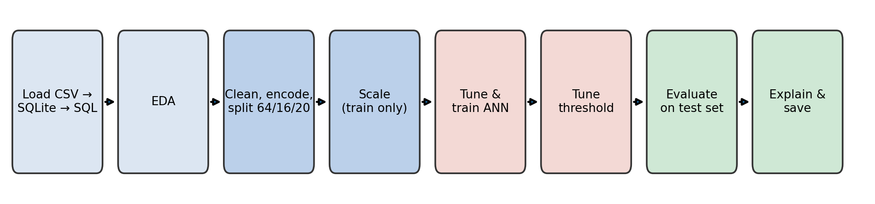
Figure 3.1 — Project workflow
- Load the HR dataset, store it in an SQLite database and retrieve it with an SQL query.
- Explore the data: class balance, missing values, duplicates and relationships with attrition.
- Remove constant and identifier columns, one-hot encode categorical features and split into training, validation and test sets.
- Standardise the features using statistics from the training set only.
- Select hyper-parameters with a grid search on the validation set.
- Train the baseline ANN and the four improved variants (ablation study) over 10 random seeds.
- Select the decision threshold on the validation set.
- Evaluate on the untouched test set, compare with Logistic Regression and Random Forest, and quantify uncertainty by bootstrapping.
- Interpret the final network with permutation importance and error analysis; save the model.

3.3 Model Training and Saving
Every model was trained on the training subset only. The validation subset was used for monitoring and selection, and the test subset was used once for evaluation. Seeds for Python, NumPy and TensorFlow were set before each run so the results can be reproduced. The representative final network (seed 42) stopped after 38 epochs, because its validation AUC peaked at epoch 18 and did not improve during the following 20 epochs; the weights from epoch 18 were restored.
The trained network was saved as models/final_ann_attrition.keras, the fitted scaler as models/scaler.joblib, and the feature list and decision threshold as models/model_config.json, so that predictions can be made without retraining.

3.4 Project Components
Table 3.2 — Project files
File / folder | Responsibility
Employee_Attrition_ANN_Mini_Project.ipynb | Complete executed notebook: data, EDA, models, evaluation and figures
data/ | Raw dataset (kept separate from derived files)
models/ | Saved ANN, scaler and configuration
figures/ | All figures used in this report
outputs/ | Grid-search results, per-seed ablation results, comparison table, feature importance, bootstrap results

3.5 Prediction Process
- The employee’s attributes are arranged in the same 44-column structure used in training.
- The saved scaler standardises the values.
- The saved ANN outputs the probability of leaving.
- The probability is compared with the saved decision threshold (0.70); at or above it the employee is flagged as high risk.
The notebook demonstrates this process on three test employees:
Table 3.3 — Prediction demonstration (final ANN, seed 42)
Test row | Actual outcome | Predicted probability | Decision
4 | Left | 0.491 | Likely to stay
0 | Stayed | 0.714 | HIGH RISK of leaving
35 | Left | 0.744 | HIGH RISK of leaving

The three examples include a correct detection, a missed leaver and a false alarm. They illustrate that the model produces risk estimates, not certainties.

3.6 Reproducibility and Testing
The whole notebook was executed from start to finish, and all numbers in this report were taken from that execution. As an integration check, the saved model and scaler were reloaded from disk in a fresh session and reproduced the test ROC-AUC of the original run (0.740), confirming that the saved artefacts are complete. The model’s predictive quality is established by the held-out test metrics in Chapter 4, not by the fact that the code runs.

CHAPTER 4

RESULTS AND DISCUSSION

4.1 Overview of Model Evaluation
All results are reported on the held-out test set of 294 employees, of whom 47 left. Because a single training run of a neural network depends on its random initialisation, each ANN variant was trained with 10 different seeds and results are given as mean ± standard deviation. Seed 42 was fixed in advance as the representative run used for the curves and confusion matrices. A classifier that predicts “stay” for everyone would score an accuracy of 0.840 on this test set, which is the reference against which accuracy values should be read.

4.2 Behaviour of the Baseline ANN
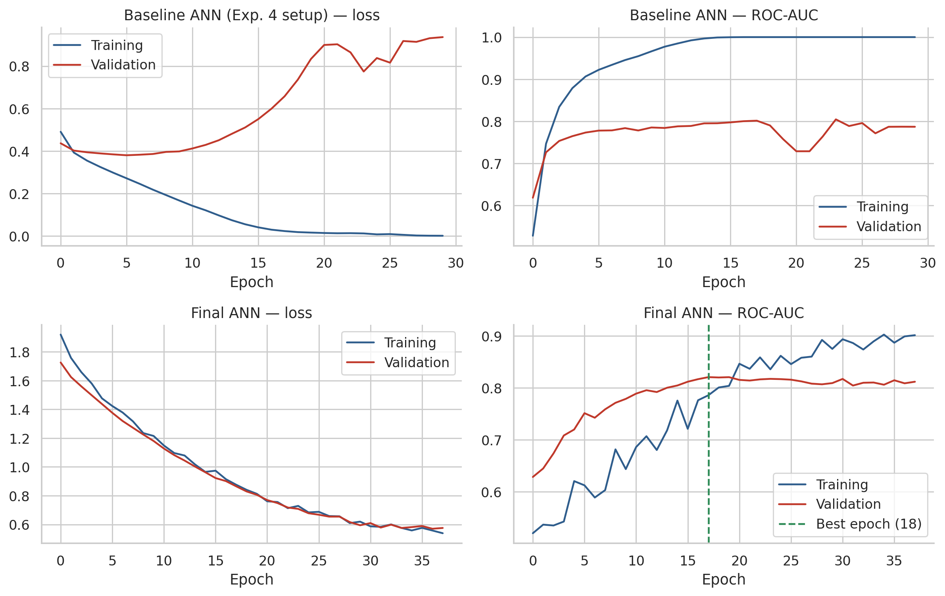
Figure 4.1 — Training and validation curves: baseline ANN (top) and final ANN (bottom)
The baseline network over-fits strongly. Its training loss falls to 0.0015 and its training AUC reaches 1.00, meaning that it has memorised the training employees, while its validation loss is lowest at epoch 6 (0.380) and then rises to 0.936 by the final epoch. The validation AUC stalls at about 0.79. The same pattern appears in the Experiment 4 notebook, where the final test loss (0.92) was more than twice its early-epoch validation loss.
The final ANN behaves very differently. Training and validation losses decrease together, and the validation AUC peaks at epoch 18 (0.821) before training is stopped. The gap between training and validation performance is much smaller.

4.3 Ablation Study
To measure the contribution of each technique, improvements were added one at a time. V0 is the Experiment 4 setup; V1 adds early stopping; V2 changes to the 64-32-16 architecture with dropout and L2 regularisation; V3 adds class weights; V4 keeps the V3 network but replaces the 0.5 threshold with the validation-selected threshold.
Table 4.1 — Ablation results on the test set (mean ± std over 10 seeds)
Variant | Accuracy | Precision | Recall | F1 | ROC-AUC
V0 Baseline ANN (Exp. 4) | 0.83 ± 0.02 | 0.49 ± 0.06 | 0.40 ± 0.06 | 0.44 ± 0.04 | 0.724 ± 0.030
V1 + Early stopping | 0.85 ± 0.01 | 0.56 ± 0.22 | 0.27 ± 0.17 | 0.34 ± 0.17 | 0.751 ± 0.018
V2 + Dropout and L2 regularisation | 0.86 ± 0.02 | 0.42 ± 0.36 | 0.20 ± 0.18 | 0.27 ± 0.23 | 0.765 ± 0.016
V3 + Class weights | 0.75 ± 0.08 | 0.36 ± 0.05 | 0.66 ± 0.09 | 0.46 ± 0.04 | 0.758 ± 0.012
V4 + Tuned decision threshold | 0.85 ± 0.01 | 0.54 ± 0.05 | 0.47 ± 0.05 | 0.50 ± 0.04 | 0.758 ± 0.012

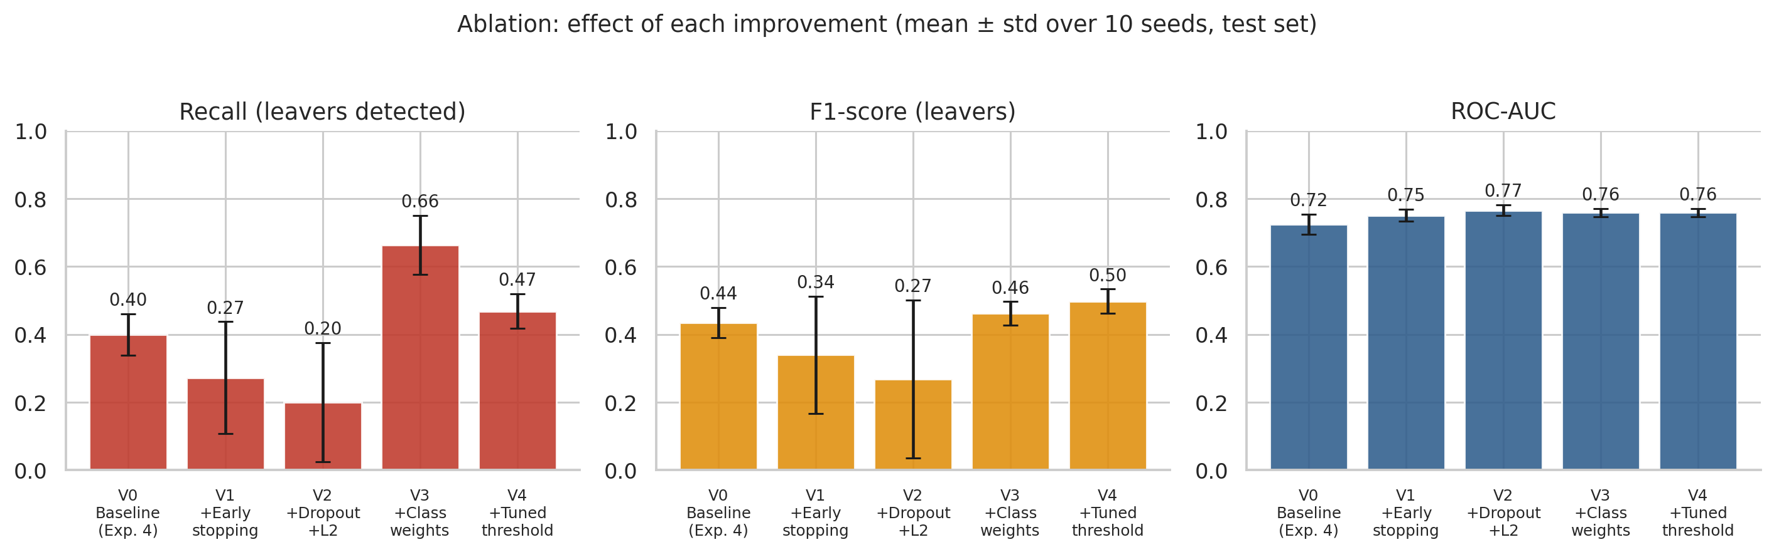
Figure 4.2 — Effect of each improvement on recall, F1-score and ROC-AUC
Ranking quality improved with regularisation. ROC-AUC rose from 0.724 (baseline) to 0.751 with early stopping and 0.765 with dropout and L2 regularisation, and its variation between seeds fell from 0.030 to 0.016. The regularised network is both better and more stable.
Threshold-based metrics need care. At the default 0.5 threshold, V1 and V2 detect fewer leavers (recall 0.27 and 0.20) than the baseline (0.40). The reason is not poorer ranking, since their AUC is higher, but that a network trained on imbalanced data rarely outputs probabilities above 0.5 for the minority class, and the more regularised it is, the more conservative it becomes. The large standard deviations (up to 0.18) show that these operating points are unstable.
Class weights move the operating point, not the ranking. Adding class weights (V3) raised recall to 0.66 at the cost of precision (0.36) and accuracy (0.75), while ROC-AUC (0.758) stayed within one standard deviation of V2 (0.765). Class weights therefore change the balance between catching leavers and raising false alarms rather than making the network a better ranker.
Threshold tuning gives the best balance. Choosing the threshold on the validation set (V4) produced the best F1-score of the five variants (0.497 compared with 0.435 for the baseline), with precision 0.54, recall 0.47 and accuracy 0.85. The selected thresholds ranged from 0.56 to 0.80 across seeds (0.70 for seed 42), which reflects the small number of leavers (38) in the validation set. The F1 improvement of about 0.06 over the baseline is real but modest, roughly 1.5 standard deviations.

4.4 Comparison of Model Performance
Table 4.2 — Model comparison on the test set (mean ± std; Logistic Regression is deterministic)
Model | Accuracy | Precision | Recall | F1 | ROC-AUC | PR-AUC
Logistic Regression | 0.78 | 0.39 | 0.68 | 0.49 | 0.789 ± 0.000 | 0.536 ± 0.000
Random Forest | 0.83 | 0.38 | 0.10 | 0.15 | 0.754 ± 0.007 | 0.371 ± 0.009
Baseline ANN (Exp. 4 setup) | 0.83 | 0.49 | 0.40 | 0.44 | 0.724 ± 0.030 | 0.468 ± 0.018
Final ANN, threshold 0.5 | 0.75 | 0.36 | 0.66 | 0.46 | 0.758 ± 0.012 | 0.520 ± 0.038
Final ANN, tuned threshold | 0.85 | 0.54 | 0.47 | 0.50 | 0.758 ± 0.012 | 0.520 ± 0.038
Logistic Regression, tuned threshold | 0.82 | 0.45 | 0.49 | 0.47 | 0.789 ± 0.000 | 0.536 ± 0.000
Random Forest, tuned threshold | 0.81 | 0.39 | 0.38 | 0.38 | 0.754 ± 0.007 | 0.371 ± 0.009

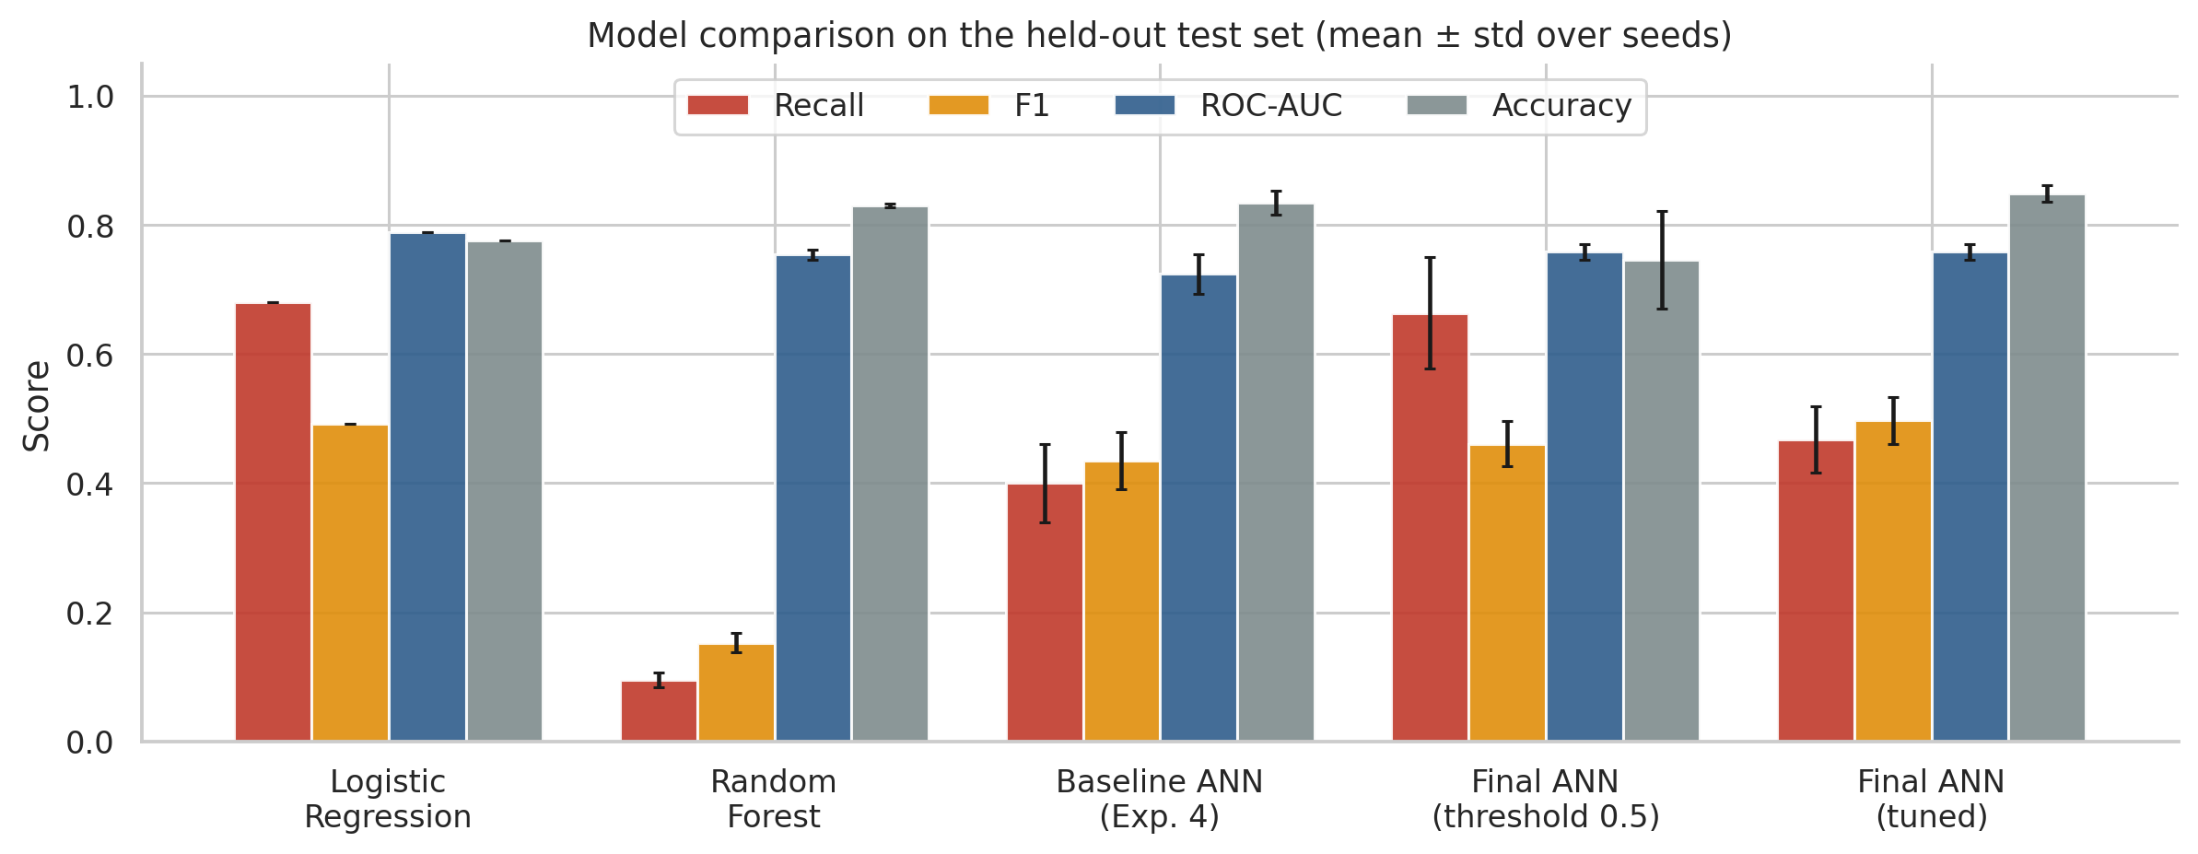
Figure 4.3 — Model comparison on the test set
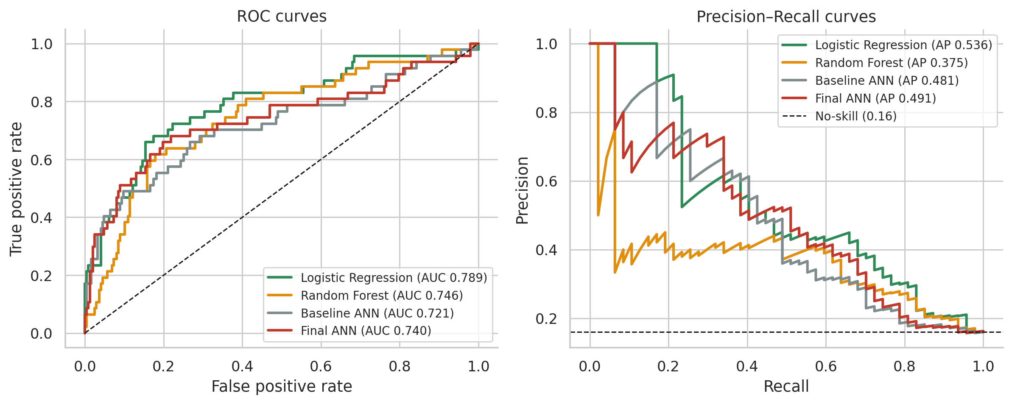
Figure 4.4 — ROC and precision–recall curves (representative runs)
Logistic Regression achieved the highest ROC-AUC (0.789) and PR-AUC (0.536) and the highest recall at the default threshold (0.68). The final ANN ranked employees somewhat less well (ROC-AUC 0.758) but, with a tuned threshold, gave the highest F1-score (0.497) and accuracy (0.85) in the table, although its F1 advantage over Logistic Regression (0.492 at 0.5, 0.469 with a tuned threshold) is small. Random Forest had an ROC-AUC similar to the ANN (0.754) but, at the default threshold, flagged almost no leavers (recall 0.10) despite an accuracy of 0.83, which is almost exactly the accuracy of predicting “stay” for everybody. Its accuracy is therefore not evidence of useful performance. The regularised ANN clearly outperformed the baseline ANN.
Logistic Regression performing so well is not unusual. With about a thousand training examples, many weakly informative features and relationships that are largely monotonic (for example, lower income and shorter tenure go with higher attrition), a linear model has little to lose by being simple, while a neural network with more than five thousand parameters has more room to fit noise. This is a common finding for small tabular datasets.

4.5 The Final ANN in Detail (Representative Run, Seed 42)
With the threshold chosen on the validation set (0.70), the representative final network classified the test employees as shown in Figure 4.6 and Table 4.3. For comparison, the baseline network of the same seed is shown beside it.
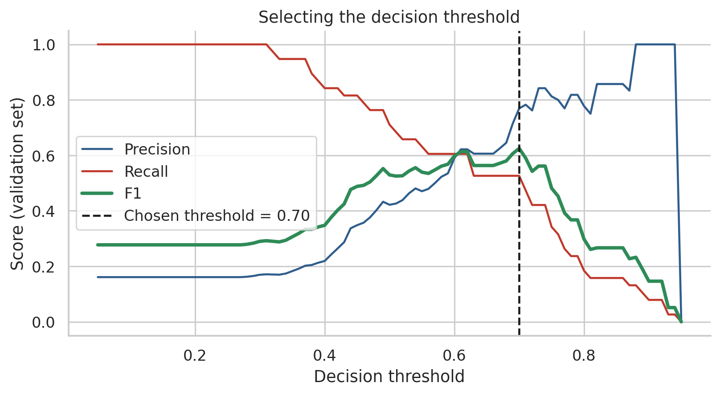
Figure 4.5 — Choosing the decision threshold on the validation set
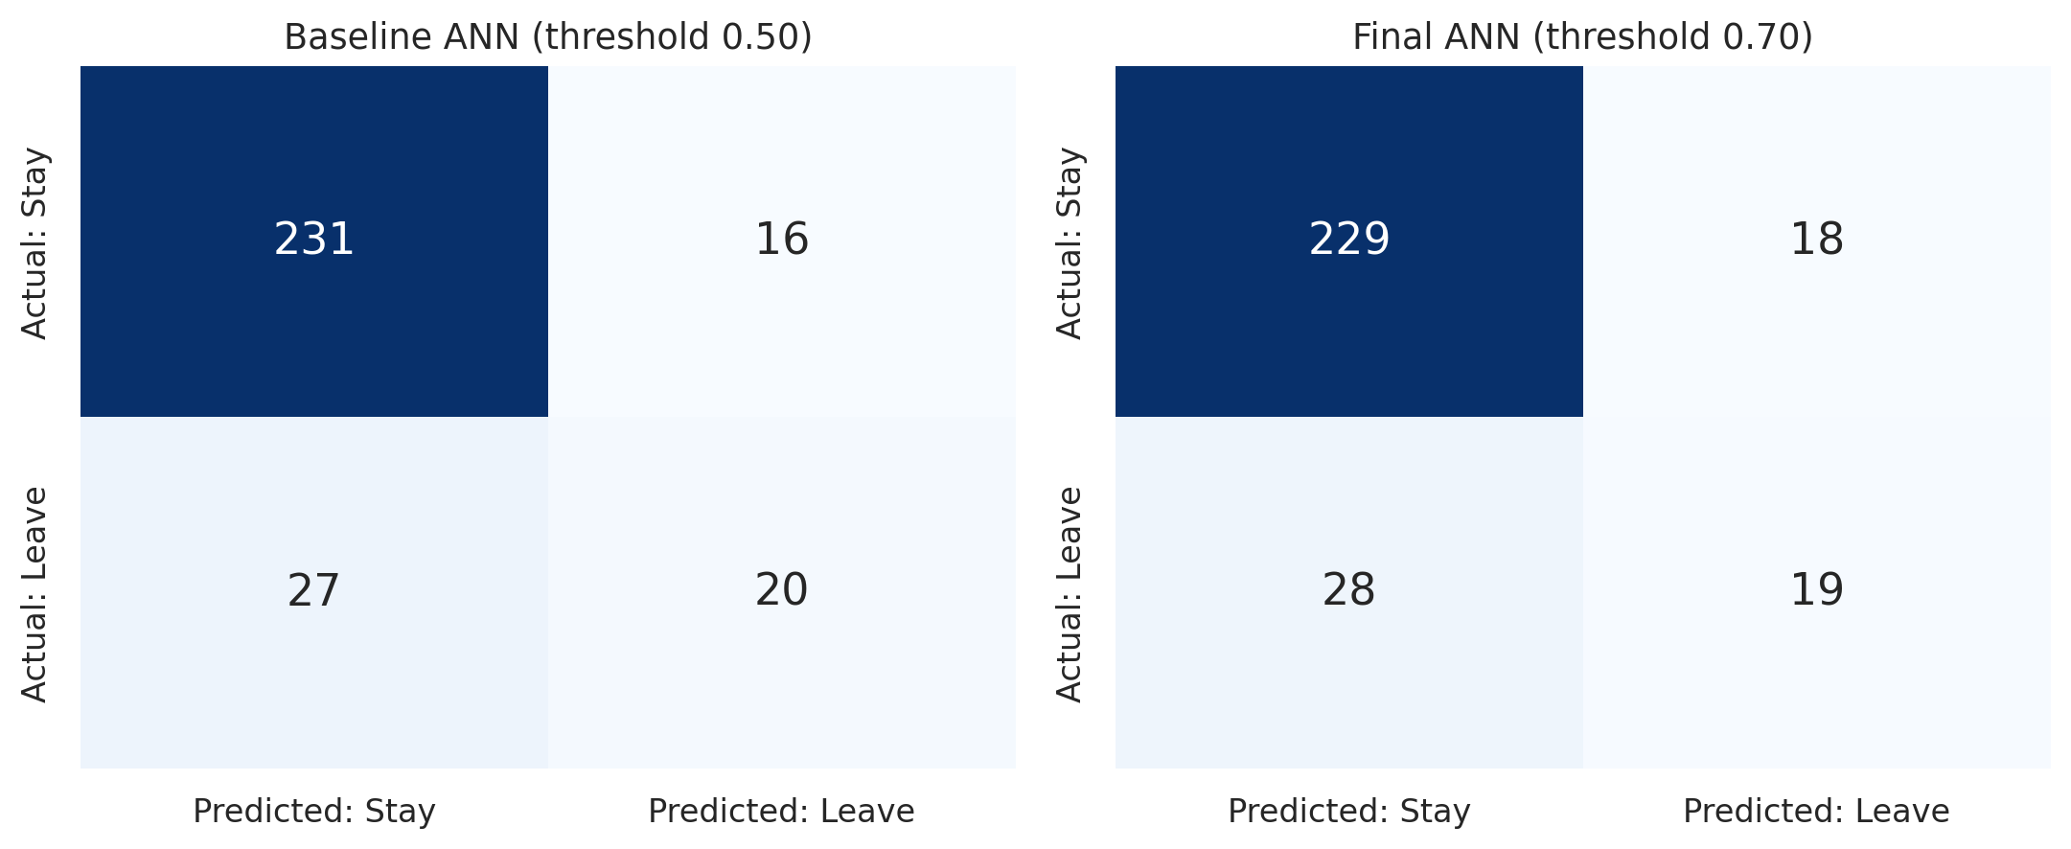
Figure 4.6 — Confusion matrices on the test set: baseline ANN (left) and final ANN (right)
Table 4.3 — Representative run (seed 42) on the test set
Metric | Baseline ANN (0.50) | Final ANN (0.50) | Final ANN (0.70)
Accuracy | 0.854 | 0.765 | 0.844
Precision (leavers) | 0.556 | 0.369 | 0.513
Recall (leavers) | 0.425 | 0.660 | 0.404
F1-score (leavers) | 0.482 | 0.473 | 0.452
ROC-AUC | 0.721 | 0.740 | 0.740
PR-AUC | 0.481 | 0.491 | 0.491

At threshold 0.70 the final network identified 19 of the 47 leavers and missed 28, with 18 false alarms among 247 employees who stayed. Seed 42 happens to be a below-average seed for the final ANN (ROC-AUC 0.740 against a 10-seed mean of 0.758), and for this seed the baseline network happened to score a slightly higher F1 (0.482 against 0.452) than the final network, although its ROC-AUC (0.721) was lower. This illustrates why conclusions should rest on the 10-seed averages in Section 4.3 rather than on a single run. The validation AUC of this run (0.820) is higher than its test AUC because the hyper-parameters, early-stopping epoch and threshold were all selected on the validation set, and because that set contains only 38 leavers.

4.6 Statistical Uncertainty
With only 47 leavers in the test set, a model’s measured performance could change noticeably with a different sample of employees. To quantify this, the test set was resampled 2,000 times (bootstrap) and 95% confidence intervals were computed for the representative final ANN and for Logistic Regression, using the same threshold (0.70) for both.
Table 4.4 — Bootstrap 95% confidence intervals on the test set
Quantity | Final ANN (seed 42) | Logistic Regression | Difference (ANN − LR)
ROC-AUC | 0.740 [0.642, 0.826] | 0.789 [0.706, 0.862] | [-0.114, 0.006]
F1-score | 0.452 [0.298, 0.575] | 0.469 [0.333, 0.583] | [-0.124, 0.087]

The confidence intervals are wide: each model’s ROC-AUC is uncertain by roughly ±0.08 to ±0.09. The interval for the AUC difference only just includes zero, and the interval for the F1 difference comfortably includes zero. The data therefore do not allow a confident claim that either model is better. The safe conclusion is that Logistic Regression ranks employees at least as well as the ANN on this dataset, that the ANN’s advantage in F1 is not statistically meaningful, and that the clear improvement of the regularised ANN over the baseline ANN is supported by the consistent 10-seed results.

4.7 Feature Importance
Permutation importance measures how much the test ROC-AUC (0.740) falls when a single feature’s values are randomly shuffled (20 repetitions), breaking its relationship with the outcome.
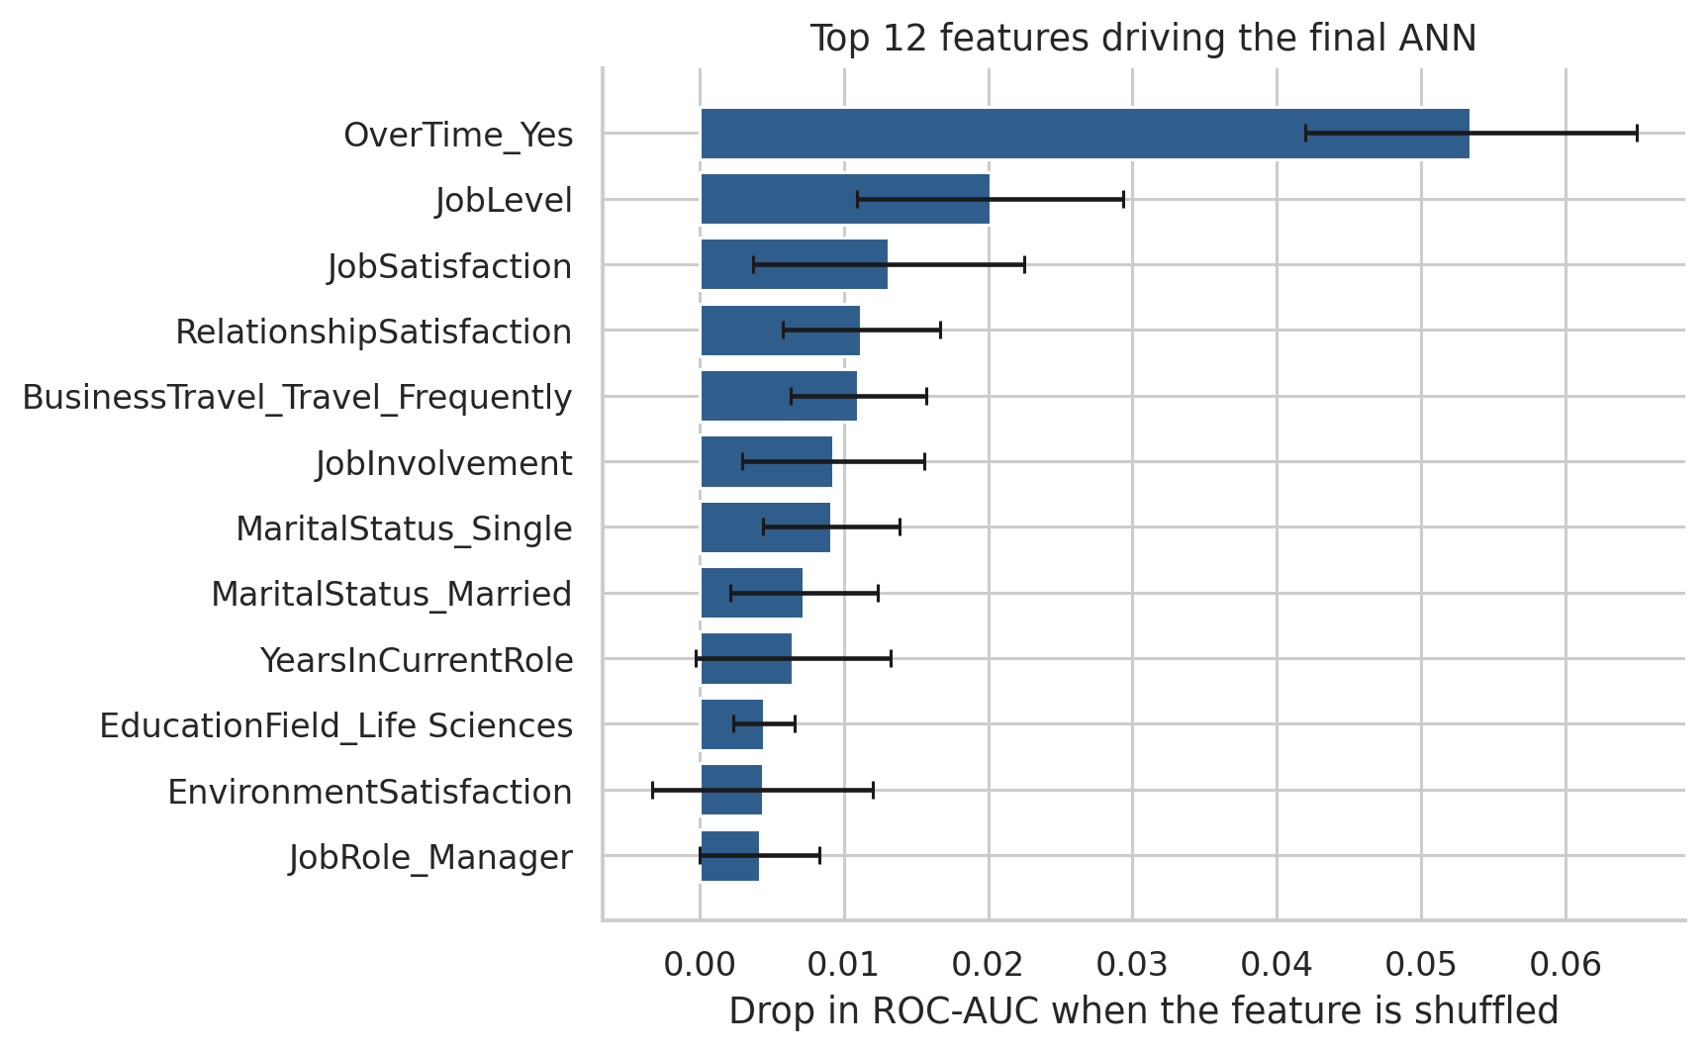
Figure 4.7 — Permutation importance of the twelve most influential features
OverTime is by far the most influential feature (AUC drop 0.053), more than twice that of the next feature, JobLevel (0.020), followed by JobSatisfaction (0.013), RelationshipSatisfaction, frequent business travel, JobInvolvement and marital status. This agrees with the exploratory analysis, where overtime separated leavers from stayers most clearly. The individual importances are small in absolute terms because many correlated features share the same information, and permutation importance describes what this particular model relies on, not what causes employees to leave.

4.8 Error Analysis
Table 4.5 — Final ANN (seed 42) errors by overtime status on the test set
Group | Employees | Actual leavers | Detected | Missed | False alarms | Recall
OverTime = Yes | 76 | 30 | 14 | 16 | 3 | 0.47
OverTime = No | 218 | 17 | 5 | 12 | 15 | 0.29
All employees | 294 | 47 | 19 | 28 | 18 | 0.40

The network is better at detecting leavers who work overtime (recall 0.47, with only 3 false alarms) than those who do not (recall 0.29, with 15 false alarms). Leavers without overtime are harder to identify because the dataset contains few other strong signals for them, and 12 of the 28 missed leavers belong to this group. These counts are small, so the percentages are indicative only.

4.9 Selection of the Final Model
For the purposes of this ANN-focused project, the final model is the regularised ANN with class weights and a validation-selected threshold (V4). It is clearly better than the Experiment 4 baseline in ranking quality, stability and F1-score. However, this report does not claim that the ANN is the best possible model for the problem: Logistic Regression ranks employees at least as well and is simpler and easier to explain. In a practical HR setting, the choice between them would depend on whether interpretability, recall or precision matters most.

4.10 Summary of Results
- The Experiment 4 ANN over-fits (training AUC 1.00, validation AUC 0.79) and detects only about 40% of leavers on average.
- Dropout, L2 regularisation and early stopping raised test ROC-AUC from 0.724 to about 0.77 and reduced variability between seeds.
- Class weights and a validation-selected threshold gave the best F1-score (0.497 against 0.435) at precision 0.54 and recall 0.47.
- Logistic Regression achieved the highest ROC-AUC (0.789); differences between it and the final ANN are within sampling uncertainty.
- Overtime, job level and job satisfaction are the features the network relies on most.

CHAPTER 5

CONCLUSION AND FUTURE SCOPE

5.1 Conclusion
This project extended the ANN of Experiment 4 into a complete and carefully evaluated attrition-prediction study. The data was retrieved through SQL, explored, cleaned and pre-processed without data leakage; the baseline network was shown to over-fit; and a regularised ANN was developed using validation-based hyper-parameter selection, class weights and a validation-selected decision threshold. The contribution of each technique was measured with an ablation study repeated over 10 random seeds, and the final network was compared with Logistic Regression and Random Forest on a held-out test set.
The final ANN improved the test ROC-AUC from 0.724 to 0.758 and the F1-score for leavers from 0.435 to 0.497 compared with the baseline, and became considerably more stable across random seeds. At the same time, the results are honest about the limits of what a neural network achieves here: Logistic Regression ranked employees at least as well (ROC-AUC 0.789), the bootstrap intervals show that the differences between these two models are within sampling uncertainty, and no model detected more than about two-thirds of leavers without a large number of false alarms. Overtime, job level and job satisfaction emerged as the most influential factors.
The project provided practical experience of database-based data preparation, the design and regularisation of neural networks, the handling of imbalanced data, reproducible experimentation, statistical evaluation and model interpretation.

5.2 Limitations
- The dataset is small (1,470 employees) and simulated; the test set contains only 47 leavers, so metrics carry wide confidence intervals.
- A single train/validation/test split was used. The 10 seeds capture variation from network initialisation but not variation from the choice of split; repeated or stratified k-fold cross-validation would give more robust estimates.
- The threshold and early-stopping point were selected on a validation set with only 38 leavers, which makes them noisy (selected thresholds ranged from 0.56 to 0.80 across seeds).
- Permutation importance shows what the model relies on; it does not show why employees leave. Correlation is not causation.
- The data contains sensitive attributes (age, gender, marital status). A model using them could produce unfair outcomes for some groups, and no fairness analysis was carried out.
- Predictions are probabilities for research purposes. They must not be used as the sole basis for decisions about real employees.

5.3 Future Scope

5.3.1 More Data and Cross-Validation
Evaluating on larger, real-world HR datasets with repeated cross-validation would give more reliable comparisons between models and a better test of whether neural networks can outperform simpler models for this task.

5.3.2 Advanced Handling of Imbalance
Techniques such as oversampling (for example SMOTE), focal loss or cost-sensitive threshold selection based on the real cost of losing an employee versus the cost of an unnecessary retention conversation could be investigated and compared with class weighting.

5.3.3 Explainability
Methods such as SHAP values could explain individual predictions and not only overall feature importance, which would make the model more useful and more transparent to HR professionals.

5.3.4 Model Variants
Other architectures (for example batch normalisation, residual connections or tabular-specific networks), ensembles of ANNs trained with different seeds, and gradient-boosted trees could be evaluated, together with fairness analysis across demographic groups.

5.3.5 Deployment
The saved model could be wrapped in a web application (for example with Streamlit) that lets an analyst enter employee attributes and view a risk estimate with an explanation. This is future work and is not implemented in the current project.

5.4 Final Remarks
The project demonstrates that careful regularisation, evaluation on suitable metrics and honest statistical reporting matter at least as much as network architecture. The regularised ANN is a clear improvement over the laboratory baseline, while the comparison with simpler models is a reminder that the most complex model is not automatically the best one.

REFERENCES
1. Subhash, P. IBM HR Analytics Employee Attrition & Performance. Kaggle. https://www.kaggle.com/datasets/pavansubhasht/ibm-hr-analytics-attrition-dataset
2. IBM. employee-attrition-aif360 (data/emp_attrition.csv). GitHub. https://github.com/IBM/employee-attrition-aif360
3. Abadi, M. et al. TensorFlow: Large-Scale Machine Learning on Heterogeneous Systems. https://www.tensorflow.org/
4. Keras Documentation. Dense layer, Dropout layer, Regularizers, EarlyStopping. https://keras.io/api/
5. Pedregosa, F. et al. (2011). Scikit-learn: Machine Learning in Python. Journal of Machine Learning Research, 12, 2825–2830.
6. Scikit-learn Developers. LogisticRegression, RandomForestClassifier, StandardScaler, train_test_split and metrics documentation. https://scikit-learn.org/stable/
7. Srivastava, N., Hinton, G., Krizhevsky, A., Sutskever, I. and Salakhutdinov, R. (2014). Dropout: A Simple Way to Prevent Neural Networks from Overfitting. Journal of Machine Learning Research, 15, 1929–1958.
8. Kingma, D. P. and Ba, J. (2015). Adam: A Method for Stochastic Optimization. International Conference on Learning Representations (ICLR).
9. Saito, T. and Rehmsmeier, M. (2015). The Precision-Recall Plot Is More Informative than the ROC Plot When Evaluating Binary Classifiers on Imbalanced Datasets. PLOS ONE, 10(3), e0118432.
10. Breiman, L. (2001). Random Forests. Machine Learning, 45(1), 5–32.
11. Efron, B. and Tibshirani, R. J. (1993). An Introduction to the Bootstrap. Chapman & Hall.
12. SQLite Documentation. https://www.sqlite.org/docs.html

