Cross-Context Consistency of SHAP-Based Feature Importance for Application Classification Across VPN and Non-VPN Traffic
Prabhav Gomase, Ganesh Khekare*, Piyush Kothari, B Jeevan Sai Reddy, Nishok Khumar SD

School of Computer Science and Engineering,
Vellore Institute of Technology, Vellore, 632014, Tamil Nadu, India
prabhav.tushar2024@vitstudent.ac.in, ganesh.khekare@vit.ac.in*, piyush.kothari2024@vitstudent.ac.in, bandrevu.jeevan2024@vitstudent.ac.in, nishok.khumarsd2024@vitstudent.ac.in
Abstract—Global SHAP rankings are often read as a description of encrypted traffic, but a ranking learned in one observation context need not hold in another. We test this on the seven-class application task of the ISCX VPN-nonVPN benchmark, using TreeSHAP to explain Random Forest and XGBoost models trained separately on Non-VPN and VPN flows. On the primary split the rankings agree only in part (Spearman ρ 0.83 for Random Forest and 0.79 for XGBoost, with half-split means of 0.77 and 0.82; rank-biased overlap 0.58 and 0.75), and each model keeps three of its five leading features. Against flow-level random half-splits of one context, the within-minus-cross gap in ρ is 0.13 for XGBoost and 0.19 for Random Forest (means over 11 repeats; SD 0.03 and 0.04), and a permutation null that keeps each context's class mix gives −0.002 and +0.028. The gap shrinks substantially under stricter references. When the two training halves are built from whole clusters of similar flows, a proxy for capture sessions, the Spearman gap falls to 0.08–0.10 with clusters of about ten flows and 0.01–0.04 with clusters of about 35, and its mean approaches zero only under the coarsest grouping (about 140 flows per cluster); top-weighted RBO gaps shrink less (0.06–0.08 at about 35 flows). The cross-context difference is therefore sensitive to how related flows are grouped, but these proxy experiments cannot measure a true between-session effect. Resampling a context to the other context's class mix moves its ranking toward the other context's by at most 0.02 in ρ. A model trained in one context reaches only 0.43–0.61 macro F1 in the other, whereas reusing the other context's SHAP-selected Top-10 feature list changes macro F1 by −0.013 to +0.004 on average. The design is observational and the processed data carry no session identifiers, so none of these differences can be attributed to tunnelling.
Keywords: Encrypted traffic classification, VPN, explainable artificial intelligence, SHAP, TreeSHAP, explanation consistency, aggregated feature-family importance, network security

I. INTRODUCTION
Encryption now covers most network traffic, and a growing share of it also passes through virtual private networks. Under these conditions, payload inspection and port-based rules lose most of their value [1, 2]. One response has been to infer the application category from features that survive encryption, such as packet timings, sizes and volumes [3, 4]. Tree ensembles, convolutional networks and transformers have all been tried on this problem since, with good results [5–8].
A VPN does not change which application a flow comes from. What it changes is how much an observer on the network can see. Inside a tunnel, keep-alive messages, encryption overhead and hidden traffic direction are layered over the application's own pattern, so two applications that look different in the clear can become hard to tell apart [4]. Several encrypted flows may also share one tunnel. Extra headers and padding then enter the features measured at the tunnel entrance, and the classifier has to separate the mixed traffic with the same feature set. Draper-Gil et al. [4] showed that timing-based features were enough for this, and the ISCX VPN-nonVPN dataset released with their work has been a common benchmark ever since.
High accuracy is only part of what a traffic classifier needs. When its output feeds security or network-management decisions, people also need to see why it decided as it did, so that the decision can be audited [9–12].
Post-hoc explanation methods are a common tool for this kind of audit [13]. For tabular models, SHAP has become the most widely used of them, and TreeSHAP [14] computes SHAP values for tree ensembles quickly enough to be practical. Its output is usually presented as a feature ranking, with the most influential feature first. Readers then tend to treat that list as a description of the traffic itself, taking short inter-arrival gaps as the mark of VoIP, say, or high throughput as the mark of video. Such a reading assumes that the ranking is a stable property of the traffic, and there are good reasons to doubt it. Importance values change with the training data, the model and the explanation method [15–17]. Shapley values also handle correlated features poorly: credit among them is split according to the fitted model and not the data distribution [18–20], and flow-based traffic features are heavily correlated. The minimum, mean, maximum and total inter-arrival times of a flow move together. When two similar models rank them differently, the change might reflect a real difference in how the models work, or it might be nothing more than training randomness.
The VPN and Non-VPN parts of the dataset allow model reliance to be compared across two observation contexts that use the same labels and the same feature encoding. The comparison is observational: class composition and capture sessions also differ between the parts. Cross-context disagreement therefore means little on its own. It has to be set against the disagreement between models trained on different data from the same context, and that reference is only as good as the independence of the data it is built from. Flows from one capture session are often near copies of each other, so a random split of one context puts related flows on both sides and can make within-context agreement look higher than it would be across sessions. Earlier classification studies have concentrated on predictive accuracy, and explanation consistency needs an assessment of its own (Section II). In this paper we ask whether models lean on similar flow features when making the same predictions for VPN and Non-VPN traffic, how that disagreement compares with within-context references of increasing strictness, and whether it has practical consequences. Telling VPN from Non-VPN traffic is not the classification target here.
The work makes four contributions. First, it compares separately trained classifiers against three within-context references: flow-level random half-splits, half-splits that keep whole clusters of similar flows together as a proxy for capture sessions, and a permutation null in which flows are reassigned at random between two pseudo-contexts. Second, it tests the class-mix explanation directly by resampling each context to the other's class mix. Third, it measures two practical consequences: the cost of applying a trained model to the other context, and the cost of reusing the other context's SHAP-selected feature list. Fourth, it aggregates importance into semantic feature families and reports a set of sensitivity checks. No new classifier, attribution method or dataset is proposed. Section II reviews related work and Section III describes the data and its audit. Section IV gives the methodology and Sections V to IX the results. Section X summarises and discusses them, Section XI sets out threats to validity, and Section XII concludes.

II. RELATED WORK

A. Encrypted and VPN Traffic Classification
As encryption spread, traffic classification moved away from port and payload methods toward statistical and learning-based classifiers, a shift documented in several surveys [1–3]. Encryption leaves flow statistics measurable: inter-arrival times, packet sizes, byte and packet rates, and flow duration. Conventional learners built on these statistics score well on many benchmarks [3, 4]. On several datasets, deep models fed with packet sequences or raw bytes have since gone further in accuracy [5–8, 21]. Whether those numbers can be compared is disputed, since studies differ in preprocessing, data splitting and label definitions [22, 23].
VPN traffic hides one more layer. Draper-Gil et al. [4] captured traffic from several application categories both inside and outside a VPN, and found that time-related features support both VPN detection and characterisation of the application inside the tunnel. A companion study used the same feature design for Tor traffic [24]. The same data later served as a test bed for deep classifiers working on packet- and byte-level inputs [5, 7]. Across this literature, a method is judged by its classification performance, usually accuracy or F1 on a single train/test partition.

B. Studies Using ISCX VPN-nonVPN
ISCX VPN-nonVPN is widely used as a public benchmark for encrypted and VPN traffic classification. Some studies use its time-related features [4]; others rebuild packet- or byte-level inputs from the raw captures [5, 7, 8]. Two facts about it matter here: it is old, and it has been reused heavily. Jacobs et al. [23] distilled strong network-security classifiers into interpretable surrogate models and showed that several of them leaned on shortcuts and spurious correlations that would probably fail outside the benchmark. Their finding warns directly against reading benchmark explanations as general truths about network traffic. We use the benchmark differently. Our aim is not a better classifier. Instead, we hold the classifier family fixed and ask whether its explanation stays consistent across the two observation contexts the dataset was built to contrast.

C. Explainable AI in Network Security
Security classifiers are increasingly expected to come with explanations, both to help analysts and to expose spurious correlations [11, 25–27]. Warnecke et al. [9] judged explanation methods for security models on several criteria, stability and robustness among them. Intrusion detectors have been explained with SHAP and similar techniques by Wang et al. [10] and by El Houda et al. [28], and Nascita et al. [12] applied explainability to multimodal classifiers of mobile traffic. The work closest to ours is by Sarhan et al. [29], who examined how SHAP explanations of intrusion detectors vary over several datasets with a common standard feature set and found that the most influential features changed from one dataset to the next. Those datasets, however, come from different networks with different attack mixes and labels, so a change in explanation cannot be traced to one change in observation conditions. Methodological guidance for security machine learning asks that evaluations guard against sampling bias, data snooping and spurious correlation [26, 30], and explanations need the same scrutiny.

D. Shapley Values, TreeSHAP and Correlated Features
SHAP treats the model output as the payoff of a cooperative game and assigns each feature its Shapley value [31] in that game. For one instance, these local attributions sum to the gap between the prediction and a baseline value [13]. For tree ensembles, TreeSHAP computes these attributions efficiently [14], and it comes in two common formulations. The tree-path-dependent version takes its reference behaviour from the cover statistics stored in the trees, so it needs no separate background data. The interventional version averages over a background sample, which cuts the dependence between features and amounts to a marginal (interventional) value function [19, 32]. The two formulations answer different questions, and neither makes a causal claim about how the data were generated [19, 32, 33].
With correlated features, attribution can shift among the members of a correlated set depending on the fitted model and the value function [18, 20, 34]. Similar dependence problems affect other importance measures as well [35, 36]. Several grouped explanation methods exist for summarising related variables [37–39], although each aggregation rule measures something different. A signed sum at the instance level can cancel out, and treating a whole group as one player changes the game being solved. We do neither. Our analysis adds up mean absolute SHAP importances already computed for each member feature. We call this descriptive quantity aggregated feature-family importance and do not equate it with either instance-level Group SHAP construction.

E. Stability of Explanations
Most studies of explanation stability look at input perturbations [15, 16], sampling inside local surrogate methods [40], adversarial manipulation [41] or cases in which explanation methods disagree [17]. Fisher et al. [42] found that a set of almost equally good models can rely on different variables, so the importance profile of any single model is just one of many plausible profiles. Comparing two rankings calls for rank-based measures. Spearman's ρ [43] and Kendall's τ [44] give every rank the same weight, whereas rank-biased overlap (RBO) puts more weight on agreement near the top of the list [45]. Bootstrap resampling gives a way to put uncertainty bounds on an empirical ranking [46, 47].

F. Gap Addressed by This Study
SHAP has been used before to explain the cross-domain performance of network intrusion detection [48], and explainable traffic-analysis studies have looked at encrypted-traffic datasets, ISCX VPN-nonVPN among them [49]. Our question is narrower. Within the shared ISCX feature schema and the same seven-class application task, do the global SHAP rankings of VPN and Non-VPN traffic differ by more than the rankings of models trained on different, and suitably independent, data from one context? We also aggregate importance into six predefined feature families and measure what happens to predictive performance when a trained model, or a Top-k feature list, is carried from one context to the other. The contribution is tied to this benchmark and this evaluation design, and it is not offered as the first SHAP study to span domains.

III. DATASET AND EXPERIMENTAL SETUP

A. Dataset and Observation Contexts
Our input is the time-related feature release of the ISCX VPN-nonVPN dataset [4], distributed by the Canadian Institute for Cybersecurity at the University of New Brunswick [50]. We use the Scenario A2 files for the 15 s flow timeout (TimeBasedFeatures-Dataset-15s-NO-VPN.arff and TimeBasedFeatures-Dataset-15s-VPN.arff), which hold 8,965 and 9,793 flows. We removed exact duplicate rows, identical in all 23 features and the label, within each context (271 and 413 rows), leaving 8,694 Non-VPN and 9,380 VPN flows. We then split each context once into stratified 80% training and 20% test partitions. This split is our own and is not supplied with the dataset; we call it the primary split and its parts the primary partitions. We checked that every processed record maps back to a row of the original ARFF files.
Some feature vectors still occur more than once inside a training partition after this step: 2 vectors account for 6 Non-VPN training rows (4 surplus rows) and 11 vectors for 26 VPN training rows (15 surplus rows). Every one of them carries more than one label, which is why exact-row deduplication kept them. They are label conflicts, not copies, and like the collisions in Section III-C they mark flows that the 23 features cannot separate.
Every record is one flow, described by the 23 features in Table I. These cover flow duration, rates of bytes and packets, inter-arrival-time (IAT) statistics in the forward, backward and combined directions, and statistics of active and idle periods. Each record carries one of seven application labels: BROWSING (0), CHAT (1), FT (file transfer, 2), MAIL (3), P2P (4), STREAMING (5) and VOIP (6). Both contexts use the same feature definitions and label set. The target in each context is the application category, so we solve two separate seven-class problems. No model is trained on data from both contexts, and none predicts the context.
TABLE I
The 23 time-related flow features and six semantic feature families
Feature | Family | Description
flowBytesPerSecond | Flow throughput | Bytes per second over the flow
flowPktsPerSecond | Flow throughput | Packets per second over the flow
duration | Flow duration | Flow duration
min_fiat | Directional IAT statistics | Minimum inter-arrival time of packets in the forward direction
mean_fiat | Directional IAT statistics | Mean forward inter-arrival time
max_fiat | Directional IAT statistics | Maximum forward inter-arrival time
total_fiat | Directional IAT statistics | Sum of forward inter-arrival times
min_biat | Directional IAT statistics | Minimum inter-arrival time of packets in the backward direction
mean_biat | Directional IAT statistics | Mean backward inter-arrival time
max_biat | Directional IAT statistics | Maximum backward inter-arrival time
total_biat | Directional IAT statistics | Sum of backward inter-arrival times
min_flowiat | Flow IAT statistics | Minimum inter-arrival time, both directions
mean_flowiat | Flow IAT statistics | Mean inter-arrival time, both directions
max_flowiat | Flow IAT statistics | Maximum inter-arrival time, both directions
std_flowiat | Flow IAT statistics | Standard deviation of inter-arrival time, both directions
min_active | Active-period statistics | Minimum length of an active period before the flow goes idle
mean_active | Active-period statistics | Mean active-period length
max_active | Active-period statistics | Maximum active-period length
std_active | Active-period statistics | Standard deviation of active-period length
min_idle | Idle-period statistics | Minimum idle-period length before the flow becomes active
mean_idle | Idle-period statistics | Mean idle-period length
max_idle | Idle-period statistics | Maximum idle-period length
std_idle | Idle-period statistics | Standard deviation of idle-period length
Note. The feature set is the time-related representation introduced by Draper-Gil et al. [4]. IAT values and active/idle lengths are stored in microseconds. Where a statistic cannot be defined for a flow (a flow with no backward packets, say, or with no idle period), the files hold −1; Section IV-H explains how this sentinel is treated. Every entry below −1 in the files belongs to min_flowiat (55 Non-VPN and 43 VPN training flows and 17 and 12 test flows, as low as −1,247); Section VI-E examines them.

B. Class Distributions
Table II and Fig. 1 list how many flows of each class sit in the primary partitions. Inside each context, training and test look alike: the total variation distance between them is 0.001 for both Non-VPN and VPN, as expected from the stratified split. Across contexts the picture changes. FT accounts for 9.9% of Non-VPN training flows and 20.1% of VPN training flows. VOIP goes the other way, from 32.5% down to 24.2%. MAIL is the smallest class in both contexts, though it grows from 2.7% to 4.6%. The two training distributions sit 0.142 apart in total variation distance, and a chi-square homogeneity test gives χ² = 447.4 on 6 degrees of freedom (p < 0.001), with Cramér's V = 0.176. In Non-VPN the largest class is 11.9 times the size of the smallest; in VPN the ratio is 5.8. A model fitted to one class mix may hand out attribution differently from a model fitted to another, even if the flows inside each class look the same, so we treat class mix as a possible confounder and test it directly in Section VI-D.
BROWSING is the exception to these differences. It has exactly 2,500 flows in both contexts (2,000 training and 500 test), while every other class differs in size between contexts. The cap comes from the dataset release. Every Scenario A2 file, for all four flow timeouts (15, 30, 60 and 120 s) and both contexts, contains exactly 2,500 BROWSING flows, and every Non-VPN file contains exactly 1,000 P2P flows, while the other classes vary with the timeout. None of the 2,500 BROWSING rows in the two 15 s files is an exact duplicate, so our deduplication kept all of them; 59 of the 1,000 Non-VPN P2P rows were duplicates, leaving 941. The frequencies of these two classes are therefore set by how the benchmark was assembled, not by the traffic, and we do not interpret them. They do contribute to the class-mix difference tested in Section VI-D.
TABLE II
Dataset statistics for the two observation contexts (primary partitions, verified counts)
 | Non-VPN |  |  | VPN
Class | Train | Test | Train % | Train | Test | Train %
0 = BROWSING | 2,000 | 500 | 28.8 | 2,000 | 500 | 26.7
1 = CHAT | 709 | 178 | 10.2 | 926 | 232 | 12.3
2 = FT | 686 | 171 | 9.9 | 1,506 | 377 | 20.1
3 = MAIL | 190 | 48 | 2.7 | 346 | 86 | 4.6
4 = P2P | 753 | 188 | 10.8 | 533 | 133 | 7.1
5 = STREAMING | 360 | 90 | 5.2 | 380 | 95 | 5.1
6 = VOIP | 2,257 | 564 | 32.5 | 1,813 | 453 | 24.2
Total | 6,955 | 1,739 | 100.0 | 7,504 | 1,876 | 100.0
Unique feature rows | 6,951 | 1,737 |  | 7,489 | 1,875
Train/test exact collisions | 1 |  |  | 13
Matched subset (per class) | 190 | 48 | 14.3 | 190 | 48 | 14.3
Matched subset (total) | 1,330 | 336 | 100.0 | 1,330 | 336 | 100.0
Note. An exact collision is a unique 23-dimensional feature vector found in both partitions after duplicate rows within each partition have been dropped; their labels disagree across partitions. The matched-subset rows give the per-class sizes used for class-matched training in Section VI-D.
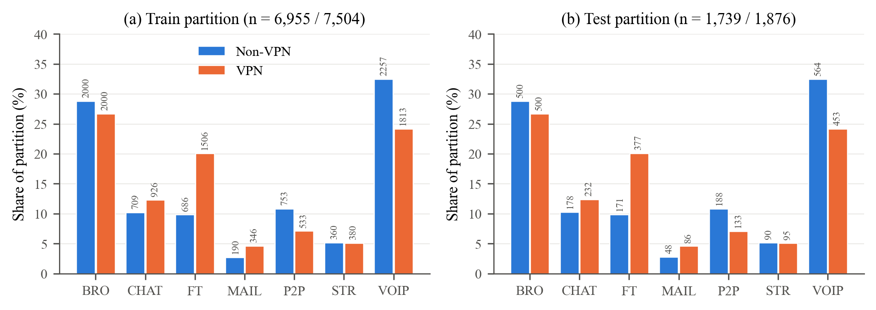
Fig. 1. Class make-up of the primary partitions for the two observation contexts. Each bar is the percentage of a partition taken by one class, with its count shown as a label. (a) Training partitions. (b) Test partitions. Within a context, training and test proportions are almost identical; between contexts they differ, most clearly for FT and VOIP.

C. Leakage, Near-Duplicate and Grouping Audit
We audited the partitions before training anything. Once repeated rows inside a partition are dropped, Non-VPN keeps 6,951 distinct feature vectors in training and 1,737 in test, and exactly one vector appears on both sides. VPN keeps 7,489 and 1,875, with thirteen shared. Every shared vector has one label in training and another in test, so we call them exact feature-vector collisions, not copies. Because the labels disagree, memorising these rows cannot raise test accuracy. They make up at most 0.7% of VPN test rows, and we left them in.
Near duplicates needed a different check. On standardised raw features the nearest-neighbour distances are tiny (Non-VPN median test-to-train distance 0.0032 standard deviations), because a handful of extreme values dominate each heavy-tailed feature. We therefore repeated the audit after a log transform, log(x + 2) with values clipped at −1 so that the sentinel maps to zero, followed by standardisation, and after a rank (quantile) transform, both fitted on training data only. For each record we measured the distance to the closest record on the other side of the split and to the closest other record on its own side. Under the log transform the median test-to-training distance is 0.108 for Non-VPN against 0.101 from training to training; for VPN the values are 0.109 and 0.108. The rank transform gives 0.088 and 0.092 (Non-VPN) and 0.075 and 0.074 (VPN).
Test records are as close to the training data as training records are to each other. That is what a random split of correlated flows produces, so the audit rules out gross copying but not dependence between related flows. As a proxy for session grouping we clustered the log-transformed training flows of each context into 50 k-means clusters and compared five-fold cross-validation that keeps clusters intact with ordinary stratified five-fold cross-validation. On Non-VPN, macro F1 falls from 0.924 to 0.642 for XGBoost and from 0.901 to 0.475 for Random Forest; on VPN, from 0.880 to 0.551 and from 0.862 to 0.493. Holding out whole clusters also asks a model to extrapolate to unseen regions of feature space, so this drop overstates what session grouping alone would cost, but performance clearly depends on having similar flows on both sides of a split.
The processed files carry no session or capture identifiers, so a true group-aware split cannot be built from them. The raw packet captures would allow one: flows could be regenerated with the original feature extractor and split by capture file. They are distributed separately as large PCAP archives, and regenerating the 23 features from them was beyond what this study could do while keeping the published feature set unchanged. We therefore keep the primary partitions for single fits and use cluster-grouped half-splits at three granularities as within-context references (Section IV-D), and we return to this limitation in Section XI.

D. Models and Implementation
Two tree ensembles carry the analysis because they treat correlated inputs differently. Random Forest [51] averages many deep trees, and each split chooses from a random subset of features. XGBoost [52] builds shallower trees in sequence, with regularisation. Both are explained with TreeSHAP. Extra Trees [53] appears only in the robustness checks of Section IX. An earlier version also reported multinomial Logistic Regression as a performance baseline. Even with a log(x + 2) transform it reached only 0.754 (Non-VPN) and 0.724 (VPN) macro F1 against 0.85–0.93 for the ensembles, it was never explained, and it added nothing to the explanation analysis, so we have dropped it.
Configurations are listed in Table III and do not change between contexts. Hyperparameters were set once and not tuned; Section IX reports how far rankings move under other XGBoost settings and seeds. The primary models use random_state 42, and every model in the repeated designs of Section IV-D has its own seed. The code relies on scikit-learn [54] and XGBoost [52], with TreeSHAP from the SHAP library [14]. Every number in this version was produced in one software environment (Table III). The previous version mixed two environments, which made the same XGBoost condition differ by up to 0.011 macro F1 between two tables. Random Forest results are identical in both environments; XGBoost single fits moved by at most 0.006 macro F1 relative to the previous version.
TABLE III
Model and explanation configurations
Model | Configuration | Use
Random Forest | 200 trees; max_features = sqrt; min_samples_leaf = 1; bootstrap = True; class_weight = None; random_state = 42 | TreeSHAP
XGBoost | 200 estimators; multi:softprob, 7 classes; max_depth = 6; learning_rate = 0.1; subsample = 0.8; colsample_bytree = 0.8; min_child_weight = 1; eval_metric = mlogloss; random_state = 42 | TreeSHAP
Extra Trees | 500 trees; max_features = sqrt; min_samples_leaf = 1; random_state = 42 | Robustness only
TreeSHAP | Path-dependent primary; interventional robustness with 200 training background records. Random Forest and Extra Trees: class probabilities; XGBoost: class margins | Ranks and normalised shares
Note. The same hyperparameters are used in both contexts, and all models take the original features. Every result was computed under Python 3.13.16, NumPy 2.5.3, pandas 3.0.5, scikit-learn 1.9.1, XGBoost 3.4.1 and SHAP 0.53.0 on Linux (x86-64). XGBoost was run single-threaded; refitting with two threads gave identical predictions.

IV. METHODOLOGY

A. Overview
Fig. 2 sketches the analysis. Primary models and rankings are fitted on the primary partitions. Three within-context references describe how much rankings move without any change of context (Section IV-D). On top of that we test class composition directly, retrain without the minimum-IAT features and compare with permutation importance, aggregate importance into feature families, measure two practical consequences of explanation differences, and run sentinel and robustness checks.
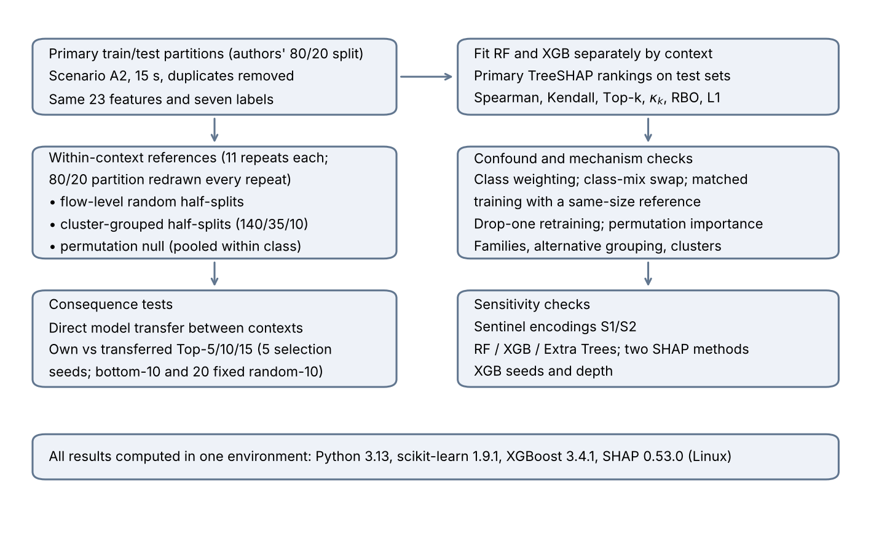
Fig. 2. Experimental pipeline. Each context is modelled on its own. The repeated designs redraw the 80/20 partition in every repeat, and the consequence tests select features inside training partitions only.

B. TreeSHAP and Global Importance
Take a model with class outputs $f_{c}$, $c\text{=}1,…,C$ ($C\text{=}7$). For an instance $x$ described by $m\text{=}23$ features, SHAP returns attributions $ϕ_{j,c}\left(x\right)$, and these obey local accuracy:
$f_{c}\left(x\right)\text{=}ϕ_{0,c}\text{+}\sum_{j\text{=}1}^{m}{ϕ_{j,c}}\left(x\right),c\text{=}1,…,C$ (1)
where $ϕ_{0,c}$ is the expected output under the reference distribution [13]. For the primary analysis we use the tree-path-dependent form of TreeSHAP [14]. It builds its reference from cover statistics stored along the tree paths, so no background sample is needed. What gets explained differs by model. For Random Forest it is the class probability; for XGBoost, trained with the multiclass soft-probability objective, it is the raw margin of each class before softmax. Raw attribution sizes cannot be compared between models as a result, and wherever we compare models we use ranks or normalised shares computed within each model. Explanations are always computed on the held-out test partition of the context in question. Feature $j$ gets a global importance equal to its absolute SHAP value averaged over the $n$ explained instances and all classes. Its normalised share $s_{j}$ is that number divided by the total over features:
$I_{j}\text{=}\frac{1}{nC}\sum_{i\text{=}1}^{n}{\sum_{c\text{=}1}^{C}{\left|ϕ_{j,c}\left(x_{i}\right)\right|}},s_{j}\text{=}\frac{I_{j}}{\sum_{l\text{=}1}^{m}{I_{l}}}$ (2)
Averaging over output classes leaves one global ranking for each model and context. That is not the same as balancing the true classes among the explained records. Each test record still counts once, so frequent classes contribute more records; we therefore also report importance with true classes weighted equally. Neither version speaks to class-specific or instance-level consistency.
Two things about the method limit how far the rankings can be read. The tree-path-dependent formulation inherits whatever dependence structure the trees happened to learn. When several correlated features could serve for the same split, the one the model actually used gets the credit, and two otherwise similar models may divide attribution among correlated features quite differently [18, 19]. Also, SHAP values are about the model. A feature with a large attribution is one that the model output depends on, which does not make it a cause of the application label [20, 32]. We therefore treat a ranking as a description of what a model relies on, and our comparisons across contexts are comparisons of that reliance.

C. Ranking Agreement Measures
Our first agreement measure is Spearman's rank correlation [43],
$ρ\text{ = }1\text{ - }\frac{6\sum_{j\text{=}1}^{m}{d_{j}^{2}}}{m\left(m^{2}\text{ - }1\right)}$ (3)
where d_{j} is the rank difference for feature j. The second is Kendall's τ_{b} [44],
$τ_{b}\text{ = }\frac{n_{c}\text{ - }n_{d}}{\sqrt{\left(n_{0}\text{ - }n_{1}\right)\left(n_{0}\text{ - }n_{2}\right)}}$ (4)
Its denominator corrects for ties. Spearman correlation is computed on ranks with tied values given their average rank, so (3) is just the familiar no-tie formula. Top-k overlap O_{k} is the number of features two Top-k sets share. With m = 23, two sets of size k must share at least max(0, 2k − m) features. For two Top-k sets picked independently at random, the expected overlap and a chance-corrected version are
$E[O_{k}]\text{ = }\frac{k^{2}}{m}, κ_{k}\text{ = }\frac{O_{k}\text{ - }E[O_{k}]}{k\text{ - }E[O_{k}]}$ (5)
where κ_{k} is 0 at random expectation and 1 when the two sets are identical. We also report mean absolute rank displacement, the average distance a feature's rank moves between the two lists. It expresses disagreement in rank positions, which the correlations do not.
Spearman and Kendall weight a swap between ranks 20 and 21 as heavily as one between ranks 1 and 2, and the bottom third of each list carries only about 0.2–3% of importance per feature (Fig. 4). We therefore add two measures that emphasise the top. Rank-biased overlap [45] averages the overlap of the two Top-d sets with depth weights (1 − p)p^{d−1} that shrink by a factor p at each further depth d; we use the extrapolated form with p = 0.9. These depth weights sum to 1 − 0.9¹⁰ ≈ 0.65 over the first ten depths, but the agreement at rank i enters the overlap at every depth d ≥ i, so the first ten ranks carry about 86% of the total weight (Webber et al. [45], Eq. 21). The second is the L1 distance between the normalised importance vectors, the sum over features of |s_{j} − s′_{j}|, which is twice the total-variation distance and ranges from 0 to 2. It compares the shares themselves, so features with negligible shares barely contribute.
In short, we report Spearman, Kendall, Top-k overlap together with its chance-corrected form κ_{k} from (5), RBO and the L1 share distance. With m = 23, κ₅ = 0.49 corresponds to three shared features out of five and κ₁₀ = 0.65 to eight out of ten. Whole-ranking agreement and agreement at the top are read together, because either one alone can make two explanations look more interchangeable than they are.

D. Within-Context References and Permutation Null
A cross-context comparison needs a reference: how far do rankings move when the context does not change? We use three designs, each repeated 11 times for both models. In every repeat the deduplicated flows of each context are split afresh into stratified 80% training and 20% test partitions, with a seed that changes from repeat to repeat, so the spread over repeats includes partition-level variation as well as training and seed variation.
Flow-level random half-splits. The training partition of each context is split, stratified by class, into two disjoint halves, and each half is subsampled (again stratified) to at most 3,477 records (3,476–3,477) so that all halves have the same size in both contexts. Each half-model gets its own random_state and is explained on the test partition of its repeat. Within-context agreement compares the two halves of one context; cross-context agreement averages the four Non-VPN-half versus VPN-half pairs of the same repeat. The gap is
Δ = ½ (ρ_{within,NV} + ρ_{within,VPN}) − ρ_{cross} (6)
computed per repeat, and in the same way for RBO, Top-5 overlap, κ₅ and family-level ρ.
Cluster-grouped half-splits. Random halves put near-duplicate flows from one session on both sides, which can inflate within-context agreement. As a proxy for sessions, the training flows of each class are clustered with k-means on log(x + 2)-standardised features. The number of clusters is set so that the average cluster holds about 10, 35 or 140 flows, with at least four clusters per class. Whole clusters are assigned at random to the two halves, larger clusters first, each to the currently smaller half. Each class is then subsampled to the size of its smaller half, and the halves of both contexts are subsampled to a common size (3,368–3,476 records). Only the division of the training partition into halves is grouped: the outer 80/20 partition remains a random stratified split, so the explained test records are not separated by cluster from either half, and the design tests sensitivity to grouping, not session independence. The three granularities bracket the unknown session structure. About 10 flows per cluster keeps only very close neighbours together. About 140 also separates broader regions of feature space and so asks more of a model than session grouping would, which is why the half-models' macro F1 falls as the clusters grow (Table VII).
Permutation null. For each class, the flows of both contexts are pooled and randomly reassigned to two pseudo-contexts that keep the original per-class counts. The pseudo-contexts therefore inherit the class mixes of Non-VPN and VPN but not their capture conditions. The flow-level random design is then applied to the pseudo-contexts and Δ is computed in the same way. Under this null, Δ shows what the half-split procedure and the class-mix difference produce when nothing else separates the two contexts.
XGBoost half-models are explained on the full test partition of each repeat. Random Forest TreeSHAP is much slower, so each Random Forest half-model is explained on a class-stratified sample of 800 test records; for the primary models, rankings from five such samples agree with the full-test ranking at ρ ≥ 0.997. Importance is also computed with true classes weighted equally. The repeats share one dataset and overlap in their test records, so they are not independent replications. We use the standard deviation and range of Δ across repeats to describe its spread, not as a standard error. The training-bootstrap reference of the previous version, whose resamples shared most of their records and one model seed, is no longer used. The other ISCX time windows (30, 60 and 120 s) are recomputed from the same captures and cannot serve as an independent second pair of contexts.

E. Class-Composition Tests
Three checks address class mix. First, global importance is recomputed with true classes weighted equally, on the primary fits and in every half-split repeat. Second, in a class-mix swap, each context's training partition is resampled without replacement to 3,400 flows with the other context's class proportions, the largest size both contexts allow. As a control, it is also resampled to 3,400 flows with its own proportions. Both models are explained on the context's own test partition and compared with the primary rankings of both contexts, using five draws for XGBoost and three for Random Forest. If class mix drove the cross-context disagreement, the swapped models should move toward the other context's ranking. Third, class-matched training uses 190 training flows per class, the number of Non-VPN MAIL flows. Six draws of 1,330 flows per context are compared with a same-size within-context reference built from two disjoint draws with each context's natural class mix.

F. Aggregated Feature-Family Importance
Table I sorts the 23 features into six semantic families: one flow-duration feature, eight directional IAT statistics, two throughput features, and four statistics each for flow IAT, active periods and idle periods. For a family G, we add up the global importances I_{j} of its members from (2) and then normalise across the six families. Because absolute values are taken before summing, member contributions of opposite sign cannot cancel. The result is aggregated feature-family importance; it is neither instance-level Group SHAP nor a Shapley game with families as players.
Two features of this grouping affect what it can show. Families have different sizes, so a large family can lead a ranking by size alone; we therefore also rank families by the mean importance of their members. And the grouping is a choice: total_fiat and total_biat correlate with duration at Spearman 0.89–0.95 yet sit in the directional family, while duration forms a family of one. We therefore also use an alternative grouping that moves the two totals into a duration-and-totals family, and data-driven clusters formed by average-linkage clustering of 1 − |ρ_{S}|, where ρ_{S} is the Spearman correlation between two features averaged over the two training partitions, cut at 0.2. Family-level agreement is computed on the primary fits and in every half-split repeat.

G. Consequence Tests
A difference between explanations has practical weight if acting on it changes predictive performance. We test two actions. In direct model transfer, the primary model of one context is applied unchanged to the test partition of the other. This shows whether the learned mapping from features to applications carries over at all, and it is the scenario that motivates the study: a classifier trained without a VPN and deployed where traffic is tunnelled, or the reverse.
In feature-list transfer, selection uses training data only [55–57]. Each training partition is split into a stratified 80% inner-training and 20% inner-validation subset. A selector is trained on the former, its TreeSHAP importance is measured on the latter (for Random Forest, on a stratified sample of 800 inner-validation records), and the k highest-ranked features are retained. A reduced model is then refitted on the whole training partition with those features and scored on the untouched test partition. The own list comes from the target context, and the transferred list from the other context with the same inner-split seed. Our original plan named k = 15, and the previous version reported k = 10 as its main cutoff with incomplete runs at other values. We now run k = 5, 10 and 15 for both models, give them equal weight, and repeat the selection with five inner-split seeds.
Two controls show whether SHAP-based selection matters at all: the ten lowest-ranked features of the target-context selector (bottom-10), and 20 random 10-feature subsets that are drawn once and used for every model and target. For the first selection seed at k = 10, 3,000 class-stratified paired bootstrap draws of the test records give percentile intervals for the own-minus-transferred difference. These intervals hold the fitted models fixed and leave out training and selection uncertainty, which the five seeds show separately.

H. Sentinel Representations and Robustness Configurations
In the processed features, −1 stands for an undefined statistic. The sentinel experiment builds ten indicator variables, one each for min_fiat, min_biat, max_fiat, max_biat, min_flowiat, max_flowiat, min_active, max_active, min_idle and max_idle, equal to one when the source feature is −1. The primary representation keeps the raw sentinels in all 23 features. In S1, −1 stays in the original features and the ten indicators are appended; in S2, −1 is replaced by NaN, which both tree models handle natively, and the same indicators are appended. Across both partitions, min_fiat is −1 in 12.6% of Non-VPN and 10.0% of VPN flows, min_biat in 16.1% and 16.6%, the active and idle minima and maxima in 65.0% and 53.5%, and min_flowiat in only 0.3% and 0.4%. Ranks are compared over the 23 original features, and the indicators' share is reported separately.
The robustness analysis crosses three tree models (Random Forest, XGBoost and Extra Trees [53]) with the path-dependent and interventional TreeSHAP formulations. Each model is explained on a class-stratified sample of 500 test records of its own context (seed 42). For interventional TreeSHAP, the background is a separate class-stratified set of 200 training records from the same context, all of which are used. Percentile 95% intervals for cross-context ρ come from 2,000 resamples of the explained records within each context, with models and backgrounds fixed; they reflect explained-record noise only. We also refit XGBoost with three other seeds and with max_depth = 3 and 10.

I. Statistical Reporting
We report effect sizes and their spread, not significance tests. For consistency, the effect is Δ in Spearman units (and the analogous gaps in RBO, Top-5 overlap and κ₅), and its spread is the standard deviation and range over the 11 repeats of each design. Because these repeats share one dataset and overlapping test records, ratios of Δ to its standard deviation are not test statistics, and we do not report them. For the consequence tests, effects are paired differences in macro F1, read against the spread over selection seeds and against the random-subset controls. All intervals are marginal 95% percentile intervals, and none allows for clustering by capture or session.

V. BASELINE CLASSIFICATION RESULTS
Table IV and Fig. 3 report results on the primary test partitions. Both ensembles do well in both contexts, with XGBoost slightly ahead. Without a VPN, XGBoost reaches 0.9586 accuracy and 0.9340 macro F1, and Random Forest 0.9454 and 0.9171. With a VPN, XGBoost drops to 0.9051 and 0.8836 and Random Forest to 0.8811 and 0.8533, a macro F1 loss of 0.0504 and 0.0637. We prefer macro F1 because class mixes differ between contexts and BROWSING and VOIP fill over half of each test partition.
Per class, VOIP is hardly affected, with recall above 0.99 in both contexts, and BROWSING stays at 0.93 or above. CHAT, FT, MAIL and P2P pay most of the cost: with XGBoost, MAIL recall falls from 0.917 to 0.826, P2P from 0.979 to 0.910, CHAT from 0.865 to 0.767 and FT from 0.901 to 0.841. STREAMING goes the other way, from 0.856 to 0.916 for XGBoost and from 0.822 to 0.926 for Random Forest. We do not read this as evidence that a VPN makes streaming easier to identify; the captured streaming sessions, or the classes streaming is confused with, may differ between contexts, and a flow-level dataset cannot separate these explanations.
TABLE IV
Baseline performance and per-class recall on the primary test partitions
Context | Model | Acc. | Macro F1 | BROW | CHAT | FT | MAIL | P2P | STRM | VOIP
Non-VPN | RF | 0.9454 | 0.9171 | 0.980 | 0.809 | 0.871 | 0.917 | 0.979 | 0.822 | 0.991
Non-VPN | XGB | 0.9586 | 0.9340 | 0.988 | 0.865 | 0.901 | 0.917 | 0.979 | 0.856 | 0.993
VPN | RF | 0.8811 | 0.8533 | 0.934 | 0.767 | 0.782 | 0.744 | 0.835 | 0.926 | 0.993
VPN | XGB | 0.9051 | 0.8836 | 0.950 | 0.767 | 0.841 | 0.826 | 0.910 | 0.916 | 0.991
Note. BROW = BROWSING, STRM = STREAMING. Test support (Non-VPN / VPN): BROWSING 500/500, CHAT 178/232, FT 171/377, MAIL 48/86, P2P 188/133, STREAMING 90/95, VOIP 564/453.
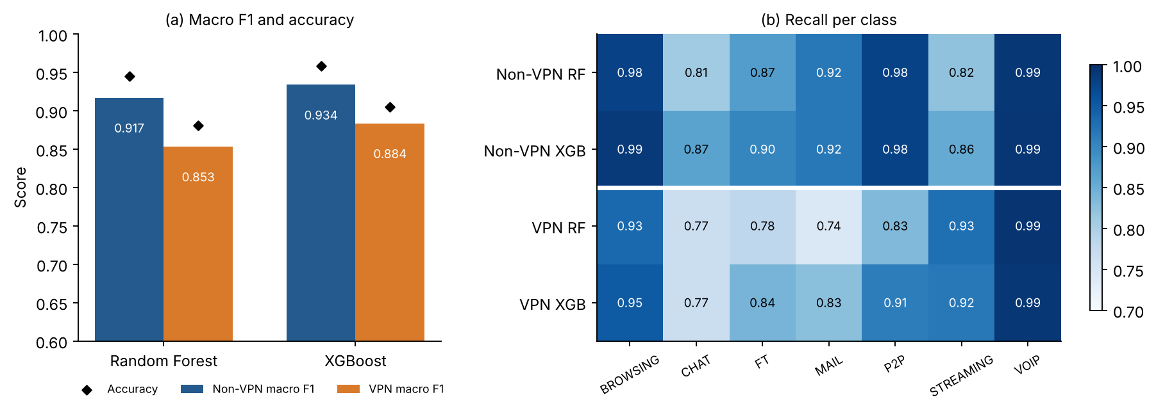
Fig. 3. Baseline performance on the primary test partitions. (a) Macro F1 (bars) and accuracy (diamonds). (b) Recall per class. Under VPN the ensembles lose 0.050 (XGBoost) and 0.064 (Random Forest) macro F1, mostly in CHAT, FT, MAIL and P2P.

VI. EXPLANATION CONSISTENCY

A. Global Rankings in Each Context
The primary importance profiles are given in Table V and Fig. 4. Without a VPN, the five most important features account for 40.3% of total importance in Random Forest and 50.1% in XGBoost; with a VPN, 41.1% and 45.3%. The top ten take between 65.1% and 75.4%. These are normalised sums of mean absolute SHAP, not shares of explained variance.
On Non-VPN data the top five for Random Forest are total_biat, min_flowiat, total_fiat, flowBytesPerSecond and duration; on VPN data they are flowBytesPerSecond, min_fiat, min_biat, min_flowiat and total_biat. XGBoost puts flowBytesPerSecond, min_flowiat, total_biat, min_fiat and flowPktsPerSecond on top for Non-VPN, and flowBytesPerSecond, min_fiat, min_flowiat, min_biat and mean_biat for VPN. The two models agree with each other at Spearman 0.814 on Non-VPN and 0.917 on VPN.
TABLE V
Ten leading features of the primary TreeSHAP rankings, with normalised importance shares (%)
Rank | RF Non-VPN | RF VPN | XGB Non-VPN | XGB VPN
1 | total_biat (9.83) | flowBytesPerSecond (10.94) | flowBytesPerSecond (14.05) | flowBytesPerSecond (13.48)
2 | min_flowiat (8.27) | min_fiat (8.28) | min_flowiat (14.04) | min_fiat (8.45)
3 | total_fiat (8.09) | min_biat (8.15) | total_biat (8.30) | min_flowiat (8.16)
4 | flowBytesPerSecond (7.86) | min_flowiat (6.90) | min_fiat (7.97) | min_biat (8.10)
5 | duration (6.29) | total_biat (6.78) | flowPktsPerSecond (5.76) | mean_biat (7.15)
6 | std_flowiat (5.92) | duration (5.82) | mean_flowiat (5.56) | duration (6.58)
7 | mean_fiat (4.89) | mean_biat (5.78) | duration (5.43) | max_flowiat (6.44)
8 | mean_biat (4.79) | total_fiat (5.59) | total_fiat (5.09) | std_flowiat (6.06)
9 | max_flowiat (4.71) | max_flowiat (5.38) | std_flowiat (4.85) | total_fiat (4.99)
10 | min_biat (4.42) | std_flowiat (5.26) | min_biat (4.30) | mean_flowiat (4.63)
Note. Shares are percentages of total mean absolute SHAP, averaged over test records and model output classes; within each model and context they sum to 100% over all 23 features. Fig. 4 shows all 23 shares.
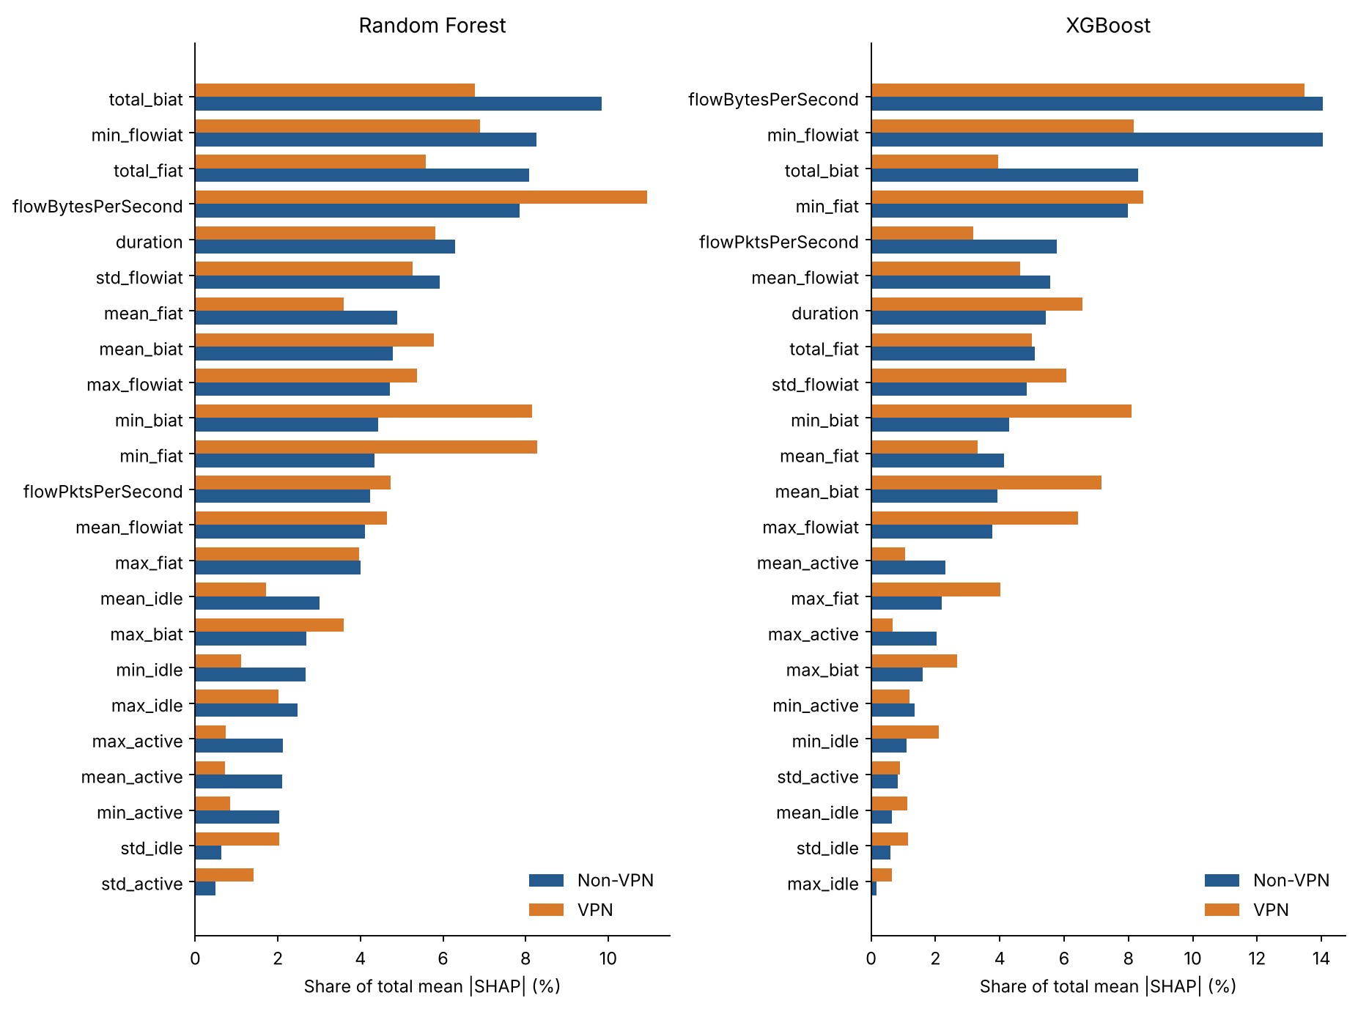
Fig. 4. Primary TreeSHAP importance shares, Random Forest left and XGBoost right. Features are ordered by Non-VPN importance so that the two contexts can be compared directly.

B. Cross-Context Agreement on the Primary Split
For Random Forest, Spearman ρ between the Non-VPN and VPN rankings is 0.8300 and Kendall τ_{b} is 0.6443; for XGBoost, ρ = 0.7856 and τ_{b} = 0.5810 (Table VI). The whole-ranking correlations look high, yet each model keeps only three of its top five features (κ₅ = 0.49), and RBO is 0.580 for Random Forest and 0.755 for XGBoost. The L1 distance between share vectors is 0.333 and 0.360, so about a sixth of the total importance changes hands, and the mean absolute rank displacement is 3.04 and 3.39 positions. At ten features the overlap is 9 of 10 for Random Forest (κ₁₀ = 0.82) and 8 of 10 for XGBoost (κ₁₀ = 0.65). Weighting true classes equally changes the within-context rankings little (ρ between weighted and unweighted rankings 0.976–0.998) and leaves the cross-context values at a similar level.
Fig. 5 follows single features (Non-VPN rank → VPN rank). In Random Forest, min_fiat (11 → 2) and min_biat (10 → 3) move up, while total_biat (1 → 5), total_fiat (3 → 8) and mean_fiat (7 → 14) move down. In XGBoost, mean_biat (12 → 5), min_biat (10 → 4) and max_flowiat (13 → 7) rise, whereas total_biat (3 → 12) and flowPktsPerSecond (5 → 14) fall. Some directional features rise while others in the same family fall, so a description in terms of forward versus backward misses most of what happens.
Several of the movers are correlated with other features, which matters for how SHAP shares out credit (Fig. 6). Some pairs are close to redundant: duration correlates with total_fiat and total_biat at Spearman 0.89–0.95, total_fiat with total_biat at 0.84–0.90, and the two throughput features at 0.94. A model can move credit within such a group with little change in its predictions, which fits the fall of total_biat and total_fiat. The three minimum IATs are less tightly linked. Spearman correlation is 0.60 (Non-VPN) and 0.60 (VPN) between min_fiat and min_biat, 0.11 and 0.41 between min_fiat and min_flowiat, and 0.19 and 0.24 between min_biat and min_flowiat. By construction min_flowiat never exceeds the smaller of min_fiat and min_biat, but it equals that minimum in only 43% of Non-VPN and 31% of VPN training flows, because interleaved forward and backward packets create shorter gaps. Moderate and non-monotone dependence of this kind can still redistribute SHAP credit, so Section VI-E tests the minimum-IAT shifts by retraining.
TABLE VI
Cross-context ranking agreement of the primary fits
Model | Spearman ρ | Kendall τ_{b} | RBO | L1 | Top-5 (κ₅) | Top-10 (κ₁₀) | Rank disp.
RF | 0.8300 | 0.6443 | 0.580 | 0.333 | 3/5 (0.49) | 9/10 (0.82) | 3.04
XGB | 0.7856 | 0.5810 | 0.755 | 0.360 | 3/5 (0.49) | 8/10 (0.65) | 3.39
RF, classes weighted | 0.8211 | 0.6443 | 0.732 | 0.270 | 3/5 (0.49) | 8/10 (0.65) | —
XGB, classes weighted | 0.7925 | 0.5968 | 0.778 | 0.376 | 3/5 (0.49) | 7/10 (0.47) | —
Note. Single fits on the primary partitions, explained on the full test partitions. RBO is extrapolated rank-biased overlap with p = 0.9; L1 is the distance between normalised share vectors (0 to 2); κ_{k} is the chance-corrected Top-k overlap of (5); rank disp. is the mean absolute rank displacement. Class-weighted rows give every true class the same weight in (2).
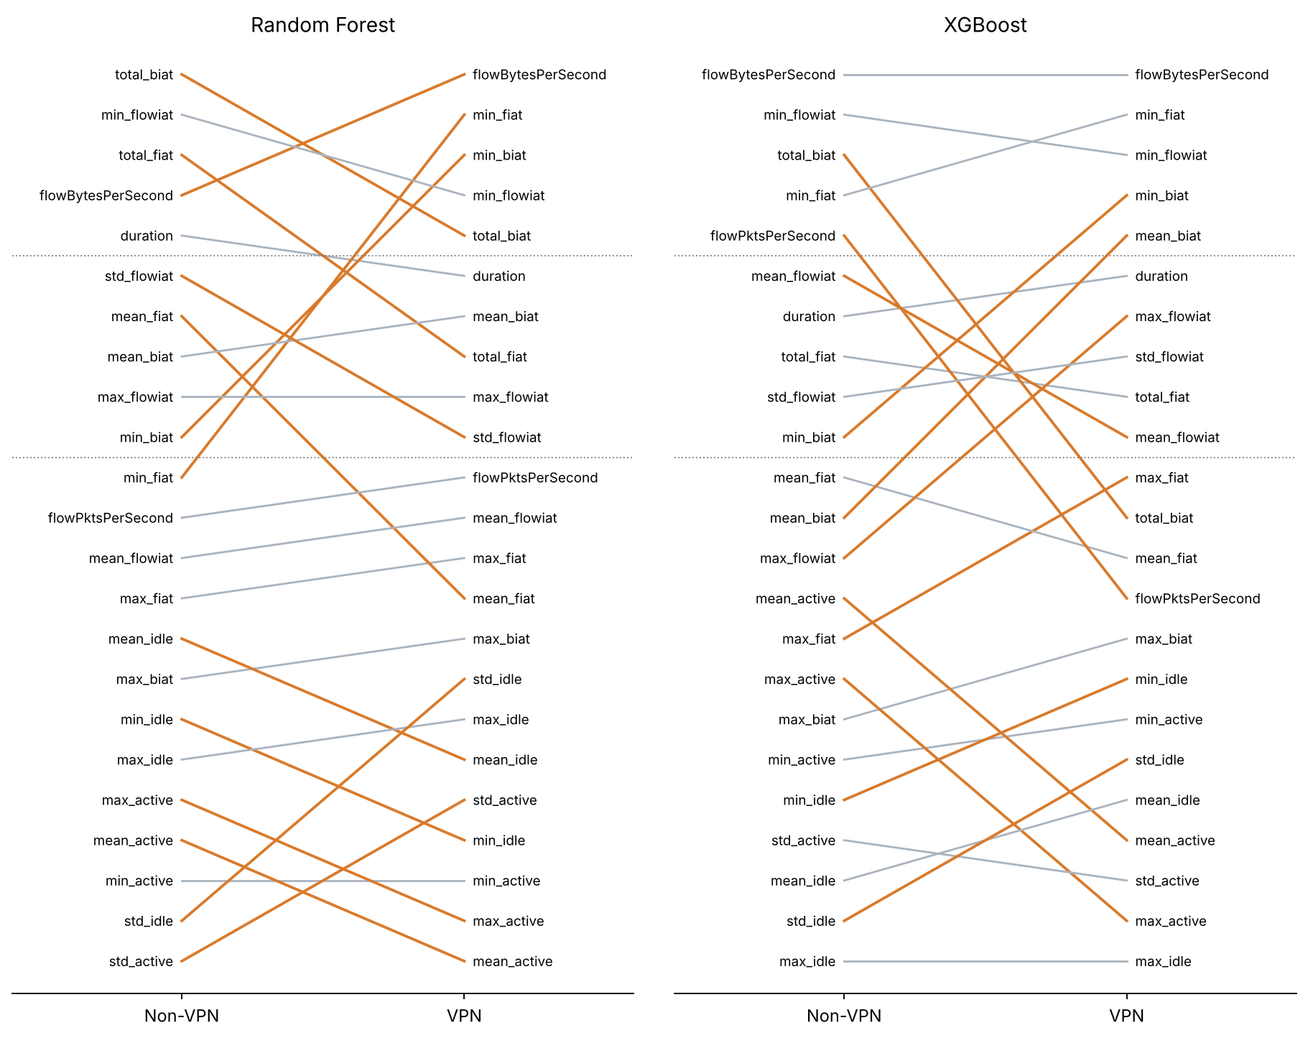
Fig. 5. Feature ranks under Non-VPN and VPN on the primary split, for Random Forest (left) and XGBoost (right). Each line joins the two ranks of a feature; dotted lines mark the Top-5 and Top-10 cut-offs. Features that move by three or more ranks are drawn in colour.
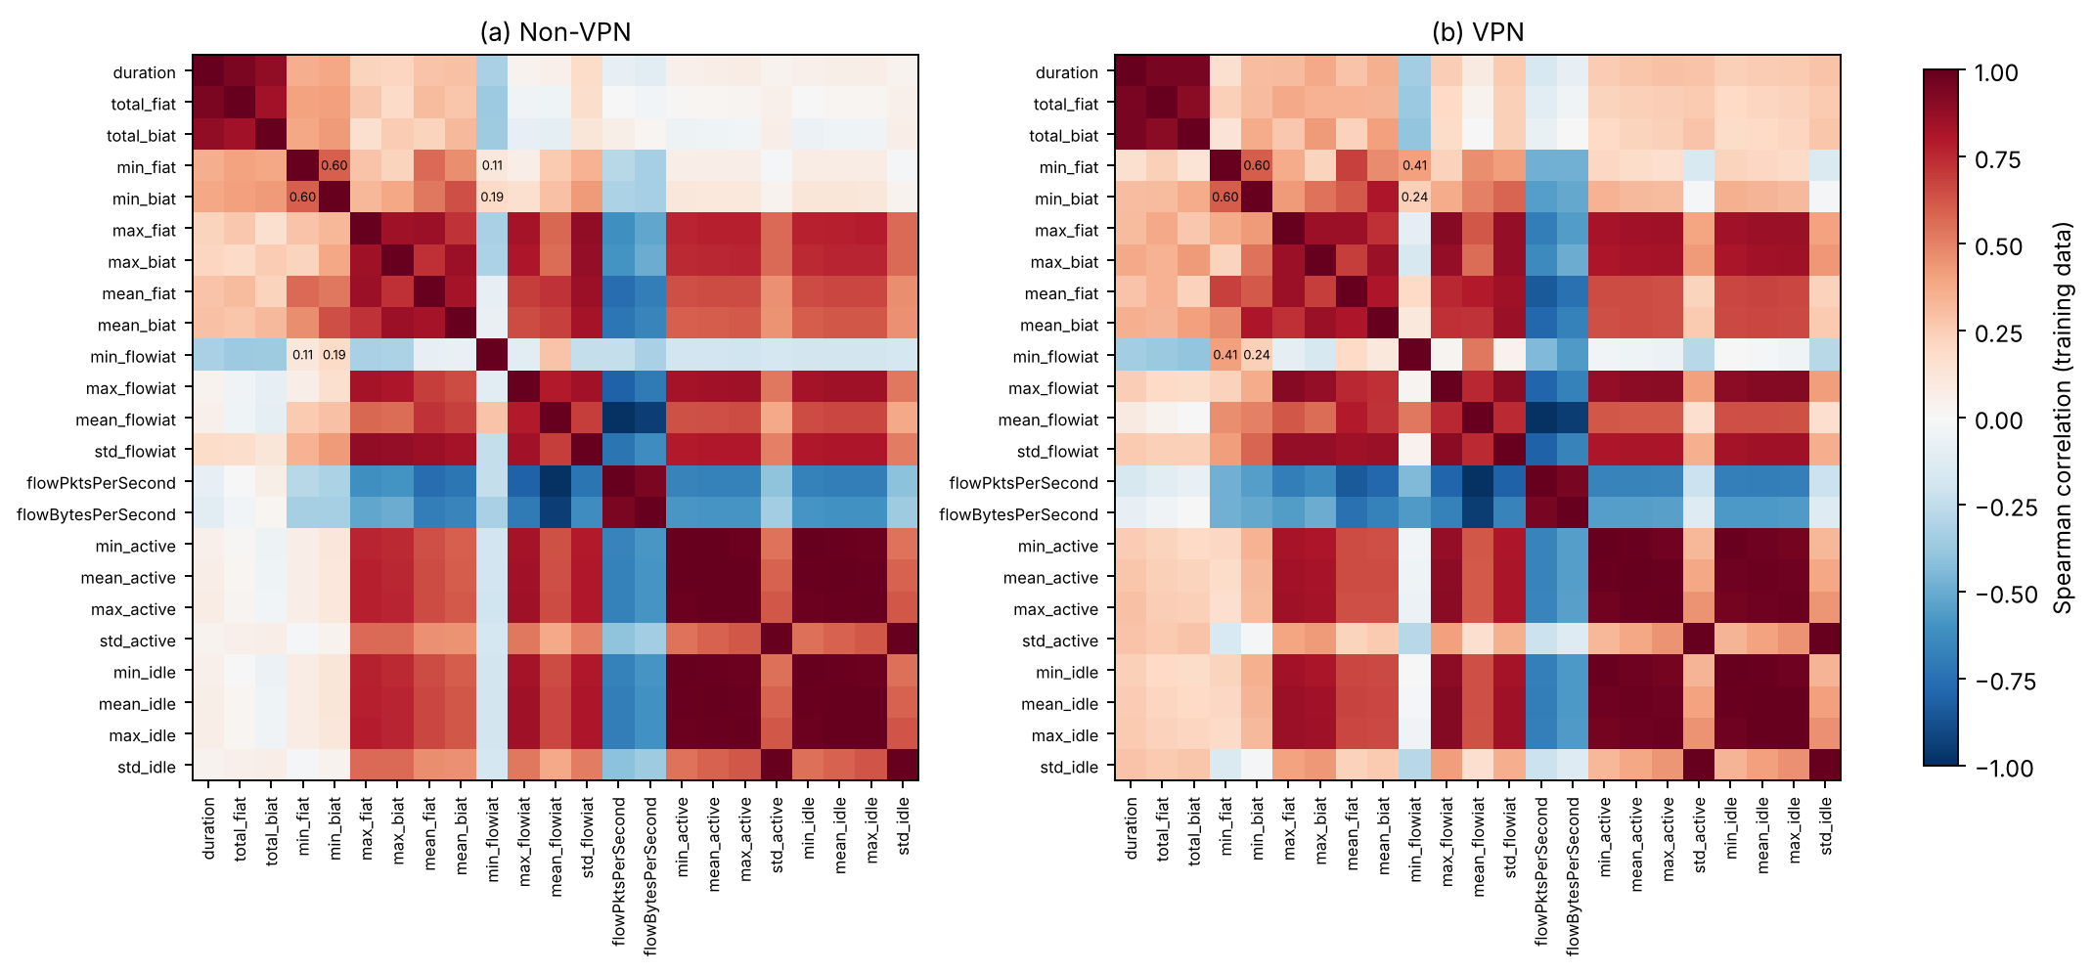
Fig. 6. Spearman correlations between the 23 features on the training partition of (a) Non-VPN and (b) VPN flows. Values are printed for the three minimum IAT features (min_fiat, min_biat, min_flowiat). Duration and the total IATs, the two throughput features, and the maximum, active and idle statistics form tightly correlated blocks.

C. Within-Context References and Permutation Null
Table VII and Fig. 7 set the cross-context agreement against the three reference designs. With flow-level random halves, within-context agreement is high (0.943 and 0.964 for XGBoost on Non-VPN and VPN, 0.928 and 0.976 for Random Forest) and cross-context agreement is lower (0.825 and 0.766). The gap is 0.129 for XGBoost (SD 0.028, range 0.072 to 0.163 over 11 repeats) and 0.186 for Random Forest (SD 0.036, range 0.143 to 0.252). Because each repeat now redraws the 80/20 partition, these spreads are two to four times larger than in the previous version, which reused one partition. The gap appears at the top of the list as well: random halves of one context share 4.1–4.4 of five leading XGBoost features against 3.1 across contexts, and the RBO gap is 0.152 for XGBoost and 0.302 for Random Forest. With true classes weighted equally the ρ gaps are 0.133 and 0.183.
The permutation null shows that this gap is not produced by the half-split procedure or by the class-mix difference alone. When flows are reassigned at random between two pseudo-contexts that keep the Non-VPN and VPN class mixes, Δ is −0.002 for XGBoost (range −0.018 to 0.009) and +0.028 for Random Forest (range −0.010 to 0.052).
The cluster-grouped references change the picture. Keeping clusters of about ten similar flows on one side lowers within-context agreement (XGBoost 0.888 and 0.934, Random Forest 0.850 and 0.809) while cross-context agreement barely moves, and Δ shrinks to 0.079 and 0.100. With about 35 flows per cluster Δ is 0.014 and 0.042, and with about 140 it is −0.015 and +0.002. The coarsest grouping is harsh: its half-models reach only 0.53–0.61 macro F1, and Random Forest rankings become unstable in every comparison. But even the finest grouping, which separates only very close neighbours, removes 39% of the XGBoost gap and 47% of the Random Forest gap.
Taken together, cross-context rankings disagree more than random halves of one context do, and this excess is not an artefact of the half-split procedure or of class mix. When the training halves are formed from whole clusters, the Spearman gap shrinks substantially as the clusters grow, but it does not vanish at intermediate grouping: with about 35 flows per cluster the Random Forest gap is still 0.042 and positive in all 11 repeats (0.015 to 0.071), and the RBO gaps are 0.063 for XGBoost and 0.084 for Random Forest. Mean Spearman gaps near zero occur only under the coarsest grouping, which also separates broad regions of feature space. The scope of these designs is limited: the outer 80/20 partition is still random, and clusters are kept together only when the training data are divided into halves. The results show that the cross-context gap is sensitive to how related flows are grouped and that much of the random-split gap may reflect variation between groups of related flows. They cannot measure the actual between-session effect, but they do not support the earlier reading of the random-split gap as a context effect.
TABLE VII
Within- and cross-context Spearman agreement under three reference designs
Model / design | Half-model F1  NV / VPN | Within  NV | Within  VPN | Cross | Δρ mean (SD)  range | ΔRBO | ΔTop-5 | Δρ classes  weighted
XGBoost (11 repeats per design)
Random halves | 0.912 / 0.865 | 0.943 | 0.964 | 0.825 | +0.129 (0.028)  0.072 to 0.163 | +0.152 | +1.14 | +0.133
Grouped, ~10 per cluster | 0.818 / 0.747 | 0.888 | 0.934 | 0.832 | +0.079 (0.028)  0.034 to 0.136 | +0.111 | +0.73 | +0.074
Grouped, ~35 per cluster | 0.709 / 0.649 | 0.825 | 0.877 | 0.837 | +0.014 (0.017)  −0.014 to 0.039 | +0.063 | −0.05 | +0.017
Grouped, ~140 per cluster | 0.614 / 0.552 | 0.804 | 0.740 | 0.787 | −0.015 (0.025)  −0.048 to 0.026 | +0.021 | +0.07 | −0.020
Permutation null | 0.843 / 0.853 | 0.938 | 0.944 | 0.942 | −0.002 (0.009)  −0.018 to 0.009 | −0.007 | −0.11 | −0.002
Random Forest (11 repeats per design)
Random halves | 0.887 / 0.842 | 0.928 | 0.976 | 0.766 | +0.186 (0.036)  0.143 to 0.252 | +0.302 | +1.64 | +0.183
Grouped, ~10 per cluster | 0.774 / 0.715 | 0.850 | 0.809 | 0.730 | +0.100 (0.018)  0.078 to 0.128 | +0.171 | +0.84 | +0.079
Grouped, ~35 per cluster | 0.661 / 0.623 | 0.723 | 0.726 | 0.682 | +0.042 (0.017)  0.015 to 0.071 | +0.084 | +0.59 | +0.030
Grouped, ~140 per cluster | 0.589 / 0.531 | 0.612 | 0.431 | 0.519 | +0.002 (0.111)  −0.183 to 0.226 | −0.054 | −0.73 | −0.023
Permutation null | 0.816 / 0.826 | 0.949 | 0.953 | 0.923 | +0.028 (0.019)  −0.010 to 0.052 | +0.062 | +0.27 | +0.032
Note. Every repeat redraws the stratified 80/20 partition of each context. Within values compare the two halves of one context; cross values average the four Non-VPN-half versus VPN-half pairs of the same repeat. Δ is the mean within value minus the cross value, averaged over repeats; SD and range describe its spread over repeats and are not standard errors. Half-model F1 is macro F1 on the repeat's test partition. Grouped designs keep whole k-means clusters (fitted within class on log(x + 2)-standardised features) in one half. The null pools flows within class across contexts and reassigns them at random to pseudo-contexts with the original class counts. Random Forest half-models are explained on 800 test records per repeat.
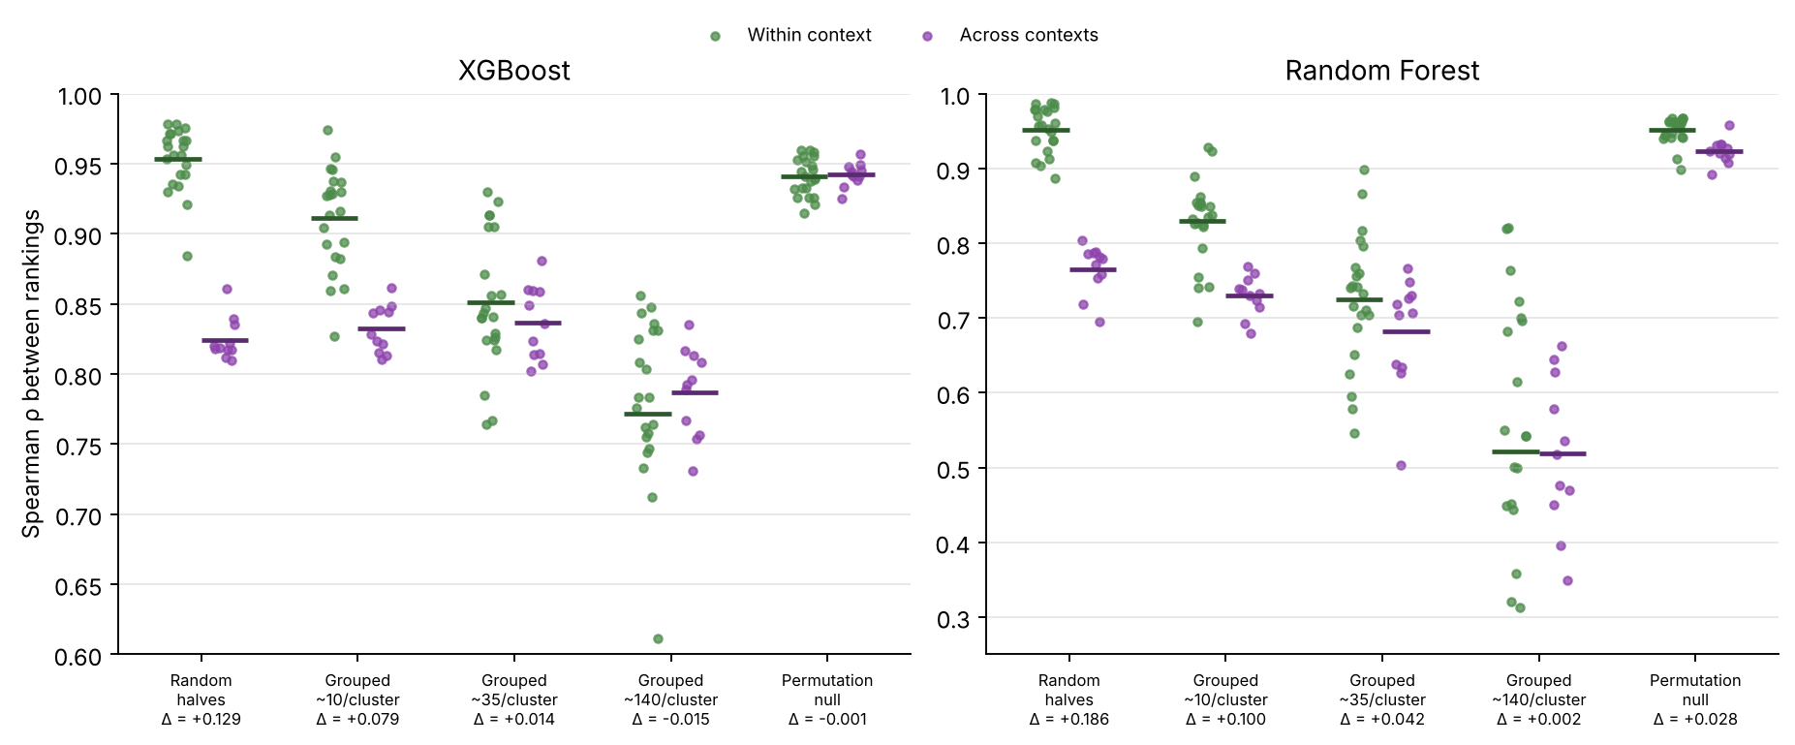
Fig. 7. Within-context (green) and cross-context (purple) Spearman agreement for each repeat of the five reference designs, with means as bars. The gap Δ under each design is given below its label. Values are dependent across repeats and are shown descriptively.

D. Class Composition
Table VIII reports the class-mix swap. Resampling a context to the other context's class mix changes its own ranking only a little (ρ between natural-mix and swapped-mix models 0.924–0.977) and does not bring it closer to the other context. Agreement with the other context's primary ranking changes by +0.008, +0.017, −0.035, −0.007 for XGBoost (Non-VPN, VPN) and Random Forest (Non-VPN, VPN), against a cross-context gap of 0.13–0.19 under random halves. The permutation null of Section VI-C, which keeps both class mixes and removes everything else, gives no XGBoost gap and a Random Forest gap of 0.03. Class-weighted importance leaves the gaps in place (Table VII).
Class-matched training gives the same answer once it is compared with a reference of its own size. With 1,330 training flows per model, two disjoint natural-mix draws of one context agree at ρ = 0.946 (Non-VPN) and 0.945 (VPN); natural-mix draws of different contexts agree at 0.853 and class-matched draws at 0.857. The rise in cross-context ρ under matching that the previous version reported (to about 0.85) is therefore a property of small training sets, which agree more with everything, and not a sign that class mix explains the gap: at this size the within-minus-cross gap is still 0.09 with natural mixes. Two matched draws of Non-VPN share all 190 MAIL flows, so their agreement (0.971) is not used as a reference.
TABLE VIII
Class-mix swap: models trained on 3,400 flows with their own or the other context's class proportions
Model / context | Training mix | Macro F1 | ρ with own  primary ranking | ρ with other  context's ranking | RBO with other  context's ranking
XGB / Non-VPN (5 draws) | Own | 0.922 | 0.977 | 0.823 | 0.681
XGB / Non-VPN (5 draws) | Other context's | 0.925 | 0.971 | 0.831 | 0.700
XGB / VPN (5 draws) | Own | 0.859 | 0.986 | 0.781 | 0.775
XGB / VPN (5 draws) | Other context's | 0.841 | 0.980 | 0.797 | 0.787
RF / Non-VPN (3 draws) | Own | 0.895 | 0.983 | 0.799 | 0.576
RF / Non-VPN (3 draws) | Other context's | 0.898 | 0.936 | 0.765 | 0.553
RF / VPN (3 draws) | Own | 0.841 | 0.979 | 0.837 | 0.581
RF / VPN (3 draws) | Other context's | 0.808 | 0.966 | 0.830 | 0.610
Note. Means over draws. Models are explained on their own context's test partition and compared with the primary rankings of Section VI-A (Random Forest on a fixed 800-record test sample). If class mix drove the cross-context disagreement, the swapped rows would show higher agreement with the other context than the own-mix rows.

E. The Minimum Inter-Arrival-Time Shifts
The features that move most between contexts are the three minimum IATs. Because they are moderately correlated, a SHAP shift among them could reflect credit passing between features that the model treats as substitutes. We tested this in three ways (Table IX).
Drop-one and grouped retraining. Removing any one of the three and retraining changes macro F1 by +0.001 to −0.016, whereas removing all three costs 0.012–0.028. As a block, the minimum IATs carry information the other features do not; individually they are partly interchangeable. Credit does move among them when one is removed. In the VPN Random Forest, dropping min_fiat raises the shares of min_flowiat and min_biat by 2.2 and 1.5 percentage points, and in the Non-VPN XGBoost model dropping min_flowiat moves min_biat from rank 10 to 5. Part of the cross-context shift among the three can therefore be redistribution of credit. With all three removed, cross-context ρ over the remaining 20 features is 0.890 for Random Forest and 0.833 for XGBoost, so the disagreement is not confined to them.
Permutation importance. Permutation importance on the test partitions, measured as the loss of macro F1, does not split credit by Shapley rules. Under it, min_fiat and min_biat already rank high without a VPN (4 and 3 for Random Forest, 3 and 5 for XGBoost) and move up by only one or two places with one (3 and 2; 2 and 4). The large SHAP rises of min_fiat (Random Forest, 11 to 2) and min_biat (Random Forest 10 to 3, XGBoost 10 to 4) are therefore not reproduced by this measure. Without a VPN the directional minima matter for the predictions, but TreeSHAP assigns much of their credit to other, correlated features. Permuting the three minima jointly costs 0.168 and 0.155 macro F1 for Random Forest and 0.326 and 0.267 for XGBoost, and cross-context agreement of the permutation rankings is ρ = 0.611 (Random Forest) and 0.719 (XGBoost).
Entries below −1. All entries below −1 in the data are negative min_flowiat values: 55 Non-VPN training flows (43 of them FT) and 43 VPN training flows (22 P2P). A negative gap between consecutive packets is physically impossible and most likely a timestamp artefact. The test partitions hold 17 and 12 such flows, which carry 0.6% and 0.5% of the min_flowiat attribution of the Random Forest models (1.0% and 0.6% for XGBoost). Removing them from training leaves the rankings almost unchanged (ρ with the primary ranking 0.986–0.997), so they do not drive the minimum-IAT shifts.
In sum, the minimum IATs matter as a group in both contexts. Their large rise in the SHAP rankings under VPN is only partly a change in what the models rely on: permutation importance shows a much smaller shift, and retraining shows that credit moves among the three when one is removed. A substantial part of the most visible cross-context difference in the SHAP rankings is therefore a difference in how Shapley credit is split among correlated timing features, not in which information the models use. The remaining shift could reflect tunnelling, but the present data cannot separate that from differences between capture sessions.
TABLE IX
Checks on the minimum-IAT features: retraining without them and permutation importance
Model / context | SHAP ranks  fiat / biat / flowiat | ΔF1 drop  min_fiat | ΔF1 drop  min_biat | ΔF1 drop  min_flowiat | ΔF1 drop  all three | Permutation ranks  fiat / biat / flowiat | ΔF1 joint  permutation
RF / Non-VPN | 11 / 10 / 2 | −0.007 | −0.009 | −0.004 | −0.028 | 4 / 3 / 2 | −0.168
RF / VPN | 2 / 3 / 4 | +0.001 | −0.009 | −0.002 | −0.012 | 3 / 2 / 4 | −0.155
XGB / Non-VPN | 4 / 10 / 2 | −0.007 | 0.000 | −0.004 | −0.026 | 3 / 5 / 2 | −0.326
XGB / VPN | 2 / 4 / 3 | −0.016 | −0.012 | −0.007 | −0.024 | 2 / 4 / 6 | −0.267
Note. SHAP ranks are those of the primary models on the full test partitions (Table V, Fig. 5); share changes after dropping a feature are computed on a fixed 800-record test sample for Random Forest. ΔF1 is the change in macro F1 after retraining without the listed feature(s), or after permuting all three minima together in the test partition (mean of 10 permutations). Permutation importance uses macro F1 and 10 repeats.

F. Why VPN Rankings Look Steadier
Under flow-level random halves, VPN rankings agree more with each other than Non-VPN rankings do (XGBoost 0.964 against 0.943; Random Forest 0.976 against 0.928), although VPN accuracy is lower. The pattern does not hold under grouping. With clusters of about 140 flows, within-VPN agreement falls below within-Non-VPN agreement for both models (0.740 against 0.804, and 0.431 against 0.612), and Random Forest already shows the reversal at about ten flows per cluster. The apparent steadiness of VPN explanations therefore seems to come from redundancy among related VPN flows, which random halves share, more than from any stability of the VPN explanation itself. A second, smaller contributor may be class balance: the rarest VPN class holds 4.6% of training flows against 2.7% for Non-VPN MAIL, and rare classes produce noisier attributions. The data do not allow a firmer explanation.

VII. AGGREGATED FEATURE-FAMILY IMPORTANCE
Under the six semantic families, directional IAT comes first, flow IAT second and throughput third in every model and context on the primary fits. From Non-VPN to VPN the directional share of Random Forest grows from 43.07% to 45.73% and that of XGBoost from 37.51% to 42.63%; flow IAT moves from 23.00% to 22.18% and from 28.23% to 25.30%. Table X compares four aggregation rules on the primary fits and in the half-split repeats.
The steadiness of the six-family summary depends on the grouping. Summed over six families, the half-split gap is 0.112 for Random Forest and 0.075 for XGBoost, smaller than the feature-level gaps, but six ranks are coarse (swapping one adjacent pair changes ρ by about 0.06), and the eight-member directional family tops every ranking partly by size. Ranked by mean importance per member, the gaps are 0.149 and 0.064, and throughput or duration leads. Moving total_fiat and total_biat into a duration-and-totals family gives gaps of 0.096 and 0.088, and it changes the primary summary: the shares of the three leading families on Non-VPN data are then within 2.1 percentage points of each other for Random Forest, and for XGBoost the leading family is Flow IAT without a VPN and Directional IAT with one. The eight data-driven clusters give gaps of 0.096 and 0.099, larger than the semantic-family gaps, consistent with the three minimum IATs staying in separate clusters. With cluster-grouped halves of about ten flows the summed-family gap is +0.005 for Random Forest and +0.077 for XGBoost. Family summaries are therefore useful only together with their grouping rule and family sizes.
TABLE X
Family-level agreement under four aggregation rules
Model / aggregation | Primary ρ | Within NV | Within VPN | Cross | Δ random  halves | Δ grouped  ~10 per cluster
RF / Six families, summed | 0.943 | 0.953 | 0.990 | 0.860 | +0.112 | +0.005
RF / Six families, mean per member | 0.886 | 0.865 | 0.943 | 0.754 | +0.149 | +0.016
RF / Totals moved to duration, summed | 0.943 | 0.927 | 1.000 | 0.868 | +0.096 | +0.006
RF / Eight correlation clusters, summed | 0.881 | 0.989 | 0.950 | 0.873 | +0.096 | +0.055
XGB / Six families, summed | 0.829 | 0.958 | 0.974 | 0.891 | +0.075 | +0.077
XGB / Six families, mean per member | 0.886 | 0.974 | 0.922 | 0.884 | +0.064 | +0.054
XGB / Totals moved to duration, summed | 0.886 | 0.984 | 0.943 | 0.875 | +0.088 | +0.070
XGB / Eight correlation clusters, summed | 0.905 | 0.983 | 0.948 | 0.866 | +0.099 | +0.091
Note. Within, cross and Δ are means over the 11 flow-level random half-split repeats (Section IV-D); the last column uses the cluster-grouped design with about ten flows per cluster. The alternative grouping moves total_fiat and total_biat from the directional family into a duration-and-totals family. Clusters come from average-linkage clustering of 1 − |ρ_{S}| on training data, cut at 0.2.

VIII. CONSEQUENCE TESTS

A. Direct Model Transfer
Models do not carry over between contexts (Fig. 8a). The Non-VPN XGBoost model reaches 0.430 macro F1 on VPN test flows, against 0.884 for the VPN model, and the VPN model reaches 0.613 on Non-VPN flows, against 0.934. Random Forest gives 0.438 and 0.606. BROWSING keeps the highest recall (0.78 and 0.89 for XGBoost), and VOIP transfers well only from VPN to Non-VPN (0.98, against 0.62 in the other direction). CHAT, FT and P2P recall falls to 0.20–0.29 for the Non-VPN XGBoost model on VPN data. These scores are comparable to, or below, those of the cluster-grouped cross-validation of Section III-C (0.47–0.64), so the two contexts differ at least as much in the feature-to-label mapping as distant clusters of one context do. For the practical question that motivates the study, the answer is clear: a classifier trained on one context needs retraining on the other.

B. Transfer of a SHAP-Selected Feature List
Reusing the other context's feature list costs much less. Own and transferred lists share 3 of 5 features at k = 5, 7.4–8.4 of 10 at k = 10 and 14–15 of 15 at k = 15 (means over five selection seeds), so each contrast rests on the features that differ. At k = 10 the own-minus-transferred difference in macro F1, averaged over seeds, is −0.004 and +0.013 for Random Forest (Non-VPN and VPN targets) and +0.004 and +0.006 for XGBoost (Table XI). The VPN Random Forest contrast is a measurable cost: it is positive for all five seeds (range +0.007 to +0.017), and its paired interval for the first seed, [0.006, 0.028], excludes zero. The XGBoost VPN contrast is also positive for every seed but smaller (+0.002 to +0.009), and its interval includes zero. For the Non-VPN targets the transferred list does as well or better: the Random Forest contrast is negative for every seed (−0.007 to −0.003), and the XGBoost contrast changes sign across seeds.
The size of the cost depends on k. At k = 15 every contrast lies within 0.005 of zero, because the lists differ by at most one feature. At k = 5 the contrasts are larger and of either sign: +0.046 for the VPN Random Forest, but −0.026 and −0.018 for the Non-VPN targets, where the transferred list does better. A shorter list exposes the ranking disagreement more, but not always in the direction of a cost.
The controls show that SHAP-based selection itself matters. The bottom-10 lists reach 0.67–0.77 macro F1, and the 20 random 10-feature lists average 0.818–0.899. Own Top-10 lists beat 80–100% of the random lists and transferred lists 87–100% (means over seeds; Table XI). A ranking learned in the other context is thus a reasonable guide to which features to keep, even though the model built on those features must be retrained.
TABLE XI
Transfer of SHAP-selected Top-k feature lists (macro F1 on the untouched test partitions)
Target / model | Shared  k = 5/10/15 | Δ k = 5  mean [min, max] | Δ k = 10  mean [min, max] | Δ k = 15  mean | Δ k = 10, seed 1  95% interval | Bottom-10 | Random-10  mean [min, max] | Beat random  own / transferred
Non-VPN / RF | 3.0 / 8.4 / 14.4 | −0.026  [−0.027, −0.022] | −0.004  [−0.007, −0.003] | +0.001 | [−0.018, 0.006] | 0.717 | 0.887  [0.852, 0.924] | 80% / 90%
Non-VPN / XGB | 3.0 / 7.4 / 14.4 | −0.018  [−0.030, −0.002] | +0.004  [−0.003, +0.010] | −0.001 | [−0.006, 0.010] | 0.696 | 0.899  [0.854, 0.938] | 92% / 87%
VPN / RF | 3.0 / 8.4 / 14.4 | +0.046  [+0.044, +0.048] | +0.013  [+0.007, +0.017] | −0.003 | [0.006, 0.028] | 0.685 | 0.818  [0.783, 0.863] | 100% / 89%
VPN / XGB | 3.0 / 7.4 / 14.4 | −0.007  [−0.019, +0.002] | +0.006  [+0.002, +0.009] | +0.001 | [−0.006, 0.015] | 0.735 | 0.838  [0.808, 0.876] | 100% / 100%
Note. Δ is macro F1 of the own list minus that of the transferred list, so positive values are a cost of transfer; means, minima and maxima are over five inner-split selection seeds. The interval is a 3,000-draw class-stratified paired bootstrap over test records for the first seed, with models fixed. Bottom-10 is the mean over seeds of the ten lowest-ranked features of the target selector. The 20 random 10-feature lists are drawn once and shared by every model and target; the last column gives the share of them that the own and transferred Top-10 lists beat, averaged over seeds.
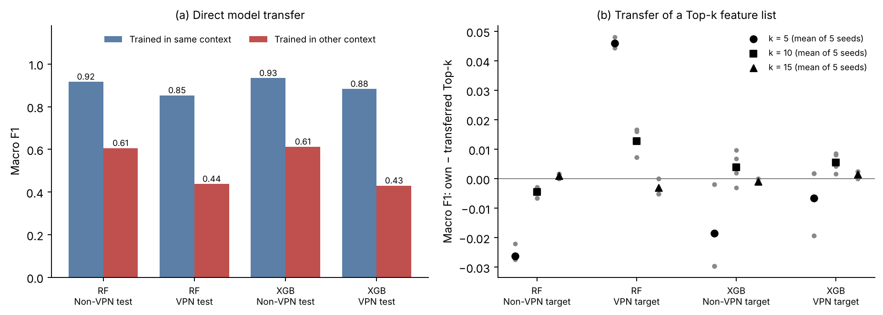
Fig. 8. Consequences of the cross-context differences. (a) Macro F1 of models applied to their own context and to the other context. (b) Own-minus-transferred macro F1 for Top-k feature lists; grey points are the five selection seeds and black markers their mean. Positive values favour the own list.

IX. SENTINEL AND ROBUSTNESS CHECKS
Table XII collects the sensitivity checks. The two sentinel encodings differ in macro F1 by at most 0.0085, and within one context they rank the 23 original features at ρ = 0.887–0.943. Random Forest gives the indicators 8.54% (S1) and 7.16% (S2) of total importance on Non-VPN data and 4.17% and 3.56% on VPN data; XGBoost gives them at most 0.59%. These numbers describe how the models allocate importance, not how much information missingness carries.
How large is the encoding effect? The S1-versus-S2 disagreement, 1 − ρ = 0.06–0.11, is about 1.5 to 4 times smaller than the cross-context disagreement on the primary split (1 − ρ = 0.17–0.21). The more relevant comparison is the disagreement between random halves of one context (1 − ρ = 0.02–0.07). The two ranges overlap, although the encoding change can produce the larger disagreement, so changing the encoding of undefined statistics moves a ranking by an amount comparable in scale to random-half retraining variation. The previous version's statement that encoding moves rankings almost as much as the change of context overstated this. Cross-context agreement under the alternative encodings stays close to the primary values: ρ = 0.8281 under both S1 and S2 for Random Forest, and 0.7915 (S1) and 0.7806 (S2) for XGBoost. We recomputed the identical Random Forest values from the saved rankings; the two rankings differ (Kendall τ_{b} 0.6364 and 0.6285, Top-5 overlap 3 and 2), but their squared rank differences happen to sum to the same total.
Across the six model and TreeSHAP configurations explained on 500 records, cross-context ρ ranges from 0.681 to 0.819, and three of five leading features are shared in all six. Within one model and context, path-dependent and interventional rankings agree at ρ = 0.969–0.984. Extra Trees agrees less well with the path-dependent Random Forest (0.709–0.801). Refitting XGBoost with three other seeds gives mean within-context ρ of 0.9928 (Non-VPN) and 0.9928 (VPN), so seed noise alone is small, and max_depth = 3 or 10 leaves cross-context ρ at 0.767 and 0.803. Table XII gives percentile intervals from resampling the explained records. The resampled values are centred within 0.015 of the point estimates, above them for some configurations and below for others, so we see no consistent bias.
TABLE XII
Sensitivity of cross-context agreement to sentinel encoding, model, TreeSHAP formulation and hyperparameters
Configuration | Macro F1  NV / VPN | Cross-context ρ | 95% interval  (explained records) | RBO | Top-5
Primary fits and sentinel encodings (full test partitions)
RF, raw sentinel (primary) | 0.917 / 0.853 | 0.8300 | — | 0.580 | 3/5
RF, S1 | 0.919 / 0.855 | 0.8281 | — | 0.639 | 3/5
RF, S2 | 0.920 / 0.853 | 0.8281 | — | 0.564 | 2/5
XGB, raw sentinel (primary) | 0.934 / 0.884 | 0.7856 | — | 0.755 | 3/5
XGB, S1 | 0.935 / 0.886 | 0.7915 | — | 0.809 | 3/5
XGB, S2 | 0.933 / 0.878 | 0.7806 | — | 0.766 | 3/5
Model and TreeSHAP formulation (500 explained records per context)
Random Forest, path-dependent | 0.917 / 0.853 | 0.8192 | [0.803, 0.841] | 0.578 | 3/5
Random Forest, interventional | 0.917 / 0.853 | 0.8024 | [0.771, 0.814] | 0.767 | 3/5
XGBoost, path-dependent | 0.934 / 0.884 | 0.7955 | [0.769, 0.804] | 0.658 | 3/5
XGBoost, interventional | 0.934 / 0.884 | 0.7727 | [0.761, 0.794] | 0.754 | 3/5
Extra Trees, path-dependent | 0.899 / 0.849 | 0.6808 | [0.633, 0.763] | 0.764 | 3/5
Extra Trees, interventional | 0.899 / 0.849 | 0.7381 | [0.661, 0.771] | 0.750 | 3/5
XGBoost hyperparameters (full test partitions)
XGBoost, max_depth = 3 | 0.928 / 0.864 | 0.7668 | — | 0.727 | 3/5
XGBoost, max_depth = 10 | 0.931 / 0.872 | 0.8034 | — | 0.768 | 3/5
Note. S1 keeps −1 and appends ten undefined-value indicators; S2 replaces −1 by NaN and appends the same indicators; agreement is computed over the 23 original features. Intervals are 95% percentile intervals from 2,000 resamples of the explained records within each context, with models and backgrounds fixed; they exclude training, background and session-level uncertainty.

X. SUMMARY AND DISCUSSION
Table XIII collects the main quantities from Sections V to IX in one place.
TABLE XIII
Summary of the main results
Quantity | Random Forest | XGBoost | Section
Macro F1, Non-VPN / VPN | 0.917 / 0.853 | 0.934 / 0.884 | V
Primary cross-context ρ / RBO / Top-5 | 0.830 / 0.580 / 3 | 0.786 / 0.755 / 3 | VI-B
Half-split cross-context ρ (mean) | 0.766 | 0.825 | VI-C
Δρ, random halves (SD) | +0.186 (0.036) | +0.129 (0.028) | VI-C
Δρ, permutation null (SD) | +0.028 (0.019) | −0.002 (0.009) | VI-C
Δρ, grouped ~10 / ~35 / ~140 per cluster | +0.100 / +0.042 / +0.002 | +0.079 / +0.014 / −0.015 | VI-C
Class-mix swap: change in ρ with the other context (NV / VPN) | −0.035 / −0.007 | +0.008 / +0.017 | VI-D
Model transfer macro F1, Non-VPN→VPN / VPN→Non-VPN | 0.438 / 0.606 | 0.430 / 0.613 | VIII-A
Top-10 list transfer, own − transferred F1 (NV / VPN target) | −0.004 / +0.013 | +0.004 / +0.006 | VIII-B
Within-context ρ, S1 vs S2 encoding (NV / VPN) | 0.914 / 0.887 | 0.942 / 0.943 | IX
Note. Δρ is the mean over 11 repeats of within-context minus cross-context Spearman agreement; SD describes the spread over repeats. Positive transfer differences are a cost of using the other context's feature list.

A. What the References Show
The answer to the question in the title depends on what cross-context agreement is compared with. Against models trained on random halves of one context, VPN and Non-VPN rankings disagree clearly more, and the permutation null shows that neither the half-split procedure nor the class-mix difference produces such a gap. When the training halves are built from whole clusters of related flows, the Spearman excess shrinks substantially, and its mean approaches zero only under the coarsest grouping; the top-weighted RBO gaps shrink less, and the Random Forest Spearman gap is still positive in every repeat with clusters of about 35 flows. The random-half gaps are positive across all reported repeats, but much of the cross-context difference is of the same order as the difference between clusters of related flows within one context. Because the clusters are only a proxy for capture sessions and the outer 80/20 split stays random, these experiments establish sensitivity to grouping, not the size of a true between-session effect. Without session identifiers or an independent second capture, the benchmark cannot show whether the VPN itself changes model reliance. A random within-context split, which is the usual way such references are built, would have suggested that it does.

B. Accuracy and Correlation Do Not Guarantee Consistent Explanations
Predictive accuracy, whole-ranking correlation and agreement among the leading features are separate properties. A cross-context Spearman of about 0.8 coexists with three shared Top-5 features and an RBO of 0.58–0.75, and the leading features themselves change with the explanation method: the minimum IATs that rise most under SHAP move much less under permutation importance. Reporting performance, whole-ranking and top-weighted agreement, a within-context reference built from data that is as independent as possible, and a second importance measure gives a fuller picture than any one summary.

C. Correlated Features and the Role of Grouping
Aggregation into semantic families narrows the gaps, but a family-level ranking measures something different from a feature ranking, and the family definitions decide which differences get hidden. Summing favours large families, per-member means and correlation-based clusters give larger gaps, and moving two correlated totals into the duration family changes which family leads. Family-level conclusions should be stated together with the grouping rule and the family sizes.

D. Do Explanation Differences Matter?
The two consequence tests point in different directions. A trained model does not survive the change of context: macro F1 falls to 0.43–0.61. A SHAP-selected feature list mostly does: at k = 10 and 15 the transferred list loses at most about 0.013 macro F1 on average across selection seeds (0.017 for the worst single seed), and for some targets it does better than the own list. Feature lists are coarse summaries that tolerate the ranking disagreement, while the models built on them are not. At k = 5, where the lists differ in two of five features, the cost can reach 0.05 for one model and context, so the conclusion holds only for moderately long lists.

E. Implications for Explainable Network Security Systems
An explanation report for a traffic classifier should name the observation context, the fitted model, the attribution formulation, the encoding of undefined statistics and any aggregation rule. Consistency claims need a reference, and that reference should be built from data that does not share sessions with itself; a random split of correlated flows will overstate within-context agreement. Where an explanation drives a decision, such as pruning features, the decision should be checked on held-out data from the target context, and a deployed model should not be expected to transfer to a differently observed context because its explanations look similar.

XI. THREATS TO VALIDITY AND LIMITATIONS
Session dependence and the missing group split. This is the most serious limitation, and it decides the main conclusion. The processed files carry no session or capture identifiers, so no reference in this paper is a true group split. Cluster-grouped halves are a proxy: fine clusters may still let related flows cross the split, and coarse clusters also separate regions of feature space that a session split would not. Only the division of training data into halves is grouped; the outer 80/20 split is random. The cross-context gap shrinks steadily as grouping becomes stricter, so its size depends on an unknown session structure. Regenerating flows from the raw captures and splitting by capture file, or using a second independent capture of both contexts, would settle this.
Benchmark age, reuse and construction. The ISCX VPN-nonVPN captures are several years old, come from one laboratory and one VPN service, and reflect the applications and protocols in use at the time. The dataset is among the most reused benchmarks in the field, and the released files cap BROWSING at 2,500 flows and Non-VPN P2P at 1,000 flows, so two class frequencies reflect the dataset's construction. We claim no dataset novelty and draw no conclusions about present-day applications or VPN technologies.
Class distribution. The contexts have different class mixes. Class weighting, the class-mix swap, class-matched training with a same-size reference and the permutation null all leave the class-mix effect small, but the swapped training sets are limited to 3,400 flows and the matched sets reuse every Non-VPN MAIL flow.
Correlated features and aggregation. How attribution is allocated depends on the model and the value function, and the drop-one and permutation checks show that part of the minimum-IAT shift is credit moving among partial substitutes. Summed family importance neither corrects for feature dependence nor provides an instance-level group attribution, and other groupings give other consistency patterns.
Model, TreeSHAP and global aggregation. Only tree ensembles are explained, hyperparameters were not tuned, and only two TreeSHAP formulations were compared, the interventional one with a background of 200 training records. Importance is averaged over model outputs and explained records, so the results say nothing definite about consistency for particular classes or single flows.
Consequence tests. The feature-list test uses five inner splits per context and one refit per feature set; its intervals hold the models fixed, and it is not an equivalence test. The model-transfer test uses one model per context.
Representation. The data offer 23 time-related flow statistics and nothing else. Packet-size features and packet sequences, which modern encrypted-traffic classifiers rely on, are missing, and so are newer protocols such as TLS 1.3 and QUIC and VPN technologies such as WireGuard. Other treatments of undefined statistics, such as dropping them or imputation, were not evaluated, and some timestamp artefacts (negative minimum IATs) remain in the released files.
Replication. Every conclusion concerns one dataset, one flow timeout and one feature representation. The repeated designs reuse one dataset and overlapping test records, and Random Forest half-models are explained on 800 test records each. None of this replaces replication on independent captures or modern traffic.

XII. CONCLUSION AND FUTURE WORK
We asked whether a classifier explains the same seven application categories with the same features when traffic is observed with and without a VPN, using the ISCX VPN-nonVPN benchmark and its 23 time-related flow features.
Both ensembles lose performance under VPN (XGBoost macro F1 0.9340 to 0.8836, Random Forest 0.9171 to 0.8533), and a model trained in one context reaches only 0.43–0.61 macro F1 in the other. The primary SHAP rankings are related across contexts but not interchangeable: Spearman ρ is 0.83 and 0.79, RBO 0.58 and 0.75, and each model keeps three of its five leading features.
Whether this disagreement reflects the context depends on the reference. Against random halves of one context the within-minus-cross gap is 0.13 for XGBoost and 0.19 for Random Forest over 11 repeats with redrawn partitions, and a permutation null that keeps the class mixes gives little or none (−0.002 and +0.028). When the training halves keep clusters of similar flows together, the Spearman gap shrinks to 0.08–0.10 with clusters of about ten flows and 0.01–0.04 with about 35, and its mean approaches zero only with the coarsest clusters; top-weighted RBO gaps shrink less. Class mix explains little, and the most visible shift, the rise of the minimum IATs, is partly a redistribution of Shapley credit among correlated timing features. A SHAP-selected feature list transfers between contexts at a cost of at most about 0.013 macro F1 on average across selection seeds for lists of ten or more features.
On this benchmark, then, the cross-context differences in SHAP rankings are sensitive to how related flows are grouped, and much of the random-split gap is of the same order as the differences between groups of related flows within a context. They should not be read as an effect of the VPN, and the proxy experiments here cannot settle how large a true between-session effect is. Settling the question requires captures that keep session identifiers or a second independent capture of both contexts, more recent traffic, and class-specific explanations.

REFERENCES
[1] P. Velan, M. Čermák, P. Čeleda, and M. Drašar, “A survey of methods for encrypted traffic classification and analysis,” Int. J. Netw. Manage., vol. 25, no. 5, pp. 355-374, 2015, doi: 10.1002/nem.1901.
[2] S. Rezaei and X. Liu, “Deep learning for encrypted traffic classification: An overview,” IEEE Commun. Mag., vol. 57, no. 5, pp. 76-81, 2019, doi: 10.1109/MCOM.2019.1800819.
[3] T. T. T. Nguyen and G. Armitage, “A survey of techniques for internet traffic classification using machine learning,” IEEE Commun. Surveys Tuts., vol. 10, no. 4, pp. 56-76, 2008, doi: 10.1109/SURV.2008.080406.
[4] G. Draper-Gil, A. H. Lashkari, M. S. I. Mamun, and A. A. Ghorbani, “Characterization of encrypted and VPN traffic using time-related features,” in Proc. 2nd Int. Conf. Inf. Syst. Secur. Privacy (ICISSP), Rome, Italy, 2016, pp. 407-414, doi: 10.5220/0005740704070414.
[5] W. Wang, M. Zhu, J. Wang, X. Zeng, and Z. Yang, “End-to-end encrypted traffic classification with one-dimensional convolution neural networks,” in Proc. IEEE Int. Conf. Intell. Secur. Informat. (ISI), 2017, pp. 43-48, doi: 10.1109/ISI.2017.8004872.
[6] G. Aceto, D. Ciuonzo, A. Montieri, and A. Pescapè, “Mobile encrypted traffic classification using deep learning: Experimental evaluation, lessons learned, and challenges,” IEEE Trans. Netw. Service Manag., vol. 16, no. 2, pp. 445-458, 2019, doi: 10.1109/TNSM.2019.2899085.
[7] M. Lotfollahi, M. J. Siavoshani, R. S. H. Zade, and M. Saberian, “Deep packet: A novel approach for encrypted traffic classification using deep learning,” Soft Comput., vol. 24, no. 3, pp. 1999-2012, 2020, doi: 10.1007/s00500-019-04030-2.
[8] X. Lin, G. Xiong, G. Gou, Z. Li, J. Shi, and J. Yu, “ET-BERT: A contextualized datagram representation with pre-training transformers for encrypted traffic classification,” in Proc. ACM Web Conf. (WWW), 2022, pp. 633-642.
[9] A. Warnecke, D. Arp, C. Wressnegger, and K. Rieck, “Evaluating explanation methods for deep learning in security,” in Proc. IEEE Eur. Symp. Secur. Privacy (EuroS&P), 2020, pp. 158-174.
[10] M. Wang, K. Zheng, Y. Yang, and X. Wang, “An explainable machine learning framework for intrusion detection systems,” IEEE Access, vol. 8, pp. 73127-73141, 2020.
[11] N. Capuano, G. Fenza, V. Loia, and C. Stanzione, “Explainable artificial intelligence in cybersecurity: A survey,” IEEE Access, vol. 10, pp. 93575-93600, 2022.
[12] A. Nascita, A. Montieri, G. Aceto, D. Ciuonzo, V. Persico, and A. Pescapè, “XAI meets mobile traffic classification: Understanding and improving multimodal deep learning architectures,” IEEE Trans. Netw. Service Manag., vol. 18, no. 4, pp. 4225-4246, 2021.
[13] S. M. Lundberg and S.-I. Lee, “A unified approach to interpreting model predictions,” in Proc. Adv. Neural Inf. Process. Syst. (NeurIPS), vol. 30, 2017, pp. 4765-4774.
[14] S. M. Lundberg, G. Erion, H. Chen, A. DeGrave, J. M. Prutkin, B. Nair, R. Katz, J. Himmelfarb, N. Bansal, and S.-I. Lee, “From local explanations to global understanding with explainable AI for trees,” Nature Mach. Intell., vol. 2, no. 1, pp. 56-67, 2020, doi: 10.1038/s42256-019-0138-9.
[15] D. Alvarez-Melis and T. S. Jaakkola, “On the robustness of interpretability methods,” 2018, arXiv:1806.08049.
[16] A. Ghorbani, A. Abid, and J. Zou, “Interpretation of neural networks is fragile,” in Proc. AAAI Conf. Artif. Intell., vol. 33, 2019, pp. 3681-3688.
[17] S. Krishna, T. Han, A. Gu, J. Pombra, S. Jabbari, S. Wu, and H. Lakkaraju, “The disagreement problem in explainable machine learning: A practitioner's perspective,” 2022, arXiv:2202.01602.
[18] K. Aas, M. Jullum, and A. Løland, “Explaining individual predictions when features are dependent: More accurate approximations to Shapley values,” Artif. Intell., vol. 298, Art. no. 103502, 2021, doi: 10.1016/j.artint.2021.103502.
[19] H. Chen, J. D. Janizek, S. Lundberg, and S.-I. Lee, “True to the model or true to the data?” 2020, arXiv:2006.16234.
[20] I. E. Kumar, S. Venkatasubramanian, C. Scheidegger, and S. Friedler, “Problems with Shapley-value-based explanations as feature importance measures,” in Proc. 37th Int. Conf. Mach. Learn. (ICML), PMLR vol. 119, 2020, pp. 5491-5500.
[21] T. Shapira and Y. Shavitt, “FlowPic: Encrypted internet traffic classification is as easy as image recognition,” in Proc. IEEE INFOCOM Workshops, 2019, pp. 680-687.
[22] J. Holland, P. Schmitt, N. Feamster, and P. Mittal, “New directions in automated traffic analysis,” in Proc. ACM SIGSAC Conf. Comput. Commun. Secur. (CCS), 2021, pp. 3366-3383.
[23] A. S. Jacobs, R. Beltiukov, W. Willinger, R. A. Ferreira, A. Gupta, and L. Z. Granville, “AI/ML for network security: The emperor has no clothes,” in Proc. ACM SIGSAC Conf. Comput. Commun. Secur. (CCS), 2022, pp. 1537-1551.
[24] A. H. Lashkari, G. Draper-Gil, M. S. I. Mamun, and A. A. Ghorbani, “Characterization of Tor traffic using time based features,” in Proc. 3rd Int. Conf. Inf. Syst. Secur. Privacy (ICISSP), Porto, Portugal, 2017, pp. 253-262.
[25] R. Sommer and V. Paxson, “Outside the closed world: On using machine learning for network intrusion detection,” in Proc. IEEE Symp. Secur. Privacy, 2010, pp. 305-316, doi: 10.1109/SP.2010.25.
[26] D. Arp, E. Quiring, F. Pendlebury, A. Warnecke, F. Pierazzi, C. Wressnegger, L. Cavallaro, and K. Rieck, “Dos and don'ts of machine learning in computer security,” in Proc. 31st USENIX Secur. Symp., 2022, pp. 3971-3988.
[27] G. Apruzzese, P. Laskov, E. Montes de Oca, W. Mallouli, L. Brdalo Rapa, A. V. Grammatopoulos, and F. Di Franco, “The role of machine learning in cybersecurity,” Digit. Threats: Res. Pract., vol. 4, no. 1, Art. no. 8, 2023.
[28] Z. A. El Houda, B. Brik, and L. Khoukhi, “‘Why should I trust your IDS?’: An explainable deep learning framework for intrusion detection systems in Internet of Things networks,” IEEE Open J. Commun. Soc., vol. 3, pp. 1164-1176, 2022.
[29] M. Sarhan, S. Layeghy, and M. Portmann, “Evaluating standard feature sets towards increased generalisability and explainability of ML-based network intrusion detection,” Big Data Res., vol. 30, Art. no. 100359, 2022.
[30] F. Pendlebury, F. Pierazzi, R. Jordaney, J. Kinder, and L. Cavallaro, “TESSERACT: Eliminating experimental bias in malware classification across space and time,” in Proc. 28th USENIX Secur. Symp., 2019, pp. 729-746.
[31] L. S. Shapley, “A value for n-person games,” in Contributions to the Theory of Games, vol. II, H. W. Kuhn and A. W. Tucker, Eds. Princeton, NJ, USA: Princeton Univ. Press, 1953, pp. 307-317.
[32] D. Janzing, L. Minorics, and P. Blöbaum, “Feature relevance quantification in explainable AI: A causal problem,” in Proc. 23rd Int. Conf. Artif. Intell. Statist. (AISTATS), PMLR vol. 108, 2020, pp. 2907-2916.
[33] M. Sundararajan and A. Najmi, “The many Shapley values for model explanation,” in Proc. 37th Int. Conf. Mach. Learn. (ICML), PMLR vol. 119, 2020, pp. 9269-9278.
[34] G. Hooker, L. Mentch, and S. Zhou, “Unrestricted permutation forces extrapolation: Variable importance requires at least one more model, or there is no free variable importance,” Statist. Comput., vol. 31, Art. no. 82, 2021.
[35] C. Strobl, A.-L. Boulesteix, A. Zeileis, and T. Hothorn, “Bias in random forest variable importance measures: Illustrations, sources and a solution,” BMC Bioinformatics, vol. 8, Art. no. 25, 2007, doi: 10.1186/1471-2105-8-25.
[36] C. Strobl, A.-L. Boulesteix, T. Kneib, T. Augustin, and A. Zeileis, “Conditional variable importance for random forests,” BMC Bioinformatics, vol. 9, Art. no. 307, 2008, doi: 10.1186/1471-2105-9-307.
[37] M. Jullum, A. Redelmeier, and K. Aas, “groupShapley: Efficient prediction explanation with Shapley values for feature groups,” 2021, arXiv:2106.12228.
[38] Q. Au, J. Herbinger, C. Stachl, B. Bischl, and G. Casalicchio, “Grouped feature importance and combined features effect plot,” Data Min. Knowl. Discov., vol. 36, pp. 1401-1450, 2022.
[39] I. Covert, S. M. Lundberg, and S.-I. Lee, “Understanding global feature contributions with additive importance measures,” in Proc. Adv. Neural Inf. Process. Syst. (NeurIPS), vol. 33, 2020, pp. 17212-17223.
[40] G. Visani, E. Bagli, F. Chesani, A. Poluzzi, and D. Capuzzo, “Statistical stability indices for LIME: Obtaining reliable explanations for machine learning models,” J. Oper. Res. Soc., vol. 73, no. 1, pp. 91-101, 2022.
[41] D. Slack, S. Hilgard, E. Jia, S. Singh, and H. Lakkaraju, “Fooling LIME and SHAP: Adversarial attacks on post hoc explanation methods,” in Proc. AAAI/ACM Conf. AI, Ethics, Soc. (AIES), 2020, pp. 180-186, doi: 10.1145/3375627.3375830.
[42] A. Fisher, C. Rudin, and F. Dominici, “All models are wrong, but many are useful: Learning a variable's importance by studying an entire class of prediction models simultaneously,” J. Mach. Learn. Res., vol. 20, no. 177, pp. 1-81, 2019.
[43] C. Spearman, “The proof and measurement of association between two things,” Amer. J. Psychol., vol. 15, no. 1, pp. 72-101, 1904.
[44] M. G. Kendall, “A new measure of rank correlation,” Biometrika, vol. 30, no. 1/2, pp. 81-93, 1938.
[45] W. Webber, A. Moffat, and J. Zobel, “A similarity measure for indefinite rankings,” ACM Trans. Inf. Syst., vol. 28, no. 4, Art. no. 20, 2010, doi: 10.1145/1852102.1852106.
[46] B. Efron and R. J. Tibshirani, An Introduction to the Bootstrap. New York, NY, USA: Chapman & Hall, 1993.
[47] P. Hall and H. Miller, “Using the bootstrap to quantify the authority of an empirical ranking,” Ann. Statist., vol. 37, no. 6B, pp. 3929-3959, 2009.
[48] S. Layeghy and M. Portmann, “Explainable cross-domain evaluation of ML-based network intrusion detection systems,” Comput. Electr. Eng., vol. 108, Art. no. 108692, 2023, doi: 10.1016/j.compeleceng.2023.108692.
[49] S. Mali, S. Agarwal, R. Chintawar, and A. K. Cherukuri, “Analyzing encrypted traffic analysis using explainable AI,” Ann. Math. Comput. Sci., vol. 31, pp. 1–22, 2025, doi: 10.56947/amcs.v31.660.
[50] Canadian Institute for Cybersecurity, “VPN-nonVPN dataset (ISCXVPN2016),” University of New Brunswick. [Online]. Available: https://www.unb.ca/cic/datasets/vpn.html
[51] L. Breiman, “Random forests,” Mach. Learn., vol. 45, no. 1, pp. 5-32, 2001, doi: 10.1023/A:1010933404324.
[52] T. Chen and C. Guestrin, “XGBoost: A scalable tree boosting system,” in Proc. 22nd ACM SIGKDD Int. Conf. Knowl. Discov. Data Min., 2016, pp. 785-794, doi: 10.1145/2939672.2939785.
[53] P. Geurts, D. Ernst, and L. Wehenkel, “Extremely randomized trees,” Mach. Learn., vol. 63, no. 1, pp. 3-42, 2006, doi: 10.1007/s10994-006-6226-1.
[54] F. Pedregosa et al., “Scikit-learn: Machine learning in Python,” J. Mach. Learn. Res., vol. 12, pp. 2825-2830, 2011.
[55] C. Ambroise and G. J. McLachlan, “Selection bias in gene extraction on the basis of microarray gene-expression data,” Proc. Nat. Acad. Sci. USA, vol. 99, no. 10, pp. 6562-6566, 2002.
[56] S. Kaufman, S. Rosset, C. Perlich, and O. Stitelman, “Leakage in data mining: Formulation, detection, and avoidance,” ACM Trans. Knowl. Discov. Data, vol. 6, no. 4, Art. no. 15, 2012.
[57] S. Kapoor and A. Narayanan, “Leakage and the reproducibility crisis in machine-learning-based science,” Patterns, vol. 4, no. 9, Art. no. 100804, 2023.

