Cross-Context Consistency of SHAP-Based Feature Importance for Application Classification Across VPN and Non-VPN Traffic
Prabhav Gomase, Ganesh Khekare*, Piyush Kothari, B Jeevan Sai Reddy, Nishok Khumar SD

School of Computer Science and Engineering,
Vellore Institute of Technology, Vellore, 632014, Tamil Nadu, India
prabhav.tushar2024@vitstudent.ac.in, ganesh.khekare@vit.ac.in*, piyush.kothari2024@vitstudent.ac.in, bandrevu.jeevan2024@vitstudent.ac.in, nishok.khumarsd2024@vitstudent.ac.in
Abstract—Global SHAP rankings are often read as a description of encrypted traffic, but a ranking learned in one observation context need not hold in another. We test this on the seven-class application task of the ISCX VPN-nonVPN benchmark, using TreeSHAP to explain Random Forest and XGBoost models trained separately on Non-VPN and VPN flows. Across contexts the rankings agree only in part (Spearman ρ 0.83 and 0.81, rank-biased overlap 0.58 and 0.71), and each model keeps three of its five leading features. Against models trained with their own seeds on disjoint, size-matched halves of one context's data, the within-minus-cross gap is 0.14 for XGBoost (SD 0.014 over 11 splits) and 0.16 for Random Forest. Class weighting, class-matched training and other sentinel encodings leave the difference in place. Six semantic feature families give a steadier summary, partly because of family size, and transferring a Top-10 selection between contexts changed macro F1 by less than 0.01. The design is observational: class mix and capture sessions also differ between the two contexts.
Keywords: Encrypted traffic classification, VPN, explainable artificial intelligence, SHAP, TreeSHAP, explanation consistency, aggregated feature-family importance, network security

I. INTRODUCTION
Encryption now covers most network traffic, and a growing share of it also passes through virtual private networks. Under these conditions, payload inspection and port-based rules lose most of their value [1, 2]. One response has been to infer the application category from features that survive encryption, such as packet timings, sizes and volumes [3, 4]. Tree ensembles, convolutional networks and transformers have all been tried on this problem since, with good results [5–8].
A VPN does not change which application a flow comes from. What it changes is how much an observer on the network can see. Inside a tunnel, keep-alive messages, encryption overhead and hidden traffic direction are layered over the application's own pattern, so two applications that look different in the clear can become hard to tell apart [4]. Several encrypted flows may also share one tunnel. Extra headers and padding then enter the features measured at the tunnel entrance, and the classifier has to separate the mixed traffic with the same feature set. Draper-Gil et al. [4] showed that timing-based features were enough for this, and the ISCX VPN-nonVPN dataset released with their work has been a common benchmark ever since.
High accuracy is only part of what a traffic classifier needs. When its output feeds security or network-management decisions, people also need to see why it decided as it did, so that the decision can be audited [9–12].
Post-hoc explanation methods are a common tool for this kind of audit [13]. For tabular models, SHAP has become the most widely used of them, and TreeSHAP [14] computes SHAP values for tree ensembles quickly enough to be practical. Its output is usually presented as a feature ranking, with the most influential feature first. Readers then tend to treat that list as a description of the traffic itself, taking short inter-arrival gaps as the mark of VoIP, say, or high throughput as the mark of video. Such a reading assumes that the ranking is a stable property of the traffic, and there are good reasons to doubt it. Importance values change with the training data, the model and the explanation method [15–17]. Shapley values also handle correlated features poorly: credit among them is split according to the fitted model and not the data distribution [18–20], and flow-based traffic features are heavily correlated. The minimum, mean, maximum and total inter-arrival times of a flow move together. When two similar models rank them differently, the change might reflect a real difference in how the models work, or it might be nothing more than training randomness.
The VPN and Non-VPN parts of the dataset allow model reliance to be compared across two observation contexts that use the same labels and the same feature encoding. This comparison is observational, because class composition and capture conditions can differ between the parts as well. If cross-context disagreement is larger than the disagreement between models trained on different data from the same context, that is evidence of a context-associated difference relative to that within-context reference. On its own, it says nothing about a causal effect of tunnelling. Earlier classification studies have concentrated on predictive accuracy, and explanation consistency needs an assessment of its own (Section II). In this paper we ask whether models lean on similar flow features when making the same predictions for VPN and Non-VPN traffic, and whether any differences in explanation are consistent and have practical consequences. Telling VPN from Non-VPN traffic is not the classification target here. The work contributes an empirical comparison of separately trained classifiers against within-context references built from disjoint half-splits and training bootstraps, a semantic aggregation of feature importance, an exploratory feature-selection analysis that uses training data only, and a set of sensitivity checks. No new classifier, attribution method or dataset is proposed. Section II reviews related work, and Section III describes the data and how it was audited. The methodology is given in Section IV, the results in Sections V to XI and the discussion in Section XII. Section XIII sets out threats to validity, and Section XIV concludes.

II. RELATED WORK

A. Encrypted and VPN Traffic Classification
As encryption spread, traffic classification moved away from port and payload methods toward statistical and learning-based classifiers, a shift documented in several surveys [1–3]. Encryption leaves flow statistics measurable: inter-arrival times, packet sizes, byte and packet rates, and flow duration. Conventional learners built on these statistics score well on many benchmarks [3, 4]. On several datasets, deep models fed with packet sequences or raw bytes have since gone further in accuracy [5–8, 21]. Whether those numbers can be compared is disputed, since studies differ in preprocessing, data splitting and label definitions [22, 23].
VPN traffic hides one more layer. Draper-Gil et al. [4] captured traffic from several application categories both inside and outside a VPN, and found that time-related features support both VPN detection and characterisation of the application inside the tunnel. A companion study used the same feature design for Tor traffic [24]. The same data later served as a test bed for deep classifiers working on packet- and byte-level inputs [5, 7]. Across this literature, a method is judged by its classification performance, usually accuracy or F1 on a single train/test partition.

B. Studies Using ISCX VPN-nonVPN
ISCX VPN-nonVPN is widely used as a public benchmark for encrypted and VPN traffic classification. Some studies use its time-related features [4]; others rebuild packet- or byte-level inputs from the raw captures [5, 7, 8]. Two facts about it matter here: it is old, and it has been reused heavily. Jacobs et al. [23] distilled strong network-security classifiers into interpretable surrogate models and showed that several of them leaned on shortcuts and spurious correlations that would probably fail outside the benchmark. Their finding warns directly against reading benchmark explanations as general truths about network traffic. We use the benchmark differently. Our aim is not a better classifier. Instead, we hold the classifier family fixed and ask whether its explanation stays consistent across the two observation contexts the dataset was built to contrast.

C. Explainable AI in Network Security
Security classifiers are increasingly expected to come with explanations, both to help analysts and to expose spurious correlations [11, 25–27]. Warnecke et al. [9] judged explanation methods for security models on several criteria, stability and robustness among them. Intrusion detectors have been explained with SHAP and similar techniques by Wang et al. [10] and by El Houda et al. [28], and Nascita et al. [12] applied explainability to multimodal classifiers of mobile traffic. The work closest to ours is by Sarhan et al. [29], who examined how SHAP explanations of intrusion detectors vary over several datasets with a common standard feature set and found that the most influential features changed from one dataset to the next. Those datasets, however, come from different networks with different attack mixes and labels, so a change in explanation cannot be traced to one change in observation conditions. Methodological guidance for security machine learning asks that evaluations guard against sampling bias, data snooping and spurious correlation [26, 30], and explanations need the same scrutiny.

D. Shapley Values, TreeSHAP and Correlated Features
SHAP treats the model output as the payoff of a cooperative game and assigns each feature its Shapley value [31] in that game. For one instance, these local attributions sum to the gap between the prediction and a baseline value [13]. For tree ensembles, TreeSHAP computes these attributions efficiently [14], and it comes in two common formulations. The tree-path-dependent version takes its reference behaviour from the cover statistics stored in the trees, so it needs no separate background data. The interventional version averages over a background sample, which cuts the dependence between features and amounts to a marginal (interventional) value function [19, 32]. The two formulations answer different questions, and neither makes a causal claim about how the data were generated [19, 32, 33].
With correlated features, attribution can shift among the members of a correlated set depending on the fitted model and the value function [18, 20, 34]. Similar dependence problems affect other importance measures as well [35, 36]. Several grouped explanation methods exist for summarising related variables [37–39], although each aggregation rule measures something different. A signed sum at the instance level can cancel out, and treating a whole group as one player changes the game being solved. We do neither. Our analysis adds up mean absolute SHAP importances already computed for each member feature. We call this descriptive quantity aggregated feature-family importance and do not equate it with either instance-level Group SHAP construction.

E. Stability of Explanations
Most studies of explanation stability look at input perturbations [15, 16], sampling inside local surrogate methods [40], adversarial manipulation [41] or cases in which explanation methods disagree [17]. Fisher et al. [42] found that a set of almost equally good models can rely on different variables, so the importance profile of any single model is just one of many plausible profiles. Comparing two rankings calls for rank-based measures. Spearman's ρ [43] and Kendall's τ [44] give every rank the same weight, whereas rank-biased overlap (RBO) puts more weight on agreement near the top of the list [45]. Bootstrap resampling gives a way to put uncertainty bounds on an empirical ranking [46, 47].

F. Gap Addressed by This Study
SHAP has been used before to explain the cross-domain performance of network intrusion detection [55], and explainable traffic-analysis studies have looked at encrypted-traffic datasets, ISCX VPN-nonVPN among them [56]. Our question is narrower. Within the shared ISCX feature schema and the same seven-class application task, do the global SHAP rankings of VPN and Non-VPN traffic differ by more than the variation between models trained on disjoint halves of one context's training data? We also aggregate importance into six predefined feature families and check what happens to predictive performance when a Top-10 feature subset is carried from one context to the other. The contribution is tied to this benchmark and this evaluation design, and it is not offered as the first SHAP study to span domains.

III. DATASET AND EXPERIMENTAL SETUP

A. Dataset and Observation Contexts
Our input is the time-related feature release of the ISCX VPN-nonVPN dataset [4], distributed by the Canadian Institute for Cybersecurity at the University of New Brunswick [57]. We use the Scenario A2 files for the 15 s flow timeout (TimeBasedFeatures-Dataset-15s-NO-VPN.arff and TimeBasedFeatures-Dataset-15s-VPN.arff), which hold 8,965 and 9,793 flows. We removed exact duplicate rows within each context (271 and 413 rows), leaving 8,694 Non-VPN and 9,380 VPN flows, and split each context once into stratified 80% training and 20% test partitions. These are the "provided partitions" used throughout; we checked that every processed record maps back to a row of the original ARFF files. Every record is one flow, described by the 23 features in Table I. These cover flow duration, rates of bytes and packets, inter-arrival-time (IAT) statistics in the forward, backward and combined directions, and statistics of active and idle periods. Each record carries one of seven application labels: BROWSING (0), CHAT (1), FT (file transfer, 2), MAIL (3), P2P (4), STREAMING (5) and VOIP (6). Both contexts use the same feature definitions and label set. The target in each context is the application category, so we solve two separate seven-class problems. No model ever sees data from both contexts, and none predicts the context.
TABLE I
The 23 time-related flow features and six semantic feature families
Feature | Family | Description
flowBytesPerSecond | Flow throughput | Bytes per second over the flow
flowPktsPerSecond | Flow throughput | Packets per second over the flow
duration | Flow duration | Flow duration
min_fiat | Directional IAT statistics | Minimum inter-arrival time of packets in the forward direction
mean_fiat | Directional IAT statistics | Mean forward inter-arrival time
max_fiat | Directional IAT statistics | Maximum forward inter-arrival time
total_fiat | Directional IAT statistics | Sum of forward inter-arrival times
min_biat | Directional IAT statistics | Minimum inter-arrival time of packets in the backward direction
mean_biat | Directional IAT statistics | Mean backward inter-arrival time
max_biat | Directional IAT statistics | Maximum backward inter-arrival time
total_biat | Directional IAT statistics | Sum of backward inter-arrival times
min_flowiat | Flow IAT statistics | Minimum inter-arrival time, both directions
mean_flowiat | Flow IAT statistics | Mean inter-arrival time, both directions
max_flowiat | Flow IAT statistics | Maximum inter-arrival time, both directions
std_flowiat | Flow IAT statistics | Standard deviation of inter-arrival time, both directions
min_active | Active-period statistics | Minimum length of an active period before the flow goes idle
mean_active | Active-period statistics | Mean active-period length
max_active | Active-period statistics | Maximum active-period length
std_active | Active-period statistics | Standard deviation of active-period length
min_idle | Idle-period statistics | Minimum idle-period length before the flow becomes active
mean_idle | Idle-period statistics | Mean idle-period length
max_idle | Idle-period statistics | Maximum idle-period length
std_idle | Idle-period statistics | Standard deviation of idle-period length
Note. The feature set is the time-related representation introduced by Draper-Gil et al. [4]. IAT values and active/idle lengths are stored in microseconds. Where a statistic cannot be defined for a flow (a flow with no backward packets, say, or with no idle period), the files hold −1; Section IV-G explains how this sentinel is treated. A few entries (55 in Non-VPN training, 43 in VPN training) lie below −1 in the original files and were kept as released.

B. Class Distributions
Table II and Fig. 1 list how many flows of each class sit in the provided partitions. Inside each context, training and test look alike: the total variation distance between them is 0.001 for Non-VPN and also 0.001 for VPN, as expected from the stratified split. Across contexts the picture changes. FT accounts for 9.9% of Non-VPN training flows and 20.1% of VPN training flows. VOIP goes the other way, from 32.5% down to 24.2%. MAIL is the smallest class in both contexts, though it grows from 2.7% to 4.6%. The two training distributions sit 0.142 apart in total variation distance, and a chi-square homogeneity test gives χ2 = 447.4 on 6 degrees of freedom (p < 0.001), with Cramér's V = 0.176. In Non-VPN the biggest class is 11.9 times the size of the smallest; in VPN the ratio is 5.8. We flag this as a possible confounder. A model fitted to one class mix may hand out attribution differently from a model fitted to another mix, even if the flows inside each class look the same. The primary experiments use the full partitions. Section VII-F reports class-matched models and class-weighted explanations as checks on this confounder.
TABLE II
Dataset statistics for the two observation contexts (provided partitions, verified counts)
 | Non-VPN |  |  | VPN
Class | Train | Test | Train % | Train | Test | Train %
0 = BROWSING | 2,000 | 500 | 28.8 | 2,000 | 500 | 26.7
1 = CHAT | 709 | 178 | 10.2 | 926 | 232 | 12.3
2 = FT | 686 | 171 | 9.9 | 1,506 | 377 | 20.1
3 = MAIL | 190 | 48 | 2.7 | 346 | 86 | 4.6
4 = P2P | 753 | 188 | 10.8 | 533 | 133 | 7.1
5 = STREAMING | 360 | 90 | 5.2 | 380 | 95 | 5.1
6 = VOIP | 2,257 | 564 | 32.5 | 1,813 | 453 | 24.2
Total | 6,955 | 1,739 | 100.0 | 7,504 | 1,876 | 100.0
Unique feature rows | 6,951 | 1,737 |  | 7,489 | 1,875
Train/test exact collisions | 1 |  |  | 13
Matched subset (per class) | 190 | 48 | 14.3 | 190 | 48 | 14.3
Matched subset (total) | 1,330 | 336 | 100.0 | 1,330 | 336 | 100.0
Note. An exact collision is a unique 23-dimensional feature vector found in both partitions after duplicate rows within each partition have been dropped; their labels disagree across partitions. The matched-subset rows give the class-matched data used in Section VII-F.
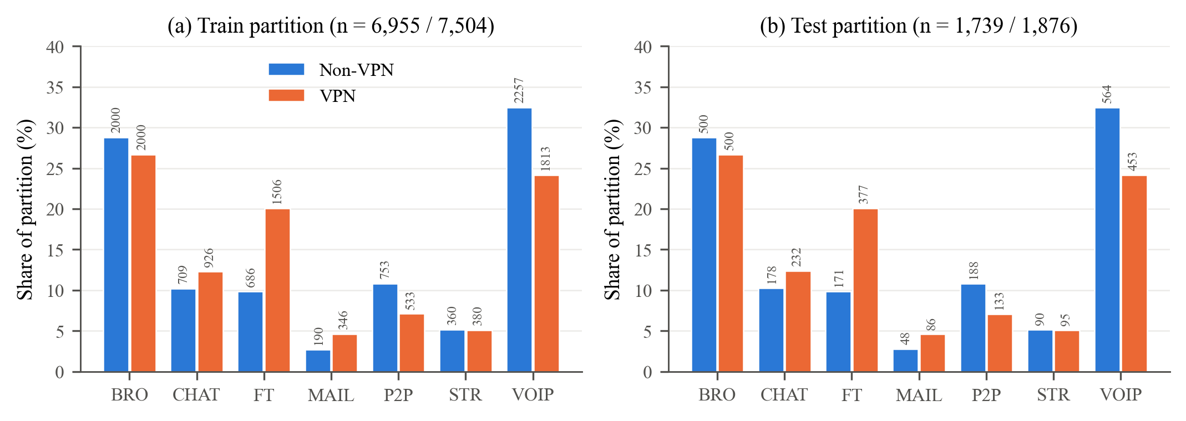
Fig. 1. Class make-up of the provided partitions for the two observation contexts. Each bar is the percentage of a partition taken by one class, with its count shown as a label. (a) Training partitions. (b) Test partitions. Within a context, training and test proportions are almost identical; between contexts they differ, most clearly for FT and VOIP.

C. Leakage and Near-Duplicate Audit
We audited the partitions before training anything. Once repeated rows inside a partition are dropped, Non-VPN keeps 6,951 distinct feature vectors in training and 1,737 in test, and exactly one vector shows up on both sides. VPN keeps 7,489 and 1,875, with thirteen shared. Every shared vector has one label in training and another in test. Calling them copied samples would be misleading, so we refer to them as exact feature-vector collisions. Because the labels disagree, memorising these rows cannot push test accuracy up. What they do tell us is that the 23 features cannot separate a handful of flows. They make up at most 0.7% of VPN test rows, and we left them in.
Near duplicates needed a different check. On standardised raw features the nearest-neighbour distances are tiny (Non-VPN median test-to-train distance 0.0032 standard deviations), because a handful of extreme values dominate each heavy-tailed feature and squeeze most flows together. We therefore repeated the audit after a log transform, log(1 + x + 1) with values clipped at −1, followed by standardisation, and after a rank (quantile) transform, both fitted on training data only. For each record we measured the Euclidean distance to the closest record on the other side of the split and to the closest other record on its own side. Under the log transform the Non-VPN medians are 0.108 from test to training and 0.101 from training to training; for VPN they are 0.109 and 0.108. The rank transform gives 0.088 and 0.092 (Non-VPN) and 0.075 and 0.074 (VPN).
Test records are as close to the training data as training records are to each other under all three representations. That pattern is what a random split of correlated flows would produce, so the audit rules out only gross copying and does not rule out leakage between related flows. As a rough proxy for session grouping we clustered the log-transformed training flows of each context into 50 k-means clusters and compared five-fold cross-validation that keeps clusters intact with ordinary stratified five-fold cross-validation. XGBoost macro F1 falls from 0.924 to 0.642 on Non-VPN and from 0.880 to 0.551 on VPN when whole clusters are held out. This proxy is harsh, because holding out whole clusters also asks the model to extrapolate to unseen regions of feature space, so the drop overstates what session grouping alone would cost. It still shows that performance depends heavily on having similar flows on both sides of the split. The processed files carry no session or capture identifiers, so a true group-aware split cannot be rebuilt; we keep the provided partitions and return to this dependence in Section XIII.

D. Class-Matched Subsets and Evaluation Scope
Each balanced subset takes 190 training and 48 test records from every class, sampled without replacement from the relevant provided partition; 190 is the number of MAIL training flows in Non-VPN. Per context that comes to 1,330 training and 336 test records with equal class counts. Section VII-F trains and explains models on these subsets and on repeated class-matched draws.

E. Models and Implementation
Three model families were picked because they treat correlated inputs differently. Random Forest [48] averages many deep trees, and each split chooses from a random subset of features. XGBoost [49] builds shallower trees in sequence, with regularisation, as a gradient-boosted ensemble. Logistic Regression, a multinomial linear model, comes from another hypothesis class entirely. Only Random Forest and XGBoost go through TreeSHAP, and these two carry the explanation analysis. Logistic Regression is kept as a performance baseline and a reference point for model family; we never explain it with TreeSHAP. Extra Trees [50] appears only in the robustness checks of Section XI.
Configurations are listed in Table III and do not change between contexts. Random Forest and XGBoost both get 200 trees, and Logistic Regression may run for up to 2,000 iterations. Hyperparameters were set once and not tuned; Section XI-B reports how far the rankings move under other XGBoost settings and other model seeds. The primary models and the training-bootstrap runs use random_state 42, while every half-split model in Section VII-B receives its own seed, so that reference also contains seed variance. The code relies on scikit-learn [51] and XGBoost [49], with TreeSHAP taken from the SHAP library [14].
TABLE III
Model and explanation configurations used in the implemented experiments
Model | Configuration | Explanation
Random Forest | 200 trees; max_features = sqrt; min_samples_leaf = 1; bootstrap = True; class_weight = None; random_state = 42;n_jobs = -1 | TreeSHAP
XGBoost | 200 estimators; multi:softprob, 7 classes; max_depth = 6; learning_rate = 0.1; subsample = 0.8; colsample_bytree = 0.8; min_child_weight = 1; eval_metric = mlogloss; random_state = 42;n_jobs = -1 | TreeSHAP
Logistic Regression | max_iter = 2000; random_state = 42; remaining parameters at library defaults; training-fitted feature standardisation | Performance baseline
Extra Trees | 500 trees; max_features = sqrt; min_samples_leaf = 1; random_state42;n_jobs = -1 | Robustness only
TreeSHAP | Path-dependent primary; interventional robustness with 200 training background records. RF/Extra Trees probability outputs; XGBoost class margins. Robustness explains 500 test records per context. | Ranks and normalised importance
Note. The same hyperparameters are used in both contexts. Tree models take the original features, while Logistic Regression uses standardisation fitted on the training data (and, in Section V, a log transform before it). The primary, bootstrap, sentinel, robustness and Top-10 runs were recorded under Python 3.14.7, NumPy 2.5.3, pandas 3.0.5, scikit-learn 1.9.0, XGBoost 3.4.1 and SHAP 0.52.0. The half-split, class-matched, control and sensitivity runs added in this revision used scikit-learn 1.9.1 and SHAP 0.53.0 on Linux; refitting the primary Random Forests in that environment reproduces their rankings exactly.

IV. METHODOLOGY

A. Overview
Fig. 2 sketches the analysis. The primary models and rankings are fitted on the provided partitions. Two within-context references describe how much rankings move without any change of context: 30 class-stratified bootstraps of each training partition, and repeated disjoint, size-matched half-splits with separate model seeds. On top of that we examine class weighting and class-matched training, six feature families and data-driven feature clusters, a Top-10 feature-selection experiment with random and bottom-ranked controls, alternative sentinel encodings, and other tree models, TreeSHAP formulations and hyperparameters.
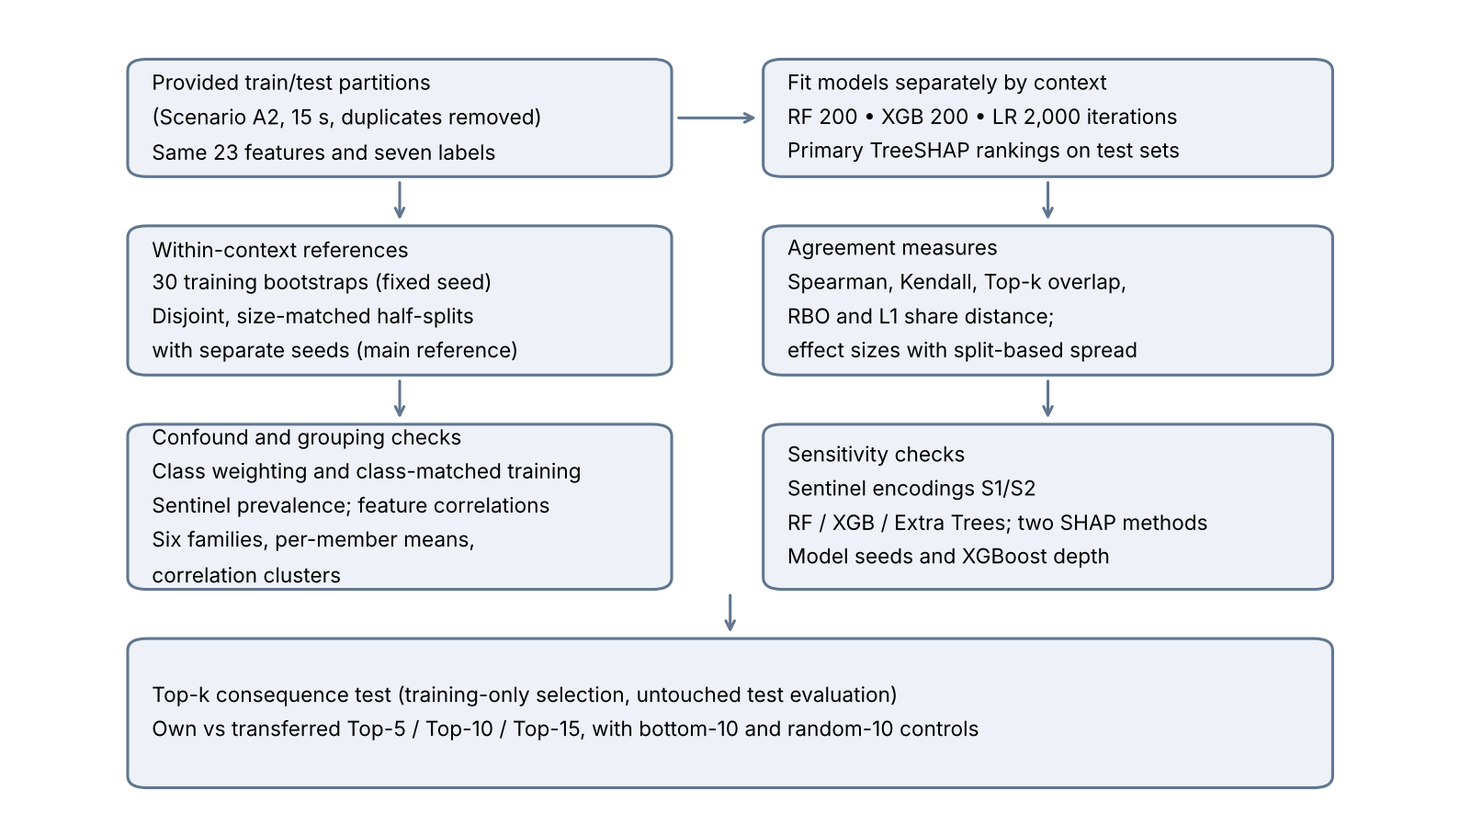
Fig. 2. Experimental pipeline as implemented. Each context is modelled on its own. Repeated training resampling keeps the test partitions fixed, and the consequence test selects features only inside the original training partitions. Numbers next to RF and XGB give the estimator count; the number next to LR is its iteration cap.

B. TreeSHAP and Global Importance
Take a model with class outputs $f_{c}$, $c\text{=}1,…,C$ ($C\text{=}7$). For an instance $x$ described by $m\text{=}23$ features, SHAP returns attributions $ϕ_{j,c}\left(x\right)$, and these obey local accuracy:
$f_{c}\left(x\right)\text{=}ϕ_{0,c}\text{+}\sum_{j\text{=}1}^{m}{ϕ_{j,c}}\left(x\right),c\text{=}1,…,C$ (1)
where $ϕ_{0,c}$ is the expected output under the reference distribution [13]. For the primary analysis we use the tree-path-dependent form of TreeSHAP [14]. It builds its reference from cover statistics stored along the tree paths, so no background sample is needed. What gets explained differs by model. For Random Forest it is the class probability; for XGBoost, trained with the multiclass soft-probability objective, it is the raw margin of each class before softmax. Raw attribution sizes cannot be compared between models as a result, and wherever we compare models we use ranks or normalised shares computed within each model. Explanations are always computed on the held-out test partition of the context in question. Feature $j$ gets a global importance equal to its absolute SHAP value averaged over the $n$ explained instances and all classes. Its normalised share $s_{j}$ is that number divided by the total over features:
$I_{j}\text{=}\frac{1}{nC}\sum_{i\text{=}1}^{n}{\sum_{c\text{=}1}^{C}{\left|ϕ_{j,c}\left(x_{i}\right)\right|}},s_{j}\text{=}\frac{I_{j}}{\sum_{l\text{=}1}^{m}{I_{l}}}$ (2)
Averaging over output classes leaves one global ranking for each model and context. That is not the same as balancing the true classes among the explained records. Each test record still counts once, so frequent classes contribute more records, and for this reason our global results cannot speak to class-specific or instance-level consistency (Section VI-C).
Two things about the method limit how far the rankings can be read. The tree-path-dependent formulation inherits whatever dependence structure the trees happened to learn. When several correlated features could serve for the same split, the one the model actually used gets the credit, and two otherwise similar models may divide attribution among correlated features quite differently [18, 19]. Also, SHAP values are about the model. A feature with a large attribution is one that the model output depends on, which does not make it a cause of the application label [20, 32]. We therefore treat a ranking as a description of what a model relies on, and our comparisons across contexts are comparisons of that reliance.

C. Ranking Agreement Measures
Our first agreement measure is Spearman's rank correlation [43],
$ρ\text{ = }1\text{ - }\frac{6\sum_{j\text{=}1}^{m}{d_{j}^{2}}}{m\left(m^{2}\text{ - }1\right)}$ (3)
where d_{j} is the rank difference for feature j. The second is Kendall's τ_{b} [44],
$τ_{b}\text{ = }\frac{n_{c}\text{ - }n_{d}}{\sqrt{\left(n_{0}\text{ - }n_{1}\right)\left(n_{0}\text{ - }n_{2}\right)}}$ (4)
Its denominator corrects for ties. Spearman correlation is computed on ranks with tied values given their average rank, so (3) is just the familiar no-tie formula. Top-k overlap O_{k} is the number of features two Top-k sets share. With m = 23, two sets of size k must share at least max(0, 2k − m) features. For two Top-k sets picked independently at random, the expected overlap and a chance-corrected version are
$E[O_{k}]\text{ = }\frac{k^{2}}{m}, κ_{k}\text{ = }\frac{O_{k}\text{ - }E[O_{k}]}{k\text{ - }E[O_{k}]}$ (5)
where κ_{k} is 0 at random expectation and 1 when the two sets are identical. We also report mean absolute rank displacement, the average distance a feature's rank moves between the two lists. It expresses disagreement in rank positions, which the correlations do not.
Spearman and Kendall weight a swap between ranks 20 and 21 as heavily as one between ranks 1 and 2, and the bottom third of the list carries only about 0.2–3% of importance per feature (Table VI). We therefore add two measures that emphasise the top. Rank-biased overlap [45] averages the overlap of the two Top-d sets with weights that shrink by a factor p at each further depth d; we use the extrapolated form with p = 0.9, which puts about 86% of the weight on the first ten ranks. The second is the L1 distance between the normalised importance vectors, the sum over features of |s_j − s′_j|, which is twice the total-variation distance and ranges from 0 to 2. It compares the shares themselves, so features with negligible shares barely contribute.
In short, we report Spearman, Kendall, Top-k overlap, rank-biased overlap (RBO) and the L1 share distance. Whole-ranking agreement and agreement at the top are read together, because either one on its own can make two explanations look more interchangeable than they are.

D. Repeated Training-Bootstrap Consistency Design
For each context we drew 30 class-stratified bootstrap samples from the original training partition. Sampling was with replacement, and each class kept its original record count. Bootstrap seeds ran from 1002 to 1031, while the model random_state stayed at 42. Each resampled training set was used to fit Random Forest and XGBoost, and each fitted model was explained on the full, fixed test set with tree-path-dependent TreeSHAP, with importance computed by (2).
That gives 30 rankings per model and context. Within a context, all 435 distinct pairs of runs are compared, or 870 once both contexts are pooled. Across contexts, every one of the 30 × 30 = 900 pairs is used. There is no pairing between the two lists of runs; a Non-VPN run and a VPN run with the same seed index are not matched in any meaningful sense. We take the consistency gap to be the mean within-context correlation minus the mean cross-context correlation:
Δ = ½ (mean ρ_{within,NV} + mean ρ_{within,VPN}) − mean ρ_{cross} (6)
Both within-context means carry the same weight in (6). This bootstrap reference is a weak one. About 63% of the distinct records in one bootstrap sample also appear in another drawn from the same partition, the samples use one model seed and are explained on one test set, whereas a Non-VPN and a VPN model share no records at all. Some within-versus-cross gap is therefore expected from any two datasets. We keep the bootstrap results as a description of refitting noise and use the half-split design below as the main reference.
In the half-split design, each repeat splits the training partition of each context, stratified by class, into two disjoint halves. Each half is subsampled (again stratified) to 3,476–3,477 records, so that all halves have the same size in both contexts, and each half-model gets its own random_state. Within-context agreement compares the two halves of one repeat, which share no training records; cross-context agreement averages the four Non-VPN-half versus VPN-half pairs of the same repeat. The gap Δ of (6) is computed per repeat, and its spread over repeats is our uncertainty estimate. We ran 11 repeats for XGBoost and, because Random Forest TreeSHAP is far slower, 3 repeats for Random Forest. Importance is computed in three ways: on the full test set; on disjoint, stratified halves of the test set (half A explained on test half A, half B on test half B), so that within-context pairs share neither training nor explained records; and with true classes weighted equally.
Neither design uses an independent capture. The other ISCX time windows (30, 60 and 120 s) are recomputed from the same packet captures, so they cannot serve as a second, independent pair of contexts, and we did not use them.

E. Aggregated Feature-Family Importance
Table I sorts the 23 features into six semantic families: one flow-duration feature, eight directional IAT statistics, two throughput features, and four statistics each for flow IAT, active periods and idle periods. The directional family holds the total, minimum, maximum and mean IAT in both the forward and the backward direction. For a family G, we add up the global importances I_{j} of its members from (2) and then normalise across the six families. The primary family analysis starts from the saved primary SHAP importances, and the repeated family rankings apply exactly the same rule to every training-bootstrap run.
Because absolute values are taken before summing, member contributions of opposite sign cannot cancel. What results is aggregated feature-family importance; it is neither instance-level Group SHAP nor a Shapley game with families as players. Families have different sizes, so a large family can lead a ranking by size alone. We therefore also rank families by the mean importance of their members, and we form data-driven clusters by average-linkage clustering of 1 − |ρ_S|, where ρ_S is the Spearman correlation between two features averaged over the two training partitions, cut at 0.2 (features joined when |ρ_S| ≥ 0.8 on average).

F. Consequence Test
A difference between explanations has practical weight if acting on the explanation would alter predictive performance. Feature selection is one such action. The consequence test asks whether a SHAP-chosen subset from one context, when used in the other, performs below a subset chosen in that other context directly.
Selection uses training data only [52–54]. We split the original training partition of each context into a stratified 80% inner-training subset and a 20% inner-validation subset, with seed 20261008. A selector model is trained on the inner-training part, its TreeSHAP importance is measured on the inner-validation part, and the ten highest-ranked features are retained. With that subset, a new reduced model is retrained on the whole original training partition (random_state 42 again) and scored on the test partition, which has not been touched. Three feature sets are compared: (i) the full set of 23 features; (ii) the context-specific subset, chosen from the training partition of the target context; and (iii) the transferred subset, chosen from the training partition of the other context and used unchanged to train and evaluate the target-context model.
We ran k = 10 as the main cutoff. Our original plan named k = 15; we report Top-10 as the main analysis because it was the setting run in full, and add k = 5 and, for XGBoost, k = 15. The main contrast subtracts the macro F1 of the transferred Top-10 model from that of the context-specific Top-10 model, so a value above zero means the transfer costs performance. Only the list of features moves between contexts, and each target model is always fitted on training data from its own context. Two controls show whether SHAP-based selection matters at all: the ten lowest-ranked features of the target-context selector (bottom-10), and random 10-feature subsets drawn once and shared by both contexts. Compute limited the number of random subsets (20 and 6 for XGBoost, 3 for Random Forest; Table XV).
For the Top-10 contrasts, the held-out records were resampled with 3,000 class-stratified paired bootstrap draws, giving percentile intervals for macro F1 and for the paired differences. These intervals are conditional on the fitted models and the selected features and leave out training and selection uncertainty, so we treat the results as effect sizes.

G. Sentinel Representations
In the processed features, −1 stands for an undefined statistic. The sentinel experiment builds ten indicator variables, one each for min_fiat, min_biat, max_fiat, max_biat, min_flowiat, max_flowiat, min_active, max_active, min_idle and max_idle. An indicator equals one when its source feature is −1. Our primary representation retains the raw sentinels in all 23 original features. Each alternative instead has 33 inputs. In S1, −1 stays in the original features and the ten binary indicators are appended. In S2, −1 is replaced by NaN and the same ten indicators are appended. Random Forest and XGBoost both handle missing values natively in the recorded software environment, so no median imputation is applied. The sentinel is common for some statistics. Across both partitions, min_fiat is −1 in 12.6% of Non-VPN and 10.0% of VPN flows, min_biat in 16.1% and 16.6%, the active and idle minima and maxima in 65.0% and 53.5%, and min_flowiat in only 0.3% and 0.4%. Each maximum is undefined exactly when the matching minimum is, so max_fiat, max_biat, max_active and max_idle share these rates, and max_flowiat is −1 in 0.07% and 0.06%.
Each transformation is applied in the same way to training and test partitions, and no test outcomes are used. Ranks are compared over the 23 original features alone. We report indicator importance on its own, as its share of the total mean absolute SHAP across all 33 inputs. When family shares of the original features are computed, the indicators are left out and the shares are normalised over the original features alone.

H. Robustness Configurations
The robustness analysis crosses three tree models (Random Forest, XGBoost and Extra Trees [50]) with the two TreeSHAP formulations, path-dependent and interventional, giving six configurations. Random Forest and XGBoost have 200 estimators apiece, and Extra Trees has 500. Each model is explained on a class-stratified sample of 500 test records from its own context, drawn with seed 42. For interventional TreeSHAP, the background is a separate class-stratified set of 200 training records from the same context, fixed at that size. Spearman intervals come from 2,000 independent within-context resamples of the explained test records, with bootstrap seed 20261008, while models and backgrounds stay fixed. Because the path-dependent results here use the same 500-record subsets, they need not match the full-test primary results. The intervals reflect uncertainty over explained records only and exclude training, selection and background-sampling uncertainty.

I. Statistical Analysis
We report effect sizes rather than significance tests. For the consistency comparison, the effect is the gap Δ in Spearman units (and the analogous gaps in RBO and L1), and its uncertainty is the spread of Δ across repeated disjoint half-splits. An earlier version of this analysis treated the 30 bootstrap fits as the sample and reported run-level intervals and permutation p-values. Those quantities measure the bootstrap itself: their width depends on B = 30, and the p-values of 1/3001 and 1/10001 were the floors set by the number of replicates. We no longer use them for inference.
For the consequence test, effects are paired differences in macro F1 with percentile intervals from class-stratified resampling of test records, read against the random-subset controls. All intervals are marginal 95% intervals and none allows for clustering by capture or session.

V. BASELINE CLASSIFICATION RESULTS
Tables IV and V report results on the provided test partitions, and Fig. 3 shows the same numbers graphically.
TABLE IV
Baseline classification performance on the provided test partitions
Context | Model | Accuracy | Macro precision | Macro recall | Macro F1
Non-VPN | Random Forest | 0.9454 | 0.9257 | 0.9099 | 0.9171
Non-VPN | XGBoost | 0.9580 | 0.9422 | 0.9280 | 0.9347
Non-VPN | Logistic Regression | 0.7366 | 0.5365 | 0.4797 | 0.4653
VPN | Random Forest | 0.8811 | 0.8526 | 0.8546 | 0.8533
VPN | XGBoost | 0.9030 | 0.8768 | 0.8799 | 0.8779
VPN | Logistic Regression | 0.6333 | 0.5879 | 0.4367 | 0.4254
TABLE V
Per-class recall on the provided test partitions
 | Test support |  | Non-VPN |  |  | VPN
Class | NV | VPN | RF | XGB | LR | RF | XGB | LR
BROWSING | 500 | 500 | 0.9800 | 0.9860 | 0.9460 | 0.9340 | 0.9540 | 0.9120
CHAT | 178 | 232 | 0.8090 | 0.8652 | 0.2247 | 0.7672 | 0.7759 | 0.2845
FT | 171 | 377 | 0.8713 | 0.9064 | 0.2515 | 0.7825 | 0.8329 | 0.5093
MAIL | 48 | 86 | 0.9167 | 0.9167 | 0.0000 | 0.7442 | 0.8023 | 0.0000
P2P | 188 | 133 | 0.9787 | 0.9734 | 0.8777 | 0.8346 | 0.8872 | 0.0075
STREAMING | 90 | 95 | 0.8222 | 0.8556 | 0.0778 | 0.9263 | 0.9158 | 0.3789
VOIP | 564 | 453 | 0.9911 | 0.9929 | 0.9805 | 0.9934 | 0.9912 | 0.9647
The two tree ensembles do well in both contexts, with XGBoost a little ahead of Random Forest in each. Without a VPN, XGBoost gets 0.9580 accuracy and 0.9347 macro F1, and Random Forest gets 0.9454 and 0.9171. With a VPN, XGBoost drops to 0.9030 and 0.8779 and Random Forest to 0.8811 and 0.8533. In macro F1 that is a loss of 0.0568 for XGBoost and 0.0638 for Random Forest. We prefer macro F1 here. Class mixes differ between contexts, and accuracy is driven mostly by BROWSING and VOIP, which together fill over half of each test partition.
The per-class view shows which classes pay for the VPN. VOIP is hardly affected, with both ensembles above 0.99 recall in either context, and BROWSING stays above 0.93. CHAT, FT, MAIL and P2P take the biggest hits. With XGBoost, MAIL recall falls from 0.9167 to 0.8023, P2P from 0.9734 to 0.8872, CHAT from 0.8652 to 0.7759 and FT from 0.9064 to 0.8329. STREAMING is the odd one out. Its recall is higher with the VPN (0.9158 for XGBoost, 0.9263 for Random Forest) than without it (0.8556 and 0.8222). We are not suggesting that a VPN makes streaming easier to spot. The streaming sessions that were captured may simply differ between contexts, or the classes streaming gets confused with may differ, and a flow-level dataset offers no way to separate those explanations.
Logistic Regression lags far behind on standardised raw features, at 0.4653 macro F1 for Non-VPN and 0.4254 for VPN. It converged in both contexts (139 and 183 of 2,000 iterations), so the gap is not an optimisation failure. Most of it comes from preprocessing. The features are heavy-tailed and contain −1 sentinels, and after standardisation a few extreme flows set the scale. With a log transform, log(1 + x + 1), before standardisation, macro F1 rises to 0.7537 (Non-VPN) and 0.7243 (VPN), with accuracy of 0.8695 and 0.7692. That is still well below the tree ensembles, which leaves room for nonlinear structure, but the raw-feature numbers in Table IV mostly reflect the input scaling. We keep Logistic Regression as a performance baseline and do not explain it.
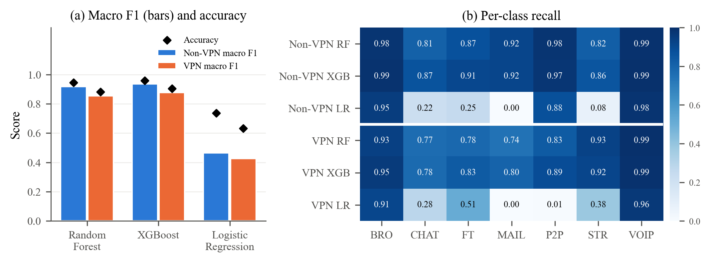
Fig. 3. Baseline performance on the provided test partitions. (a) For each model and context, bars give macro F1 and diamonds give accuracy. (b) Recall per class, with Non-VPN rows above the white line and VPN rows below it. Under VPN the tree ensembles lose between 0.057 and 0.064 macro F1, mostly in CHAT, FT, MAIL and P2P.
The VPN context is harder for every model. The tree ensembles remain accurate enough in both contexts for their explanations to be worth comparing, but accuracy cannot tell us whether the two contexts are being solved with the same evidence.

VI. SHAP-BASED EXPLANATION ANALYSIS

A. Global Rankings in Each Context
The primary global importance profiles are given in Table VI and Fig. 4. Without a VPN, the five most important features account for 40.34% of total importance in Random Forest and 49.75% in XGBoost. With a VPN the figures are 41.05% and 45.95%. The top ten take between 65.07% and 75.39%. These are normalised sums of mean absolute SHAP and should not be confused with shares of explained variance.
On Non-VPN data the top five for Random Forest are total_biat, min_flowiat, total_fiat, flowBytesPerSecond and duration, while on VPN data they are flowBytesPerSecond, min_fiat, min_biat, min_flowiat and total_biat. XGBoost puts min_flowiat, flowBytesPerSecond, total_biat, min_fiat and duration on top for Non-VPN, and flowBytesPerSecond, min_flowiat, min_biat, min_fiat and mean_biat for VPN. The two models agree with each other fairly well, with cross-model Spearman of 0.8340 for Non-VPN and 0.9298 for VPN. What moves between contexts is a set of particular timing statistics. Forward-direction features as a group do not simply drop out.
TABLE VI
Global TreeSHAP rankings on the held-out partitions; normalised importance shares (%)
Rank | RF Non-VPN (%) | RF VPN (%) | XGB Non-VPN (%) | XGB VPN (%)
1 | total_biat  9.83 | flowBytesPerSecond  10.94 | min_flowiat  13.97 | flowBytesPerSecond  13.95
2 | min_flowiat  8.27 | min_fiat  8.28 | flowBytesPerSecond  13.88 | min_flowiat  8.41
3 | total_fiat  8.09 | min_biat  8.15 | total_biat  8.65 | min_biat  8.40
4 | flowBytesPerSecond  7.86 | min_flowiat  6.90 | min_fiat  7.44 | min_fiat  7.97
5 | duration  6.29 | total_biat  6.78 | duration  5.81 | mean_biat  7.22
6 | std_flowiat  5.92 | duration  5.82 | flowPktsPerSecond  5.81 | duration  6.76
7 | mean_fiat  4.89 | mean_biat  5.78 | mean_flowiat  5.74 | max_flowiat  6.09
8 | mean_biat  4.79 | total_fiat  5.59 | total_fiat  5.35 | std_flowiat  5.93
9 | max_flowiat  4.71 | max_flowiat  5.38 | std_flowiat  4.47 | mean_flowiat  4.88
10 | min_biat  4.42 | std_flowiat  5.26 | min_biat  4.28 | total_fiat  4.16
11 | min_fiat  4.35 | flowPktsPerSecond  4.74 | mean_fiat  4.25 | total_biat  4.11
12 | flowPktsPerSecond  4.23 | mean_flowiat  4.64 | mean_biat  4.00 | max_fiat  3.99
13 | mean_flowiat  4.11 | max_fiat  3.97 | max_flowiat  3.63 | flowPktsPerSecond  3.30
14 | max_fiat  4.00 | mean_fiat  3.60 | mean_active  2.18 | mean_fiat  3.01
15 | mean_idle  3.02 | max_biat  3.59 | max_fiat  2.09 | max_biat  2.41
16 | max_biat  2.69 | std_idle  2.03 | max_biat  1.84 | min_idle  2.21
17 | min_idle  2.68 | max_idle  2.02 | max_active  1.75 | std_idle  1.50
18 | max_idle  2.47 | mean_idle  1.71 | min_active  1.34 | min_active  1.36
19 | max_active  2.13 | std_active  1.42 | min_idle  1.14 | mean_idle  1.29
20 | mean_active  2.11 | min_idle  1.11 | std_active  0.80 | mean_active  0.95
21 | min_active  2.03 | min_active  0.85 | mean_idle  0.77 | max_idle  0.77
22 | std_idle  0.63 | max_active  0.73 | std_idle  0.64 | max_active  0.71
23 | std_active  0.49 | mean_active  0.72 | max_idle  0.17 | std_active  0.63
Note. Each cell names a feature and gives its percentage of total mean absolute SHAP, with the average taken over records and model output classes. Within each model and context the shares add up to 100%, apart from rounding.
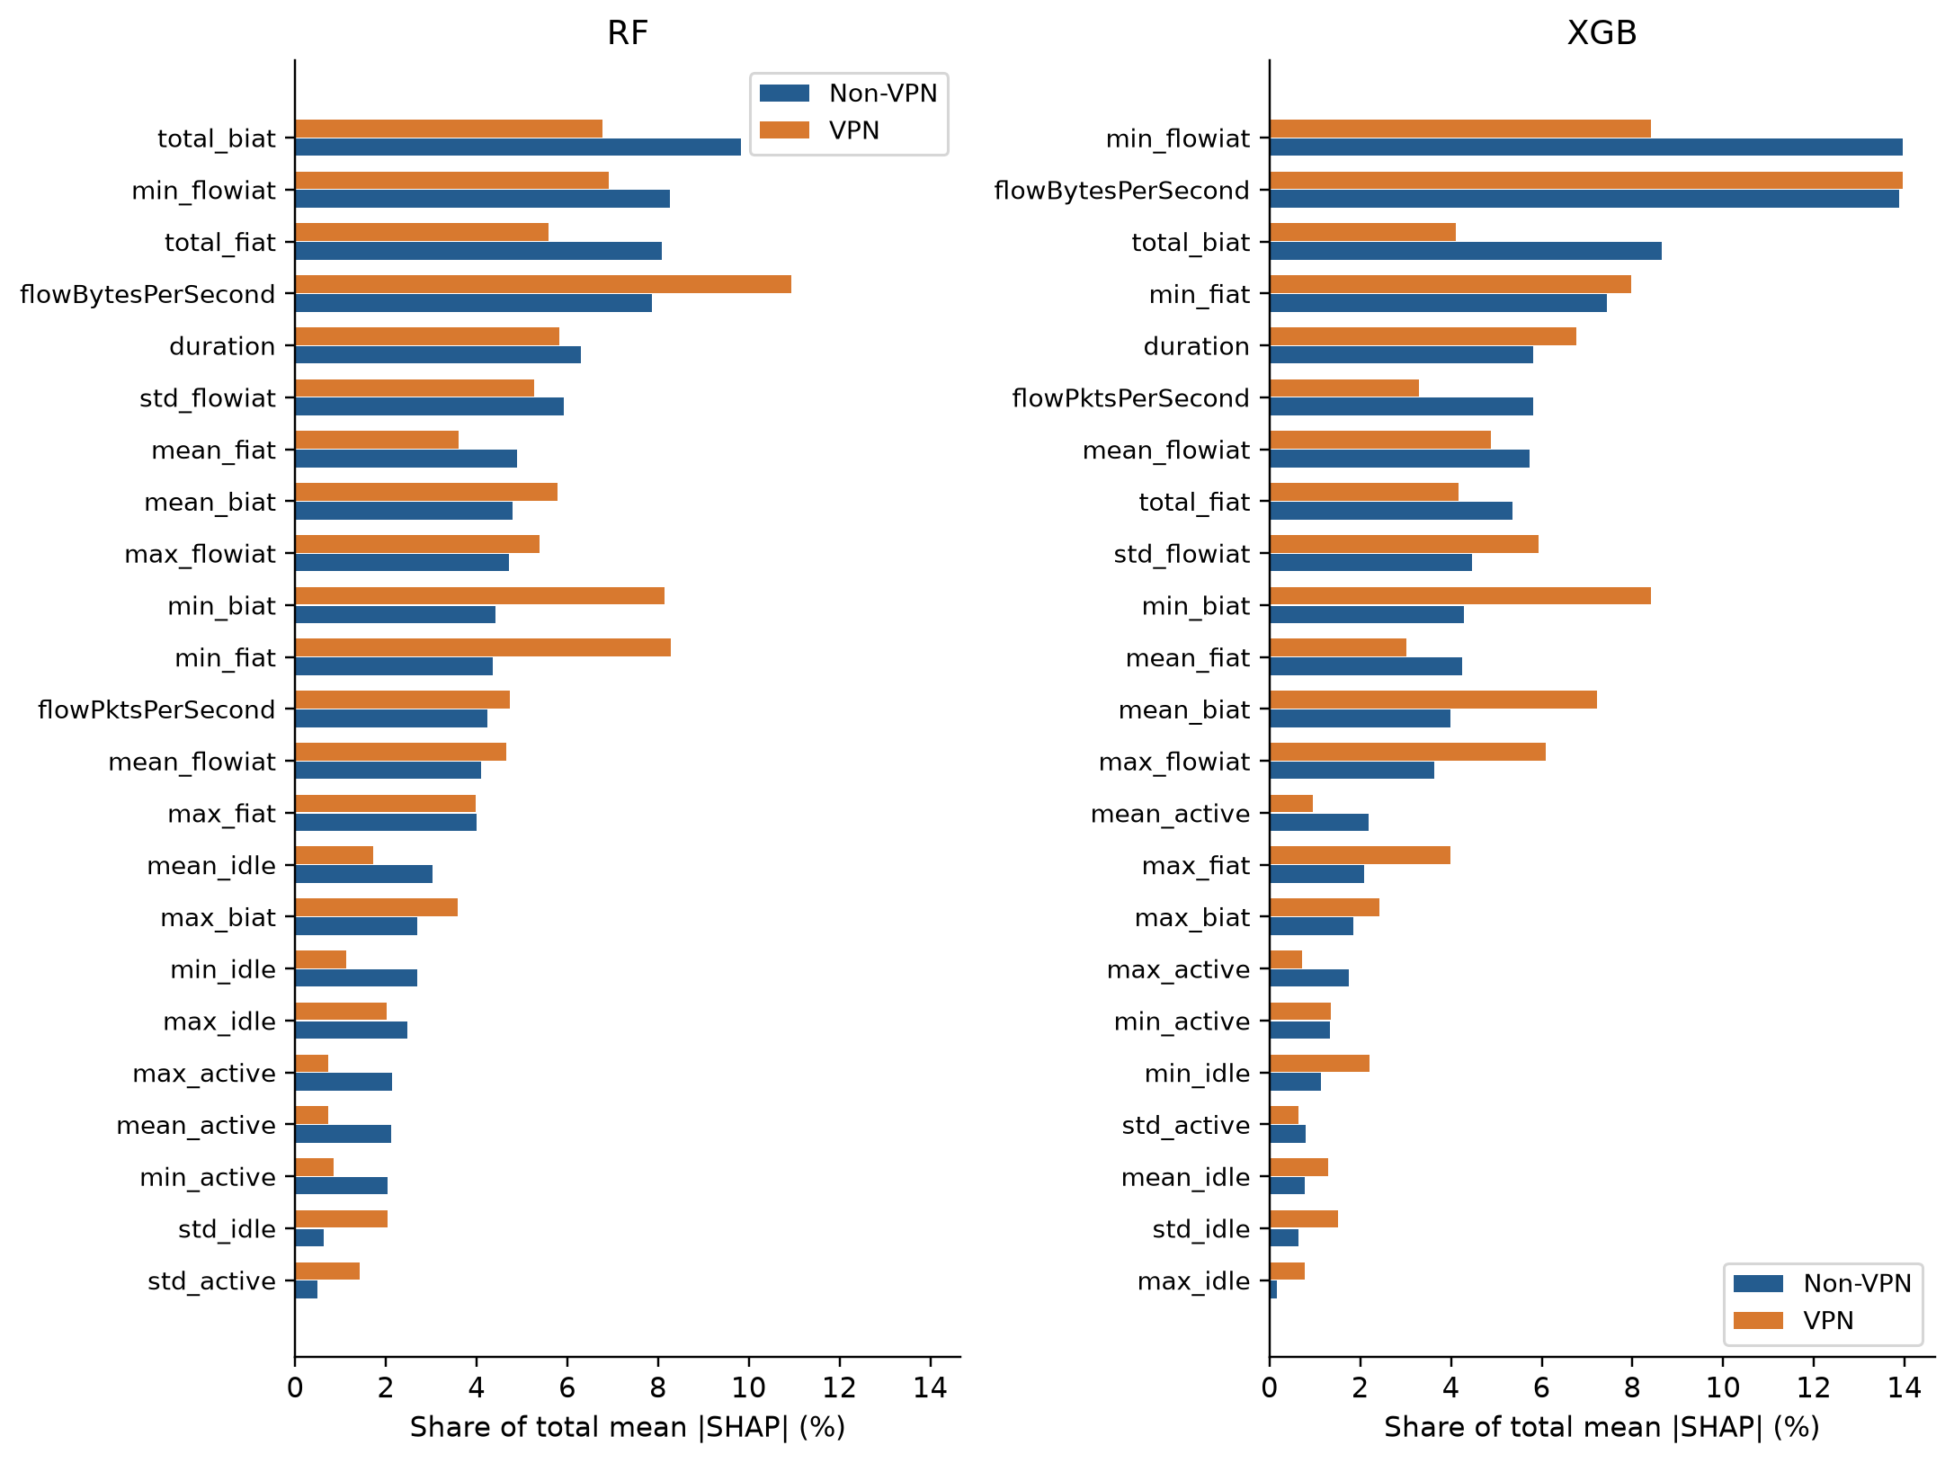
Fig. 4. Primary global TreeSHAP importance shares, with Random Forest on the left and XGBoost on the right. In each panel, features are ordered from highest to lowest Non-VPN importance, which lets the two contexts be compared directly.

B. Cross-Context Agreement on the Provided Split
How similar are the two contexts on the provided partitions? For Random Forest, Spearman ρ between the Non-VPN and VPN rankings is 0.8300 and Kendall τb is 0.6443. XGBoost comes in at ρ = 0.8073 and τb = 0.6047 (Table VII). Those values look high, yet each model keeps only three of its top five features when the context changes. The top-weighted measures make this visible: RBO is 0.580 for Random Forest and 0.713 for XGBoost, and the L1 distance between share vectors is 0.333 and 0.367, so about a sixth of the total importance changes hands. Mean absolute rank displacement is 3.04 and 3.30 positions. At ten features the overlap is 9 of 10 for Random Forest and 8 of 10 for XGBoost.
Following single features through Fig. 5 makes the shifts concrete. In Random Forest, min_fiat jumps from rank 11 to rank 2 and min_biat from 10 to 3, while total_biat goes from first to fifth and total_fiat from third to eighth. XGBoost has its own movers. Here min_biat climbs from 10 to 3, mean_biat from 12 to 5 and max_flowiat from 13 to 7, whereas total_biat sinks from 3 to 11 and flowPktsPerSecond from 6 to 13. Some directional features rise while others in the same family fall, so a description in terms of forward versus backward would miss most of what happens.
Several of the movers are correlated with other features, which matters for how SHAP shares out credit (Fig. 6 gives the full Spearman correlation matrix of each context). Some pairs are close to redundant: duration correlates with total_fiat and total_biat at Spearman 0.89–0.95, total_fiat with total_biat at 0.84–0.90, and the two throughput features at 0.94. A model can move credit within such a group with little change in its predictions, which fits the swap between total_biat and total_fiat. The minimum IATs behave differently. By construction min_flowiat never exceeds the smaller of min_fiat and min_biat, but it equals that minimum in only 43% of Non-VPN and 31% of VPN flows, because interleaved forward and backward packets create shorter gaps. Its Spearman correlation with min_fiat is 0.11 (Non-VPN) and 0.41 (VPN), and with min_biat 0.19 and 0.24. The rise of min_fiat and min_biat from ranks 10–11 to ranks 2–3 is therefore not a simple transfer of credit from min_flowiat, which stays in the top four in both contexts. Sentinel prevalence does not explain it either: −1 is slightly less common for min_fiat under VPN (10.0% against 12.6%) and about equally common for min_biat, and in the VPN Random Forest the sentinel records carry only 8% of the min_fiat attribution, against 22% without a VPN. The VPN models lean on the defined minimum gaps.
TABLE VII
Cross-context ranking agreement on the provided partitions
Model | Spearman ρ | Kendall τb | RBO (p = 0.9) | Top-5 | Top-10
RF | 0.8300 | 0.6443 | 0.580 | 3/5 | 9/10
XGB | 0.8073 | 0.6047 | 0.713 | 3/5 | 8/10
Note. All values are based on the primary SHAP rankings over the full test set. RBO is extrapolated rank-biased overlap with p = 0.9; mean rank displacement and the L1 share distance are given in the text. Table XVII reports a separate 500-record robustness analysis with bootstrap intervals.
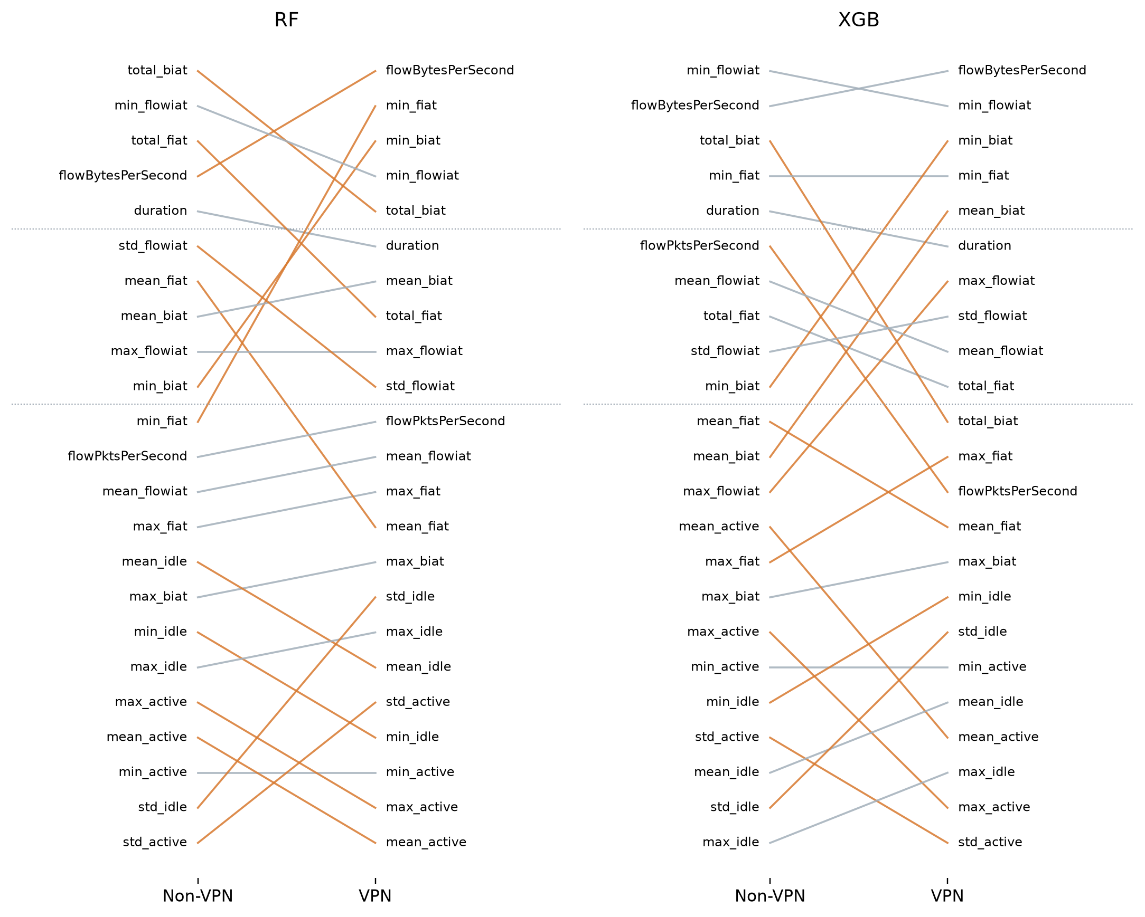
Fig. 5. Feature ranks under Non-VPN and VPN on the provided split, for (a) Random Forest and (b) XGBoost. Each line joins the two ranks of a feature, and dotted lines mark the Top-5 and Top-10 cut-offs. Features that move by three or more ranks are drawn in colour.
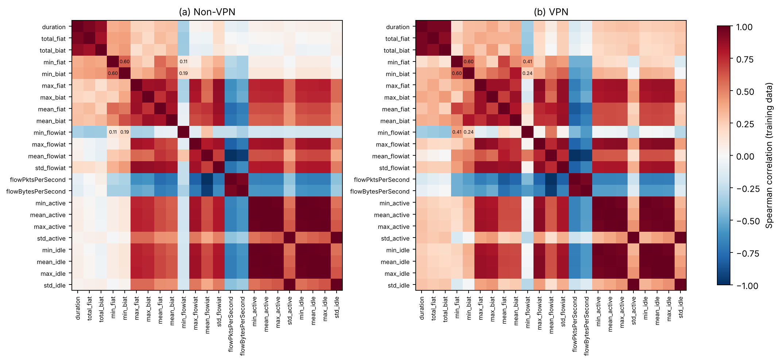
Fig. 6. Spearman correlations between the 23 features on the training partition of (a) Non-VPN and (b) VPN flows. Values are printed for the three minimum IAT features (min_fiat, min_biat, min_flowiat), which move most between contexts. Duration and the total IATs, the two throughput features, and the maximum, active and idle statistics form tightly correlated blocks.

C. Scope of the Global Explanation Results
The global ranking averages absolute attribution over all test records and all seven model outputs, so frequent classes contribute more records. Weighting the true classes equally, which is equivalent to explaining a class-balanced test sample, barely changes the rankings within a context (ρ between weighted and unweighted rankings 0.976–0.998). Across contexts it gives ρ = 0.8211 for Random Forest and 0.7915 for XGBoost, with RBO 0.732 and 0.793 and still three shared Top-5 features. The global results still cannot show that the explanation of a particular class, or of a single flow, is consistent.

D. Summary for the Provided Split
On the provided split, the primary rankings of the two contexts are related but disagree at the top. The next section asks how large this disagreement is compared with the disagreement between models trained on different data from the same context.

VII. CROSS-CONTEXT CONSISTENCY ANALYSIS

A. Within-Context Versus Cross-Context Agreement
Table VIII and Fig. 7 report what the thirty class-stratified training-bootstrap runs show. Inside each context the rankings barely move. Random Forest reaches a mean within-context Spearman of 0.9650 on Non-VPN and 0.9860 on VPN, XGBoost reaches 0.9681 and 0.9797, and the equal-weighted pooled means are 0.9755 and 0.9739. One detail stands out. Under this fixed-test design the VPN rankings are the more consistent of the two, even though predictive performance is lower in that context.
Between contexts the agreement is much lower. Averaged over all 900 cross-context pairs, Spearman is 0.7888 for Random Forest and 0.8177 for XGBoost, which puts the within-minus-cross gap at 0.1867 and 0.1562. The top-weighted measures show a larger difference: pooled within/cross RBO is 0.948/0.573 for Random Forest and 0.911/0.687 for XGBoost, and the L1 share distance is 0.068/0.342 and 0.094/0.361. Kendall points the same way, with pooled within/cross means of 0.9008/0.5930 for Random Forest and 0.8895/0.6286 for XGBoost. As Section IV-D explains, these bootstrap gaps overstate the context effect, because bootstrap refits share most of their records.
The primary Spearman values from Section VI (0.8300 and 0.8073) need not match these bootstrap means, and in fact they do not: the Random Forest value lies above its bootstrap mean and the XGBoost value below. A bootstrap sample repeats some records and leaves others out, so it holds fewer distinct records than the full partition. What is being compared here is a set of different fits scored on one fixed test set, not a set of held-out splits.
TABLE VIII
Mean pairwise Spearman agreement over 30 training-bootstrap runs per context
Level / model | Within Non-VPN | Within VPN | Pooled within | Cross-context | Gap Δ | Δ in RBO
Feature / RF | 0.9650 | 0.9860 | 0.9755 | 0.7888 | 0.1867 | 0.375
Feature / XGB | 0.9681 | 0.9797 | 0.9739 | 0.8177 | 0.1562 | 0.224
Family / RF | 0.9426 | 1.0000 | 0.9713 | 0.9295 | 0.0418 | —
Family / XGB | 0.9706 | 0.9926 | 0.9816 | 0.8951 | 0.0865 | —
Note. Each within-context mean uses 435 pairs, the pooled within value uses 870 pairs, and the cross-context value uses all 900 pairs. Δ is the pooled within mean minus the cross mean. The last column gives the same gap for RBO (p = 0.9). In the family rows, every run aggregates member mean absolute SHAP over the same six families.
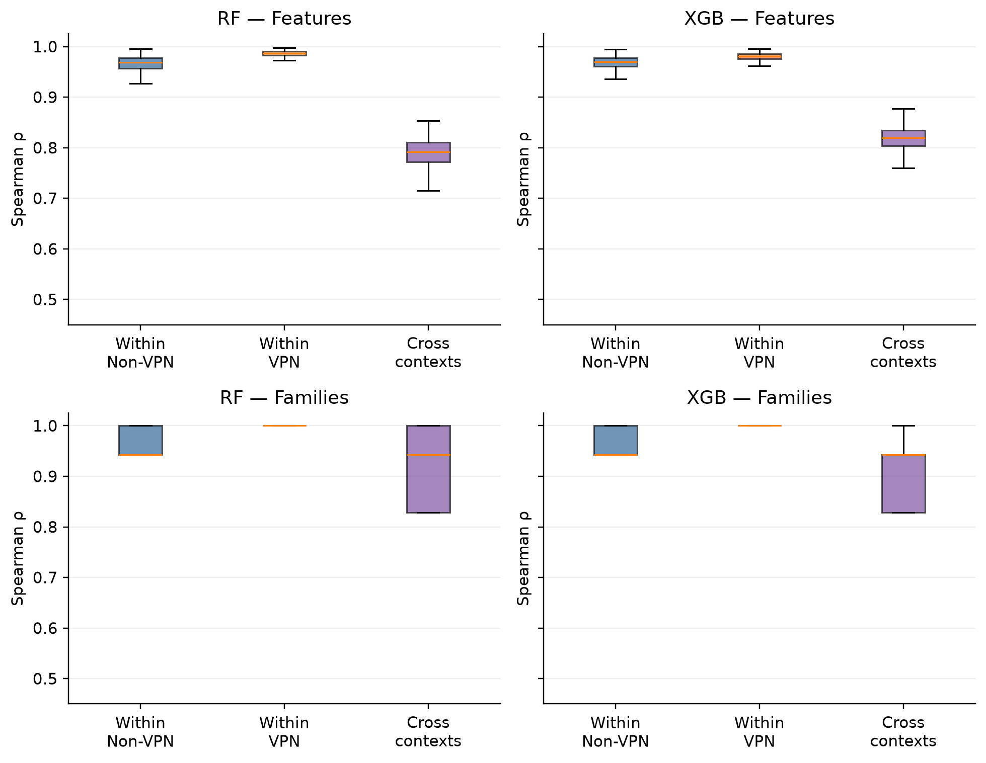
Fig. 7. Distributions of pairwise Spearman correlation for the 30 training-bootstrap runs. The top row uses the 23 features and the bottom row the six aggregated families. Each within-context box summarises 435 pairs and each cross-context box 900 pairs. Boxes show quartiles and medians, whiskers extend to 1.5 IQR, and outliers are not drawn; Table VIII gives the means. Pairwise values are dependent and are shown descriptively, not as independent units for inference.

B. Disjoint Half-Split Reference
Table IX gives the half-split results. Taking away the shared records and the shared seed lowers within-context agreement, most clearly for Random Forest on Non-VPN (ρ = 0.920 against 0.965 under the bootstrap) and for XGBoost on Non-VPN (0.948 against 0.968). Cross-context agreement hardly changes (0.820 for XGBoost and 0.782 for Random Forest). The XGBoost gap is therefore 0.139, down from 0.156, with a standard deviation of 0.014 across 11 repeats and a range of 0.108 to 0.166; the gap is about 10 standard deviations from zero. Explaining each half on its own half of the test set gives 0.137, and weighting true classes equally gives 0.153. Random Forest, with only 3 repeats, gives 0.165 and 0.162. At the top of the list the picture is the same: within-context halves share 4.1 of five leading XGBoost features against 3.0 across contexts, and the RBO gap is 0.183 (SD 0.060). Half-models are trained on half the data and score lower (0.922 and 0.859 macro F1 for XGBoost), so these figures describe models of that size.
TABLE IX
Within- and cross-context agreement for disjoint, size-matched half-splits
Model, measure, importance | Within Non-VPN | Within VPN | Cross-context | Gap Δ | SD of Δ [range]
XGB ρ, full test (R = 11) | 0.9478 | 0.9711 | 0.8203 | 0.1391 | 0.0140 [0.108, 0.166]
XGB ρ, disjoint test halves | 0.9477 | 0.9698 | 0.8216 | 0.1371 | 0.0152 [0.107, 0.168]
XGB ρ, classes weighted | 0.9492 | 0.9706 | 0.8069 | 0.1531 | 0.0107 [0.140, 0.180]
XGB RBO, full test | 0.8760 | 0.9106 | 0.7107 | 0.1826 | 0.0596 [0.092, 0.264]
XGB Top-5, full test | 4.0909 | 4.1818 | 3.0227 | 1.1136 | 0.2589 [0.750, 1.500]
RF ρ, full test (R = 3) | 0.9200 | 0.9740 | 0.7824 | 0.1645 | 0.0095 [0.154, 0.173]
RF ρ, disjoint test halves | 0.9223 | 0.9727 | 0.7858 | 0.1616 | 0.0090 [0.152, 0.169]
RF RBO, full test | 0.7866 | 0.9327 | 0.5662 | 0.2934 | 0.0599 [0.257, 0.362]
Note. Each repeat splits each training partition into two disjoint, class-stratified halves of 3,476–3,477 records; every half-model has its own seed. Within values compare the two halves of a repeat; cross values average the four Non-VPN-half versus VPN-half pairs of the same repeat. Gap Δ is the mean over repeats of the pooled within value minus the cross value; the last column is its standard deviation and range across repeats. Top-5 values are numbers of shared features.

C. Top-k Analysis
Table X and Fig. 8 focus on the top of the repeated-run rankings. For the Top-5, pooled within/cross overlap averages 4.905/3.000 with Random Forest and 4.325/3.078 with XGBoost. For the Top-10, the averages are 9.430/8.369 and 9.344/7.500. Cross-context overlaps sit well above what chance would give (1.09 at k = 5 and 4.35 at k = 10), yet clearly under the within-context values.
Overlap was stored for k = 5, 10, 12, 15 and 18. Larger sets overlap more simply because there are only 23 features to choose from; at k = 18, even the two most different sets possible share 13 features. That is why Table X also lists the random expectation and the minimum overlap for each k. Apart from k = 10, none of these cutoffs was used in a consequence experiment, so they describe ranking agreement only.
TABLE X
Mean Top-k overlap within and across contexts in the training-bootstrap analysis
k | Random E[O] | Minimum O | RF within | RF cross | XGB within | XGB cross
5 | 1.09 | 0 | 4.905 | 3.000 | 4.325 | 3.078
10 | 4.35 | 0 | 9.430 | 8.369 | 9.344 | 7.500
12 | 6.26 | 1 | 11.374 | 10.327 | 11.591 | 10.233
15 | 9.78 | 7 | 14.624 | 14.133 | 14.528 | 14.167
18 | 14.09 | 13 | 17.254 | 16.150 | 17.277 | 16.464
Note. Within columns pool all 870 run pairs inside contexts, and cross columns use the 900 pairs across contexts. E[O] = k²/23 and minimum O = max(0, 2k − 23). The separate exploratory consequence experiment uses only k = 10.
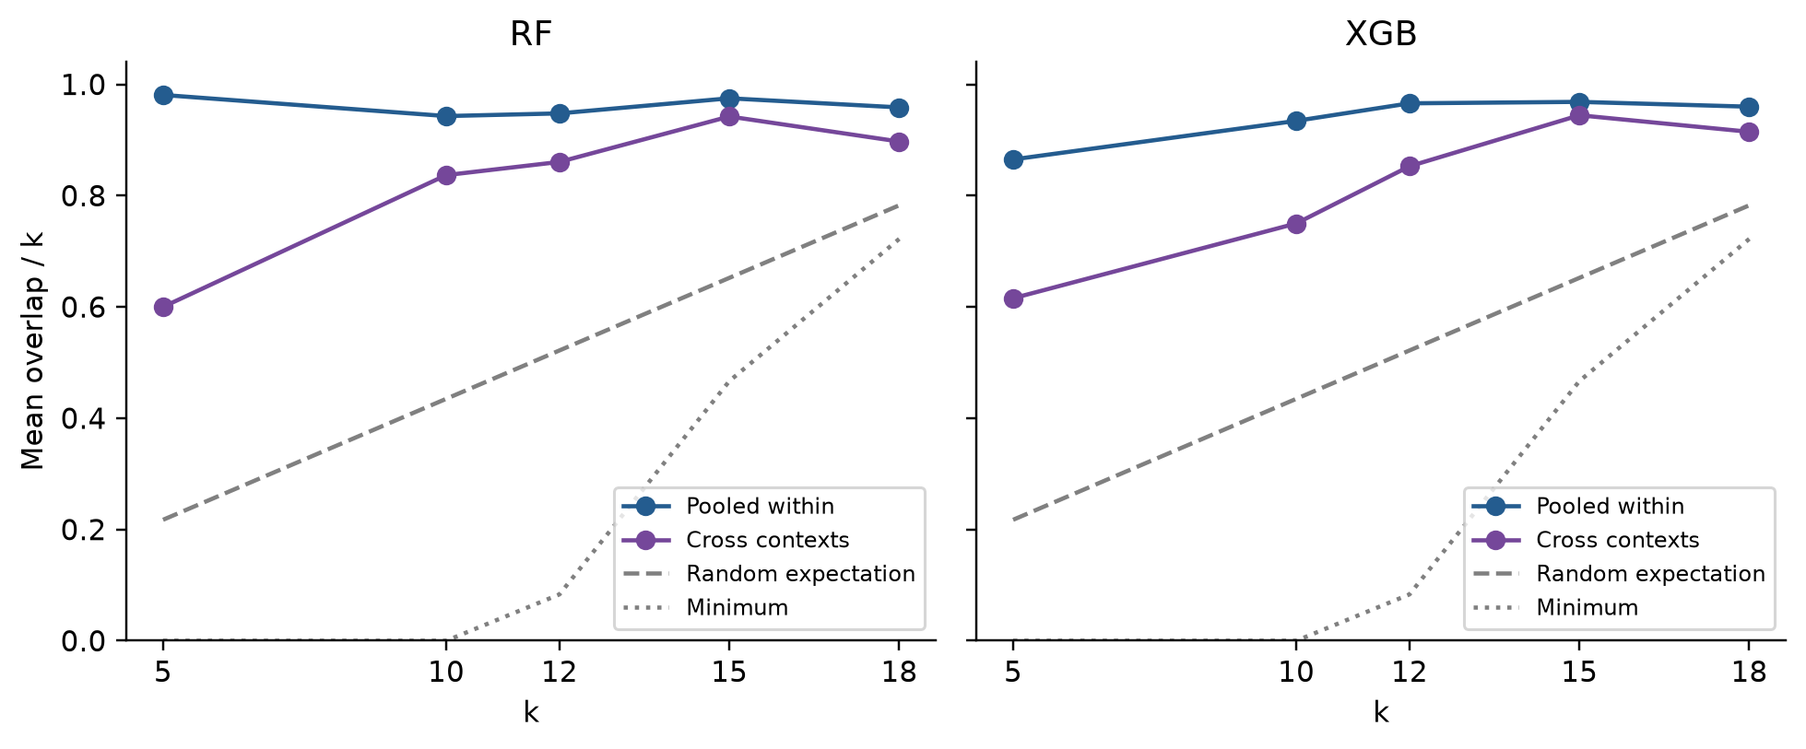
Fig. 8. Average Top-k overlap, as a fraction of k, across the repeated training-bootstrap rankings. Curves for pooled within-context pairs and for all cross-context pairs are shown with the random expectation k/23 and the lowest achievable overlap. The cutoffs describe ranking agreement and are not experiments on the sensitivity of predictive cost.

D. Training-Only Top-10 Feature Selection
The Top-10 sets that the consequence test selected on inner training splits are listed in Table XI. Random Forest picks nine of the same features in both contexts; mean_fiat is chosen only in Non-VPN and min_fiat only in VPN. XGBoost agrees on seven features. Its Non-VPN-only choices are total_biat, flowPktsPerSecond and mean_fiat, and its VPN-only choices are min_biat, mean_biat and max_flowiat. The Jaccard similarities are 9/11 = 0.818 and 7/13 = 0.538. These sets are distinct from the primary rankings computed on held-out test records, and they feed the exploratory paired performance comparison in Fig. 9.
TABLE XI
Agreement between the training-selected Top-10 feature sets
Model | Shared / 10 | Jaccard | Only Non-VPN selection | Only VPN selection
RF | 9/10 | 0.818 | mean_fiat | min_fiat
XGB | 7/10 | 0.538 | total_biat, flowPktsPerSecond, mean_fiat | min_biat, mean_biat, max_flowiat
Note. Selection was done on the inner validation subset carved out of each original training partition. The Jaccard similarity is the size of the intersection divided by the size of the union. No test records are used in selection.
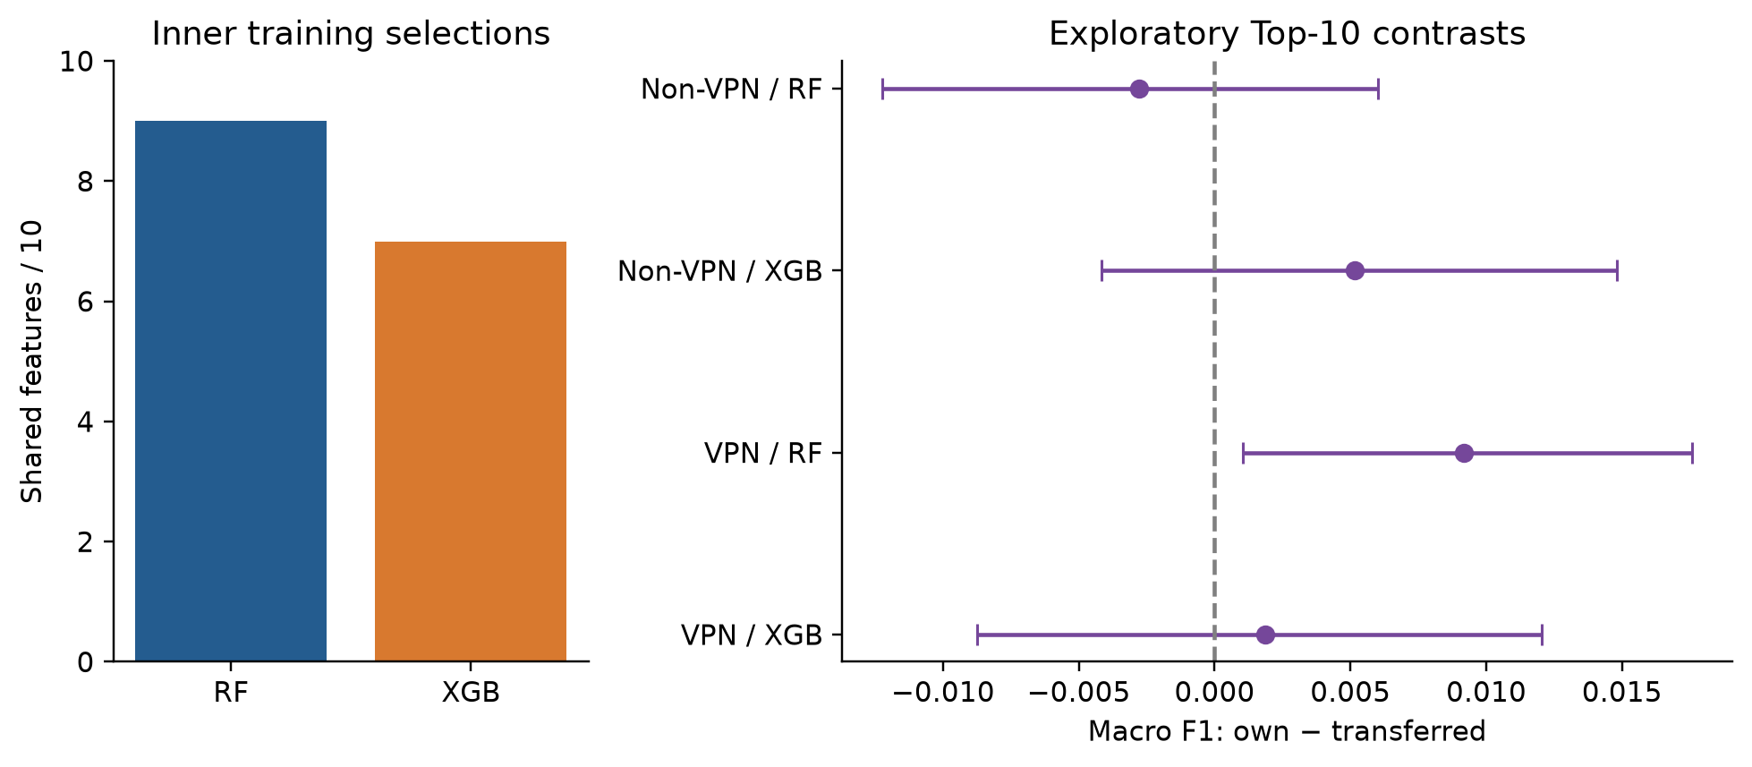
Fig. 9. Exploratory Top-10 selection and transfer. Left: how many selected features the two contexts share. Right: macro F1 in the target context for the own selection minus the transferred selection, with 95% intervals from a class-stratified paired bootstrap over test records. Values above zero favour the own selection.

E. Model Performance Versus Explanation Consistency
Predictive performance and explanation consistency measure different things. Both main models perform worse on VPN traffic, yet their within-context agreement is higher there under both references. Random Forest shows the higher cross-context agreement on the primary fit, while XGBoost shows the higher mean agreement across bootstrap fits.

F. Class-Matched Training and Class Weighting
Class composition differs between contexts (Section III-B), so we trained both models on the class-matched subsets (190 training and 48 test flows per class) and explained them on the balanced test subsets. Macro F1 is 0.9069 (Non-VPN) and 0.8562 (VPN) for XGBoost and 0.8855 and 0.8359 for Random Forest. Cross-context agreement on matched data is ρ = 0.8271 for XGBoost and 0.7381 for Random Forest, with RBO 0.647 and 0.593 and 3 and 2 shared Top-5 features. Matching classes therefore does not bring the rankings together. Because a single small subset is noisy, we also drew six pairs of XGBoost training sets of the same size (1,330 flows) per context, once with matched classes and once with each context's natural class mix, and compared the contexts. Mean cross-context ρ is 0.852 (SD 0.017) with matched classes and 0.844 (SD 0.027) with natural ones. Together with the class-weighted half-split gap in Table IX, this suggests that the difference in class mix is not the main source of the cross-context gap, although MAIL in Non-VPN has only 190 training flows, so every matched draw reuses all of them.

VIII. AGGREGATED FEATURE-FAMILY IMPORTANCE
Table XII and Fig. 10 show the six families on the primary fits. In every model and context, directional IAT comes first, flow IAT second and throughput third. From Non-VPN to VPN, the directional-IAT share of Random Forest grows from 43.07% to 45.74%, its flow-IAT share moves from 23.00% to 22.18%, and its throughput share rises from 12.08% to 15.68%. For XGBoost the same shares go from 37.91% to 41.27%, from 27.80% to 25.31% and from 19.68% to 17.25%. So the family view shows the same leading categories of model reliance in both contexts, with shifts in how much each one carries.
TABLE XII
Aggregated feature-family importance shares (%) and ranks on the primary fits
Family (size) | RF Non-VPN | RF VPN | XGB Non-VPN | XGB VPN
Flow duration (1) | 6.29 (6) | 5.82 (5) | 5.81 (5) | 6.76 (4)
Directional IAT statistics (8) | 43.07 (1) | 45.74 (1) | 37.91 (1) | 41.27 (1)
Flow throughput (2) | 12.08 (3) | 15.68 (3) | 19.68 (3) | 17.25 (3)
Flow IAT statistics (4) | 23.00 (2) | 22.18 (2) | 27.80 (2) | 25.31 (2)
Active-period statistics (4) | 6.76 (5) | 3.71 (6) | 6.07 (4) | 3.65 (6)
Idle-period statistics (4) | 8.80 (4) | 6.88 (4) | 2.72 (6) | 5.77 (5)
Note. Values are the summed mean absolute SHAP importance of family members, normalised by the total over all six families; descending ranks are given in parentheses. Absolute values are taken before aggregation so that opposing contributions do not cancel. Directional IAT contains both forward and backward features.
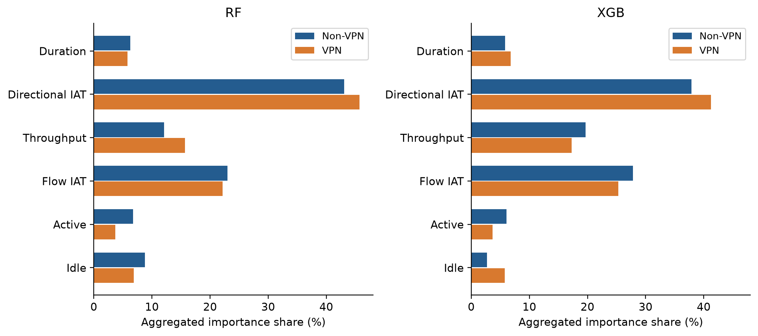
Fig. 10. Aggregated importance shares of the six semantic families, with Random Forest on the left and XGBoost on the right. Directional IAT and flow IAT lead in both contexts. Because families differ in size, a share reflects the total importance of the members and not the average importance per feature.
Family ranks on the primary fits agree with Spearman values of 0.9429 (Random Forest) and 0.8286 (XGBoost). Across the bootstrap runs, pooled within/cross agreement at family level reaches 0.9713/0.9295 for Random Forest and 0.9816/0.8951 for XGBoost, so the gaps, 0.0418 and 0.0865, are smaller than their feature-level counterparts.
With these six families, aggregation gives a steadier coarse summary, but part of that steadiness comes from family size. The eight-member directional family tops every ranking almost by construction. Ranked by the mean importance per member, the families agree less well: primary cross-context ρ is 0.8857 for Random Forest and 0.8857 for XGBoost, the bootstrap gaps are 0.1587 and 0.1011, and throughput and duration now take the lead in most cases (duration leads for Random Forest on Non-VPN), with directional IAT dropping to third place or lower. Data-driven clusters tell a similar story (Table XIII). At a correlation cut of 0.8 the 23 features form eight clusters: one of ten maximum, active and idle statistics; duration with total_fiat and total_biat; the throughput pair with mean_flowiat; mean_fiat with mean_biat; the two standard deviations of active and idle periods; and min_fiat, min_biat and min_flowiat each on their own. Summing importance within these clusters gives bootstrap gaps of 0.0956 (Random Forest) and 0.1125 (XGBoost), larger than the semantic-family gaps, which is consistent with the three minimum IATs, the features that move most, staying in separate clusters.
Six ranks also give coarse resolution: with six untied ranks, swapping one adjacent pair changes ρ by about 0.057. This explains the within-VPN family agreement of 1.0000 for Random Forest in Table VIII. All 30 VPN bootstrap runs produced the same family order (Non-VPN runs produced 3 orders), so every pairwise ρ is exactly one. It reflects the resolution of the measure, not perfect agreement of member attributions.
TABLE XIII
Family-level agreement under three aggregation rules (training-bootstrap runs)
Model / aggregation | Primary ρ | Within Non-VPN | Within VPN | Cross-context | Gap Δ
RF / six families, summed | 0.9429 | 0.9426 | 1.0000 | 0.9295 | 0.0418
RF / six families, mean per member | 0.8857 | 0.9411 | 0.9023 | 0.7630 | 0.1587
RF / eight correlation clusters, summed | 0.8810 | 0.9932 | 0.9840 | 0.8930 | 0.0956
XGB / six families, summed | 0.8286 | 0.9706 | 0.9926 | 0.8951 | 0.0865
XGB / six families, mean per member | 0.8857 | 0.9962 | 0.9853 | 0.8897 | 0.1011
XGB / eight correlation clusters, summed | 0.8810 | 0.9812 | 0.9549 | 0.8556 | 0.1125
Note. Within and cross values are mean pairwise Spearman correlations over the 30 training-bootstrap runs per context (435 within pairs per context, 900 cross pairs). Clusters come from average-linkage clustering of 1 − |ρ_S| on training data, cut at 0.2.

IX. CONSEQUENCE TEST
The selections from Table XI feed this experiment, and none of them used test data. In each context the selector is trained on the inner-training subset and its TreeSHAP importance is computed on the inner-validation subset. Using only the selected features, we then refit the model on the whole original training partition and evaluate it on a test partition that has not been used up to this point. Table XIV lists the resulting scores.
TABLE XIV
Exploratory Top-10 consequence test on the untouched test partitions
Target | Model | Feature set | Accuracy | Macro F1 | 95% CI for F1
Non-VPN | RF | Full (23) | 0.9454 | 0.9171 | [0.8990, 0.9348]
Non-VPN | RF | Own Top-10 | 0.9431 | 0.9143 | [0.8961, 0.9318]
Non-VPN | RF | Transferred Top-10 | 0.9436 | 0.9171 | [0.8994, 0.9336]
Non-VPN | XGB | Full (23) | 0.9580 | 0.9347 | [0.9179, 0.9500]
Non-VPN | XGB | Own Top-10 | 0.9586 | 0.9382 | [0.9229, 0.9534]
Non-VPN | XGB | Transferred Top-10 | 0.9574 | 0.9331 | [0.9163, 0.9482]
VPN | RF | Full (23) | 0.8811 | 0.8533 | [0.8335, 0.8723]
VPN | RF | Own Top-10 | 0.8939 | 0.8663 | [0.8471, 0.8853]
VPN | RF | Transferred Top-10 | 0.8870 | 0.8571 | [0.8376, 0.8763]
VPN | XGB | Full (23) | 0.9030 | 0.8779 | [0.8603, 0.8951]
VPN | XGB | Own Top-10 | 0.8998 | 0.8757 | [0.8576, 0.8932]
VPN | XGB | Transferred Top-10 | 0.8961 | 0.8738 | [0.8548, 0.8918]
Note. Own and transferred Top-10 sets are chosen from original training data only. The Full rows reproduce the baseline models. Intervals come from 3,000 class-stratified test-record bootstrap replicates; they are conditional on the fitted model and selected subset and exclude training and selection uncertainty.
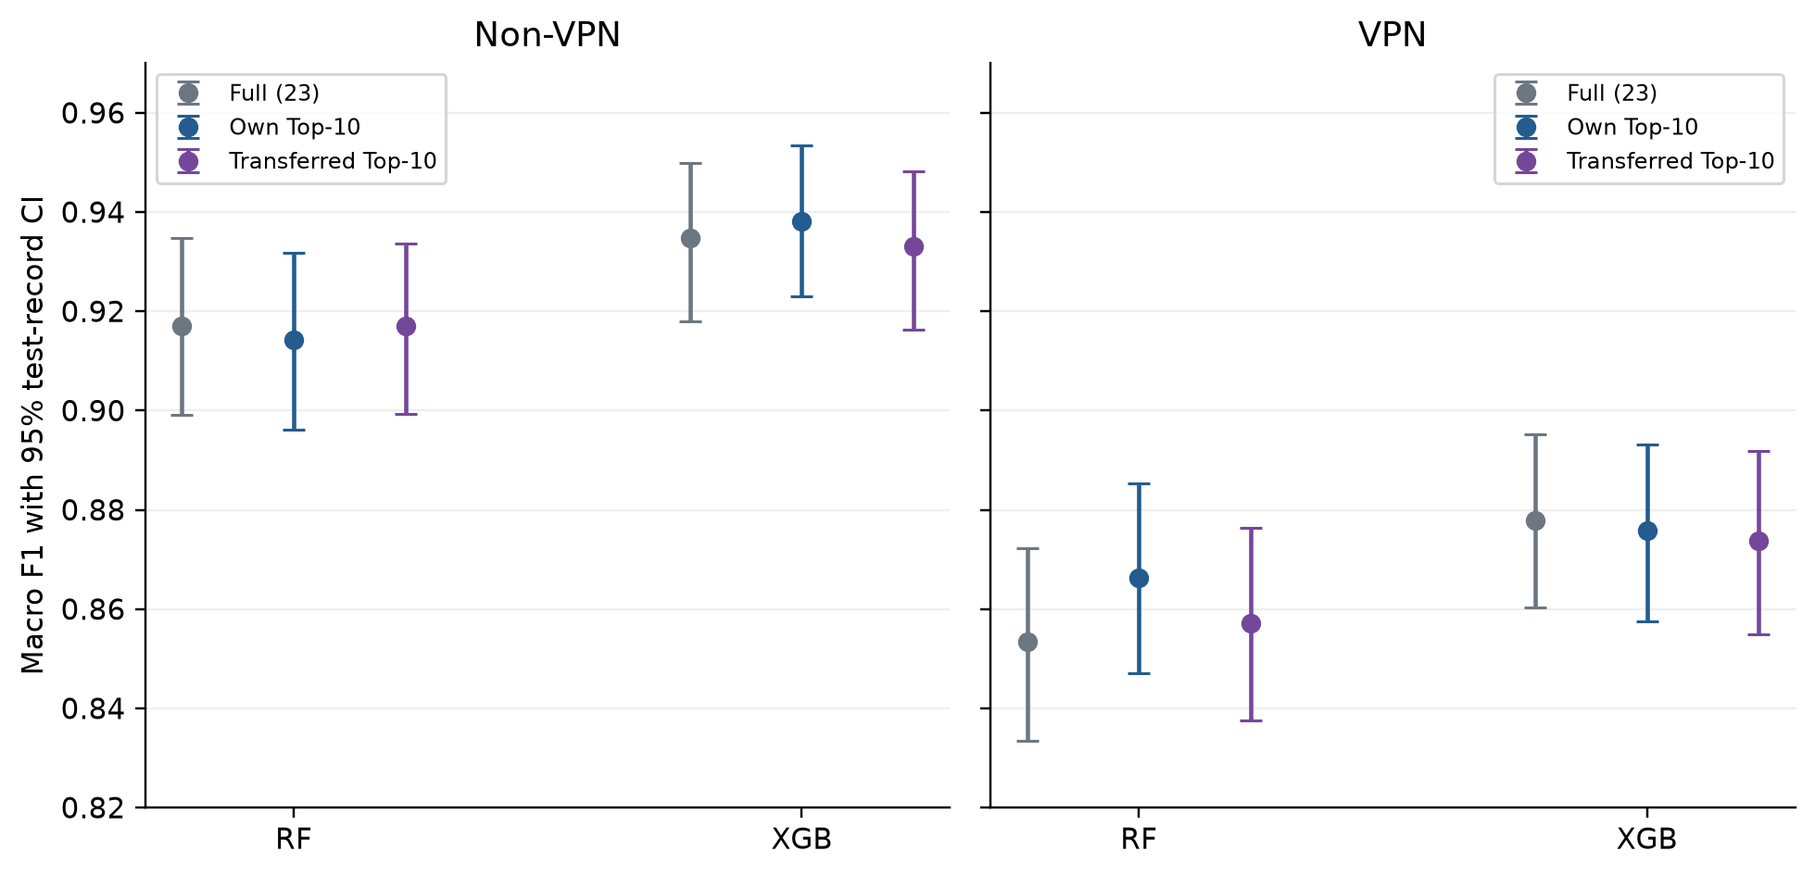
Fig. 11. Macro F1 with all features, the own-context Top-10 selection and the transferred Top-10 selection. The Non-VPN target is on the left and the VPN target on the right. Each point is the score of one condition, and its whiskers mark the 95% interval from class-stratified bootstrapping of test records. Paired transfer differences appear in Fig. 9.
Own and transferred Top-10 sets overlap heavily (9 of 10 features for Random Forest, 7 of 10 for XGBoost), so each contrast rests on one to three swapped features. The own-minus-transferred differences are −0.0028 and 0.0092 macro F1 for Random Forest (Non-VPN and VPN targets) and 0.0051 and 0.0019 for XGBoost. Only the VPN Random Forest interval, [0.0010, 0.0176], excludes zero. Refitting the same XGBoost selections in the revision environment moved macro F1 by a few thousandths and reversed the sign of the VPN contrast (own 0.8799, transferred 0.8852).
Table XV adds the controls. For RF on Non-VPN, random 10-feature subsets reach 0.901 on average (0.882–0.922) and the bottom-10 set 0.773, against 0.914 for the own Top-10; for XGB on Non-VPN, random 10-feature subsets reach 0.897 on average (0.846–0.939) and the bottom-10 set 0.705, against 0.935 for the own Top-10; for RF on VPN, random 10-feature subsets reach 0.826 on average (0.803–0.842) and the bottom-10 set 0.678, against 0.866 for the own Top-10; for XGB on VPN, random 10-feature subsets reach 0.844 on average (0.818–0.854) and the bottom-10 set 0.741, against 0.880 for the own Top-10. Across these comparisons the own and transferred Top-10 sets beat between 67% and 100% of the random subsets and are far above the bottom-ranked features, so SHAP-based selection does matter here; the choice between the two contexts' SHAP rankings makes little difference at k = 10. At k = 5, where the own and transferred sets share fewer features, the differences are +0.0097 (XGB, Non-VPN, 2 shared), +0.0016 (XGB, VPN, 2 shared).
These estimates come from one selection and one refit for each context and model, so they are small, context-dependent effect sizes. They do not show that the own and transferred subsets are equivalent.
TABLE XV
Top-k transfer with random and bottom-ranked controls (macro F1 on the untouched test partitions)
Target / model | Own Top-10 | Transferred Top-10 | Own / transferred Top-5 | Bottom-10 | Random-10 mean [min, max]
Non-VPN / RF | 0.9143 | 0.9171 | — | 0.7730 | 0.9010 [0.882, 0.922] (n = 3)
Non-VPN / XGB | 0.9350 | 0.9336 | 0.9276 / 0.9180 | 0.7046 | 0.8967 [0.846, 0.939] (n = 20)
VPN / RF | 0.8663 | 0.8571 | — | 0.6781 | 0.8258 [0.803, 0.842] (n = 3)
VPN / XGB | 0.8799 | 0.8852 | 0.8535 / 0.8519 | 0.7412 | 0.8442 [0.818, 0.854] (n = 6)
Note. Own and transferred sets come from training-only SHAP rankings (Section IV-F). Bottom-10 is the ten lowest-ranked features of the target-context selector. Random subsets are drawn once and shared by both contexts. All models are refitted on the full training partition of the target context in the revision environment, so XGBoost values can differ from Table XIV by up to about 0.005. XGBoost Top-15 (own / transferred): Non-VPN 0.9355 / 0.9325.

X. SENTINEL ANALYSIS
Table XVI and Fig. 12 compare the two alternative representations, S1 and S2, each with ten individual indicators and 33 inputs in total. Their macro F1 scores differ by about 0.0021 at most. Their rankings of the original features are similar but not identical, with within-context Spearman agreement between 0.8874 and 0.9615. In other words, small differences in predictive performance can come with larger differences in attribution order.
TABLE XVI
Sentinel sensitivity: raw −1 with ten indicators (S1) versus NaN with ten indicators (S2)
Context / model | S1 F1 | S2 F1 | ρ(S1,S2) | Top-5 / Top-10 overlap | Indicator share S1 / S2 (%)
Non-VPN / RF | 0.9194 | 0.9196 | 0.9140 | 5/5; 8/10 | 8.541 / 7.157
Non-VPN / XGB | 0.9329 | 0.9330 | 0.9615 | 5/5; 10/10 | 0.343 / 0.011
VPN / RF | 0.8548 | 0.8531 | 0.8874 | 4/5; 9/10 | 4.169 / 3.557
VPN / XGB | 0.8829 | 0.8808 | 0.9427 | 5/5; 9/10 | 0.236 / 0.032
Note. In S2, both tree models handle NaN natively. Agreement and Top-k overlap are computed on the 23 original features alone. The indicator share equals the summed mean absolute SHAP of the ten indicators divided by total importance over all 33 inputs.
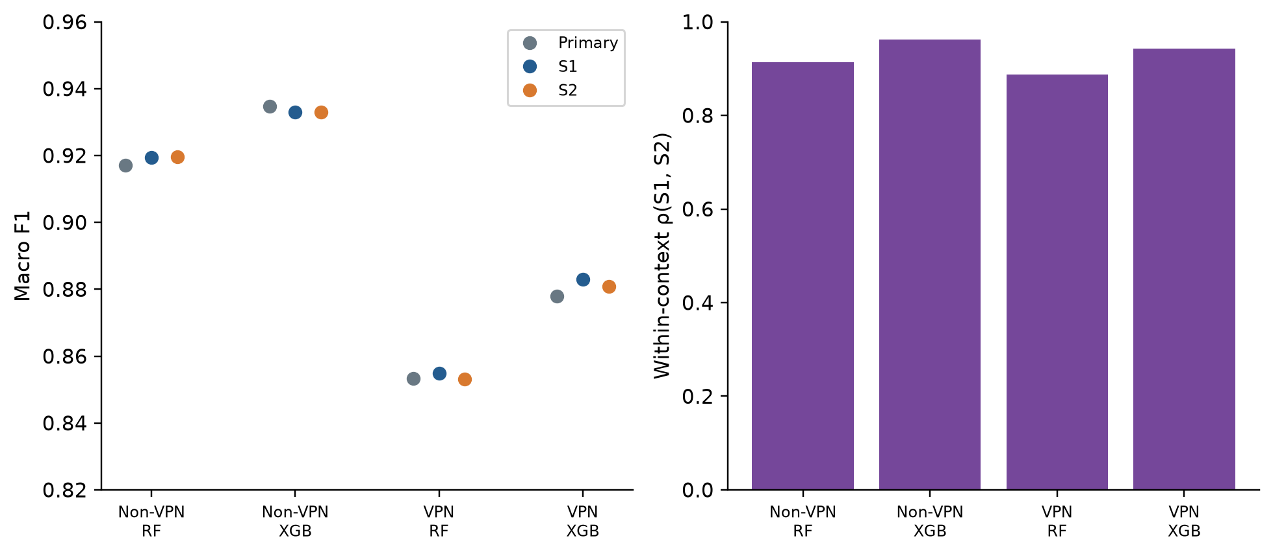
Fig. 12. Sentinel sensitivity. Left: macro F1 for the primary 23-feature input and for both 33-feature alternatives. Right: Spearman agreement, within each context, between how S1 and S2 rank the 23 original features. These values are not cross-context correlations.
In Random Forest the indicators receive 8.541% (S1) and 7.157% (S2) of total importance on Non-VPN data, against 4.169% and 3.557% on VPN data. XGBoost assigns them much less, with S1/S2 shares of 0.343%/0.011% for Non-VPN and 0.236%/0.032% for VPN. In all four model-context combinations, indicator attribution falls from S1 to S2. These numbers describe how the models allocate importance and do not measure how much causal information missingness carries.
Performance hardly changes between S1 and S2, but feature rankings and indicator contributions do. The S1-versus-S2 agreement within a context, ρ = 0.887–0.962, is not far above the cross-context range of the primary and robustness fits (ρ = 0.68–0.83, and 0.79–0.82 for the bootstrap means). The encoding of undefined statistics therefore moves rankings almost as much as the change of context does, and a ranking should be reported together with the encoding used to produce it. The cross-context comparison itself is not an artefact of the raw encoding: over the 23 original features, cross-context ρ is 0.8281 under both S1 and S2 for Random Forest, and 0.8043 (S1) and 0.7895 (S2) for XGBoost, close to the primary values.

XI. ROBUSTNESS AND SENSITIVITY ANALYSIS

A. Model Family and TreeSHAP Formulation
Table XVII and Fig. 13 give the robustness comparisons based on 500 records. Cross-context Spearman agreement ranges from 0.6808 to 0.8192 across configurations. Random Forest scores 0.8192 with path-dependent SHAP and 0.8024 with interventional SHAP, XGBoost scores 0.7796 and 0.7787, and Extra Trees scores 0.6808 and 0.7381. In every configuration, three of the five top features are shared across contexts. Inside a single context and model, path-dependent and interventional rankings agree closely, with Spearman values of 0.9753 (Non-VPN) and 0.9694 (VPN) for Random Forest and 0.9812 and 0.9881 for XGBoost. Agreement between Extra Trees and the reference, path-dependent Random Forest, is lower, between 0.7095 and 0.8014. The comparison involving interventional Extra Trees changes the model and the formulation at the same time.
Whichever of the six configurations is used, both contexts agree on the two leading families, and family-rank agreement lies between 0.7143 and 0.9429. The XGBoost path interval in Table XVII, [0.7767, 0.8103], lies almost entirely above its point estimate of 0.7796. We re-ran this bootstrap and obtained the same interval: only 7% of the resampled correlations fall below the point estimate, and their mean is 0.7915. Resampling records smooths the importance estimates of both contexts, which pushes ρ upward, so the percentile interval inherits a bias of about +0.012. The bias-corrected basic interval is [0.7490, 0.7826] for XGBoost and [0.7974, 0.8350] for Random Forest. We keep the percentile intervals in the table for comparability and read them as describing the spread of explained-record noise, not as confidence intervals for the cross-context ρ.
TABLE XVII
Cross-context robustness across tree models and TreeSHAP formulations
Model / method | ρ | 95% CI for ρ | τb | Top-5 | Top-10 | Family ρ
RF / Path | 0.8192 | [0.8034, 0.8409] | 0.6285 | 3/5 | 9/10 | 0.9429
XGB / Path | 0.7796 | [0.7767, 0.8103] | 0.5810 | 3/5 | 7/10 | 0.8286
RF / Interv. | 0.8024 | [0.7708, 0.8142] | 0.6126 | 3/5 | 8/10 | 0.9429
XGB / Interv. | 0.7787 | [0.7698, 0.7945] | 0.5731 | 3/5 | 8/10 | 0.8286
ExtraTrees / Path | 0.6808 | [0.6334, 0.7628] | 0.5731 | 3/5 | 6/10 | 0.8286
ExtraTrees / Interv. | 0.7381 | [0.6611, 0.7708] | 0.5731 | 3/5 | 7/10 | 0.7143
Note. Path is tree-path-dependent and Interv. is interventional TreeSHAP. Per context, 500 test records are explained, and the interventional background holds 200 training records. Intervals are percentile intervals from 2,000 independent context-specific bootstrap resamples of explained test records, with fitted models and backgrounds held fixed. Kendall τb takes values in steps of 2/253 here; the three entries of 0.5731 each correspond to 54 discordant pairs out of 253, while ρ differs because the discordant pairs span different rank distances. We recomputed all six τb values from the saved rankings. With 500 estimators, Extra Trees achieves accuracy/macro F1 of 0.9316/0.8995 on Non-VPN and 0.8747/0.8491 on VPN.
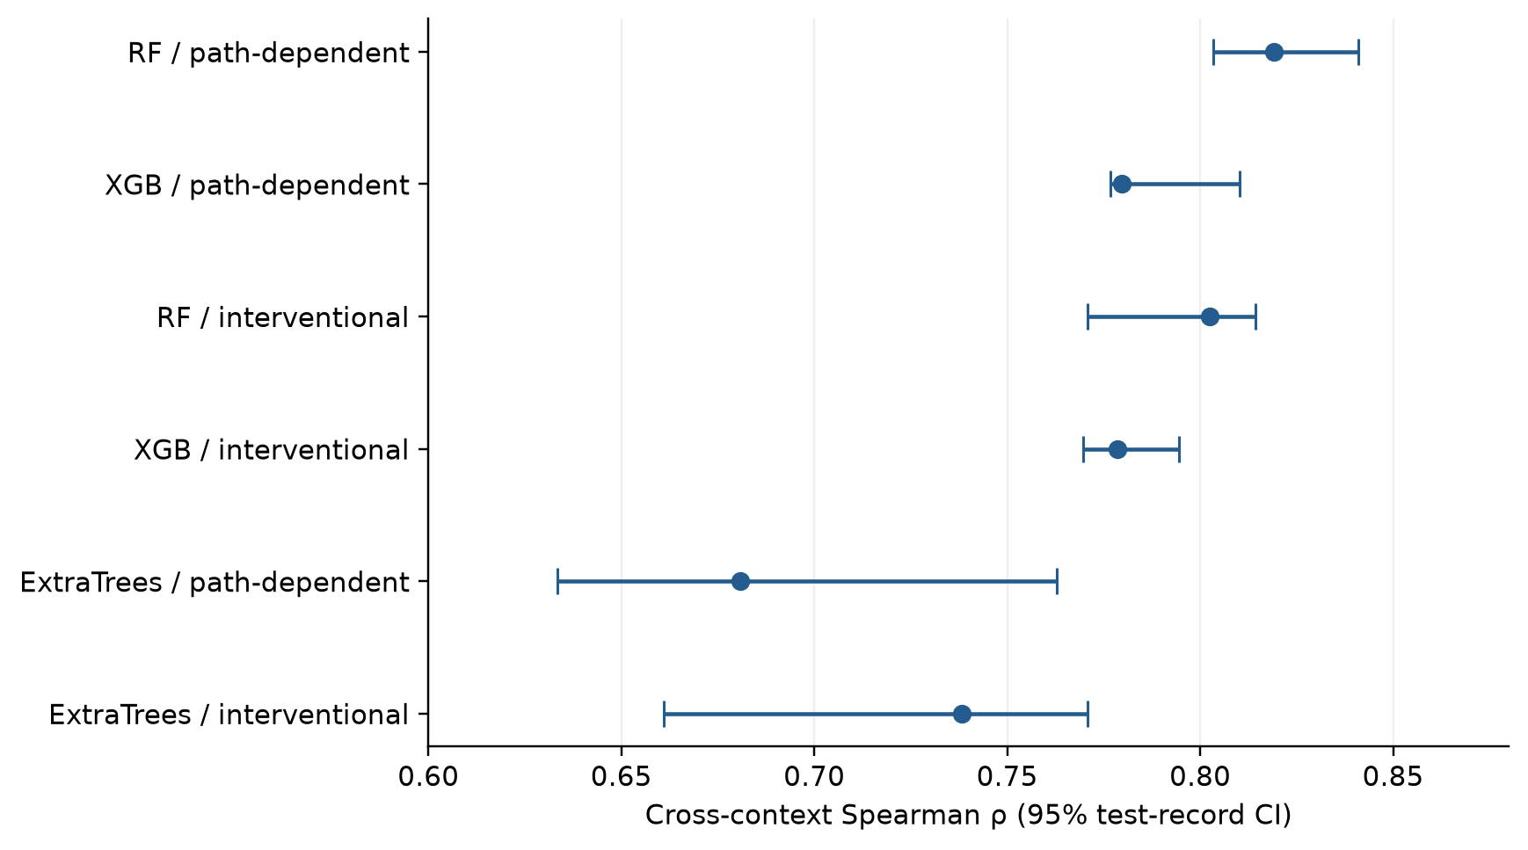
Fig. 13. Cross-context Spearman agreement for the six robustness configurations. Whiskers show 95% intervals from bootstrapping the 500 records explained in each context, with the fitted models and the interventional backgrounds left unchanged. They do not include training, background-selection or session-level uncertainty.

B. Model Seeds and Hyperparameters
The primary and bootstrap models hold random_state at 42, so seed variance is absent from the bootstrap reference. Refitting XGBoost on the full training partitions with three other seeds gives mean pairwise within-context ρ of 0.9928 (Non-VPN) and 0.9928 (VPN), so seed noise alone is small. The half-split reference of Section VII-B includes seed variance. No hyperparameters were tuned. For XGBoost we refitted two other settings in both contexts: max_depth = 10 gives ρ = 0.8034, RBO 0.768 and 3 shared Top-5 features (macro F1 0.931/0.872); max_depth = 3 gives ρ = 0.7668, RBO 0.727 and 3 shared Top-5 features (macro F1 0.928/0.864). None of them brings the contexts close to within-context agreement.

C. Summary of Sensitivity Checks
Taken together, the context-associated ranking differences sit alongside real sensitivity to the model, the explanation formulation and the sentinel encoding, and cross-context Top-5 agreement stays incomplete in every configuration we ran.

XII. DISCUSSION

A. What Stays the Same and What Changes
Every model variant shares one set of feature definitions, and yet for the same application labels the two contexts give the same features noticeably different importance. Throughput and timing features carry most of the importance, while some directional features change sharply: min_biat gains importance for both main models, total_biat loses importance for both, and min_fiat rises steeply for Random Forest. The three minimum-IAT features are only weakly to moderately correlated with one another (Spearman 0.11–0.60, Section VI-B), so these moves are not just credit passing between redundant features. min_biat stays among the five leading VPN features under class weighting and class matching; the position of min_fiat is less settled, since it also enters the Non-VPN Top-5 when classes are matched. Tunnelling could change which minimum gaps are informative, but the present data cannot separate that from differences between capture sessions.

B. Accuracy and Correlation Do Not Guarantee Consistent Explanations
Predictive accuracy, rank correlation and agreement among the leading features are separate properties. A cross-context Spearman of about 0.8 coexists with only three shared Top-5 features and an RBO of 0.58–0.71. Reporting performance, whole-ranking and top-weighted agreement, and a within-context reference built from disjoint data gives a fuller picture than any one summary.

C. Correlated Features and the Role of Grouping
Aggregation into the six semantic families shrinks the gaps, but a family-level ranking measures something different from a feature ranking. Summing favours large families, and per-member means and correlation-based clusters give larger gaps (Table XIII). The family definitions decide which differences get hidden: the eight directional IAT features form one group spanning both directions, so forward and backward changes can offset each other inside it. Family-level conclusions should be stated together with the grouping rule and family sizes.

D. Do Explanation Differences Matter?
The Top-10 experiment looks at one decision an explanation might drive. SHAP-chosen subsets clearly beat bottom-ranked and typical random subsets, but which context's SHAP ranking is used makes a difference of under 0.01 macro F1. On this benchmark the ranking disagreement is real but has little effect on this particular decision.

E. What the Sentinel and Robustness Analyses Add
Each extra analysis tests a different source of sensitivity. Swapping S1 for S2 leaves predictive performance almost unchanged but moves rankings nearly as much as the change of context. Path-dependent and interventional rankings track each other closely within each main model and context, whereas Extra Trees agrees less well with the reference.

F. Implications for Explainable Network Security Systems
A few practical points follow for anyone building explainable traffic classifiers. An explanation report should name the observation context, the fitted model, the attribution formulation and any aggregation rule used. Consistency needs a reference point, ideally models trained on disjoint data from the same context, and Top-k overlap should be reported next to whole-ranking correlations. Family-level summaries are useful as long as readers are told how the families were defined and how large they are. When an explanation drives a decision, such as pruning features, that decision should be checked on held-out target-context data it never touched, with uncertainty estimates that fit the decision.

XIII. THREATS TO VALIDITY AND LIMITATIONS
Age and reuse of the benchmark. The ISCX VPN-nonVPN captures date from several years back and reflect the applications, protocols and VPN set-up in use at the time. The dataset is also among the most reused benchmarks in the field, which raises the chance that familiarity with it has shaped methodological choices, ours included. We claim no dataset novelty and draw no conclusions about present-day applications or VPN technologies.
Capture conditions. All traffic came from one laboratory environment and one VPN service. Some of the differences between contexts may come from the capture sessions themselves (users, times, application versions) and not from the VPN. The STREAMING result in Section V shows how context-specific capture differences can push performance in an unexpected direction.
Class-distribution differences. The two contexts have different class proportions. Class-weighted explanations and class-matched training both leave a cross-context gap (Section VII-F), but the matched subsets are small and reuse every Non-VPN MAIL flow, so a residual effect of class composition cannot be excluded.
Exact feature-vector collisions. We retained one Non-VPN and 13 VPN feature vectors that occur in both partitions under conflicting labels. They show that the feature representation is ambiguous for some flows. That they are few does not prove that their effect on every attribution summary is negligible; a sensitivity analysis that removes them would be needed to measure that effect.
No capture- or session-level grouping. No session identifiers can be recovered from the processed files, so neither the provided split nor our references are group splits. Cluster-grouped cross-validation lowers macro F1 noticeably (Section III-C), which points to dependence between related flows.
Residual flow-level dependence. Flows from one session share timing characteristics. This can inflate absolute performance and make within-context rankings look more consistent than they would be across sessions. If so, even the half-split reference is optimistic, and the cross-context gap would overstate the effect of context relative to between-session variation. We regard this as the most serious limitation of the consistency analysis; only data with session identifiers, or a second independent capture of both contexts, can address it.
Correlated features. How attribution is allocated depends on the model and the value function. Adding up the mean absolute SHAP of family members yields a semantic aggregate; it neither corrects for feature dependence nor provides an instance-level group attribution. Other groupings could produce other consistency patterns.
Model dependence and tuning. Only tree ensembles are explained, and hyperparameters were not tuned. Path-dependent and interventional rankings agree well within the two main models, agreement between Extra Trees and Random Forest is lower, and two other XGBoost settings leave the cross-context difference in place. Other model classes may call for different evidence [17, 42].
TreeSHAP methodological dependence. Only two TreeSHAP formulations were compared, and the interventional one used a background of 200 training records. Changing the background size, the value function or the attribution method would change the magnitudes. In any case, SHAP describes how a model behaves, not the causal structure of the data.
Global aggregation. Importance is averaged over model outputs and explained records. Weighting true classes equally changes little, but the global results say nothing definite about consistency for particular classes or single instances.
Feature-selection dependence. The consequence test uses one inner split per context and one refit per feature set, and its intervals hold the models fixed. It does not test equivalence, and its random-subset controls are few.
Inactive-feature representation. We compared raw sentinels with indicators against native NaN handling with the same indicators. Other options, such as dropping the affected statistics or imputation, were not evaluated, and the repeated-run references were not repeated under each encoding.
Limits of the 23-feature representation. The data offer time-related flow statistics and nothing else. Packet-size features and packet sequences, which carry much of the information that modern encrypted-traffic classifiers rely on, are missing, and explanations built on them could be more or less stable.
Generalisation to modern encrypted traffic. Newer protocols like TLS 1.3 and QUIC, and VPN technologies like WireGuard, shape packet timing and sizes in ways not represented in the benchmark. The results should not be extended to them without new data.
One benchmark and limited replication. Every conclusion concerns one dataset, one flow timeout and one feature representation. The half-split reference has 11 repeats for XGBoost and only 3 for Random Forest. The bootstrap and test-record intervals describe resampling noise under the stated designs, conditional on the fitted models. None of this replaces replication on independent captures, other datasets or modern traffic.

XIV. CONCLUSION AND FUTURE WORK
We asked whether a classifier explains the same seven application categories with the same features when traffic is observed with and without a VPN, using the ISCX VPN-nonVPN benchmark and its 23 time-related flow features.
Every model loses performance under VPN: macro F1 for XGBoost drops from 0.9347 to 0.8779, and for Random Forest from 0.9171 to 0.8533, with CHAT, FT, MAIL and P2P losing the most recall.
The primary SHAP rankings are related across contexts but not interchangeable. Spearman agreement is 0.83 and 0.81, RBO is 0.58 and 0.71, and each model keeps three of its top five features. Against models trained on disjoint, size-matched halves of the same context, with their own seeds, the within-minus-cross Spearman gap is 0.139 for XGBoost (SD 0.014 over 11 repeats) and 0.165 for Random Forest. Cross-context agreement stays at a similar level under class weighting, class-matched training and other XGBoost settings. The largest moves involve the minimum inter-arrival times, which are only weakly to moderately correlated with one another.
Summing importance into six semantic families gives a steadier summary, but per-member means and correlation-based clusters show that part of this steadiness comes from family size. Transferring a Top-10 selection between contexts changed macro F1 by less than 0.01, while SHAP-chosen subsets clearly beat bottom-ranked ones. Sentinel encoding moves rankings almost as much as the change of context.
On this benchmark, which features dominate an explanation depends on the observation context and on how the model was fitted, as well as on the task. Whether this generalises will take independent captures that keep session identifiers, more recent traffic and class-specific explanations.

REFERENCES
[1] P. Velan, M. Čermák, P. Čeleda, and M. Drašar, “A survey of methods for encrypted traffic classification and analysis,” Int. J. Netw. Manage., vol. 25, no. 5, pp. 355-374, 2015, doi: 10.1002/nem.1901.
[2] S. Rezaei and X. Liu, “Deep learning for encrypted traffic classification: An overview,” IEEE Commun. Mag., vol. 57, no. 5, pp. 76-81, 2019, doi: 10.1109/MCOM.2019.1800819.
[3] T. T. T. Nguyen and G. Armitage, “A survey of techniques for internet traffic classification using machine learning,” IEEE Commun. Surveys Tuts., vol. 10, no. 4, pp. 56-76, 2008, doi: 10.1109/SURV.2008.080406.
[4] G. Draper-Gil, A. H. Lashkari, M. S. I. Mamun, and A. A. Ghorbani, “Characterization of encrypted and VPN traffic using time-related features,” in Proc. 2nd Int. Conf. Inf. Syst. Secur. Privacy (ICISSP), Rome, Italy, 2016, pp. 407-414, doi: 10.5220/0005740704070414.
[5] W. Wang, M. Zhu, J. Wang, X. Zeng, and Z. Yang, “End-to-end encrypted traffic classification with one-dimensional convolution neural networks,” in Proc. IEEE Int. Conf. Intell. Secur. Informat. (ISI), 2017, pp. 43-48, doi: 10.1109/ISI.2017.8004872.
[6] G. Aceto, D. Ciuonzo, A. Montieri, and A. Pescapè, “Mobile encrypted traffic classification using deep learning: Experimental evaluation, lessons learned, and challenges,” IEEE Trans. Netw. Service Manag., vol. 16, no. 2, pp. 445-458, 2019, doi: 10.1109/TNSM.2019.2899085.
[7] M. Lotfollahi, M. J. Siavoshani, R. S. H. Zade, and M. Saberian, “Deep packet: A novel approach for encrypted traffic classification using deep learning,” Soft Comput., vol. 24, no. 3, pp. 1999-2012, 2020, doi: 10.1007/s00500-019-04030-2.
[8] X. Lin, G. Xiong, G. Gou, Z. Li, J. Shi, and J. Yu, “ET-BERT: A contextualized datagram representation with pre-training transformers for encrypted traffic classification,” in Proc. ACM Web Conf. (WWW), 2022, pp. 633-642.
[9] A. Warnecke, D. Arp, C. Wressnegger, and K. Rieck, “Evaluating explanation methods for deep learning in security,” in Proc. IEEE Eur. Symp. Secur. Privacy (EuroS&P), 2020, pp. 158-174.
[10] M. Wang, K. Zheng, Y. Yang, and X. Wang, “An explainable machine learning framework for intrusion detection systems,” IEEE Access, vol. 8, pp. 73127-73141, 2020.
[11] N. Capuano, G. Fenza, V. Loia, and C. Stanzione, “Explainable artificial intelligence in cybersecurity: A survey,” IEEE Access, vol. 10, pp. 93575-93600, 2022.
[12] A. Nascita, A. Montieri, G. Aceto, D. Ciuonzo, V. Persico, and A. Pescapè, “XAI meets mobile traffic classification: Understanding and improving multimodal deep learning architectures,” IEEE Trans. Netw. Service Manag., vol. 18, no. 4, pp. 4225-4246, 2021.
[13] S. M. Lundberg and S.-I. Lee, “A unified approach to interpreting model predictions,” in Proc. Adv. Neural Inf. Process. Syst. (NeurIPS), vol. 30, 2017, pp. 4765-4774.
[14] S. M. Lundberg, G. Erion, H. Chen, A. DeGrave, J. M. Prutkin, B. Nair, R. Katz, J. Himmelfarb, N. Bansal, and S.-I. Lee, “From local explanations to global understanding with explainable AI for trees,” Nature Mach. Intell., vol. 2, no. 1, pp. 56-67, 2020, doi: 10.1038/s42256-019-0138-9.
[15] D. Alvarez-Melis and T. S. Jaakkola, “On the robustness of interpretability methods,” 2018, arXiv:1806.08049.
[16] A. Ghorbani, A. Abid, and J. Zou, “Interpretation of neural networks is fragile,” in Proc. AAAI Conf. Artif. Intell., vol. 33, 2019, pp. 3681-3688.
[17] S. Krishna, T. Han, A. Gu, J. Pombra, S. Jabbari, S. Wu, and H. Lakkaraju, “The disagreement problem in explainable machine learning: A practitioner's perspective,” 2022, arXiv:2202.01602.
[18] K. Aas, M. Jullum, and A. Løland, “Explaining individual predictions when features are dependent: More accurate approximations to Shapley values,” Artif. Intell., vol. 298, Art. no. 103502, 2021, doi: 10.1016/j.artint.2021.103502.
[19] H. Chen, J. D. Janizek, S. Lundberg, and S.-I. Lee, “True to the model or true to the data?” 2020, arXiv:2006.16234.
[20] I. E. Kumar, S. Venkatasubramanian, C. Scheidegger, and S. Friedler, “Problems with Shapley-value-based explanations as feature importance measures,” in Proc. 37th Int. Conf. Mach. Learn. (ICML), PMLR vol. 119, 2020, pp. 5491-5500.
[21] T. Shapira and Y. Shavitt, “FlowPic: Encrypted internet traffic classification is as easy as image recognition,” in Proc. IEEE INFOCOM Workshops, 2019, pp. 680-687.
[22] J. Holland, P. Schmitt, N. Feamster, and P. Mittal, “New directions in automated traffic analysis,” in Proc. ACM SIGSAC Conf. Comput. Commun. Secur. (CCS), 2021, pp. 3366-3383.
[23] A. S. Jacobs, R. Beltiukov, W. Willinger, R. A. Ferreira, A. Gupta, and L. Z. Granville, “AI/ML for network security: The emperor has no clothes,” in Proc. ACM SIGSAC Conf. Comput. Commun. Secur. (CCS), 2022, pp. 1537-1551.
[24] A. H. Lashkari, G. Draper-Gil, M. S. I. Mamun, and A. A. Ghorbani, “Characterization of Tor traffic using time based features,” in Proc. 3rd Int. Conf. Inf. Syst. Secur. Privacy (ICISSP), Porto, Portugal, 2017, pp. 253-262.
[25] R. Sommer and V. Paxson, “Outside the closed world: On using machine learning for network intrusion detection,” in Proc. IEEE Symp. Secur. Privacy, 2010, pp. 305-316, doi: 10.1109/SP.2010.25.
[26] D. Arp, E. Quiring, F. Pendlebury, A. Warnecke, F. Pierazzi, C. Wressnegger, L. Cavallaro, and K. Rieck, “Dos and don'ts of machine learning in computer security,” in Proc. 31st USENIX Secur. Symp., 2022, pp. 3971-3988.
[27] G. Apruzzese, P. Laskov, E. Montes de Oca, W. Mallouli, L. Brdalo Rapa, A. V. Grammatopoulos, and F. Di Franco, “The role of machine learning in cybersecurity,” Digit. Threats: Res. Pract., vol. 4, no. 1, Art. no. 8, 2023.
[28] Z. A. El Houda, B. Brik, and L. Khoukhi, “‘Why should I trust your IDS?’: An explainable deep learning framework for intrusion detection systems in Internet of Things networks,” IEEE Open J. Commun. Soc., vol. 3, pp. 1164-1176, 2022.
[29] M. Sarhan, S. Layeghy, and M. Portmann, “Evaluating standard feature sets towards increased generalisability and explainability of ML-based network intrusion detection,” Big Data Res., vol. 30, Art. no. 100359, 2022.
[30] F. Pendlebury, F. Pierazzi, R. Jordaney, J. Kinder, and L. Cavallaro, “TESSERACT: Eliminating experimental bias in malware classification across space and time,” in Proc. 28th USENIX Secur. Symp., 2019, pp. 729-746.
[31] L. S. Shapley, “A value for n-person games,” in Contributions to the Theory of Games, vol. II, H. W. Kuhn and A. W. Tucker, Eds. Princeton, NJ, USA: Princeton Univ. Press, 1953, pp. 307-317.
[32] D. Janzing, L. Minorics, and P. Blöbaum, “Feature relevance quantification in explainable AI: A causal problem,” in Proc. 23rd Int. Conf. Artif. Intell. Statist. (AISTATS), PMLR vol. 108, 2020, pp. 2907-2916.
[33] M. Sundararajan and A. Najmi, “The many Shapley values for model explanation,” in Proc. 37th Int. Conf. Mach. Learn. (ICML), PMLR vol. 119, 2020, pp. 9269-9278.
[34] G. Hooker, L. Mentch, and S. Zhou, “Unrestricted permutation forces extrapolation: Variable importance requires at least one more model, or there is no free variable importance,” Statist. Comput., vol. 31, Art. no. 82, 2021.
[35] C. Strobl, A.-L. Boulesteix, A. Zeileis, and T. Hothorn, “Bias in random forest variable importance measures: Illustrations, sources and a solution,” BMC Bioinformatics, vol. 8, Art. no. 25, 2007, doi: 10.1186/1471-2105-8-25.
[36] C. Strobl, A.-L. Boulesteix, T. Kneib, T. Augustin, and A. Zeileis, “Conditional variable importance for random forests,” BMC Bioinformatics, vol. 9, Art. no. 307, 2008, doi: 10.1186/1471-2105-9-307.
[37] M. Jullum, A. Redelmeier, and K. Aas, “groupShapley: Efficient prediction explanation with Shapley values for feature groups,” 2021, arXiv:2106.12228.
[38] Q. Au, J. Herbinger, C. Stachl, B. Bischl, and G. Casalicchio, “Grouped feature importance and combined features effect plot,” Data Min. Knowl. Discov., vol. 36, pp. 1401-1450, 2022.
[39] I. Covert, S. M. Lundberg, and S.-I. Lee, “Understanding global feature contributions with additive importance measures,” in Proc. Adv. Neural Inf. Process. Syst. (NeurIPS), vol. 33, 2020, pp. 17212-17223.
[40] G. Visani, E. Bagli, F. Chesani, A. Poluzzi, and D. Capuzzo, “Statistical stability indices for LIME: Obtaining reliable explanations for machine learning models,” J. Oper. Res. Soc., vol. 73, no. 1, pp. 91-101, 2022.
[41] D. Slack, S. Hilgard, E. Jia, S. Singh, and H. Lakkaraju, “Fooling LIME and SHAP: Adversarial attacks on post hoc explanation methods,” in Proc. AAAI/ACM Conf. AI, Ethics, Soc. (AIES), 2020, pp. 180-186, doi: 10.1145/3375627.3375830.
[42] A. Fisher, C. Rudin, and F. Dominici, “All models are wrong, but many are useful: Learning a variable's importance by studying an entire class of prediction models simultaneously,” J. Mach. Learn. Res., vol. 20, no. 177, pp. 1-81, 2019.
[43] C. Spearman, “The proof and measurement of association between two things,” Amer. J. Psychol., vol. 15, no. 1, pp. 72-101, 1904.
[44] M. G. Kendall, “A new measure of rank correlation,” Biometrika, vol. 30, no. 1/2, pp. 81-93, 1938.
[45] W. Webber, A. Moffat, and J. Zobel, “A similarity measure for indefinite rankings,” ACM Trans. Inf. Syst., vol. 28, no. 4, Art. no. 20, 2010, doi: 10.1145/1852102.1852106.
[46] B. Efron and R. J. Tibshirani, An Introduction to the Bootstrap. New York, NY, USA: Chapman & Hall, 1993.
[47] P. Hall and H. Miller, “Using the bootstrap to quantify the authority of an empirical ranking,” Ann. Statist., vol. 37, no. 6B, pp. 3929-3959, 2009.
[48] L. Breiman, “Random forests,” Mach. Learn., vol. 45, no. 1, pp. 5-32, 2001, doi: 10.1023/A:1010933404324.
[49] T. Chen and C. Guestrin, “XGBoost: A scalable tree boosting system,” in Proc. 22nd ACM SIGKDD Int. Conf. Knowl. Discov. Data Min., 2016, pp. 785-794, doi: 10.1145/2939672.2939785.
[50] P. Geurts, D. Ernst, and L. Wehenkel, “Extremely randomized trees,” Mach. Learn., vol. 63, no. 1, pp. 3-42, 2006, doi: 10.1007/s10994-006-6226-1.
[51] F. Pedregosa et al., “Scikit-learn: Machine learning in Python,” J. Mach. Learn. Res., vol. 12, pp. 2825-2830, 2011.
[52] C. Ambroise and G. J. McLachlan, “Selection bias in gene extraction on the basis of microarray gene-expression data,” Proc. Nat. Acad. Sci. USA, vol. 99, no. 10, pp. 6562-6566, 2002.
[53] S. Kaufman, S. Rosset, C. Perlich, and O. Stitelman, “Leakage in data mining: Formulation, detection, and avoidance,” ACM Trans. Knowl. Discov. Data, vol. 6, no. 4, Art. no. 15, 2012.
[54] S. Kapoor and A. Narayanan, “Leakage and the reproducibility crisis in machine-learning-based science,” Patterns, vol. 4, no. 9, Art. no. 100804, 2023.
[55] S. Layeghy and M. Portmann, “Explainable cross-domain evaluation of ML-based network intrusion detection systems,” Comput. Electr. Eng., vol. 108, Art. no. 108692, 2023, doi: 10.1016/j.compeleceng.2023.108692.
[56] S. Mali, S. Agarwal, R. Chintawar, and A. K. Cherukuri, “Analyzing encrypted traffic analysis using explainable AI,” Ann. Math. Comput. Sci., vol. 31, pp. 1–22, 2025, doi: 10.56947/amcs.v31.660.
[57] Canadian Institute for Cybersecurity, “VPN-nonVPN dataset (ISCXVPN2016),” University of New Brunswick. [Online]. Available: https://www.unb.ca/cic/datasets/vpn.html

