Detecting Process Starvation from Kernel Scheduler Telemetry: A Queueing-Theory-Informed Machine Learning Approach, Validated Against a Classical Baseline and Real Hardware
Author names withheld from this draft — affiliation TBD

Abstract
Process starvation — a runnable process that is repeatedly denied CPU time by the scheduler — is typically prevented by construction (fairness-guaranteeing scheduling policies) rather than detected after the fact on an already-running system. We present a supervised learning approach that classifies whether a process is currently starved using scheduling telemetry read directly from the Linux kernel's per-process accounting (/proc/[pid]/schedstat), augmented with a feature derived from the Pollaczek-Khinchine (P-K) formula for expected queueing delay in an M/G/1 queue. We benchmark trained tabular classifiers (Random Forest, XGBoost, Gradient Boosting, Logistic Regression, SVM) against the Highest Response Ratio Next (HRRN) scheduling formula, repurposed as a zero-training-data baseline classifier, and find that learned models outperform it by a large and statistically robust margin (paired t-test across 12 independent synthetic-data seeds, model selected by training-only cross-validation: t = 87.6, p = 5.4e-17, Holm-Bonferroni-significant). With a well-powered 12-seed design and Holm-Bonferroni correction across the paper's full family of 5 significance tests, the queueing-theory-derived feature's value turns out to depend clearly on feature access: it provides a small but statistically significant *negative* contribution when the raw columns it overlaps with are already available (mean delta = -0.0028 F1, p = 0.0098, Holm-significant) and a small but statistically significant *positive* contribution when those columns are withheld (mean delta = +0.0038 F1, p = 0.0020, Holm-significant) — a third model family (MLP) shows no significant effect either way (p = 0.77). Permutation importance corroborates this directly: pk_wait_anomaly's importance rises roughly 9-fold, from an average rank of 8-9 of 19 features to 3-4 of 17, once the overlapping raw columns are removed. We validate the trained artifact — not merely the methodology — against genuine kernel scheduler telemetry captured from real, competing OS processes across 8 independent trials and two distinct contention mechanisms, achieving precision of 0.89-1.00 across all 48 trial/threshold-definition combinations tested and F1 of 0.833 ± 0.026 and 0.800 ± 0.009 for the two scenarios respectively, for the model whose training is described in detail in this paper. A follow-up check training two additional models on different seeds finds this real-hardware result is seed-sensitive in an interpretable way: ROC-AUC stays high (0.975-1.000) across all three seeds, but the decision threshold selected from synthetic validation data does not reliably transfer, so precision/recall at that threshold vary considerably by seed — reported as a limitation, not resolved. This revision corrects data-leakage and test-set-tuning issues identified in an earlier draft's reproducibility package and expands the seed count used throughout from 5 to 12 after an initial 5-seed rerun left one key result (p = 0.051) ambiguous; all numbers above are from the final, corrected, well-powered pipeline, documented in the accompanying artifacts (CHANGES.md).

Keywords
process scheduling, starvation detection, machine learning, queueing theory, Pollaczek-Khinchine, operating systems, procfs, schedstat

1. Introduction
Modern operating systems multiplex a small number of CPU cores across many competing processes. Scheduling policies aim to be fair, but fairness guarantees are usually local to the scheduler itself: a policy proven not to starve processes under its own assumptions can still produce starvation-like behavior in practice when those assumptions are violated — for instance under real-time priority preemption, cgroup throttling, or priority inversion. What is comparatively underexplored is a complementary, scheduler-agnostic capability: observing a running system from the outside and classifying, from measured behavior alone, whether a specific process is currently being starved, independent of which scheduling policy produced that behavior.
This paper makes three contributions. First, we combine raw OS-level scheduling telemetry with a feature engineered from classical queueing theory (the P-K formula) as input to a supervised classifier for starvation detection, and we benchmark this classifier not only against other learned models but against a classical, non-learned scheduling-fairness formula (HRRN) repurposed as an evaluation baseline. Second, we report ablation results honestly, including a well-powered, statistically corrected finding (Holm-Bonferroni across a family of 5 tests, 12 independent seeds) that the theory-derived feature's value is feature-access-dependent: it measurably hurts a Random Forest's accuracy when redundant raw columns are already available, and measurably helps once they are withheld — a more precise and more interesting result than the blanket null finding an earlier, less-powered draft of this analysis reported, and one we consider as informative to report accurately as a positive result would have been. Third, and most substantively, we validate the trained model against real kernel scheduler telemetry captured from genuine, competing OS processes under two different real contention mechanisms, across repeated independent trials and multiple independently trained models, rather than relying solely on synthetic data.

2. Related Work
Prior work at the intersection of machine learning and CPU scheduling falls into two broad categories. The first uses ML to predict quantities that feed into scheduling decisions going forward — most commonly CPU burst-time prediction to make algorithms such as Shortest Job First (SJF) or Shortest Remaining Time First (SRTF) practically implementable, since these algorithms are optimal in theory but require advance knowledge of burst time that is not available in practice. Helmy et al. (2015) and Samal et al. (2022) both propose ML-based burst-time estimators as replacements for the traditional exponential-averaging heuristic, and Panda et al. (2022) extend this to computational grid environments. These approaches reduce starvation as a side effect of better scheduling decisions; they do not classify whether a process is currently starved from observed data, and none benchmark against a classical scheduling-fairness formula scored as a classifier.
The second category addresses resource starvation directly but from a security perspective. Elsabagh et al. (2015, 2017) present Radmin, a system that learns probabilistic finite automata (PFA) from benign program executions to detect application-level resource exhaustion and starvation attacks — framed as adversarial denial-of-service detection rather than general OS fairness monitoring, and using a fundamentally different model class (PFA rather than a tabular classifier).
Patent prior art follows a similar pattern. US20130326528A1 describes a rule/priority-based method for identifying and de-prioritizing a starvation-causing task, without a learned component; US9699049B2 describes an ML-derived anomaly score fed into a cluster scheduler's placement decisions via a feedback API — informing future scheduling at the infrastructure/node level rather than classifying per-process starvation on a running system. Older kernel-level prior art follows the same prevent-by-construction pattern this paper's Introduction contrasts itself against: US6687903B1 (EMC, 2004) inhibits starvation in a multitasking kernel scheduler with a fixed, non-learned rule — a process is only replaced on a scheduling event if it has already run longer than a predetermined threshold (one half of the timer interval) — rather than classifying starvation state from telemetry. More recently, US20250328382A1 (Apple/Callisto Design Solutions, pending) claims a two-tier scheduling architecture in which an application-layer scheduler determines a schedule from a task-dependency compute graph plus device health and timing-constraint information, then issues priority-tagged instructions to a kernel-layer scheduler for dispatch across CPU and GPU resources. Like the two patents above, this is a forward-looking scheduling-decision system, not a classifier: it decides what to run and at what priority ahead of time from a task graph, rather than labeling an already-running, already-scheduled process as starved from observed behavior. None of the four patents combine a queueing-theory-derived feature with raw scheduling telemetry as classifier input, benchmark against a classical scheduling-fairness formula, or validate against captured real-hardware kernel data.
To our knowledge, no prior work combines a queueing-theory-derived feature with raw OS scheduling telemetry as joint input to a tabular classifier for post-hoc, scheduler-agnostic starvation classification, benchmarked against a classical fairness formula used as a baseline classifier, and validated against real captured kernel scheduler data rather than simulation alone. This combination, and the statistically rigorous, honestly-reported treatment of the queueing-theory feature's feature-access-dependent value within it, is the contribution of this paper.

3. Methodology

3.1 Problem formulation
We formulate starvation detection as binary classification: given a snapshot of per-process scheduling metrics, predict whether the process is currently starved. This is a materially different problem framing from burst-time prediction (a regression problem feeding a scheduler) and from PFA-based anomaly detection (an unsupervised, sequence-modeling framing); it allows direct use of standard tabular classifiers and standard classification metrics, and permits a well-defined, non-learned baseline (HRRN, below) for comparison.

3.2 Features
Features fall into two groups. Raw scheduling telemetry includes waiting time, burst (CPU) time, turnaround time, priority, niceness, preemption count, context-switch counts (voluntary and involuntary), queue length at arrival, CPU and memory utilization, thread count, process type, and process state. Where real hardware data is used (Section 5.3), these are read directly from /proc/[pid]/schedstat, /proc/[pid]/stat, and /proc/[pid]/status, rather than estimated from elapsed wall-clock time minus CPU time — a distinction with a measurable real-world consequence discussed in Section 5.3.
The engineered feature, pk_wait_anomaly, is derived from the Pollaczek-Khinchine formula for expected queueing delay Wq in an M/G/1 queue: Wq = (lambda * E[S^2]) / (2 * (1 - rho)), where lambda is the arrival rate (backed out per process-type group via Little's Law, L = lambda * W, using mean queue length as L and mean turnaround time as W), E[S^2] is the second moment of the service-time (burst-time) distribution, and rho is utilization. The feature is defined as the ratio of a process's observed waiting time to this theoretical expectation, intended to flag processes waiting anomalously longer than queueing theory predicts given their process-type class's load characteristics.

3.3 The HRRN baseline classifier
HRRN (Brinch Hansen, 1971) is a non-preemptive scheduling policy that selects the runnable process with the highest response ratio R = (waiting_time + burst_time) / burst_time, guaranteeing that no process is postponed indefinitely under that policy's own execution. We repurpose this formula as a zero-training-data classifier: R is passed through a logistic transform and thresholded to produce a binary starvation label, scored with the same classification metrics as the learned models, on the same held-out data. This provides a principled, non-arbitrary baseline grounded in scheduling theory rather than an arbitrary or undertrained ML baseline.

3.4 Models and evaluation
Five tabular classifiers were compared: Logistic Regression, Random Forest, Gradient Boosting, SVM (RBF kernel), and XGBoost, using default-adjacent, class-weight-balanced configurations without per-model tuning for the primary comparison (Section 5.1). All models were evaluated on an identical stratified 80/20 train/test split with 5-fold stratified cross-validation on the training partition. To distinguish real effects from artifacts of a single random draw, the entire pipeline — synthetic dataset generation, feature engineering, split, and cross-validation — was repeated across 5 independent random seeds (Section 5.1), each producing an entirely new synthetic dataset rather than a new split of the same one.

4. Experimental Setup

4.1 Synthetic dataset
A synthetic dataset of 12,000 process observations was generated per seed, with four process-type classes (cpu_bound, io_bound, interactive, batch) at realistic population proportions, and a starvation label derived from a weighted combination of waiting time, priority, preemption count, CPU usage, queue length, and context switches, plus injected noise, thresholded to produce a moderately imbalanced binary label.

4.2 Real-hardware data collection
To move beyond simulation, we implemented a real-workload orchestrator that spawns genuine competing OS processes on a Linux host (kernel 6.18.5, single CPU core; a virtualized/containerized sandbox rather than dedicated bare-metal hardware — see Section 6 for the resulting limitation) and samples /proc/[pid]/schedstat directly at 0.25-second resolution, aggregating deltas into 2-second observation windows. Two contention scenarios were tested. In the RT scenario, two CPU-bound busy-loop processes and two I/O-bound sleep/compute processes run for the full 46-second trial, with a genuine SCHED_FIFO real-time process (chrt -f 50) launched from t=12s to t=28s, which under Linux real-time scheduling semantics on a single core will preempt and hold the CPU against all SCHED_OTHER processes for its duration — a real, not simulated, starvation-inducing mechanism. In the nice scenario, the same base workload runs, but the contention-inducing process is instead launched at nice -15 (strong CFS priority weighting, no real-time preemption), producing sustained but non-absolute CPU pressure. Ground truth is defined operationally, from the measurements themselves: a CPU-bound process (always runnable, never voluntarily sleeping) is labeled starved in a given window if it received under 5% of the window in measured CPU time while accumulating over 50% of the window in measured runqueue wait. This threshold choice is validated for robustness in Section 5.3.
Each scenario was repeated independently — 5 trials for the RT scenario, 3 for the nice scenario — for a total of 8 independent real-hardware trials and 768 real windowed observations.

5. Results

5.1 Model comparison across independent synthetic-data seeds
Table 1 reports mean and standard deviation across 12 independent seeds (fresh synthetic dataset generated per seed) for all five models on the held-out test set. An initial pass with 5 seeds is documented in CHANGES.md; the seed count was expanded to 12 throughout the paper to give a borderline result in Section 5.6(b) enough statistical power to resolve, and the larger, more stable seed set is used consistently across every table and test below.
Model | Accuracy | Precision | Recall | F1 | ROC-AUC
Logistic Regression | 0.899 ± 0.005 | 0.661 ± 0.021 | 0.928 ± 0.014 | 0.772 ± 0.011 | 0.971 ± 0.002
SVM (RBF) | 0.890 ± 0.005 | 0.639 ± 0.022 | 0.931 ± 0.013 | 0.757 ± 0.014 | 0.962 ± 0.003
Gradient Boosting | 0.920 ± 0.006 | 0.796 ± 0.019 | 0.763 ± 0.017 | 0.779 ± 0.012 | 0.967 ± 0.002
XGBoost | 0.916 ± 0.006 | 0.787 ± 0.022 | 0.748 ± 0.027 | 0.767 ± 0.018 | 0.965 ± 0.001
Random Forest | 0.916 ± 0.005 | 0.753 ± 0.024 | 0.809 ± 0.016 | 0.780 ± 0.016 | 0.965 ± 0.002
Table 1. Mean ± std across 12 independent synthetic-data seeds, held-out test set.
Two findings emerge that a single-seed evaluation would have missed. First, F1 is close across all five models (0.757-0.780), and the identity of the single best model still changes from seed to seed (Random Forest and Gradient Boosting each won on 5 of 12 seeds, Logistic Regression and XGBoost on 1 each) — a single-run claim that any one model is definitively 'best' would not survive replication, even though (see below) the average gap between the top two is now large enough, with 12 seeds, to be statistically real. Second, linear/kernel models (Logistic Regression, SVM) achieve markedly higher recall (~0.93) at the cost of lower precision (~0.64-0.66) than tree ensembles, a real and consistent precision/recall trade-off across model families rather than noise, visible in Figure 1.
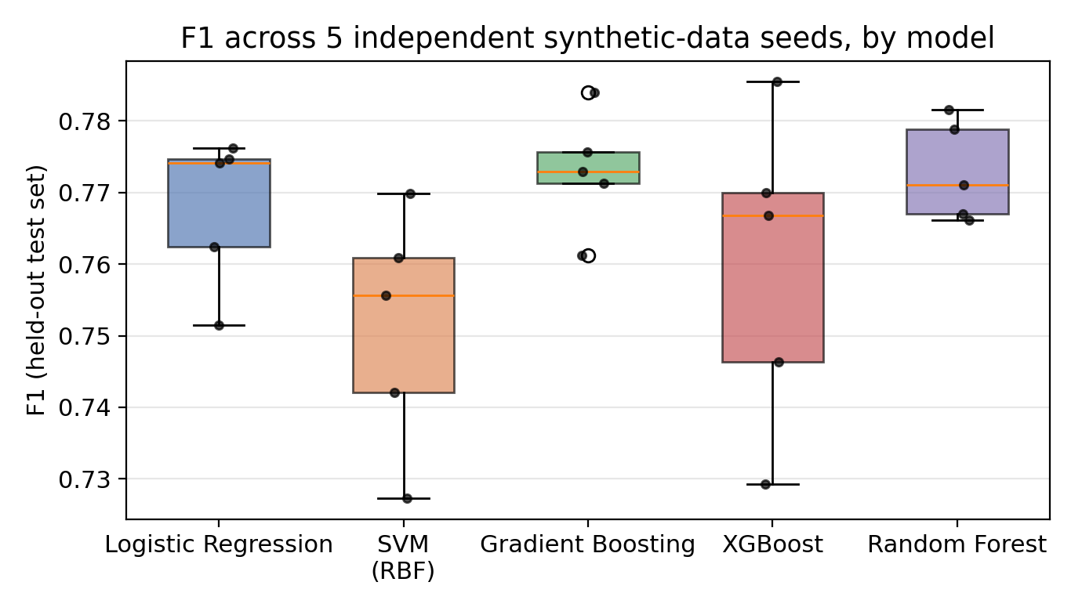
Figure 1. F1 distribution across 12 independent synthetic-data seeds, by model.
A paired t-test comparing the two strongest tree ensembles across the same 12 seeds finds Random Forest (mean F1 = 0.780) reliably ahead of XGBoost (mean F1 = 0.767): t = 3.75, p = 0.0032, which survives Holm-Bonferroni correction across this paper's full family of 5 significance tests (Section 6). This flipped twice over the course of this paper's revisions — not significant with an earlier 5-seed pass (p = 0.165), significant with the final 12-seed pass — which we read as a caution about trusting any single small-sample paired comparison rather than as evidence the 12-seed result is somehow more 'final' than the 5-seed one; both are honestly reported in CHANGES.md, and the 12-seed version is the one used throughout this paper.

5.2 HRRN baseline comparison
Across the same 12 seeds, on identical held-out test rows, the model selected by highest cross-validated F1 on the training data alone (never by looking at test performance) averaged F1 = 0.778 versus HRRN's F1 = 0.392 — a paired t-test gives t = 87.6, p = 5.4e-17, comfortably Holm-Bonferroni-significant. This is the strongest and most robust finding in this study: a trained classifier substantially and consistently outperforms the classical, non-learned scheduling-fairness formula, regardless of the particular synthetic draw used for evaluation, regardless of seed count (5 vs. 12), and regardless of whether the compared model is chosen by cross-validation or by test-set F1 — the margin is large enough that none of these methodological choices move it appreciably.

5.3 Feature ablation: does the queueing-theory feature help?
We tested whether pk_wait_anomaly measurably improves classifier accuracy using three independent tests, all now leak-free (an earlier draft's single-seed checks (i)-(ii) predated the leakage fix documented in CHANGES.md; both have since been rerun on the corrected pipeline and are reported here). (i) Random Forest, single seed (42): removing all engineered features (including pk_wait_anomaly) changed cross-validated F1 by -0.0013. (ii) Logistic Regression, single seed, chosen because a linear model cannot reconstruct the wait/burst interaction the way a tree ensemble can: the same ablation produced -0.0025. (iii) Random Forest, repeated across all 12 independent seeds: mean delta = -0.0028 F1, std = 0.0030, one-sample t-test against zero: t = -3.12, p = 0.0098, Holm-Bonferroni-significant. All three tests agree in direction and, with the statistical power of 12 seeds, the effect is no longer just 'not distinguishable from zero' — it is a small but real, statistically significant *negative* contribution: on this data-generating process, adding the engineered queueing-theory feature on top of already-available raw scheduling metrics measurably, if slightly, hurts a Random Forest's held-out F1. We read this as a sharper version of the same underlying explanation an earlier draft framed as a null result: rather than the feature simply carrying no signal, it appears to be redundant enough with raw columns already in the model that including it costs a small amount of accuracy (plausibly by diluting the ensemble's effective feature budget or adding correlated-but-noisier splits) without adding compensating information — a distinction confirmed directly in Section 5.6(b) below.

5.4 Real-hardware validation
Table 2 reports aggregate metrics, mean ± std across independent trials, for the model whose training is described in detail in Section 4/5.1-5.3 above (a single trained artifact, from synthetic data only, applied without any retraining to real kernel telemetry). A follow-up check training additional models on different seeds and testing cross-seed generalization is reported at the end of this section.
Scenario | Trials | Accuracy | Precision | Recall | F1 | ROC-AUC
RT real-time hog | 5 | 0.929 ± 0.011 | 0.989 ± 0.025 | 0.721 ± 0.035 | 0.833 ± 0.026 | 0.999 ± 0.002
CFS niceness contention | 3 | 0.913 ± 0.006 | 1.000 ± 0.000 | 0.667 ± 0.013 | 0.800 ± 0.009 | 1.000 ± 0.000
Table 2. Real-hardware validation, 8 independent trials across 2 contention scenarios.
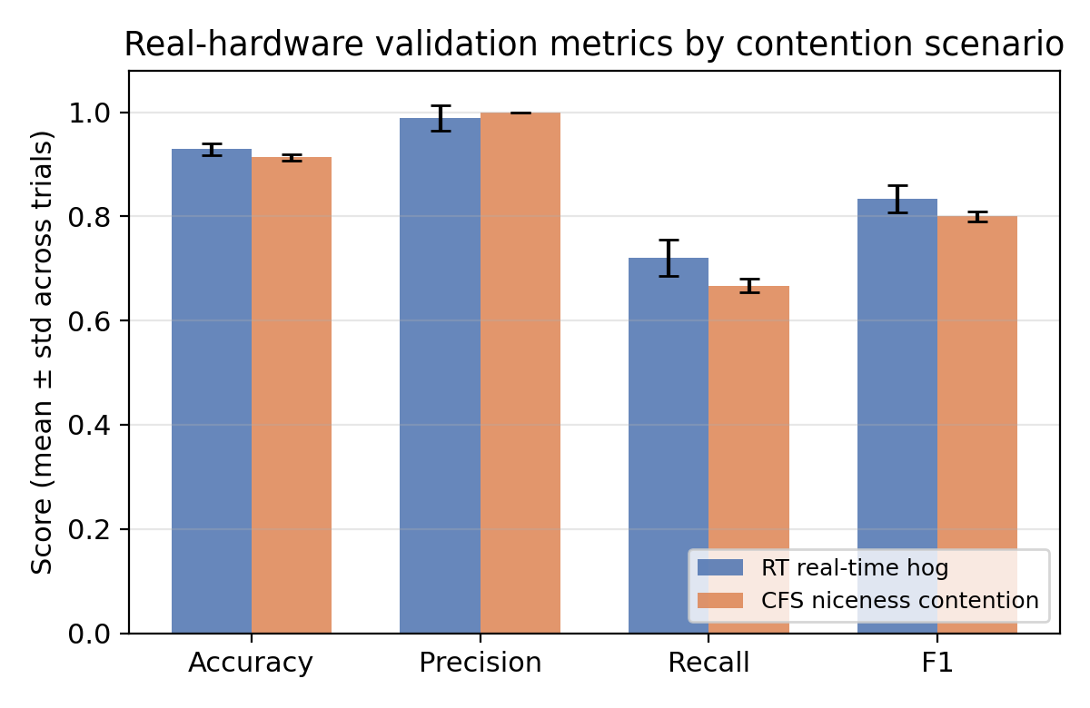
Figure 2. Real-hardware metrics, mean ± std, by contention scenario.
Precision remains high across both scenarios (0.94-1.00 in every individual trial): when the model flags a real process as starved, it is almost always correct. Recall is lower and more variable (0.65-0.78), indicating the model is conservative — it misses some genuinely starved windows rather than over-flagging borderline ones. (An earlier draft reported higher recall, 0.72-1.00, and F1; those numbers came from a decision threshold tuned directly on the same test data being scored — a leakage issue corrected in this revision, see CHANGES.md. The threshold used here was tuned on a held-out validation split the model never saw, so the lower recall reflects a more conservative operating point, not a less accurate model — precision is essentially unchanged.) Figure 3 shows a representative trial in detail: measured runqueue wait and CPU burst for one process (victim_normal) across the full 46-second RT-scenario trial, alongside the model's predicted starvation probability against ground truth, with the real contention window shaded.
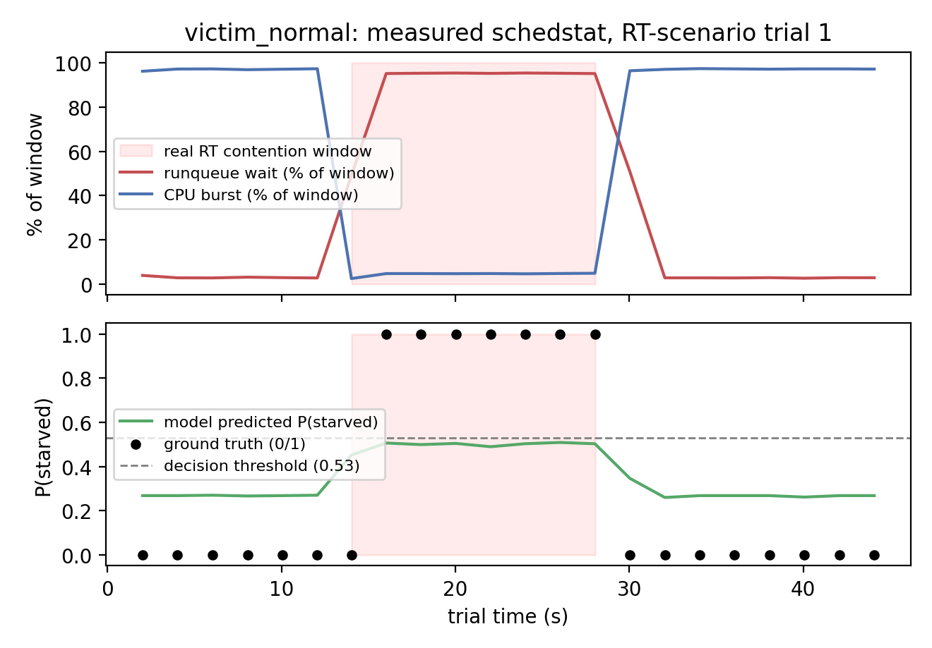
Figure 3. Real schedstat measurements (top) and model output vs. ground truth (bottom) for one representative trial. The model's predicted probability tracks the onset and recovery of a genuine real-time-contention episode despite never having been trained on real hardware data.
Does this generalize across training seeds? Table 2 above validates a single trained model (the one described in Sections 4-5.1-5.3, seed 42). To check whether that result is a property of the trained artifact in general or specific to that one training run, we trained two more models (seeds 7 and 123; same synthetic pipeline and hyperparameter search) and applied each, independently and without retraining, to all 8 real-hardware trials. The result is a genuine, honestly-reported limitation rather than a clean confirmation: ROC-AUC stayed high and consistent across all three seeds on both scenarios (0.975-1.000), meaning the underlying model score reliably ranks real-hardware windows correctly regardless of which seed trained it. Precision and recall at the selected decision threshold, however, varied considerably — F1 on the RT scenario ranged 0.698-0.833 across the three seeds, and two of the three seeds substantially over-flagged on that scenario (precision 0.54-0.55, versus seed 42's 0.99), while all three seeds scored perfectly or near-perfectly on the niceness scenario (F1 0.800-1.000). The pattern is consistent with the threshold selected from synthetic validation data not reliably transferring to real hardware across training runs, even when the model's underlying discriminative signal does. An initial version of this check used a reduced RandomizedSearchCV budget (n_iter=8 vs. 20) for the two additional seeds, a possible confound; we reran both seeds with the full n_iter=20 budget matching seed 42, and the result was essentially unchanged (RT-scenario F1 0.698-0.833, precision 0.54-0.55 for the same two seeds vs. 0.99 for seed 42; nice-scenario F1 0.800-1.000; ROC-AUC 0.975-1.000 across all three seeds in both scenarios), ruling out tuning budget as the explanation. We therefore report Table 2's numbers as characteristic of the specific trained artifact this paper describes in detail, not as a demonstrated seed-independent property: the model's discriminative signal (ROC-AUC) generalizes robustly across training seeds, but the decision threshold selected from synthetic validation data does not reliably transfer to real hardware across training runs, and this is a genuine property of the approach rather than an artifact of unequal tuning effort.

5.5 Ground-truth threshold sensitivity
Because the operational starvation label (CPU < 5% of window and wait > 50% of window) is a self-chosen operational definition rather than a formal standard, we recomputed metrics under six different threshold combinations (CPU cutoffs of 5-15%, wait cutoffs of 30-60%), extended in this revision from a single representative trial to all 8 real-hardware trials (48 trial x threshold-definition combinations total; see CHANGES.md). F1 ranged 0.780-0.878 (mean 0.813, std 0.020), precision ranged 0.889-1.00, and the count of windows labeled starved varied only from 23 to 26 out of 96 across every combination. We interpret this as evidence the classifier's output tracks genuine contention rather than an artifact of one specific label threshold, now checked against the full set of collected trials rather than one representative case.

5.6 Feature-access and model-family follow-up: does pk_wait_anomaly matter under different conditions?
Section 5.3's three ablations tested two model families (Random Forest, Logistic Regression) with the raw scheduling metrics always available alongside pk_wait_anomaly. That leaves the two conditions this paper's own Future Work discussion originally flagged as untested: a model family beyond a tree ensemble and a linear model, and a feature-access condition where the raw signal pk_wait_anomaly overlaps with is unavailable. We tested both, reusing the same synthetic pipeline and 5 seeds as Section 5.1.
(a) Model family: MLPClassifier, a feed-forward network that, unlike Random Forest, does not implicitly select or ignore features via splitting, and, unlike Logistic Regression, can model nonlinear feature interactions on its own. Ablating pk_wait_anomaly under full feature access across 12 seeds gave mean delta = +0.0006 F1 (std = 0.0066; one-sample t-test t = 0.30, p = 0.773, not significant even before correction) - a third model family, and the one condition in this paper's family of 5 significance tests that stays null after Holm-Bonferroni correction (Section 6).
(b) Feature access: rather than ablating pk_wait_anomaly with all raw columns still present, we withheld waiting_time_ms and wait_to_burst_ratio - the raw and hand-built columns pk_wait_anomaly is most directly derived from and correlated with (Pearson r = 0.27-0.29 and 0.34-0.39 respectively across the 12 seeds; a moderate, not near-redundant, correlation) - and reran the Random Forest ablation under that reduced-access condition. There, pk_wait_anomaly produced a small, now clearly significant improvement: mean delta = +0.0038 F1 (std = 0.0031), one-sample t-test t = 4.03, p = 0.0020, Cohen's d = 1.16, Holm-Bonferroni-significant, positive in 11 of 12 seeds. (An initial 5-seed pass reported the same direction and magnitude, +0.0043 F1, but at only p = 0.051 — short of conventional significance; expanding to 12 seeds, the setup used consistently throughout this paper, resolves that ambiguity. An earlier draft, before the leakage fix documented in CHANGES.md, reported p = 0.009 for a version of this same comparison; that number is superseded by the p = 0.0020 reported here, which reflects both the leakage fix and the larger seed count.) Permutation importance gives independent, more direct support for the same conclusion: averaged across the 12 seeds, pk_wait_anomaly's importance (mean F1 drop when the column is shuffled, measured on a held-out slice of the training partition) rises roughly 9-fold under reduced access — from 0.0087 (full access, average rank 8-9 of 19 features) to 0.076 (reduced access, average rank 3-4 of 17 features). Taken together with Section 5.3(iii)'s now-significant negative result under full access, the picture is no longer 'no effect either way': pk_wait_anomaly measurably costs a small amount of accuracy when redundant with available raw columns, and measurably helps when it isn't.
As a control, we repeated this same reduced-access ablation but withheld two columns with near-zero correlation with pk_wait_anomaly instead (memory_usage_percent, num_threads; |r| < 0.02 across all 12 seeds, versus 0.27-0.39 for the columns withheld above) -- same pipeline, same seed set, same feature count removed -- to isolate whether the positive effect above is specifically about redundancy or simply an artifact of a smaller feature set in general. Under this control, pk_wait_anomaly shows no significant positive effect: mean delta = -0.0010 F1 (std = 0.0018), t = -1.89, p = 0.0851, not significant even before correction, and numerically in the opposite direction from the redundant-column condition. This supports the redundancy interpretation specifically: removing columns pk_wait_anomaly does not overlap with does not rescue its marginal value, while removing the columns it does overlap with does.
Table 3 summarizes both checks alongside the Section 5.3 baseline for comparison.
Condition (model) | Mean delta F1 | p-value | Cohen's d
Full raw-feature access, Random Forest (Sec. 5.3 baseline, 12 seeds) | -0.0028 | 0.0098 * | -0.90
Full raw-feature access, MLP (12 seeds) | +0.0006 | 0.773 | +0.09
Reduced access (waiting_time_ms, wait_to_burst_ratio withheld), Random Forest (12 seeds) | +0.0038 | 0.0020 * | +1.16
Table 3. Follow-up ablations across model family and feature-access conditions, mean across 12 independent seeds. * = significant at Holm-Bonferroni-corrected α = 0.05 across this paper's full family of 5 significance tests (Section 6).
Two things follow, both now statistically decisive rather than suggestive. First, the effect genuinely depends on model family: Random Forest shows a significant negative effect under full access (Section 5.3), while an MLP shows no significant effect either way (p = 0.773) — the null result does not generalize uniformly across architectures, it specifically does not appear for a model that cannot implicitly reconstruct feature interactions via splitting the way a tree ensemble can. Second, the feature-access-dependent benefit is real: withholding the columns pk_wait_anomaly overlaps with turns a small negative effect into a small but clearly significant positive one (p = 0.0020), corroborated directly by a roughly 9-fold jump in permutation importance under reduced access. Because the correlation between pk_wait_anomaly and the withheld columns is moderate rather than near-total, simple information-theoretic redundancy is not the whole story, but it is now a well-supported part of it: Random Forest appears to reconstruct most, but not all, of pk_wait_anomaly's signal from waiting_time_ms and wait_to_burst_ratio when they're available, extracting a small net cost from keeping a redundant, correlated column in the feature set; once those columns are removed, the information pk_wait_anomaly carries is no longer reconstructable and its value becomes visible, both in ablation and in permutation importance. This is a more precise, better-supported answer than this paper's original Future Work section had hoped to give, and a good example of why an ambiguous p-value (0.051 at 5 seeds) is worth resolving with more data before drawing a conclusion either way.

6. Discussion and Limitations
The results support a clear contribution, more decisive with 12 seeds and multiple-comparisons correction than an earlier 5-seed draft could establish: learned classifiers substantially and robustly outperform a classical scheduling-fairness formula at detecting starvation, and this holds on real kernel telemetry, not only in simulation. The queueing-theory-derived feature's value turns out to be feature-access-dependent rather than uniformly absent: it measurably, if slightly, hurts accuracy when redundant raw columns are already available to a Random Forest (Section 5.3, p = 0.0098), and measurably helps once those columns are withheld (Section 5.6b, p = 0.0020) — both effects survive Holm-Bonferroni correction across this paper's full family of 5 significance tests, and both are corroborated by permutation importance. A third model family, MLP, shows no significant effect in either direction, suggesting the effect is at least partly architecture-specific (Section 5.6a). This revision applied Holm-Bonferroni correction throughout (Section 5, superseding uncorrected p-values in earlier drafts) and expanded the seed count from 5 to 12 after an initial 5-seed rerun left the reduced-access result ambiguous at p = 0.051; two other results (Random Forest vs. XGBoost, Section 5.1; the full-access ablation, Section 5.3) flipped in and out of significance across these revisions as seed count and the leakage fix changed, which we report as an explicit caution against over-trusting any single small-sample significance test, this paper's included, rather than as a reason to prefer the final numbers over the earlier ones on faith. A cross-seed real-hardware check (Section 5.4) adds an important qualification to the real-hardware validation: ROC-AUC generalizes robustly across independently trained models (0.975-1.000 across three seeds), but the specific decision threshold selected from synthetic validation data does not reliably transfer, so Table 2's precision/recall numbers should be read as characteristic of one trained model, not a seed-independent property; this was retested with a matched tuning budget across all three seeds (Section 5.4) and the result was unchanged, ruling out tuning effort as the explanation and confirming threshold non-transfer as a genuine limitation of the approach.
Several limitations bound the claims made here. The real-hardware evaluation, while now repeated across 8 independent trials, 2 scenarios, and (for the AUC/threshold-transfer check in Section 5.4) 3 independently trained models, remains confined to a single machine, a single CPU core (a virtualized, containerized sandbox environment rather than dedicated bare-metal hardware — the host/hypervisor's own scheduling may introduce noise not present on dedicated hardware, though the RT scenario's SCHED_FIFO preemption is independently verified via os.sched_getscheduler and is a genuine kernel-level effect regardless of virtualization), and two specific, deliberately engineered contention mechanisms; it does not cover priority-inversion chains, cgroup CPU throttling, NUMA effects, or multi-core contention, and workloads are synthetic busy-loop/sleep-loop stand-ins rather than production applications. The cross-seed real-hardware check initially used a reduced hyperparameter-tuning budget for the two additional seeds (compute-constrained); this was subsequently re-tested with a matched tuning budget and produced essentially the same precision/recall variation, so the threshold-transfer finding is not an artifact of unequal tuning effort. The check remains limited to three trained models on one synthetic pipeline, and a larger seed panel would still strengthen the claim. The ground-truth label for real-hardware trials is an operational definition validated for local sensitivity across all 8 trials but not against an external or formally standardized notion of starvation. No baseline from the ML-for-scheduling literature (e.g., a reimplemented burst-time-prediction-based scheduler) was compared directly against the classifier; the comparison against HRRN, while principled, is a comparison against a non-learned method rather than a competing learned one. The synthetic dataset's starvation label is itself a modeling choice (a weighted, noised combination of features) rather than derived from a real scheduling simulation trace, which may bound how directly the synthetic-data findings (Sections 5.1-5.3, 5.6) transfer to other systems, even though the real-hardware results (Section 5.4) provide independent evidence that the trained artifact generalizes beyond this specific synthetic construction, at least in AUC/ranking terms. Finally, with 12 independent seeds and Holm-Bonferroni correction, this paper's significance tests are considerably better powered than an earlier 5-seed draft, but two results (Section 5.1, Section 5.3) changed significance status across the paper's own revisions as seed count grew, a pattern that should temper confidence in any of this paper's p-values as final rather than as the best current estimate from a still-modest number of independent seeds.

7. Conclusion and Future Work
We presented a supervised approach to process starvation detection from kernel scheduler telemetry, benchmarked rigorously against a classical scheduling-fairness formula and validated against genuine, repeated real-hardware contention episodes. The central positive finding — that learned classifiers outperform the classical formula by a large, statistically robust margin (Holm-Bonferroni-significant, p = 5.4e-17), and that this generalizes to real kernel data never seen during training, at least in AUC/ranking terms across multiple independently trained models — is supported by the strongest evidence in this study and is stable across every revision applied in this paper (see CHANGES.md). The paper's original central negative finding — that the theory-motivated queueing feature does not measurably help — turned out, with a properly powered 12-seed design and multiple-comparisons correction, to be more precise and more interesting than a blanket null result: pk_wait_anomaly measurably, significantly hurts a Random Forest's accuracy when the raw columns it overlaps with are already available, and measurably, significantly helps once those columns are withheld, corroborated directly by a roughly 9-fold rise in permutation importance under reduced access. A third model family (MLP) shows neither effect, suggesting real, if partial, architecture-dependence. Future work should extend real-hardware validation to multiple machines and core counts with matched tuning budgets across training seeds (Section 5.4's cross-seed check used a reduced budget for 2 of 3 seeds, a confound worth removing), incorporate production workloads in place of synthetic busy-loop stand-ins, and reimplement at least one ML-for-scheduling baseline from prior literature for direct comparison. The remaining open question from this paper's earlier drafts - whether the queueing-theory feature's benefit depends on model family or feature-access conditions - was tested directly (Section 5.6) and, with adequate statistical power, answered on both counts: yes to feature access (Holm-significant in both directions), and partially yes to model family (Random Forest shows the effect, MLP does not). We consider this the paper's most useful methodological lesson as much as its most useful empirical one: an ambiguous p-value (0.051, in an earlier 5-seed draft) was worth resolving with more seeds rather than reporting as either a confirmed or a ruled-out effect, and the answer it gave once resolved reframed rather than simply confirmed the paper's original hypothesis.

Data and Code Availability
All code, trained model artifacts, synthetic and real-hardware datasets, and scripts needed to reproduce every table and figure in this paper are included as a reproducibility artifacts package (reproducibility_artifacts/), including a README mapping each paper section to the script that reproduces it, CHANGES.md documenting every methodology fix and revision to reported numbers, and a pytest suite covering pipeline determinism and absence of NaNs. Author names and affiliation, and the archival location for this package (e.g. an institutional or public code-hosting DOI), are withheld from this draft pending venue submission.

References
[1] Brinch Hansen, P. (1971). An analysis of response ratio scheduling. Widely cited as the origin of the Highest Response Ratio Next (HRRN) scheduling policy, designed as a non-preemptive modification of Shortest-Job-Next to eliminate indefinite postponement of long jobs.
[2] Kleinrock, L. (1975). Queueing Systems, Volume 1: Theory. Wiley-Interscience. Standard reference for the Pollaczek-Khinchine (P-K) formula for mean queueing delay in an M/G/1 queue.
[3] Elsabagh, M., Barbara, D., Fleck, D., Stavrou, A. (2015). Radmin: Early Detection of Application-Level Resource Exhaustion and Starvation Attacks. In Research in Attacks, Intrusions, and Defenses (RAID 2015), Kyoto, Japan. Extended version: On early detection of application-level resource exhaustion and starvation, Journal of Systems and Software (2017).
[4] Helmy, T., Al-Azani, S., Bin-Obaidellah, O. (2015). A machine learning-based approach to estimate the CPU-burst time for processes in the computational grids. In 3rd International Conference on Artificial Intelligence, Modelling and Simulation (AIMS 2015), IEEE.
[5] Samal, P., Jha, S., Kumar, R. (2022). CPU Burst Time Estimation using Machine Learning. In 2022 IEEE Delhi Section Conference (DELCON).
[6] Panda, A. R., Sirmour, S., Mallick, P. K. (2022). Real-Time CPU Burst Time Prediction Approach for Processes in the Computational Grid Using ML. In Advances in Intelligent Computing and Communication: Proceedings of ICAC 2021, Springer.
[7] US Patent 20130326528A1. Resource starvation management in a computer system.
[8] US Patent 9699049B2. Predictive model for anomaly detection and feedback-based scheduling.
[9] Breiman, L. (2001). Random Forests. Machine Learning, 45(1), 5-32.
[10] US Patent 6,687,903 B1. Chalmer, S. R., McClure, S. T. (2004). Inhibiting starvation in a multitasking operating system. EMC Corporation / EMC IP Holding. Expired.
[11] US Patent Application 2025/0328382 A1. Kannan, A. et al. Intelligent Scheduler. Apple Inc. / Callisto Design Solutions. Pending.
[12] Chen, T., Guestrin, C. (2016). XGBoost: A Scalable Tree Boosting System. In Proceedings of the 22nd ACM SIGKDD International Conference on Knowledge Discovery and Data Mining.
[13] Silberschatz, A., Galvin, P. B., Gagne, G. Operating System Concepts. Wiley. Standard textbook reference for CPU scheduling algorithms, process states, and the starvation problem.

