Mod 3 Program Assignment 2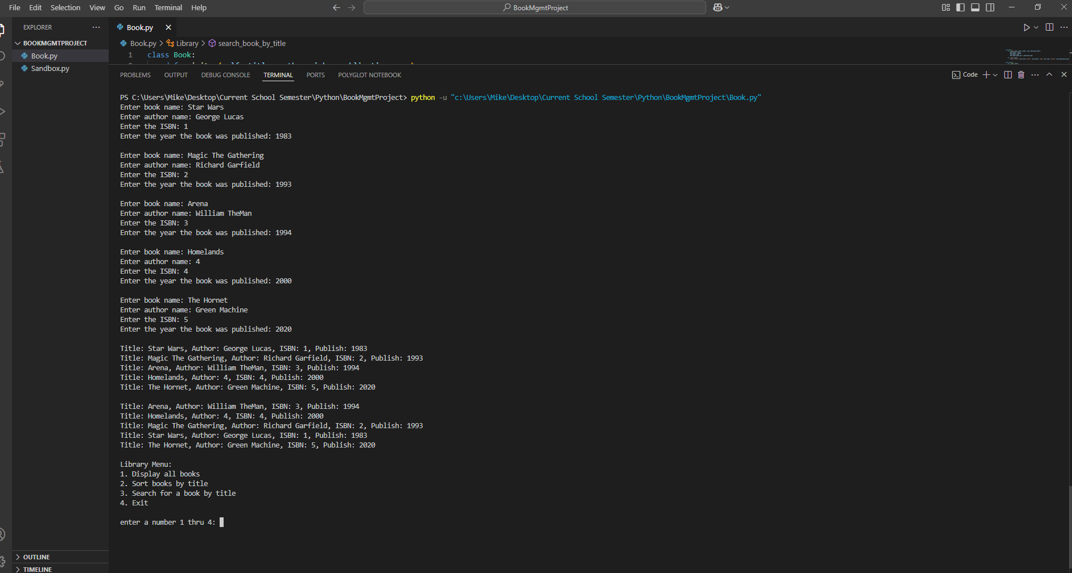me filling in the book titles and adding them to the library

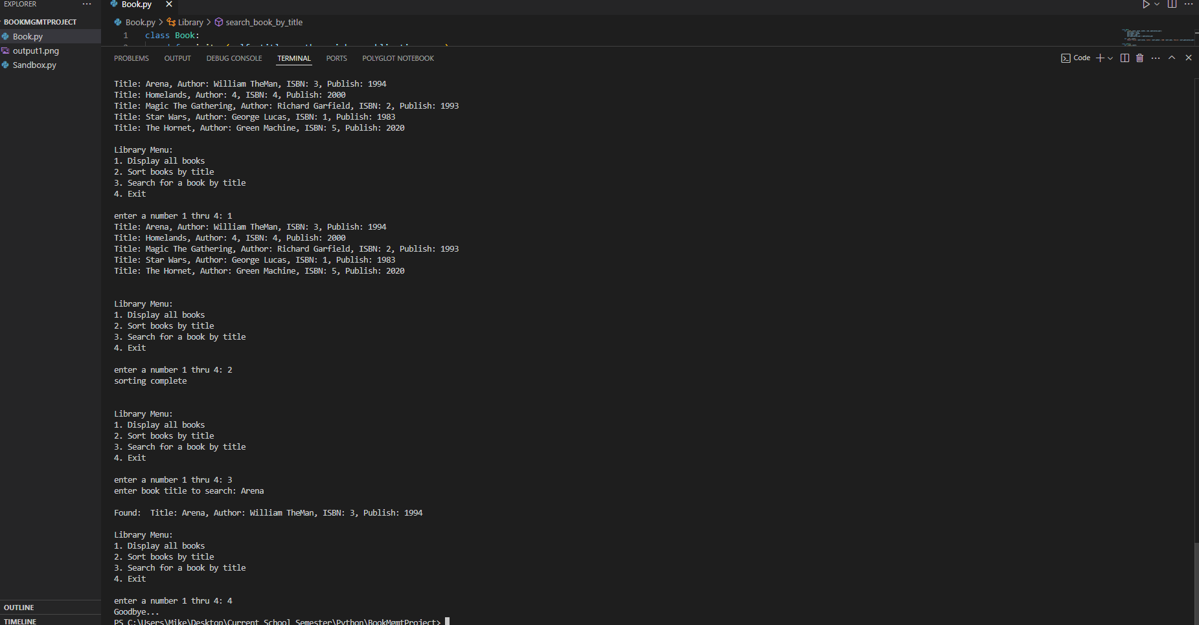Using menu to select options