Contextual Substitutability “Car Park” Demo Application
Premek Brada <brada@kiv.zcu.cz> 1. Feb 2012, 7. Jul 2017
The application consists of several bundles. It evolves in 6 application revisions between which combinations of changes to bundles happen that lead to strict and/or contextual substitutability. Descriptions here are those not clear from bundle manifests.
TODO
- add indication of purely internal changes, ie when just code but no import pkg is changed
- `bnd` generates package version numbers different from what we have here, check and either correct here or override in bnd files

Abbreviations
- svc = service pkg = package
- v = version rev = revision

Note on running the application
Deployment and application startup support is rather rudimentary. Apache Felix with command line is assumed as the OSGi framework. The following sequence can be used:
- Copy the desired mix of bundles in the Felix deployment folder (for the mixes corresponding to prepared app revisions, see columns in the table in Bundle revisions section below).
- Start Felix using `rm -rf felix-cache/* ; java -jar bin/felix.jar` on command line.

Core and shared things
- Namespace prefix: cz.zcu.kiv.osgi.demo.parking .
- All bundles except statsbase use SLF4J for logging => import package org.slf4j .
- All bundles except statsbase have activator => import org.osgi.framework
The slf4j and osgi packages are called “system” ones below.

Bundle revisions and pkg versions per application revisions
Unchanged are in normal weight, newly introduced are underlined, changed are in boldface.
Bundle | 1 | 2 | 3 | 4 | 5 | 6 | ← App Rev | Mmu?
StatsBase | 1 / 1.0.0 | 1 | 1 | 2 / 1.0.1 | 2 | 2 | ← rev / OSGi vers  ← revs working in ctx given by app rev
StatsBase | 1, 2 | 1, 2 | 1, 2 | 2 | 2 | 2 | ← rev / OSGi vers  ← revs working in ctx given by app rev | OK
Dashboard | 1 / 1.0.0 | 1 | 2 / 1.0.1 | 2 | 2 | 2 | ← rev / OSGi vers  ← revs working in ctx given by app rev
Dashboard | 1, 2 | 1, 2 | 1, 2 | 1, 2 | 1, 2 | 1, 2 | ← rev / OSGi vers  ← revs working in ctx given by app rev | OK
Gate | 1 / 1.0.0 | 2 / 1.0.1 | 3 / 1.1.0 | 4 / 2.0.0 | 4 | 4 | ← rev / OSGi vers  ← revs working in ctx given by app rev
Gate | 1, 2, 3 | 1, 2, 3 | 1, 2, 3 | 3, 4 | 4 | 4 | ← rev / OSGi vers  ← revs working in ctx given by app rev | SOME
CarPark | 1 / 1.0.0 | 1 | 1 | 2 / 1.1.0 | 3 / 2.0.0 | 3 | ← rev / OSGi vers  ← revs working in ctx given by app rev
CarPark | 1 | 1 | 1 | 1, 2, 3 | 1, 2, 3 | 1, 2, 3 | ← rev / OSGi vers  ← revs working in ctx given by app rev | FEW
TrafficLane |  |  | 1 / 1.0.0 | 2 / 1.0.1 | 3 / 1.0.2 | 4 / 2.0.0 | ← rev / OSGi vers  ← revs working in ctx given by app rev
TrafficLane |  |  | 1 | 2 |  |  | ← rev / OSGi vers  ← revs working in ctx given by app rev
RoadSign |  |  |  |  | 1 / 1.0.0 | 1 | ← rev / OSGi vers  ← revs working in ctx given by app rev
RoadSign |  |  |  |  | 1 |  | ← rev / OSGi vers  ← revs working in ctx given by app rev

The “Mmu?” column tells whether OSGi “Major.minor.micro” semantic bundle versions work for the given bundle in contextual substitutability scenarios.

Explanations of ctx substitutability issues, per bundle
(Notation: “G/3” means “table cell Gate in app rev 3”, “G3” is “bundle Gate rev 3”.)
- S/1-S/3: can use S2 here because it is a superset of S1
- S/4-S/6: rev 1 cannot be used here because it lacks abstract base class used by APP/3-APP/6 statistics bundles;
- D: both versions can be in any app rev because StatsBase is always available
- G/1-G/3: cannot have G4 here because it needs S2, plus for G/1 and G/2 cases because LaneStats would be missing (=> OSGi bundle versions give false negative in G/3 case, work in G/1 and G/2)
- G/4: can have G3 here because G4's exported ParkingStatus operations are not needed in APP/4 (=> OSGi bundle versions give false negative in this case); but cannot have G1-G2 here because they don't export VehicleSink needed by TrafficLane (=> OSGi version work)
- G/5: cannot have G3 here because now TrafficLane needs ParkingStatus operations of G4 (=> OSGi bundle versions work)
- C/1-C/3: rev 2 cannot be used here because it needs abstract base class for statistics (=> OSGi bundle versions work)
- C/4-C/6: rev 1 can be used since it is “self-contained” and the parking statistics pkg exported by rev 2 is not used by any other bundle; and rev 3 can also be used even though it has a DEL/GEN diff on exported parking statistics pkg because that pkg is not used (=> OSGi bundle versions don't work)

TODO analysis of ctx subst for C,T,R

Detailed Analysis of Changes
Details of changes and their impact on compatibility follow, for each app revision separately. Bundle names are formatted to show what’s changed: unchanged bundles are in normal font weight, changed are in boldface, newly added are prepended with asterisk. For each bundle, its revision and OSGi version are given, then summary of changes, then differences on exported and imported sides.

Note. The SEM-SPE differences due to the switch from plain interface implementation to extending abstract base class could be completely avoided if the implementations were hidden in non-exported internal packages…
Diagrams are created in Astah Community edition version 7.0.0 (http://astah.net/editions/community).

Rev 1 – Baseline
Dashboard uses GateStats on its “gate” port only through its CountingStats subset. Gate provides LaneStatistics since there is no other bundle to do that.
All diffs are “NA” because there is no preceding revision.

*StatsBase 1 = 1.0.0
  - ex: statsbase;v=1.0.0
  - im: (none)
*Dashboard 1 = 1.0.0
imports statsbase because parent interface is used on “gate” stats port
  - ex: (none)
  - im:
gate.statistics;v=[1.0.0, 2.0.0) – (!) just to create the gate stats service via GateStats factory
lane.statistics;v=[1.0.0, 2.0.0) – ILaneStats iface and svc used
statsbase;v=[1.0.0, 2.0.0) – ICountingStats iface used on gate stats service port
*Gate 1 = 1.0.0
  - ex:
gate.statistics;v=1.0.0
lane.statistics;v=1.0.0
  - im:
carpark.flow;v=[1.0.0, 2.0.0) – IVehicleFlow and provided svc used by gate statistics
statsbase;v=[1.0.0, 1.1.0) – IGateStats and ILaneStats extend its ICountingStats
*CarPark 1 = 1.0.0
  - ex:
carpark.flow;v=1.0.0
carpark.status;v=1.0.0
  - im: (system only)
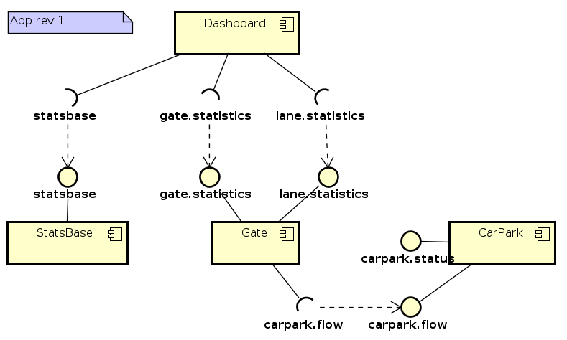

Rev 2 – Gate observes CarPark status
Gate adds dependency on ParkingStatus, provided by CarPark.

StatsBase 1 = 1.0.0 from rev 1
Dashboard 1 = 1.0.0 from rev 1
Gate 2 = 1.0.1 (NON)
INS on imported packages (ParkingStatus)
  - ex:
NON gate.statistics;v=1.0.0
NON lane.statistics;v=1.0.0
  - im:
INS carpark.status;v=[1.0.0, 2.0.0) – used by GateStats to get “carpark full” info
NON carpark.flow;v=[1.0.0, 2.0.0)
NON statsbase;v=[1.0.0, 1.1.0)
CarPark 1 = 1.0.0 from rev 1

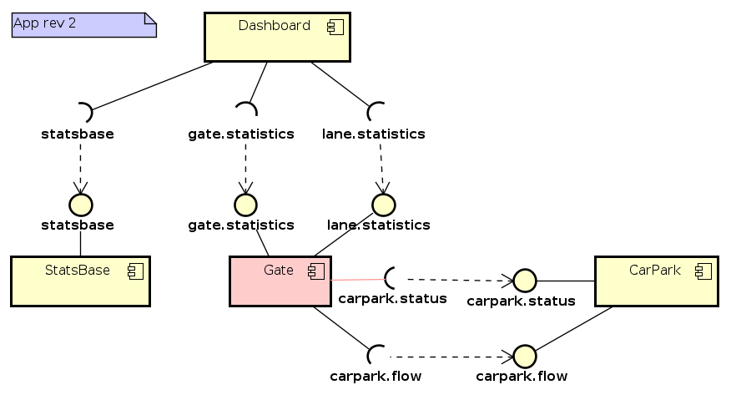

Rev 3 – TrafficLane added
LaneStatistics evolved by adding a method (which however is not used by clients in app rev 3-5). TrafficLane component added to the system, provides LaneStatistics type but the Dashboard is still connected to the Gate which still provides LaneStatistics as well – i.e. two bundles provide the same package (in this app rev, the package contents is identical). Gate newly also runs the traffic simulation internally, using the VehicleSink and TrafficSimulation classes. Dashboard now uses full GateStatistics on its “gate” port.

StatsBase 1 = 1.0.0 from rev 1
Dashboard 2 = 1.0.1 (NON)
SPE on required svc because gate stats iface imported and used instead of parent counting stats.
  - ex: (none)
  - im:
NON gate.statistics;v=[1.0.0, 2.0.0) – (used for real now, IGateStats iface needed)
NON lane.statistics;v=[1.0.0, 2.0.0)
DEL statsbase – ICountingStats no longer used (svc variable typed to IGateStats instead)
Gate 3 = 1.1.0 (SPE)
Diffs as follows, plus internal change: activator newly spawns traffic simulation thread (using the new TrafficSimulation class).
  - ex:
NON gate.statistics;v=1.0.0
SPE lane.statistics;v=1.1.0 – a getVehiclesPerInterval() method added
INS gate.control;v=1.0.0 – newly added (but not used by anybody)
  - im:
NON carpark.flow;v=[1.0.0, 2.0.0)
NON carpark.status;v=[1.0.0, 2.0.0)
NON statsbase;v=[1.0.0, 1.1.0)
CarPark 1 = 1.0.0 from rev 1
*TrafficLane 1 = 1.0.0
The lane statistics interfaces are split into two, compared to app rev 2: ILaneStatistics (exported) and ILaneUpdate (internal). The version number of the lane.statistics package is not 1.0.0 due to the SPE change on the exported ILaneStatistics interface (see Gate exports above) – not sure this is fully correct according to OSGi rules, as the TrafficLane exports the package in this implementation for the first time and from its point of view, it would be 1.0.0 version.
- ex:
NA lane.statistics;v=1.1.0 – bundle exports the same pkg as Gate
- im:
NA statsbase;v=[1.0.0, 1.1.0) – ILaneStatistics inherits from ICountingStats

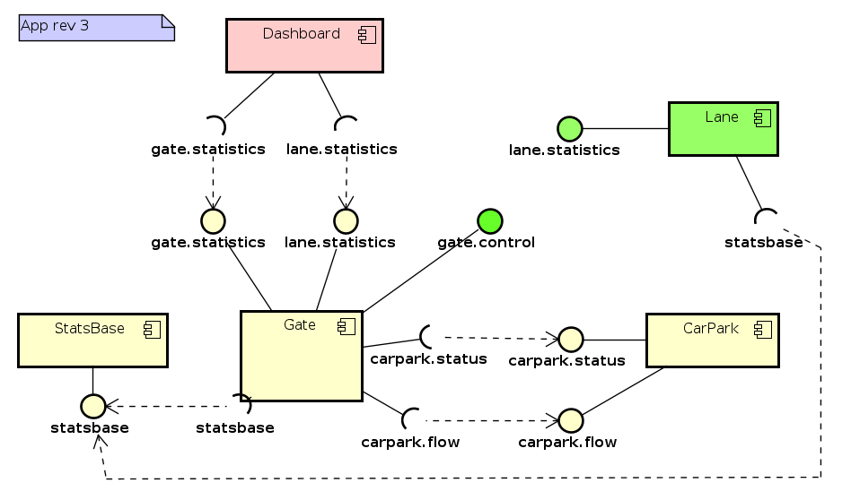

Rev 4 – TrafficLane Statistics used
TrafficLane component's interface did not change, but its LaneStatistics are now used by Dashboard, because Gate stopped providing LaneStatistics. CarPark now provides ParkingStatistics which are not used by anybody, but Gate adds its methods to the GateStatistics which it provides. StatsBase changed, now provides an abstract implementation of CountingStatistics interface, all statistics classes (gate, lane, carpark) inherit from this abstract base.

  - A better single-threaded design would be that the Gate runs a thread in which it – in something like simulation steps – repeats asking the TrafficLane and CarPark how many vehicles are coming to the gate from each (arriving from the lane, leaving from the parking lot, respectively) and performs the vehicle exchange. This would require adding a query interface on the Lane component (like lane.status.ILaneStatus with getNumVehiclesArriving()), and adding a similar method to IParkingStatus.
  - (could be implemented in app rev 4 possibly, would result in different version numbers of the exported packages and whole TrafficLane bundle but looks like would not break anything else)

StatsBase 2 = 1.0.1 (SEM-SPE)
Exported pkg evolved but ... see below for detailed reasoning behind the bundle version change.
- ex:
SEM-SPEC statsbase;v=1.0.1 – added abstract base class to the package
- im: (none)
Dashboard 2 = 1.0.1 from rev 3
Gate 4 = 2.0.0 (MUT)
- ex:
SPE gate.statistics;v=1.1.0 – adds ParkingStatus operations
SEM-SPE gate.control;v=1.0.1 – adds throw exception
DEL lane.statistics – because lane stats now provided by traffic lane bundle
- im:
SPE carpark.status;v=[1.1.0, 2.0.0) – GateStats re-exports evolved IParkStatus operations
SEM-SPE statsbase;v=[1.0.1, 1.1.0) – abstract base class extended by GateStats etc
NON carpark.flow;v=[1.0.0, 2.0.0)
CarPark 2 = 1.1.0 (SPE)
- ex:
SEM-SPE carpark.flow;v=1.0.1 – impl of VehicleFlow adds throw exception
SPE carpark.status;v=1.1.0 – new IParkingStatusUpdate, methods added to IParkingStatus
INS carpark.statistics;v=1.0.0 – whole new pkg exported; not used by anyone though
- im:
INS statsbase;v=[1.0.1, 2.0.0) – the (evolved) statsbase needed for carpark.statistics
TrafficLane 2 = 1.0.1 (SEM-SPE)
- ex:
SEM-SPE lane.statistics;v=1.1.1 – LaneStats now extends abstract base class
- im:
NON gate.vehiclesink;v=[1.0.0, 2.0.0)
SEM-SPE statsbase;v=[1.0.1, 1.1.0) – now using evolved statsbase with abstract base

Note on the version of “statsbase” package and whole bundle: the changes introduced are NON on the API part (the ICountingStatistics iface unchanged) and INS on the implementation part (abstract base class added). These changes don't break existing clients (who only used the interface so far) neither existing providers (because the interface hasn't changed). In this fairly singular case therefore, the change should IMHO be classified as internal.
OTOH, it makes versioned dependency difficult, needing to use the 1.0.1 as lower bound in gate, carpark etc which somehow feels odd. But if 1.0.0 was used as pkg vers in the import, linkage errors would result, and if 1.1.0 was used as pkg version, it would render the bundle incompatible with previous revisions of other bundles in app revs 1-3 which clearly would be wrong.
Lastly: implementation of statistics classes extend the abstract base, which makes its public methods removed from their public interface; we do not classify this as DEL → GEN difference because clients will not notice the difference.

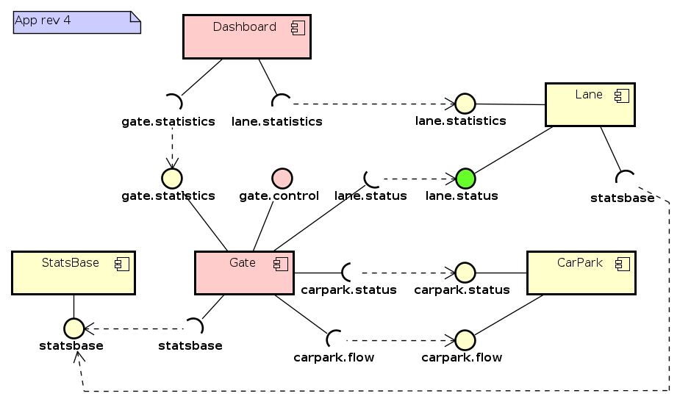

Rev 5 – RoadSign added
RoadSign component added, driven by TrafficLane; shows a sign about car park's free capacity. CarPark still provides ParkingStatistics which got changed by removing a method but which are still not used by anybody.
StatsBase 2 = 1.0.1 from rev 4
Dashboard 2 = 1.0.1 from rev 3
Gate 4 = 2.0.0 from rev 4
CarPark 3 = 2.0.0
- ex:
NON carpark.flow;v=1.0.1
NON carpark.status;v=1.1.0
GEN carpark.statistics;v=2.0.0 – method removed from IParkingStatistics
- im:
NON statsbase;v=[1.0.1, 2.0.0)
TrafficLane 3 = 1.0.2 (NON)
- ex:
NON lane.statistics;v=1.1.1
- im:
NON gate.vehiclesink;v=[1.0.0, 2.0.0)
NON statsbase;v=[1.0.1, 2.0.0)
INS gate.statistics;v=[1.1.0, 2.0.0) – to show free parking places on road sign
INS sign.roadsign;v=[1.0.0, 2.0.0) – to invoke road sign, introduced in this app revision
*RoadSign 1 = 1.0.0
- ex:
sign.roadsign;v=1.0.0
- im: (system only)

Rev 6 – TrafficLane Statistics modified
LaneStatistics interface evolved by replacing a method with another one; that method however was not used by anybody in previous app revisions.

StatsBase 2 = 1.0.1 from rev 4
Dashboard 2 = 1.0.1 from rev 3
Gate 4 = 2.0.0 from rev 4
CarPark 3 = 2.0.0 from rev 5
RoadSign 1 = 1.0.0 from rev 5
TrafficLane 4 = 2.0.0 (MUT)
MUT on exported package/interface LaneStatistics
- ex:
MUT lane.statistics;v=2.0.0 – method vehPerInterval() replaced by vehPerSecond()
- im:
NON gate.vehiclesink;v=[1.0.0, 2.0.0)
NON statsbase;v=[1.0.1, 2.0.0)
NON gate.statistics;v=[1.1.0, 2.0.0)
NON sign.roadsign;v=[1.0.0, 2.0.0)

