Camera Distortion
This document presents analysis of all distortions present in a camera-based system that are not present in daytime direct-view pilotage, together with approaches for mitigating them. It compares various approaches and makes recommendations for each. The distortions considered include the following:
- Latency (see separate document TR-001, System Latencies)
- Handling camera overlap
  - Gaps between cameras
  - Directional ambiguity
  - Stitching errors
- Camera shake
- Rolling shutter
- Field of regard
- Field of view
- Monoscopic view
- Non-egocentric projection
- Motion blur
- Geometric lens distortion
- Color space
  - Monochromatic video
  - Temperature-based brightness
  - Vignetting
  - System-induced signals
  - Different gains and offsets for different pixels
  - Varying reference (temperature dependent)
  - Noise
  - Dynamic range
  - Per-camera offset and gain differences

Summary
Changes since version 6.0 are highlighted in yellow. Three ranked recommendations are made for handling the effects of removing camera overlap by pushing each camera forward along its principal ray:
- A 25-camera solution that includes 21 zoomed cameras and four wide-FOV cameras to estimate depth.
- A 21-camera system with 16 zoomed cameras and five wide-FOV cameras to estimate depth and provide a wider, low-resolution field of view.
- A 21-camera design with vertical 40-degree FOVs per camera, with 3-5-degree overlap.
The impact of each additional distortion is described, along with approaches to mitigating them.
There are several features required to enable the system to mitigate the distortions listed above. Some of them are also needed to mitigate system latency as described in a separate document. They include the following (ordered with more-critical features closer to the top and subordinate features indented):
- Synchronized cameras: Required to avoid “tearing” at camera overlaps. Required to remove synchronization delay between cameras.
  - Triggered cameras: Required to synchronize cameras with display output to reduce synchronization delay with the output display.
  - Variable triggering: Required to synchronize cameras with both 60 Hz (desktop, HMD) and 50 Hz (Xsight) displays. This will avoid jitter and reduce synchronization delay when switching output devices.
- Consistent edge scan-out direction: Required to avoid “tearing” at boundaries between two cameras due to the pixels on each side of the boundary being scanned at different times (moving helicopter or moving objects in the scene). Each pair of neighboring cameras should scan consistently near their shared edge (both towards, both away, or both in the same direction along). For multiple rows and columns of cameras, one dimension should remain the same for the scan-along direction and the other should alternate towards and away from the boundaries (perhaps by rotating cameras 180 degrees, perhaps by adjusting scan-out direction electronically).
- System calibration rig: Required to calibrate mostly non-overlapping camera fields of view to determine the intrinsic (FOV, distortion) and extrinsic (position and orientation) camera parameters within the rigid camera system. One straightforward approach uses two small IR point emitters placed at known locations at two distances from a 2-axis motorized and encoded gimbal (~$5500 + rigging + programming) that can rotate the entire camera system.
  - Installation calibration approach: Required to determine the orientation and position of the entire rigid camera system when it is attached to the helicopter. Relative to the pilot position and orientation.
- Down-sampling and streaming: Required to enable display of low-resolution periphery in addition to high-resolution central 40x30-degree field. The incoming video signals must be down-sampled by an (ideally adjustable) ratio (perhaps 4x4) and these lower-resolution streams made available along with the high-resolution streams. The system internal bandwidth must support sending all or most of these streams alongside the frames required for the high-resolution central viewpoint.
- Wide field of view displays: Required to demonstrate the benefits of wide-FOV strap-down video capture. For example, the HTC Vive Pro 2 headset offers a 120-degree field of view and 2448x2448 per-eye resolution for $1400. Curved high-resolution desktop monitors with up to dual-UHD resolution (twice 3840x2160) are available for $2500 or less, or two curved 3440x1440 displays could be used side by side for $1600.
- Sensor temperature measurements: Required to mitigate camera-temperature differences in the images. The sensor overall reference signal depends on its temperature. If the UCIR sensors do not report their temperature, an additional sensor per camera will be needed to drive a model-based or empirical compensation. If they do, then they must be read by the system.
- Camera temperature measurement: Required to model the system-induced signals.
- Temperature controlled calibration environment: Required to calibrate per-pixel gains, offsets, and noise. An environment for image sensor calibration is required that can independently adjust the temperature of the camera body and the temperature of a black-body radiator that acts as a flat field object to be imaged.
- Orientation tracking: Required to mitigate self-rotation-induced latency artifacts caused by motion of the helicopter between image capture and display. Required to mitigate the impacts of rolling-shutter capture. Required to mitigate blurring due to long integration times. Required to mitigate camera shake. Sub-millisecond accuracy of timing relative to video capture. This can be obtained using either chips built into the control system or external USB devices.
  - Velocity tracking: (e.g. GPS) Required to mitigate the above distortions for objects closer than 1km when the helicopter is moving. Nyquist rate (twice the fastest frequency of acceleration) timing relative to capture. This can be obtained using either chips built into the control system or external USB devices.
- Depth estimation: (e.g. two camera views for each angle, perhaps at different resolutions) Required to mitigate directional ambiguity, including edge stitching errors for objects not at infinity. Required to mitigate the self-motion distortions and blurring for objects closer than 1km when the helicopter is moving. Required to enable stereoscopic projection (which avoids conflicting depth cues for bi-ocular display and helps mitigate the loss of depth information due to temperature-based brightness). Required to enable egocentric projection.

Details

Handling camera overlap
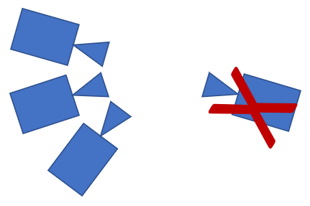
Because real cameras cannot be physically co-located, either a mirror approach must be used to give them all the same virtual center of projection or else the cameras must be pushed along their principal rays (or in some other direction) until they no longer overlap.

Pulling back along principal rays
As seen to the right, pulling the cameras backwards along their principal rays cannot be adopted for camera systems that can see very wide fields of view because cameras on one side of the array will see cameras on the other side. Thus, it does not apply here.

Pushing forwards along principal rays
This approach works for fields of view up to and including the entire sphere. It introduces two artifacts, gaps in the image between cameras and directional ambiguity for visible objects.
Gaps: When the cameras are pushed forward, their view-frustum overlaps are reduced and gaps form between camera views. If the fields of view of the neighboring ideal cameras exactly overlap, these gaps will persist to infinity. The larger the degree of overlapping fields of view in the ideal cameras, the nearer the distance at which the gaps will close.
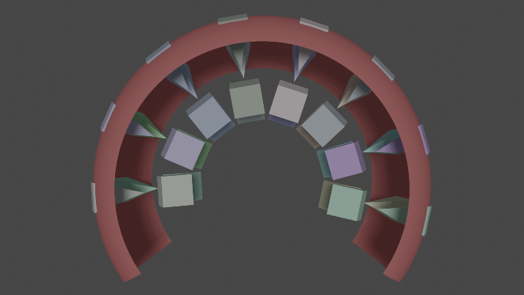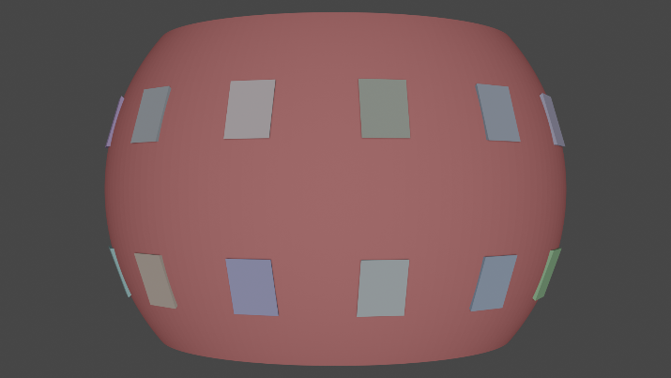
The two images above show this behavior. On the left, we see a top view with the body of each camera in a different color and the associated view frustum pointing along its principal ray. On the right, we see a side view of the desired field of view along with the faces of the frusta, showing the gaps between them near the cameras.
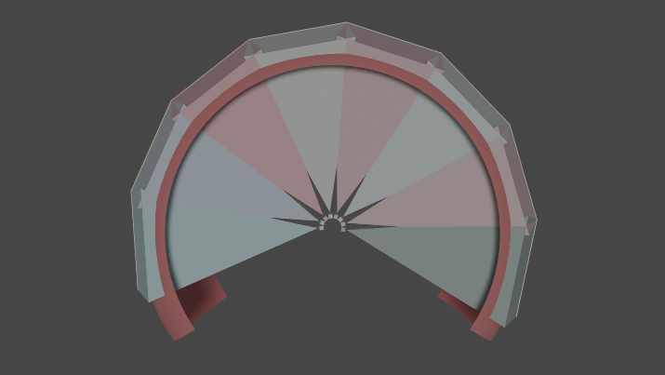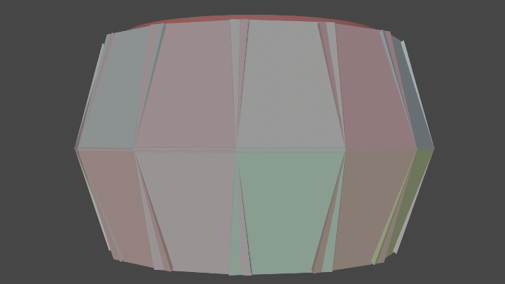
The two images above are zoomed out to the point where the frusta completely overlap, closing the gaps. The cameras are much smaller in this view, indicating the relative distance from the center of projection required to close the gaps. The distance at which this happens depends on the sizes and fields of view of the cameras and the amount of overlap. The diagram above shows 3”x3”x3” camera bodies that are 1.5” back from the aperture with 40x32 degree fields of view and a 4 degree overlap between neighboring cameras.
Directional Ambiguity: Because the cameras are pushed forwards from their common center of projection, rays other than the principal ray cover a range of directions as they move away from the camera rather than having a fixed direction from the common center of projection (the place where the principal rays from all cameras intersect). At the aperture of each camera, all rays start at the camera center of projection. At infinity, each ray approaches the same direction as it would if the camera were still located at the common center of projection.
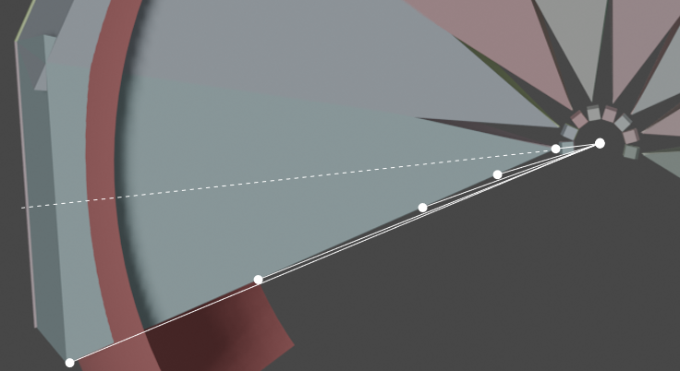
This can be seen in the image above, where white round objects at various locations along the ray on the left of a camera are located at different angles compared to the common center of projection of all cameras. They point at all angles from the principal ray (0 degrees in camera space, dashed line) to half of the field-of-view angle away from this direction. As they move further from the center, they approach the half-field-of-view angle. This progression continues past the region where the gaps close.
This happens for all rays other than the principal ray, whether they overlap with neighboring camera rays or not. Each ray has an ambiguity over its length that is equal to its angle from the principal ray. The angle of each ray depends on the distance to the object that is being viewed.
Directional ambiguity/error can be resolved if the depth of visible objects in the scene is known. The pixels can be projected to their proper depth from the camera using its pose and fields of view and then can be reprojected into the common center of projection for all cameras (or into any other frame of reference).
Stitching errors: As a direct consequence of directional ambiguity, in directions where more than one camera’s view overlaps there will be different pixel shifts among the cameras for objects that are not at infinity. This will occur across the entire region of FOV overlap between sets of cameras. (If directional ambiguity has been resolved using depth information, these errors will not occur.) Depending on the blending mode, this will produce different artifacts:
- Bisect: If view directions are partitioned such that pixels from only a single camera are shown at each direction (perhaps the one whose principal ray is closest), then there will be object discontinuity artifacts along the line of separation between cameras: small or thin objects will disappear and thick objects will become narrower with missing gaps.
- Blend: If the images from all cameras are blended equally when they overlap, small or thin objects will become dim and doubled and large objects will become blurred as the differently shifted views are offset from each other.
- Stacked: If the images are rendered on top of each other, with the last one overwriting all pixels that it covers, then there will be object discontinuity artifacts along the edges of the nearer-drawn image. As the object crosses the edge, the two misaligned versions will be drawn on either side of the edge.
Stitching error can be removed along with the directional ambiguity if the depth of visible objects in the scene is known. The pixels can be projected to their proper depth from the camera using its pose and fields of view and then can be reprojected into the common center of projection for all cameras (or into any other frame of reference).
When not known over the whole scene, depth can be estimated along the edges. To reduce visible artifacts at the edges, the pair of camera images can be drawn from the two cameras’ points of view at various depths and compared in a thin band along the border. For each region along the band, the depth associated with the pair of bands with the minimum difference can be selected as the estimated depth at this length along the edge. This will produce a line of depth estimates along the edges of each pair of overlapping images (these may differ along an edge due to a receding ground plane or a nearby object at a specific location). This can be used to produce a 3D projection manifold by triangulating between these points across each image. The images projected from each camera’s center of projection should match along the manifold edges, but in general this will produce distortions away from the edge. It basically shifts the misalignment from the edge into distortions of objects (or regions without objects) away from the edge.

Common virtual centers of projection
A seen to the right in Figure 2 of (Majumder, 1999), mirrors can be used along with real cameras to produce virtual cameras that share a common center of projection.
This design shows two rows of cameras. Dr. Hong Hua invented this initial approach and has applied it to more complex geometries in later work that can be applied to more complex camera arrangements.
This geometry avoids the gaps between cameras and avoids directional ambiguity. The mirrored design is more compact against the aircraft front than the pushed-forward design, but it is taller than that design.
Discussions with Orges Furxhi revealed that this approach has too much budget risk (large Germanium + diamond window to protect the area including the mirrors), too much schedule risk (thermally-stable mounting, opto-mechanical design), and too much technology risk (non-uniform reflections off the back of the window, temperature modulation due to enclosed space, un-modeled behavior of the window when it has a temperature gradient) to pursue this approach for the proposed in-flight IR camera system.

Comparison
The table below shows the fields of regard, distance to gap closing, and directional error from specified distances to the horizon for various configurations of an 8x2 array of 30x40 degree field of view cameras with 3”x3”x3” bodies located 1.5” back form their aperture, which must be pushed 12” forward along their principal rays to not collide.
 | 1-degree overlap | 2-degree overlap | 3-degree overlap | 4-degree overlap | Mirror system
hFOR (deg) | 249 | 242 | 235 | 228 | 256
vFOR (deg) | 79 | 78 | 77 | 76 | 80
Gap closes (ft.) | >75,000 | 83 | 21 | 11 | 0
Angle error 1’ | 24.86 deg |  |  |  | 0
1K Pos error 1’ | 463.35’ |  |  |  | 0
Angle error 10’ | 2.22 deg |  |  |  | 0
1K Pos error 10’ | 38.83’ |  |  |  | 0
Angle error 30’ | 0.73 deg |  |  |  | 0
1K Pos error 30’ | 12.79’ |  |  |  | 0
Angle error 100’ | 0.22 deg |  |  |  | 0
1K Pos error 100’ | 3.82’ |  |  |  | 0
Bold text in the table indicates very poor performance with orange background indicating choices that should probably be eliminated from consideration. Italic text indicates the best performance on a given row. The Angle and Pos errors are the range of angles for objects lying along the same camera ray from the specified distance (1’, 10’, 30’, 100’) to infinity. Listed are worst-case errors, which occur at the corners of camera view frusta. The 1K Pos error is the error in feet in the direction perpendicular to the line from the aircraft for a target that is 1000’ from the aircraft (this is how much the directional error would cause the system to miss a target that is at 1000’).
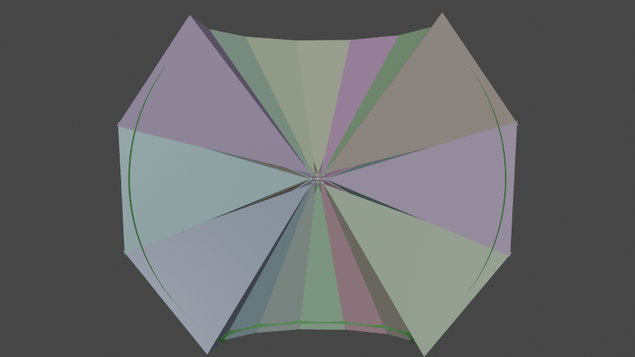
A 21-camera design that leaves no cameras to provide wide-FOV views is shown to the right. It has 3-degree overlap, closing the gaps ~20’ from its center. Its field of regard is 206x114 degrees, slightly less horizontally than the current system and quite a bit larger vertically. Its angle error specifications match those of the other non-mirrored designs. It required moving the cameras forwards 13.3” to avoid overlap on the lowest ring of cameras (this could be relaxed somewhat if the vertical FOR was shifted down to be symmetric around the horizon). This 3-layer design will not work in a mirror configuration without extension of the 2-layer approach.
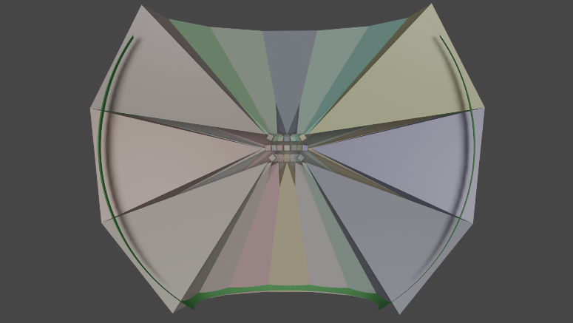
In a vertical-core, 21-camera system with cameras that are 2" cubes, the camera separation can be reduced from 13.3" to 9.4", which removes the gaps with a 5-degree overlap at around 5' (FOR 193.1x107.9 degrees) and a 3 degree overlap at around 10' (FOR 205.1x111.9 degrees). This more-compact system also has reduced angular ambiguity because the cameras are closer to the common center of projection: 18.9 degrees and 342 feet 1K Pos error at 1’, 1.72 and 30 10’, 0.57 and 9.9 at 30’ and 0.17 and 3.0 at 100’. The 5-degree overlap case is shown in the image to the right. It would allow for the performance of the 3-degree system with 2 degrees of pointing tolerance.
A 25-camera design can combine either of the above 21-camera designs with four wide-FOV cameras, each of which has a fish-eye lens that covers half of the horizontal field of view and the entire vertical field of view (103x114 degrees or 97x108 degrees). Two would be placed facing the same direction to the right, and two to the left. The two cameras on each side would be placed in the same plane perpendicular to their principal rays and they would have as wide as practical horizontal separation from each other. They would be placed in the same orientation and scan in the same direction. This design is compatible with the future use of depth determination, which enables egocentric reprojection of the viewpoint to that of the pilot and stereo display of data to the pilot, which greatly improves depth perception. This will also enable removal of the directional ambiguity and edge stitching errors by reprojecting the pixels to the common center of projection.

Recommendations
- 25-camera design described above.
- 3-4-degree overlap + wFOV cameras: To provide a system that enables most of the effective features needed for the proposed demonstration scenario while avoiding the increased system complexity and potential slight image-quality reduction of added mirrors, a 3-4-degree overlap system should be selected. The five cameras not used for the high-resolution zone should be fitted with wide lenses with 128-degree FOV on the long axis, providing two lower-resolution full views to the right, two to the left, and one forwards. These views will provide low-resolution surrounds for a wide-FOV display and will provide redundancy in case of camera failures. They will also provide an increased vertical field of view, enabling detection of (but not identification of) incoming aircraft or weapons. This design is also compatible with the future use of depth determination, which enables egocentric reprojection of the viewpoint to that of the pilot and stereo display of data to the pilot, which greatly improves depth perception. This will enable a wide-FOV, low-resolution surround with a high-resolution inset. This will also enable removal of the directional ambiguity and edge stitching errors by reprojecting the pixels to the common center of projection.
- 21-camera design: To use all 21 cameras in a manner that covers a larger range than the original system with gaps closed at 20’, the cameras should be aligned with their 40 degree axis vertical and a 3-5-degree overlap used. This design will have unavoidable directional ambiguity and will not support even future exploration of depth determination, egocentric reprojection, or stereo display. It provides the largest high-resolution region.

Rolling shutter
Some cameras include a second buffer of pixel voltages so that one set can be accumulating photons while the other is being scanned out. These are called “global shutter” and have the benefit of sampling all pixels in the image over the same period of time, using the same center of projection and camera pose for all pixels.
The IR cameras used in the proposed system have a “rolling shutter” that scans lines from one edge of the camera to the other over the course of a single frame. When the camera and scene are stationary, this does not cause geometric distortions. However, when either the camera or an object in the scene is moving, different pixels see different portions of the scene or object and the resulting image has deformations.
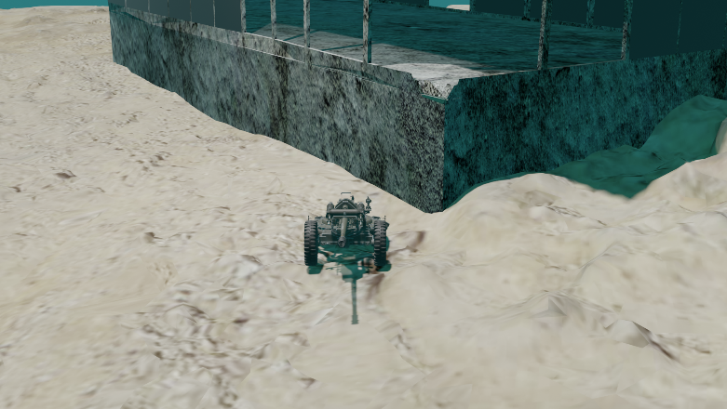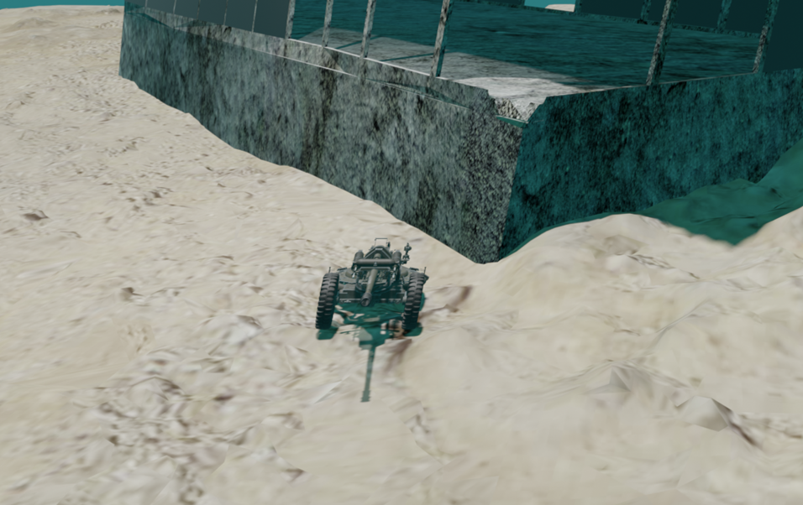
The two images above simulate this effect for a helicopter that is rotating its nose towards the right. The image on the left is from a global-shutter camera, which captures an undistorted view of the scene. In the rolling-shutter image to the right, lower scan lines are read out at a later time; this means that the camera is aimed more to the right and the objects appear further to the left. This produces a shear in the image. The amount of distortion depends on the speed of rotation and on the combination of helicopter speed and distance to visible objects during motion.
Note: The IR cameras being used will always scan as if they were operating at 60Hz. When they operate at 59.94 or 50Hz, they will insert additional blanking time between readouts. The artifacts will be at the 60Hz rates for all of them.
Rolling shutter makes the video appear to be sheared and stretched, which can contribute to simulator sickness in the pilot. It also complicates the video processing pipeline:
- It makes removal of camera-shake artifacts more difficult because neighboring scan lines are shifted horizontally and/or vertically compared to their common motion-free frame.
- It makes it removal of self-motion artifacts due to latency more difficult because the rigid-body transformations used to compensate for this effect in global-shutter cameras cannot capture the entire motion.
- It makes image alignment more difficult among two or more images because a rigid-body transformation cannot capture the entire scene offset between two cameras. For example, this precludes the use of epipolar lines to speed up registration for features in two images to determine the depth of an object in the scene.
- It makes image analysis more challenging by deforming the objects in the scene based on the motion of the helicopter and the objects themselves.
Image tearing: A separate impact for multi-camera systems like the one proposed is the fact that scan lines from neighboring cameras will be read at different times for some camera geometries. This will cause tearing of objects at image boundaries when either the helicopter or objects in the scene are moving.
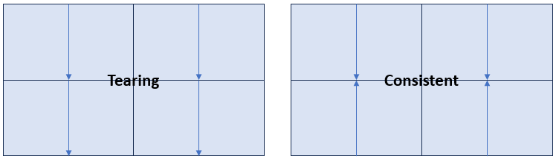
As seen above left, aligning four neighboring cameras with the same scan orientation means that at the transition from top cameras to bottom cameras the scan time jumps from the end of a frame to the start. Rotating the bottom two cameras (or scanning them in reverse order) produces consistent times at all neighboring edges.
Mitigation: To avoid tearing for moving helicopter or objects, scans should be oriented to match at all boundaries. (The following requires measurement of helicopter motion and rotation time-aligned with image capture). Borrowing the “just in time” warping techniques used in virtual-reality systems, affine transformations can be used to handle rapid left-right and up-down rotations (shear and nonlinear scaling); rotation about the eye is less common. For translations and more complex rotations, each line can be independently transformed based on the instantaneous camera pose at the time it was taken. Image alignment and analysis techniques can be performed on an image that is re-sampled from this line-by-line distorted image from an appropriate center of projection. For tasks like depth estimation that require testing multiple potential cases, the line-by-line transformations can be applied separately to each case.

Field of regard
The vertical field of regard for the pilot through the canopy glass is not specified but appears to be limited by the canopy and helicopter body to approximately -15 degrees to 90 degrees horizontally in the front and perhaps -70 to 90 to the side. The horizontal appears to be all but about 70 degrees (-145 to 145 degrees).
The field of regard of the proposed IR camera system will be significantly less horizontally (-103 to 103). The vertical will stop lower than 90 degrees (perhaps at 57 degrees) but will also go further down in the front: perhaps to -33 degrees; this gives it a larger vertical field of regard in some directions and smaller in others.
This makes the IR system better for some tasks and missions and worse for others compared to visual flight.
Mitigation: To increase the field of regard, additional cameras could be placed, or wide-FOV cameras could be added to the system to provide lower-resolution context in the regions not seen by the high-resolution cameras.

Field of view
The field of view from the eyes during daylight viewing is quite large. From (Walker, 1990) chapter 116, the region of space in which objects are visible when the gaze is steadily fixed forward:
The monocular visual field consists of central vision, which includes the inner 30 degrees of vision and central fixation, and the peripheral visual field, which extends 100 degrees laterally, 60 degrees medially, 60 degrees upward, and 75 degrees downward.
This includes a common ~114-degree stereo view forward and two monocular peripheral fields of view making up a total 200 degrees horizontal field of view of approximately (seeing slightly behind the eye on each side). The field of view is approximately 135 degrees vertical. The region is not rectangular; it is curved by occlusion from the nose and eye sockets. This is the field of view available during daylight flight.
The current 40x30-degree displays using for Apache IR pilotage provide central vision without peripheral vision. The Xsight provides a 60x30 degree window that extends the horizontal view to include a small fraction of the periphery.
Helicopter pilotage: The most directly applicable study found on the use of peripheral vision comes from (Robinski, 2013) who studied eye movements and fixation in helicopter landing maneuvers by military pilots. Their most relevant finding was (emphasis added):
Unintended [target fixations] are used more likely by student pilots who will thus overlook crucial flight situation parameters, particularly under high workload. ... Pilots who are combat ready, on the other hand, absorb specific information using [target fixations] and maintain the desired flight path, for instance by determining the changes in the retinal projection of outside object complexes and maintaining an ideal approach angle via control inputs. Expert [target fixations] represent a desirable strategy at the right moment, profiting from a fully-developed para-foveal perception and a larger peripheral vision.
This means that removing the peripheral vision from expert pilots forces them to do visual search like novice pilots during landing maneuvers. This seems almost certain also to apply to the task of navigating around buildings or other obstacles while searching for a target.
This matches research into driving, which showed that “expert drivers look primarily at the road ahead, while novice drivers gaze about much more widely … novice drivers are slower, on the whole, to notice peripheral changes”. (Vater, 2022)
Real-world tasks: (Vater, 2022) studied the literature on the use of peripheral vision in real-world tasks, including 60 relevant papers on walking, driving, and aviation. They found that peripheral vision is used to do the following:
- Monitor our surroundings, an inherent component of most, if not all, real-world tasks.
- Plan action.
- Inform eye movements.
They point to studies showing the following:
- When the environment is less predictable, a wider visual field must be monitored with peripheral vision.
- When the costs of looking away are artificially raised (as in the case of forcing head motion rather than eye motion to see the periphery), the ability to drive safely suffers.
- Drivers use peripheral vision to maintain their vehicle in a given lane, with poorer vehicle control associated with loss of field of view in studies of drivers with reduced peripheral vision (Anderson, 2020).
- Drivers respond to objects in the periphery before they fixate on them; even after fixating, a single glance can identify an object, which can then be tracked using peripheral vision while focusing on the road ahead.
- Driving license authorities in many US states have minimum visual field requirements ranging from 105-150 degrees across the horizontal median.
Mitigation: The strap-down camera system already acquires a wide field of view for every frame of video. Displaying it requires specifying sufficient down-sampling capability and bandwidth within the system to transmit low-resolution surround along with the high-resolution inset. It also requires including wide-FOV display device(s) in the demonstrations.

Monoscopic view
The disparity between an object’s location in one eye and its location in the other (stereo disparity) is a very strong depth cue for nearby objects. Its importance reduces compared to the other depth cues (motion, linear perspective, expected size) as the distance increases beyond 30 meters (Ware, 2012) (p. 285) for tasks involving relative positions of objects in space.
This means that providing monoscopic (only displaying to one eye) vs. stereoscopic display is not expected to greatly reduce the performance in the slow-navigation task for buildings beyond 30 meters, and it is not expected to impact the fast and far-field flight task. For buildings and objects closer than 30 meters, stereoscopic display is expected to improve performance.
However, displaying a bi-ocular view without stereo disparity (the same view to both eyes) provides a depth cue conflict with other cues. In this case, the built-in stereo perception machinery reports that the object is at infinity and fights with other cues (motion, linear perspective, etc.) to produce a mis-estimation of object depth. This conflict will be worse with objects that are nearer than 30 meters and will tend to incorrectly indicate that a collision will not occur when in fact it will. The relative strength of these cues will need to be studied to determine the impact on pilotage. This cue conflict can also induce simulator sickness. This impact will also need to be studied to determine the impact.
Mitigation: If a depth estimate (even at coarse resolution) is available for each pixel from each camera, the pixels can be reprojected separately to the two eyes; this will produce stereo display. Alternatively, one eye can be covered so that there is no stereo depth cue available to conflict with other cues.

Non-egocentric projection
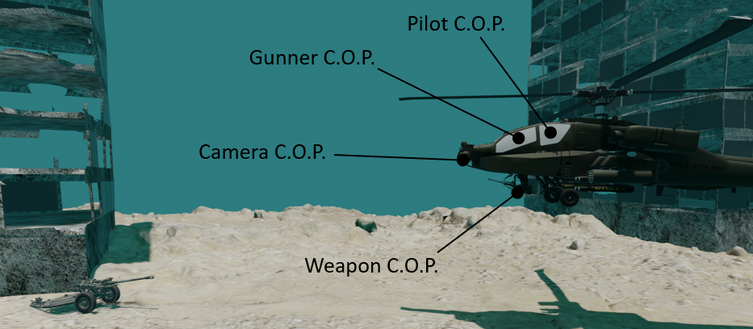
The center of projection for the camera system differs from that of the pilot, the copilot/gunner, and each weapon system. This will have three distinct impacts on the system:
- Simulation sickness: Especially with wide-FOV and immersive displays, a conflict (difference) between the physical motion of the head and the visually presented motion can induce discomfort, including nausea and headache. When the helicopter is stationary or in linear motion, these will not be in conflict. When the helicopter rotates in the presence of nearby buildings or other objects, the center of rotation for the camera and the center of rotation for the pilot will differ noticeably, causing a conflict. The magnitude of the conflict will increase with the rate of rotation and for nearer objects.
- Mental overhead: Mentally translating between the perceived and correct center of projection requires continuous effort, reducing overall attention and decision-making capability. Quantifying this effect will require detailed studies and will depend heavily on the tasks being performed, the level of stress, and the environment.
- Reduced performance: On tasks that require combining two of the fields of view (targeting a weapons system, avoiding an obstacle), errors introduced by the mental processing will reduce task performance. Quantifying this will depend on the task and training of the pilot. It may be possible to largely train away this reduction.
Mitigation: If depth information is available with the images, it can be used to reproject the pixels from the camera COP to the pilot COP (one or both eyes).

Camera shake
If the Q value of the camera mount is too high, helicopter vibrations can introduce resonant oscillations in the camera rig, causing periodic oscillations at this frequency. Assuming that the cameras are all rigidly attached to the mount, they will not move relative to one another, so image tearing and stitching should not be affected. However, this will introduce periodic “wobble” in each camera’s image; translation and/or rotation around the view frustum. This will cause simulator sickness in the pilot along with image blur and slight directional uncertainty for each pixel. It will impact AI object detection, both by distorting object shapes and by introducing directional offsets.
Mitigation: This requires measurement of camera rotation and acceleration with a period of more than twice the highest frequency oscillation, time-aligned with image capture. By determining the average camera orientation over the frame and adding it to the calibrated camera mount location, this oscillation can be compensated for and the camera images stabilized. By measuring the camera’s high-speed rotation and translation, a model of its high-frequency motion can be produced. (Because this rotates nearly about the center of the camera’s coordinate system, rotation will have much more impact than translation.) By shifting each scan line by the relative camera orientation at the time is was acquired and then resampling into a fixed rectangular pixel array at the average location across the frame, rolling-shutter effects can be mitigated.

Motion blur
The exponentially decaying integration of the sensors will cause blurred streaks with decreasing contrast to trail behind each pixel in the image due to helicopter rotation and translation and due to motion of objects in the scene. This will impede target identification while the helicopter is moving. The amount of blur increases with larger rate of rotation, larger velocity, object nearness, and longer duration of integration. For a rotation rate of 72 degrees per second and an integration time of 10ms, the blur will be ~0.72 degrees. On a sensor with 1280 pixels across a 40-degree span, this is ~23 pixels (more or less, depending on where in the image the pixels are located).
Mitigation: This requires measurement of helicopter rotation (including camera shake) time-aligned with image capture, also velocity and depth estimation for objects during helicopter motion. Approaches for deblurring single images based on a known per-pixel blurring kernel are described in the literature. For rotation, the blurring kernel does not depend on the depth of the objects seen by the camera. For translation, it does. These approaches iteratively solve the inverse problem using smoothness assumptions to avoid exaggerating noise-based artifacts.

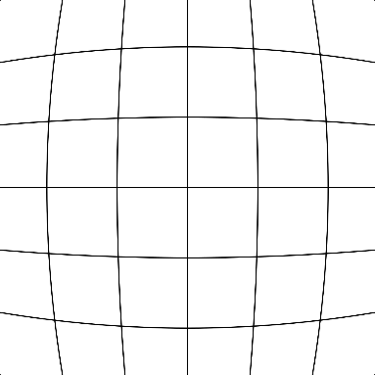
Geometric lens distortion
Camera lens systems often exhibit a radial distortion away from the center of projection (intersection of the principal ray with the sensor). The most common type is called “barrel distortion” and an example is shown on the right. Points further from the center of projection are pulled towards the center by an increasing amount. Straight lines in the image become bent and distances between points are distorted.
For adjustable lenses, distortion depends strongly on the zoom level of the lens and slightly on its focal depth.
If not corrected, this distortion produces position-varying warping in space based on the viewing direction, which causes the world to deform as the camera (or helicopter) rotates. This will contribute to simulator sickness in the pilot and it will impede depth, object size and direction estimations.
Mitigation: Fortunately, this distortion is stable over time for a given camera, it does not depend on the depth of a visible object, and it can be calibrated offline before it is used to take video. Calibration rigs, images of checkerboards, patterns of regular lines, or other approaches can be taken to measure the distortion. The image processing hardware and software can then apply the inverse transformation to move each pixel back into its original location.
Note: The correction pushes pixels further from the image center, so it is customary to re-scale the image so that pixels at the ends of the narrower axis (vertical or horizontal) do not move. This keeps the field of view along that axis the same. Some pixels further from the center than this (at the ends of the longer axis and at the image corners) are pushed beyond the boundaries of the original image, which provides a larger effective field of view for the camera but also produces a non-rectangular image. These pixels can be clipped to recover a rectangular image, or the rendering pipeline can be made to deal with non-rectangular input video.

Color space
The above distortions dealt with spatial geometry and behavior across pixels over time. There is an additional set of per-pixel distortions that must be dealt with. Some of these are common across camera types and others are specific to the microbolometer-based IR sensors being tested.

Monochromatic video
Normal human vision includes three color sensors (red, green, and blue) in the central fovea region. The IR sensors used in the proposed system are monochromatic.
The human visual system uses luminance (the sum of red + green) to determine boundaries, shapes, objects, and motion (“where” system). (Ware, 2012) It uses color (hue and saturation) to identify objects and their state (“what” system).
Mitigation: For collision avoidance and navigation, object location and motion are the relevant visual channels; this means that mitigation is not required. For target-identification purposes, some other channel will be required (perhaps an AI classifier or RADAR-based determination). If this is done, the color of each object can be changed to indicate its status.
Note: The human eye is not completely achromatic, so it focuses red, green, and blue at different distances. (Ware, 2012) This means that the three components of white light coming from a point source are blurred somewhat. This focus difference is larger for blue than the other two. To increase sharpness, monochromatic images should be drawn in green (the most-responding color channel) to increase sharpness. This is ideally done on a monochromatic display to avoid the reduction in green pixels caused by Bayer sampling on the display.

Temperature-based brightness
The human visual system normally operates in an environment where light from a single light source (the sun) and a broad illuminator (the sky) diffusely reflects off multiple surfaces. The amount of emitted light depends on the angle between the incoming light and the surface normal, which is brighter when facing the sun. Shadows cast by opaque objects help determine relative locations of objects.
None of these cues apply for IR imaging, where the primary source of light is emission from each object. Other depth cues still apply: stereo, perspective foreshortening, and (when the helicopter is moving) motion parallax.
Mitigation: It is not clear how to replace the missing depth cues. Therefore, the system should include all remaining depth cues, including accurate parallax and stereo projection to maximize the available depth information in the scene. This will require the use of depth estimation.

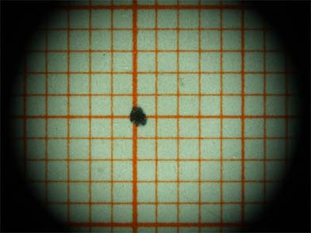
Vignetting
Camera lenses have finite size and they are often sized to just fill or slightly overfill the sensor region. For pixels near the edge of the collection region, optical elements in the lens can become partially shadowed by other lens elements or the front lens opening. This results in a reduction of light for pixels further from the principal ray (usually the center of the sensor).
This effect is more noticeable when two images are abutted to each other because it causes a sharp discontinuity in the change in image brightness at the edge where they meet.
Mitigation: This can be calibrated by taking an image of a “flat field” (a uniform intensity view). For lenses whose zoom and focus are fixed, this does not vary over time. The image processing system can then multiply each pixel by an appropriate factor based on its distance from the center of the sensor to increase the brightness. Note: This will increase noise as well as signal in these regions.

System-induced signals
Any object that is not completely transparent or reflective emits IR. This includes the lens mounts in the system and the internal bodies of the lenses. This bounces off the back of the lens elements and onto the sensor. The lenses themselves are not 100% transparent, so also emit slightly. Together, these produce a background pattern on the sensor that is not dependent on the scene being imaged, and which depends on the temperature of the camera.
Mitigation: Once modeled, this additional signal can be subtracted from each frame by determining the expected amount at each location based on the current temperature of the camera. If the effect is radially symmetric for a given camera type, it can be modeled based on the radius from the center of the system, otherwise a per-pixel texture map can be used to store it for each camera.
Modeling this signal will require adjusting the temperature of the camera over the range of expected operating conditions and observing a flat field (ideally, a very cold field) to determine the temperature-dependent signal.
Note: This signal must be removed before vignette calibration (and correction) is applied because it is an affine offset rather than a linear effect. It may be that they are best jointly modeled, with this signal as an additive temperature-dependent mask and vignetting as a constant multiplicative mask.

Varying pixel gains and offsets
Each pixel’s sensor in each camera may have a slightly different rate of change in resistance per amount of incident radiation (gain). They also have different values for a particular temperature (offset). These vary sufficiently to require per-pixel calibration to avoid fixed-pattern noise.
Mitigation: This is handled internally by the camera electronics. Note: DRS has indicated that they will only perform this calibration for a single reference temperature on the prototype cameras they are providing for the demonstration; although their production systems are calibrated across a range of temperatures, these will not be.
Mitigation: By viewing a flat field object whose temperature is varied in a controlled fashion, both the offset and the gain of each pixel can be independently estimated. The resulting maps can be stored in textures that are used by the image processing system to produce normalized images across the sensor by subtracting the offsets and multiplying the signals by the respective gains.

Varying reference
Each camera compares its pixel resistances against a reference. This reference varies with temperature, causing overall distortions in the reported values.
Mitigation: This is handled internally by the camera electronics.
Mitigation: By viewing a flat field object with fixed temperature while varying the camera temperature in a controlled fashion, the distorting caused by temperature changes in the reference can be mapped. It can then be inverted by the image processing pipeline. If there is a cross-dependency with per-pixel gains, that can also be modeled.

Noise
Per-pixel noise, perhaps with neighboring-pixel dependencies. In particular, there can be fixed-pattern noise in the scan-out processing for a particular display. (The per-pixel gains and offsets could be considered to be a subset of this fixed-pattern noise.)
Mitigation: Fixed-pattern noise is handled internally by the camera electronics.
Mitigation: Beyond standard Gaussian filtering, depending on the characteristics of this noise, various spatial and temporal filtering can be applied:
- Median filter: This removed “spike” noise by replacing each pixel with the median of its neighbors. This filter can also be applied for each pixel over time, but this will cause an additional frame of delay between readout and display.
- Bilateral filter: This edge-preserving filter considers both the brightness difference and spatial separation of neighboring pixels.

Dynamic Range
IR sensors produce 14-16-bit data outputs (up to 65536 values) but displays produce at most 8-bit outputs (256 values). This will require mapping multiple values in the input range to the same value in the display, which will reduce the information available in the image. Any adjustments should be made considering their impact on Target Task Performance (TTP) as described in (Richard H. Vollmerhausen, 2004).
Sky vs. ground: One particularly important feature of night-flight IR imagery is that it is often separated into a sky region that has very low values and a ground region that has much higher values. These two regions each have small contrast between pixels within them, but the average values of the regions are very far apart. Any linear or smooth mapping therefore squashes the contrast within each region and tends to produce a 2-color image.

Mitigation
There are several techniques available to compress high-dynamic-range images into the range of brightnesses that can be displayed on a standard monitor. The best approach, or combination of approaches, depends on both the image characteristics and the task(s) to be performed. Each approach makes some tasks easier and others more challenging by amplifying some information and hiding other information. Determining the best approach for our sensors and tasks will require searching the literature and evaluating potential solutions using actual images.
The parallel processing and image-correction features available in modern GPUs make performing most of these operations rapid and efficient to implement, even those requiring access to nearby pixels in the image. Algorithm selection is expected to be much more challenging than implementation.
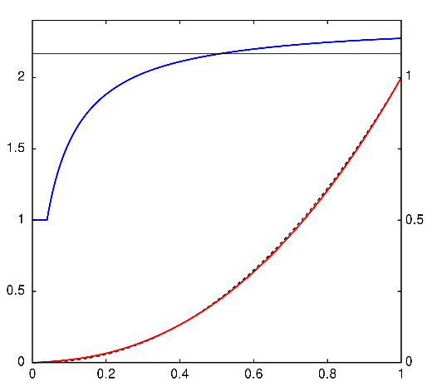
Gamma Correction and sRGB: The human visual system perceives brightness changes as fractional changes rather than linearly; each doubling of photons/second appears as an even step in perceived brightness change. This makes the system much more sensitive to small changes in brightness in regions where the total intensity is lower.
To better map pixel values (0-255) to perceived intensity changes, the intensity values can be normalized to (0-1) and then taken to the power of gamma. The result of this is the red line in the image to the right, for gamma=2.2.
The sRGB standard follows a unity slope near black (to reduce visible noise and quantization artifacts) and then a curve that closely follows gamma=2.2 while being slope-continuous with the original line (black dashed curve in the figure to the right). The slope of the sRGB curve is shown in blue.
Many computer displays perform the sRGB transformation in hardware, expecting incoming images to be in this color space.
The gamma applied to an image can be increased more or less than the monitor value, highlighting differences in different brightness regions. This may be helpful to increase the perceptibility of contrast in those regions.
Histogram equalization: In images that have two very-different background and foreground average intensities, the brightness histogram can have two large peaks. When it is important to see detail within each region, the image histogram can be adjusted to make the number of pixels for each brightness roughly equal. This is used to highlight slight changes in bone density on X-rays, for example.
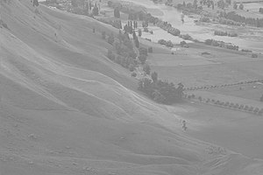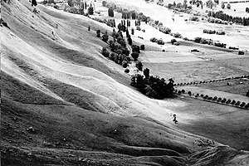
The two images above show an original image on the left and a histogram-equalized image on the right that shows additional details and uses the entire brightness range.
Extensions to this technique include adaptive histogram equalization, which separately adjusts the histogram in each region of the image to provide locally-optimal contrast (but also highlights noise) and contrast limited adaptive histogram equalization that attempts to reduce the noise enhancement by clipping the maximum local enhancement.
Pseudo-coloring: To increase the length of the curve through color space that displays colors, we can switch from a monochromatic path to a color path like that of a black-body radiator: increase the red intensity from 0 to 255 (producing brighter reds), then the green (producing brighter yellows), then the blur (producing brighter whites).
- This conflicts with the goal of reducing blur caused by different focus depths for the three colors, so perhaps only the red and yellow portions would be used.
- For scenes consisting of a dim sky with bright ground, placing the transition at the start of green-light addition would help highlight this transition. Together with histogram equalization, this would stretch the ranges across both zones.
Edge-based rendering: To support arbitrary dynamic range and highlight brightness gradients across the entire spectrum equally and locally, edge detection can be performed on the image, perhaps with edge-preserving smoothing to reduce the highlighting of noise.
- Edges can be colored based on the intensity on the bright side of the edge.
- Edge intensity can be related to the gradient magnitude across the edge.
- Edge contrast can be used to indicate edge polarity, as in Figure 3.12 from (Ware, 2012).

Per-camera gain and offset differences
The built-in internal per-camera calibrations that compute offset and gain make the results internally consistent but may not match between cameras. This will produce brightness discontinuities at edges where two cameras overlap. Removing the visible seams will require determining the relative offset and gain differences among images, bringing them into the same color space.
Mitigation: This can be estimated for each neighboring pair of cameras by examining the joint histograms of pixels within their overlap regions. Because the system will display multiple cameras (perhaps all of them for wide-FOV), this will form a system of equations that must be jointly optimized among all neighboring cameras. (Note: There may be no contrast in some overlap regions, providing only an estimate of the product of the gain and offset. This will be a particular problem when solving the joint mapping among all cameras because it removes one parameter from the sets of equations.)
Mitigation: By computing the Signal Intensity Transfer Function (SITR) for each camera, which maps from signal intensity to absolute temperature of the object being viewed, we can get consistent absolute temperature for each pixel in all cameras. This would require two temperature-controlled environments, one for the camera and one for a target blackbody radiator. These would be varied independently, and the results used to determine the per-pixel mapping. This calibration could be done as part of the varying-reference and other mitigations if these are needed beyond what is performed at the factory. To avoid requiring the nonlinear mapping from intensity to temperature, the cameras can instead be mapped to a particular offset + gain corresponding to the total incoming photon flux, perhaps the mean over all cameras. The offsets and gains would be adjusted to make their responses consistent. (Note: The geometric calibration procedure includes scanning a constant-temperature local source with a lower-temperature surround across the field of view of all cameras. This set of images will provide measurements of two very different intensities across all cameras. If this is repeated with different camera-body temperatures, linear interpolation/extrapolation could be used to cover a range of temperatures.)

Occluded lines
Some of the infrared cameras delivered in Phase I of the project have internal occlusion for around 4 lines at the top of the image and around 10 lines at the bottom. These regions should be ignored for all calculations. Because the timing data for all cameras should match (to avoid shifts in the time of the center line of the camera), changing the actual camera scan-out is not a useful approach to mitigate this.
Mitigation: To maintain consistent data flow across cameras, this data will be sent through the system – all lines from the cameras will be included in the data flow. Within the per-microcamera configuration section of the overall camera configuration JSON file, an optional cropPixels entry will be added with fields specifying the four sides of usable data within the camera. This will be used by the calibration, depth estimation, camera color matching, rendering, image analysis, and other system modules to exclude this data from processing.

References
Anderson, D. B. (2020). Glaucomatous visual fields and neurocognitive function are independently associated with poor lane maintenance during driving simulation. BMC Ophthalmol., 20(1), 419.
BOWERS, A. M., PELI, E. O., ELGIN, J., McGWIN, G. J., & OWSLEY, C. (2005). On-Road Driving with Moderate Visual Field Loss. Optometry and Vision Science, 82(8), 657-667.
Majumder, A. S. (1999). Immersive teleconferencing: a new algorithm to generate seamless panoramic video imagery. MULTIMEDIA '99: Proceedings of the seventh ACM international conference on Multimedia, 169-178.
Richard H. Vollmerhausen, E. J. (2004). The Targeting Task Performance (TTP) Metric A New Model for Predicting Target Acquisition Performance. Modeling and Simulation Division Night Vision and Electronic Sensors Directorate U.S. Army CERDEC.
Robinski, M. S. (2013). Tracking Visual Scanning Techniques in Training Simulation for Helicopter Landing. Journal of Eye Movement Research, 6(2), 1-17.
Vater, C. W. (2022). Peripheral vision in real-world tasks: A systematic review. Psychonomic Bulletin & Review, 29, 1531–1557.
Walker, H. (1990). Clinical Methods: The History, Physical, and Laboratory Examinations. 3rd edition. Boston: Butterworths.
Ware, C. (2012). Information Visualization: Perception for Design, 3rd edition. Morgan Kaufmann.

VR Gems Chapter 32 (2018)

