System Architecture
This document provides input to the architecture for the Apache IR strap-down pilotage along with system characteristics and features driving the design. It is based on the presentations in TR001v04_System_Latencies, TR002v03_Camera_Layout, and TR003v05_Camera_Distortion documents along with the decisions made at the 11/13/2023 Advanced Pilotage Sensor Characteristics design review. See the final page for a system overview.

Inputs and capabilities
Broken down by infrared (IR) and visible-light (VIS) system, sensor inputs and capabilities include the following:
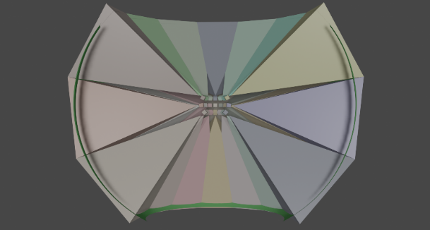
- IR: This is the primary system to be developed and demonstrated.
  - 21 cameras portrait-oriented (~30-degree horizontal and 40-degree vertical fields of view), arranged in a 7x3 grid with 5 degrees average overlap between each pair of neighboring cameras and a tilt downward to provide more vertical view below the horizon than above.
    - Monochrome up to 60 frames/second with a sensor size of 1280x1024 and 14-16 bits/pixel. (~3303 Mbytes/sec)
  - Synchronized cameras, driven by an external trigger that aligns capture with the frame rate and phase of the display.
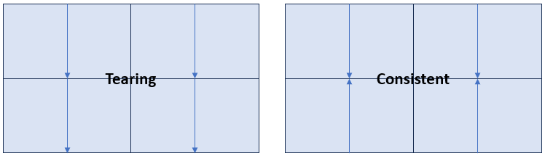
  - Every other column of cameras will be rotated by 180 degrees so that their scan-out directions are consistent at their neighboring borders. This will help prevent image tearing by sampling pixels on both sides of the edge at the same time.
  - Histograms will be computed for each incoming image to help with tone mapping. Specify number of values by bit count: 8-16 for 256-65536 values.
    - These histograms can be combined for a set of cameras, producing a single histogram with the total sums per intensity.
  - Correct color-space distortions: vignetting, secondary emission from the optical system, different gains for different pixels, temperature-dependent reference.
  - Analytic tone mapping shall be provided to map the high-dynamic-range IR images to the display intensity values in a manner that optimizes the presentation of information relevant to pilotage.
  - Temperature measurement on individual sensors shall be used to determine the expected system dynamic sensitivity changes and noise levels.
  - Temperature measurement in the portion of the camera system holding the cameras shall be made to determine the expected secondary emission from the lens systems.
  - If artifacts require it and time permits, helicopter motion estimation may be used to drive algorithmic deblurring of the images due to the long sensor integration times.
- 90-degree IR: This is a system that may be demonstrated as well.
  - A 3-camera system each with 90-degree by 90-degree FOV and 3000x3000 pixels @16bpp @60Hz. (~3240 Mbytes/second total)
  - (This camera has been removed from consideration from Phase I, but its characteristics are analyzed to ensure system generalizability in case it is added to Phase II.)
- Mix of IR: A system with a mix of 90-degree IR and smaller IR cameras may be demonstrated in Phase II.
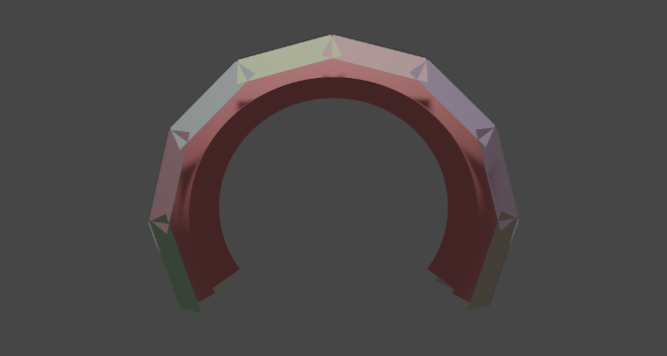
- VIS: This will be used to develop and evaluate additional characteristics as time permits.
  - 21 monochrome cameras with the same characteristics as the IR cameras, including the same resolutions, poses, overlaps, and rates.
  - An additional four wide-FOV landscape-oriented cameras with horizontal fields of view sufficient to cover half of the 21-camera horizontal field of regard and vertical fields sufficient to cover its vertical field of regard. Two cameras will be pointed to the right with overlapping fields of view, and 2 to the left. (~3932 Mbytes/sec total camera data)
  - GPS + “inertial” measurement system tracking the position and orientation of the camera platform over time. Sufficient reporting rate and latency to capture the motion frequencies of the helicopter and camera shake relevant to latency reduction and other distortion corrections. The relative timing of these measurements with the incoming video streams shall be known, ideally to within 1ms.
  - An additional 3 synchronization triggers, phase adjusted to the one driving the main 21 cameras shall be provided. These will support triggering of tracking devices and of the set of cameras used for stereo. This will reduce synchronization delays in the system by producing all inputs just as they are needed.
  - Perform correction of latency-induced head-motion distortions for HMD-based display.
  - If artifacts require it and time permits, the depth of each pixel in the wide-FOV cameras will be estimated and used to produce a 3D manifold onto which the high-resolution images will be projected.
    - This can resolve the directional ambiguity and edge stitching errors caused by the cameras not having common centers of projection.
    - This can be used to remove latency-induced helicopter-motion distortions.
    - This can be used with an HMD display to present stereo video to the pilot.
    - This can be used to provide egocentric projection from the pilot’s point of view.
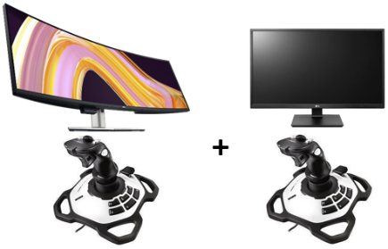
The display systems supported for the demonstration include the following:
- Desktop monitors: To provide comparison between standard and wide FOV, a pair of monitors with be supported, each with a joystick to control the viewing direction. (1) The first is a wide-FOV Samsung 75” 8K monitor that will display a full-resolution 40x30-degree central region surrounded by an additional wider field of view. (2) A ~40x30-degree secondary display with full-resolution display of an independently controllable viewpoint.
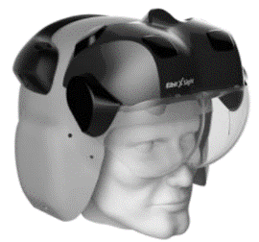
- Elbit Xsight Lab Kit: This head-mounted display (HMD) will be supported. It operates at 50 Hz with a 61x30-degree field of view and adjustable see-through. This must be calibrated to be aligned with the strap-down array video.
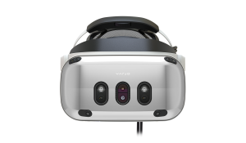
- Commercial HMD: The VIS system will be demonstrated using a wide-FOV commercial HMD. This will provide an immersive example of the importance of field of view. This demonstration will also highlight any additional features in the VIS system (3D display, egocentric projection). This must be calibrated to be aligned with the strap-down array video.

The Neural coprocessor capabilities include the following:
- Phase I:
  - Store full-sized video to disk to be analyzed offline by neural analysis coprocessors.
  - Send full-sized video of every Nth frame to an external set of neural analysis coprocessors.
  - Receive and display information from an external set of neural analysis coprocessors.
    - Alert information: Set of targets: location, radius, color, and associated text for each
    - Neural global tone map to apply across all cameras based on image histograms.
    - Act as a neural renderer (proposal section 2.2.3.2): Neural-based local tone mapping, local stitching, image fusion to take in camera subset region data and produce images with specified resolution from specified pose and view frustum and time.
The system shall be able to operate in three modes:
- Capture:
  - Shall be able to operate without a rendering engine attached.
  - Synchronize all video and data capture with appropriate frame rate and relative phases to minimize synchronization delays during replay.
    - For cameras that cannot be synchronized, record the time of each scan line relative to other cameras and to sensor data.
  - Store all full-resolution video data at full frame rate for later replay and analysis for a period of at least 30 minutes.
  - Store all sensor inputs with relative timing to video data to enable optimized replay.
- Replay:
  - Pass the required sub-regions of full-resolution data from cameras within the specified field of view to a rendering engine (possibly neural rendering engine) without introducing full-screen buffering delays and with as little latency as possible.
  - Allow requestors to specify camera subsets.
  - Pass all sensor data to the rendering engine with relative timing to video data to enable optimized viewing with as little latency as possible.
  - Render video to up to two displays with minimum uncorrected self-motion latency including all features listed above for each display modality and independent positioning control for each display.
    - Correct all geometric distortions from cameras and displays.
    - Blend individual frames into a consistent single view.
    - Adjust viewpoint based on joysticks and/or HMD tracker inputs.
    - Optionally include low-resolution displays in periphery.
  - Atomic updates for relevant state (set of cameras to read from, along with a region for each) to provide consistent frame data.
  - Provide programmatic time-stamped messages telling when events happen in the system (“started processing frame N”, “received instruction M”, “started receiving frame P from camera set Q”).
  - Provide pause/play/restart functionality to control time during replay.
  - Be able to operate without the capture engine attached.
  - Optionally pass full resolution images from the four wFOV cameras for depth reconstruction.
  - Send full-sized video to an external set of neural analysis coprocessors for detection.
    - From a subset including up to all cameras.
    - Send every Nth frame from each camera (N >= 1), selectable per camera, subject to bandwidth limits.
  - Receive and display target reports from neural analysis system.
  - Receive global tone map from neural analysis system.
  - Use neural rendering system to generate images to be displayed.
- Live:
  - Provide synchronized clock between capture system, render system, and analysis system.
  - Synchronize all video and data capture with output device scan-out (50-60Hz) to minimize synchronization delays, prevent jitter, and match frame rates.
    - Up to two different camera groups, up to two different sensor groups.
    - Hardware and software synchronization supported.
  - Perform all Replay functions.
  - Optionally perform all Capture functions.

Rendering input data bandwidth
This section determines the data bandwidth that must be sent to the rendering system based on the fraction of pixels that must be sent to cover the visible region, including all contributing factors.
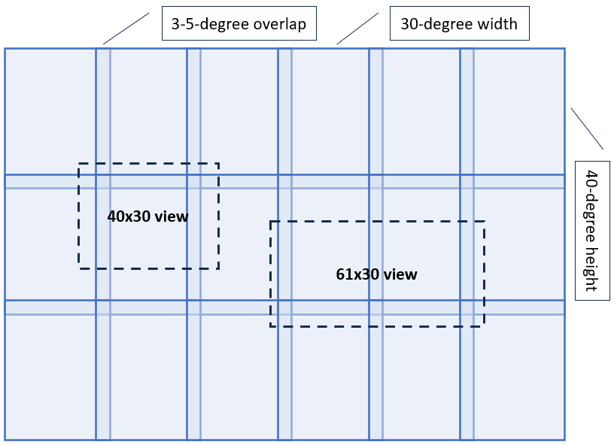
Figure Views: Overlap of 40x30-degree and 61x30-degree views on the field of regard for a 21-camera system, drawn in cylindrical angle space. (In reality, the camera regions overlap more at the upper and lower edges and each view will overlap more pixels there.) The 40x30 view overlaps with at most six cameras and the 61x30 at most eight. By selecting sub-regions of cameras, the total overlapped pixel count is greatly reduced.
Visible pixels: Figure Views shows an approximation of the overlap between cameras and the regions associated with a 40x30-degree view (the size on the current IR system) and a 61x30-degree view (the size on the Xsight). The total overlap regions are much smaller than the total pixel ranges of all overlapped cameras, motivating the ability to select subregions of images to reduce the bandwidth required between the capture and rendering systems. At the center of the camera system field of regard (FOR), each view pixel is approximately the same size as each camera pixel and their fields of view (FOV) are also similar (magnification is 1); near the top and bottom of the FOR, the view FOV covers more camera FOV (and more pixels) due to increased camera overlap.
Even with subset regions, the views overlap more pixels due to the 3-5-degree camera overlaps. In the center of the image, this increases the pixel count compared to the number of camera pixels in each region by about (2*5+40)/40 * (2*5 + 30)/30 or ~1.7x.
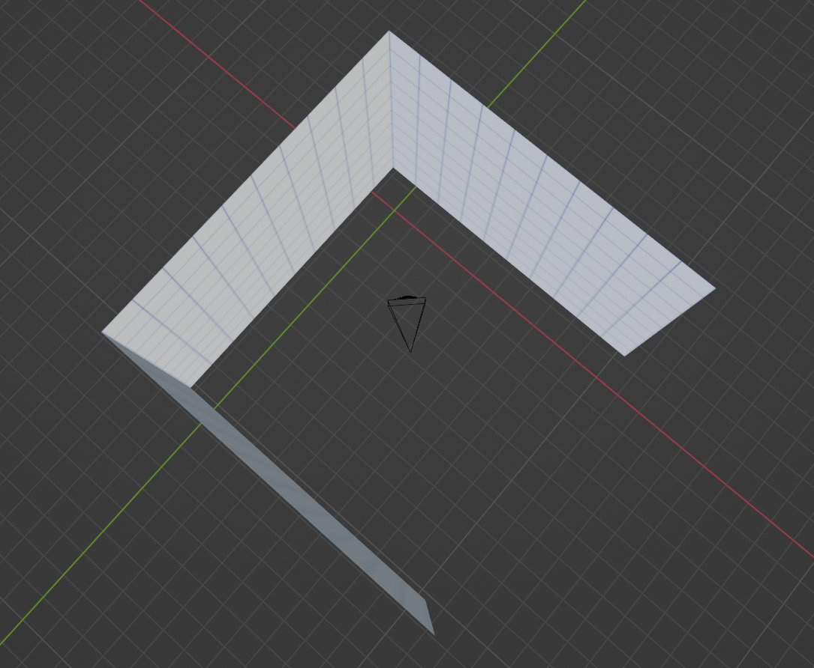
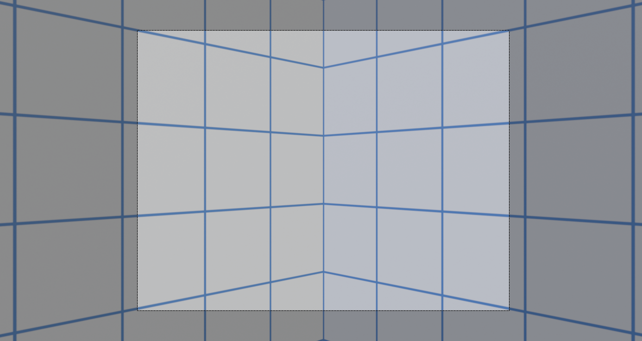
Figure View90: In the worst case, a camera that has a 40x30 degree field of view is aimed at the corner of two 90-degree projected camera images so that it can see 30 degrees vertically at its two edges, it can see pixels from the original cameras in a span that is almost 60 degrees horizontal and a little over 40 degrees vertical.
Perspective adjustment: As seen in figure View90, the 3-camera system can have a more extreme mismatch in overlap between a rendered view FOV and camera FOV. When looking straight along the principal ray of one of the cameras, the overlaps are approximately the same, but when looking at a corner the view overlaps may more degrees (and pixels) in the cameras. For a 40x30-degree view FOV, the rectangular camera regions overlapped are approximately (2*28)x40, or 56x40; ~1.9x. This will be larger for a 61x30-degree window because increasing the width also increases the projected height, causing quadratic increase in pixel count.
Latency compensation: When doing oversized rendering to support latency hiding, an additional border around the views is required; the size of this border depends on the expected prediction error (which depends on rendering latency and speed of rotation or motion). For the fastest expected head rotations of around 720 degrees/second and internal latencies of up to 40ms, we expect up to 28.8 degrees of rotation from capture to rendering. Assuming 10% prediction error would dictate 2.88-degree over-rendering; let’s round up to 3 to handle just-in-time scan-out latency compensation. This corresponds to (2*3+40)/40*(2*3+30)/30, or ~1.4x.
Total factor: Putting the three factors together produces the following: 1.7x * 1.9x * 1.4x; ~4.5x total increase. Adding a safety factor to accommodate some of our approximations and the optical distortions expected in the cameras produces ~6x total increase for a 40x30-degree view (square root of 6, ~2.4x, in each direction) in the number of camera pixels to be transmitted compared to the number of full-resolution-equivalent view pixels to be displayed.
Bandwidth requirements: The maximum bandwidth required to be sent to a rendering engine for display depends on the summed FOV*resolution for all views being displayed. This differs by case:


- 40x30 display: This matches the resolution of the current Apache IR display system and could be demonstrated using a standard 4x3 desktop monitor. This would have the same 1280x1024 displayed pixels as one of the 21-camera system cameras and so using the above factor would require 6*1280x1024*60fps*2Bpp = 944MBytes/second image data.
- Elbit Xsight: This display shows a 61x30-degree field of view with no peripheral surround. Using the approximation of scaling the pixel size by the view frustum size, this will require 61/40x the pixels for the 40x30 display, or ~1.44GBytes/second image data.
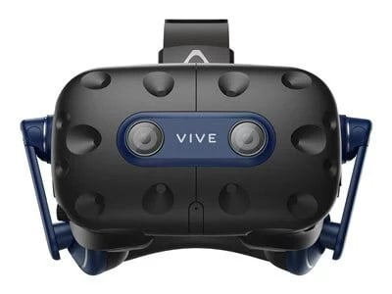

- wFOV display or commercial HMD: These displays require data from all 21 cameras in the system. This corresponds to 21*1280*1024*60fps*2Bpp/(4*4) ~= 3.3GBytes/second image data.
When supporting optional depth reconstruction, the four full-resolution wFOV cameras must also be streamed to the geometry-estimation engine (part of the rendering engine): 4cams*1280x1024*60fps*2Bpp = +629MBytes/second.
Therefore, the maximum bandwidth required for any depth estimation + rendering system that is driving a single display would be 3.3GB/s + 0.629GB/s = 3.93GBytes/second and the largest driving depth + a wFOV display + a 40x30 display (with a different viewpoint) would be the same (because all pixels are already streaming for the wFOV display).
There are additional periodic sensor inputs and timing data, but they require orders of magnitude less data.

Storage
Bandwidth: The system must at least be able to store full-rate video data from all cameras. The largest bandwidth camera system is the visible-light camera with the optional 4 depth cameras. This bandwidth is 25cams*1280*1024*2Bpp*60fps = 3.93GBytes/second.
There are additional periodic sensor inputs and timing data, but they require orders of magnitude less data.
Storage space: This requires storing 14.2TBytes per hour of recording.

Neural bandwidth
The neural analysis system has several very different potential operating modes. The bandwidth requirements for each are described separately:
- Neural global tone map: When using the set of 21 images to produce a global tone map that is used for all pixels in all cameras, 3.3GBytes/second.
- Object detection: When doing drone detection or other object detection tasks across the entire array, full resolution images from all narrow-field cameras will be required. Because this may operate on every Nth frame, this may be reduced by a factor of N. For N=1 (the maximum), the total bandwidth is 21cams*1280*1024*2Bpp*60fps = 3.3GBytes/second maximum (the 3 90-degree cameras have lower aggregate bandwidth). Note: This can be decreased by sending every Nth frame for N >= 2.
- Rendering: When performing “continuous improvement and integration of neural tone-mapping, stitching, fusion and alert integration” (proposal section 2.2.3.2), the system is basically performing all rendering operations inside the neural system. This means that it will require the full rendering input bandwidth associated with the display it is driving (see the Rendering input data bandwidth section) and its output must match the associated display input bandwidth (see the Display input bandwidth section).

Display input bandwidth
Once the viewpoint(s) (x2 for stereo, x2 for central + peripheral) have been rendered, they are passed to the display system. In a traditional rendering pipeline, the display is attached directly to the rendering engine and the rendering output memory is the same as the display scan-out memory; in this case, there is no data transfer between the two systems.
In the case of the Xsight display, the 2D rendered output will be sent via HDMI to the device itself to be converted into an appropriate bi-ocular image.
In the case of a Neural-based coprocessor that performs local tone mapping, local stitching, image fusion that system is essentially providing rendered images from requested points of view. This will require transmitting the viewpoint(s) from the neural engine to the display. For the case of wFOV displays or HMD-based displays, this will require feeding it to GPU memory and then combining the central + peripheral views for each eye and then converting into the appropriate bi-ocular image. For this case, the output rate depends on the display configuration. Assuming 8-bit displays, this corresponds to the following:
- 40x30 display: This will be sending 1280x1024 monochrome pixels at 60fps: 78.7MBytes/second.
- Elbit Xsight: Using the approximation of scaling the pixel size by the view frustum size, this will require 61/40x the pixels for the 40x30 display, or 120MBytes/second.
- wFOV display or commercial HMD: This requires the 40x30 display plus at most 4x4 down-sampled pixels from 21 cameras: 78.7MB/s + 104MB/s = 183MBytes/second for the wFOV display and twice that (one per eye) for the HMD = 366MBytes/second.

Deblurring input bandwidth
If artifacts require it and time permits, helicopter motion estimation may be used to drive algorithmic deblurring of the images due to the long sensor integration times. The deblurring operations would be performed inside the rendering engine (whether analytic or neural), perhaps only inside the high-resolution regions rather than the periphery. The same full-resolution data required for rendering would be used for deblurring. However, an additional small border of pixels will be required to support deblurring all the way to the edge of the oversized rendering region, increasing the rendering bandwidth by approximately a factor of 1.1x in the high-resolution region.

System diagrams
The system can operate in various modes. The diagrams below show increasingly complex configurations with the final diagram indicating the signal flows throughout the complete system (not all flows will be operating for any particular configuration).
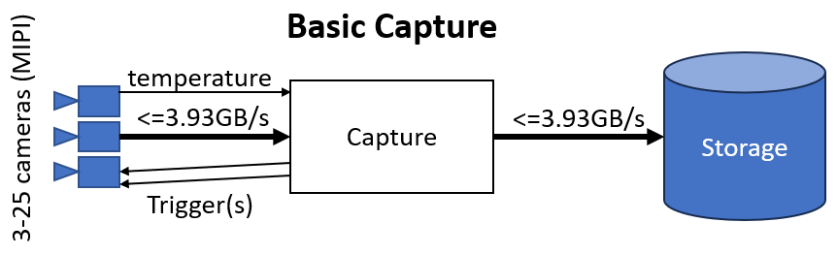
The basic capture system will be able to record video, temperature, and timing data from 3 cameras (90-degree video cameras), 21 cameras (IR) or 25 cameras (VIS + stereo option) on an external storage system.
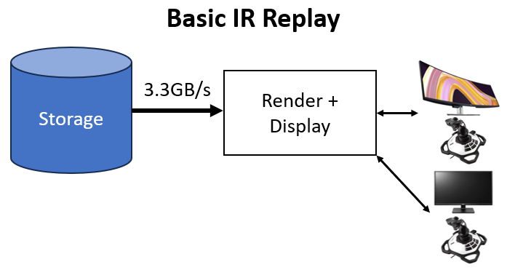
Replay from the basic 21-camera IR system is shown here, with full-resolution video required for the wFOV display.
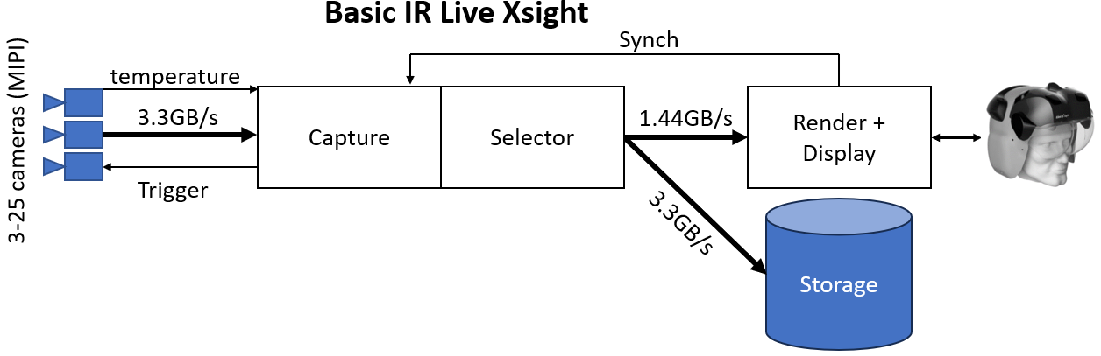
This shows the basic IR system is operating live and storing to disk. A synchronization signal is sent from the rendering system to time align image capture with display readout at a relative phase that minimizes synchronization delays in the system. The bandwidth requirements for the Xsight display being shown differ from those for the displays shown in the previous diagram.
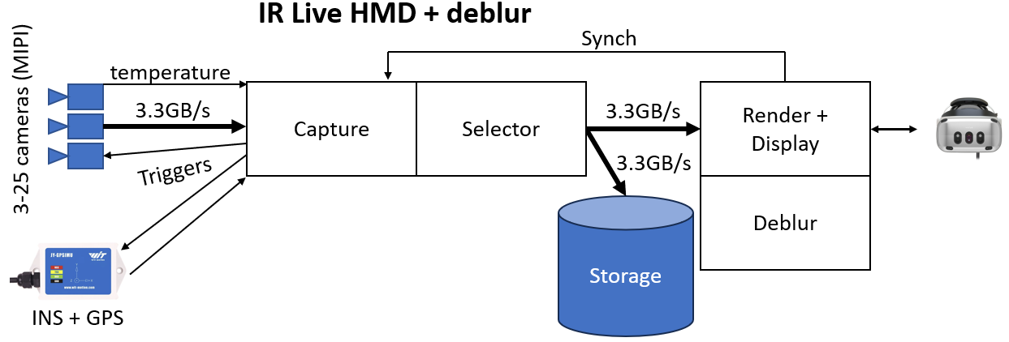
When deblurring is being done on the IR data, inertial measurements are taken time-aligned with the video capture and used to determine the pixel motion paths within each image. Because this configuration is driving a commercial HMD, full bandwidth is required for all images.
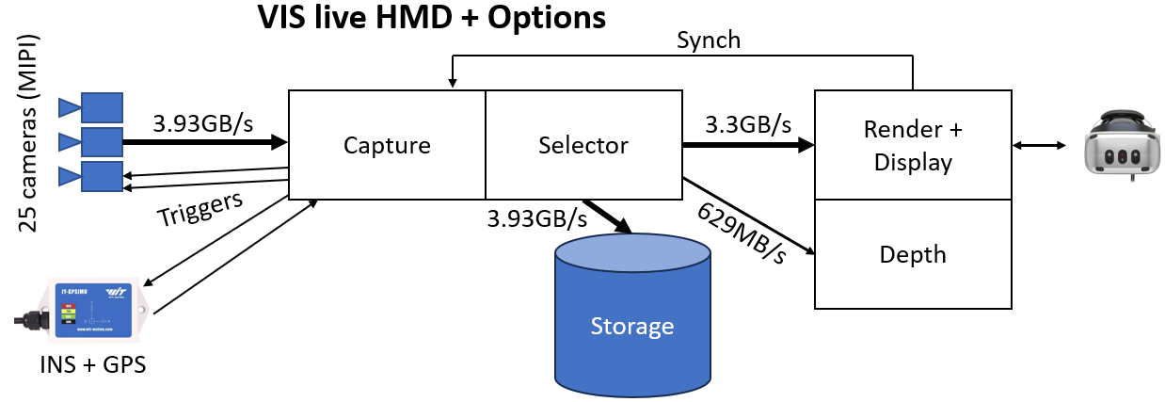
When depth estimation is being performed on the VIS system, four additional camera streams are included – bringing the total ingest bandwidth up. These four full-resolution streams are also sent to the depth estimator in addition to the image streams and peripheral streams being sent to the rendering system.

Full system diagram
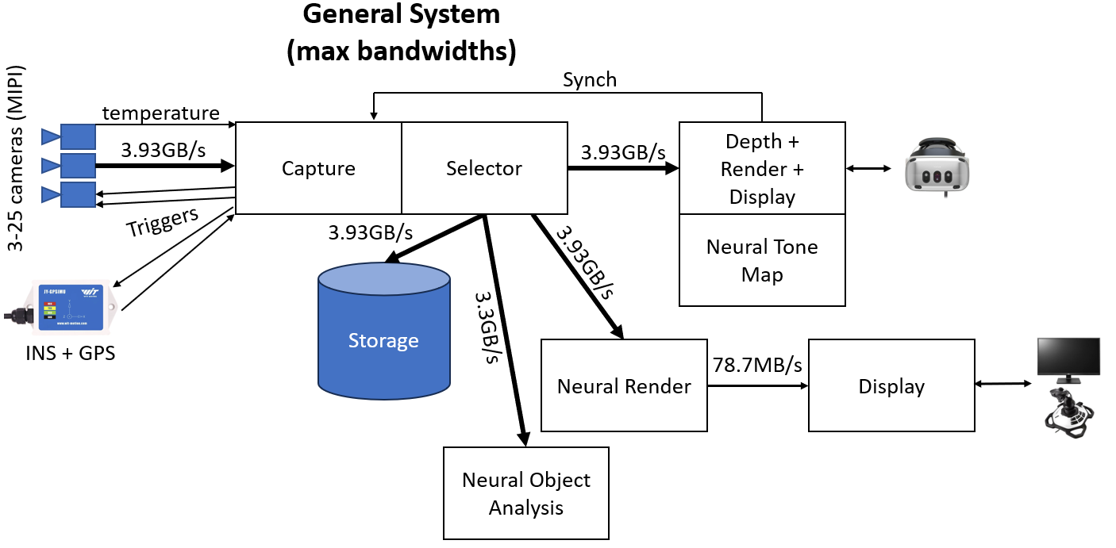
The complete system diagram is shown here, including Analytic and neural components. Not all system components will be used at the same time (only two receivers sharing the same network are guaranteed to be supported). Maximum bandwidths are shown on the links. When replaying from storage, the maximum bandwidth will be 3.93GB/second and all selection will be done by the external storage system.
The capture system’s basic functions include the following:
- Read from a set of 3-25 cameras.
  - The maximum video throughput from all cameras will be 3.93GB/s.
  - Read up to 50 temperature sensors (up to two per camera).
- Read position and orientation, along with derivatives, from INS+GPS unit.
- Synchronization
  - Provide clock synchronization with one or more downstream systems.
  - Receive a periodic hardware or software trigger with a rate of 50-60Hz.
  - Provide up to two independently-phased triggering signals to specified subsets of the camera.
  - Provide up to two independently-phased triggering signals to external sensors.
- Selected video streams
  - Write selectable subsets of every Nth frame of video from a set of full-resolution cameras to up to 2 downstream receivers with maximum bandwidth of 3.93GB/s each.

