LOGM 634 - Homework Set #3

Due 17 January 2017

# From the Ebeling text - Exercise 6.3

# From the Ebeling text - Exercise 6.8

A contractor must decide between two different sump pump systems to be installed in a new housing development. The option is to install a single $1000$ gallon per minute (gpm) system or two $500$-gpm pumps. If the two-pump system is used, one pump carry most of the load in the event the other pump fails. Both of the $500$-gpm pumps have an $MTTF$ of $800$ hr when working together. Their individual $MTTF$ is $200$ hr. The $1000$-gpm system has a rated $MTTF$ of $700$ hr. Which system is preferred on the basis of system $MTTF$? Which system has the best design life for a reliability of $0.80$?

# From the Ebeling text - Exercise 6.14

# From the Ebeling text - Exercise 7.5 (Use Eqn 7.15)

# From the Ebeling text - Exercise 7.13 (Use Table 7.2 for constant strength)

A load is exponentially distributed with a mean of 25. The strength is also exponentially distributed. Determine the minimum value of the mean strength to achieve a reliability of 0.95.

The figure below shows a plot of the density function for the applied load where $load∼EXP(λ=1/25)$. The vertical line represents $t_{0.95}$ or the load at which $F(load)=0.95$

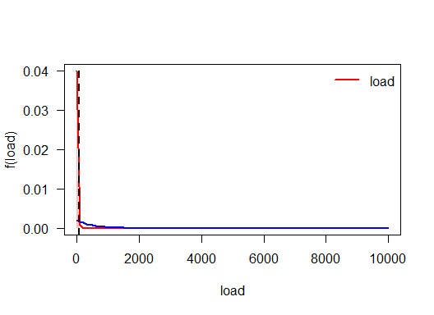

# From the Ebeling text - Exercise 7.15 (Use Eqn. 7.11)

The breaking strength of a cutting tool is a constant $25$ lb. If the load being placed on the tool has the following probability density function, compute the tool's static reliability.

$$f_{{}_{X}}(x)=\frac{200}{(x+10)^{3}} x≥0$$

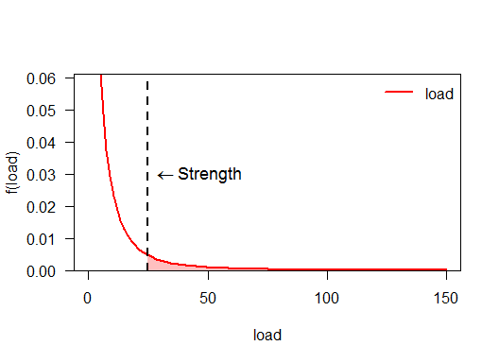

The static reliability is equal to the area under the load curve that is greater than $25$, i.e.

$$\int_{25}^{∞}{\frac{200}{(x+10)^{3}}}dx=0.0816327$$