PILEUP
"I'll deal with it tomorrow."
Famous last words.
Search the clutter, find the key, and survive what you left behind.
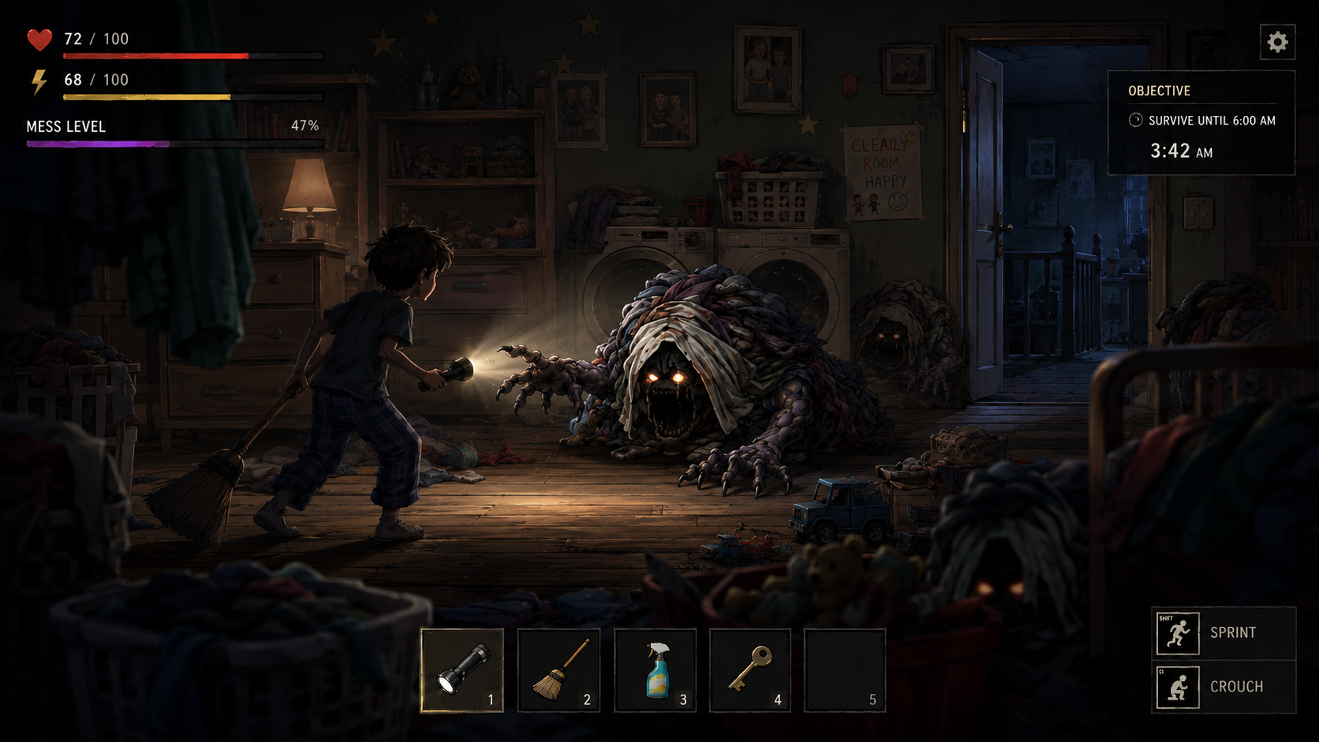
MVP / Product Requirements Document - v1

1. Executive Summary
PILEUP is a hand-drawn 2.5D survival horror game about domestic avoidance turned literal. The player moves through a lived-in house at night, searching clutter for five hidden objects they have been meaning to find all week. One object is the key needed to escape. The house is a layered parallax space with foreground, main play plane, and background depth; clutter is both set dressing and threat source.
The MVP is one complete house level: one night, one playable character, a five-item search objective, flashlight/depth interactions, escalating enemies, and a boss-stage door escape sequence. The goal is not a power fantasy. The player should scrape by.
- Title: PILEUP
- Tagline: "I'll deal with it tomorrow."
- Genre: 2.5D side-scrolling survival horror
- MVP: one house, one night, one escape route, one boss-stage finale
- Core hook: search the clutter while the clutter hunts you

2. Product Pillars
Pillar | Meaning in Game
Relatable dread | The horror comes from common household clutter: laundry, dishes, backpacks, toy bins, mail piles, shoes, cords, and things left for tomorrow.
Layered house threat | The house has foreground, main plane, and background threats. Enemies can stalk in depth and enter the play space.
Light as mechanic | Flashlight reveals, freezes, attracts, provokes, and inspects different depth layers. Darkness is emotional avoidance and mechanical risk.
Search versus safety | Every useful item is buried in a risky pile. Searching creates sound, takes time, and can wake enemies.
Hoarding consequences | Loot gives options, but too much inventory slows movement, increases noise, and raises danger.

3. MVP Scope
The first playable version should be a vertical slice called Level 01 - The Family House. It proves the complete loop without needing multiple homes, multiplayer, or a large meta-progression system.
Included | Excluded from MVP
One playable character; one house; five rooms; one night timer; five hidden objective items; one key; door escape boss stage. | Multiple houses; online co-op; full procedural generation; extended story cutscenes; broad crafting trees.
2.5D floor plane movement; parallax rooms; flashlight depth targeting; search/loot; hoard meter; enemies from foreground/background/main plane. | Final production art for every future house style; large economy; full localization; platform-specific console certification.

4. Core Game Loop
Explore room -> inspect clutter -> manage light/noise/stamina -> search pile -> collect/drop/use item -> evade/fight/stun enemies -> move deeper through the house -> find key -> escape or survive until morning.
Loop Layer | Player Action | System Response
Micro | Aim flashlight, inspect pile, start search, cancel or commit. | Pile reveals item, junk, clue, trap, or enemy ambush. Noise and time pressure rise.
Room | Move left/right and up/down through a parallax room. | Foreground/background threats stalk and transition into main plane.
Run | Find five objective items, including front door key. | Mess level escalates and the house becomes more aggressive.
Finale | Reach door and unlock under pressure. | Door boss sequence tests light, movement, inventory, and nerve.

5. Perspective, Movement, and Parallax
The game is not a single flat lane. The player moves on a 2.5D floor plane with horizontal travel and limited up/down depth movement. The visual camera is side-on, but the play space has depth. This lets enemies stalk from the background or foreground while keeping controls readable.
Layer | Purpose | Gameplay Use
Far background | Walls, photos, drawings, windows, hallway doors. | Emotional storytelling, silhouettes, safe/unsafe cues.
Background clutter lane | Shelves, closets, counters, laundry near walls. | Enemies peek, hide, leap, or crawl into main plane.
Main gameplay plane | Player movement, combat, search, main enemies. | Primary collision and interaction layer.
Foreground clutter | Baskets, hanging clothes, couch arms, bed edges, toy bins. | Occlusion, stalkers, pop-out attacks, parallax depth.
FX/light | Flashlight, dust, lint, shadow passes, eye glow. | Atmosphere and mechanical feedback.

6. Light and Darkness System
The flashlight is the signature tool. It should aim into the main plane, upward/deeper into background clutter, and downward/forward into foreground clutter. The beam is a way to look at problems, and looking has consequences.
Enemy Light Response | Behavior
Freeze in light | Stops moving while lit, resumes in darkness.
Freeze then lunge | Stops briefly, then attacks if overexposed. Good for the Laundry Pile Monster.
Move only in dark | Stalks when not watched. Good for Hanging Coat Stalker.
Reveal only | Looks like junk until light exposes eye glints or breathing.
Light hunter | Tracks the flashlight beam and uses depth lanes to flank.
Flee from room light | Avoids stable lamps but may ignore flashlight.
Darkness should feel tempting. If the lights are off, the player does not have to look at the mess. Mechanically, that means less immediate visual stress but more hidden movement and ambush risk.

7. Search, Loot, and Hoard Systems
Searching is the risk action. The player holds interact near a pile while a progress meter fills. Search time creates noise and vulnerability. Flashlight inspection can reduce risk, but may also wake some enemies.
Search Result | Effect
Required item | One of five objective items; key enables escape finale.
Useful item | Batteries, spray, tape, decoy, temporary tool.
Junk | May increase score or burden, but can punish hoarding.
Noise trap | Spikes enemy attention.
Ambush | Pile becomes enemy or releases swarm.
Memory/lore | Small emotional object that reinforces the home and can feed upgrade tokens.
Inventory should be tempting but dangerous. A five-slot hotbar covers active tools while backpack junk increases burden. At high burden, the player moves slower, makes more noise, and searches worse. The player should feel the cost of carrying everything.

8. MVP Enemy Roster
Enemy | Native Layer | Light Response | Role
Laundry Pile Monster | Main plane / background clutter | Freeze then lunge | Primary pressure enemy and identity creature.
Socklings | Foreground / main plane | Scatter in light | Fast swarm pressure; punishes slow searching.
Drawer Mimic | Background / main searchable | Eye glint reveal | Makes looting suspicious.
Hanging Coat Stalker | Foreground / background | Moves when unwatched | Depth paranoia and pop-out attacks.
Dish Stack Crawler | Kitchen background counter | Reflective stun window | Room-specific variation.
The Hoard at the Door | All layers | Mixed segment response | Boss-stage finale before escape.

9. Boss-Stage Escape
Finding the key starts the final sequence instead of ending the run. The house reacts: lights flicker, mess level spikes, shortest routes become unsafe, and dormant piles activate. At the door, the player must clear clutter, turn the lock, and hold the door open while The Hoard at the Door attacks from foreground, background, and main plane.
- Stage 1: reach the front door after key pickup.
- Stage 2: clear clutter from lock area while enemies interrupt.
- Stage 3: hold interact to unlock; interruptions lose partial progress.
- Stage 4: final pull against The Hoard before escape.
- Win: escape before 6:00 AM, or survive until dawn as a lower-tier success.

10. Randomness and Replayability
Fixed | Randomized
House topology, room order, door location, core tutorial beats, boss location. | Five objective item locations, non-key objective items, ambush piles, enemy pressure, blocked paths, resource availability.
Key always exists and can always be reached without soft-locking. | Key can appear in different legal clutter nodes based on seed and difficulty.
Randomness should create pressure, not unfairness. Each room needs bounds for active enemies, ambush frequency, and critical item placement.

11. Level 01 - The Family House
Room | Purpose | Search Nodes | Enemy Focus
Bedroom | Start/tutorial | Laundry pile, toy bin, backpack, under-bed, dresser drawer | Socklings, Laundry Pile Monster
Hallway | Connector pressure | Shoe pile, mail table, coat rack, linen basket | Hanging Coat Stalker
Bathroom | Tight resource room | Hamper, medicine cabinet, sink drawer, towel pile | Drawer Mimic, Socklings
Kitchen | Noisy high reward room | Junk drawer, dish stack, trash bag, counter pile | Dish Stack Crawler
Living room / Front Door | Finale | Couch cushions, coffee table, toy chest, front door clutter | Door Boss, Laundry Monster

12. Asset Quality Standards
Asset Type | Minimum Runtime | Preferred Source | Format / Notes
Standard enemy frame | 512 x 512 | 1024 x 1024 | RGBA PNG, true alpha, no checkerboard.
8-frame enemy sheet | 2048 x 1024 | 4096 x 2048 | 4 columns x 2 rows; JSON metadata required.
Boss frame | 1024 x 1024 | 2048 x 2048 | Split sheets if texture becomes too large.
Player frame | 512 x 512 | 768-1024 square | Needs flashlight aim/depth poses.
Room layer | 1920 x 1080 view | 3840 x 2160 minimum | Separate far_bg, bg_clutter, main_floor, fg_clutter, fx_light.
UI icon | 128/256 runtime | 512 x 512 | Readable at 720p.
Current included images are prototype references. They are useful for style, composition, and pitch. They are not final production exports until rebuilt with clean alpha, aligned frames, pivots, hitboxes, and layer separation.

13. Scalable House System
Future levels should use the same mechanics with different homes, eras, income levels, cultural textures, and design styles. The system should respect each home rather than mock it. The shared theme is avoidance, clutter, pressure, and pride in space.
Future House Direction | Possible Differences
Modern smart home | Cords, devices, glass, LEDs, malfunctioning automation.
Rustic cabin | Tools, blankets, wood piles, lanterns, mudroom clutter.
Quaint older home | Heirlooms, boxes, old portraits, basement storage.
Apartment | Tight rooms, neighbor noise, compact clutter, shared walls.
70s split-level | Wood paneling, shag textures, basement rec room, old toys.
High-income minimalist | Hidden storage, designer mess, cold lighting, status anxiety.
Multicultural family homes | Distinct domestic objects, foods, textiles, generational details handled respectfully.

14. Prototype Visual References
Prototype reference - Laundry Pile Monster idle/creep sheet. Production target: rebuild as RGBA 2048 x 1024 runtime or 4096 x 2048 source.
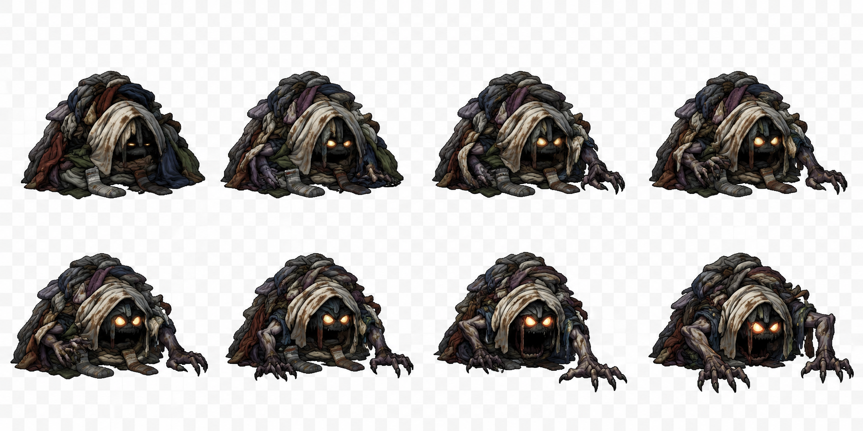
Prototype reference - Laundry Pile Monster attack sheet. Production target: clean frame alignment, pivots, and alpha.
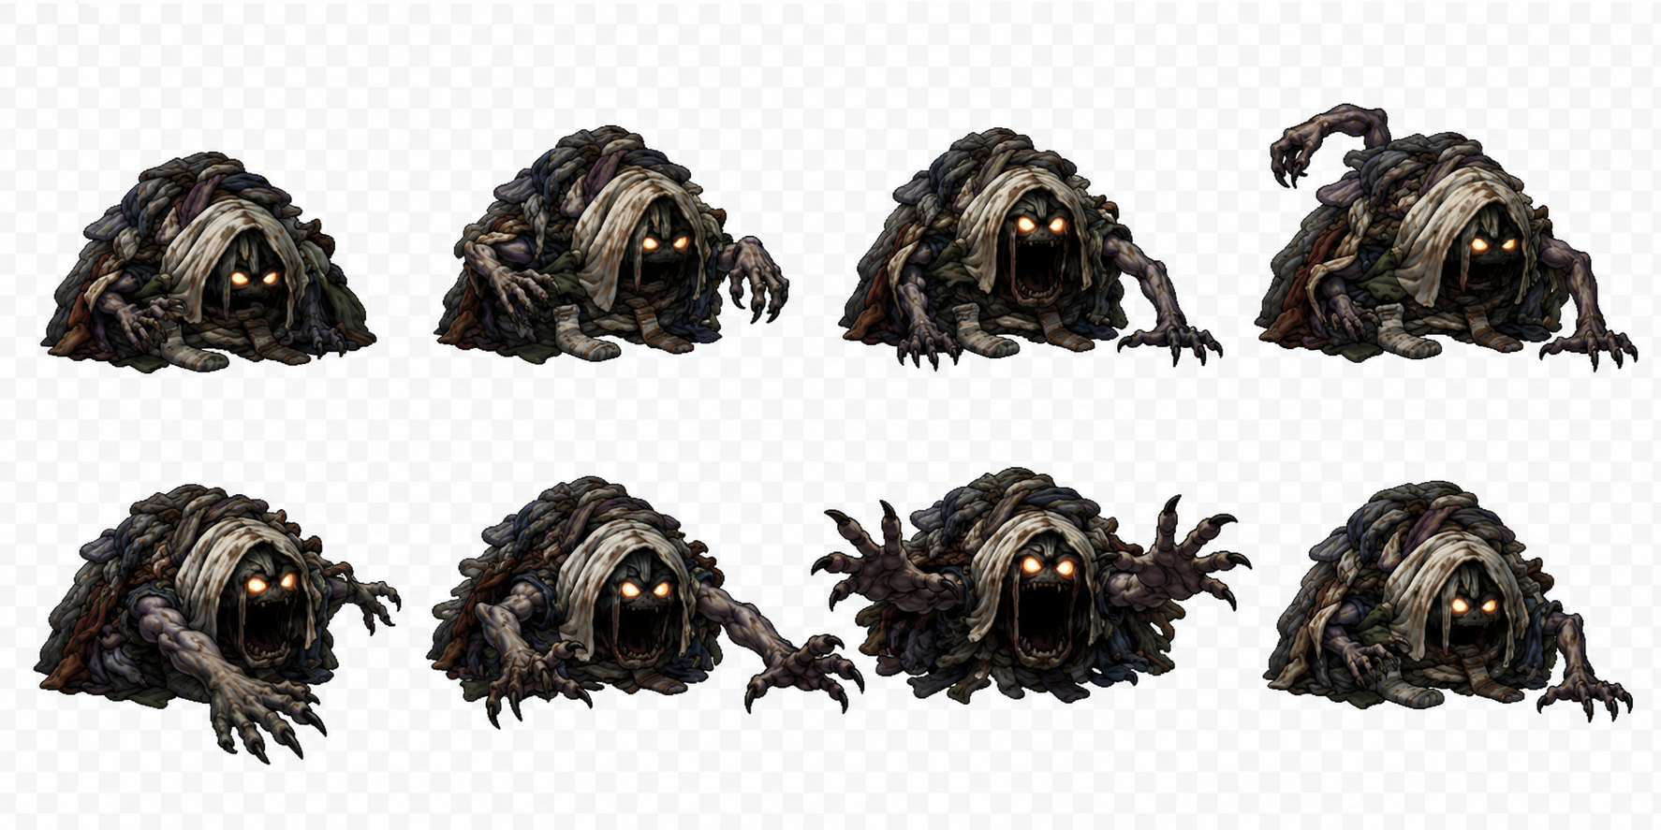
Gameplay mockup - side-view survival horror UI and monster scale reference.
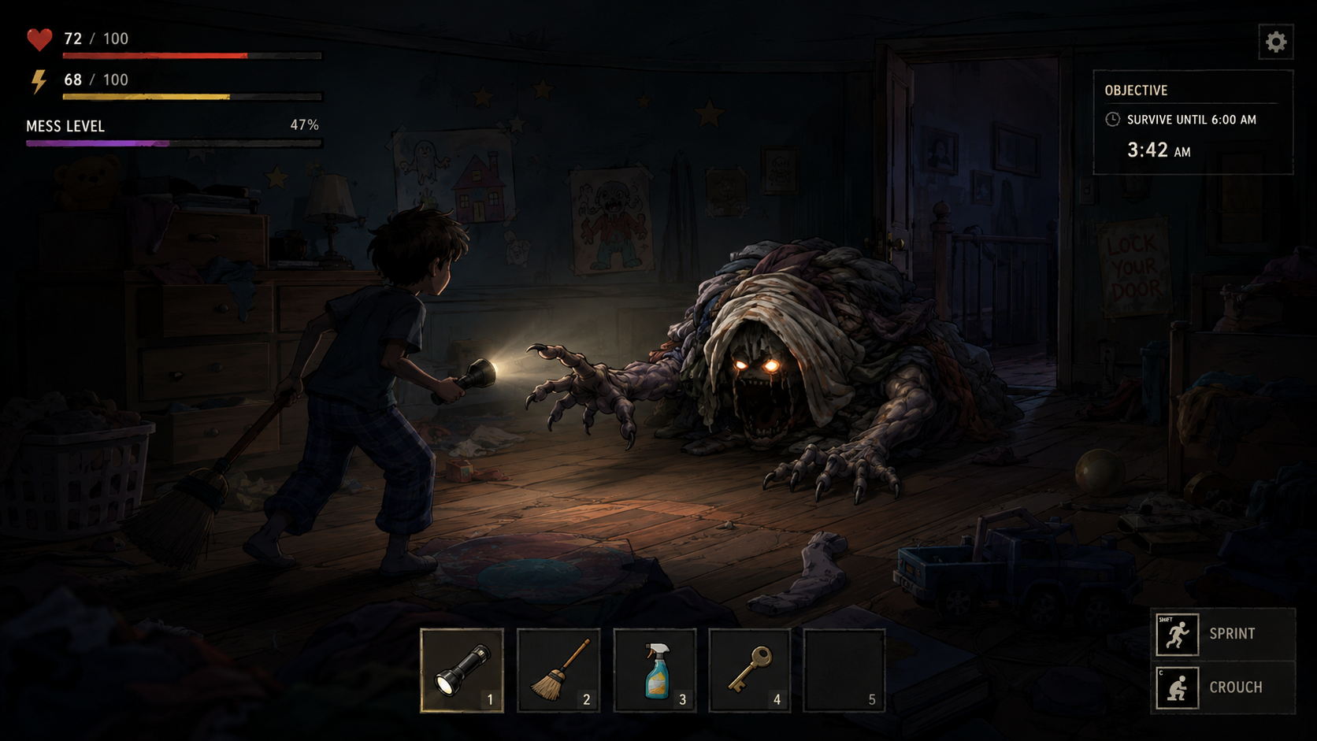
Gameplay mockup - layered parallax room with foreground/background threat direction.


15. MVP Acceptance Criteria
- Player can complete a full run from bedroom to front door.
- Player can move left/right and up/down on a 2.5D floor plane.
- Flashlight can inspect main, foreground, and background threat layers.
- Five objective items can be found through randomized searchable clutter.
- At least four enemy behaviors are represented.
- Health, stamina, battery, noise, mess level, and burden are active and readable.
- Key pickup triggers a distinct boss-stage escape sequence.
- Run can end by escape or dawn survival.
- Replay seed changes item/threat layout without soft-locking the player.

16. Included Data Files
- data/asset_manifest.json - prototype asset metadata and production targets.
- data/animation_specs.json - animation requirements and target sheet sizes.
- data/enemy_archetypes.json - enemy behavior archetypes.
- data/item_pool.json - initial item categories and effects.
- data/level_01_family_house.json - first-level room and randomization structure.
- templates/sprite_metadata_template.json - metadata template for future sprite exports.

17. One-Line Product Definition
PILEUP is a 2.5D survival horror game where a lived-in house becomes a layered monster: search the clutter, find the key, and survive the consequences of what you left for tomorrow.

v2 Addendum: Responsive Display, Asset Resolution, and UI Scaling
Goal: PILEUP must look sharp on large monitors and remain readable on small screens and phones. The game should not rely on one fixed 1920x1080 background stretched to fit every display.

Display strategy
- Use 1920x1080 as the logical design baseline, not as the maximum art quality target.
- Drive gameplay with world units. Room length, enemy range, search distance, and flashlight reach must not be pixel-based.
- Use a protected gameplay safe area so enemies, prompts, and attack telegraphs remain visible on every screen shape.
- On ultrawide monitors, show more horizontal room/parallax detail. Do not stretch background art.
- On phones, prefer landscape orientation with compact HUD, touch-safe controls, and preserved player/enemy scale.

Production art tiers
Asset type | Source target | Runtime tiers | Notes
Room segment layer | 5120x2880 preferred per 1-screen segment | 1920x1080 / 2560x1440 / 3840x2160 | Export by segment and layer; never stretch one giant background.
Player frame | 2048x2048 preferred | 512 / 768 / 1024 square | Same pivots and hitboxes across tiers.
Hero enemy frame | 2048x2048 preferred | 512 / 768 / 1024 square | Laundry monster should use high-tier source and export quality.
Boss frame | 4096x4096 preferred | 1024 / 1536 / 2048 square | Split sheets by animation to avoid huge atlases.
UI icons | 1024x1024 preferred | 128 / 256 / 512 square | Must be readable on phone and crisp on 4K.

UI scaling rules
- HUD must be anchor-based and safe-area-aware; no UI baked into room art.
- Use scalable fonts and 9-slice panels so HUD boxes stay clean at phone and 4K sizes.
- Minimum phone touch targets should be 44-48 logical pixels.
- Phone HUD uses compact meters and icons; desktop/4K HUD can use fuller labels without becoming tiny.
- Inventory, objective, and control prompts must be tested at 720p, 1080p, 1440p, 4K, ultrawide, and phone landscape.

Parallax and large-screen quality gate
- Foreground/background layers require overscan bleed so camera movement and ultrawide reveal never expose empty edges.
- Foreground clutter should frame the scene on large screens, not become a blurry stretched border.
- MVP rooms should use layered, streamable room segments with mobile, standard, and high/4K exports.
- Any asset accepted as production-ready must pass screenshot review at 720p, 1080p, 1440p, 4K, ultrawide, and phone landscape.

