Terra – Algorithm & Data Processing Specification v1.1 (Consolidated)
This consolidated specification merges the original v1.0 Algorithm & Data Processing Spec with the v1.0 Addendum. It serves as the authoritative engineering reference for Terra Phase 1 (satellite-led), including calculations, compositing logic, parameters, pipeline sequencing, confidence logic, QA, and acceptance criteria.

1. Scope (Phase 1)
• Monthly vegetation composites (Sentinel-2) and derived indices (NDVI, optional EVI).
• Structural proxy metrics (NDVI heterogeneity; optional Sentinel-1 radar summaries).
• Disturbance detection (VIIRS fire tagging; NDVI change signals).
• Connectivity and fragmentation proxies (structural-only in Phase 1).
• Plot → Zone → Portfolio aggregation scaffolding.
• Tier 1 structural confidence scoring.
• Full method versioning and reproducibility requirements.

2. Core Index Calculations

2.1 NDVI
Formula: NDVI = (NIR − Red) / (NIR + Red)
Sentinel-2 Bands: B8 (NIR), B4 (Red)
• If denominator = 0 → NoData
• Clip to range [-1,1]
• Use Level-2A surface reflectance products

2.2 EVI (Optional)
Formula: EVI = 2.5 * (NIR − Red) / (NIR + 6*Red − 7.5*Blue + 1)
Bands: B8 (NIR), B4 (Red), B2 (Blue)
• Blue band resampled to 10 m if required

2.3 Structural Heterogeneity
• Compute NDVI variance using rolling window (default 5×5 pixels)
• Store median + upper quartile per plot

3. Preprocessing & Cloud Masking
Preferred: Sentinel-2 SCL mask (cloud, shadow, cirrus removed).
Fallback: QA60 or cloud probability threshold.
Minimum valid pixel fraction per plot-month: 20% (default).

4. Monthly Composite Strategy
• Calendar month temporal window.
• Composite operator: median (default).
• Store NDVI_monthly, HET_NDVI_monthly, ValidPixelFraction.

5. Change & Disturbance Detection
ΔNDVI_mom = NDVI_t − NDVI_(t−1)
ΔNDVI_yoy = NDVI_t − NDVI_(t−12) (if available)
Default negative disturbance threshold: -0.10 NDVI (configurable).
VIIRS fire detections stored as contextual tags (not automatic degradation labels).

6. Aggregation (Plot → Zone → Portfolio)
Plot summaries: median NDVI + IQR; heterogeneity median + upper quartile.
Zone rollups: area-weighted medians; store density & depth.
Portfolio: aggregation container only (no credit logic in Phase 1).

7. Tier 1 Confidence Object
Confidence inputs:
• ValidPixelFraction
• Temporal depth (months available)
• Data consistency (variance of monthly summaries)
Outputs:
• confidence_score (0–1)
• confidence_band (Low/Medium/High)
All inputs stored for audit.

8. Default Parameters (Version-Controlled)
Parameter | Default Value
Min valid pixels | 20%
Composite operator | Median
Heterogeneity window | 5×5 pixels
ΔNDVI disturbance threshold | -0.10
Fire buffer distance | 1 km
Update cadence | Monthly

9. Pipeline Sequence (Authoritative Order)
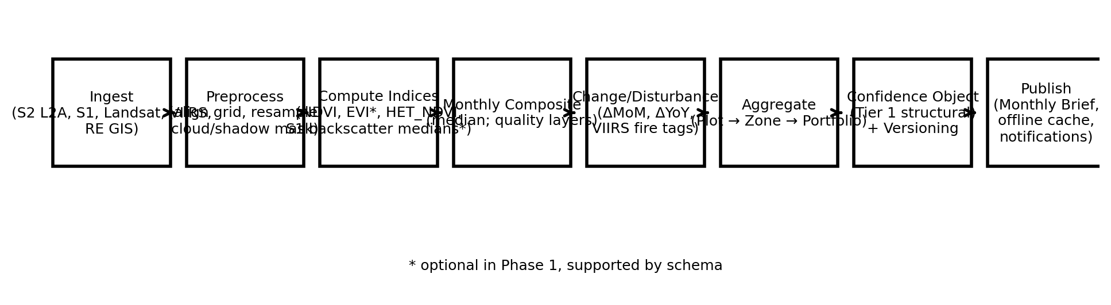

10. Acceptance Criteria (Engineering QA)
• NDVI formula verified against reference pixel values.
• Cloud-masked pixels excluded from composites.
• Monthly composites reproducible under identical inputs.
• Versioning preserves historical outputs when parameters change.
• Offline Monthly Brief cache functional.
• Push notification delivered on Monthly Brief release.

