Phase 1 Acoustic Sensor Deployment
Corridor-First Model (Founding 50)
4.2 km radius centred on 81 Boscombe Rd, Brookfield (Gondwana cluster)
Restoration mode | 1 km x 1 km targeting grid | 50 sensor cap

1. Executive Summary
Phase 1 establishes a 50-node acoustic observatory using a corridor-first deployment strategy. The network is anchored by two existing seed nodes: Gondwana (mapped watercourse on-property) and Andrew Grace (Gold Creek frontage). Deployment prioritises hydrological connectivity (headwaters → tributary → river) and restoration leverage, enabling defensible measurement of biodiversity response while remaining practical to implement and scale.
Figure 1. Conceptual corridor structure (schematic).
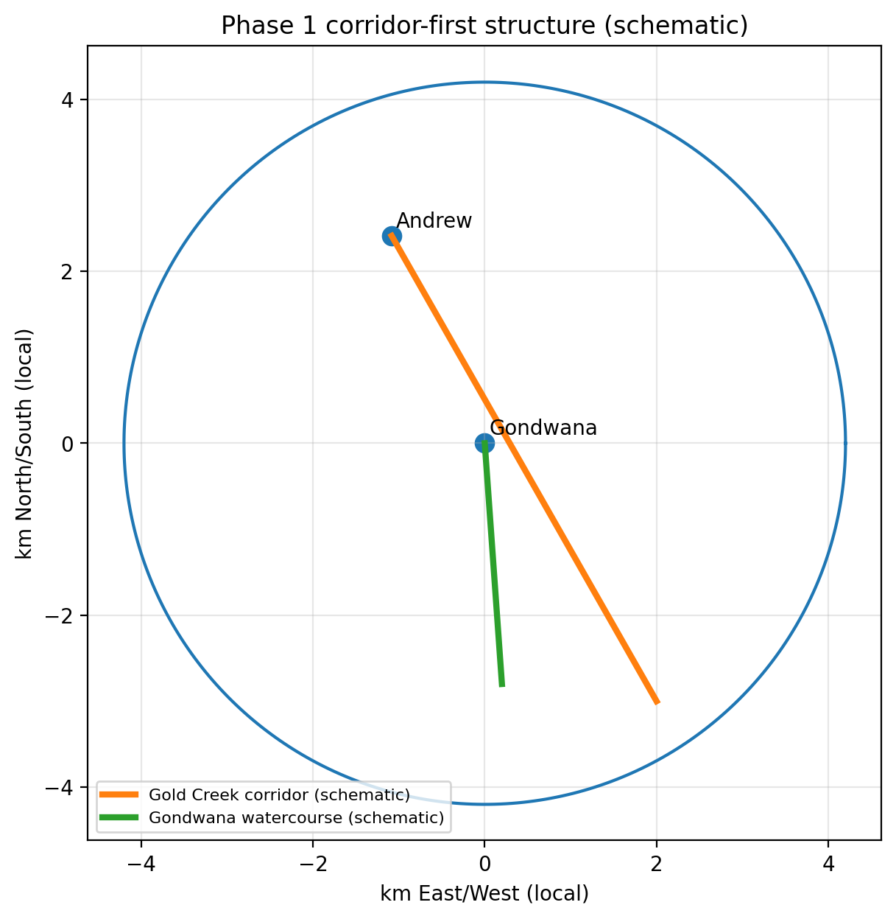

2. Corridor-First Deployment Bands
Band | Purpose | Sensors | Why it matters (Phase 1)
Band 1 | Gold Creek spine (primary tributary corridor) | 18 | Highest leverage corridor for movement, riparian specialists, and HLW alignment.
Band 2 | Gondwana feeder micro-catchment (mapped watercourse + adjacent feeders) | 10 | Headwater integrity and feeder-to-tributary continuity.
Band 3 | Riparian buffer halo (edge and transition zones) | 8 | Captures edge effects and uplift response outward from corridors.
Band 4 | Ridge & upland connectors (stepping stones between corridors) | 8 | Captures cross-corridor movement and fragmentation risk.
Band 5 | Interior controls & mosaic tiles | 6 | Baseline/control sites and high-uplift conversion targets.

Figure 2. 1 km tiles showing band assignment and initial sensor allocation (numbers indicate sensors per tile).
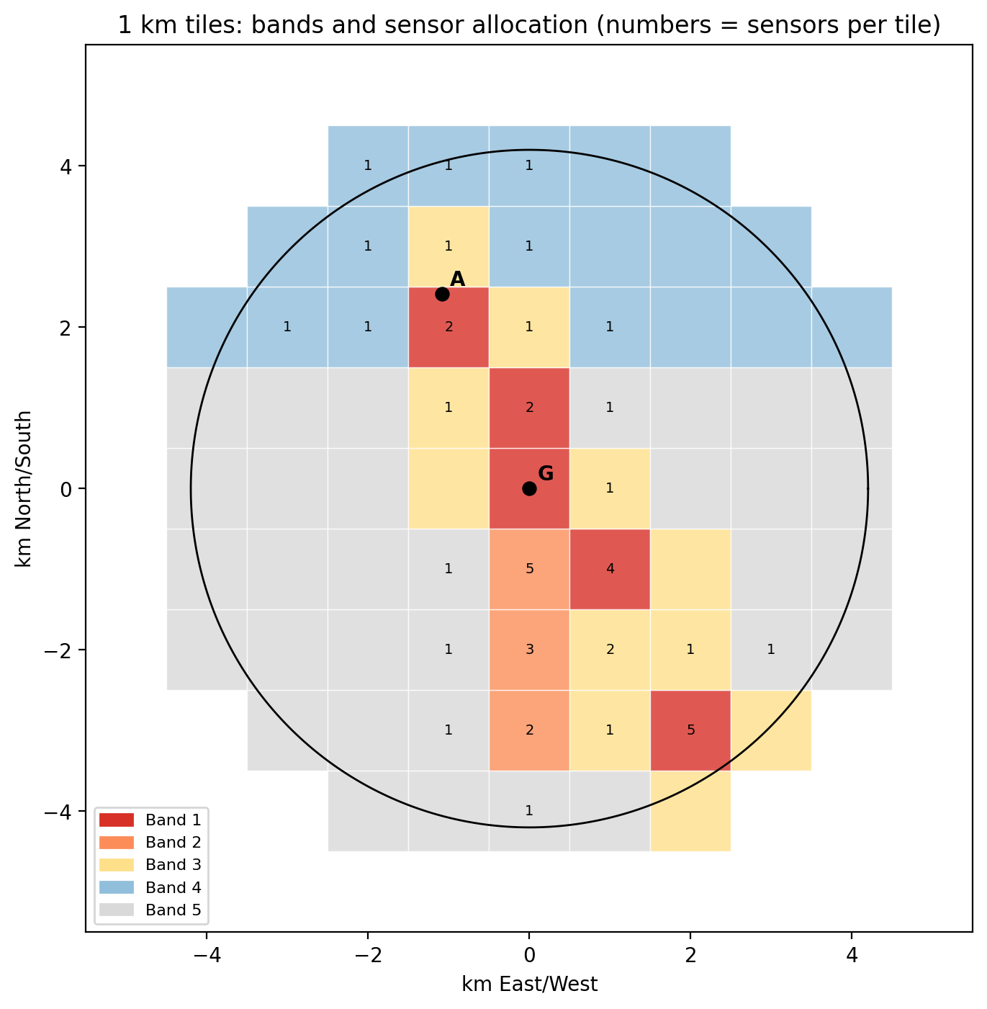

3. 1 km x 1 km Tile Targeting and Allocation
The 4.2 km radius footprint is tessellated into 1 km x 1 km tiles. Tiles are prioritised by proximity to (a) the Gold Creek corridor line, (b) the Gondwana feeder watercourse line, and (c) connector geography between the two. This creates a repeatable, scalable framework: replace the corridor lines with mapped waterway centreline(s) and tributaries for any new region, then score tiles by corridor distance and connectivity.
Table 2. Top priority tiles (illustrative IDs are relative offsets in km from the centre; Band and sensors indicate Phase 1 placement).
Tile ID | Band | Sensors | Distance to Gold Creek line (km) | Distance to Gondwana feeder line (km)
T(+0,+0) | Band 1 | 5 | 0.25 | 0.00
T(+2,-3) | Band 1 | 5 | 0.00 | 1.81
T(+1,-1) | Band 1 | 4 | 0.12 | 0.93
T(-1,+2) | Band 1 | 2 | 0.13 | 2.24
T(+0,+1) | Band 1 | 2 | 0.24 | 1.00
T(+0,-1) | Band 2 | 5 | 0.75 | 0.07
T(+0,-2) | Band 2 | 3 | 1.24 | 0.14
T(+0,-3) | Band 2 | 2 | 1.74 | 0.28
T(+1,-2) | Band 3 | 2 | 0.37 | 0.85
T(+2,-2) | Band 3 | 1 | 0.50 | 1.85
T(-1,+3) | Band 3 | 1 | 0.59 | 3.16
T(+1,+0) | Band 3 | 1 | 0.62 | 1.00
T(-1,+1) | Band 3 | 1 | 0.63 | 1.41
T(+0,+2) | Band 3 | 1 | 0.74 | 2.00
T(+1,-3) | Band 3 | 1 | 0.87 | 0.82
T(+2,-1) | Band 3 | 0 | 0.99 | 1.92
T(-1,+0) | Band 3 | 0 | 1.12 | 1.00
T(+2,-4) | Band 3 | 0 | 1.00 | 2.16
T(+3,-3) | Band 3 | 0 | 1.00 | 2.81
T(-2,+2) | Band 4 | 1 | 1.00 | 2.83
T(-2,+3) | Band 4 | 1 | 1.09 | 3.61
T(+0,+3) | Band 4 | 1 | 1.23 | 3.00
T(-1,+4) | Band 4 | 1 | 1.59 | 4.12
T(+1,+2) | Band 4 | 1 | 1.61 | 2.24
T(-2,+4) | Band 4 | 1 | 1.83 | 4.47

4. Wave 1-3 Invitation Sequence (Terra → Founding 50)
Sequencing choice: Terra Free launches first to build uptake and social proof, then Founding 50 invitations are selectively issued to the highest-priority corridor tiles. This avoids premature scarcity signalling and increases conversion when scarcity is introduced.
Figure 3. Indicative rollout timeline (weeks).
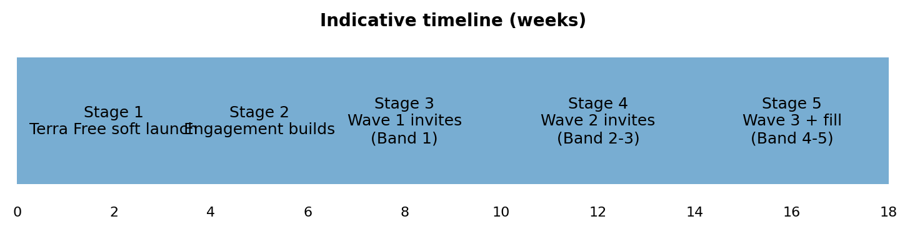
Wave definitions:
Wave 1: Band 1 tiles (Gold Creek spine) – first invitations; fastest corridor density build; strong HLW narrative.
Wave 2: Band 2-3 tiles (Gondwana feeder + riparian halo) – extends upstream integrity and edge-response capture.
Wave 3: Band 4-5 tiles (connectors + controls) – completes connectivity and embeds controls for defensibility.

5. Acoustic Coverage Overlap (Parameterised)
Effective acoustic detection range varies by species, habitat structure, microphone, weather, and noise. For planning, treat detection radius as a tunable parameter (r). Coverage footprint per sensor is approximately πr², but overlap is desirable along corridors to ensure continuity and resilience to noise/obstruction.
Figure 4. Layout with illustrative footprints (250 m and 500 m) shown for scale; use real-world calibration once sensors are deployed.
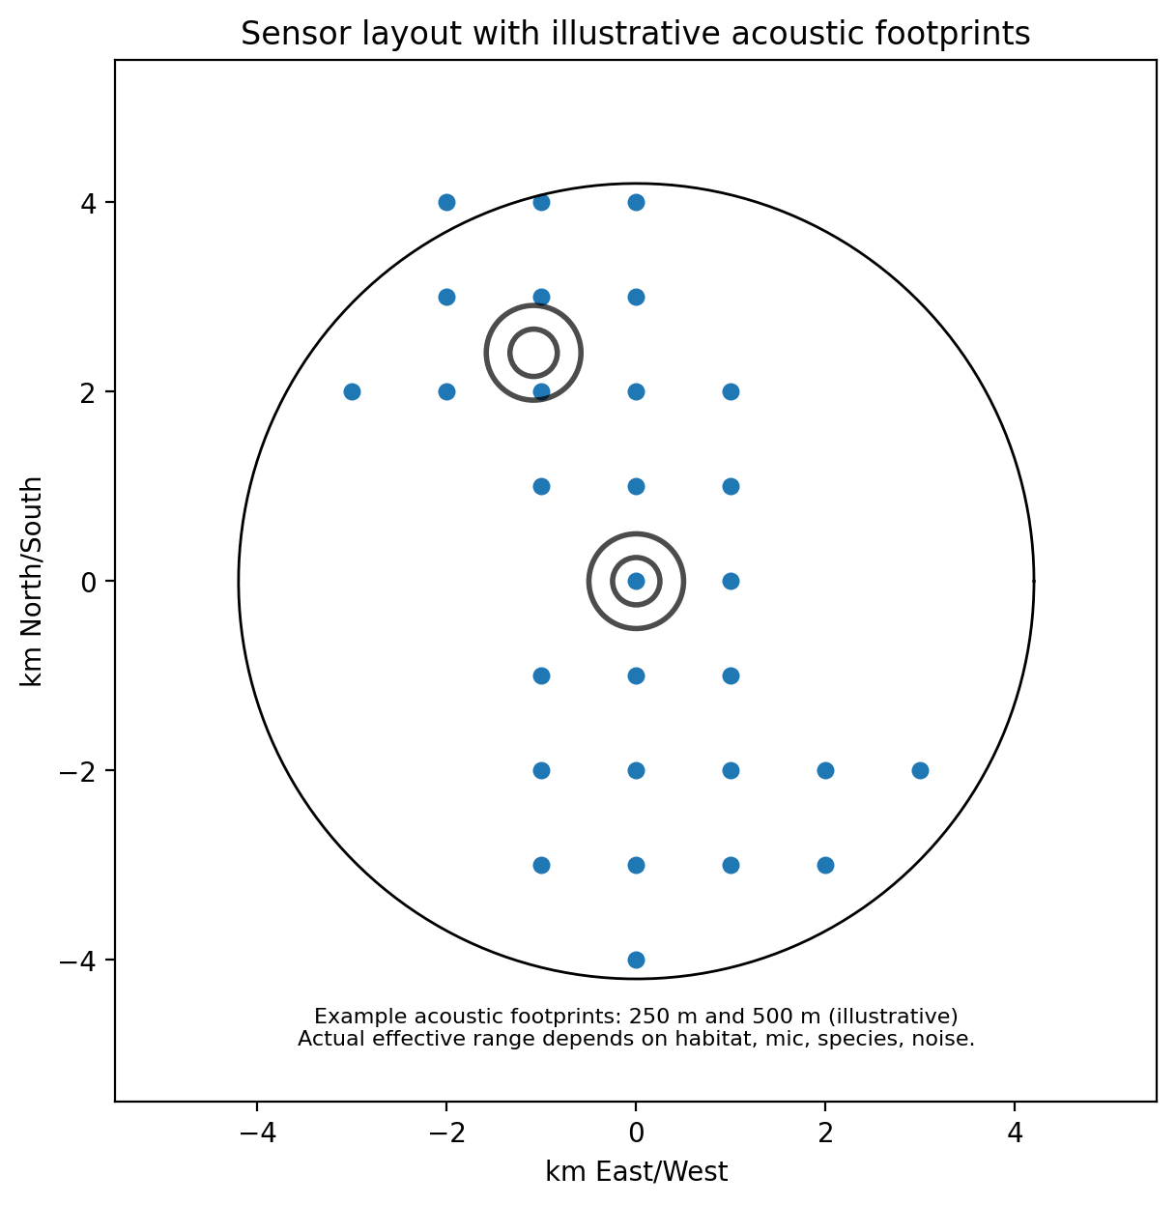
Practical corridor spacing guidance (rule-of-thumb):
Corridor continuity: aim for centre-to-centre spacing of ~0.8r to 1.5r along the creek line, depending on vegetation density and ambient noise.
Junctions and transition zones: increase density (shorter spacing) where tributaries meet or habitat changes sharply.
Controls: place farther apart; controls are for contrast, not corridor continuity.

6. Scenario Comparison (30 vs 50 vs 70 Sensors)
The table below provides indicative network density metrics for the 4.2 km radius footprint (area ≈ 55.4 km²). Nearest-neighbour spacing is shown as a baseline expectation for a random distribution; corridor-first placement will be denser on waterways and sparser in the interior.
Scenario | Average area per sensor (km²) | Sensors per km² | Expected nearest-neighbour distance (km, random baseline)
30 | 1.85 | 0.54 | 0.68
50 | 1.11 | 0.90 | 0.53
70 | 0.79 | 1.26 | 0.44
Interpretation for Phase 1:
30 sensors: viable for corridor proof-of-concept, but less robust for tile-level classification and edge-effect modelling.
50 sensors (chosen): strong balance of scientific defensibility and practical rollout; supports corridor continuity + controls.
70 sensors: increases redundancy and spatial resolution, but raises cost/coordination burden; best reserved for Phase 2 expansion once conversions are proven.

7. Repeatable Method (How to Replicate in Any Region)
1. Set centre point and radius (e.g., 4.2 km).
2. Generate 1 km x 1 km tile grid intersecting the radius.
3. Import/trace waterway centrelines (primary tributary + key feeders).
4. Score each tile on: (a) distance-to-waterway, (b) corridor connectivity (adjacent waterway tiles), (c) vegetation/remnant proxy, (d) restoration leverage (edge + opportunity).
5. Assign bands (1-5) and allocate sensors per band (e.g., 18/10/8/8/6).
6. Run Terra Free for 2-4 weeks to build uptake, then issue invitations Wave 1 → 2 → 3 based on band priority.
7. Calibrate effective acoustic radius in-field and adjust spacing/overlap rules for the region.

