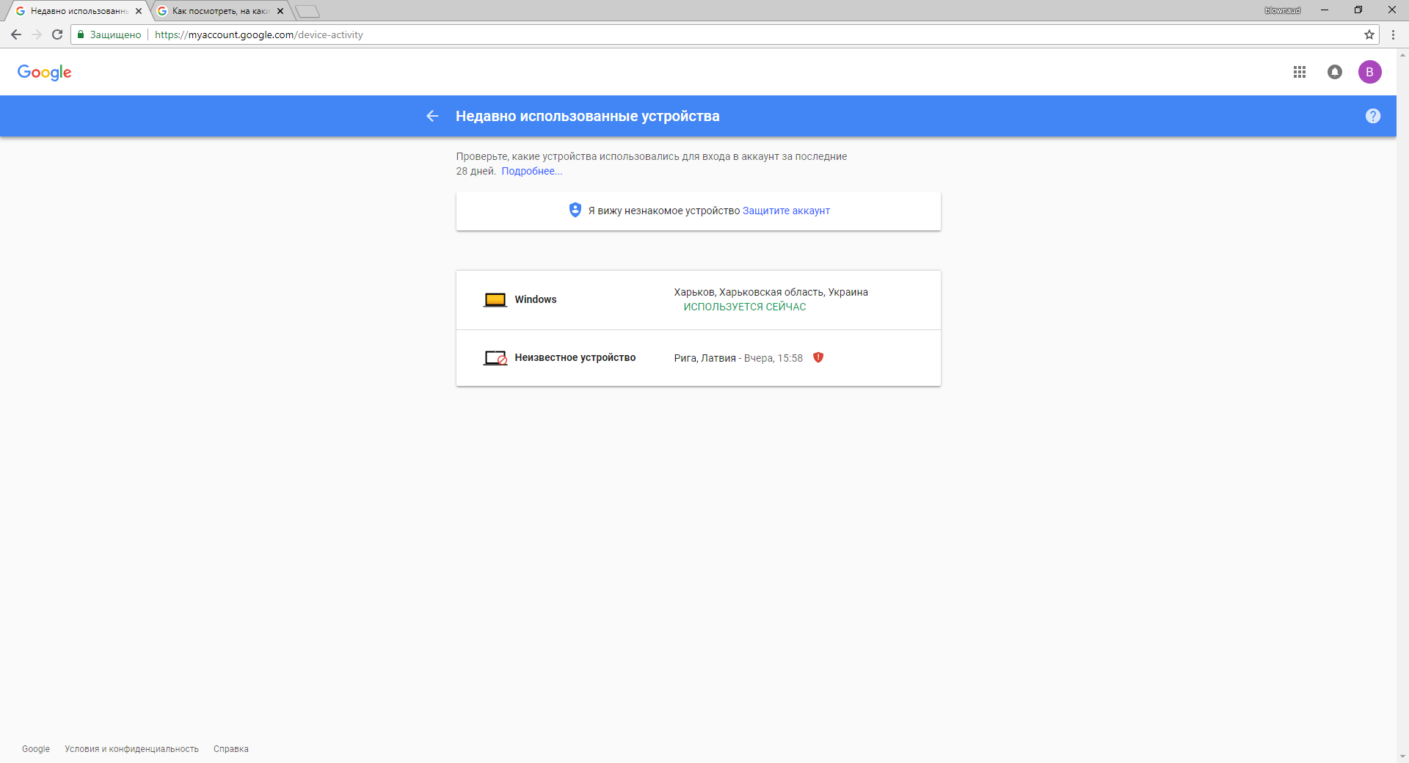

If you see error when try authentication and mail with token didn’t income you need add comp in this page