Agent Red
Technical Evaluation Report

Prepared by Remaker Digital
April 2026
CONFIDENTIAL

Table of Contents
1. Executive Summary
2. Project Overview
3. Technology Assessment
4. Engineering Maturity
5. Security Assessment
6. Multi-Tenant Architecture
7. Competitive Landscape
8. Reliability & Serviceability
9. Maintainability
10. Performance Considerations
11. Azure Deployment Configuration
12. Azure Cost Projections
13. Recommended Technical Priorities
Annex A: Agent Red vs OrbaTech Recommended Azure Configuration
Annex B: Agent Red + OrbaTech CRM Integration

1. Executive Summary
This report provides an independent technical evaluation of the Agent Red AI Customer Service platform, a multi-agent AI system built on Python/FastAPI with Azure infrastructure. The evaluation was conducted by Remaker Digital as part of a partnership assessment with OrbaTech CRM.
Agent Red is an actively developed product (approximately 6 months in development, 711 commits) built by a single developer with extensive AI-assisted development (87.6% of commits co-authored with Claude). The platform provides AI-powered customer service for Shopify merchants and standalone businesses, featuring a multi-agent pipeline, admin dashboards, and an embeddable chat widget.
Overall Assessment
Agent Red demonstrates strong engineering maturity across nearly all dimensions. The multi-agent pipeline architecture, comprehensive test suite (5,400+ tests), production-grade Azure deployment (9 containers, Terraform IaC), and defense-in-depth security posture (envelope encryption, managed identities, tenant-partitioned data) position the platform well for commercial production. Key areas for investment include SOC 2 compliance preparation, load testing at scale, and partner integration SDK development.

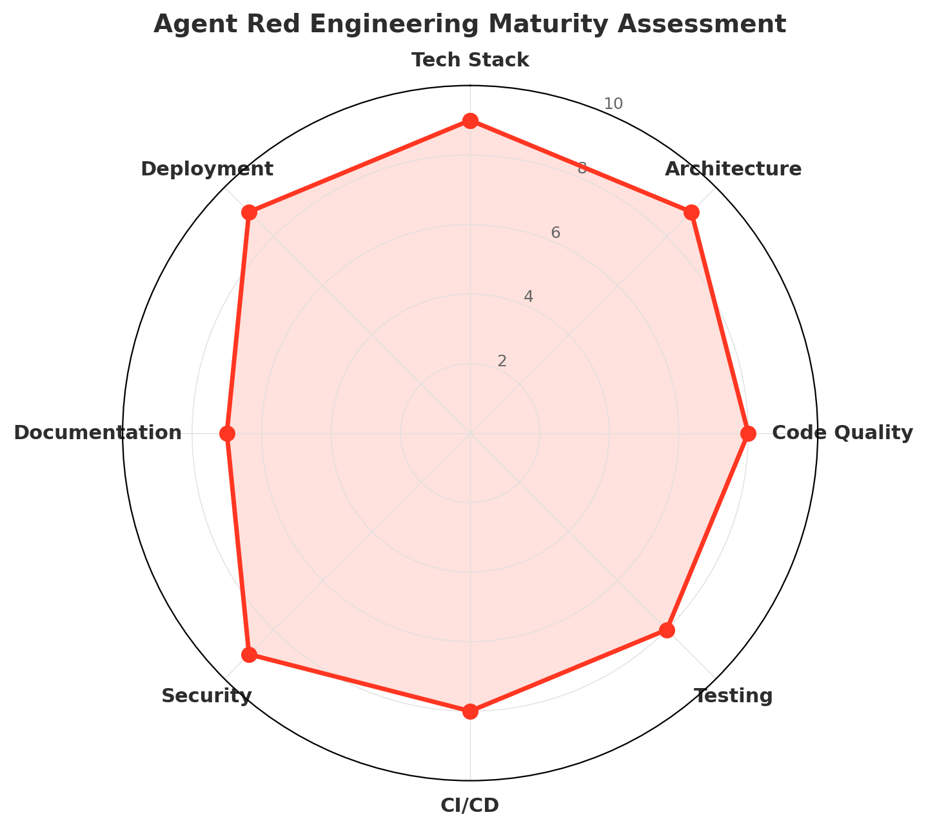
Figure 1: Engineering maturity across eight dimensions (scale of 1-10). Agent Red scores 7+ across all dimensions, with particular strength in Tech Stack, Architecture, Security, and Deployment.

2. Project Overview
Repository | github.com/mike-remakerdigital/agent-red
Description | AI-powered customer service SaaS — multi-agent pipeline, admin dashboards, AGNTCY platform
Primary Language | Python 3.12 (backend), TypeScript (frontend)
Project Age | ~6 months (since October 2025)
Total Commits | 711
Contributors | 1 developer + AI co-author (Claude Opus)
Total Files | 2,213 (2,052 source)
Test Files | 605 files, 5,400+ tests
License | Proprietary (all rights reserved)
Target Markets | Shopify merchants + standalone businesses (US/Canada)
Website | Remaker Digital

The project demonstrates exceptional development velocity with 711 commits over 6 months, averaging nearly 4 commits per day. The AI-assisted development model (87.6% co-authored commits) is a notable approach that has enabled a single developer to build and maintain a system of this complexity. The codebase comprises approximately 18 MB of source code across Python, TypeScript, HTML, CSS, T-SQL, and HCL (Terraform).

3. Technology Assessment
Technology Choices: Production-Grade
The selection of Python/FastAPI for the backend, React/Preact for frontends, Azure Cosmos DB for multi-tenant data, and NATS JetStream for agent-to-agent communication represents a well-considered, cloud-native technology stack optimized for AI workloads and horizontal scaling.

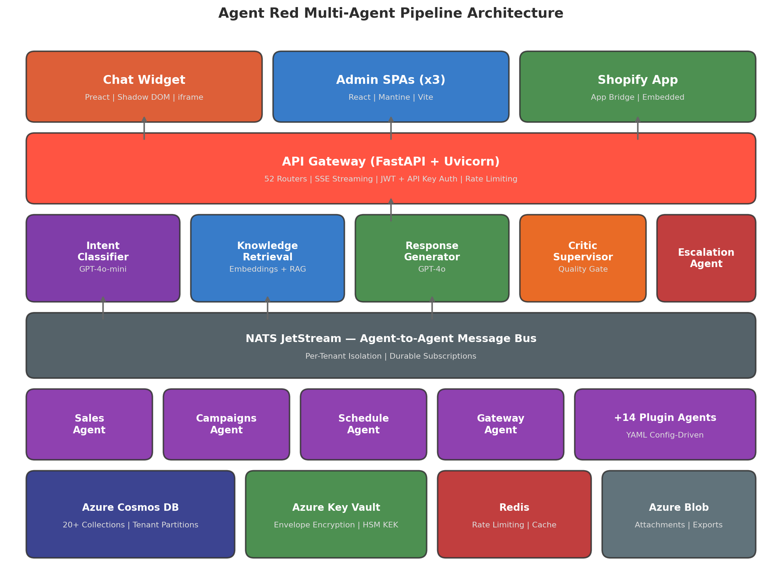
Figure 2: Agent Red multi-agent pipeline architecture showing the 6 core agents, plugin system (20 agents total), NATS message bus, and data tier.

3.1 Technology Stack Details
Layer | Technology | Assessment
API Framework | FastAPI + Uvicorn  (4 workers, tini PID 1) | High-performance async Python framework. Automatic OpenAPI docs. Pydantic v2 validation. Production-ready with tini signal handling.
AI/ML | Azure OpenAI  (GPT-4o, GPT-4o-mini) | Enterprise-grade AI models with Azure-managed scaling. Langfuse observability for prompt monitoring and cost tracking.
Database | Azure Cosmos DB  (20+ collections) | Globally distributed NoSQL with native partition-key tenant isolation. Serverless + provisioned throughput options. Continuous 7-day backup.
Message Bus | NATS JetStream | High-performance agent-to-agent communication with per-tenant isolation, durable subscriptions, and at-least-once delivery.
Frontend (Admin) | React 18.3 + Mantine  (3 SPAs) | Three tailored admin interfaces: Shopify embedded, standalone, and platform operator. Shared component library.
Frontend (Widget) | Preact 10.25  (Shadow DOM + iframe) | Lightweight embeddable widget with CSS isolation (Shadow DOM launcher) and full DOM isolation (iframe panel). 8-language support.
Encryption | AES-256-GCM  Azure Key Vault HSM KEK | Per-tenant envelope encryption with HSM-backed master key. Auto-rotation. No plaintext sensitive data at rest.
Infrastructure | Terraform + Docker  Azure Container Apps | 9 independently scaled containers. Terraform IaC for environment management. 3 Dockerfiles with non-root user.
CI/CD | GitHub Actions  (8 workflows) | Build, test (5-shard parallel), lint, deploy pipelines. Dependency vulnerability scanning. OpenAPI compatibility checks.

4. Engineering Maturity
Engineering maturity was assessed across eight dimensions using a 1-10 scale. Agent Red scores consistently high, reflecting mature engineering practices despite the relatively young project age.
Dimension | Score | Key Observations
Tech Stack | 9/10 | Python 3.12, FastAPI, Cosmos DB, NATS, React, Preact. All current versions. Cloud-native choices.
Architecture | 9/10 | Multi-agent pipeline with mixin orchestrator. Plugin system. 3 SPAs + widget. Repository pattern with tenant-scoped base class.
Code Quality | 8/10 | Ruff linting (CI-enforced), import cycle detection, dead code analysis, cyclomatic complexity monitoring. ESLint for TypeScript.
Testing | 8/10 | 5,400+ tests across 10 test types. 5-shard parallel CI. Coverage gate. API fuzzing, mutation testing, property-based testing.
CI/CD | 8/10 | 8 GitHub Actions workflows. Automated build/test/deploy pipeline. Dependency vulnerability scanning. OpenAPI compatibility.
Security | 9/10 | Envelope encryption, HSM-backed keys, managed identities, input sanitization, pre-auth rate limiting, audit logging, PII tokenization.
Documentation | 7/10 | Extensive internal docs (CLAUDE.md system, knowledge DB with 2,092 specs). Admin guide site. Legal drafts. Could improve public API docs.
Deployment | 9/10 | 9 Azure Container Apps with Terraform IaC. 3 Dockerfiles. Staging + production. Managed identity RBAC. Health probes.

4.1 Test Suite
Agent Red has an exceptionally comprehensive test suite covering 10 distinct testing methodologies. Tests run in 5 parallel shards in CI with a 75% coverage gate (ramping to 80%).
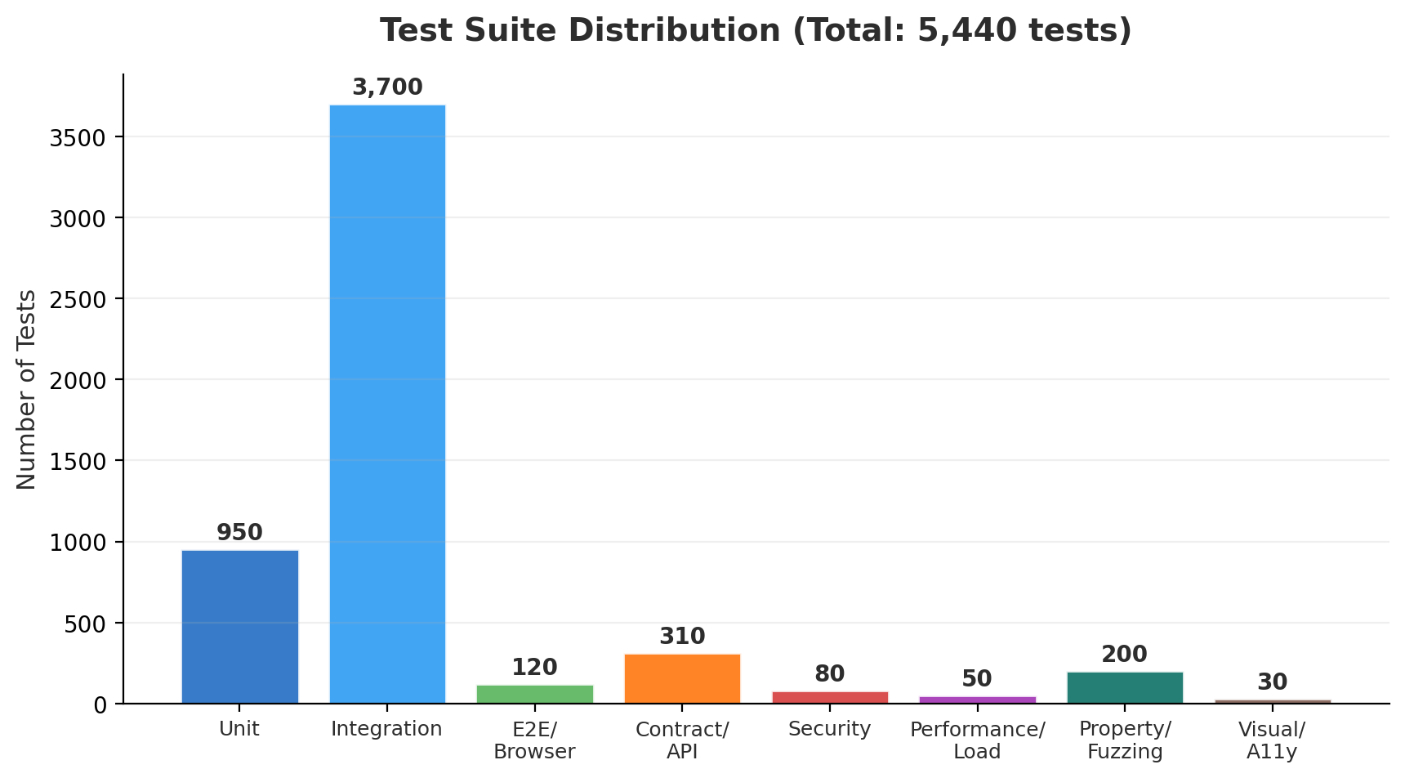
Figure 3: Test suite distribution by type. Integration tests form the largest category, with significant investment in API fuzzing, property-based testing, and security testing.

4.2 Coding Standards
- Ruff linter enforced in CI (pycodestyle, pyflakes, isort, bugbear, simplify rules)
- Import cycle detection via custom AST walker (blocking in CI)
- pip-audit dependency vulnerability scanning (blocking in CI)
- Radon cyclomatic complexity monitoring (advisory)
- Vulture dead code detection (advisory)
- ESLint with react-hooks and jsx-a11y plugins for TypeScript
- Vale prose linting for documentation with custom AgentRed style rules
- Conventional commit message format (feat, fix, chore, bump, test, docs)

5. Security Assessment
Security Posture: Strong
Agent Red implements defense-in-depth security with per-tenant envelope encryption, Azure Key Vault HSM-backed keys, managed identities, input/output sanitization, pre-auth rate limiting, audit logging, and PII tokenization. No committed credentials or hardcoded secrets were found. The .gitignore properly excludes all sensitive files.

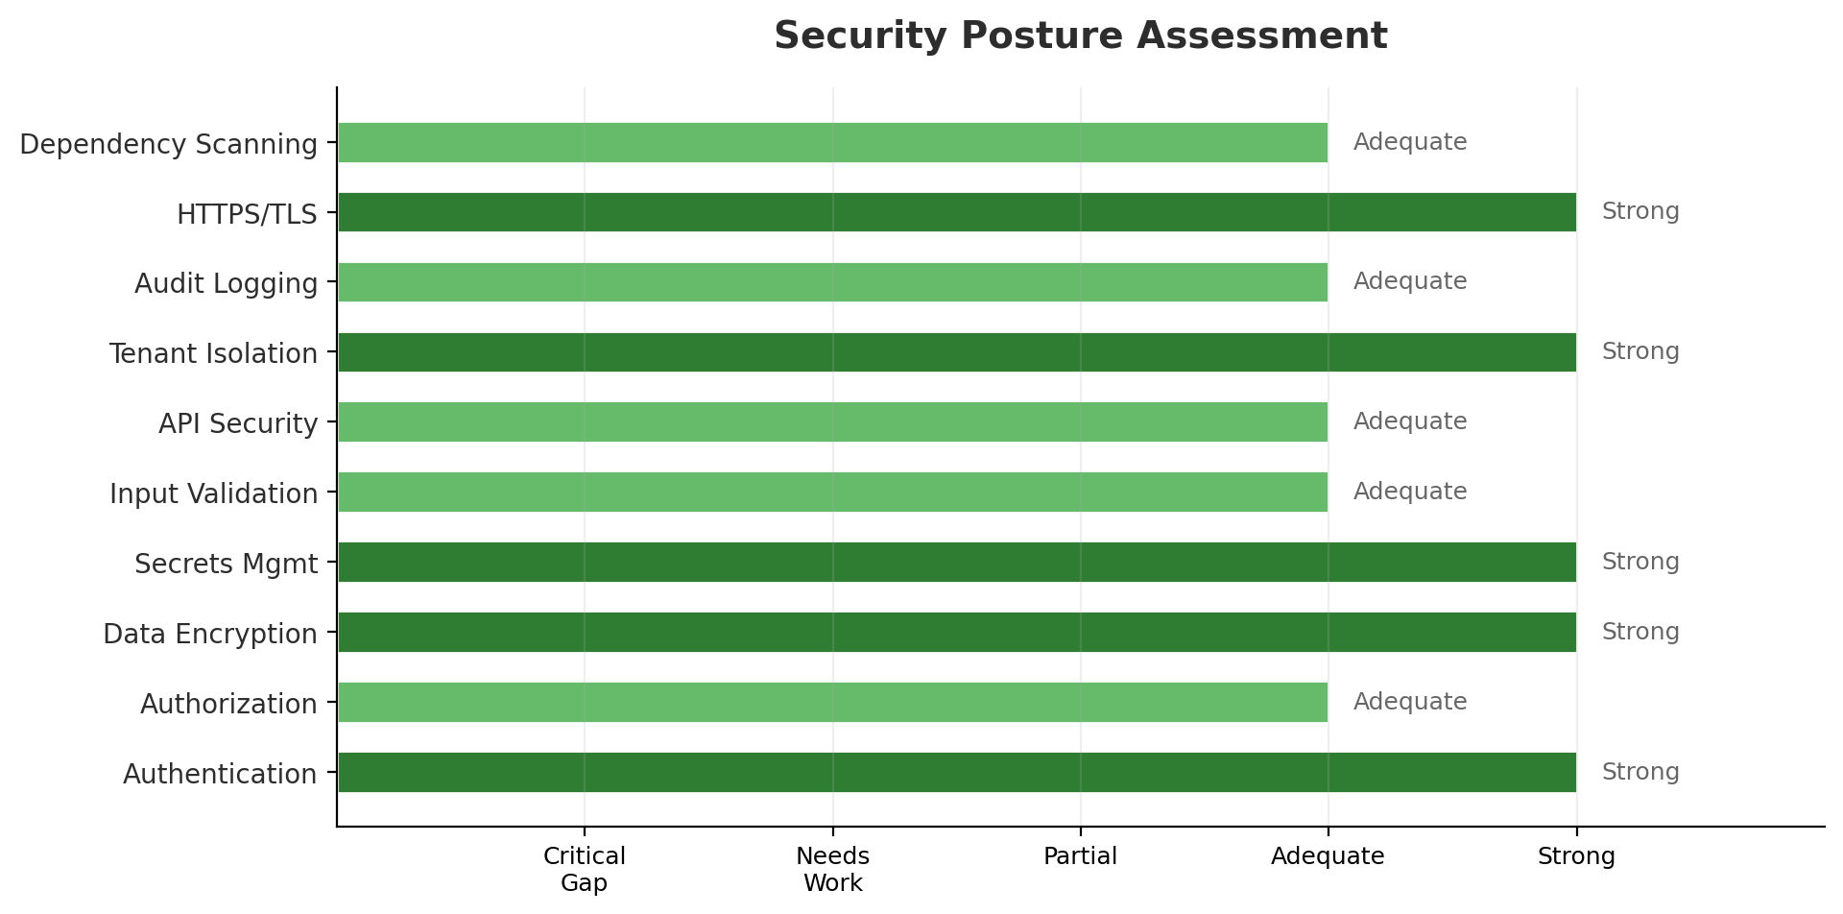
Figure 4: Security posture assessment across ten domains. All domains rate Adequate or Strong.

5.1 Security Implementation Details
Authentication (Strong): Triple authentication model: Shopify JWT session tokens, SHA-256 hashed API keys via Key Vault, and publishable widget keys with pk_live_ prefix scoping. Additional support for MFA/TOTP, magic link auth, and Argon2 password hashing.
Authorization (Adequate): Per-tenant RBAC with TeamMemberRole enum. Platform admin separated via PLATFORM_ADMIN_TENANT_ID sentinel. Dedicated admin console. Area for improvement: more granular permission model.
Data Encryption (Strong): AES-256-GCM envelope encryption with Azure Key Vault HSM-backed master KEK. Per-tenant Data Encryption Keys (DEKs). Auto-rotation via Key Vault. All sensitive data encrypted at rest.
Secrets Management (Strong): All secrets in Azure Key Vault with managed identity access. No hardcoded keys policy enforced by guardrail regex (SPEC-1845). API key rotation endpoint. CMK auto-rotation.
Tenant Isolation (Strong): Cosmos DB partition keys enforce physical data separation at the database level. TenantScopedRepository base class structurally prevents cross-tenant access. Per-tenant NATS isolation for message routing.
Audit Logging (Adequate): Append-only audit log with 12 event types and 1-year retention. GDPR compliance with PII scrubbing, data export, cascading deletion, and consent management.

5.2 Areas for Improvement
- SOC 2 Type II certification preparation (controls documentation, evidence collection)
- Penetration testing by an independent third party
- Web Application Firewall (WAF) at the ingress layer (currently using Container Apps native ingress)
- More granular RBAC beyond team member roles (field-level permissions)

6. Multi-Tenant Architecture
Agent Red implements a deeply integrated multi-tenant architecture with isolation enforced at multiple layers: database partitioning, application-level repository pattern, message bus isolation, and per-tenant encryption.
Tenant Isolation: Enterprise-Grade
The combination of Cosmos DB partition keys, TenantScopedRepository base class, per-tenant NATS isolation, and per-tenant envelope encryption provides defense-in-depth tenant isolation that exceeds typical SaaS security patterns.

6.1 Isolation Layers
Database Layer: Cosmos DB partition keys use tenant_id as the partition key on all 20+ collections. Cross-partition queries are structurally impossible without explicit tenant_id specification.
Application Layer: TenantScopedRepository base class enforces mandatory tenant_id on every database operation. All repositories inherit from this base class, making tenant isolation a structural guarantee rather than a convention.
Message Bus Layer: NATS JetStream uses per-tenant subject namespacing for agent-to-agent communication, preventing message leakage between tenants.
Encryption Layer: Per-tenant Data Encryption Keys (DEKs) ensure that even with database-level access, one tenant's data cannot be decrypted with another tenant's key.
Observability Layer: Per-tenant OpenTelemetry correlation (tenant_id as span attribute) enables isolated monitoring and debugging without cross-tenant data exposure.

6.2 Tenant Lifecycle
- 4 subscription tiers: trial, starter, professional, enterprise
- Lifecycle states: provisioning, active, past_due, grace_period (plus suspended/deprovisioned)
- Stripe-integrated billing with metered usage tracking
- Per-tenant rate limiting: 300 RPM ceiling, 10 RPM floor, platform admin exempt
- Domain index collection for tenant lookup without cross-partition queries
- License management per subscription tier

7. Competitive Landscape
Agent Red operates in the AI-powered customer service market, competing against established players ranging from enterprise platforms to SMB-focused solutions. The following comparison positions Agent Red against key competitors.
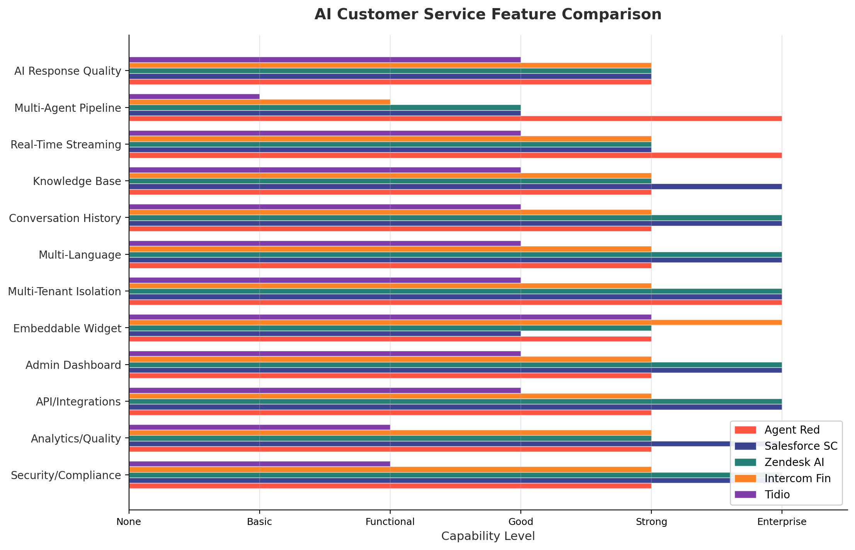
Figure 5: Feature capability comparison across twelve AI customer service dimensions. Agent Red shows strength in multi-agent pipeline, real-time streaming, and tenant isolation.

7.1 Competitor Profiles
Competitor | Pricing | Market Position
Salesforce Service Cloud | $25-$500/user/mo | Market leader with Einstein AI. Comprehensive but complex and expensive. Strong enterprise adoption. AI features are add-ons to existing CRM.
Zendesk AI | $55-$169/agent/mo | Established support platform with AI agent capabilities. Strong ticket management and knowledge base. AI features expanding rapidly.
Intercom Fin | $29-$132/seat/mo | Leading conversational support platform. Fin AI agent handles common queries. Strong in-app messaging and product tours. Growing AI capabilities.
Tidio | $0-$59/mo | Budget-friendly chatbot platform for small businesses. Limited AI sophistication. Strong Shopify integration. Growing market share in micro-business segment.

7.2 Agent Red Differentiation
- Multi-agent pipeline with specialized AI agents (intent, knowledge, response, critic) — deeper AI architecture than single-model competitors
- Critic-retraction pattern ensures AI response quality before delivery — unique quality gate not found in competitor products
- Per-tenant envelope encryption with HSM-backed keys — exceeds typical SaaS security practices
- Shopify-native integration via App Bridge — optimized for e-commerce merchants
- Embeddable widget with Shadow DOM isolation — minimal impact on merchant site performance
- AI-assisted development model (Claude co-authoring) — enables rapid feature development at scale
- CRM integration potential (OrbaTech partnership) — AI insights flowing into sales pipeline

8. Reliability & Serviceability

8.1 Reliability
Container health probes: All 9 containers have health check endpoints. Container Apps automatically restarts unhealthy instances and routes traffic away during failures.
Auto-scaling: HTTP-triggered scaling (2-8 replicas for gateway, 2-10 for response generator) and NATS-triggered scaling for agent containers ensures capacity matches demand.
Database resilience: Cosmos DB continuous backup with 7-day point-in-time restore (PITR). Serverless + provisioned throughput options prevent throttling under load.
Message durability: NATS JetStream durable subscriptions provide at-least-once delivery guarantees for agent-to-agent communication.
Critic-retraction: The critic agent can retract an AI response mid-stream if quality thresholds are not met, preventing low-quality responses from reaching customers.
Areas for improvement: Multi-region disaster recovery is not yet implemented. Load testing at 1,000+ tenant scale has not been validated. Circuit breaker patterns could be more comprehensive.

8.2 Serviceability
Deployment process: Automated build/deploy scripts (build.py, deploy.py). GitHub Actions triggers Docker build, pushes to ACR, deploys to Container Apps. UI-only overlay deploys in 30-60 seconds.
Monitoring: Azure Monitor + Application Insights for infrastructure. Langfuse for AI-specific observability (prompt monitoring, token usage, cost tracking). Custom observability pipeline.
Logging: Structured logging with Azure Log Analytics workspace. Per-tenant correlation via OpenTelemetry span attributes.
Diagnostics: Health check endpoints on all containers. Pre-flight check scripts for staging and production environments. Test host containers for automated verification.
Database management: Schema changes managed through application code (Cosmos DB is schema-flexible). Migration scripts in scripts/ directory with safety gates.

9. Maintainability

9.1 Strengths
- Well-organized project structure with clear separation: src/ (backend), admin/ (3 SPAs), widget/, tests/, infrastructure/
- TenantScopedRepository base class eliminates boilerplate and enforces tenant isolation patterns
- Specification-first development workflow with knowledge database (2,092 specs, 11,055 tests tracked)
- Comprehensive CI/CD prevents regressions: 8 workflows including lint, test, build, deploy
- Shared component library (admin/shared/) reduces duplication across 3 admin SPAs
- Configuration-driven architecture (YAML schema registry) allows tenant customization without code changes
- Conventional commit format enables automated changelog generation

9.2 Concerns
- Single-developer project with AI co-author — bus factor of 1. Knowledge transfer documentation is extensive but untested with new developers.
- Large codebase (2,213 files, 18 MB source) for a solo developer may become challenging to maintain as complexity grows.
- Three separate admin SPAs (standalone, Shopify, provider) with different Mantine versions (7.x and 8.x) may diverge over time.
- Dual AI governance system (CLAUDE.md + knowledge DB) adds operational overhead that may not scale with team growth.
- Some Azure service dependencies (Cosmos DB, Key Vault, NATS) are deeply coupled — migration to alternative providers would be costly.

10. Performance Considerations

10.1 Multi-Tenant Performance
AI Pipeline Latency: The multi-agent pipeline (intent classification, knowledge retrieval, response generation, critic review) introduces sequential latency. SSE streaming mitigates perceived latency by delivering tokens incrementally. Measured at approximately 5 seconds end-to-end, 69-80 tokens per response.
Cosmos DB Performance: Partition key-based queries are O(1) at the database level. Cross-partition queries are avoided by design. Serverless mode handles bursty workloads; provisioned throughput prevents throttling at scale.
Rate Limiting: Per-tenant rate limiting at 300 RPM (derived from ramp-to-overload testing: 1,380 RPM safe capacity per replica) provides noisy-neighbor protection.
Container Scaling: HTTP-triggered and NATS-triggered auto-scaling independently scales each agent based on actual demand. Response Generator (most compute-intensive) scales up to 10 replicas.
Caching: Redis caching for rate limiting and tenant configuration. Langfuse caching for AI observability. Additional caching opportunities exist for knowledge base embeddings.

11. Azure Deployment Configuration
Agent Red is deployed on Azure using Container Apps for compute, Cosmos DB for data, and a comprehensive set of managed services. Infrastructure is managed via Terraform (7 .tf files) with container deployments managed via Azure CLI / GitHub Actions.
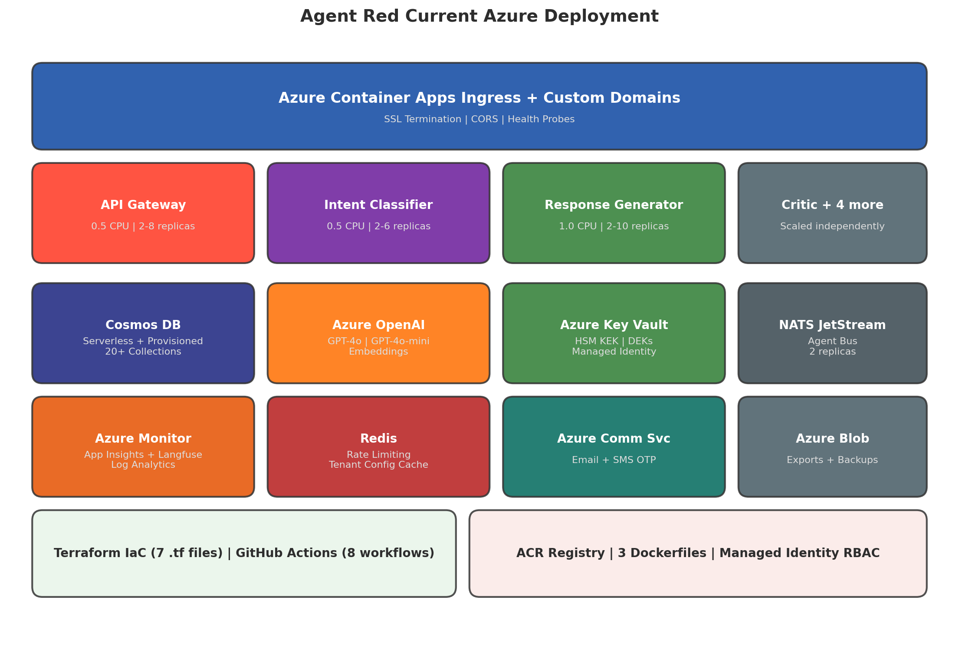
Figure 6: Current Agent Red Azure deployment showing 9 container apps, managed services, and infrastructure-as-code components.

11.1 Container Apps Configuration
Container | Resources | Replicas | Scaling | Purpose
API Gateway | 0.5 CPU, 1 GB | 2-8 replicas | HTTP scaling | Main entry point. FastAPI. SSL termination.
Intent Classifier | 0.5 CPU, 1 GB | 2-6 replicas | NATS scaling | GPT-4o-mini. Classifies customer intent.
Knowledge Retrieval | 0.5 CPU, 1 GB | 2-6 replicas | NATS scaling | RAG pipeline with embeddings.
Response Generator | 1.0 CPU, 2 GB | 2-10 replicas | NATS scaling | GPT-4o. Generates customer responses.
Critic Supervisor | 0.5 CPU, 1 GB | 2-4 replicas | NATS scaling | Quality gate. Can retract responses.
Escalation | 0.25 CPU, 0.5 GB | 1-3 replicas | NATS scaling | Human handoff orchestration.
Analytics | 0.25 CPU, 0.5 GB | 1-2 replicas | NATS scaling | Metrics aggregation.
Slim Gateway | 0.5 CPU, 1 GB | 2 (fixed) | Fixed | UI-only fast-rebuild overlay.
NATS | 0.5 CPU, 1 GB | 2 (fixed) | Fixed | JetStream message bus.

12. Azure Cost Projections
Agent Red's Azure costs are driven primarily by Azure OpenAI consumption (token-based), container compute, and Cosmos DB throughput. The following estimates model cost at three scaling tiers.
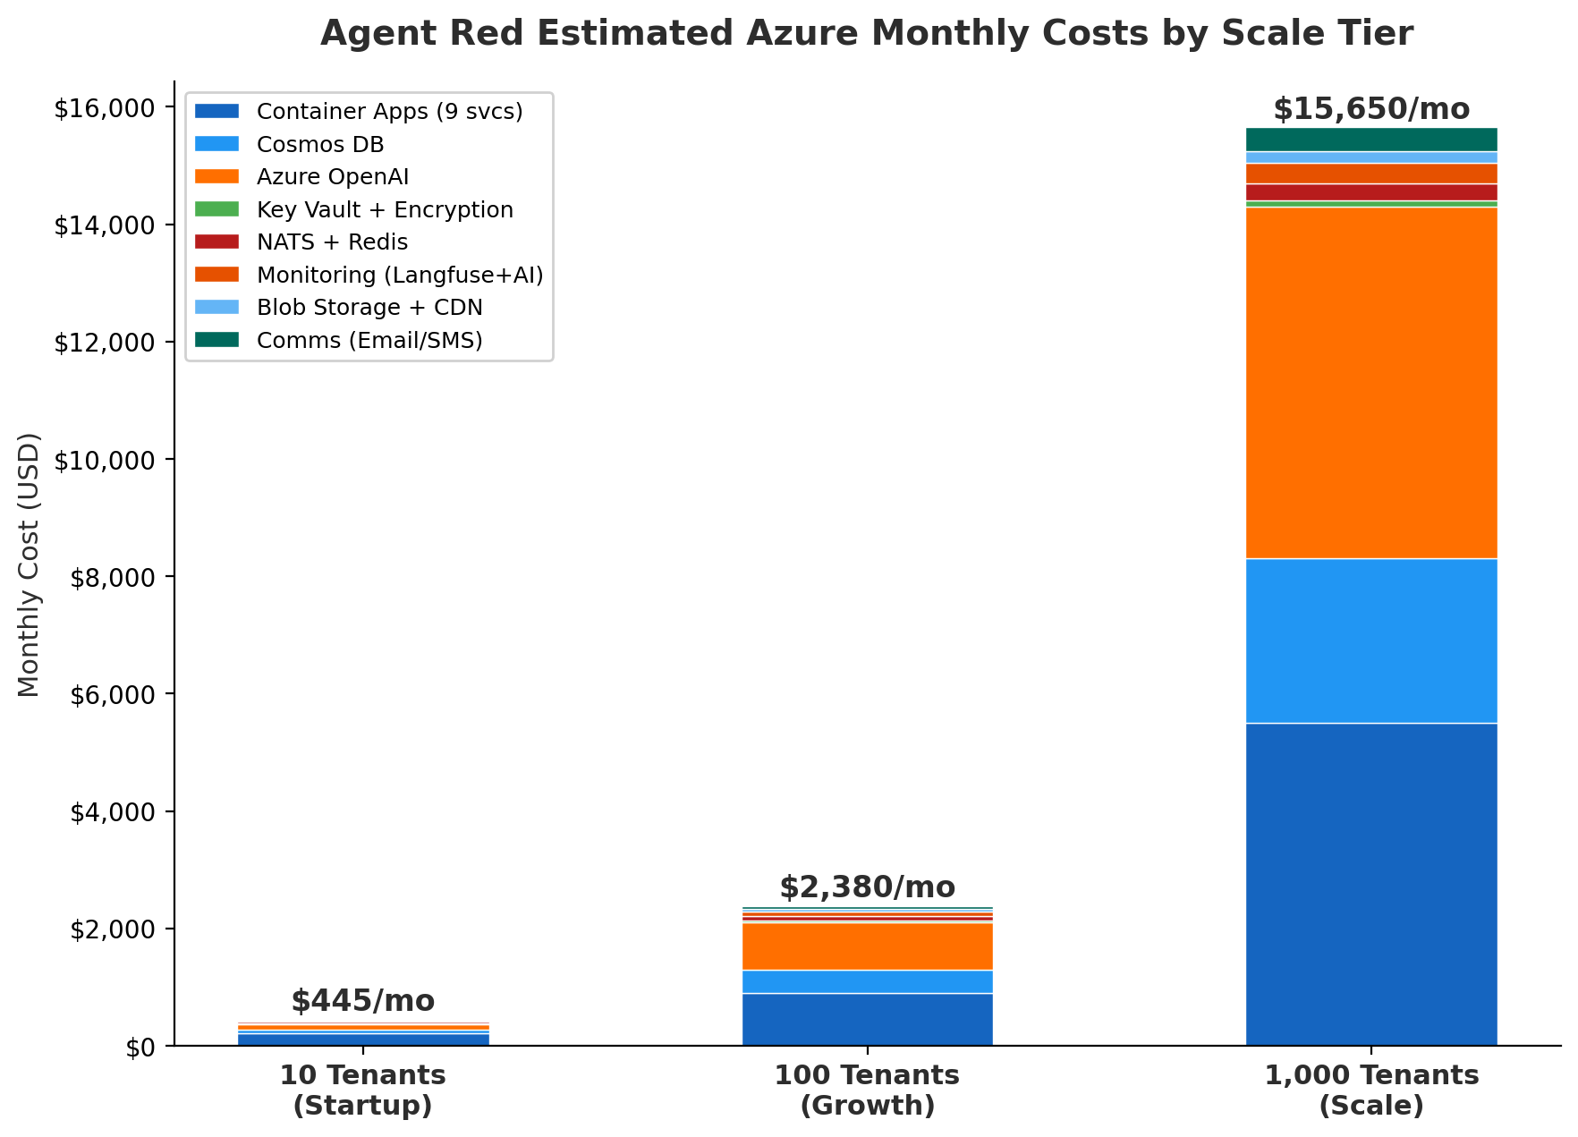
Figure 7: Estimated monthly Azure costs by scale tier. Azure OpenAI becomes the dominant cost at scale, followed by container compute and Cosmos DB.

Component | 10 Tenants | 100 Tenants | 1,000 Tenants
Container Apps (9 svcs) | $220 | $900 | $5,500
Cosmos DB | $50 | $400 | $2,800
Azure OpenAI | $100 | $800 | $6,000
Key Vault + Encryption | $10 | $30 | $100
NATS + Redis | $30 | $80 | $300
Monitoring (Langfuse+AI) | $20 | $80 | $350
Blob Storage + CDN | $10 | $40 | $200
Comms (Email/SMS) | $5 | $50 | $400
TOTAL | $445/mo | $2,380/mo | $15,650/mo

Note: Azure OpenAI costs are highly variable based on conversation volume and response length. Estimates assume average 3 conversations/tenant/day with ~500 tokens per conversation (input + output). Per-tenant cost at scale: approximately $15.65/tenant/month at 1,000 tenants. Reserved capacity and provisioned throughput discounts could reduce costs by 20-30% at scale.

13. Recommended Technical Priorities
Agent Red's engineering maturity is high, shifting priorities from foundational concerns to market readiness, compliance, and partnership enablement.
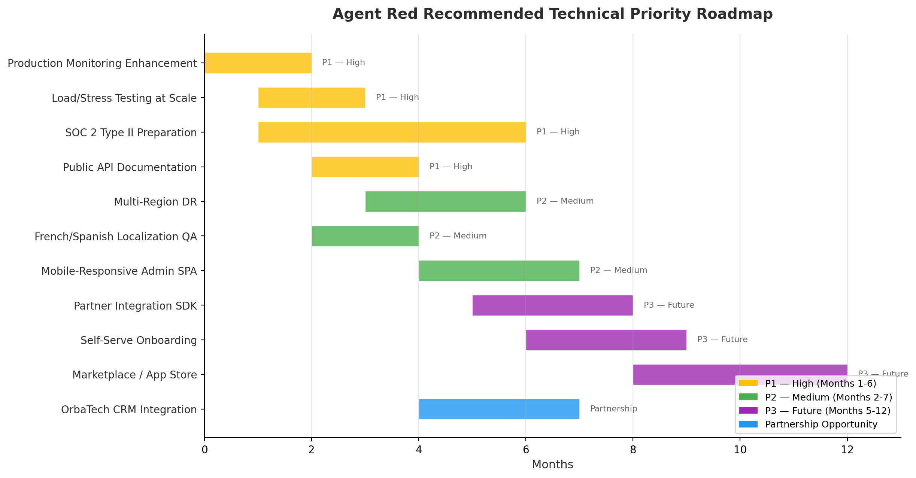
Figure 8: Recommended technical priority roadmap for Agent Red over 12 months.

P1 — High (Months 1-6)
Production Monitoring Enhancement: Extend Azure Monitor alerting rules. Add SLO dashboards (availability, latency p99, error rate). Implement on-call rotation alerting.
Load/Stress Testing at Scale: Validate 100-tenant and 1,000-tenant performance using Locust load testing. Identify bottlenecks in NATS, Cosmos DB throughput, and OpenAI rate limits.
SOC 2 Type II Preparation: Document security controls. Implement evidence collection automation. Engage third-party auditor. Target 6-month audit window.
Public API Documentation: Publish OpenAPI-based developer documentation. Create integration quickstart guides. Enable self-serve API key provisioning.

P2 — Medium (Months 2-7)
Multi-Region Disaster Recovery: Deploy secondary region (Canada East or East US 2). Configure Cosmos DB multi-region writes. Implement Azure Front Door for geographic routing and failover.
French/Spanish Localization QA: Widget supports 8 languages but admin SPAs are English-only. Extend localization to admin interfaces. Professional translation review for fr-CA and es-MX.
Mobile-Responsive Admin SPA: Optimize admin dashboards for tablet and mobile viewports. Priority: standalone admin SPA used by non-Shopify merchants.

P3 — Future (Months 5-12)
Partner Integration SDK: Publish a partner SDK enabling CRM systems (like OrbaTech) to integrate bidirectionally. Include webhooks, OAuth, and event schemas.
Self-Serve Onboarding: Automate tenant provisioning with self-serve signup, Stripe checkout, and guided setup wizard. Reduce time-to-value for new merchants.
Marketplace / App Store: Enable third-party plugin agents via the existing plugin architecture. Publish agent marketplace for domain-specific AI capabilities.

Partnership Opportunity
OrbaTech CRM Integration: Implement bidirectional data flow: CRM contact data enriches AI context, AI conversation insights flow back to CRM records. See Annex B for detailed architecture.

Annex A: Agent Red vs OrbaTech Recommended Azure Configuration
This annex compares Agent Red's current Azure deployment against the recommended Azure configuration for OrbaTech CRM. The comparison highlights different architectural approaches to similar cloud challenges and identifies opportunities for shared infrastructure.
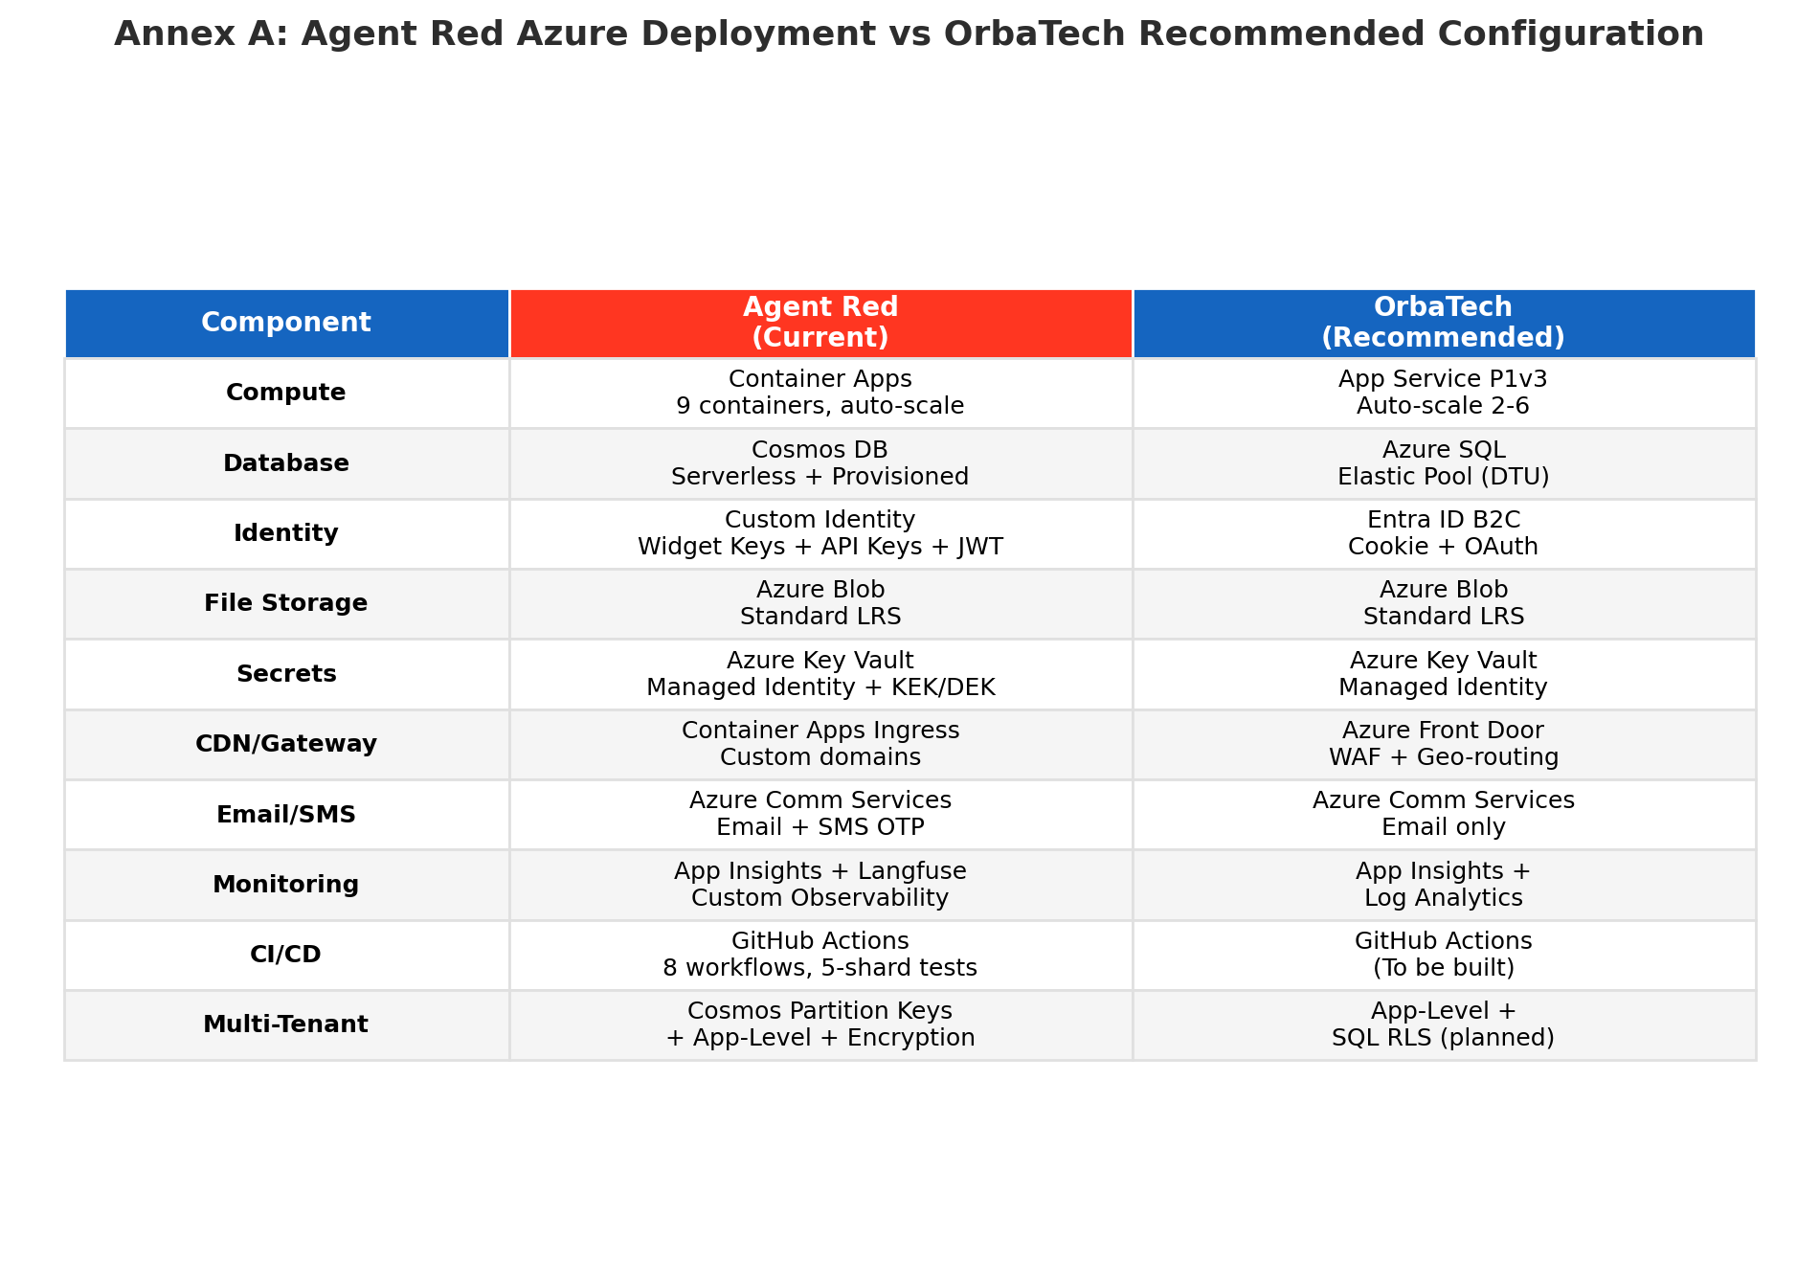
Figure 9: Side-by-side comparison of Agent Red current and OrbaTech recommended Azure deployments.

A.1 Key Architectural Differences
Compute Model: Agent Red uses Azure Container Apps with 9 independently scaled microservices, enabling fine-grained resource allocation per agent. OrbaTech's recommended App Service PaaS model is simpler and more cost-effective for a monolithic .NET application.
Database Strategy: Agent Red's Cosmos DB provides schema-flexible document storage with native partition-key tenant isolation, optimized for real-time AI conversations. OrbaTech's recommended Azure SQL with Elastic Pool is appropriate for structured CRM data with complex queries and reporting.
Identity Approach: Agent Red implements custom identity with multiple authentication paths (JWT, API keys, widget keys) to support diverse integration scenarios (Shopify, standalone, embedded widget). OrbaTech's recommended Entra ID B2C provides managed consumer identity suitable for direct user authentication.
CI/CD Maturity: Agent Red has a mature 8-workflow pipeline with 5-shard parallel testing, vulnerability scanning, and automated deployment. OrbaTech needs to build CI/CD from the ground up, but could leverage Agent Red's pipeline patterns as a template.
Security Depth: Agent Red implements per-tenant envelope encryption with HSM-backed KEK, managed identities, and pre-auth rate limiting. OrbaTech's recommended configuration includes Row-Level Security and Key Vault, but has less encryption depth.

A.2 Shared Infrastructure Opportunities
- Shared Azure Key Vault patterns for secrets management (both platforms use Key Vault)
- Common Azure Monitor / Application Insights workspace for cross-platform observability
- Shared Azure Communication Services instance for email and SMS delivery
- Common GitHub Actions workflow templates adaptable to both Python and .NET stacks
- Shared Azure Front Door configuration for unified SSL, WAF, and geographic routing
- Shared Container Registry (ACR) if OrbaTech eventually containerizes

Annex B: Agent Red + OrbaTech CRM Integration
This annex describes a bidirectional integration architecture between Agent Red AI Customer Service and OrbaTech CRM. The integration enables CRM-enriched AI conversations and AI-informed customer relationship management.
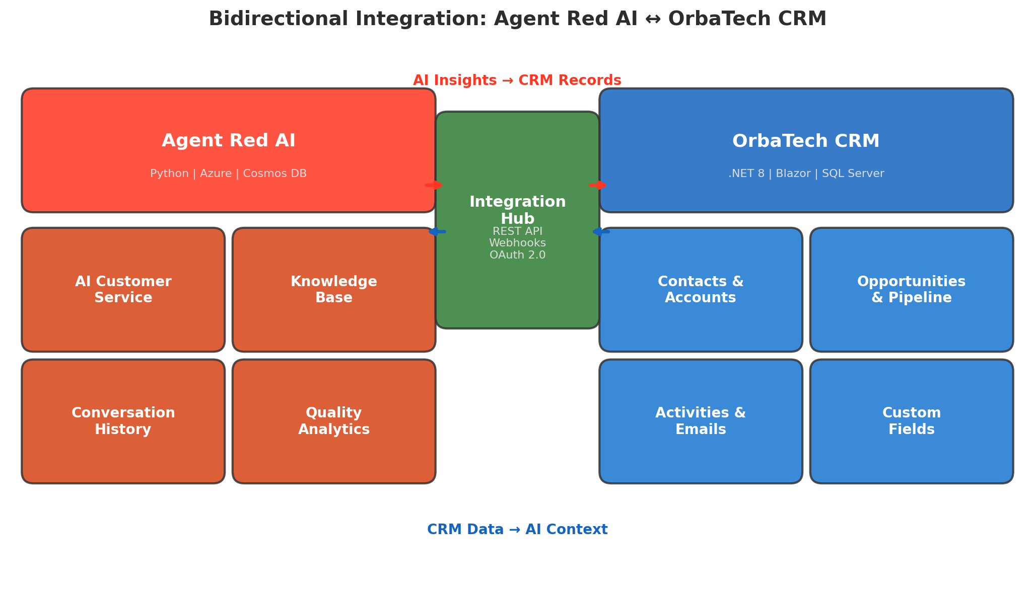
Figure 10: Bidirectional integration architecture between Agent Red AI and OrbaTech CRM.

B.1 Agent Red to CRM (AI Insights)
Conversation Summaries: AI-generated summaries of customer interactions are written to CRM contact records as activities, creating a complete interaction timeline accessible to sales teams.
Sentiment Analysis: Real-time customer sentiment scores from AI conversations are attached to opportunity records, providing sales teams with early warning signals on at-risk deals.
Quality Metrics: Per-interaction quality scores (from the critic agent) help sales managers identify training opportunities and customer satisfaction trends.
Lead Qualification: AI-assessed purchase intent signals from customer conversations automatically create or update opportunity records in the CRM pipeline.

B.2 CRM to Agent Red (Customer Context)
Contact Context: Customer profiles, purchase history, and communication preferences from OrbaTech enrich Agent Red's AI context, enabling personalized responses.
Opportunity Status: Active deals and pipeline stages inform Agent Red's conversation routing, ensuring high-value prospects receive priority handling and appropriate agent assignment.
Activity History: Recent emails, calls, and meetings from CRM provide conversation context, reducing customer frustration from repeating information.
Custom Fields: Tenant-specific custom fields from OrbaTech enable Agent Red to adapt its responses to each business's unique CRM taxonomy and domain vocabulary.

B.3 Integration Technical Requirements
- OAuth 2.0 service-to-service authentication with client credentials flow
- Agent Red's existing integration framework (manifest-based registry) can register OrbaTech as a first-class adapter
- Webhook-based event notifications for real-time data synchronization
- Tenant mapping table linking Agent Red tenant identifiers to OrbaTech TenantId
- Data transformation layer leveraging Agent Red's normalized model pattern (SPEC-1762)
- Rate limiting and circuit breaker patterns (already implemented in Agent Red's adaptive rate limiter)
- Audit logging of all cross-platform data exchanges using Agent Red's append-only audit log

Disclaimer
This report was prepared by Remaker Digital based on the Agent Red source code repository as of April 7, 2026. The findings and recommendations reflect the state of the codebase at that point in time. Technology assessments, cost estimates, and competitive comparisons are based on publicly available data and internal development records. Azure pricing estimates are approximate and subject to change.

© 2026 Remaker Digital, a DBA of VanDusen & Palmeter, LLC. All rights reserved.

