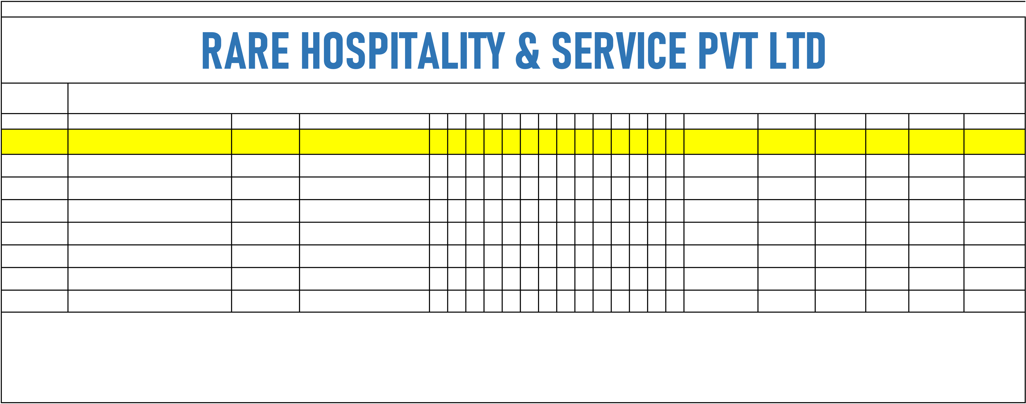
SITE NAME: STANZA LIVING HOUSE NAME: JULAICA/SYZRAN LOCATION: KONDHWA
SR.NO. | EMPLOYEE NAME | HOUSE DESIGNATION |  | 18 19 20 21 22 23 24 25 26 27 28 29 30 31 Present Days OverTime Holidays Absent Week Off Total Days
1 Bhagyashri Dattatrya AlandAustin |  |  | HK Ladies | P | P | P | P | P | P | P | P | P | P | P | 11 4hrs | 0 | 11
 |  |  | HK Ladies | p | p | p | p | p | p | p | p | p | p | p | 11 | 0 | 11
2 Manjudevi |  | Austin | HK Ladies
 |  | Austin | HK Ladies | P | P | P | P | P | P | P | P | P | P | P | 11 | 0 | 11
3 kamlavatidevi |  | Austin | HK Ladies
 |  | Austin | HK Ladies | p | p | p | p | p | p | p | p | p | p | p | 11 | 11
4 Dashrath Laal |  | Austin | HK BOY
 |  | Austin | HK BOY | P |  | P | P | P | P | P | P | P | p | p | 10 | 11
5 Pooja Sarade |  | Austin | HK Ladies
6 Kishor Narwade |  | Austin | HK BOY | p | p | p | p | p | p | p | p | p | p | p | 11 | 11
7 Sunita Sarde |  | Austin | HK LAdies | p |  |  |  |  |  |  |  |  | p | p | 3 | 3
SUPERVISIOR SIGN AUSTIN RC SIGN

