**Day 1**

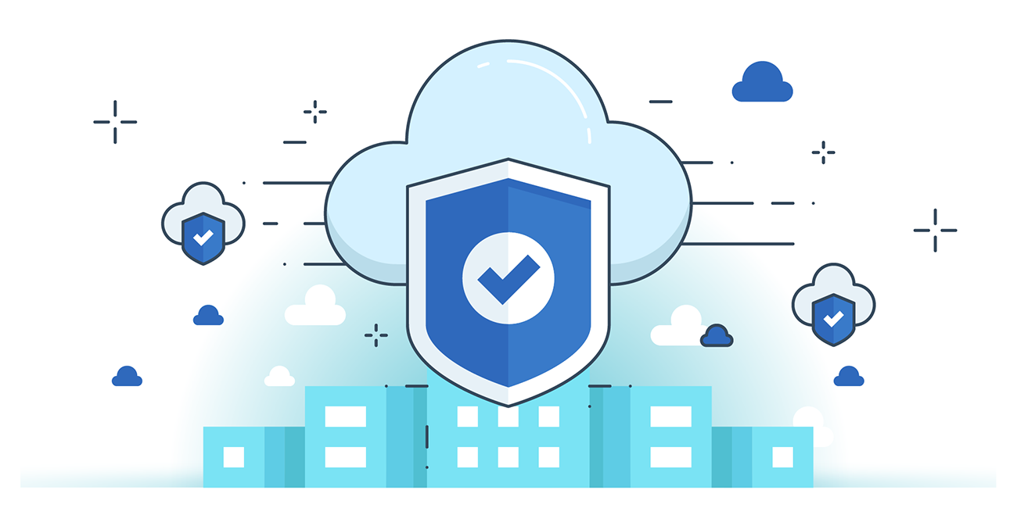



**“CLOUD SECURITY”**

**What is Cloud Computing?**

Cloud computing is the delivery of computing services—including storage, servers, databases, networking, software, and analytics—over the internet (“the cloud”). It enables on-demand access, scalability, and cost-efficiency, allowing users to access resources anytime, anywhere without owning physical infrastructure. It supports innovation, collaboration, and faster deployment of digital solutions.

**Characteristics of Cloud Computing:**

1. On-Demand Self-Service – Users can provision resources without human interaction.
2. Broad Network Access – Services are accessible via the internet from any device.
3. Resource Pooling – Resources are shared among multiple users (multi-tenancy).
4. Rapid Elasticity – Resources can scale up/down automatically as needed.
5. Measured Service – Usage is monitored, controlled, and billed based on consumption.
6. High Availability – Ensures continuous access with minimal downtime.
7. Scalability – Easily adjusts to workload changes.
8. Security – Includes built-in data protection, access control, and compliance features.

**Limitations of cloud computing:**

1. Security and Privacy Risks – Data stored off-site may face unauthorized access or breaches.
2. Downtime and Reliability – Service outages or disruptions can affect availability.
3. Limited Control – Users have less control over infrastructure and updates.
4. Vendor Lock-In – Difficult to switch providers due to compatibility or migration issues.
5. Internet Dependency – Requires stable, high-speed internet for access.
6. Hidden Costs – Unexpected costs can arise from bandwidth, storage, or scaling.
7. Compliance Issues – Meeting regulatory and data residency requirements can be complex.

**Types of Cloud Services Model:**

| **Feature** | **IaaS (Infrastructure as a Service)** | **PaaS (Platform as a Service)** | **SaaS (Software as a Service)** |
| --- | --- | --- | --- |
| **User Controls** | OS, storage, applications | Applications, data | Only application usage |
| **Managed by Provider** | Hardware, networking | Hardware, OS, runtime, middleware | Everything (hardware, platform, app) |
| **Flexibility** | Highly flexible | Moderate flexibility | Least flexible |
| **Use Case** | Hosting virtual machines, storage | App development, testing | Email, CRM, collaboration tools |
| **Examples** | AWS EC2, Microsoft Azure VM | Google App Engine, Heroku | Google Workspace, Dropbox, Salesforce |
| **Target Users** | System admins, IT teams | Developers | End users |
| **Cost Model** | Pay-per-use (compute, storage) | Pay-per-use (platform, tools) | Subscription-based |

**Types of Cloud Deployment Models:**

1. **Public Cloud**  
   Public cloud services are provided by third-party vendors over the internet and shared among multiple users. It is cost-effective, scalable, and requires no infrastructure management by the user.
2. **Private Cloud**  
   A private cloud is dedicated to a single organization, offering more control and security. It can be hosted on-premise or by a third-party provider, tailored to specific business needs.
3. **Community Cloud**  
   Community cloud is shared by several organizations with common concerns (e.g., compliance, security). It is collaborative but more restricted than public clouds.
4. **Hybrid Cloud**  
   Hybrid cloud combines two or more clouds (private, public, or community). It enables flexibility, allowing data and applications to move between environments.

| **Feature** | **Public Cloud** | **Private Cloud** | **Community Cloud** | **Hybrid Cloud** |
| --- | --- | --- | --- | --- |
| **Ownership** | Cloud provider | Single organization | Multiple similar orgs | Mixed (public + private) |
| **Security** | Moderate | High | Moderate to high | Variable, based on components |
| **Cost** | Low (shared resources) | High (dedicated setup) | Shared costs | Moderate |
| **Customization** | Limited | High | Moderate | High |
| **Scalability** | High | Moderate | Moderate | High |
| **Use Case** | Startups, testing | Banks, gov agencies | Research groups, consortia | Enterprises needing flexibility |