**Day 12**

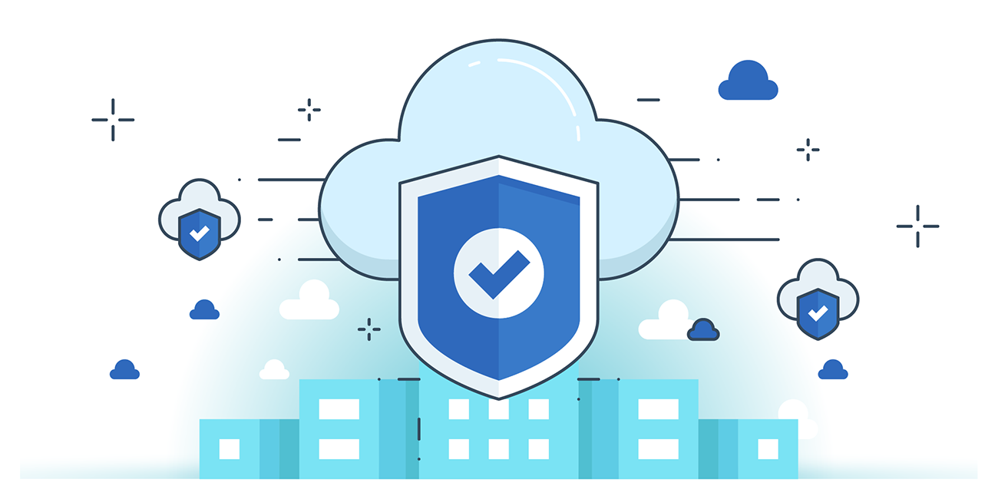



**“CLOUD SECURITY”**

**Utilizing Separate VPCs to Isolate Infrastructure**

1. **Purpose & Benefits**

* Amazon VPC provides logically isolated virtual networks within AWS to separate workloads or organizational units.
* Enhances security, network control, and resource management in the public cloud.

1. **Isolation & Configuration**

* Use subnets to separate application tiers (e.g., web, app, DB).
* Private subnets prevent direct internet access to sensitive instances.
* Administrators control IP ranges, DHCP, routing, and access policies.

1. **Security Features**

* Security Groups (SGs): Act as virtual firewalls to control traffic to/from instances.
* Access Control Lists (ACLs): Define specific IPs or applications allowed to access the VPC.
* Prevents DDoS and unauthorized access by isolating instances from public exposure.

1. **Result**

* Ensures granular access control, layer-3 Internet isolation, and multi-tenant data separation in AWS.

**Creating a VPC:**

Steps:

Open the AWS, and enter VPC in the search bar, and press enter. Following Screen will appear:

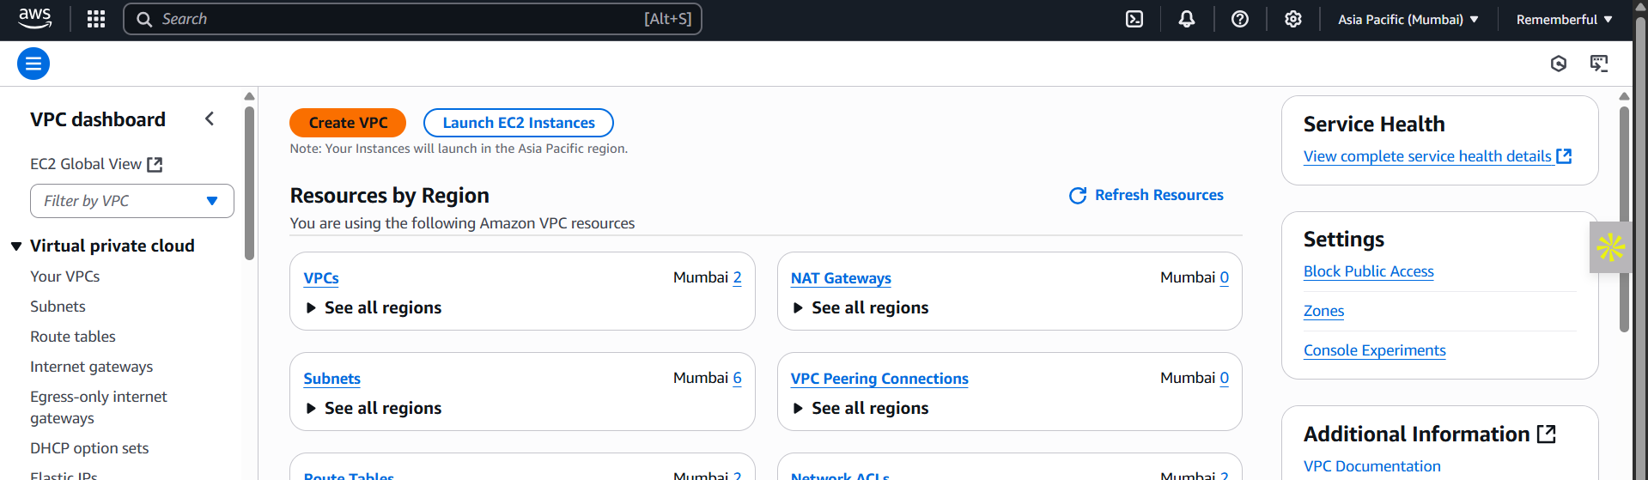

Click on the “Create VPC” button: following screen will appear

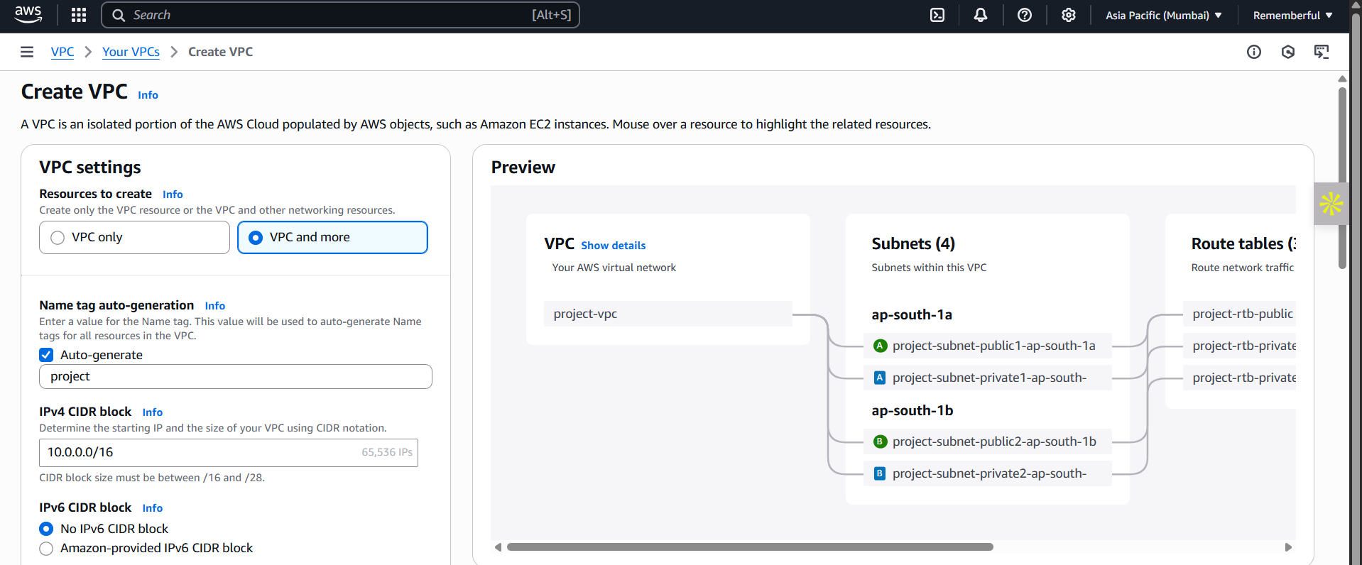

Specify the details and then click on the “create VPC” button at the bottom.

**Best practices for creating a secure and well-architected VPC in AWS:**

1. **VPC Design**

* Choose a non-overlapping CIDR block (e.g., 10.0.0.0/16).
* Create separate public and private subnets.
* Use multiple Availability Zones (AZs) for high availability.
* Isolate application tiers (web, app, DB) using subnets.

1. **Security Best Practices**

* Use Security Groups (SGs):
  + Allow only required ports/IPs.
  + Avoid 0.0.0.0/0 unless strictly necessary.
* Use Network ACLs (NACLs) for subnet-level filtering.
* Enable VPC Flow Logs for traffic monitoring and auditing.

1. **Internet & Routing**

* Attach an Internet Gateway (IGW) to VPC for internet access.
* Use NAT Gateway or NAT instance for secure internet access from private subnets.
* Configure Route Tables correctly for each subnet.

1. **Private Connectivity**

* Use VPC Endpoints (Interface/Gateway) for private AWS service access.
* Use AWS PrivateLink for secure private connectivity to third-party services.

1. **Network Management**

* Enable DNS resolution and hostnames.
* Use DHCP options set for custom domain names.
* Use Tags for organizing and managing resources.

1. **Access & Control**

* Use Bastion Host (Jump Box) for SSH access to private instances.
* Enforce IAM roles and policies for least-privilege access.
* Use multi-factor authentication (MFA) for management access.

1. **Monitoring & Compliance**

* Enable AWS CloudTrail to log all API actions.
* Use AWS Config for continuous compliance checks.
* Enable Amazon GuardDuty for threat detection.

1. **Encryption**

* Use AWS KMS for encrypting data at rest (EBS, S3).
* Enforce TLS for data in transit.

1. **High Availability**

* Deploy resources across multiple AZs.
* Use Elastic Load Balancing for distributing traffic.
* Set up Auto Scaling for resilience.