**Day 13**





**“CLOUD SECURITY”**

**AWS Network ACLs (NACLs) to secure a VPC:**

1. NACLs provide subnet-level, stateless firewall protection, requiring explicit rules for both inbound and outbound traffic.
2. They support both allow and deny rules, enabling fine-grained control over protocols, ports, and IPs—evaluated in order by rule number.
3. Best used alongside Security Groups for layered security; customize default NACLs to block unwanted traffic and mitigate DDoS attacks.

**Where can we find this NACL?**

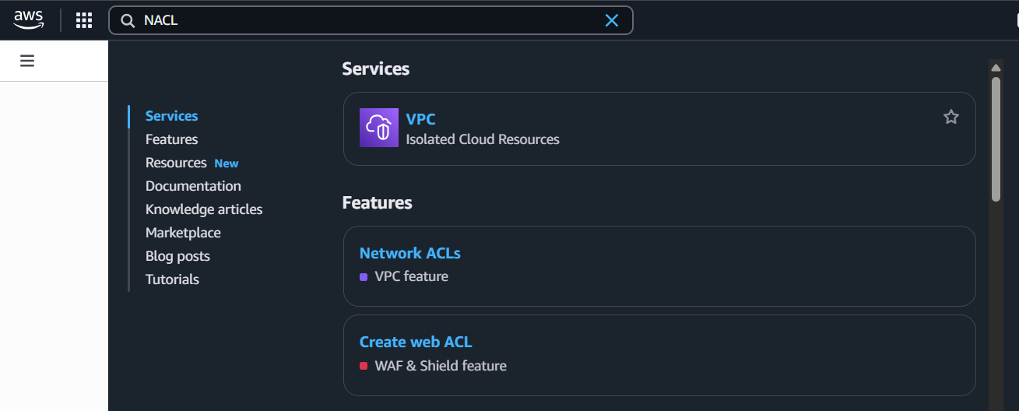

**What is NACL?**

A Network Access Control List (NACL) is a stateless, subnet-level firewall in AWS used to control inbound and outbound traffic for one or more subnets within a VPC.

**Why does NACL exist?**

NACLs exist to provide:

* An additional layer of security in your AWS VPC.
* Fine-grained control over traffic at the network level, complementing Security Groups (which work at the instance level).
* Support for both allow and deny rules, which Security Groups do not offer (SGs only allow traffic).

This helps:

* Filter out unwanted traffic.
* Mitigate threats like DDoS, unauthorized access, or scanning.
* Ensure compliance with network-level access policies.

**Why and How is NACL associated with a VPC?**

* Why: Every VPC automatically comes with a default NACL to control traffic at the subnet level.
* How: When you create a custom VPC, AWS creates a default NACL which you can customize. You can also create new NACLs and associate them with subnets in your VPC.

**Why and How is NACL associated with a Subnet?**

* Why: NACLs operate at the subnet level, not at individual instance level. Each subnet in a VPC must be associated with exactly one NACL.
* How:
  + When you create a subnet, it is automatically associated with the VPC’s default NACL.
  + You can change this by explicitly associating a different NACL with that subnet.
  + The same NACL can be reused across multiple subnets if desired.

**Creating a NACL:**

Steps:

Open the dashboard of NACL:

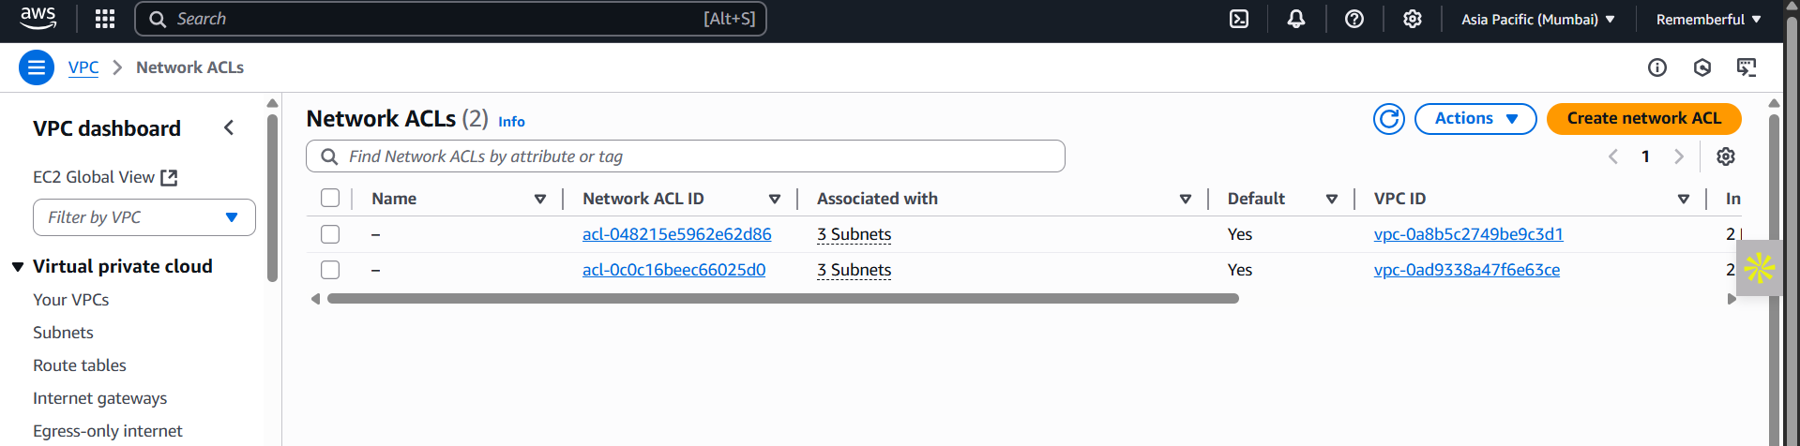

Click on the “Create Network ACL” button: following screen will appear.

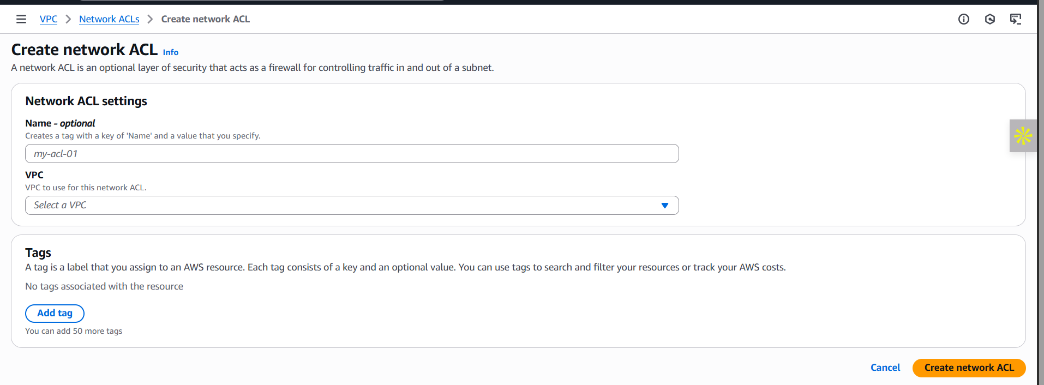

You may add the details and create the NACL associated with a particular VPC.

**Key Reasons for NACL (even with VPC):**

* Traffic Control at Subnet Level: NACLs apply before traffic even reaches EC2 or Security Groups. You can block malicious IPs or ports at subnet level.
* Support for Deny Rules: Unlike Security Groups, NACLs support explicit deny (e.g., block all traffic from a known bad IP).
* Stateless Filtering: Useful for fine-grained control of both inbound and outbound traffic — good for compliance and edge filtering.

**What are the various information we can get from the NACL?**

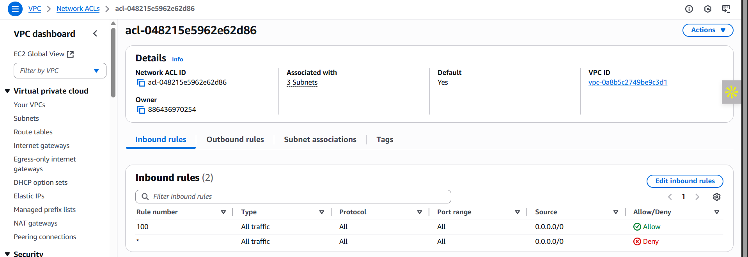

**Think of It Like This:**

* **VPC** = City boundary
* **Subnet** = Neighborhood
* **NACL** = Police checkpoint at the neighborhood entrance
* **Security Group** = Security guard at the individual house (instance)

**Best practices of NACL:**

**1. Principle of Least Privilege**

* Only allow the minimum traffic needed for a subnet to function.
* Deny all unnecessary ports and IP ranges.

**2. Configure Both Inbound and Outbound Rules**

* NACLs are stateless, so for every allowed inbound rule, a corresponding outbound rule must also be created.
  + e.g., Allow HTTP in → Allow ephemeral ports out (1024–65535).

**3. Use Rule Numbering Wisely**

* Rules are evaluated from lowest to highest number.
* Keep DENY rules at lower numbers to take precedence over ALLOW if needed.
* Use spacing (e.g., 100, 110, 120…) to make room for future rules.

**4. Deny Known Malicious IP Ranges**

* If you know malicious IPs or geographies, explicitly deny them at the NACL level.

**5. Use Custom NACLs Instead of Default**

* Default NACL allows all traffic.
* Replace with custom NACLs to apply security best practices.

**6. Combine NACLs with Security Groups**

* NACL = subnet-level, Security Group = instance-level
* Use both together for layered defense.

**7. Separate Public & Private Subnets**

* Apply restrictive NACLs to private subnets.
* Public subnets can be less strict, but should still block unnecessary ports (e.g., Deny port 22 from 0.0.0.0/0).

**8. Enable VPC Flow Logs**

* Use Flow Logs to monitor traffic going through subnets and validate whether NACLs are working as expected.

**9. Use Descriptive Rule Comments (in console or IaC)**

* When using tools like Terraform or CloudFormation, comment your rules clearly for better audit and management.

**10. Review & Audit Regularly**

* Periodically review NACLs to:
  + Remove unused rules.
  + Update ranges (e.g., if IP ownership changes).
  + Ensure they reflect current application needs.

--The End--