**Day 19**





**“CLOUD SECURITY”**

**Implementing AWS IAM:**

Steps:

Open the AWS console, and search for IAM in the Search bar of AWS:

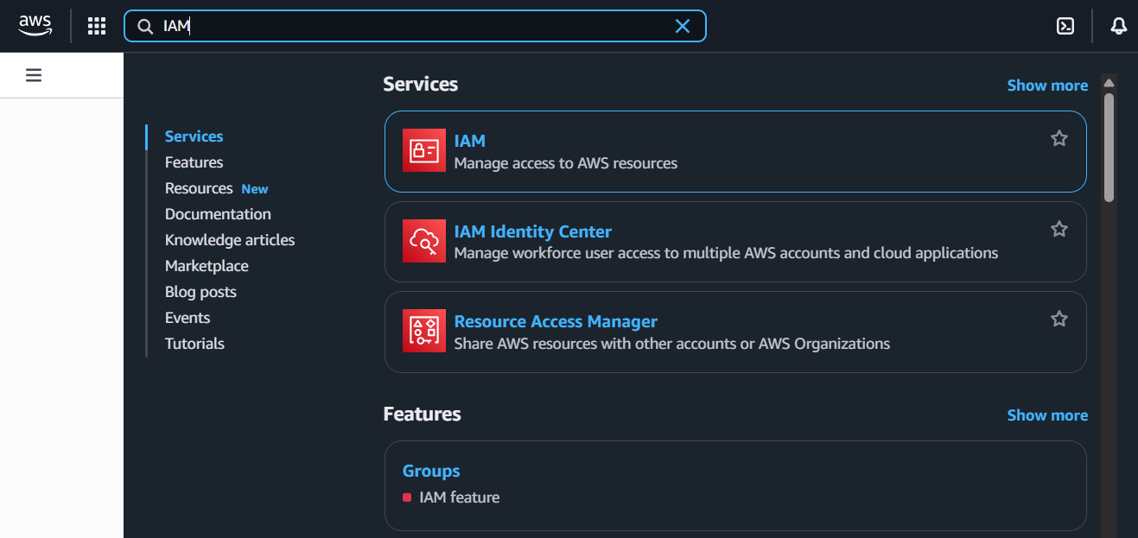

Click on it to open, following screen will appear:

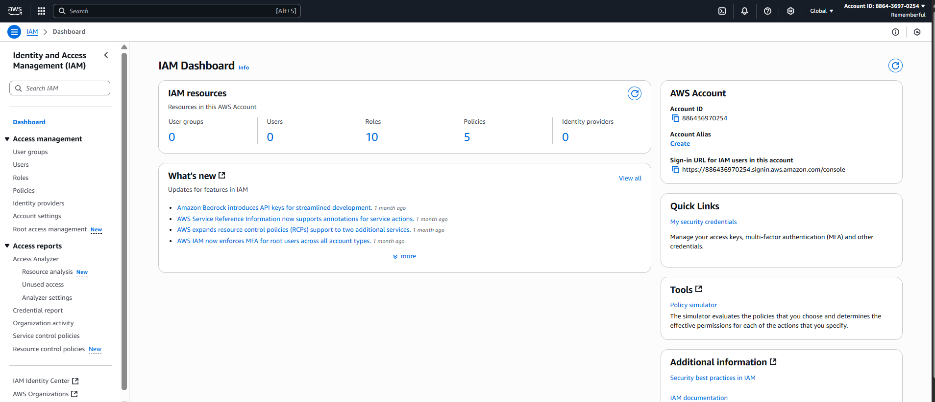

On the dashboard of your left, click on the “User Groups”:

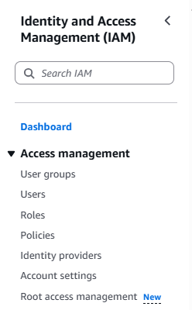

Following screen will appear:

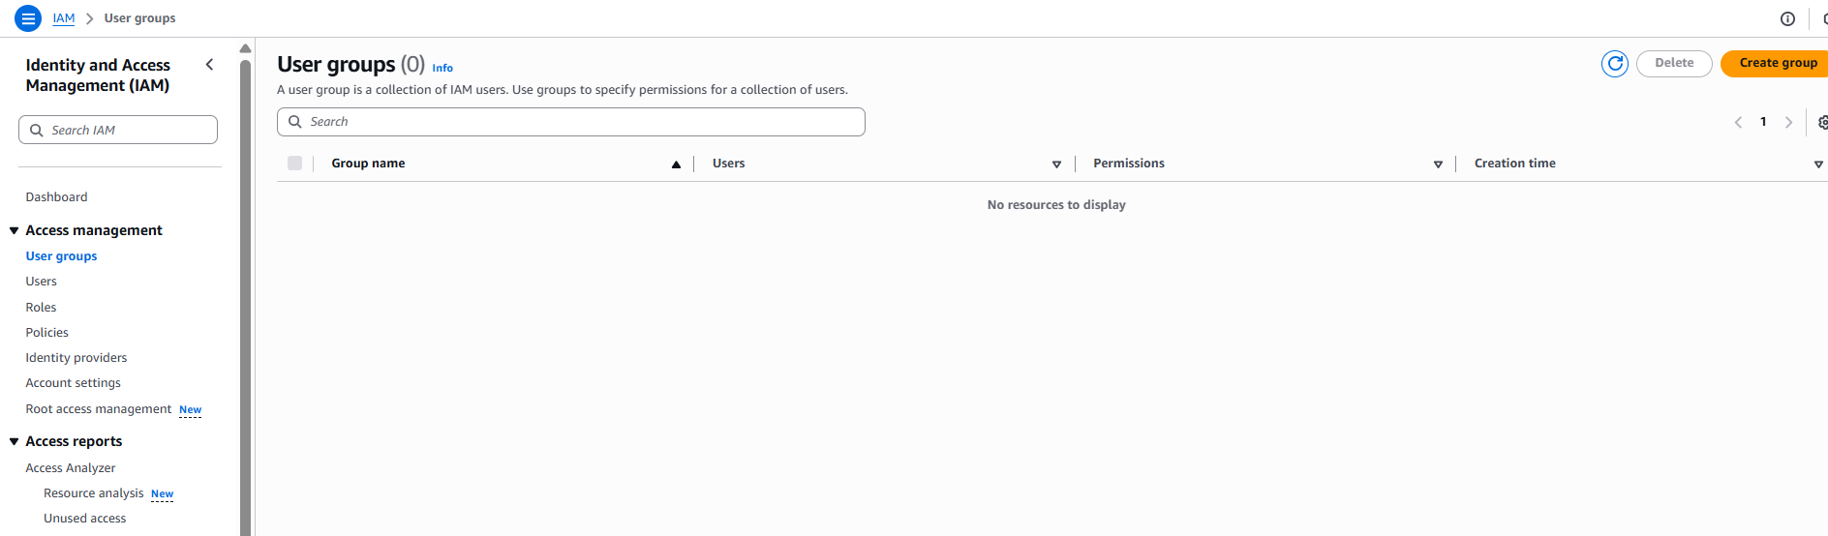

Now, to create the group, click on the “Create group” button: following screen will appear.

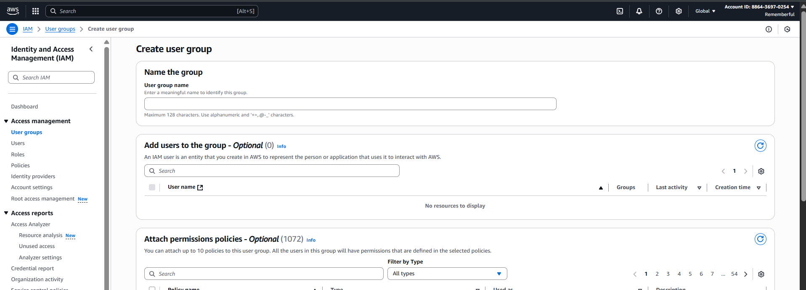

Fill it as per the need:

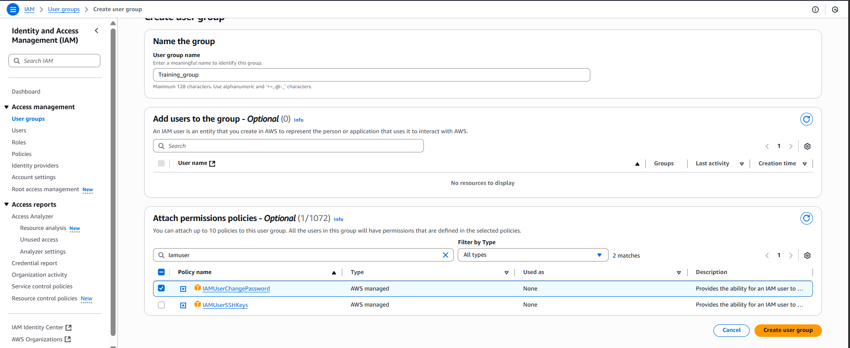

Then click on the “orange” button at the bottom, the group will be created:

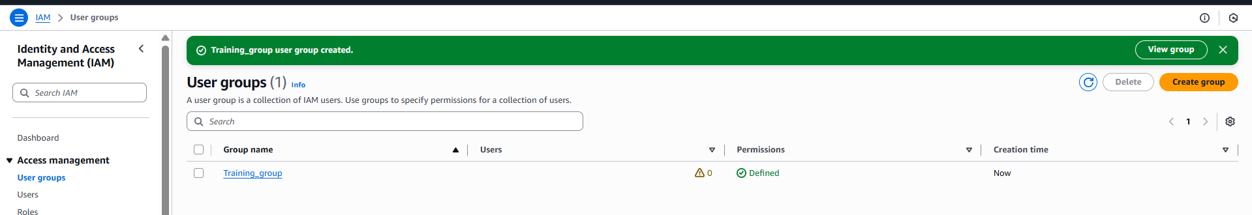

Now, click on the “users” from the dashboard at left: following screen will appear.

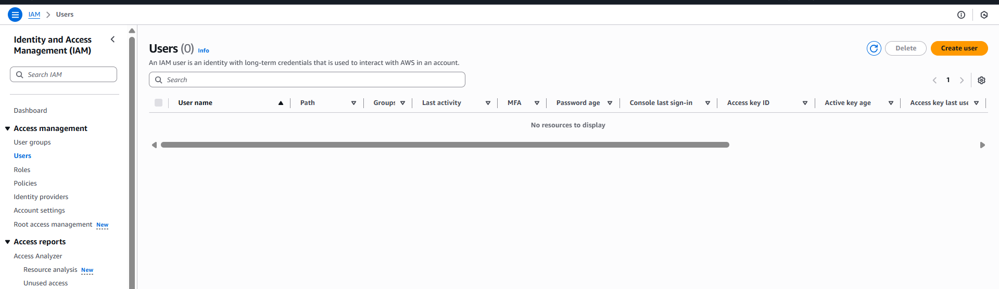

Click on the “create user” button: following screen will appear.

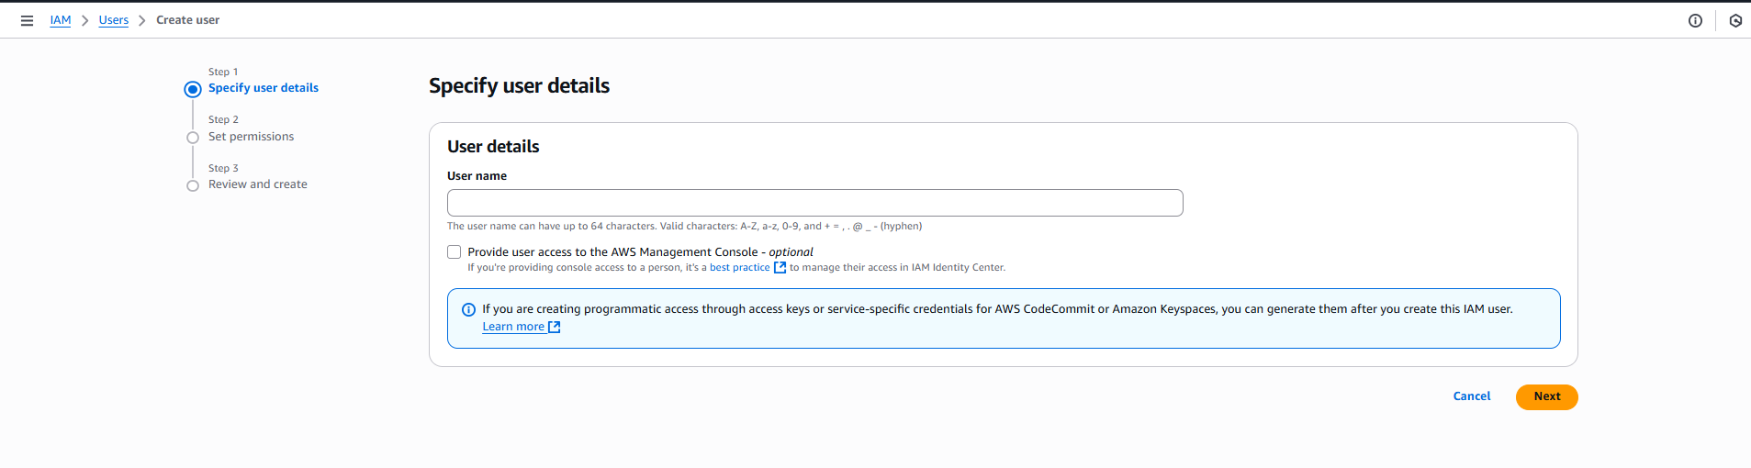

Fill that form accordingly:

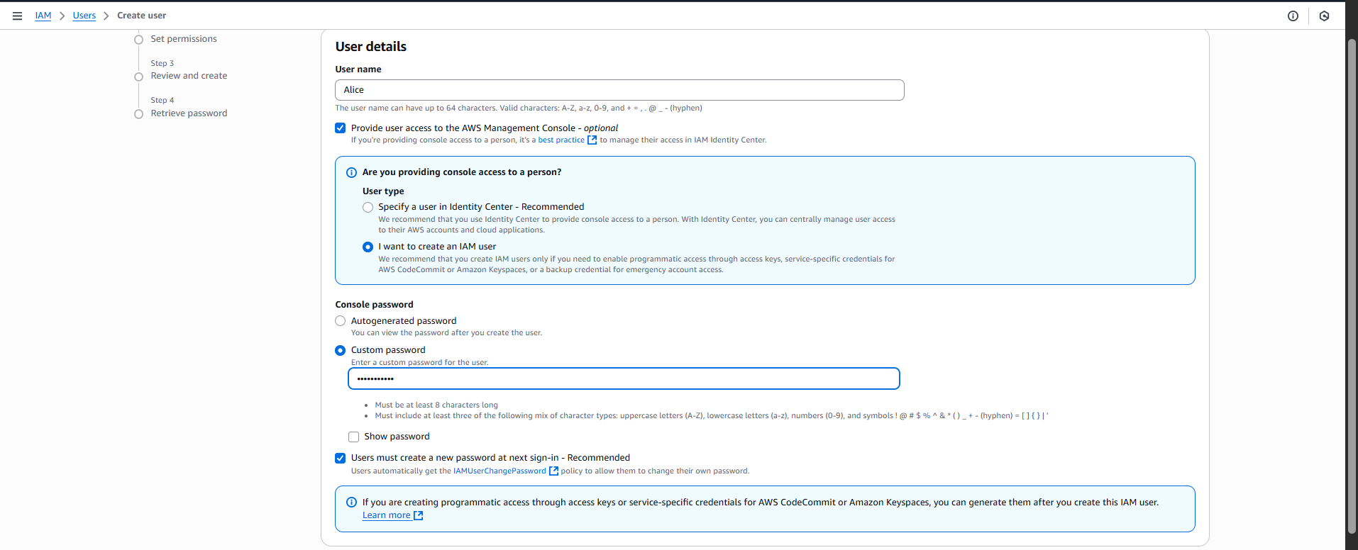

Click on the “Next” button: following screen will appear.

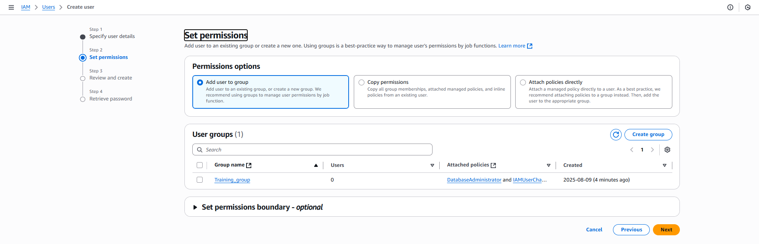

Select the group:

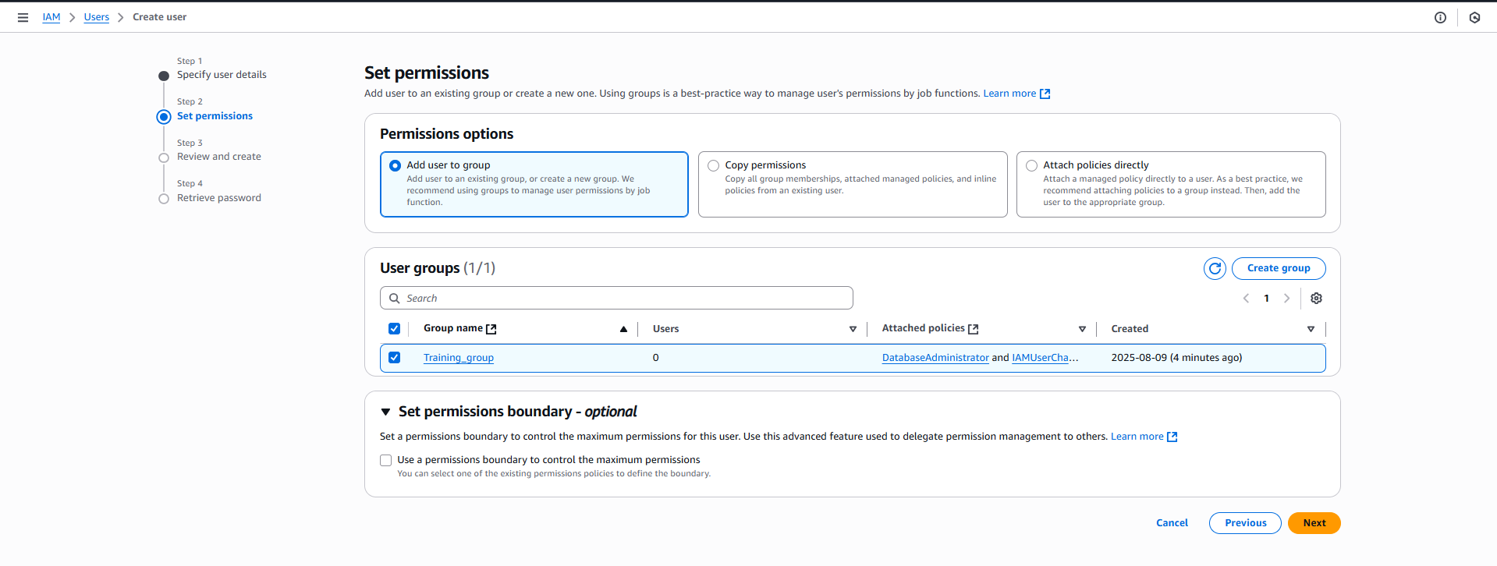

Click on “Next” button: following screen will appear.

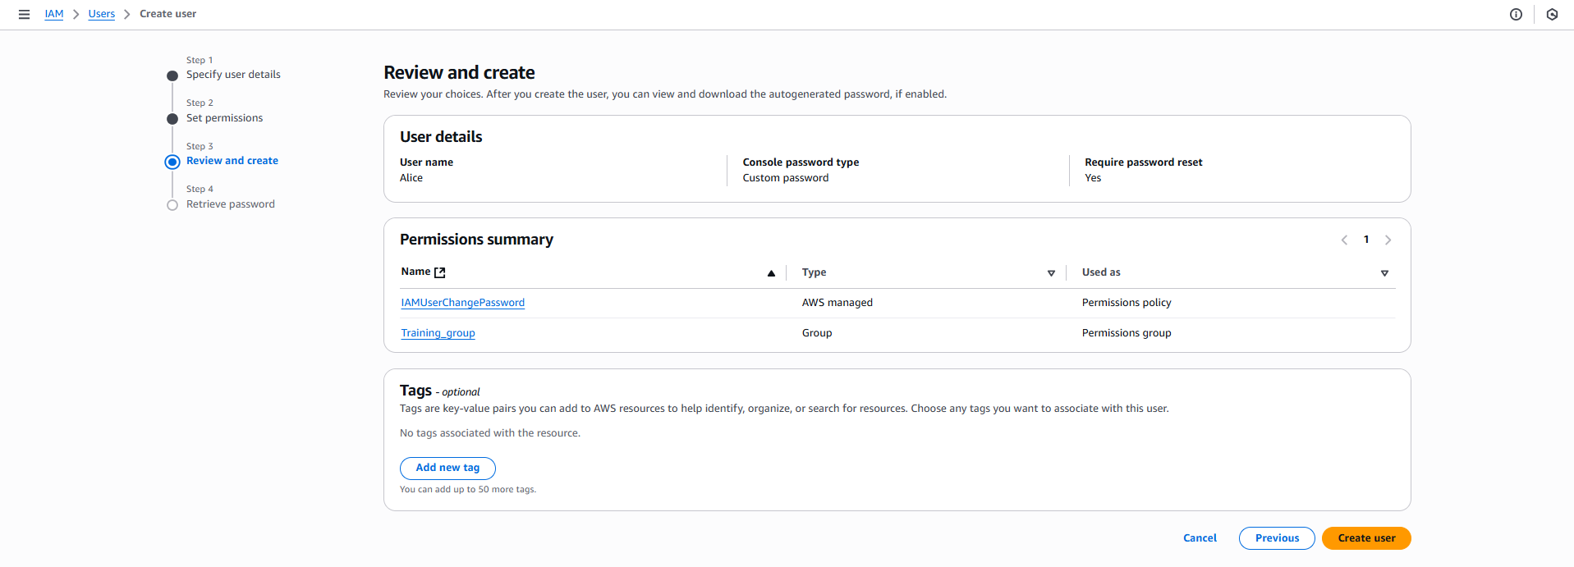

Fill it accordingly:

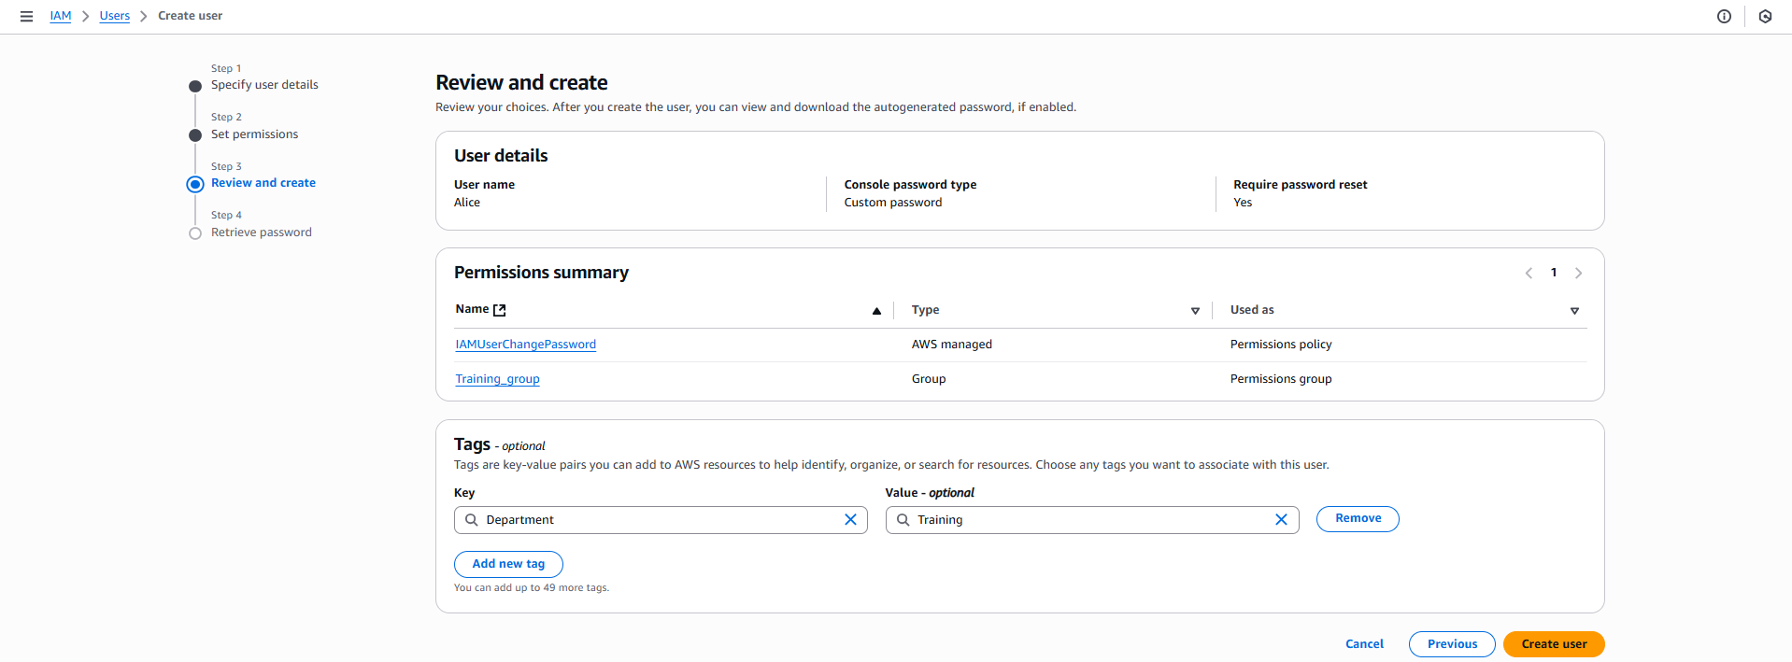

Click on the “create user” button: following confirmation will occur.

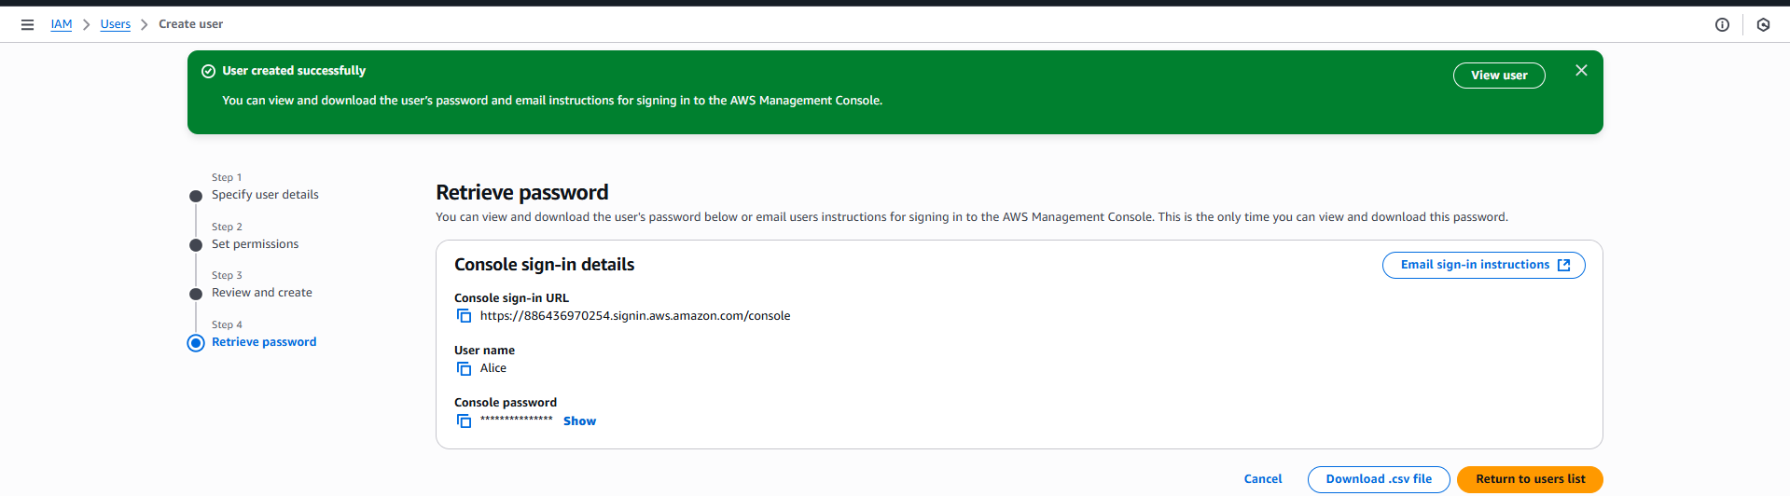

Next attach a policy to the user. Select the user to which you want to attach policy to: click on the “Alice”

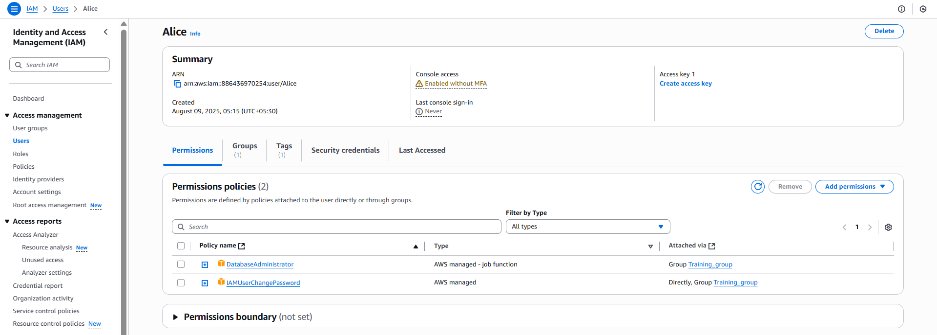

Now, to create policies by ourselves, click on the “policies” at the left dashboard: following screen will appear.

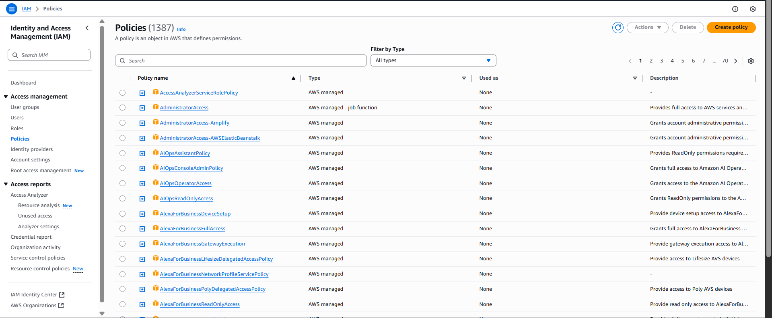

Click on the “Create Policy” button: following screen will appear.

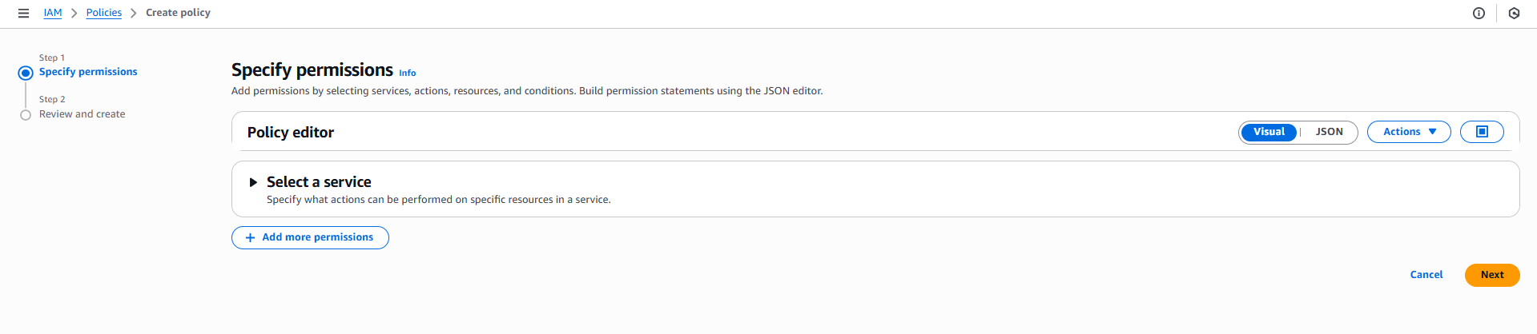

Click on the “Select a service” section: and select the service.

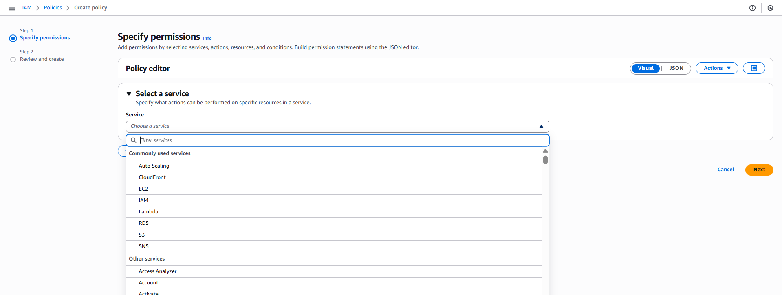

Then under the “Action allowed” select as needed:

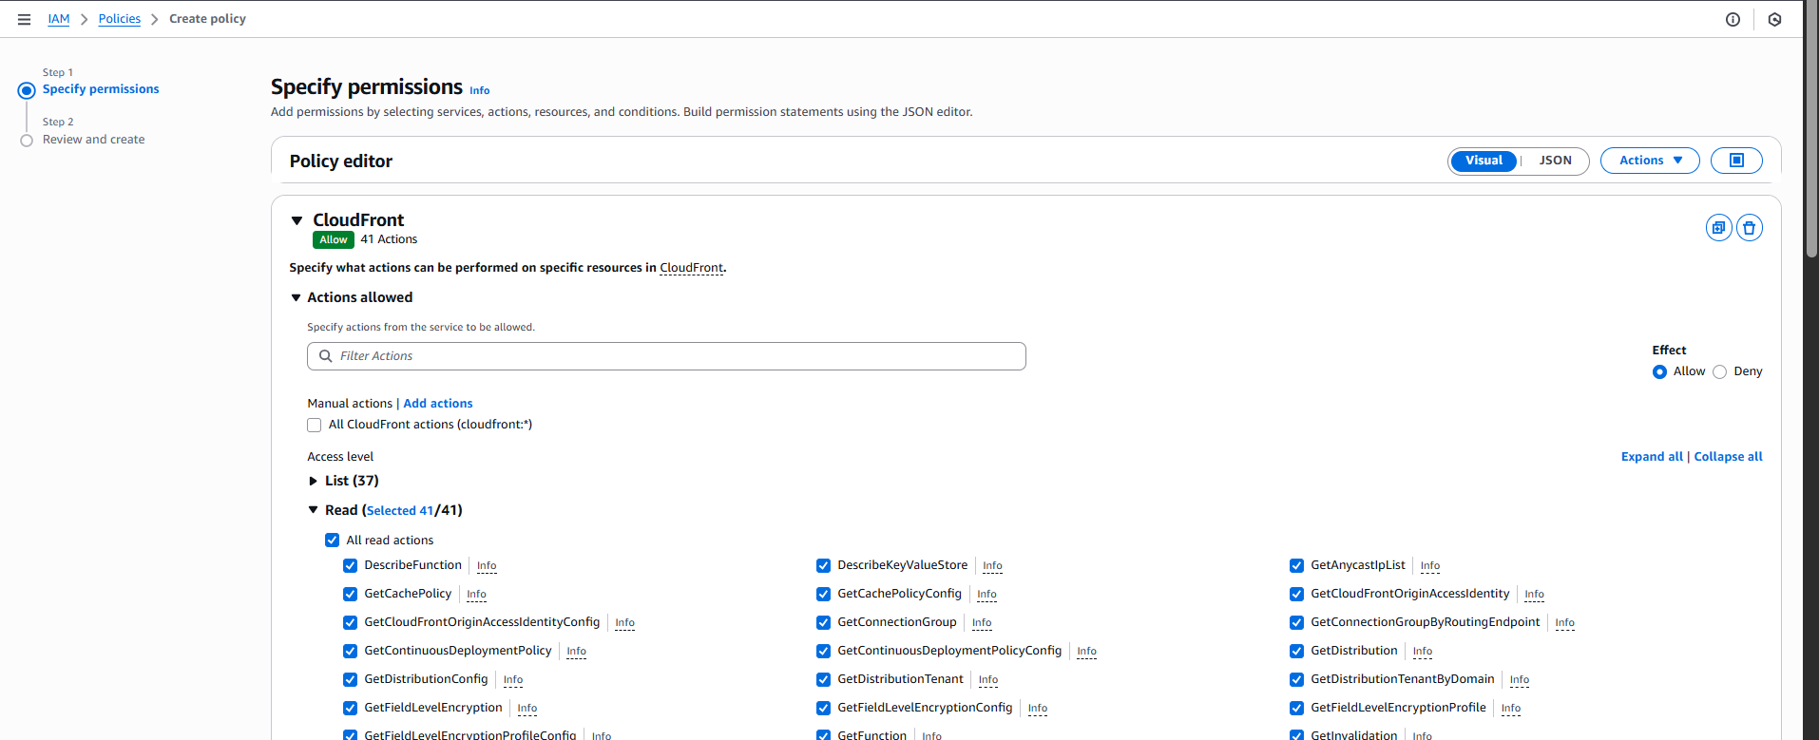

As per the requirement, Decide the “Resources” and “Request conditions - optional”.

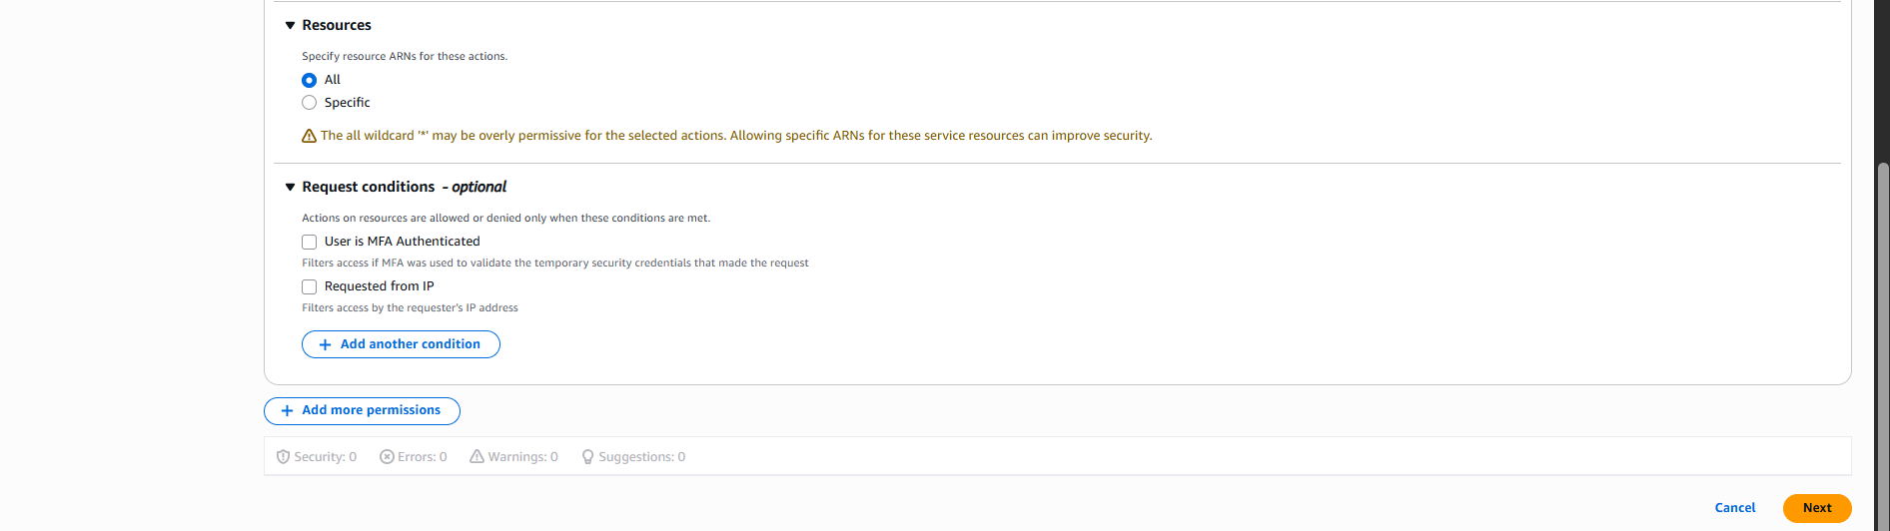

Click on the “Next” button: following screen will appear.

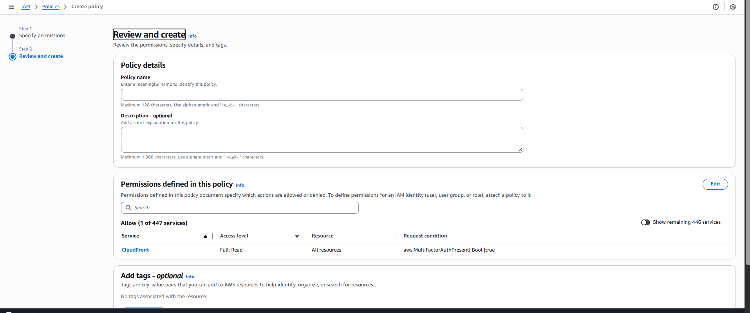

Fill it and click on the “Create Policy” button: following confirmation will appear.

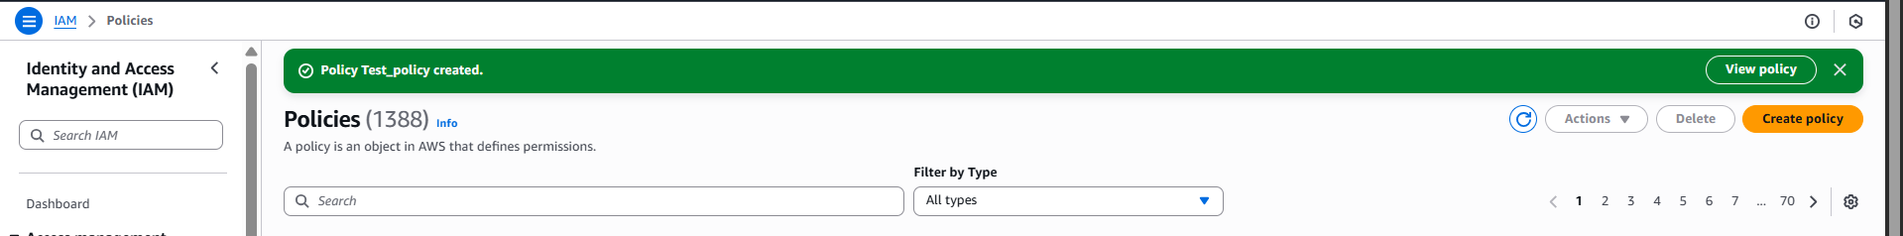

Now, to access this IAM user: click on the “dashboard” at left panel. You will be able to see a link.

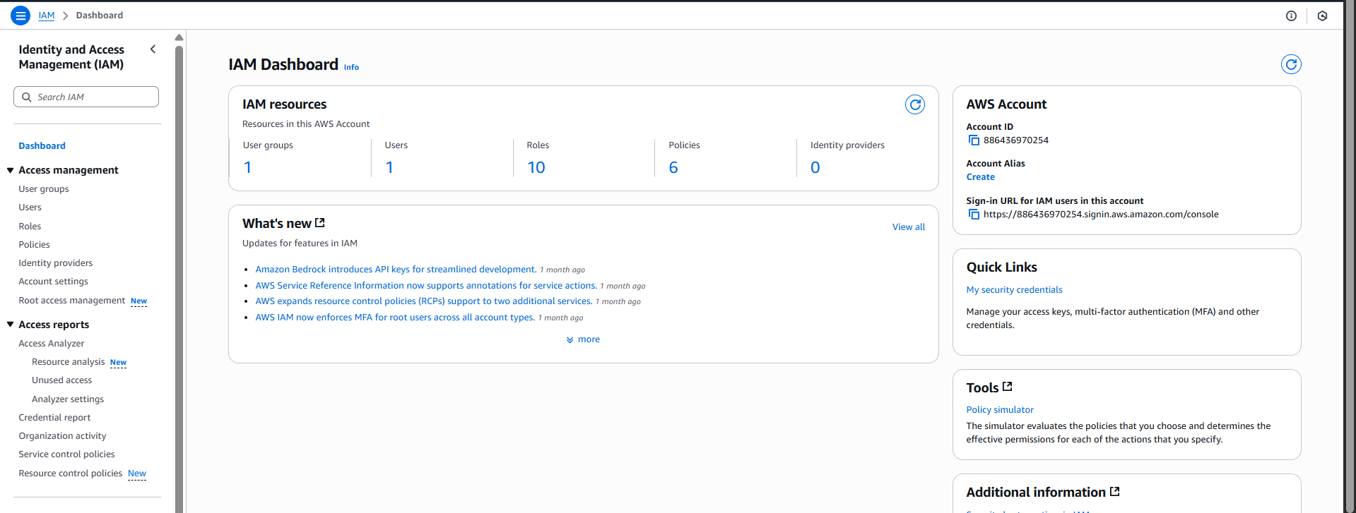

Copy and paste it in a new tab: following window appears.

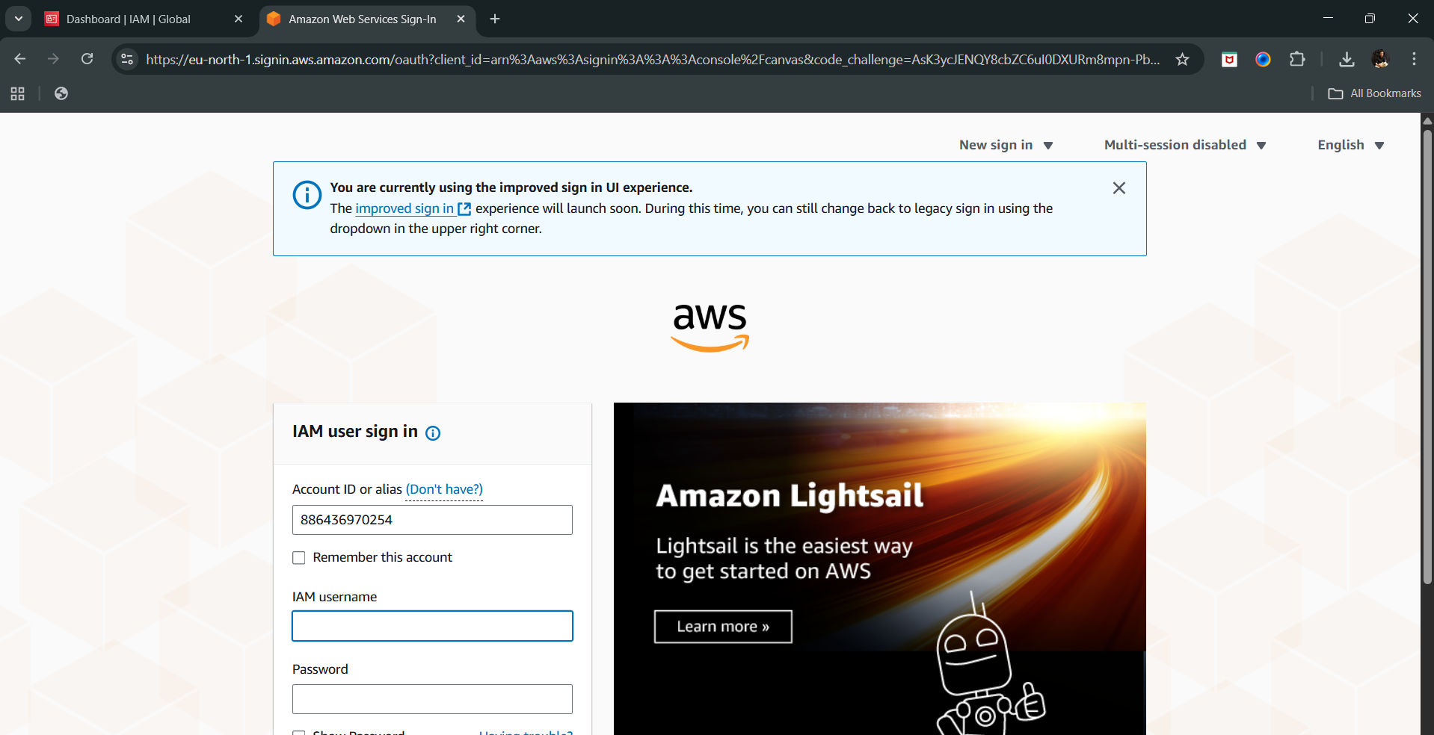

Enter the credentials which we had created recently, and click on sign-in. Following screen will appear:

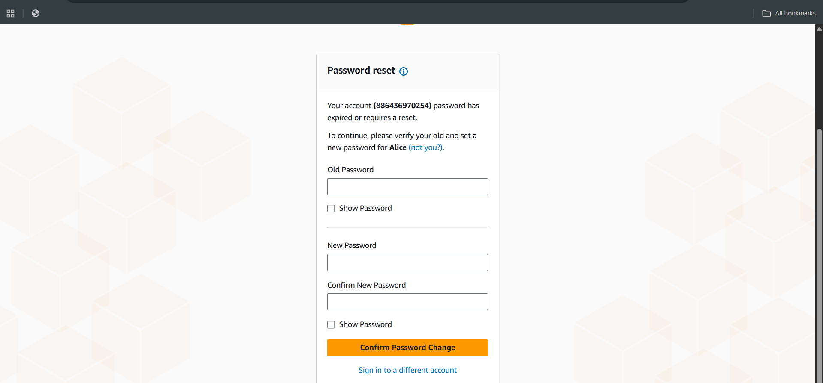

Change the password, and sign in: following screen appear.

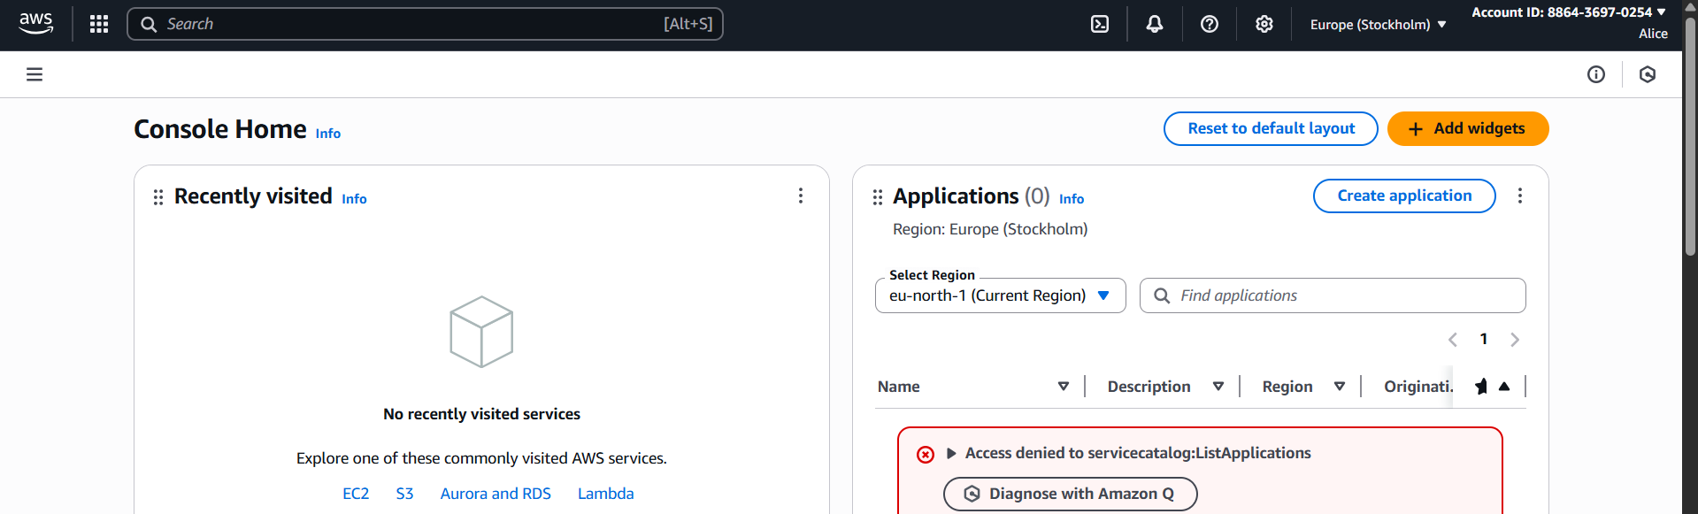

We can also cross check:



To verify the permissions: open the IAM

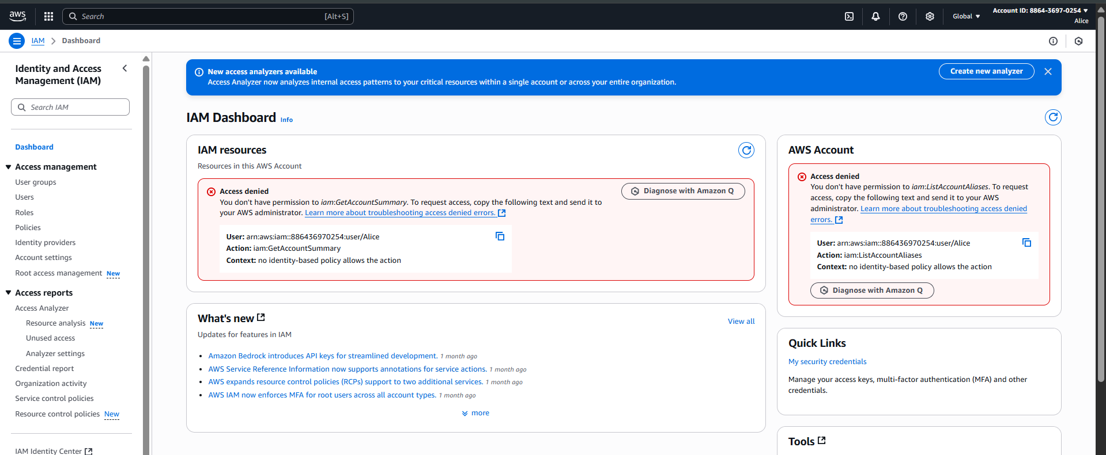

Clearly, it is working as expected. Now, delete all these resources to avoid any cost.

--The End--