**Day 22**

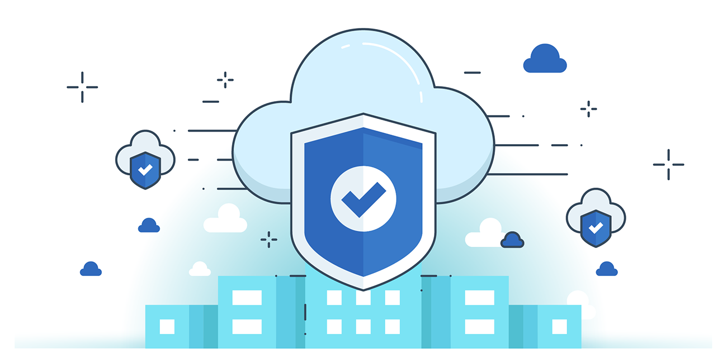



**“CLOUD SECURITY”**

**Working with KMS:**

Where can we find this KMS?

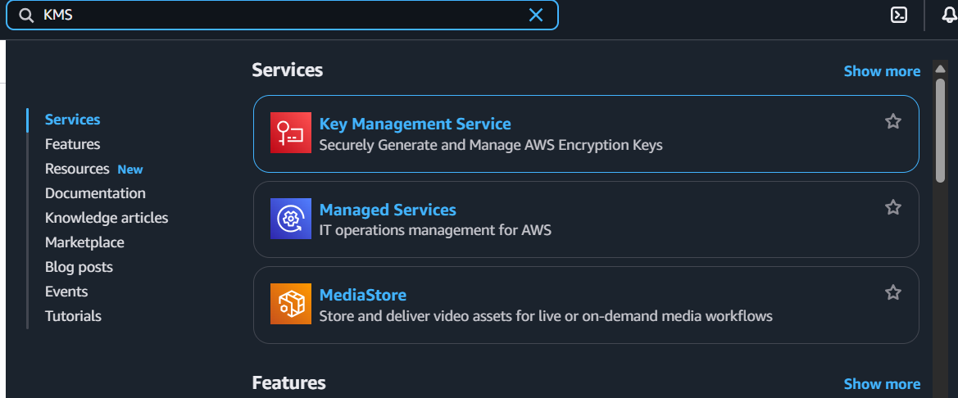

Following screen will appear:

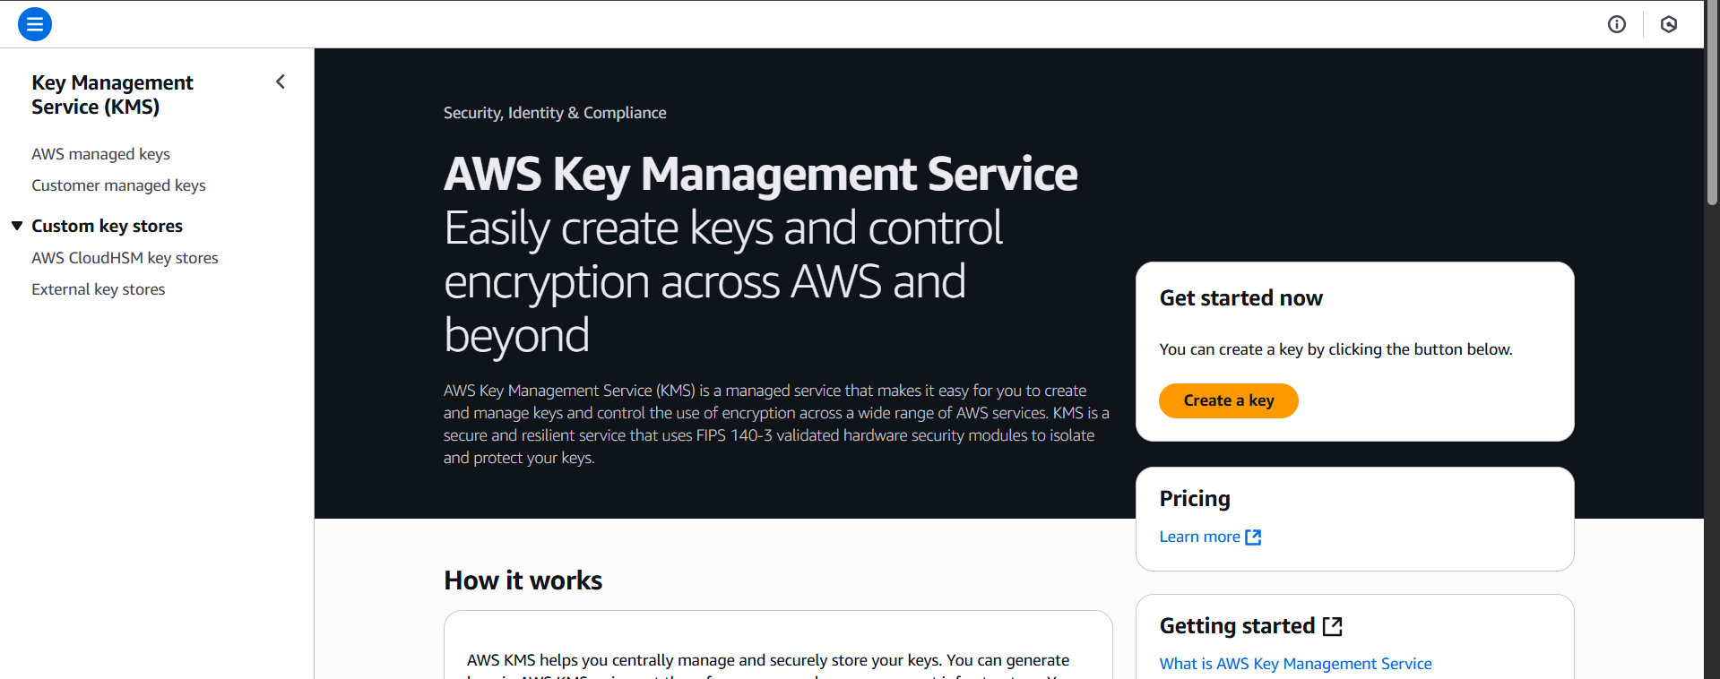

Click on the “Create a key” button: following screen will appear.

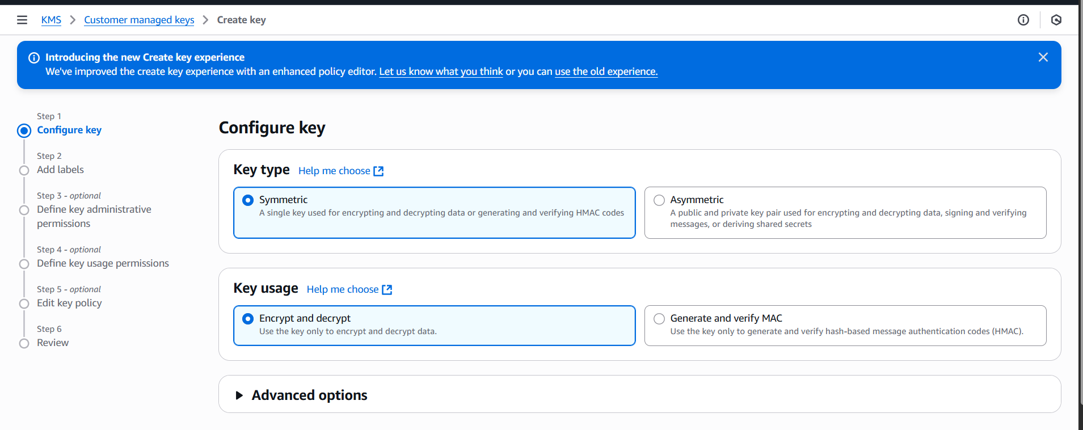

Select the suitable option, and click on the next button, following screen will appear, fill it:

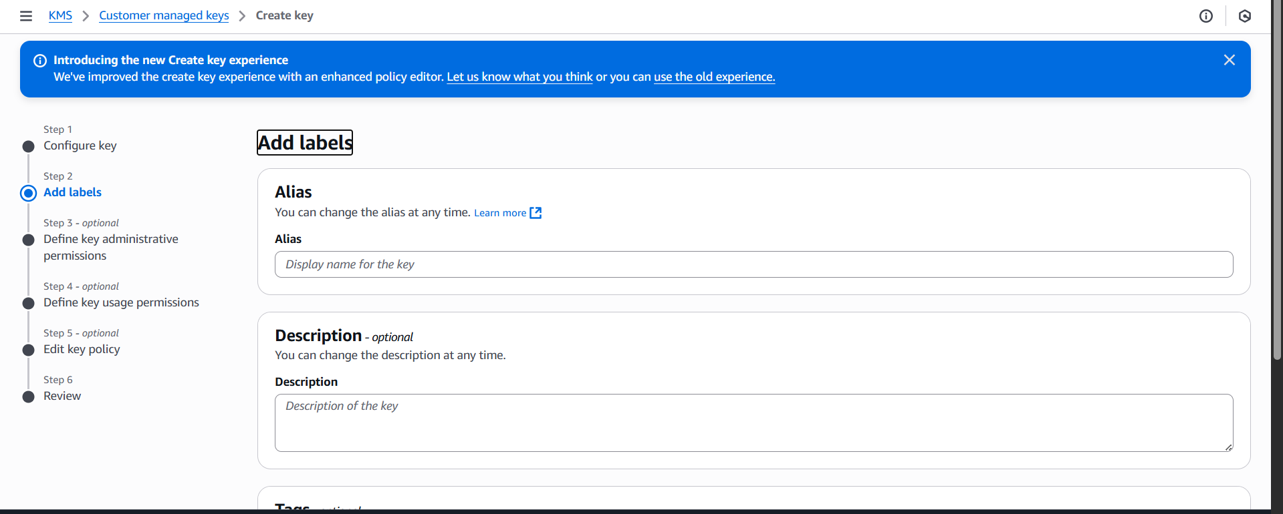

Click next, following screen will appear: select the admin.

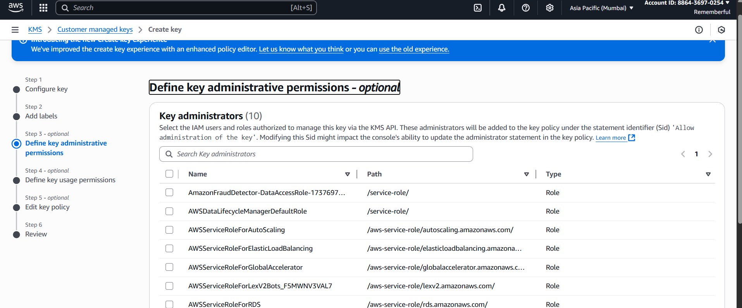

When you click Next, following screen will appear:

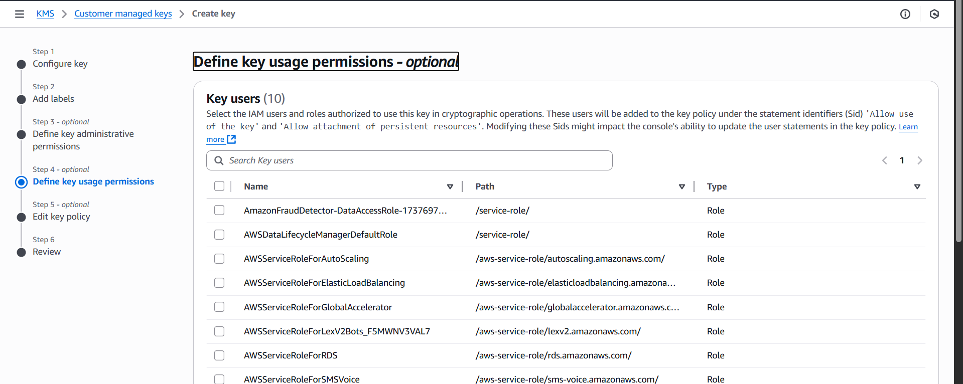

When you click next, it will ask you to review the policy:

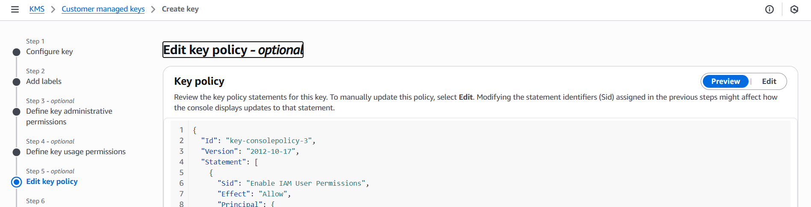

When you click on the Finish button, following confirmation will show:

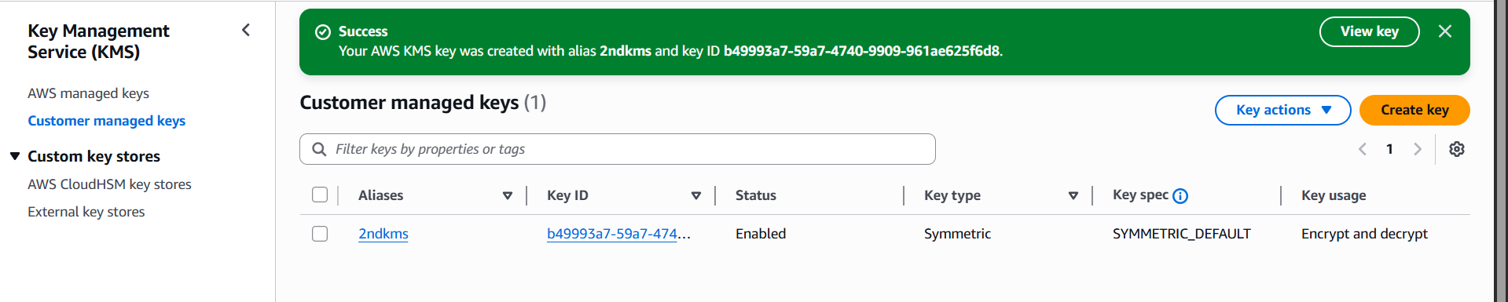

--The End--