**Day 23**

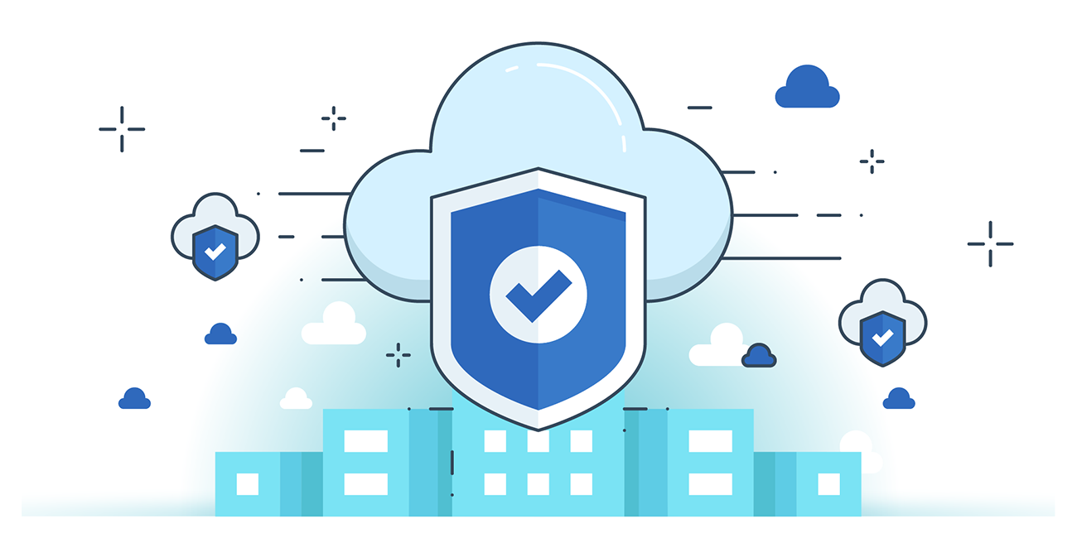



**“CLOUD SECURITY”**

**Implementing AWS Key Management Services:**

Steps:

Open the “Users” section in the IAM:

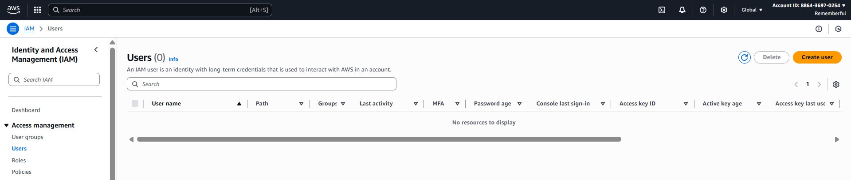

Click on “create user”: following screen will appear. Fill it accordingly, make sure to check mark the “Provide user access to the AWS Management Console – *optional”*

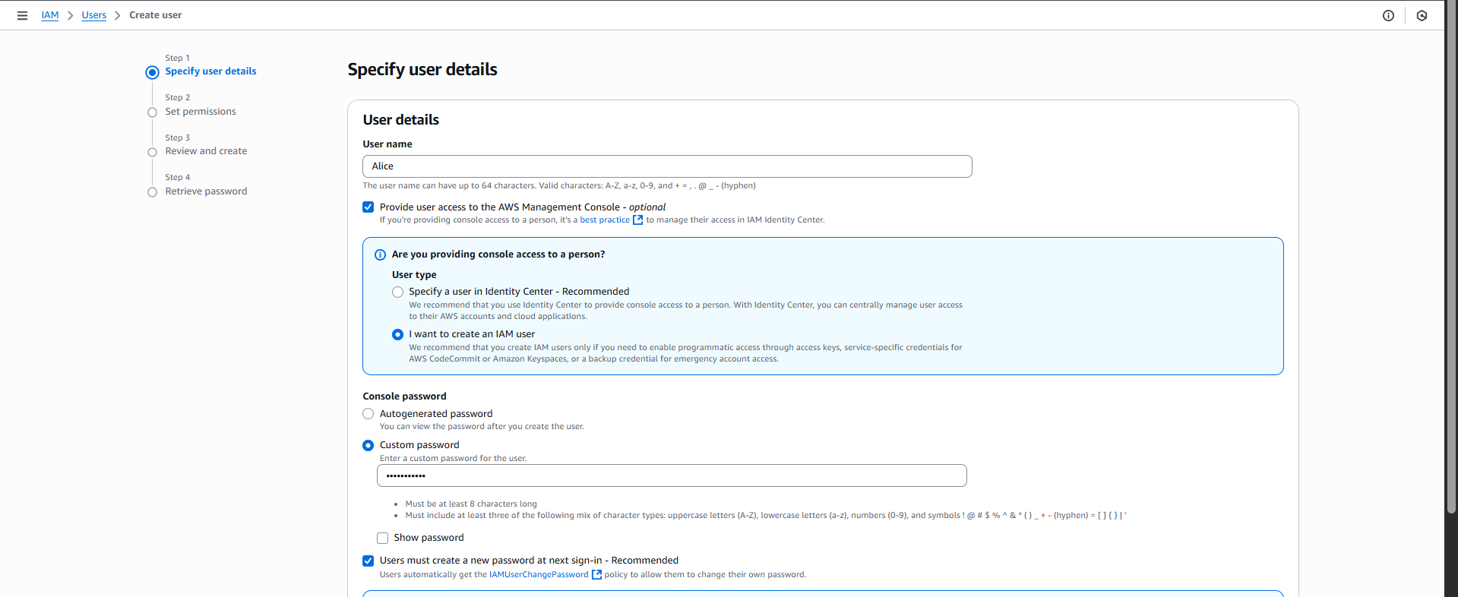

Click on the “next” button: following screen will appear, select the respective group.  
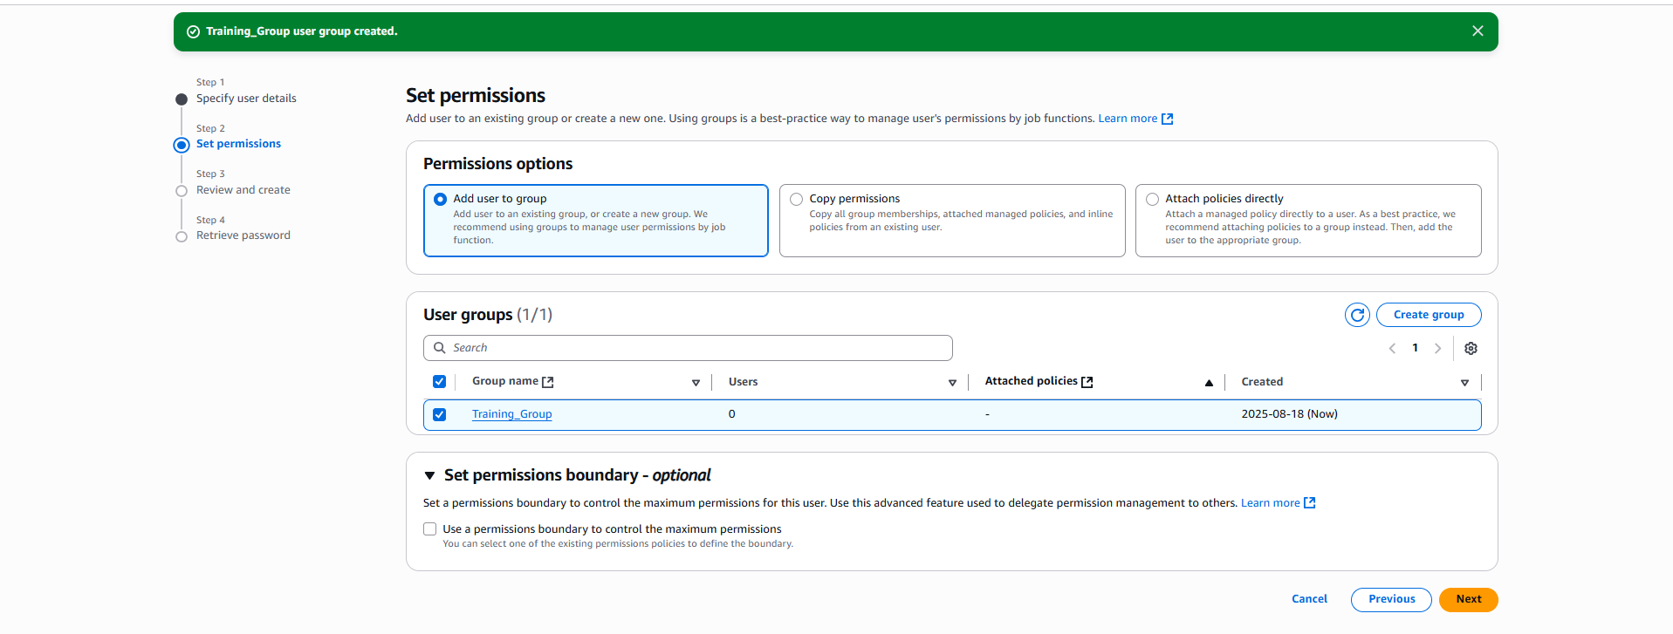

Click on the “Next” button: following screen will appear. You may add the tag, and then click on the “Create User” button.

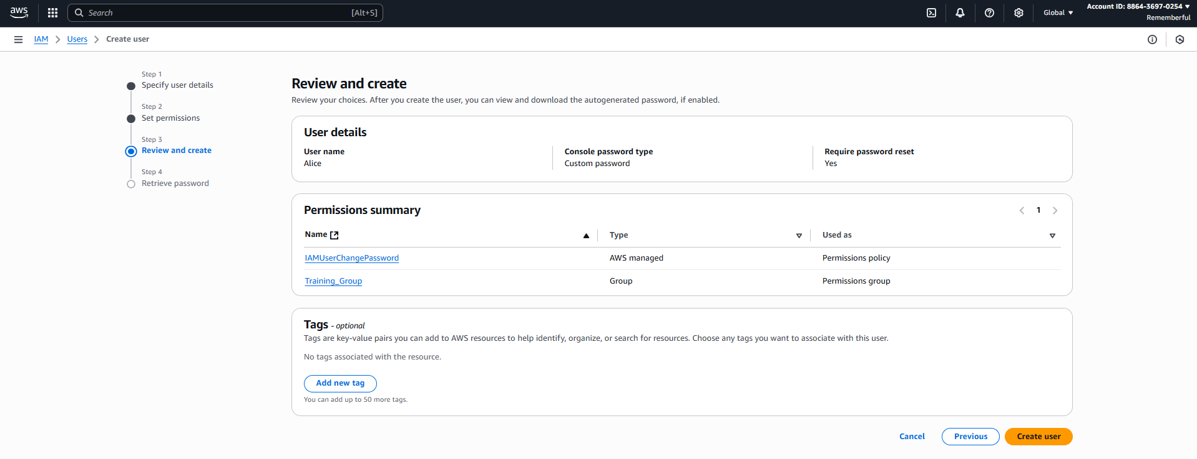

Following confirmation occurs:

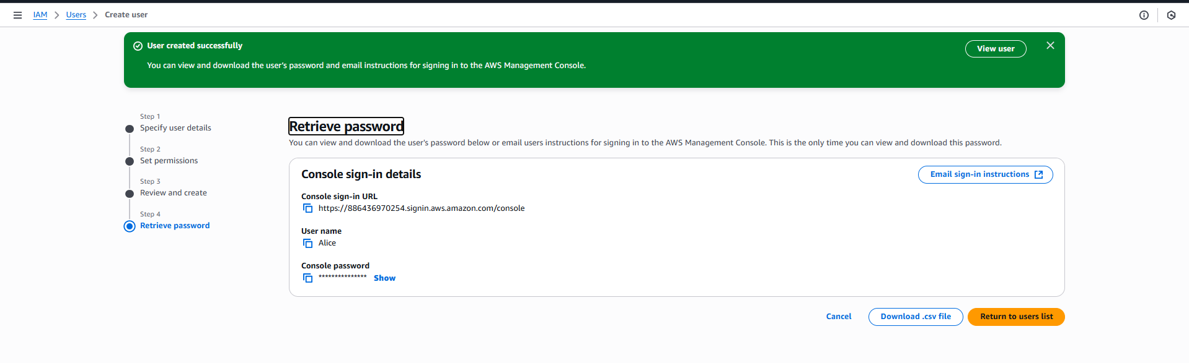

Now, open the KMS:

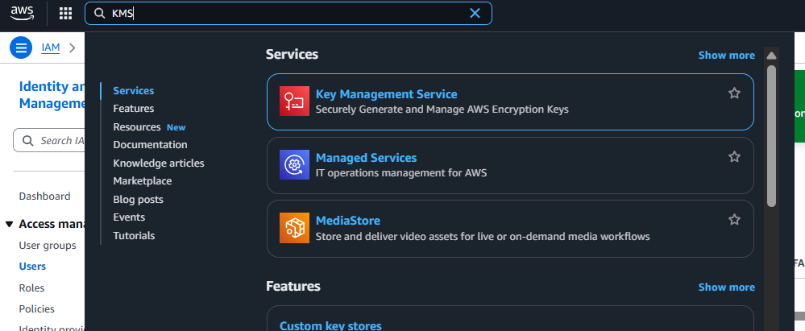

Following screen will appear:

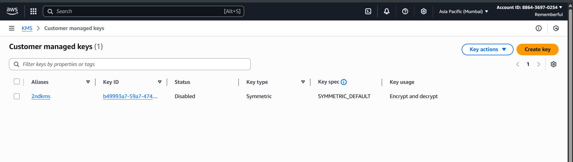

Click on the “create key” button: following screen will appear.

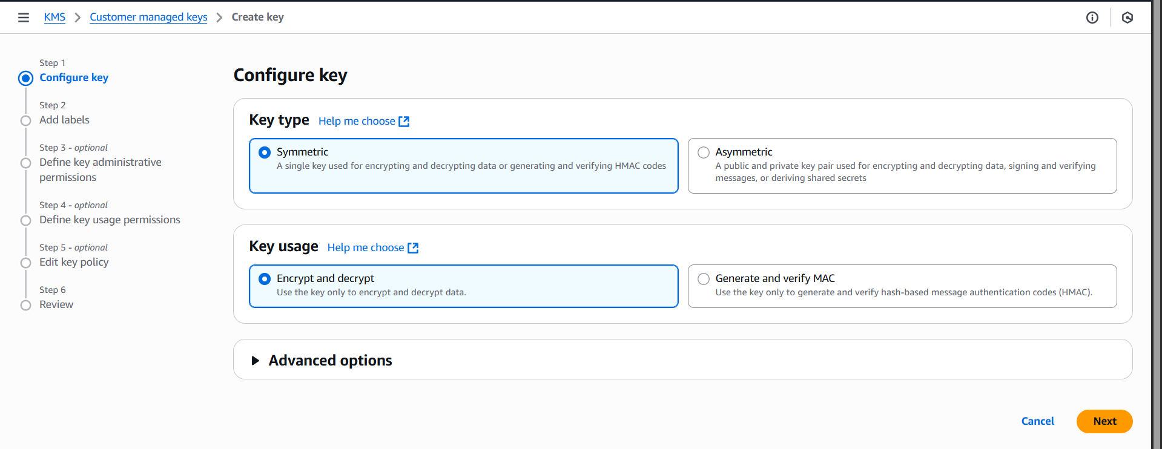

Select accordingly and click on the “next” button: following screen will appear.

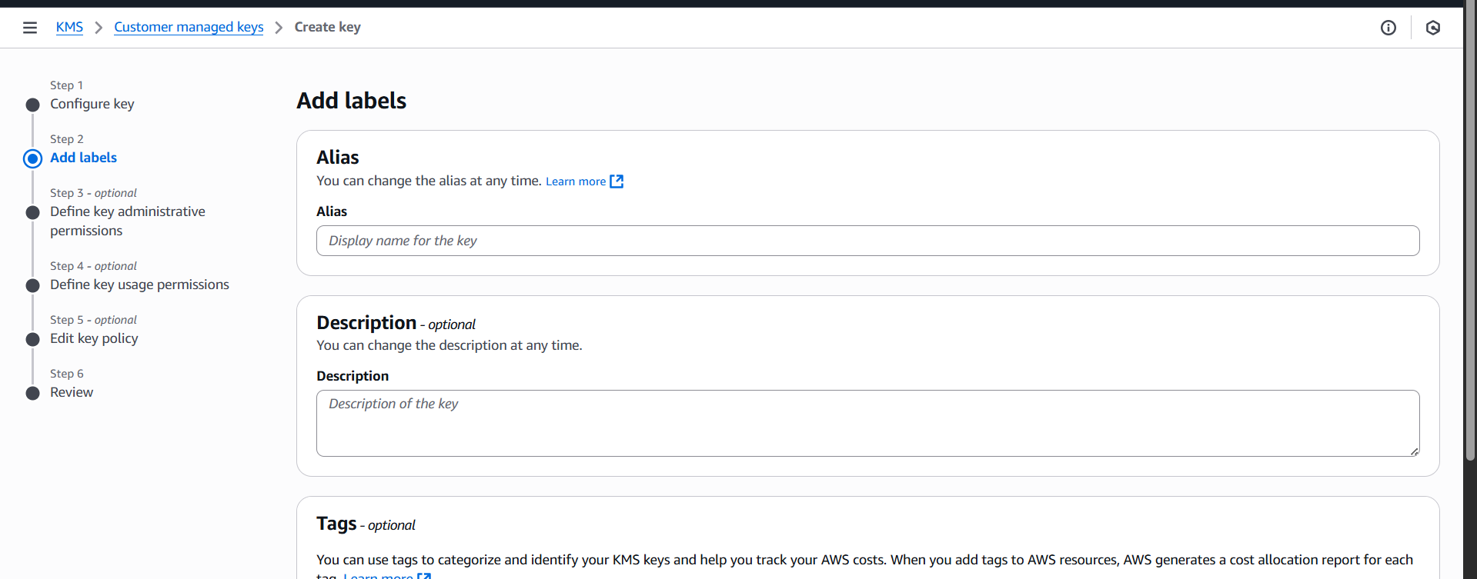

Fill it accordingly:

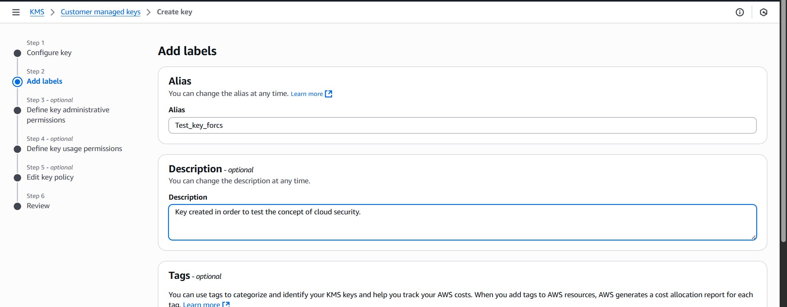

Click on the “Next” button: select the admin name (user created)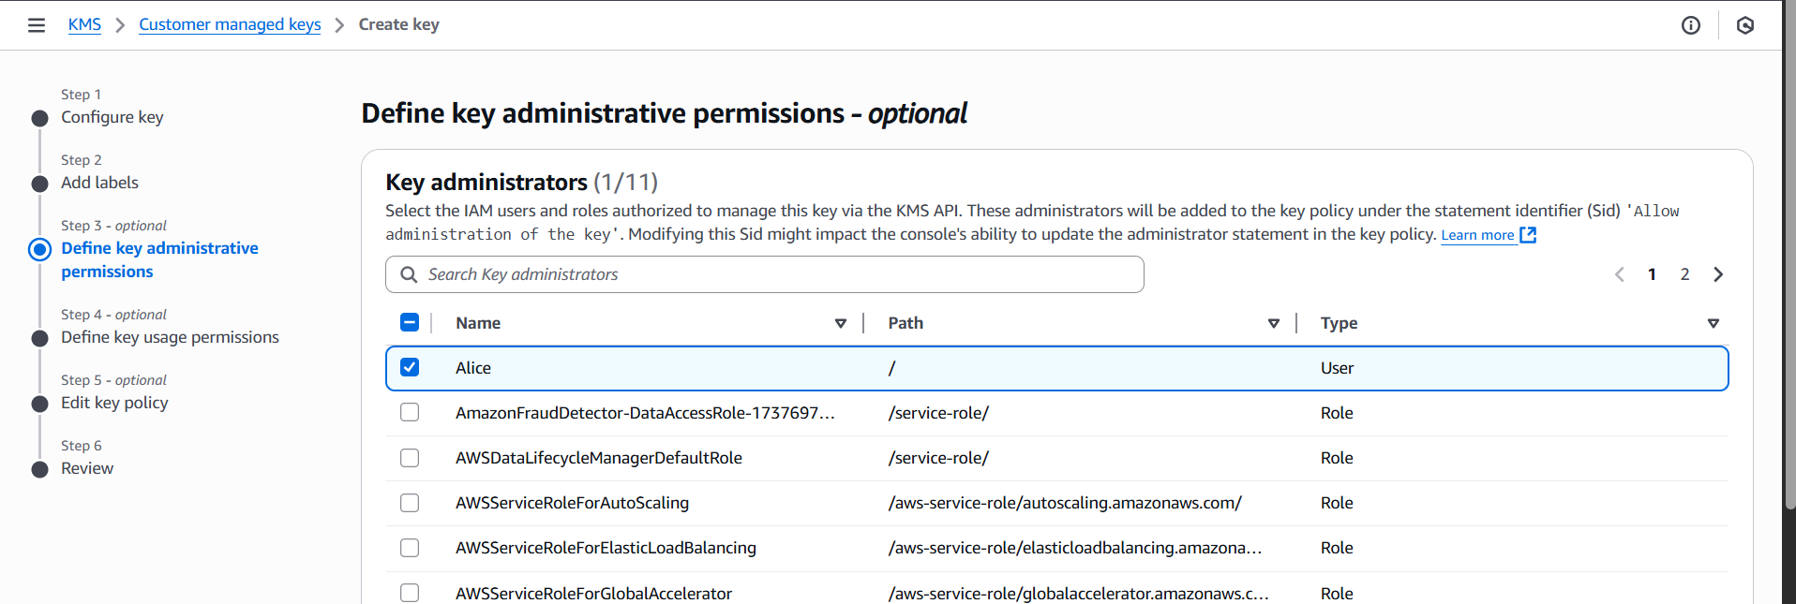

Click on the “Next” button: again select the name.

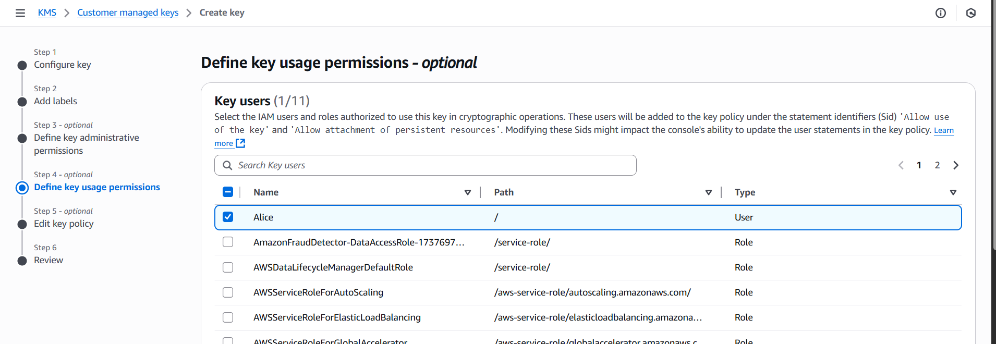

Click on the “Next” button: review the key policy, as shown below.

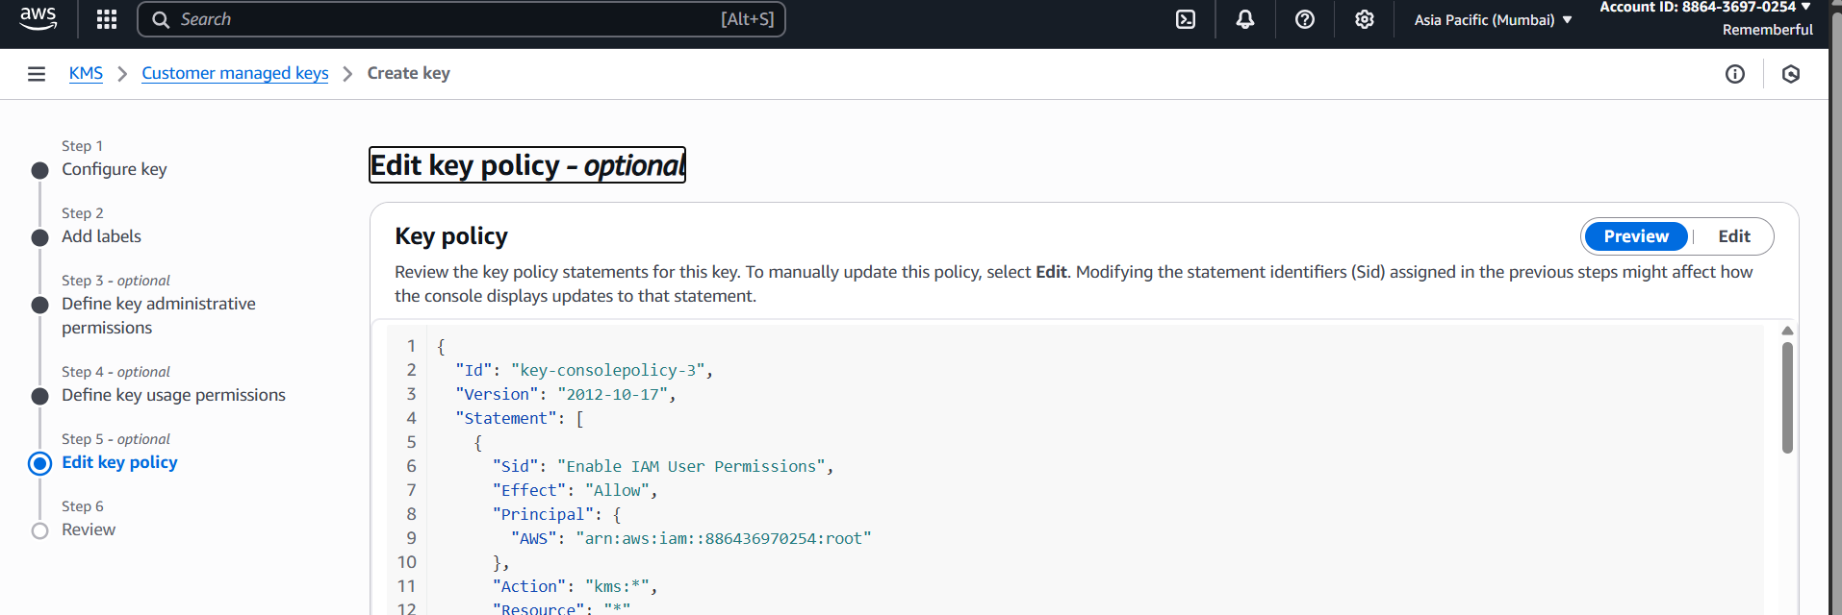

Click on the “Next” button to open the review section as shown below:

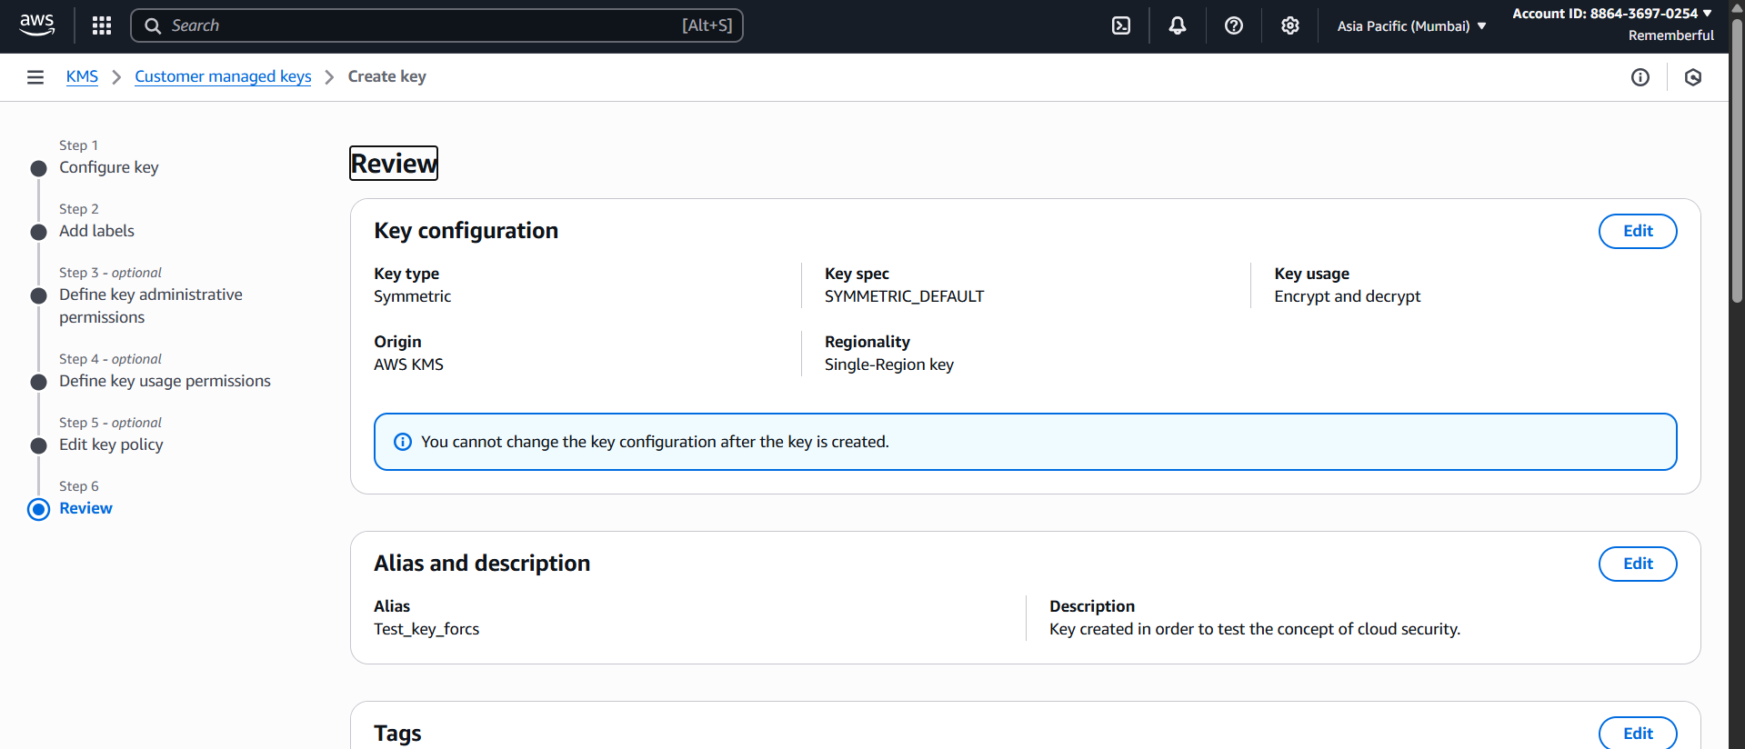

Click on the “finish” button to create the key: following confirmation will occur.

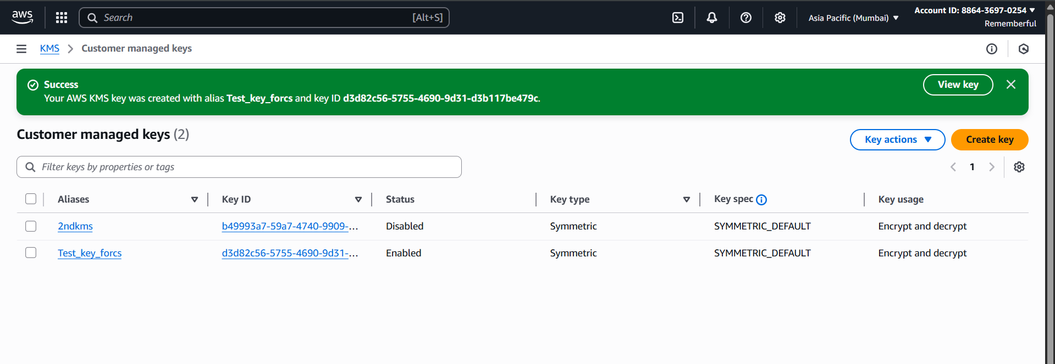

You may check the properties of that key by clicking on it, following screen will appear:

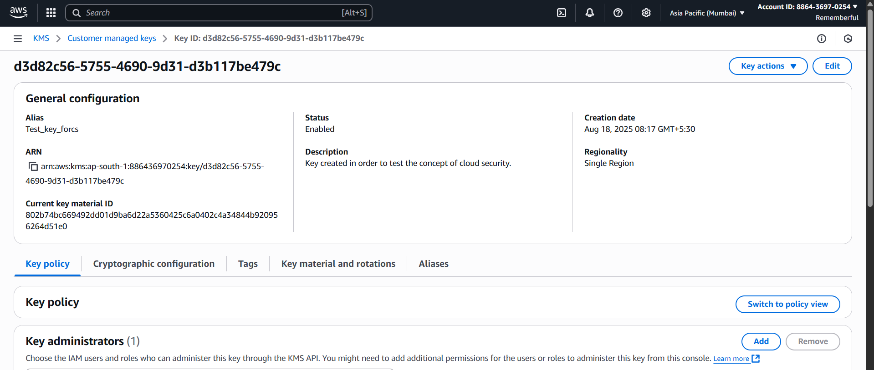

Now, click open the “S3” 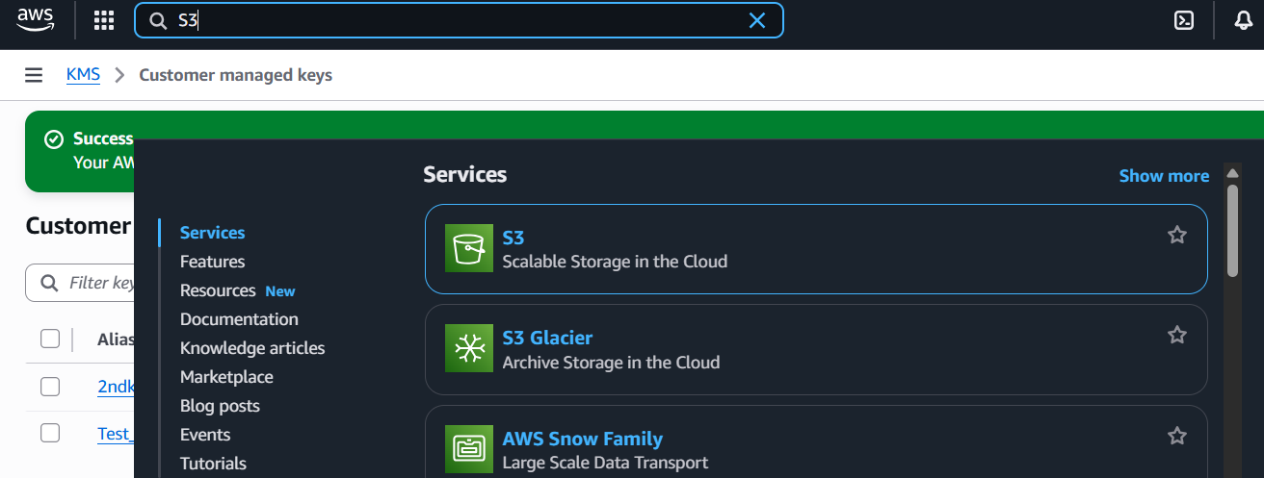

Following screen will appear:

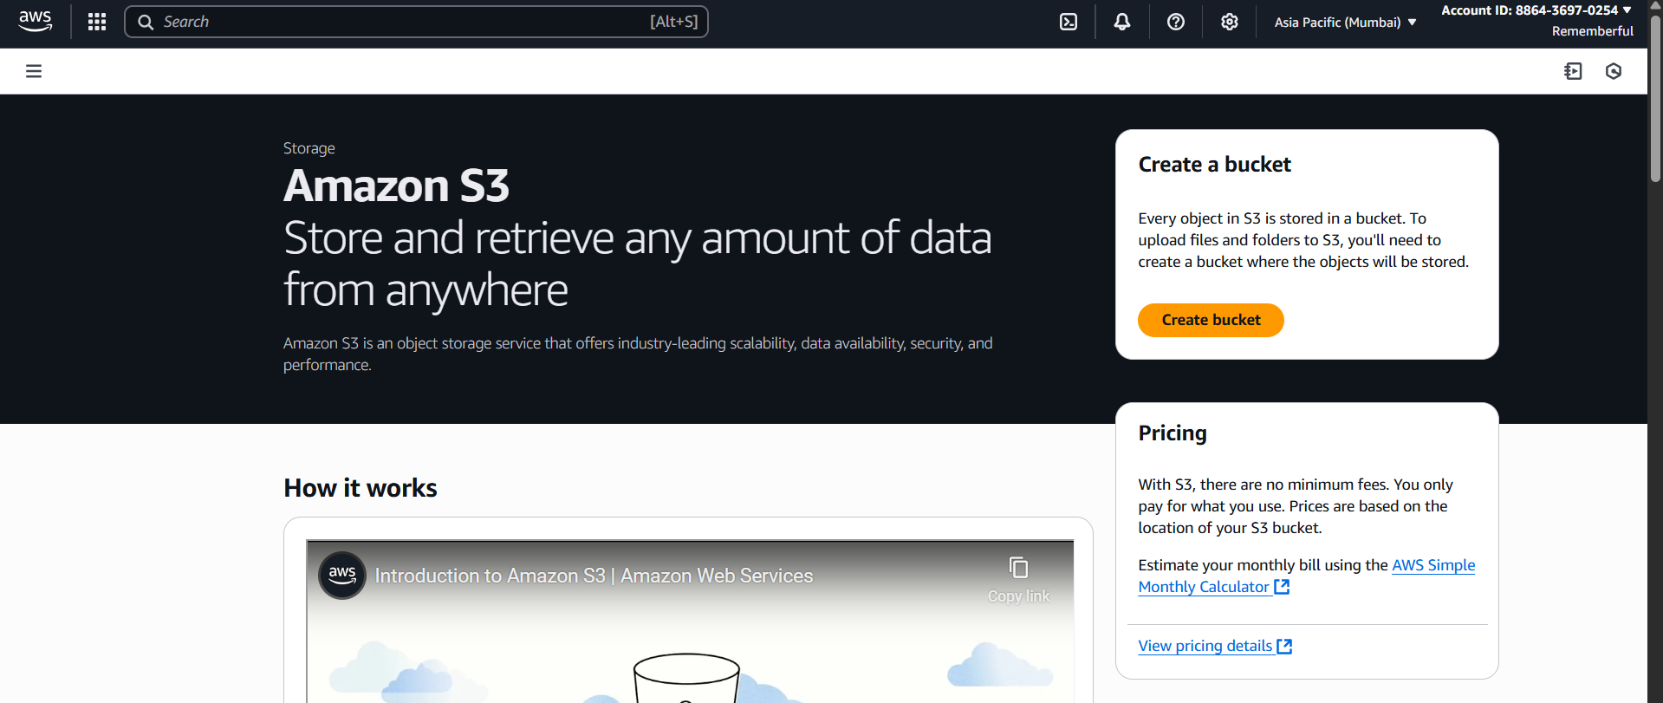

Click on the “Create Bucket” option: following screen will appear.

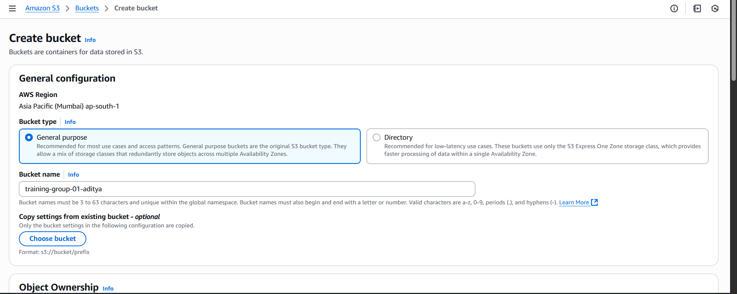

Keep everything as default and then click on the ‘Create bucket’ button at the bottom: following confirmation will occur.

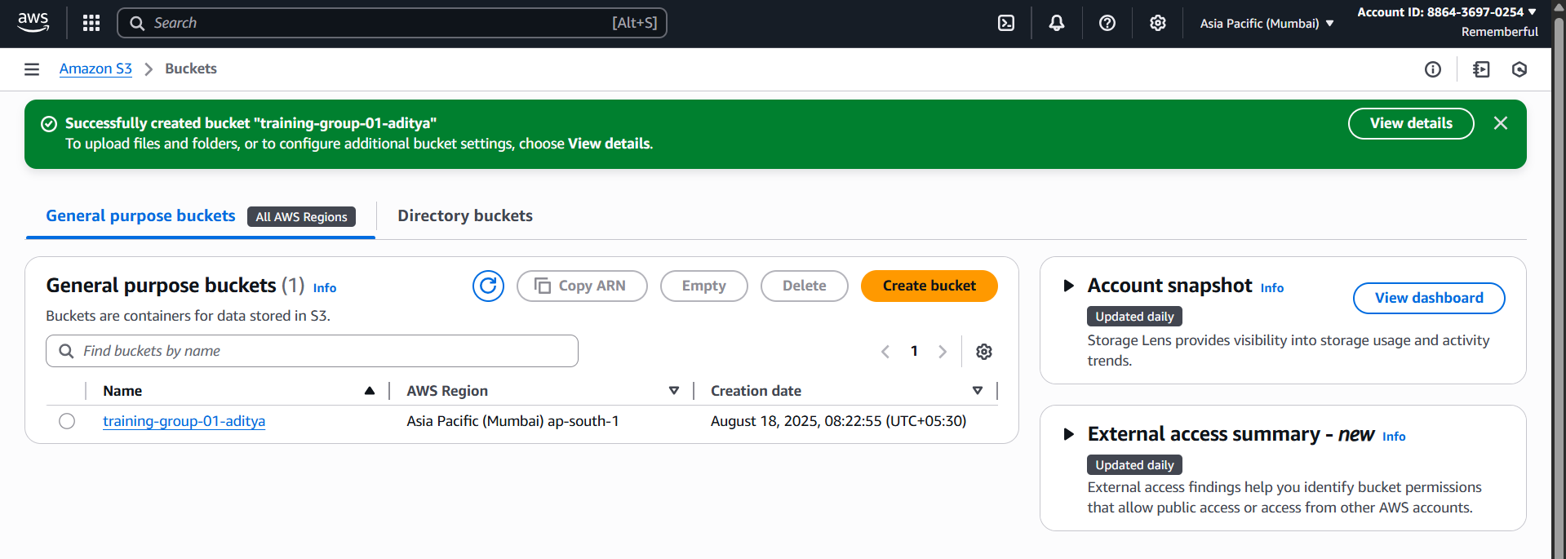

Open that bucket:

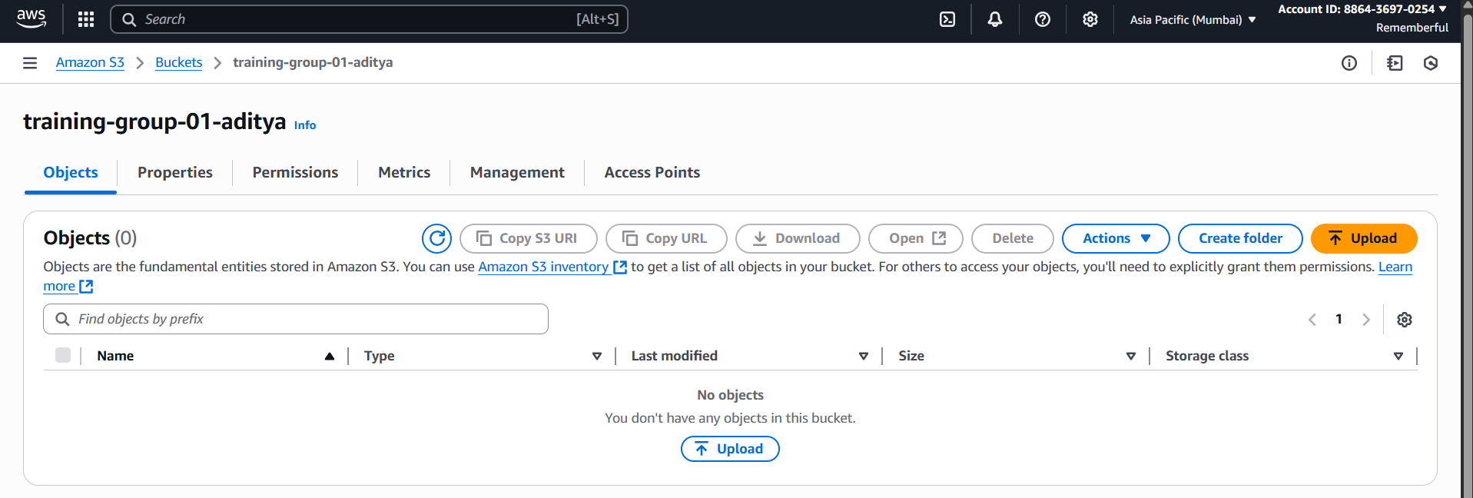

Go to the “properties” section and click on the edit button at the “bucket versioning” section: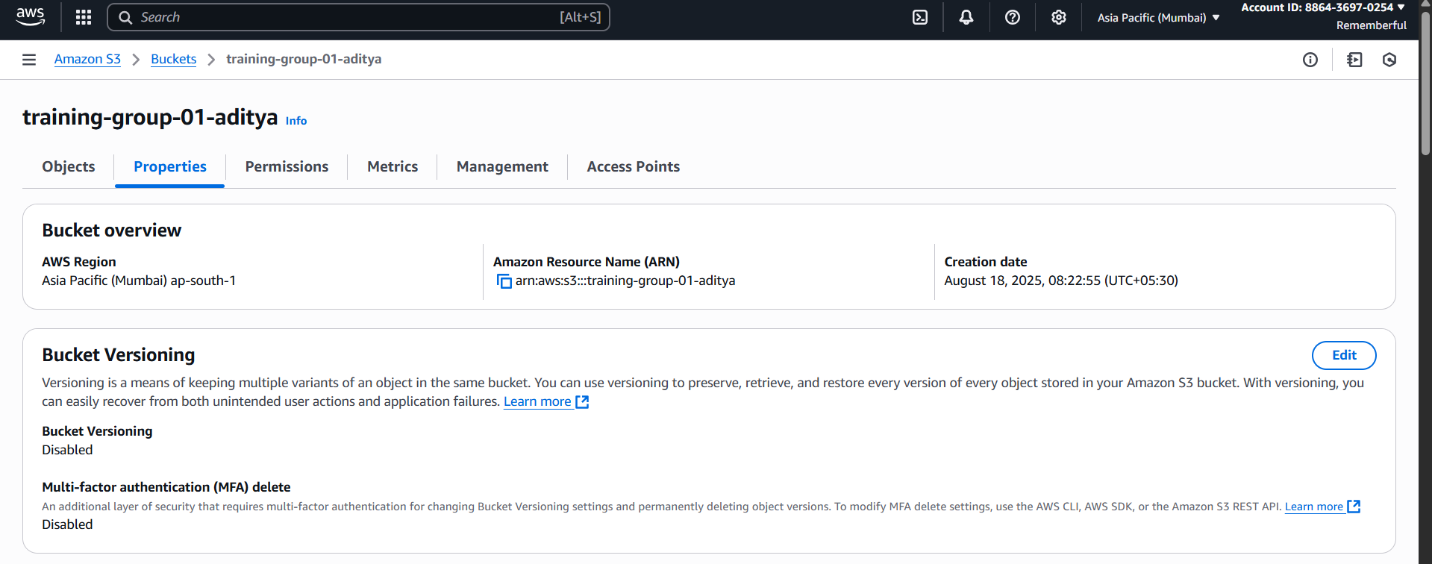

Click on the “Enable” radio button: click on the save changes.

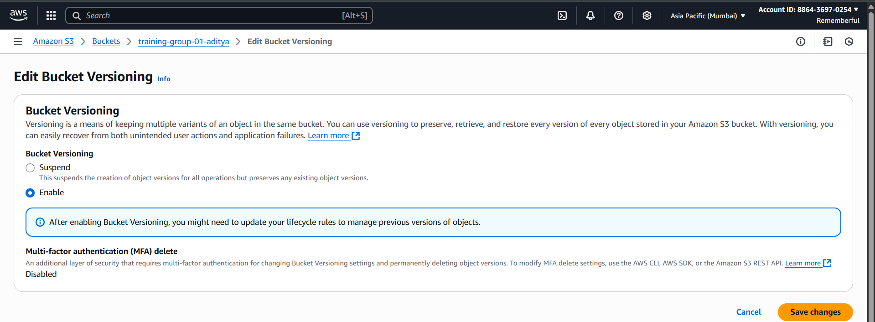

Under the “Properties” section, scroll down and reach the “Default Encryption” section: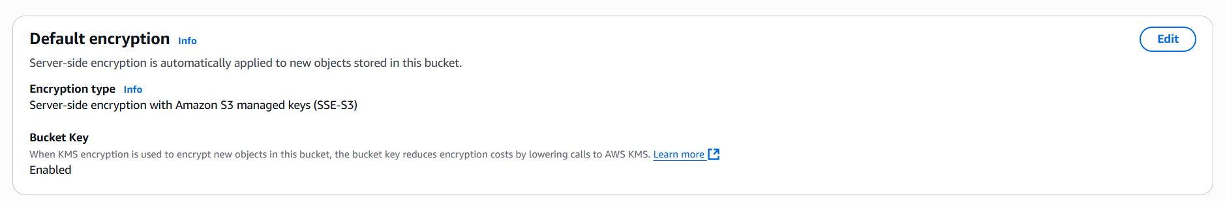

Click on the “edit” button: following options will appear.

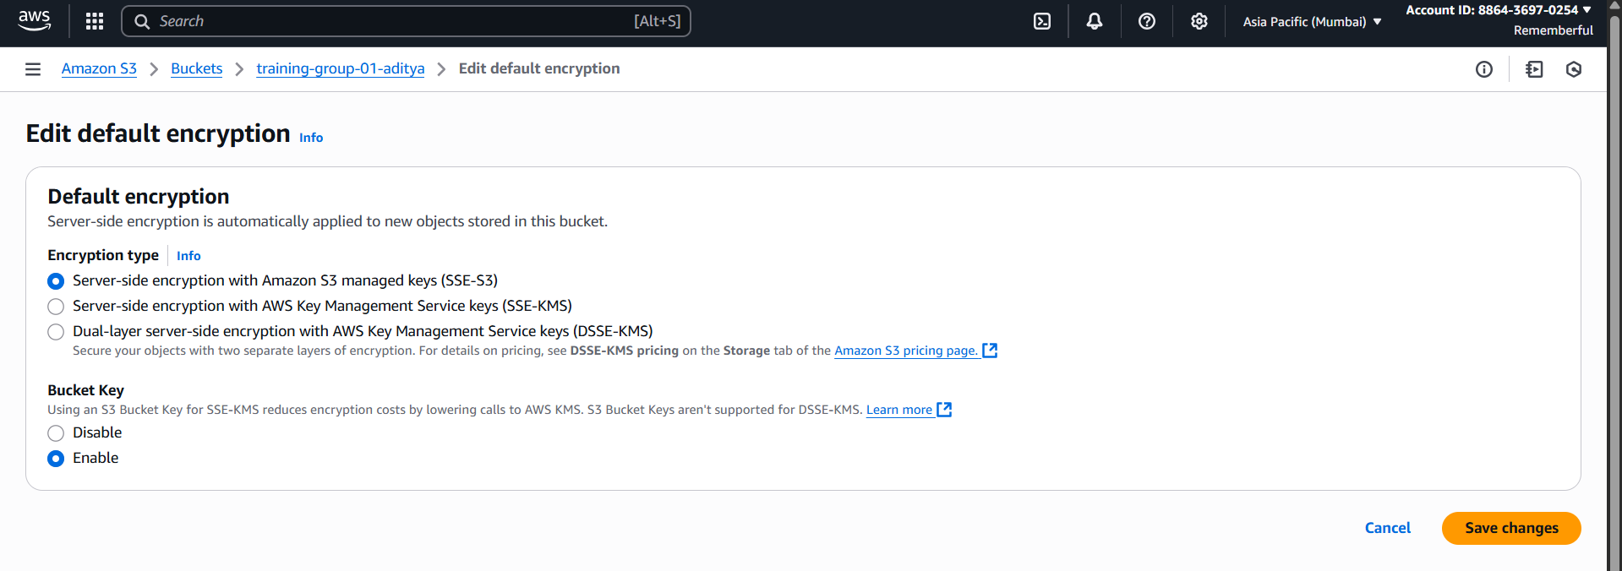

Under the “encryption type” select the “Server-side encryption with AWS Key Management Service keys (SSE-KMS)”: also specify the AWS KMS key ARN. Then click on the “Save changes” button.

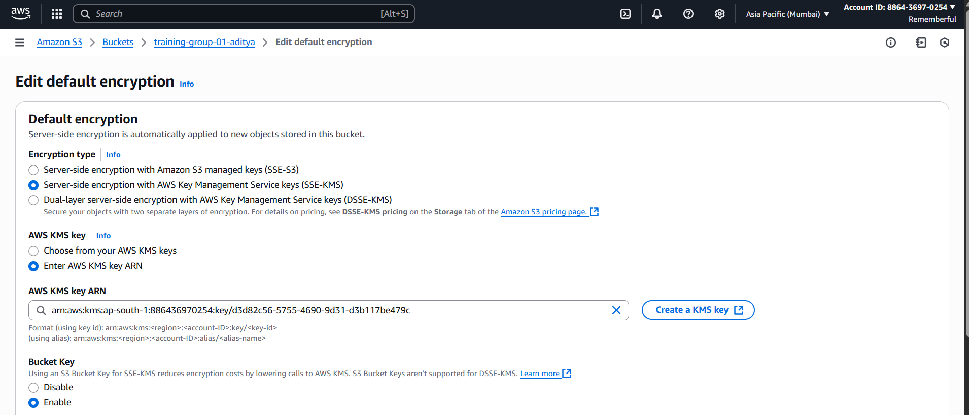

Now, open the ‘Server access logging’ section:

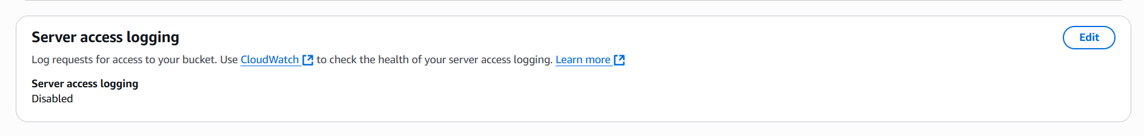

Click on the “edit” button: following screen will appear.

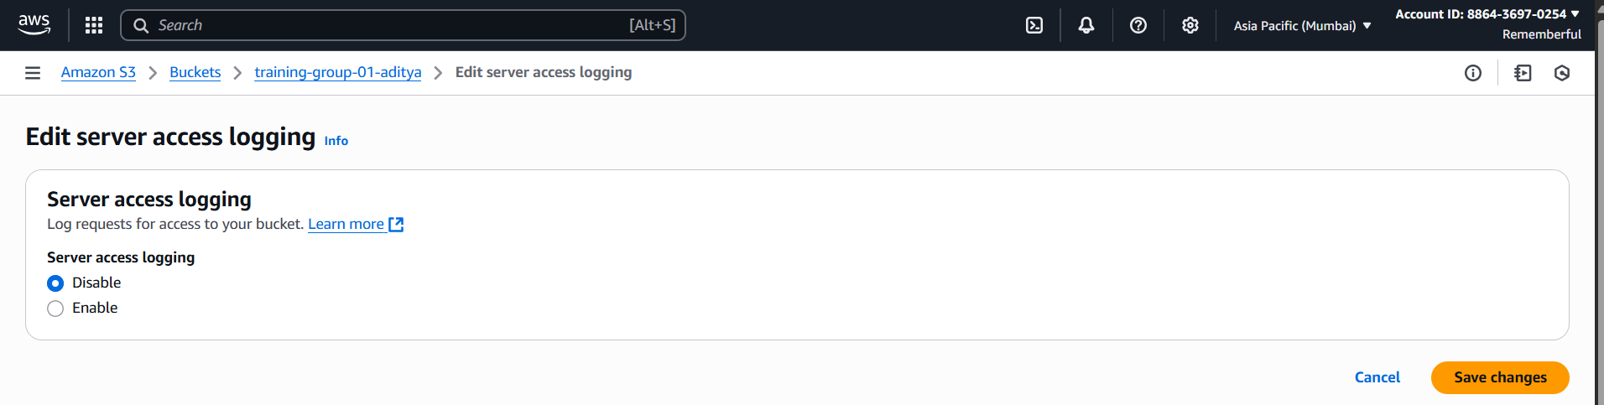

Click on the “enable” button: screen changes to this.

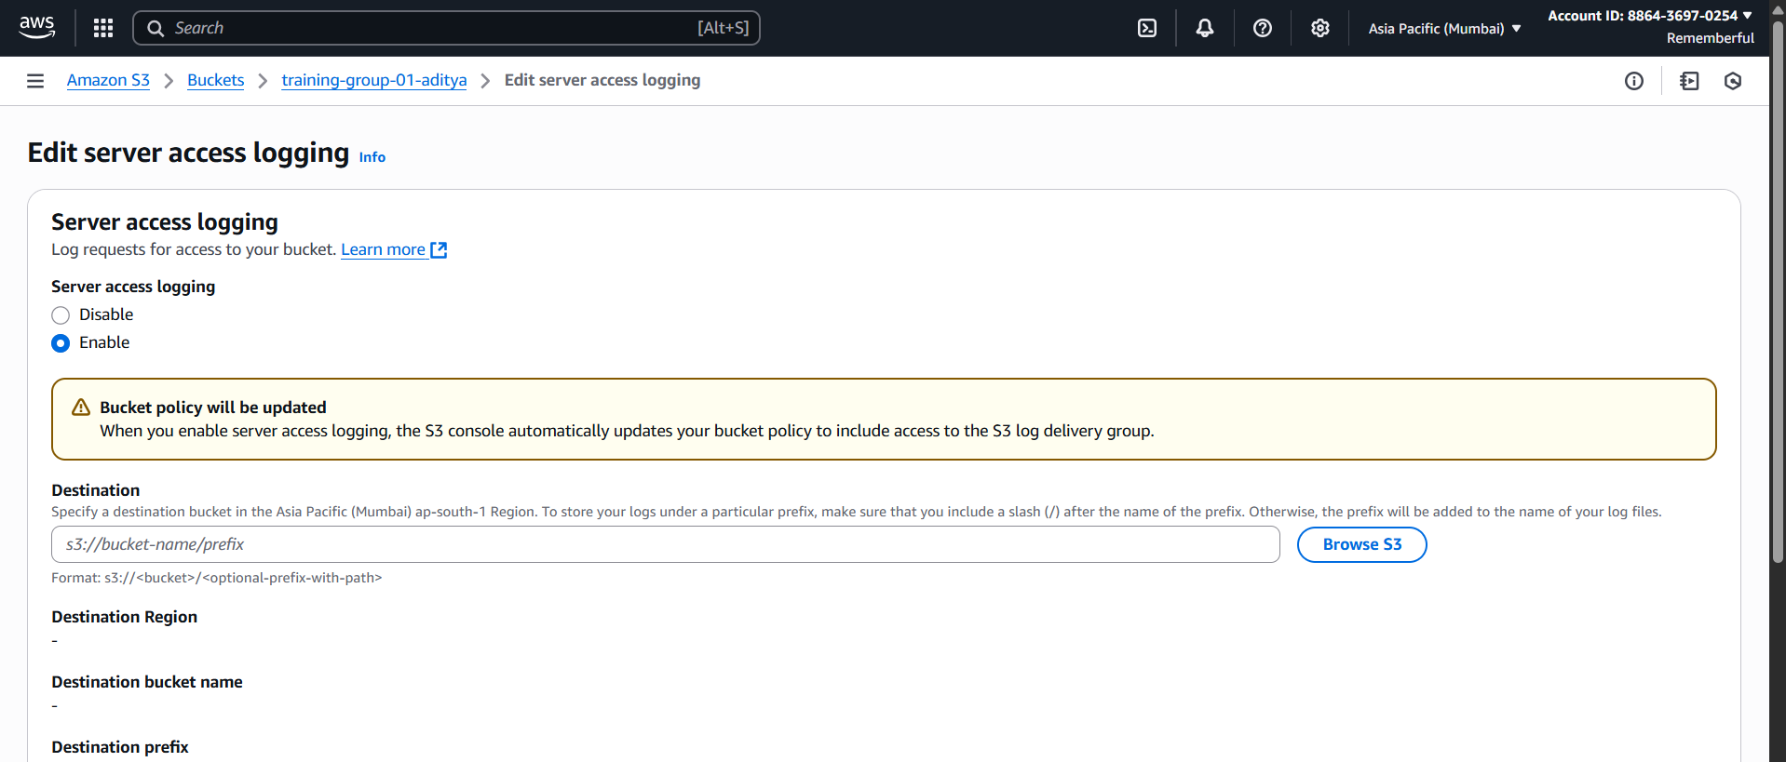

Click on the “Browse S3” button: select the Bucket.

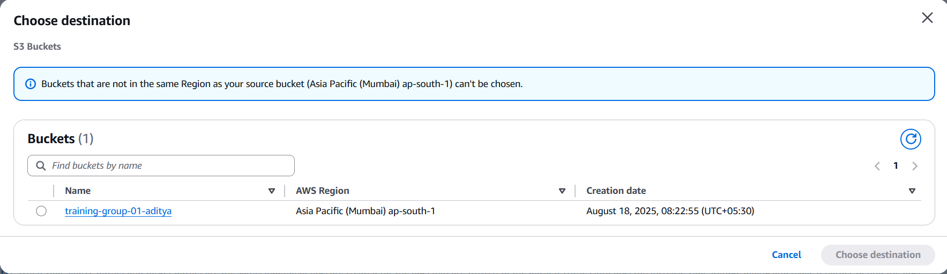

And done!

--The End--