**Day 31**





**“CLOUD SECURITY”**

**Implementing web application firewalls in AWS:**

Steps:

First, we will create a web API in AWS, for which we need to go to API Gateway:

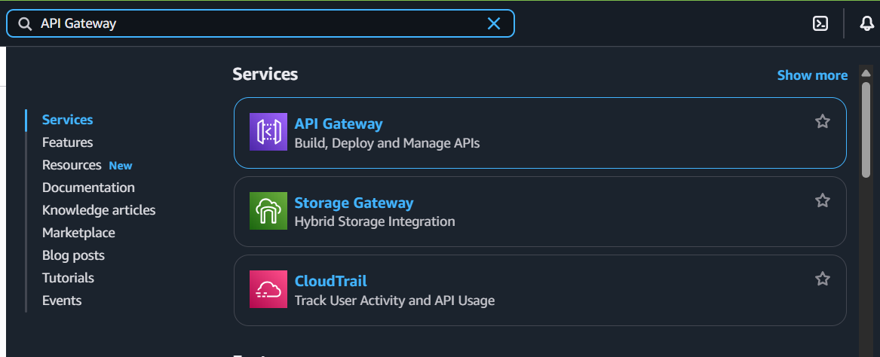

Following window will appear:

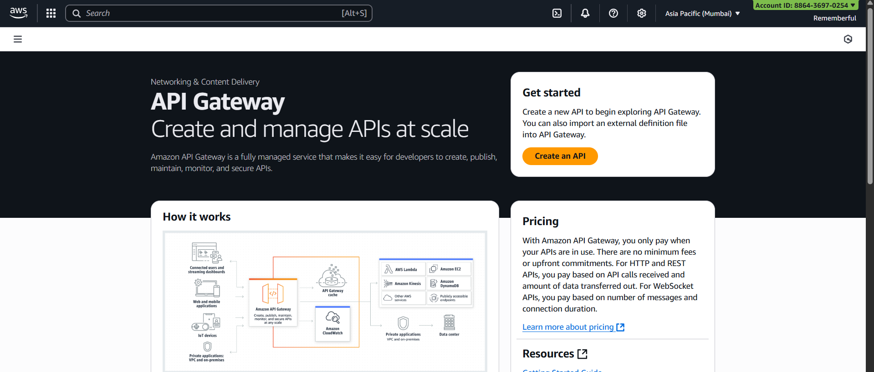

Click on the “Create an API” button: following window will appear.

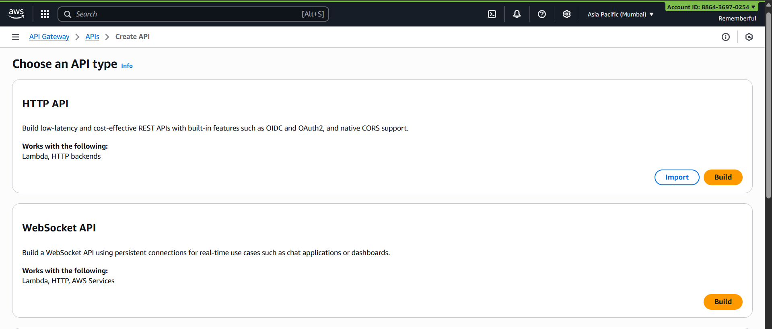

We will create a REST API Private, so scroll down and click on the “Build” button at the REST API private section: 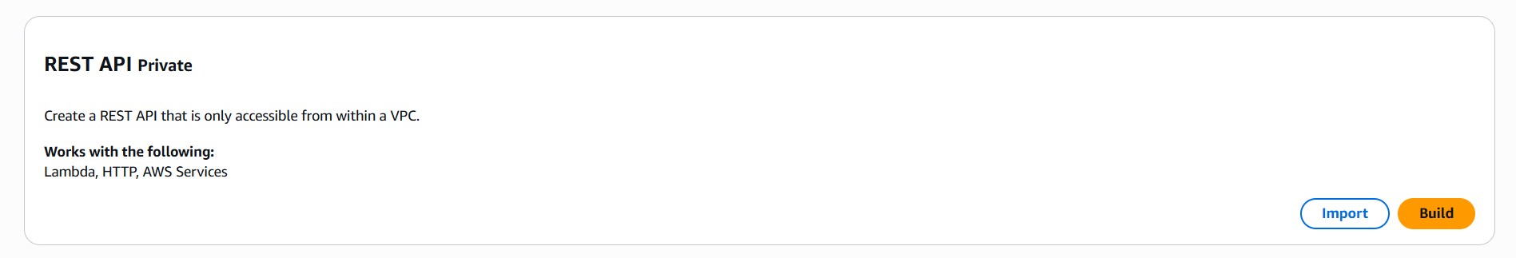

Following window will appear:

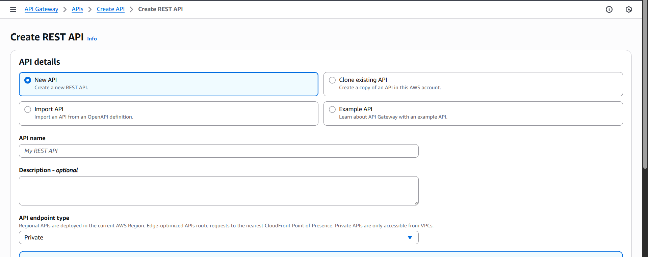

Make changes, as shown or as per the requirement:

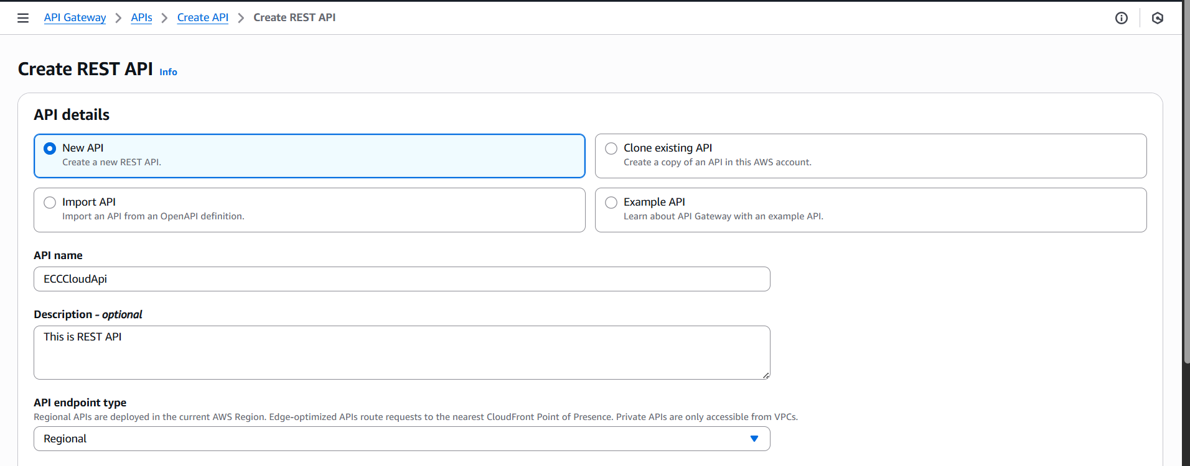

Following confirmation will occur:  
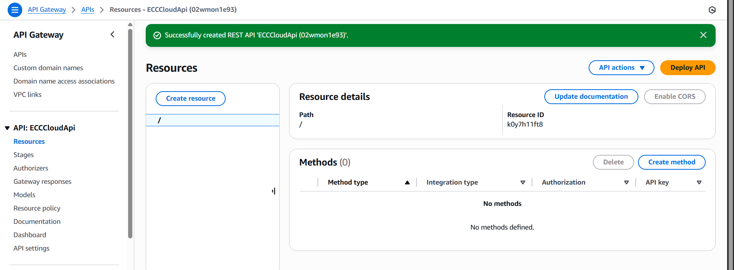

Click on the “Create Method” button as shown above:

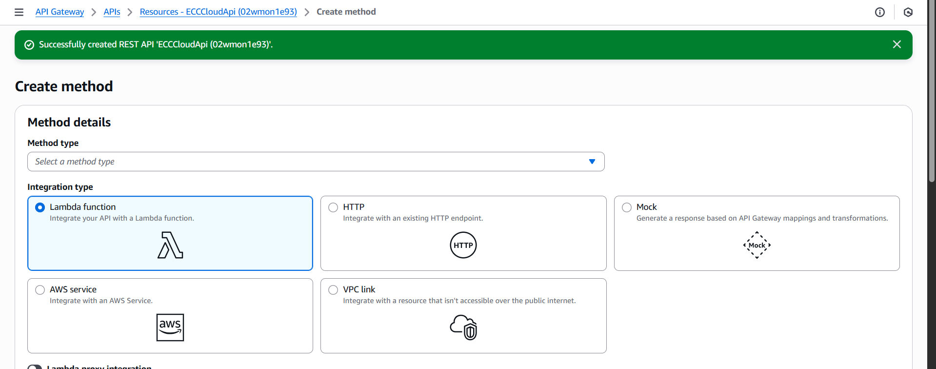

Change the options as shown below:

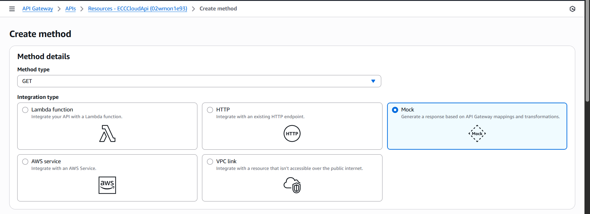

After this, click on the orange button given below, following confirmation will occur:

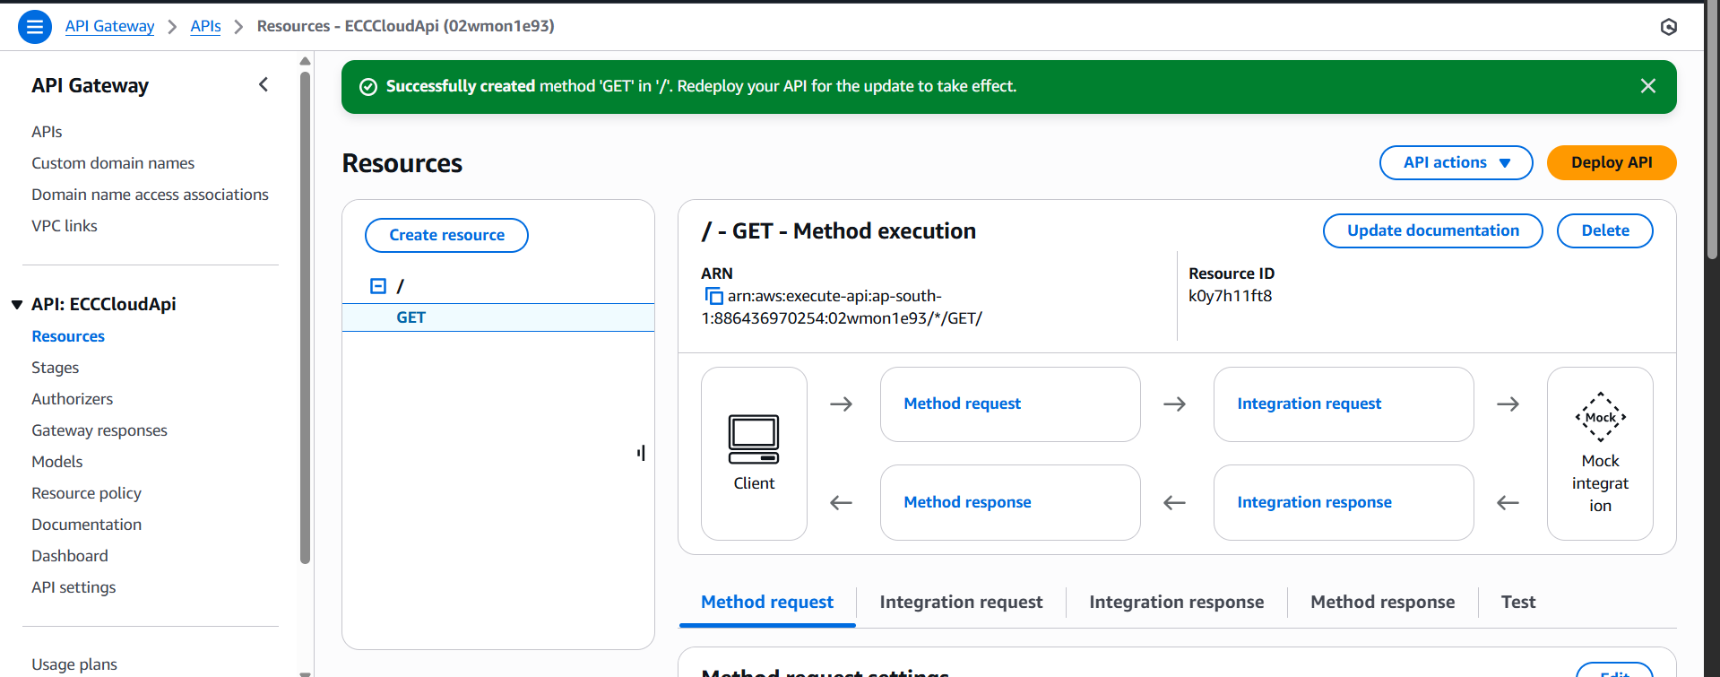

Now, click on the “integration responses” section: following option should occur.

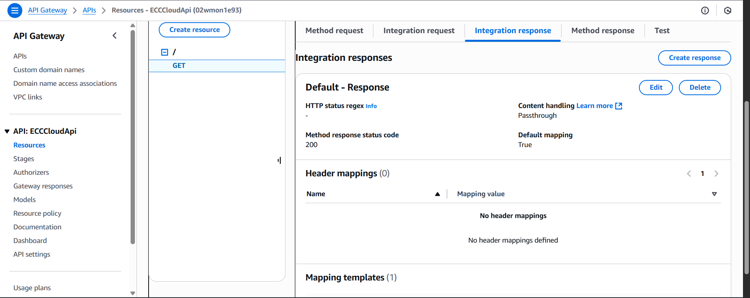

Click on the “edit” button: following window will appears.

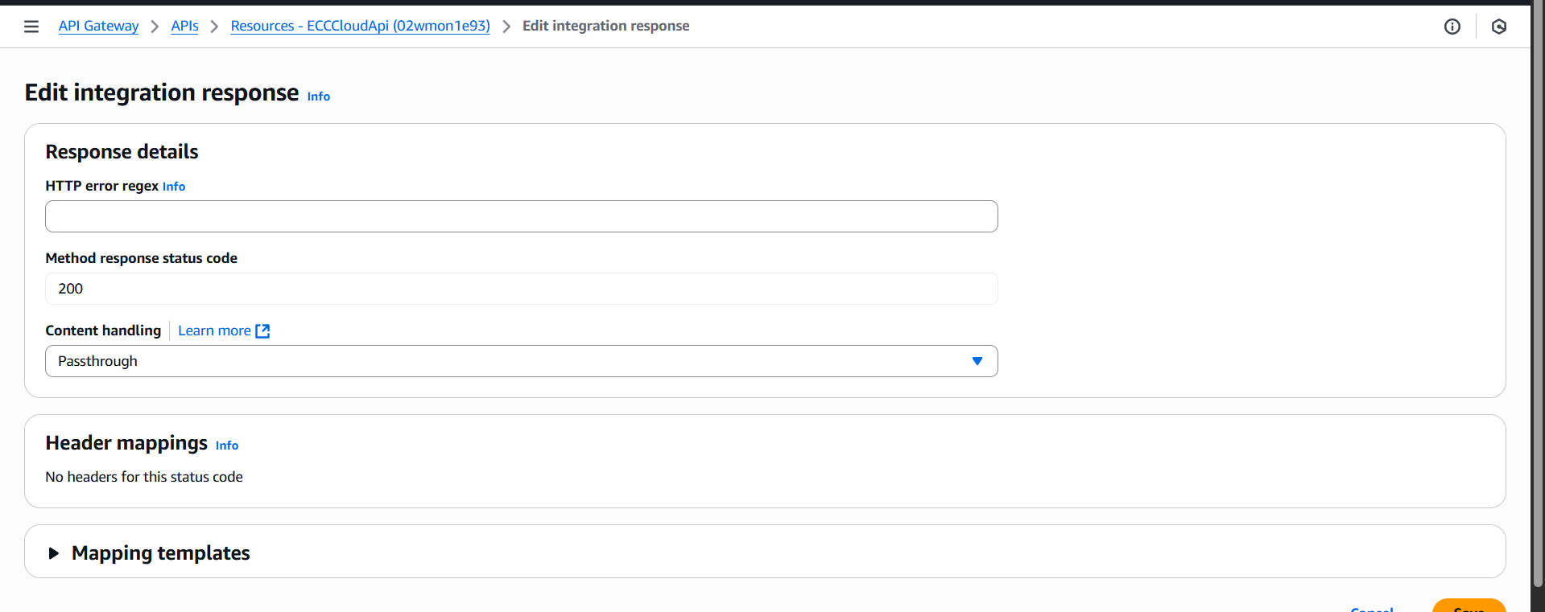

Click on the “Mapping Templates” option:

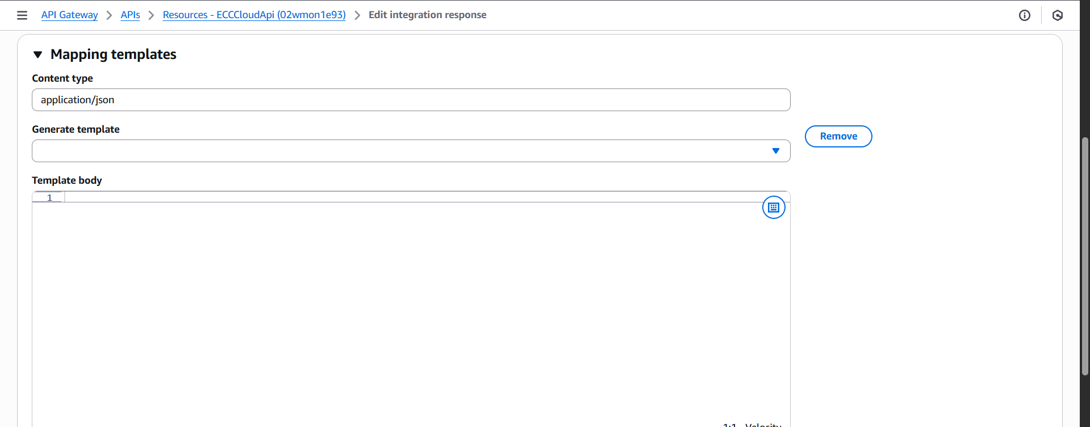

Type the following as shown:

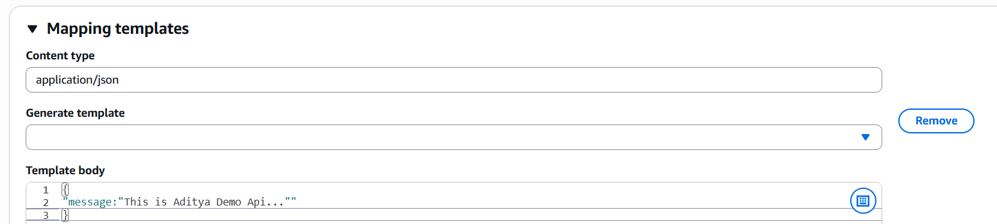

Following confirmation will occur:

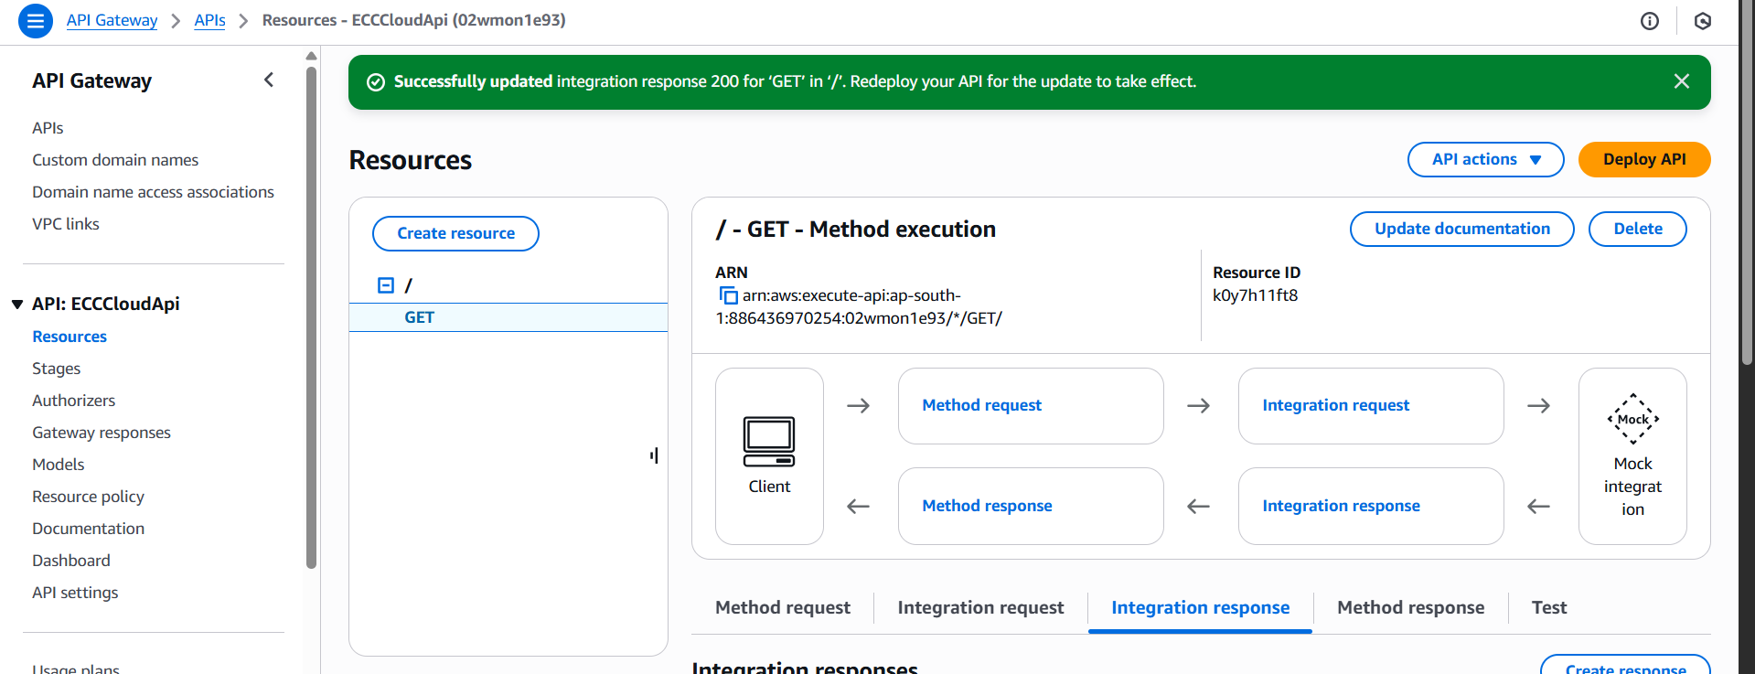

Click on the “Deploy API” button, and then select the stage as “New Stage”: then click on deploy

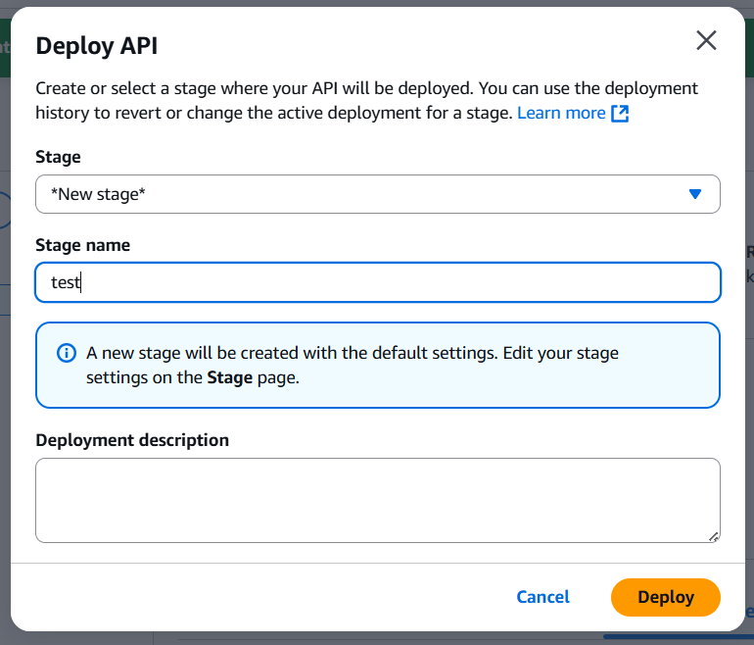

Following confirmation will occur:

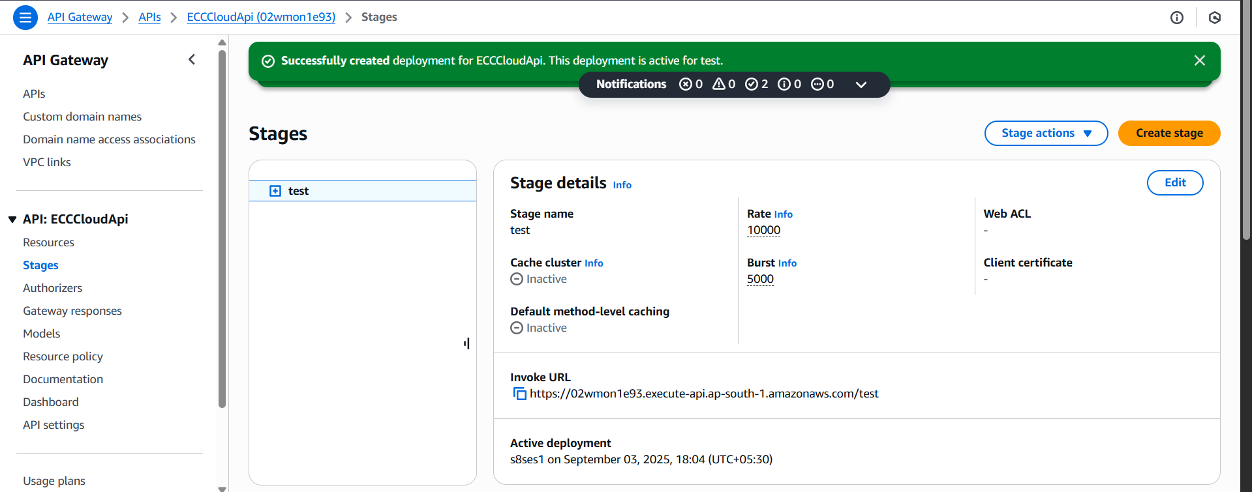

Now, paste the invoke URL which is shown there in new tab: it will show something like this.

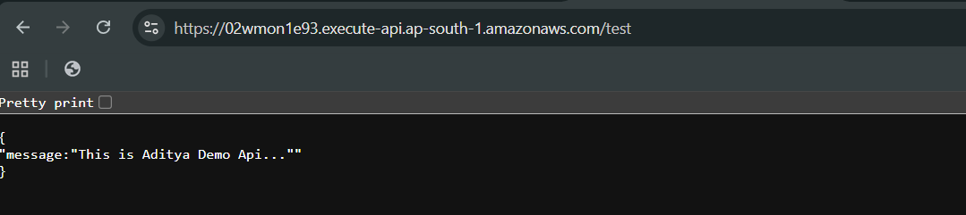

So, API is ready, now we will be protecting this API from the specified IP with WAF:

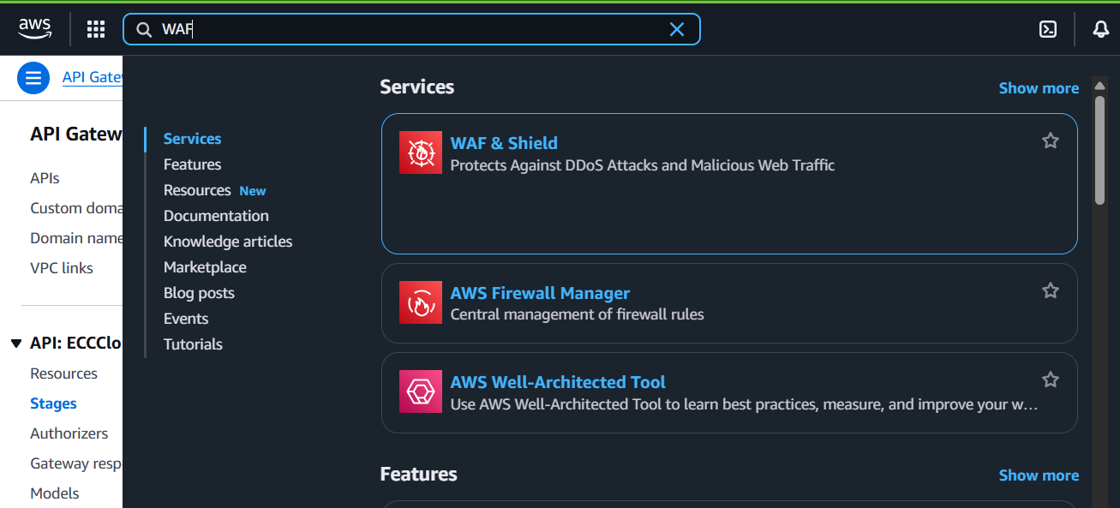

Following window will appear:

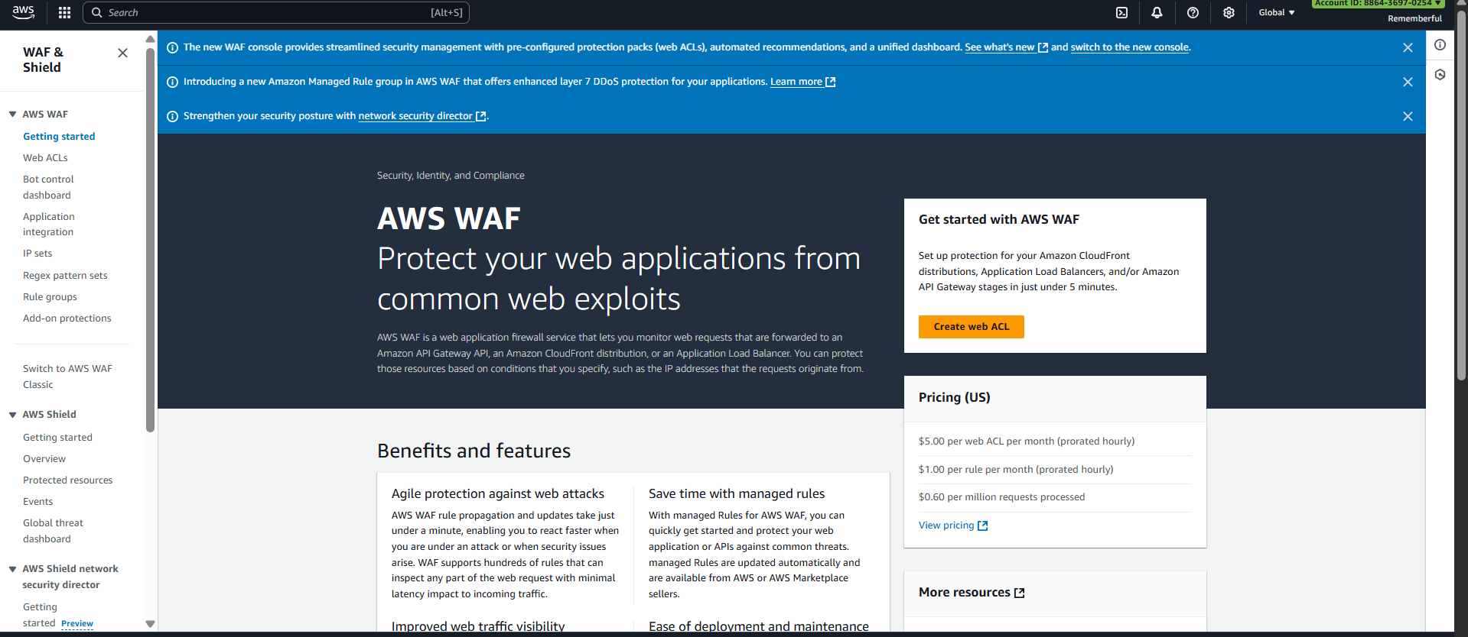

Click on the “IP sets” from the left pane:

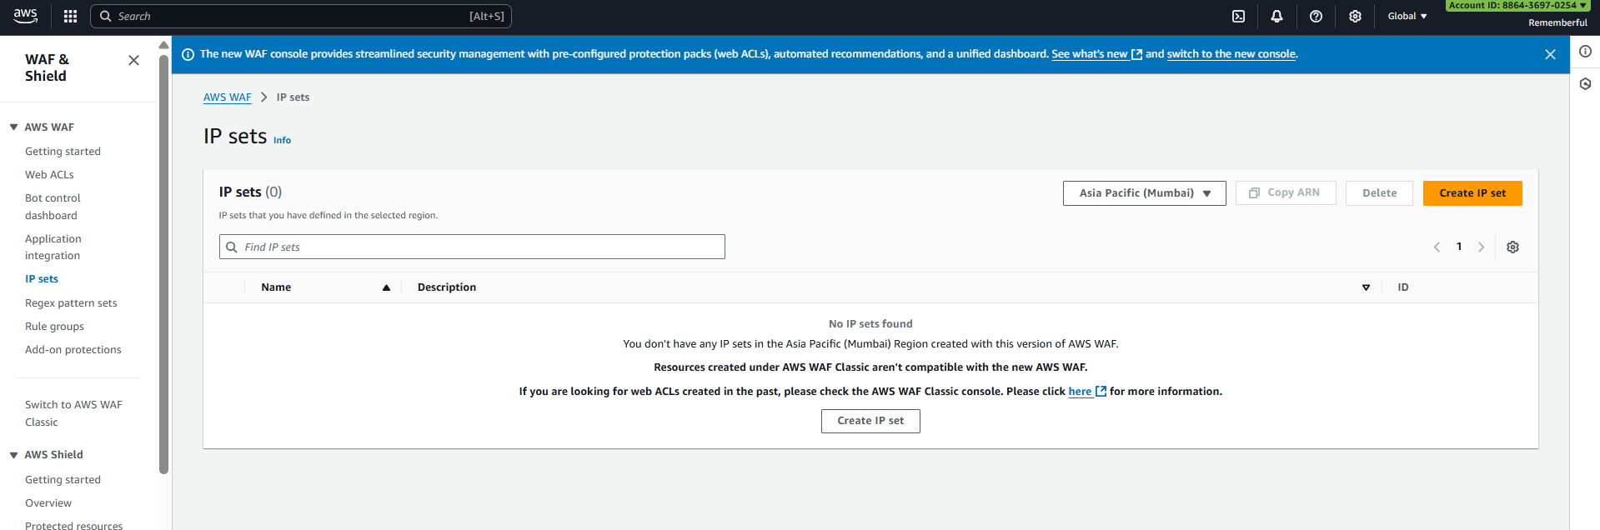

Click on the “Create IP Set” button: following page occurs.

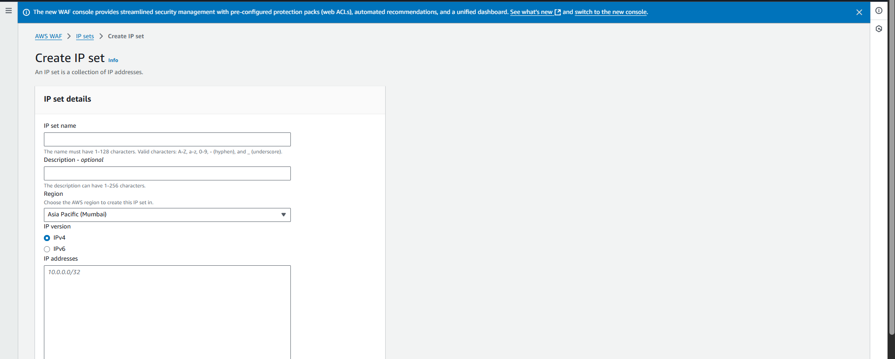

Specify the name of your choice:

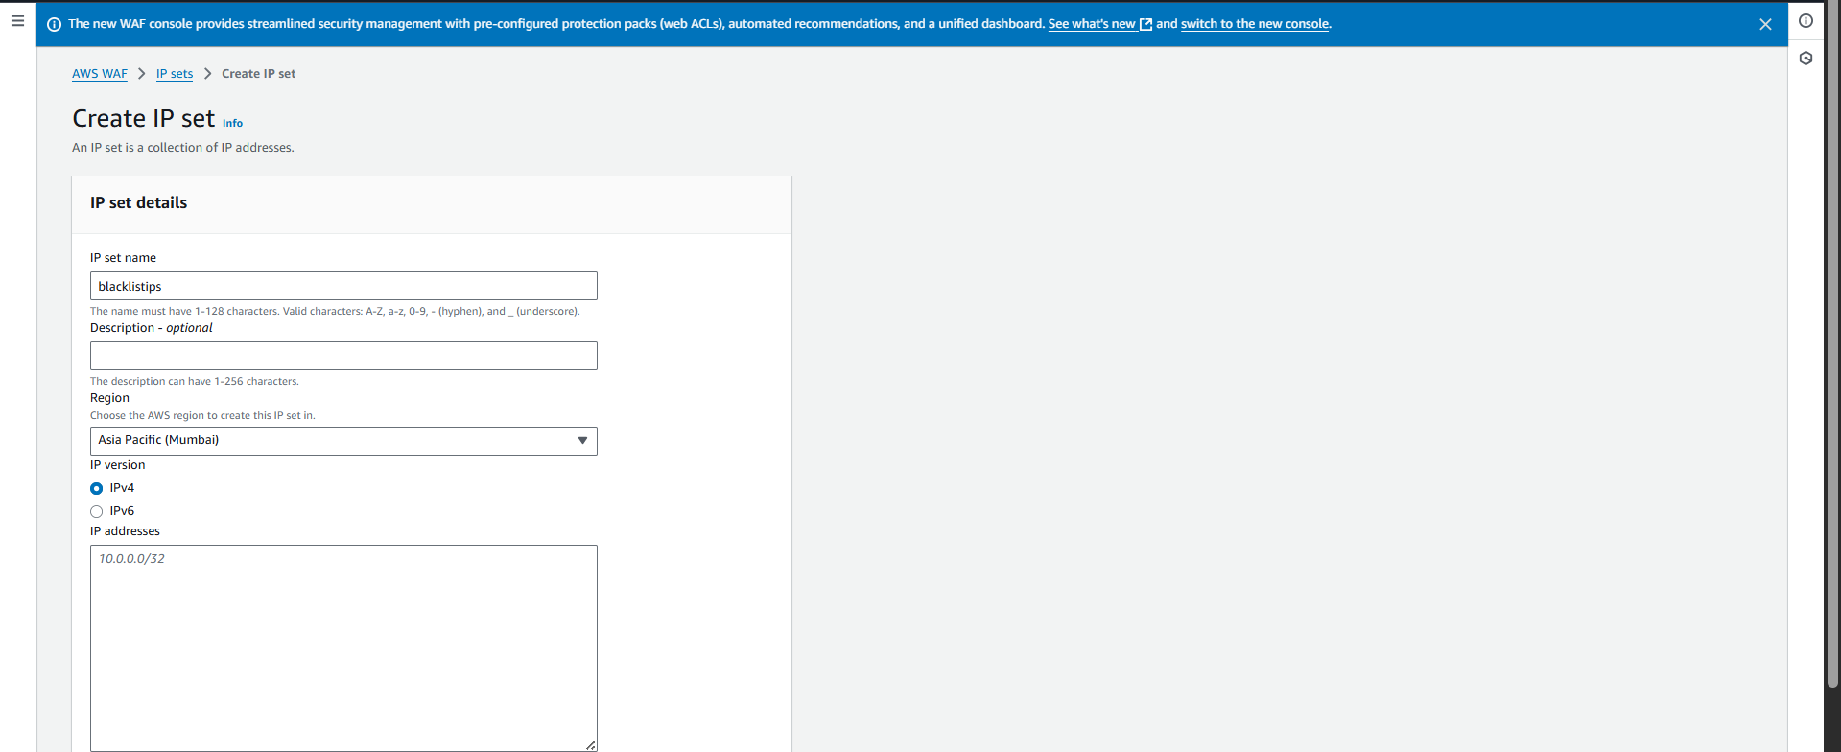

Following confirmation will occur:

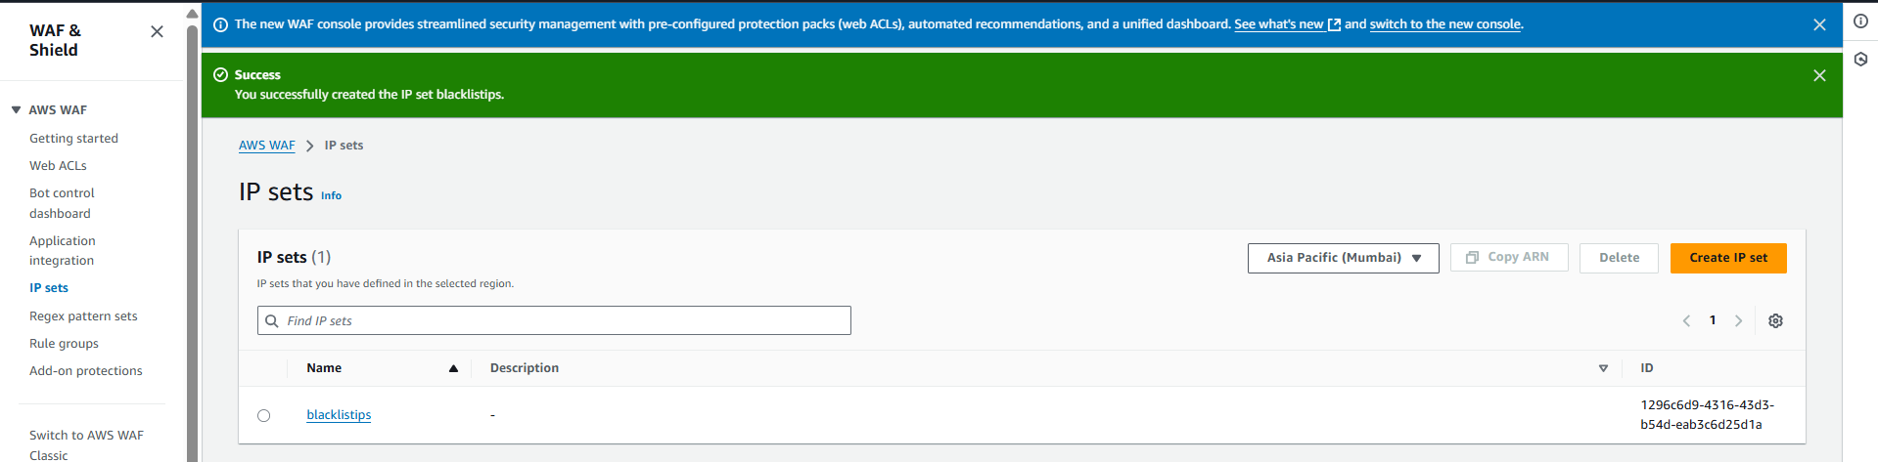

Click on the name of it:

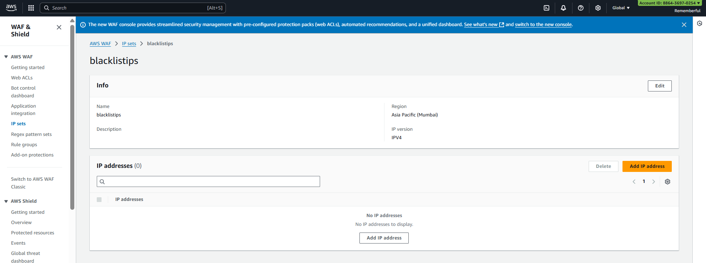

Now, click on the “Add IP address” button:

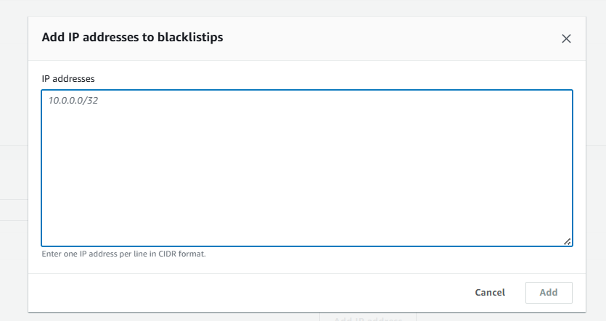

Specify the IP: here I did my own public IP.

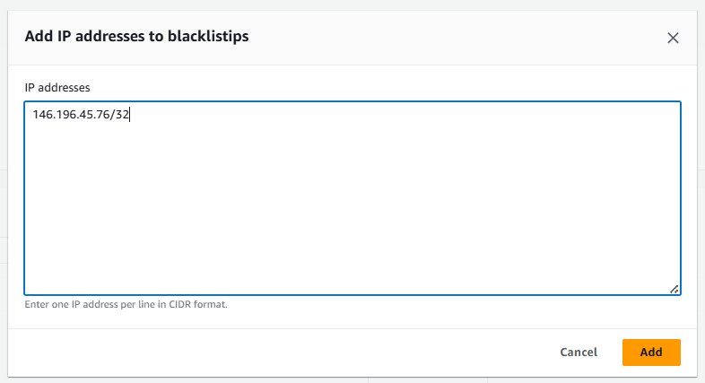



Added:

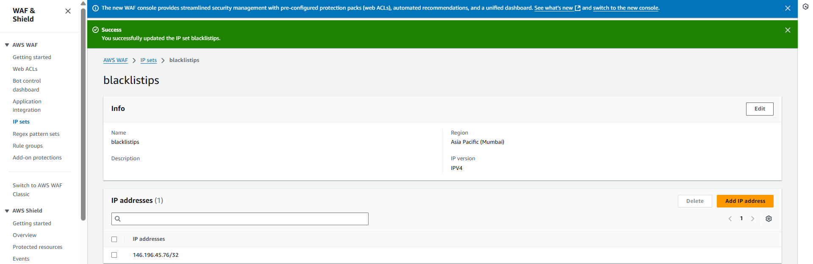

Now, we will be creating WEB ACL in WAF: click on the “Web ACLs” from the left pane.

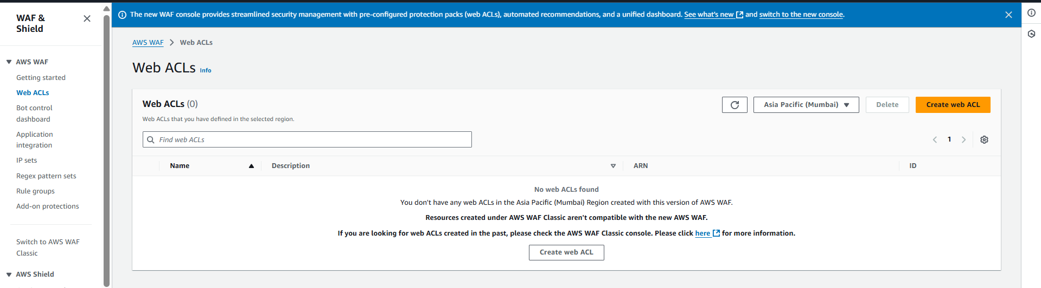

Click on the “Create Web ACL” button:

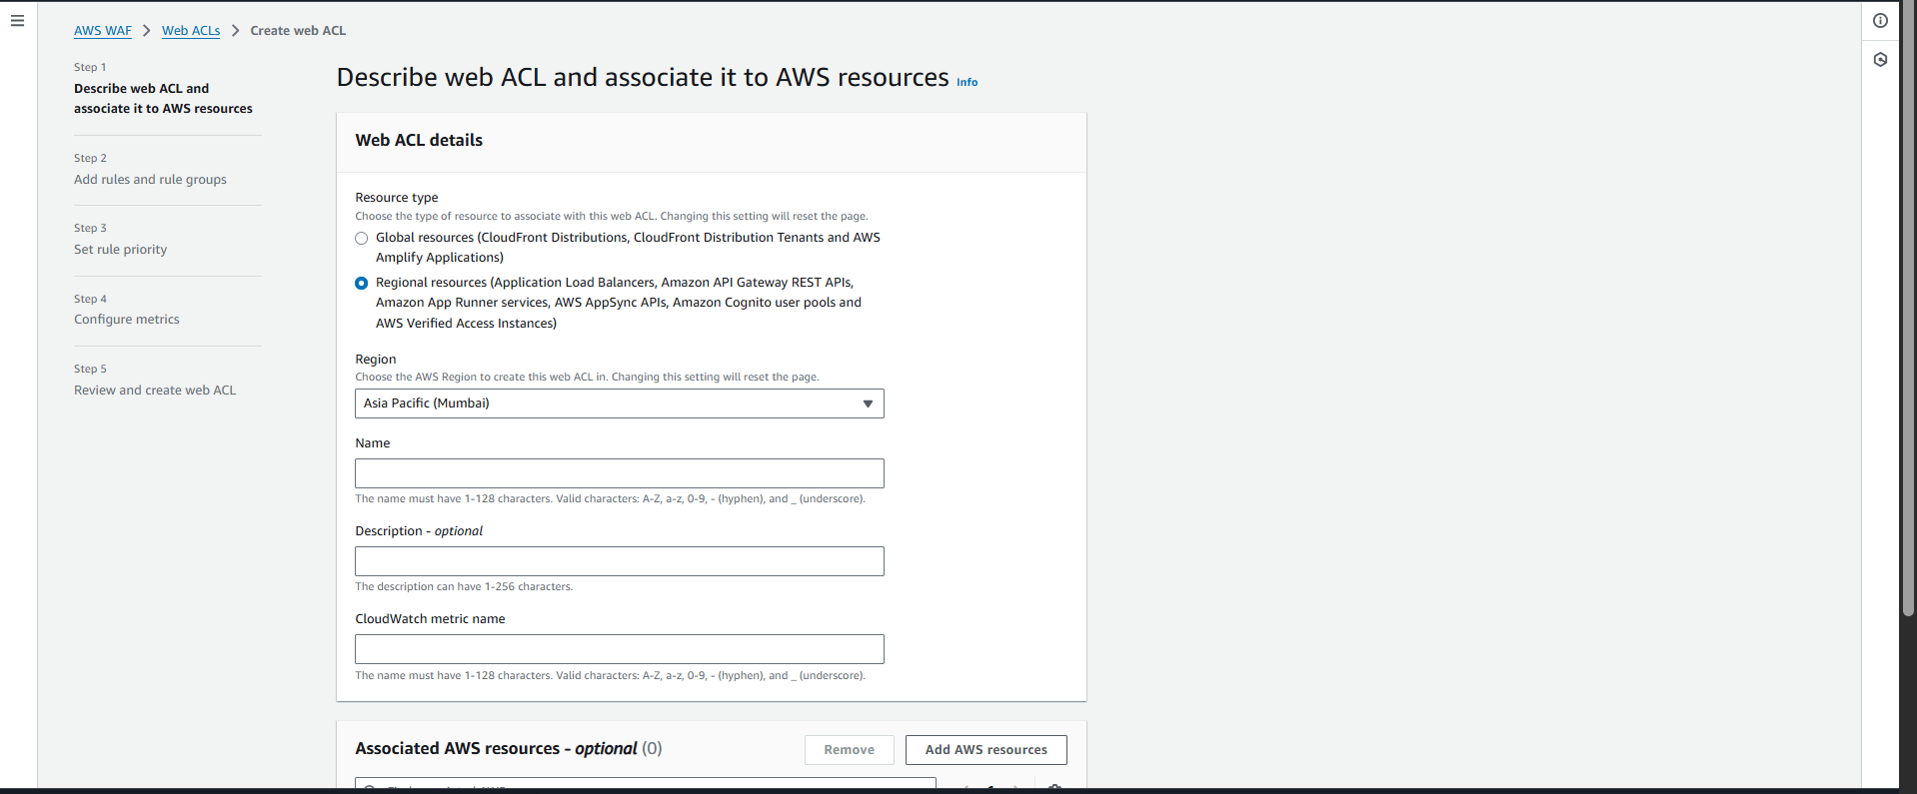

Now, specify it as like this:

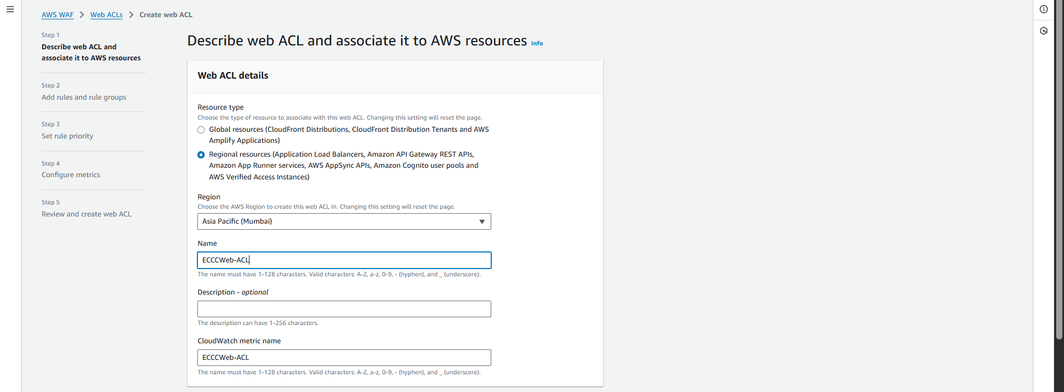

Now, “Add AWS Resources”: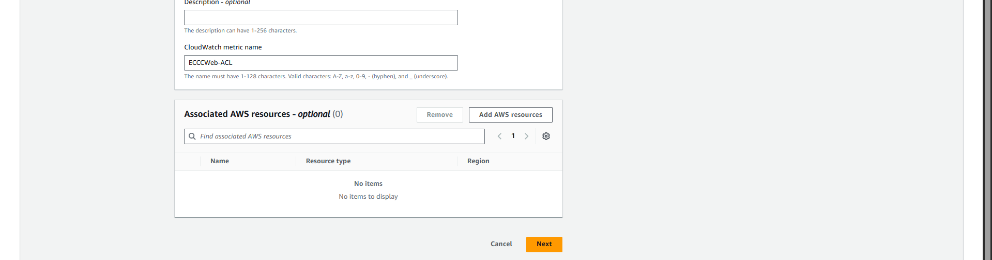

Following options occur:

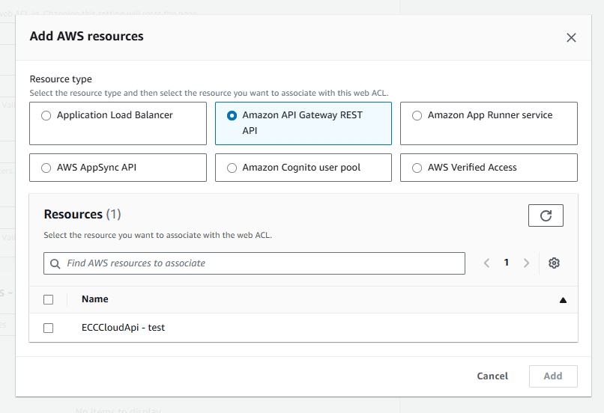

Click on the:

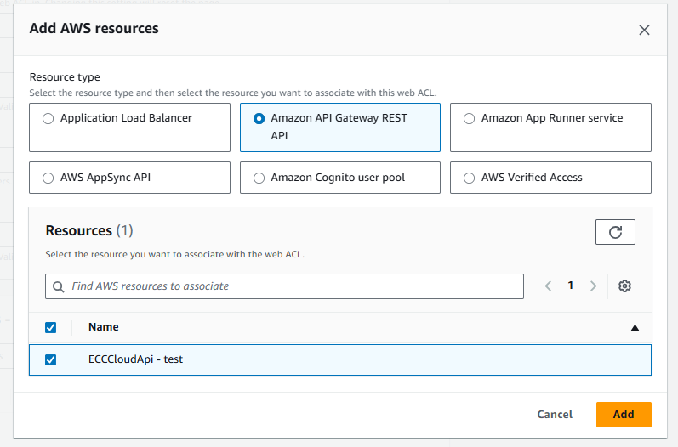

Following things shown:

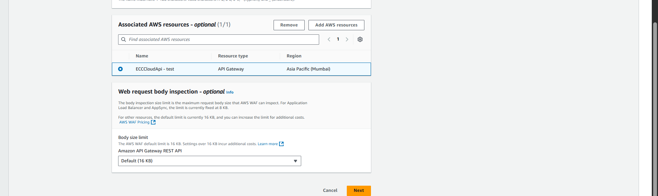

Following screen will appear:

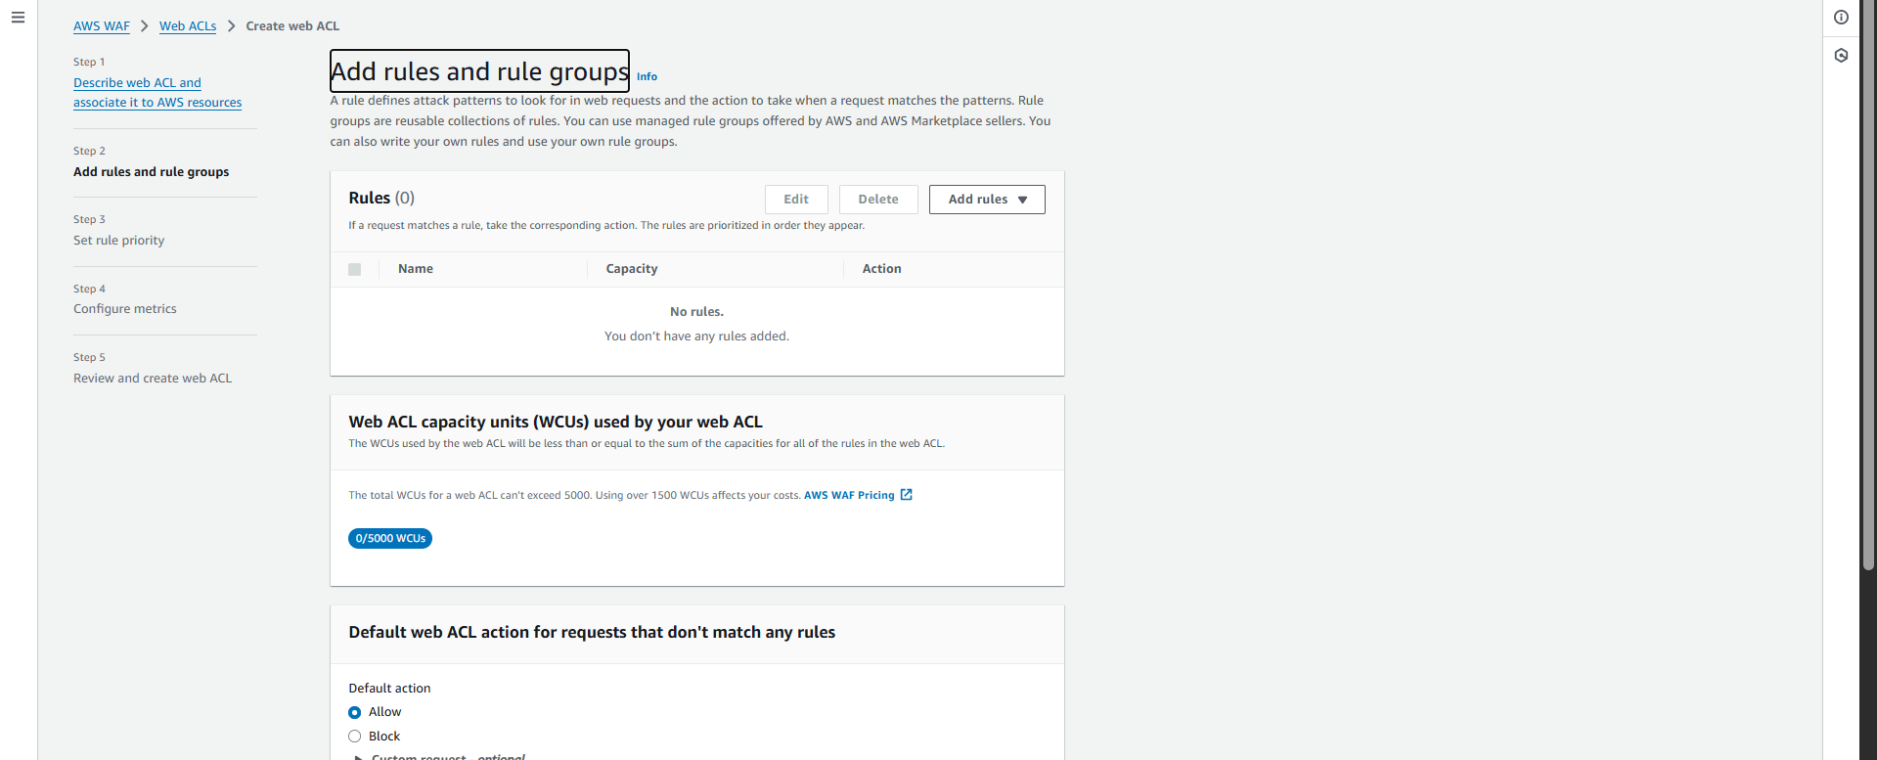

Click on the “Add rules”, click on the “Add my own rules and rule groups”:

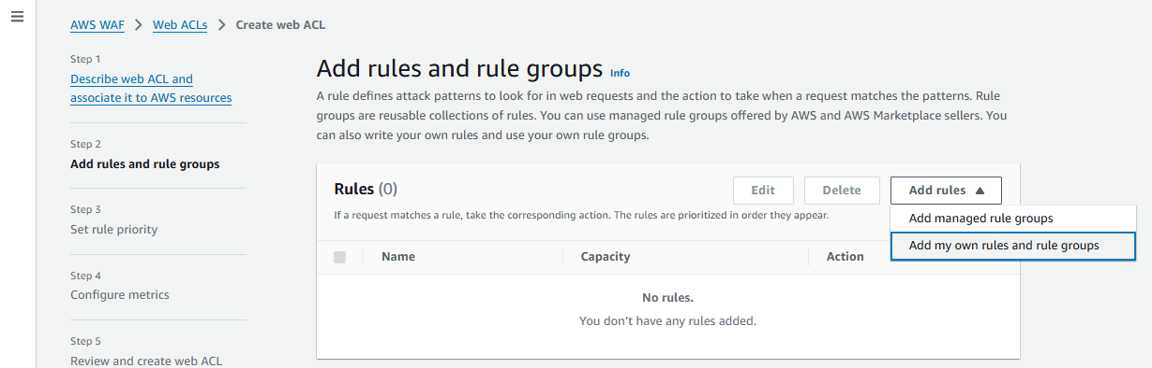

Following screen appears:

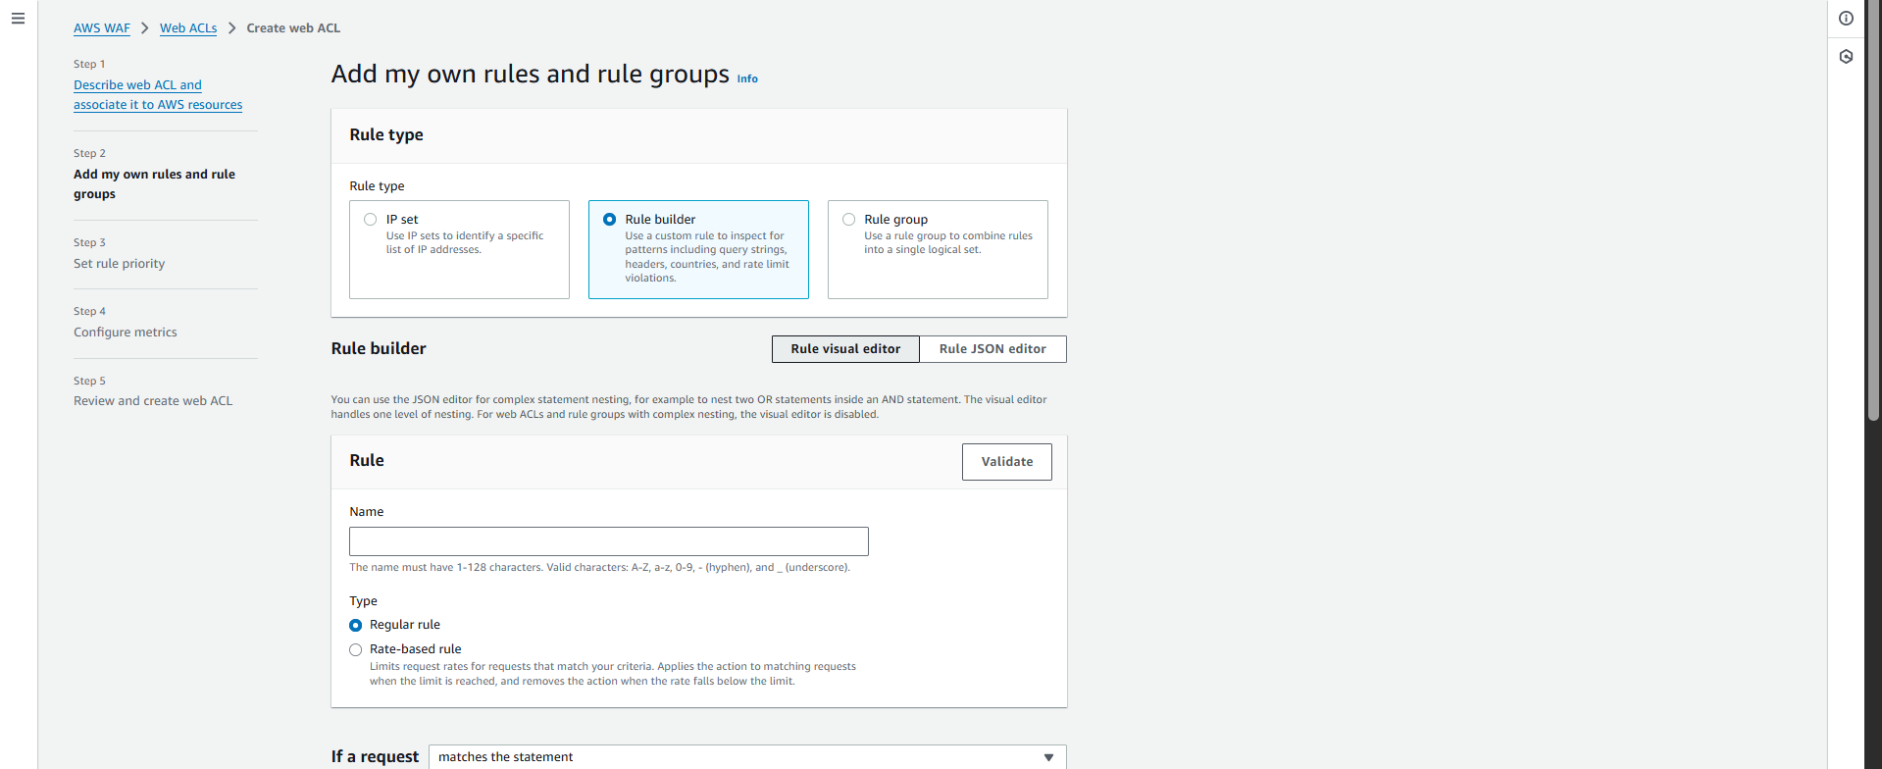

Make following changes:

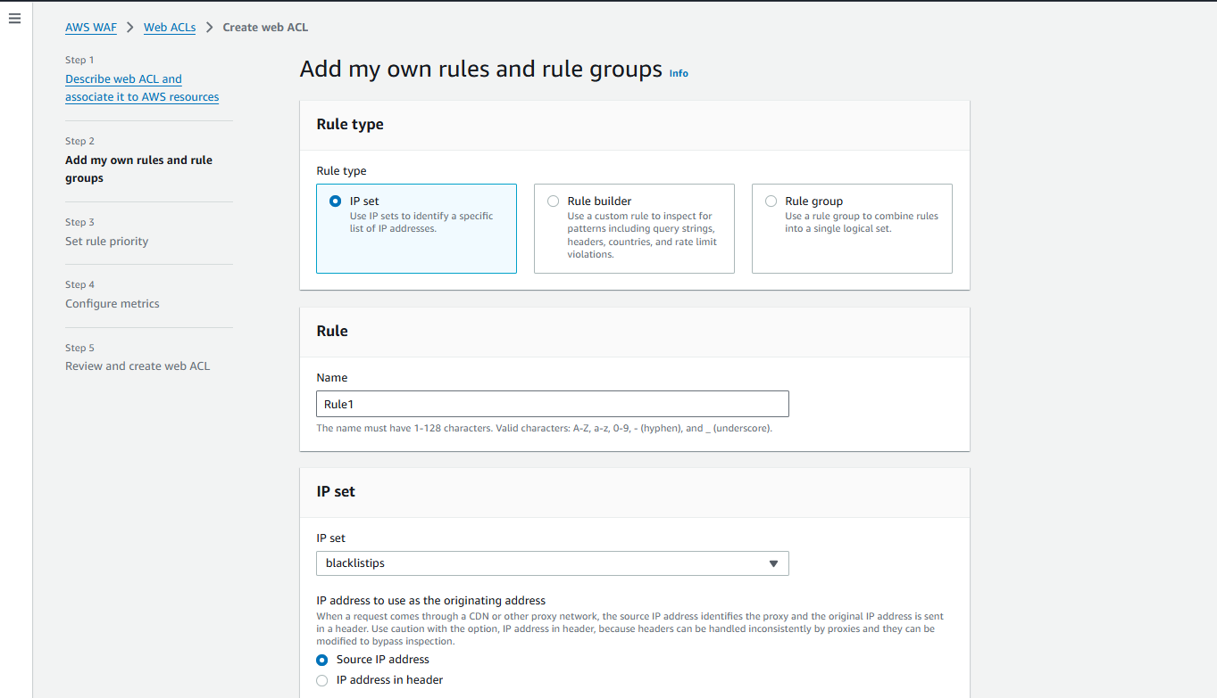

Also, ensure:

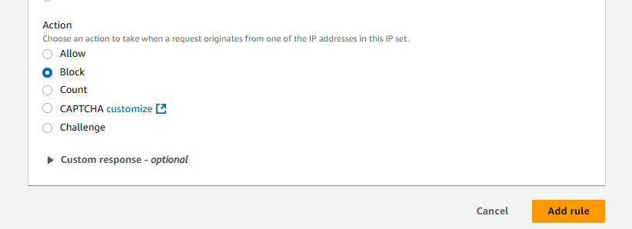

Click on “add rule” button:

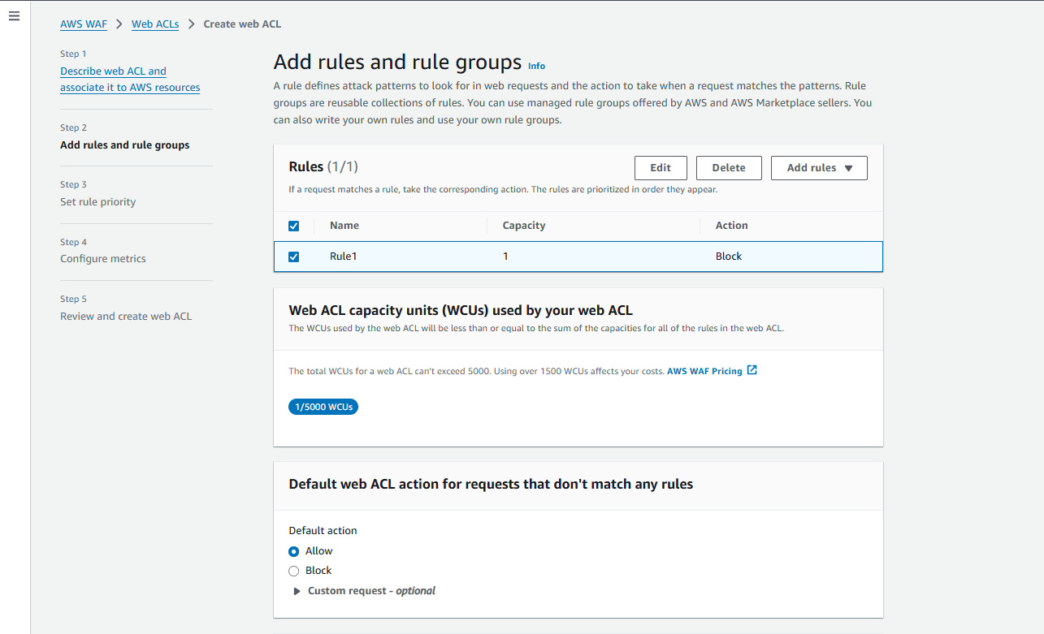

Click on the “next” button:

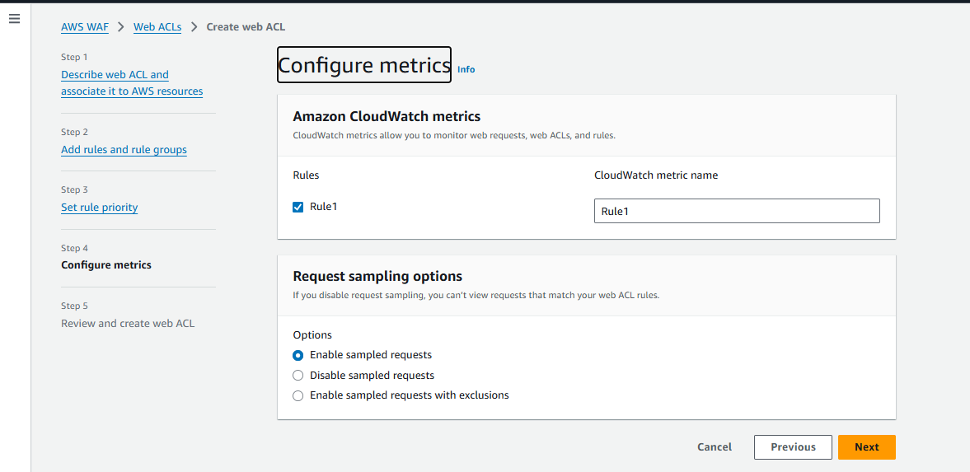

Following confirmation will occur:

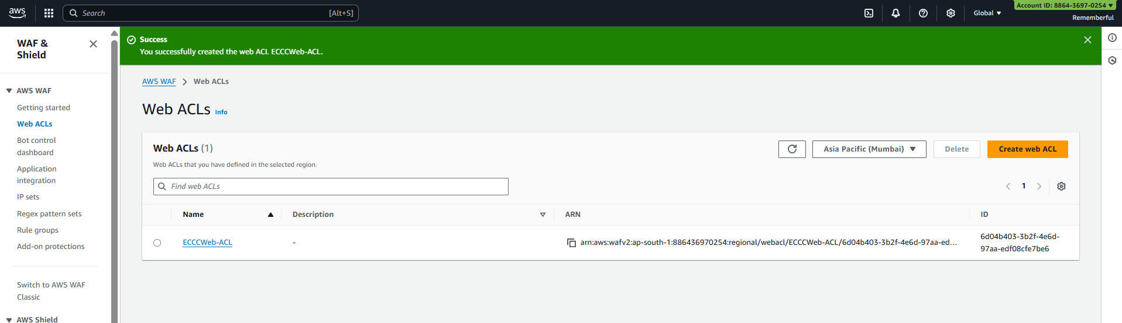

Reopen the Invoke URL: clearly it worked.

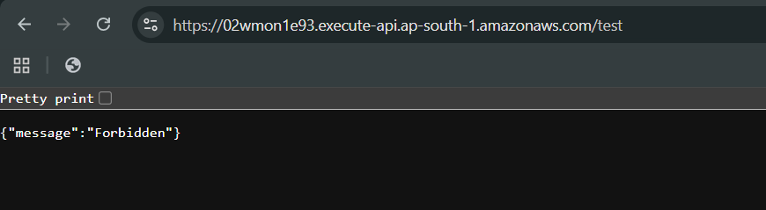

--The End--