**Day 9**

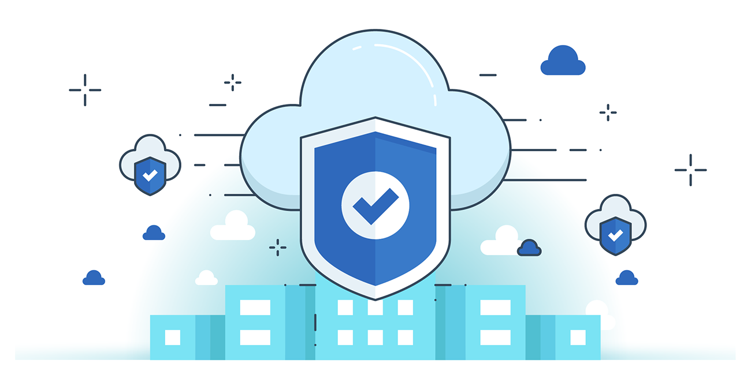



**“CLOUD SECURITY”**

**Authentication and Credentials:**

1. **Importance of Strong Authentication in Cloud:**
   1. Cloud services are internet-accessible, making accounts vulnerable if credentials are stolen.
   2. Federation (e.g., Single Sign-On) increases risk due to reliance on a single credential.
2. **Multi-Factor Authentication (MFA):**
   1. Requires 2 or more factors to access a resource, reducing account takeover risk.
   2. Identity provider must relay MFA status to relying party in federated setups.
3. **Types of MFA:**
   1. **Hard Tokens:** Hardware-based, high security (e.g., RSA tokens).
   2. **Soft Tokens:** App-based OTPs, vulnerable if device is compromised.
   3. **Out-of-Band (OOB):** OTP via SMS/email—convenient, but interception-prone.
   4. **Biometrics:** Used locally on device; not shared with cloud providers.

**Architecture of Cloud data centre:**

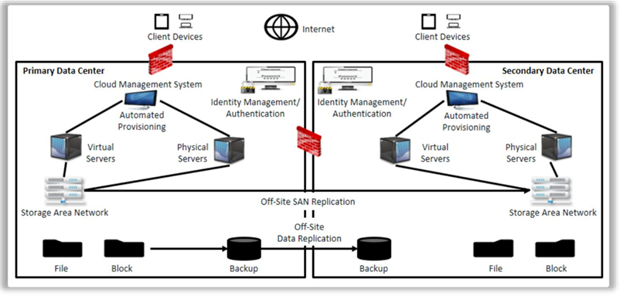

--The End--