Day 34
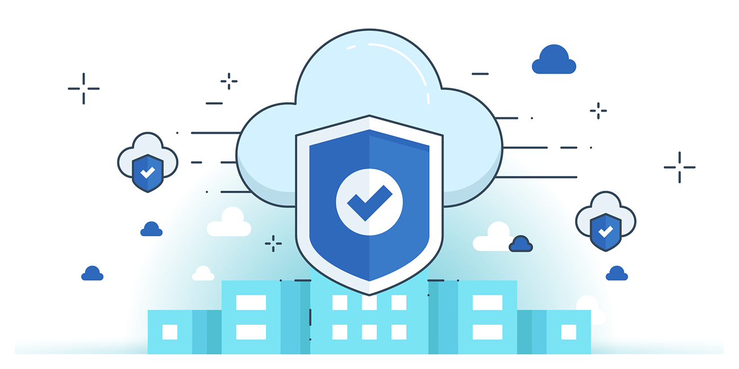

“CLOUD SECURITY”
Phases of Data life cycle in Cloud Computing:
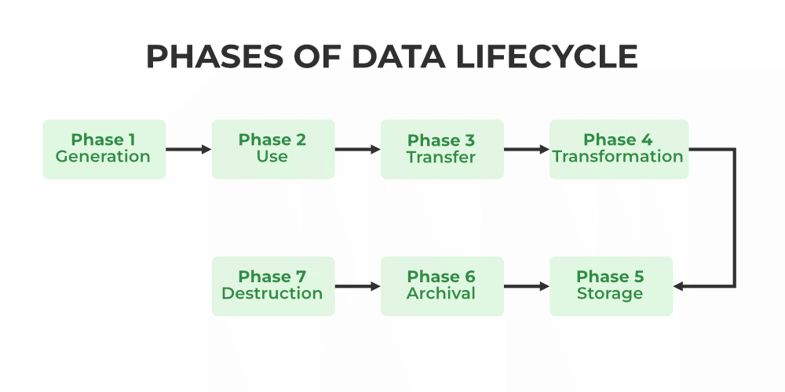
Best Practices for Cloud Data Storage:
- Planning & Classification – Assess provider’s security, classify data, and plan secure migration.
- Access & Authentication – Enforce MFA, control user activity, and manage access properly.
- Security Controls – Apply endpoint security, DLP, monitoring, and quick incident response.
- Resilience – Ensure backup, disaster recovery, and continuous technology upgrades.
Cloud Storage Data Encryption:
- Purpose – Encryption protects data privacy on shared/cloud resources by converting plain text into secret text.
- Types – Symmetric (same key) and Asymmetric (different keys) encryption.
- Techniques & Tools – Includes Identity-Based, Attribute-Based, and Homomorphic Encryption, with secure key management via Key Vaults.
Encryption in IaaS, PaaS, and SaaS:
- IaaS – Encryption is mostly handled by providers (object storage: server/client/proxy encryption; volume storage: instance/external/proxy encryption).
- PaaS – Customers secure data, apps, and user access using application-level and database encryption.
- SaaS – Providers secure infrastructure/data with client-side encryption, homomorphic encryption, and enterprise key management.

