Day 45
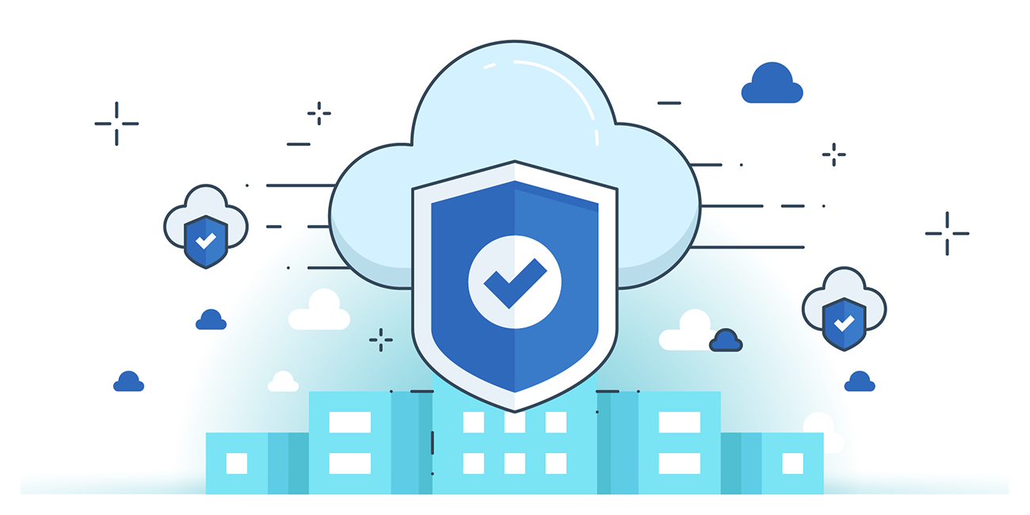

“CLOUD SECURITY”
Ensure that Amazon S3 buckets are Encrypted with Customer-Provided AWS KMS CMKs:
Steps:
Look for S3:
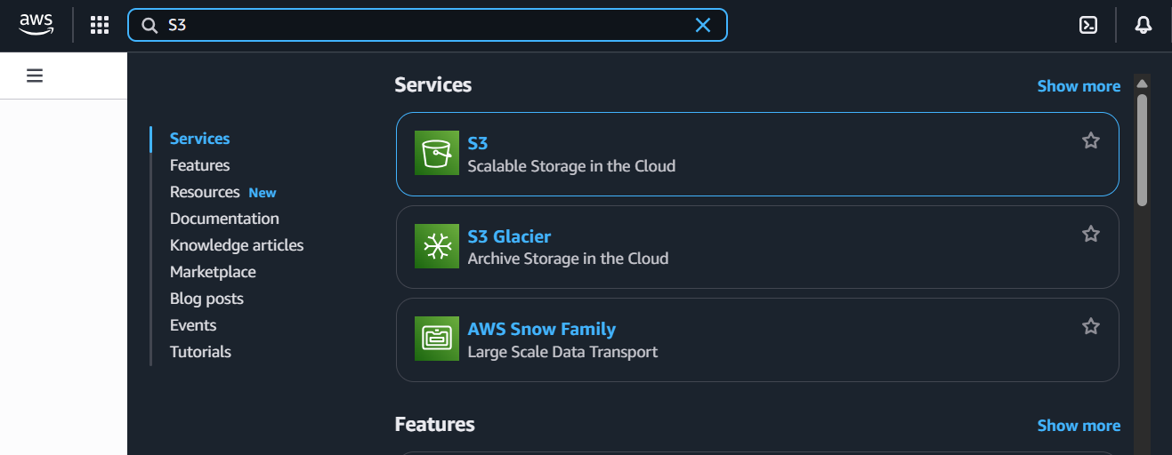
Create a bucket:
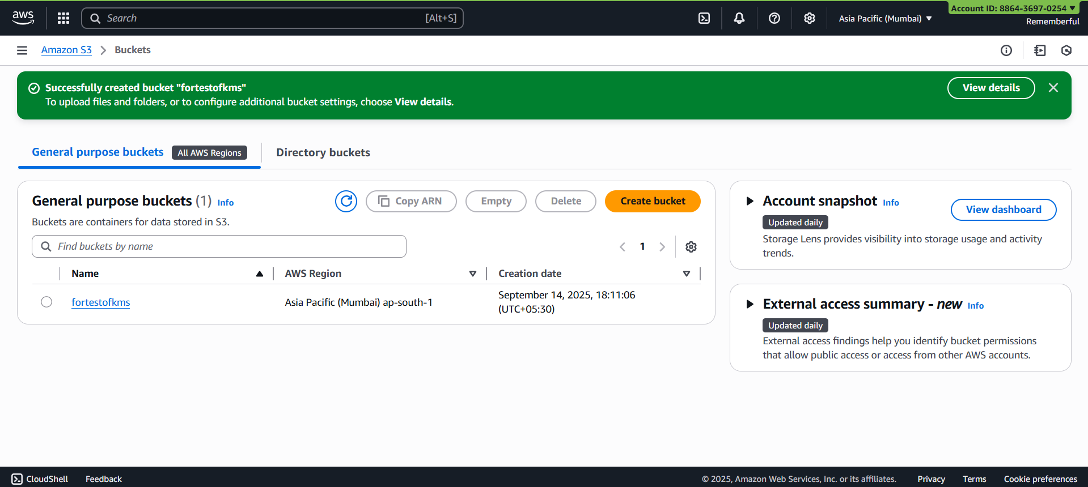

Open the bucket:
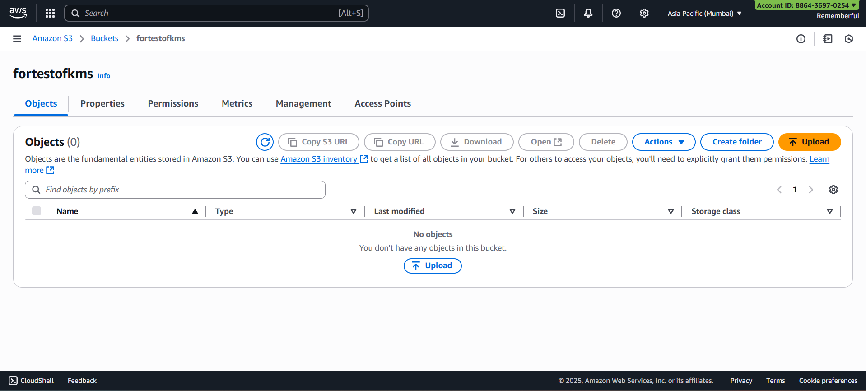
Open the ‘properties’:
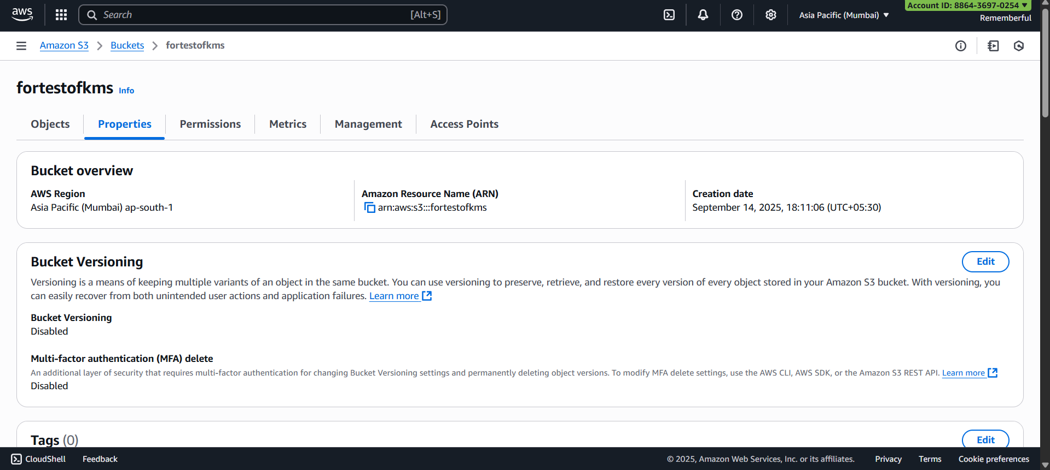
Scroll down to “default encryption”:
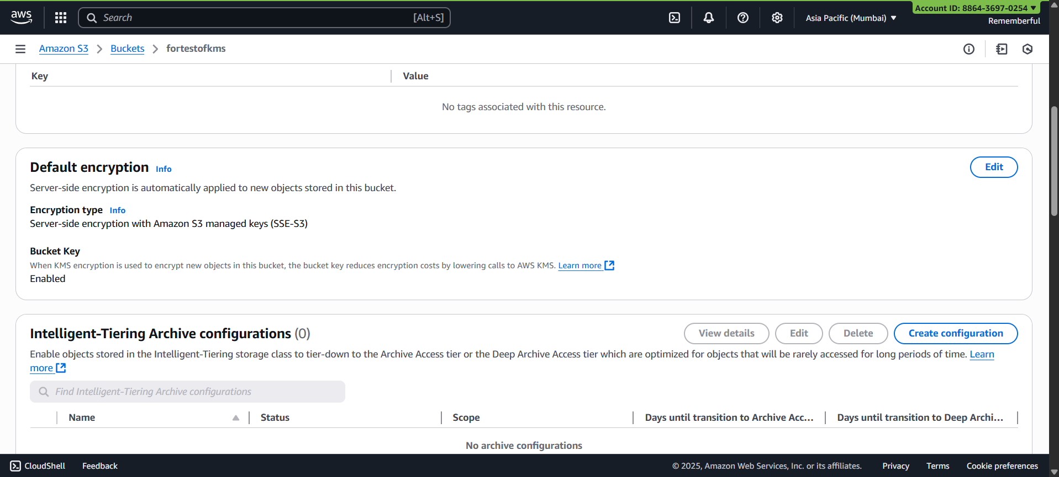
Following screen will appear:
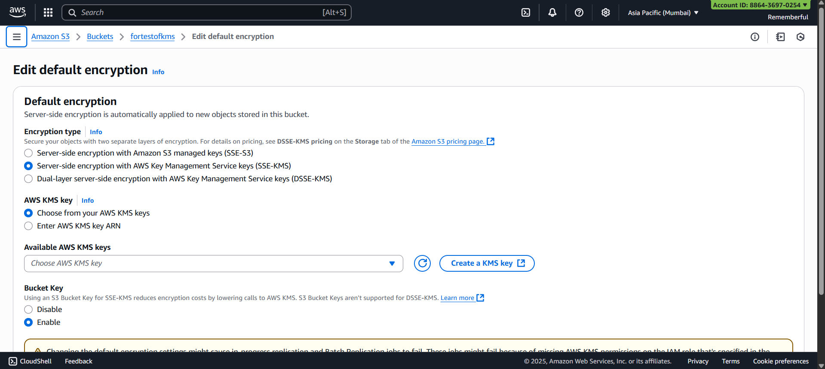
Choose the KMS key:
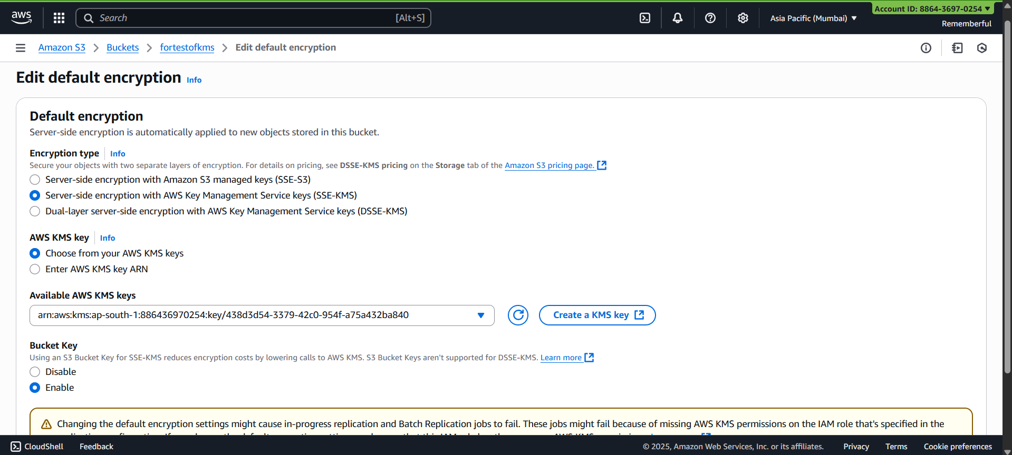
Following confirmation will occur:
Done!

Ensure AWS S3 Buckets Enforce Server-Side Encryption (SSE):
Steps:
Open the bucket:
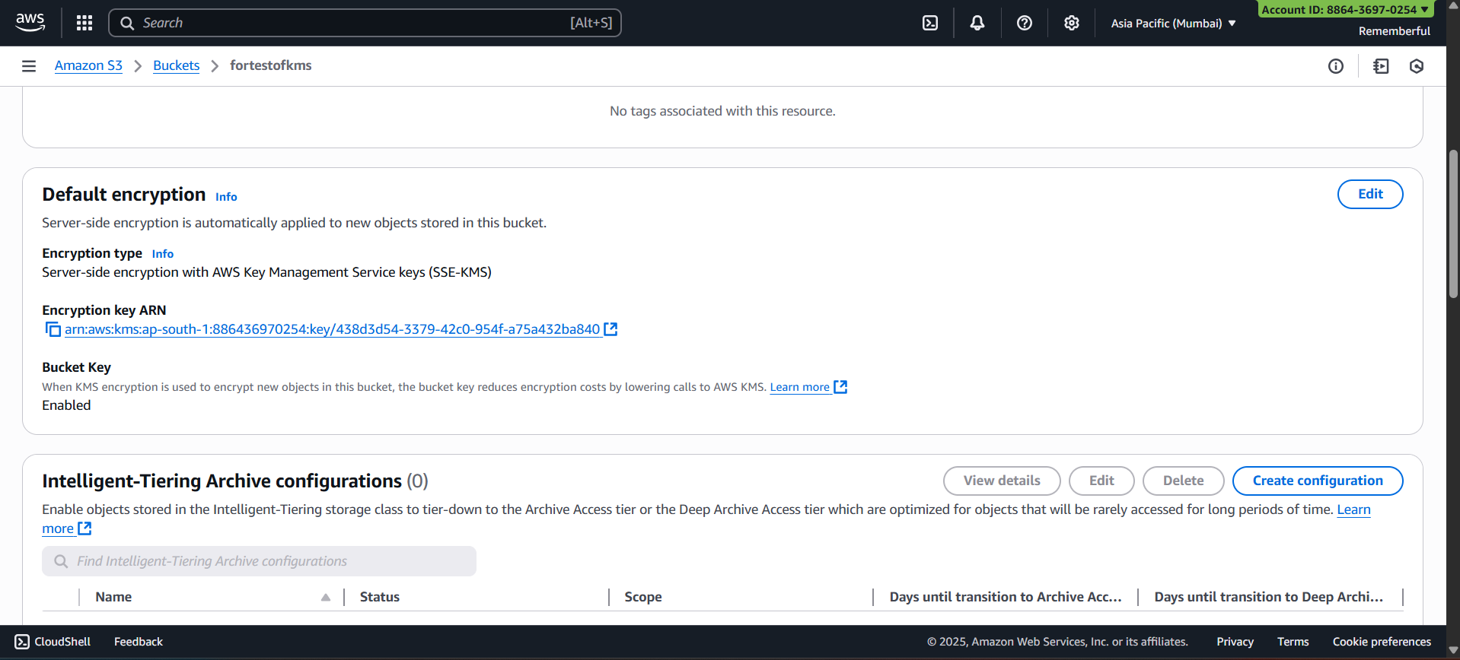
Change the available option to:
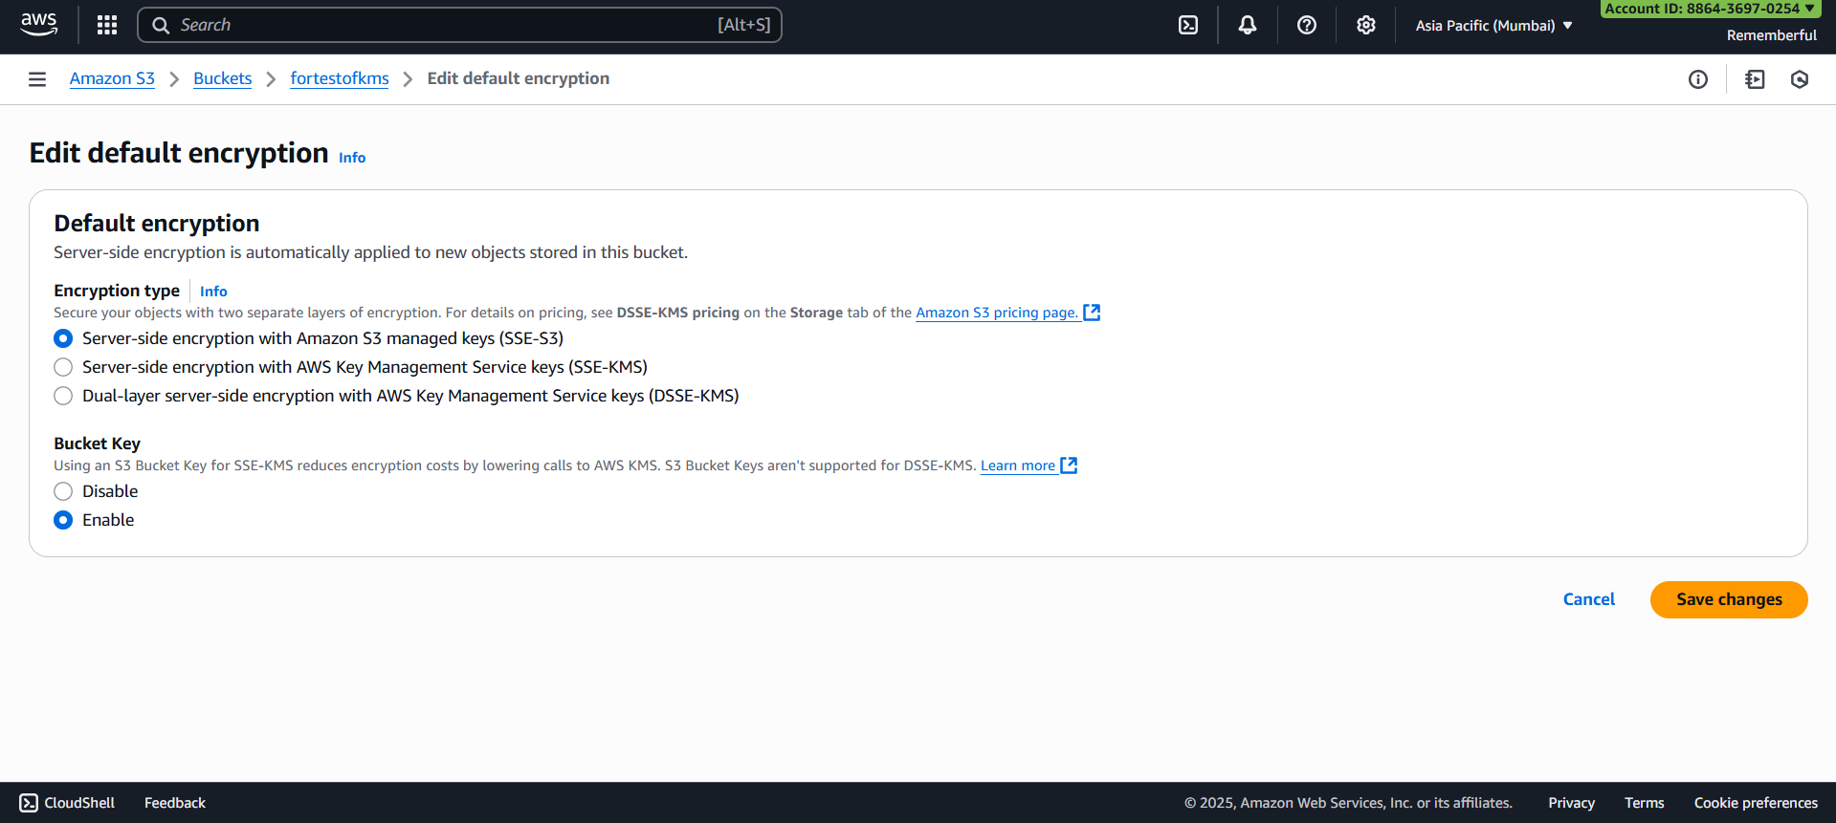
Done!
--The End--

