Day 46
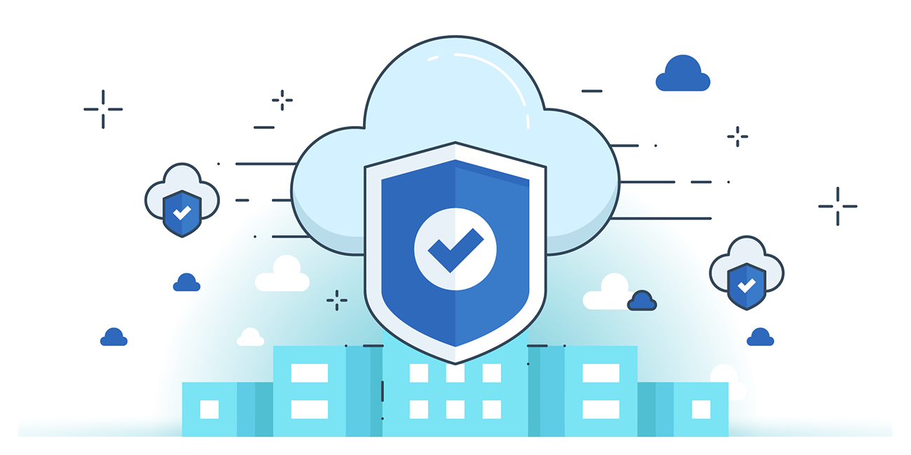

“CLOUD SECURITY”
Grant Private Access to EBS Volume Snapshot:
Steps:
Look for EC2:
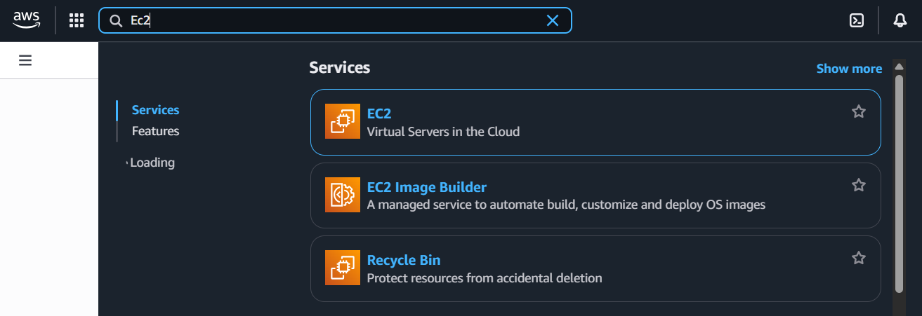
Navigate to Elastic Block Store and click on Snapshots:
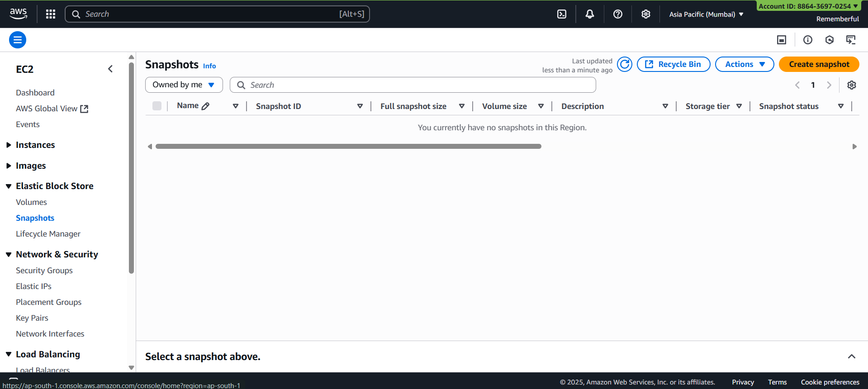

Click on “create snapshot”:
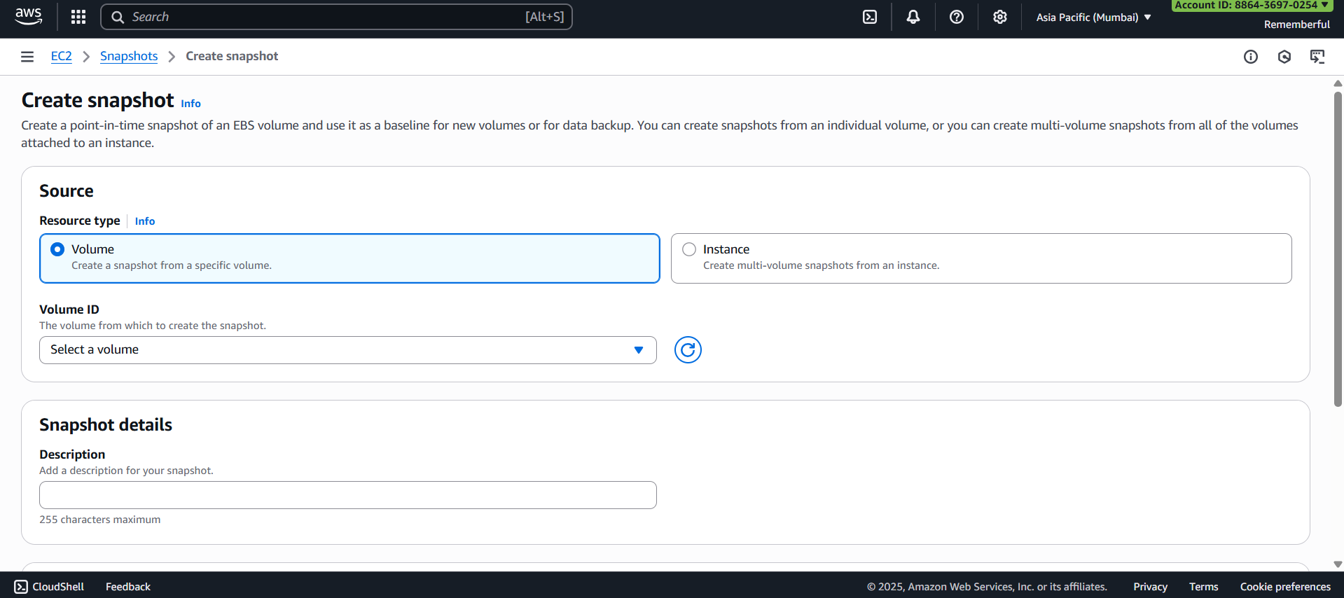
Fill the form:
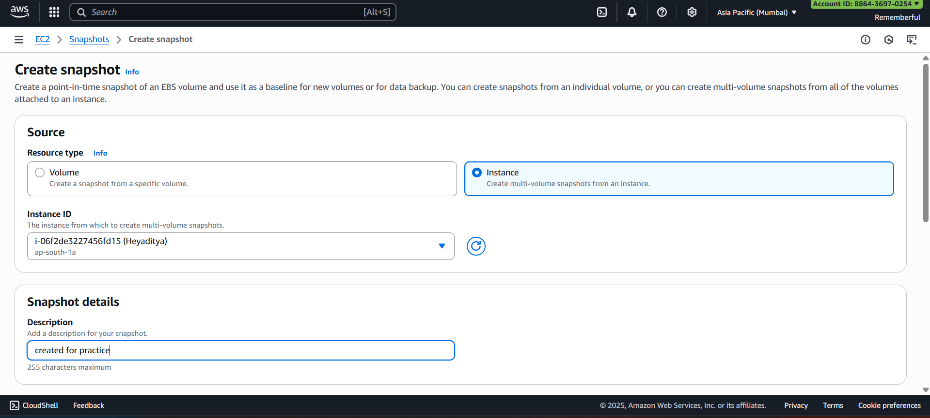
Snapshot is created:
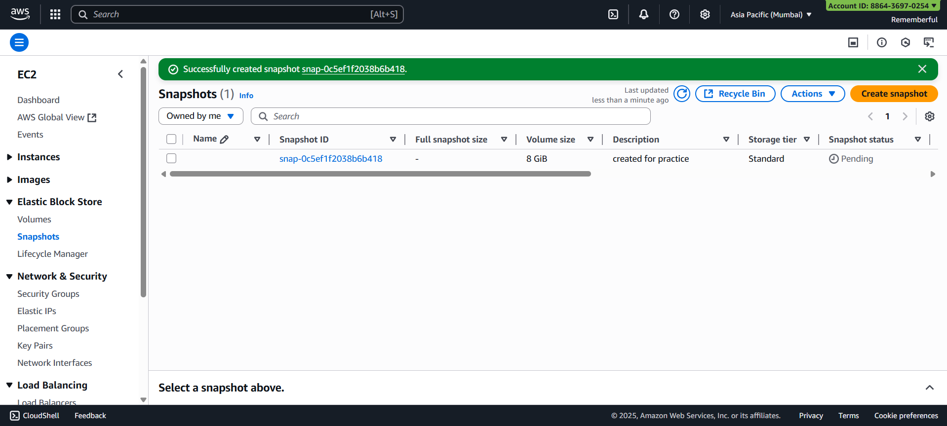
Select the snapshot, click on Modify permissions:
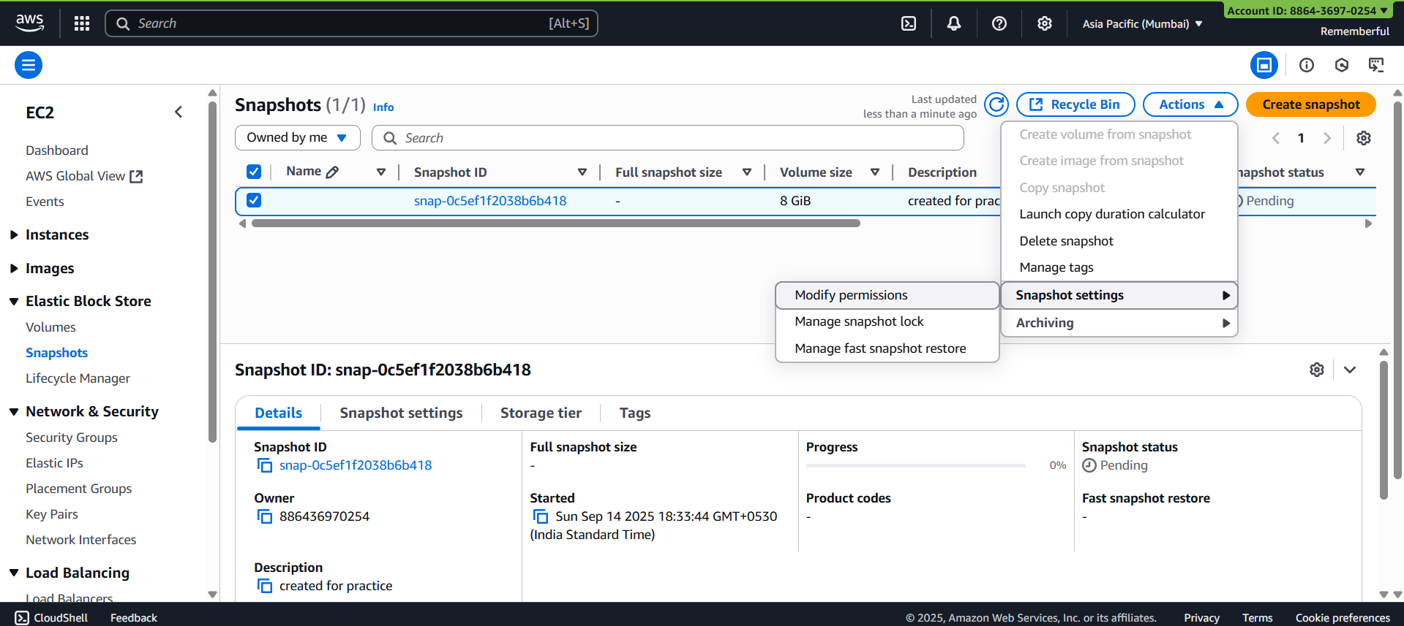
Following screen will appear:
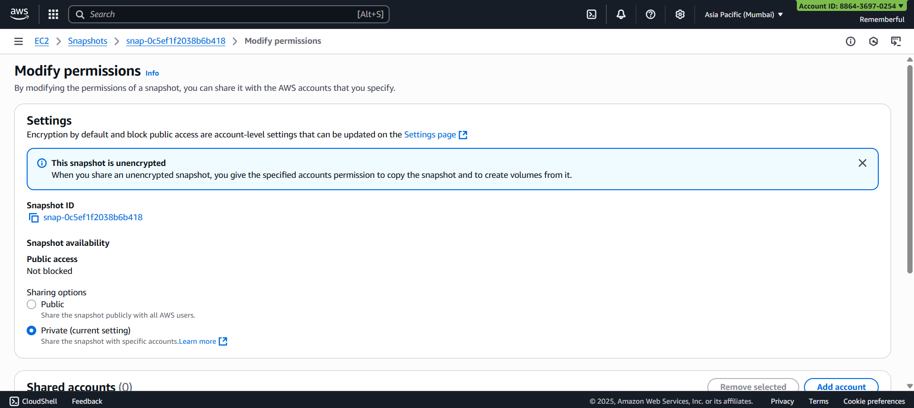
Since, it is private, it is not need to be changed.
Done!

Create Encrypted EBS Volume:
Steps:
Look for EC2:
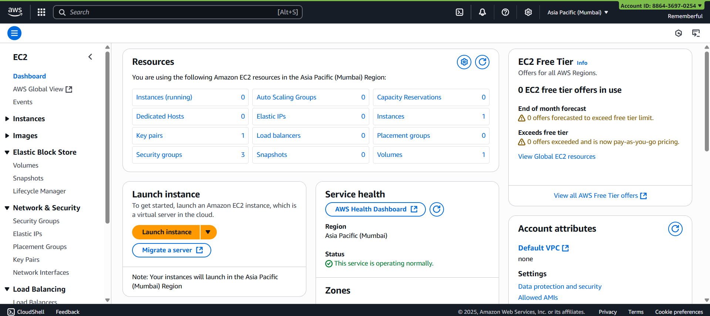
Click on “volumes”:
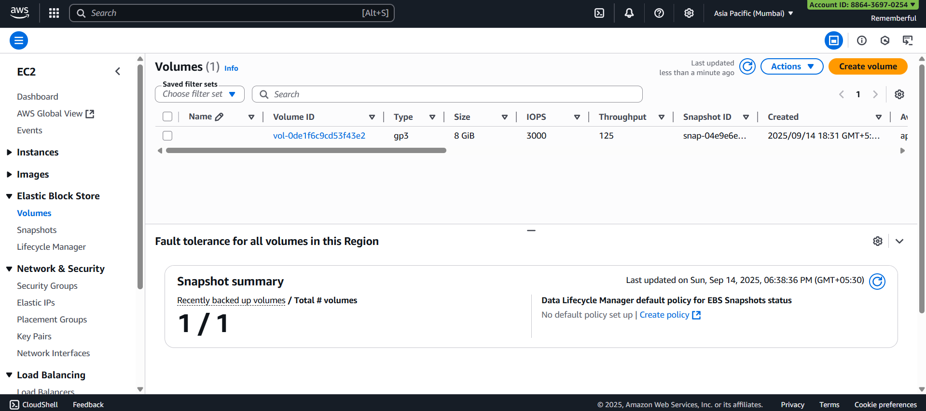

Click on “Create volume”, following screen will appear:
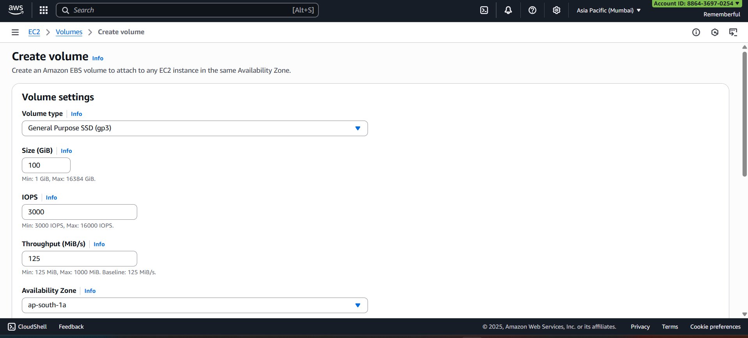
Scroll down to make it encrypted:
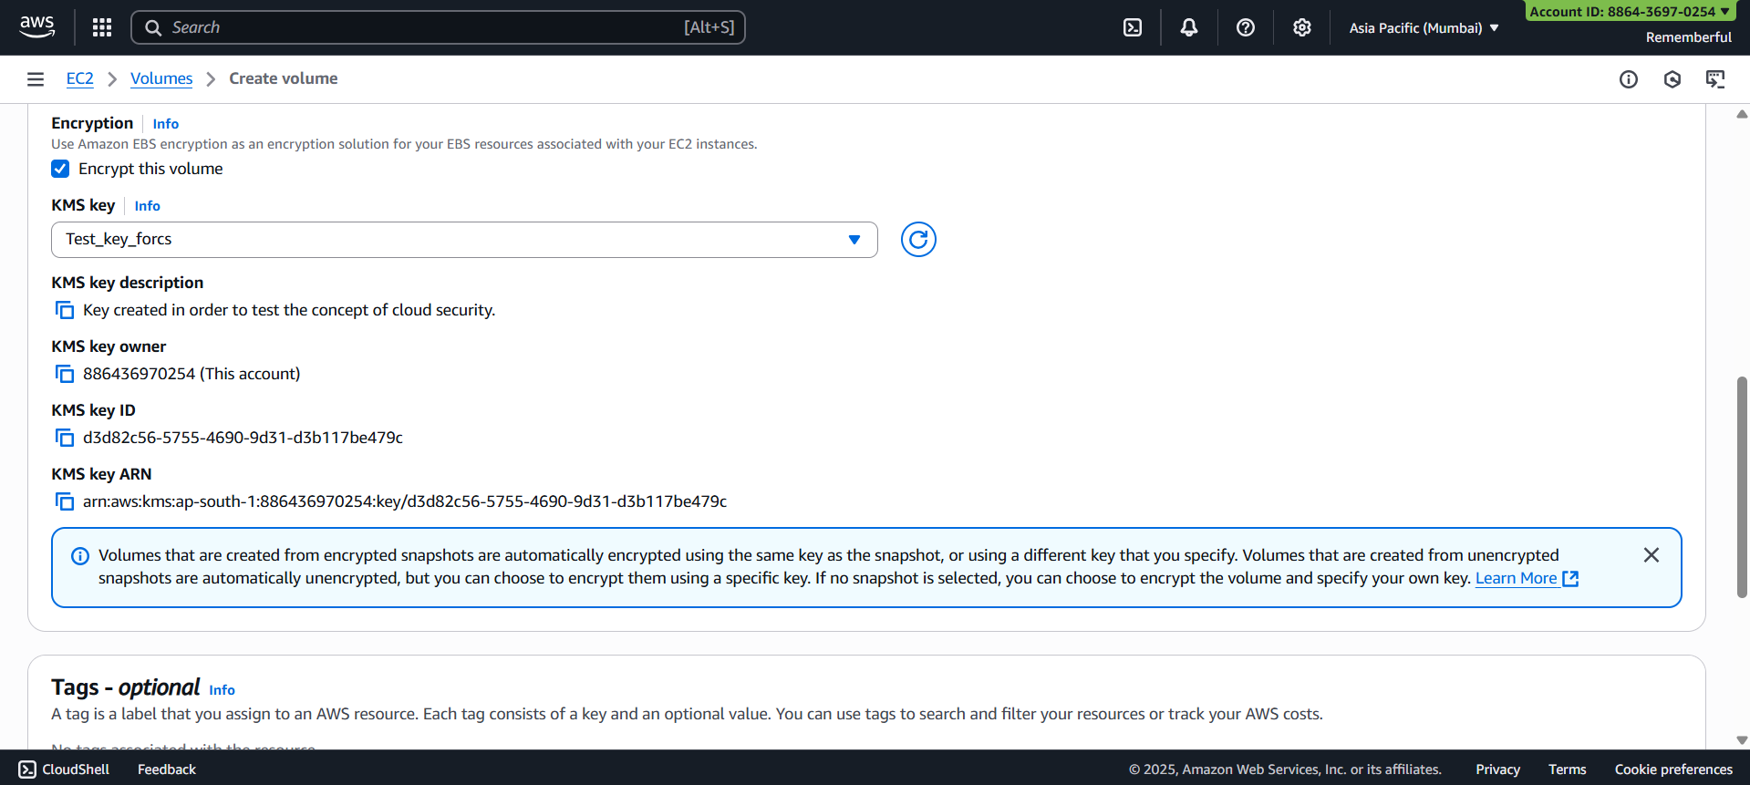
Done!
--The End--

