Day 41
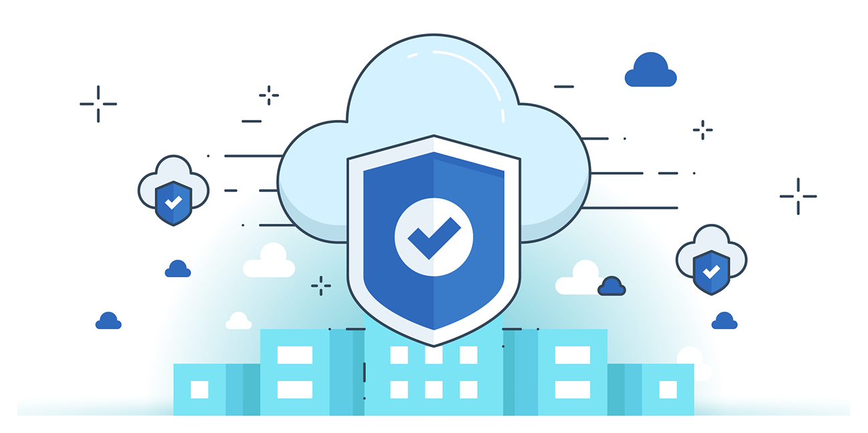

“CLOUD SECURITY”
Preventing Deletion of Backups Using an Amazon Backup Vault Resource-based Access Policy:
Steps:
First, we will create a user which will have access to AWS backups:
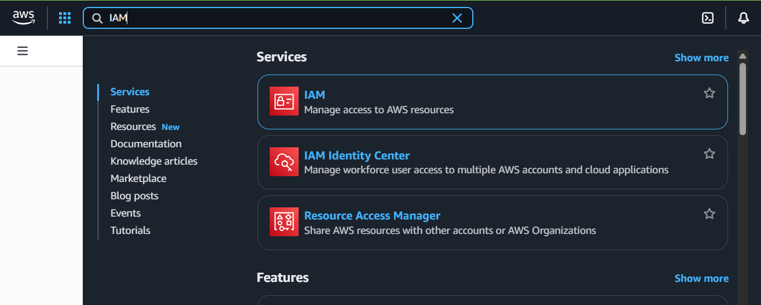
Following screen will appear:
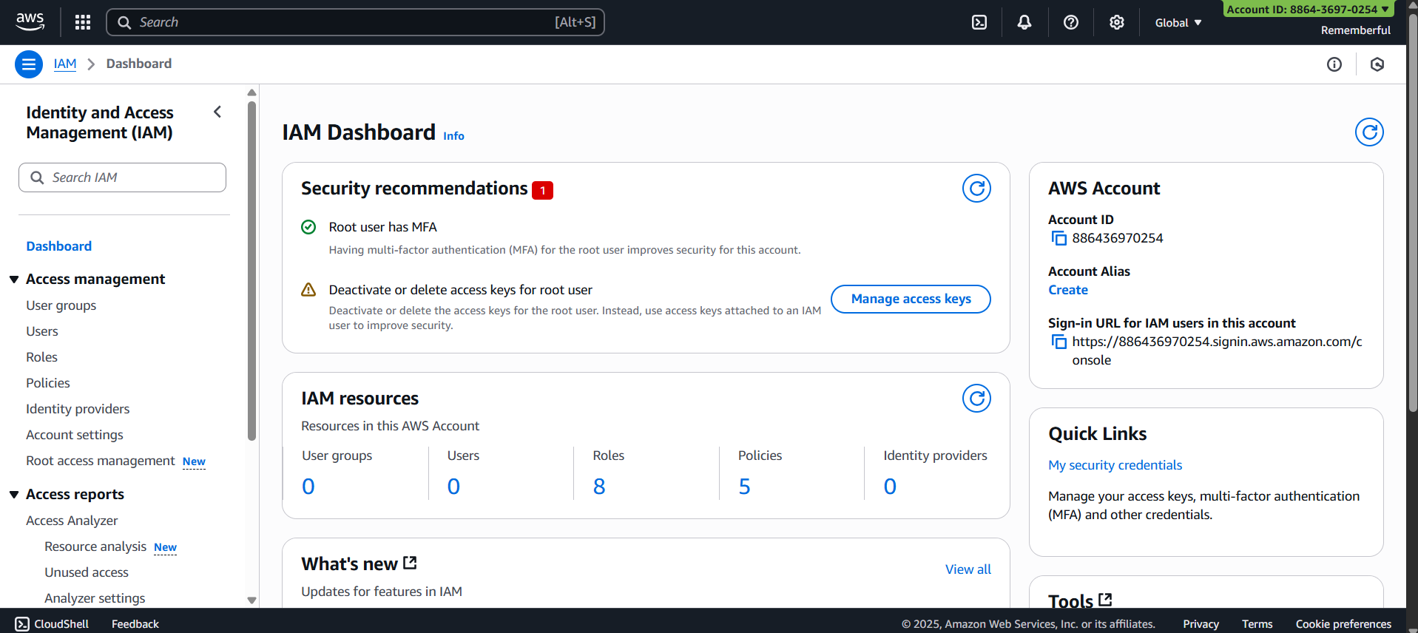

Open “users” section:
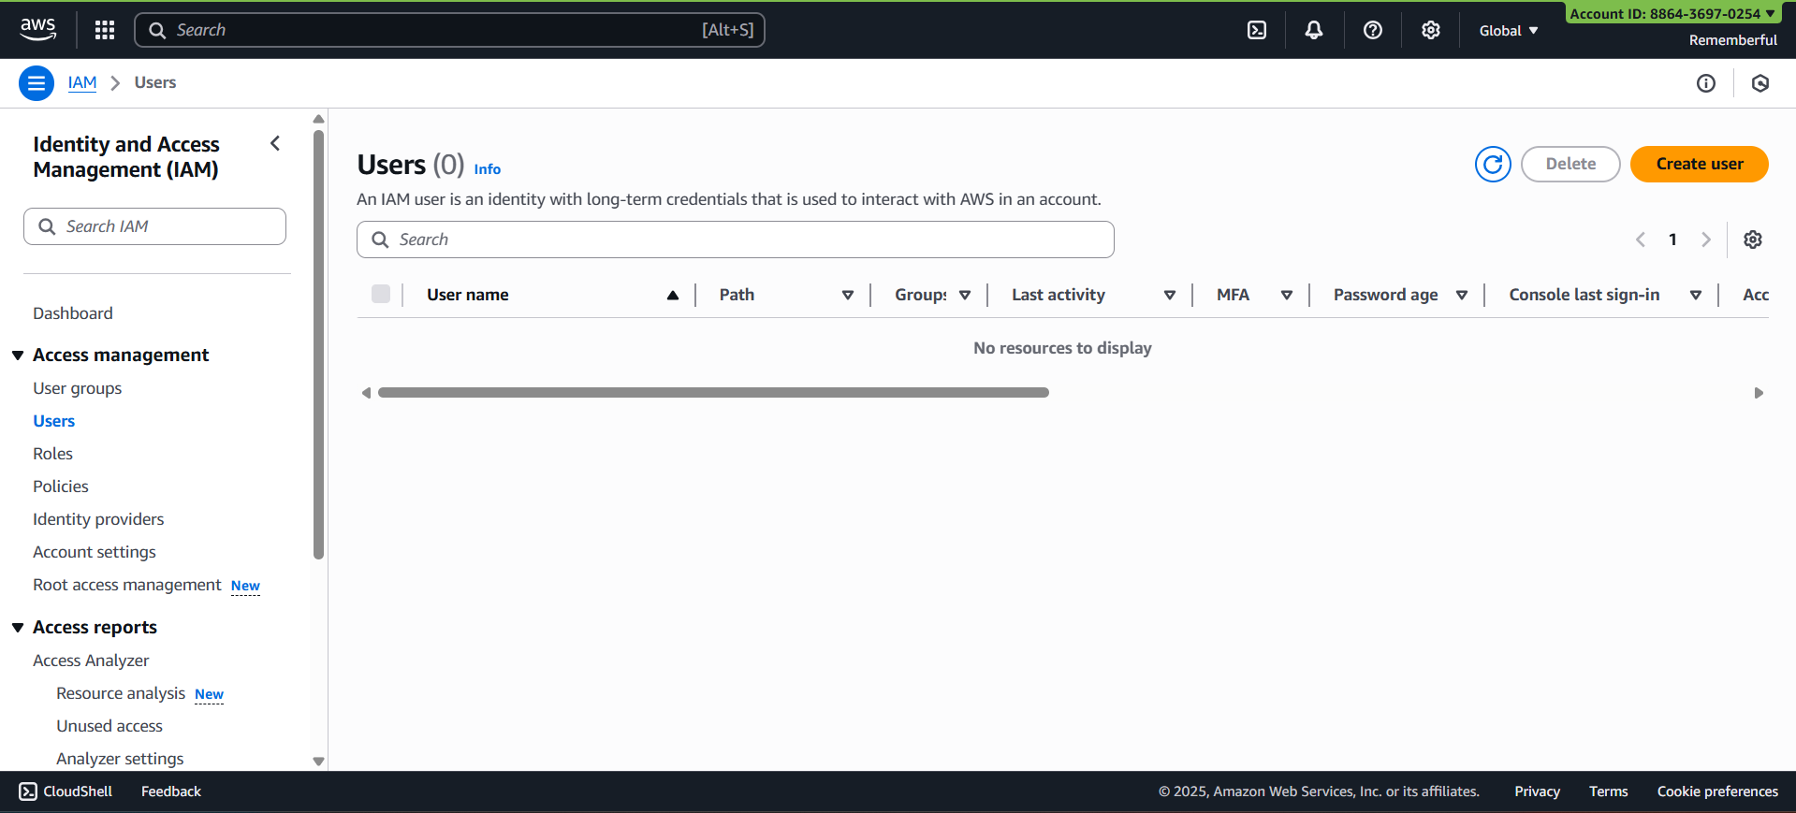
Click on “Create User”, following screen will appear: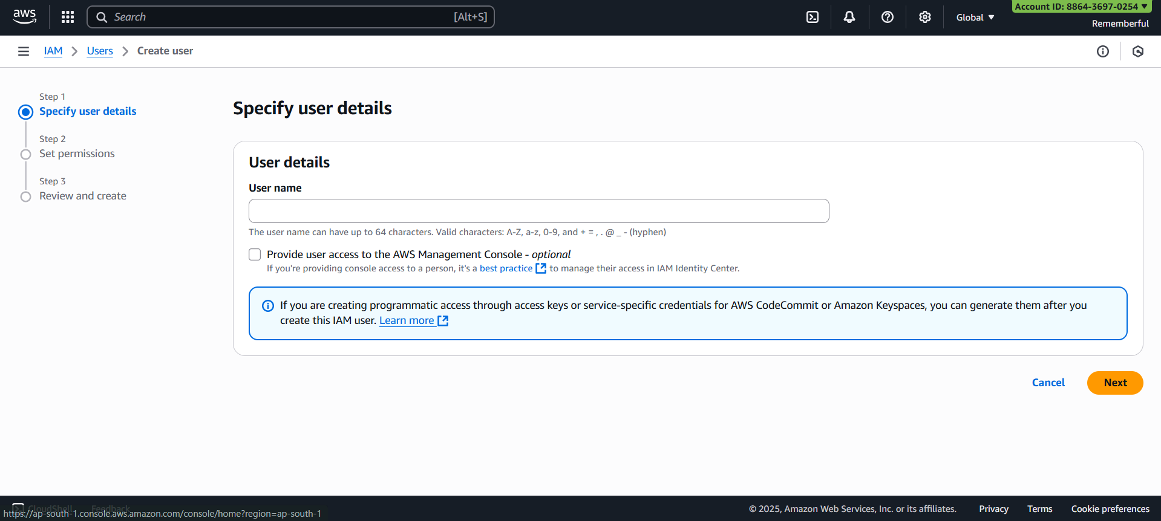
Assign password:
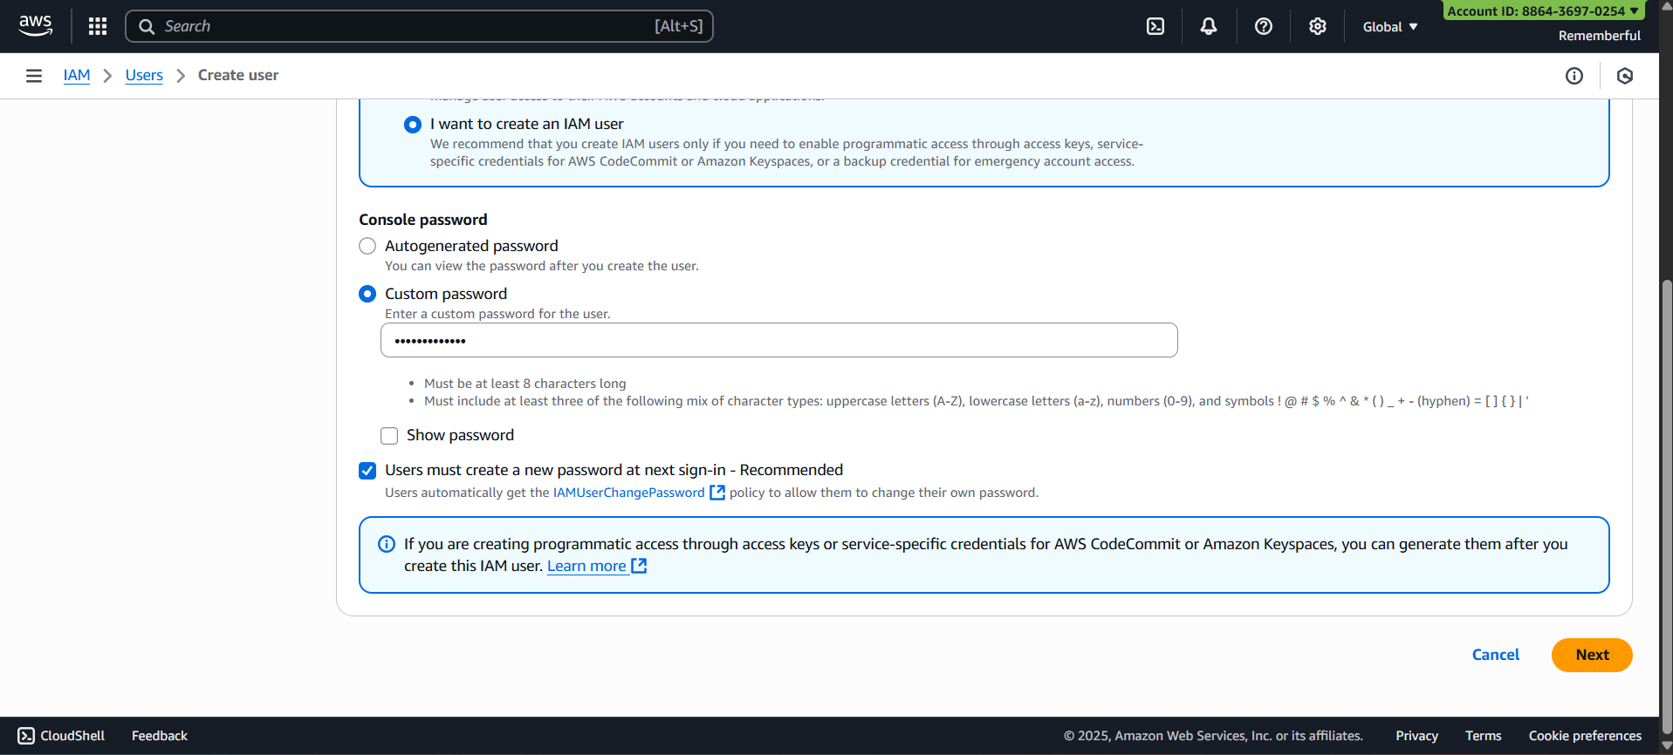
Click on “Next” following screen will appear:
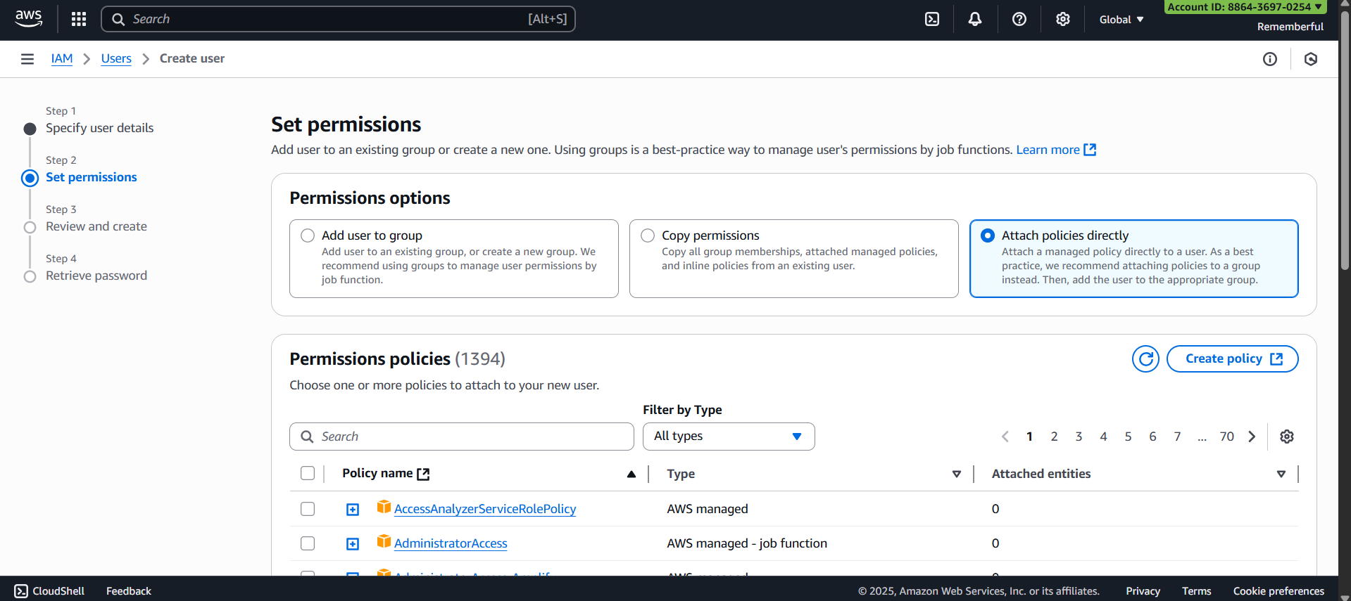
Look for “awsbackupfullaccess”: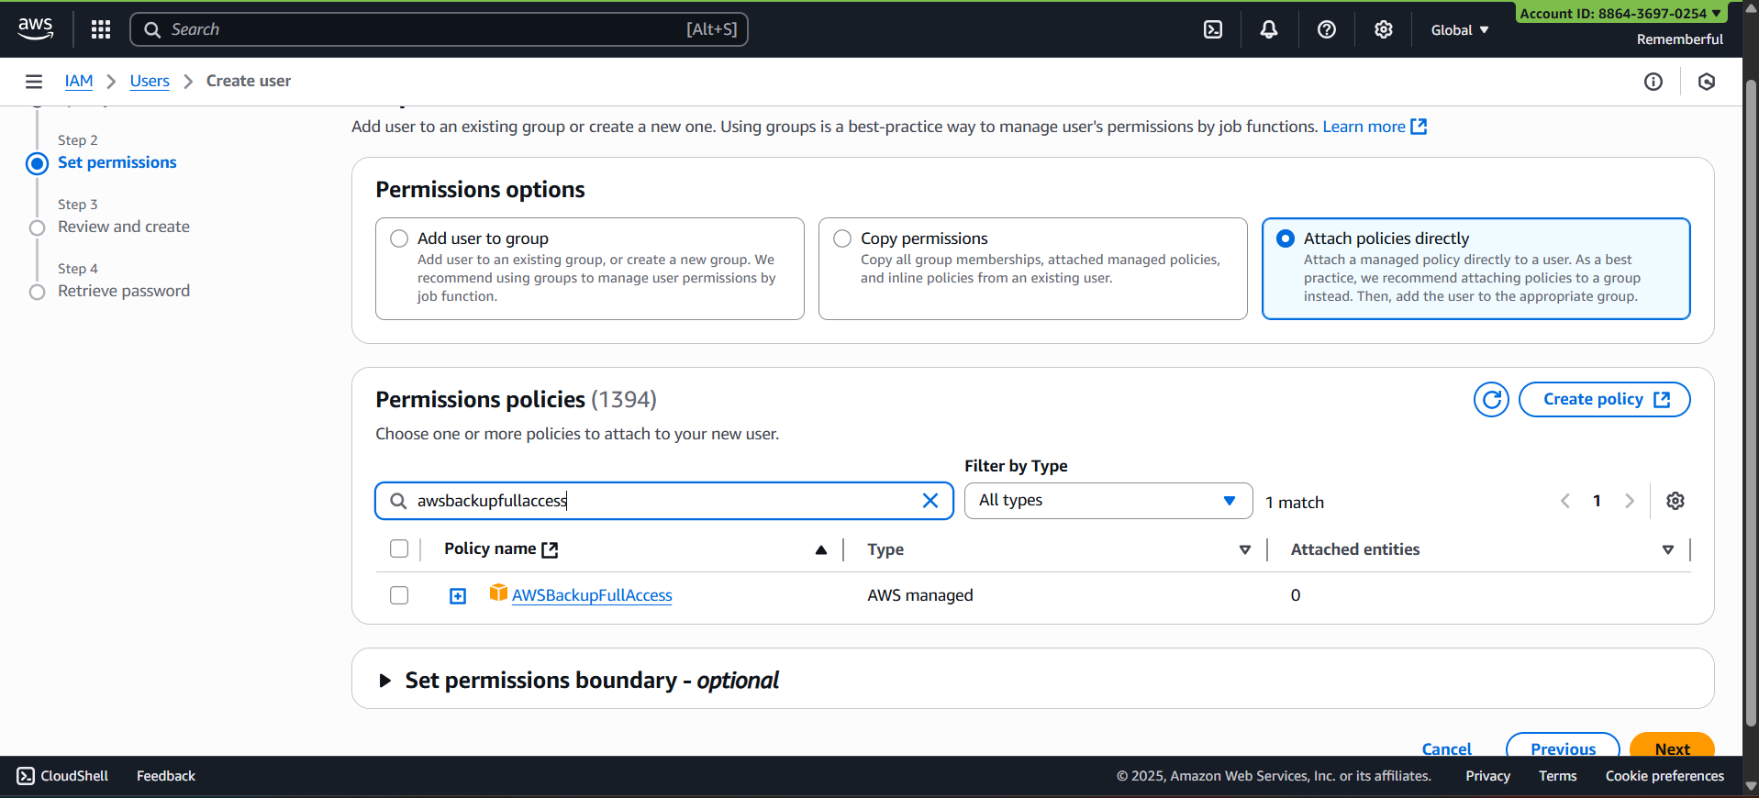
Click on “Next” following screen will appear:
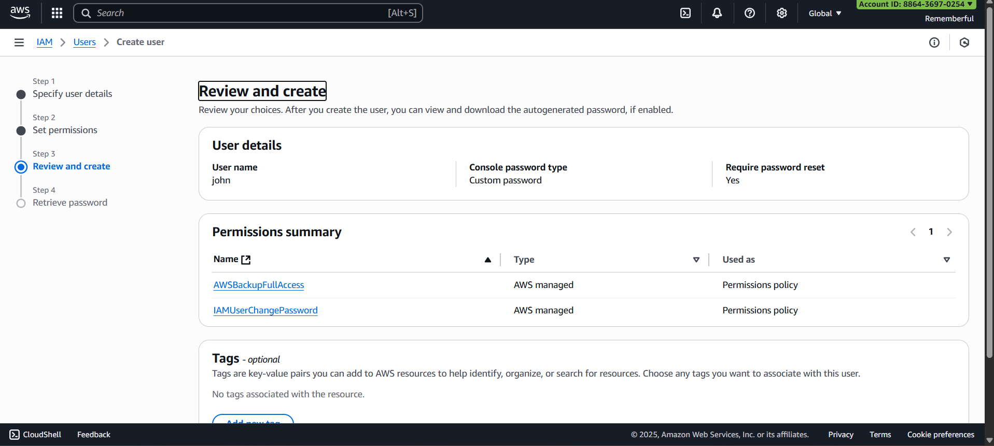
Following confirmation will occur:
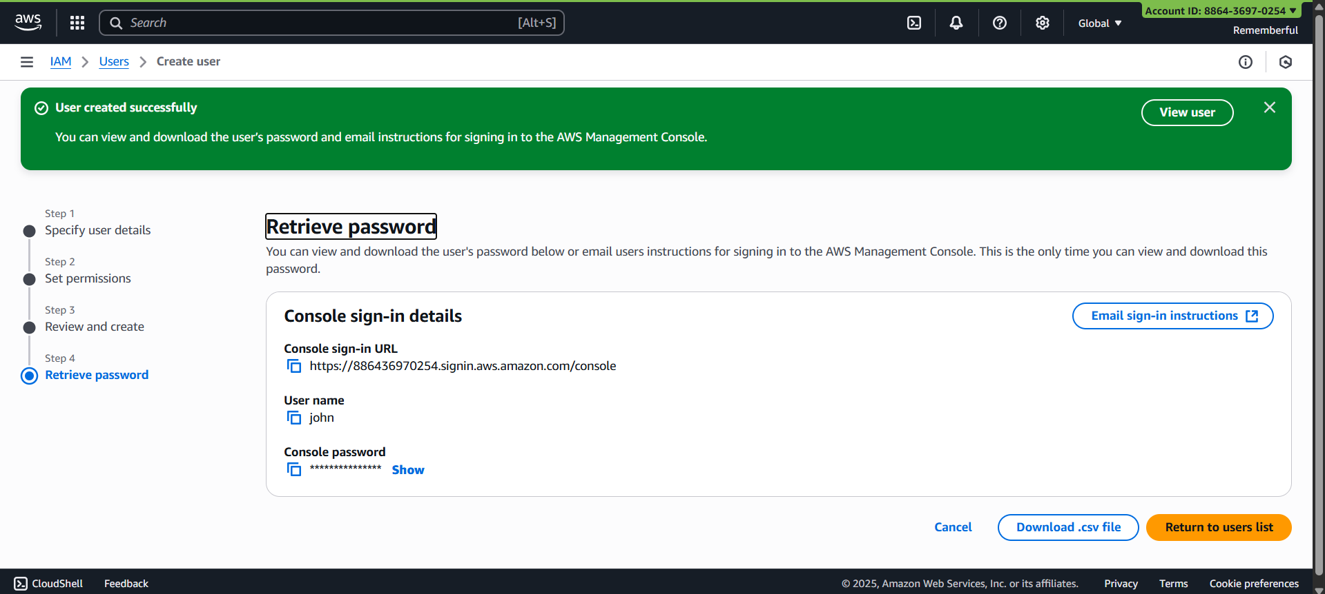
Click on “Return to users list”:
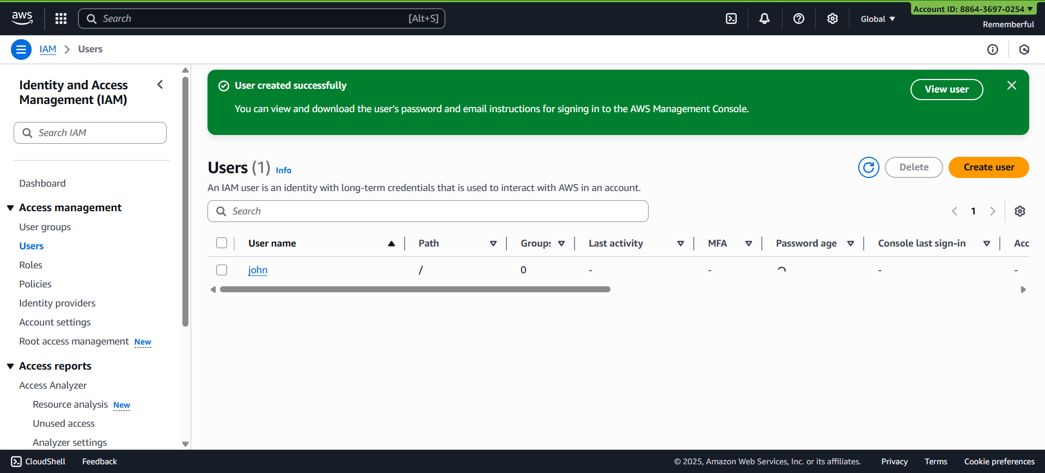
Click on the User name: copy ARN.
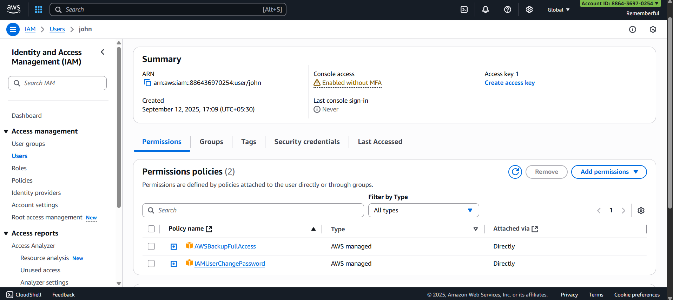
Now, look for AWS Backup:
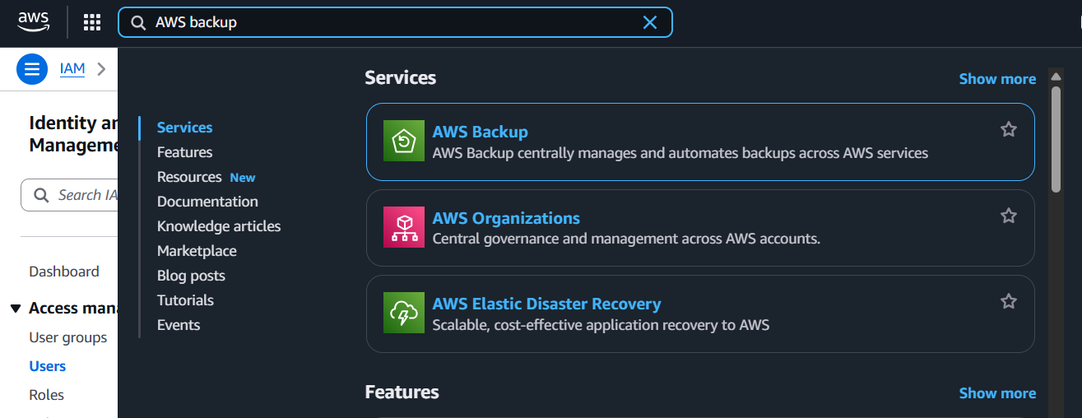
Following screen will appear:
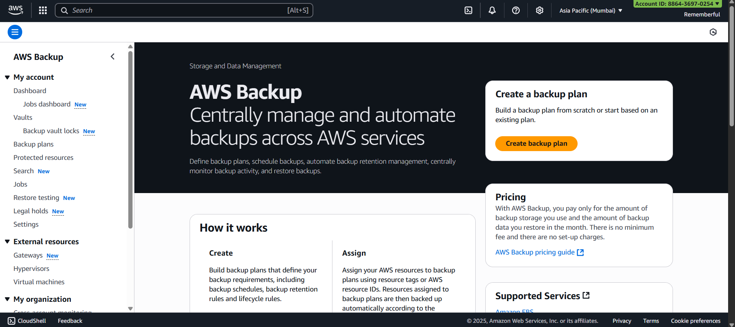
Click on “vault” option:
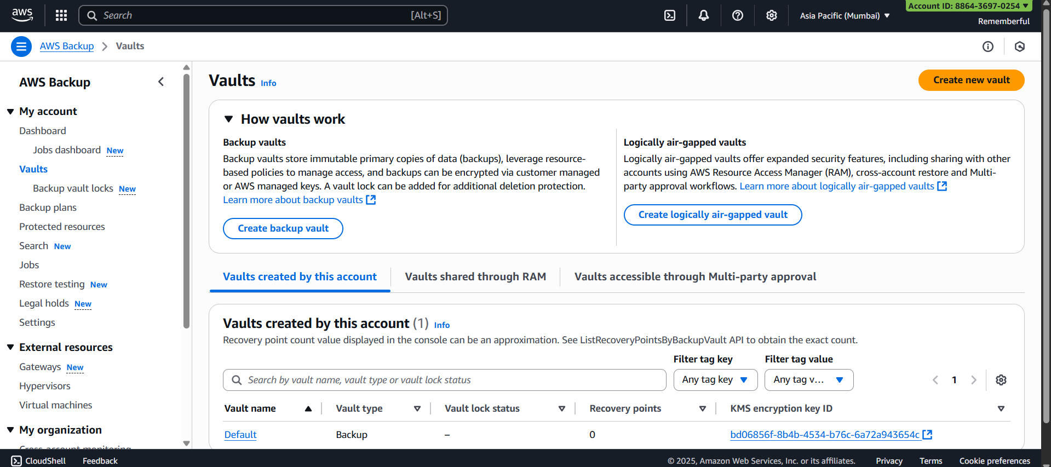

Click on “Create new vault” button: following screen will appear
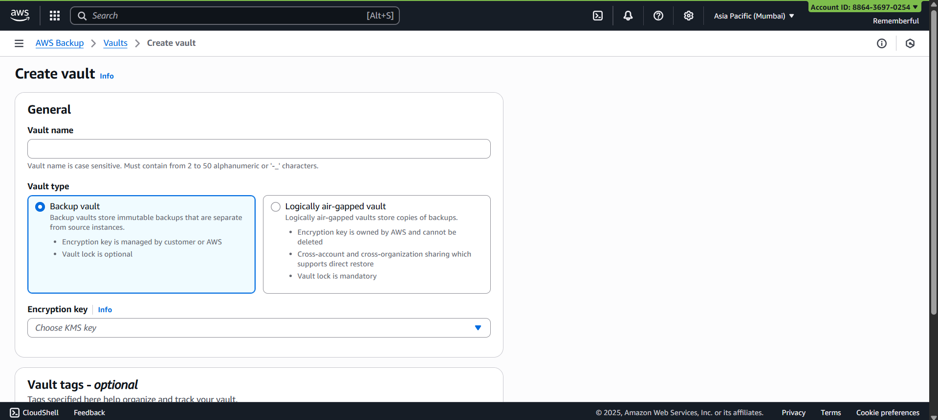
Assign name and select the encryption key:
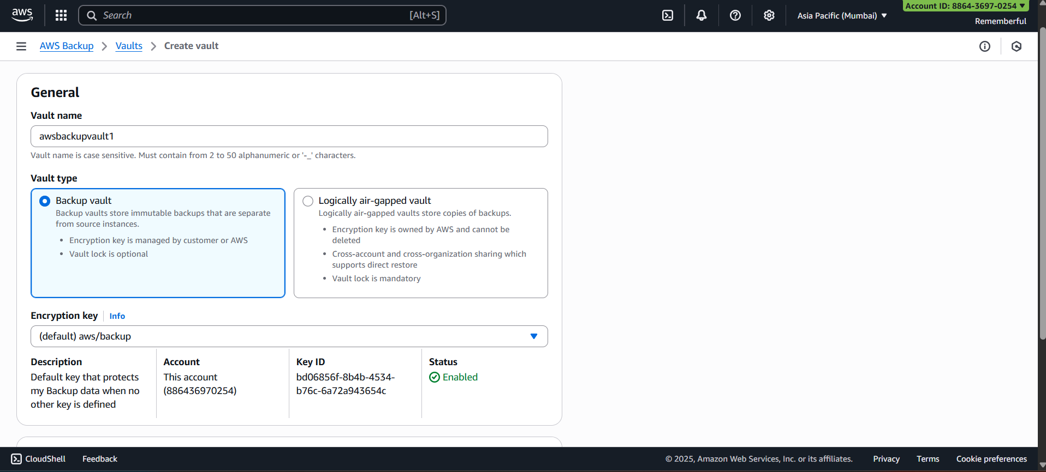
Following confirmation will occur:
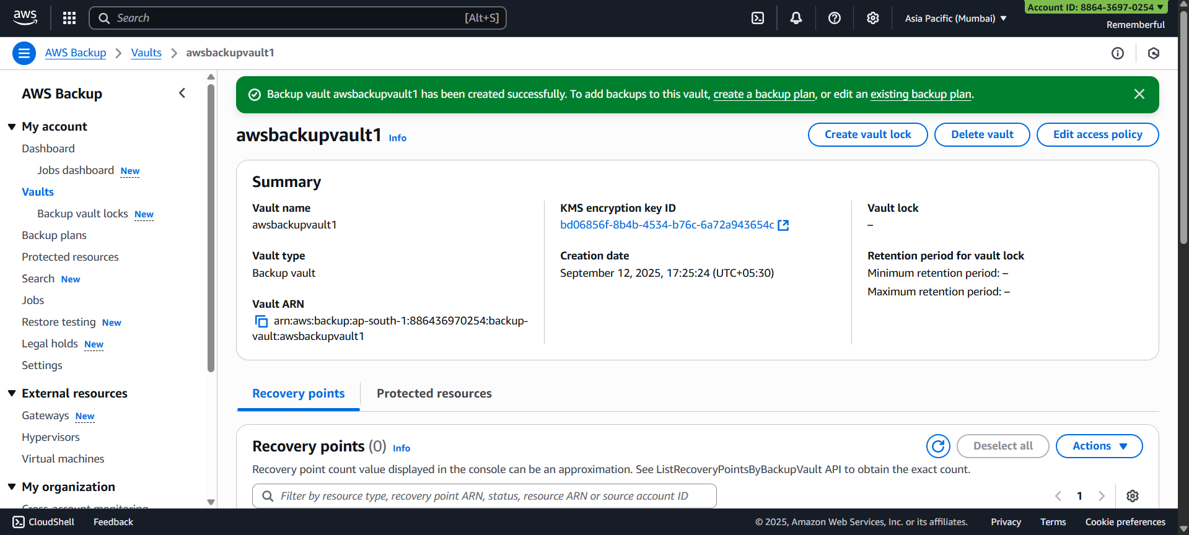
Similarly create one more backup vault: awsbackupvault1 and awsbackupvault2 done
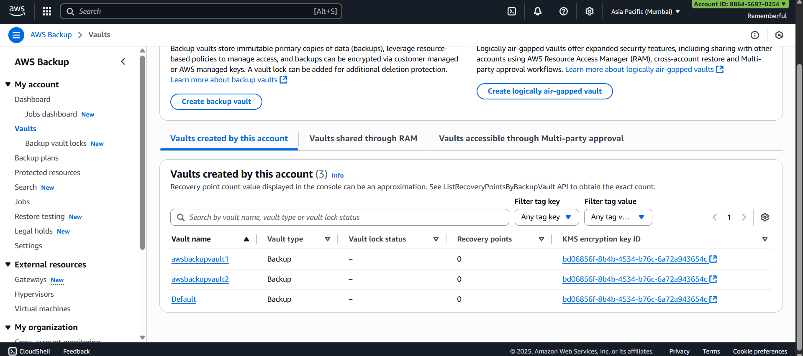
Now, to deny deletion access of John to awsbackupvault2, we will create a resource based policy:, open the 2nd :
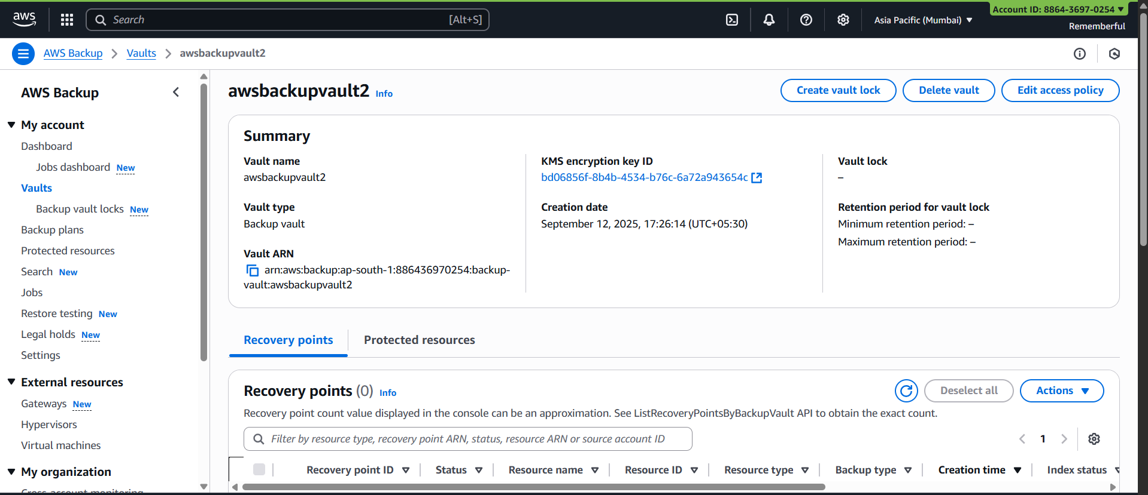
Copy the ARN, and scroll down to the section of Access policy and click on “edit”:
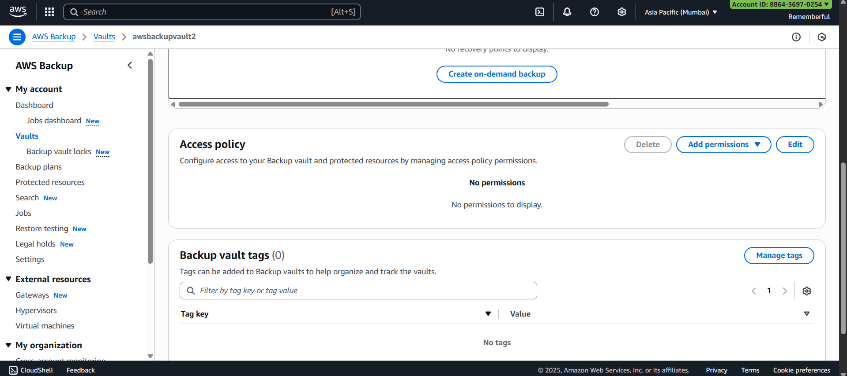
Paste the JSON policy:
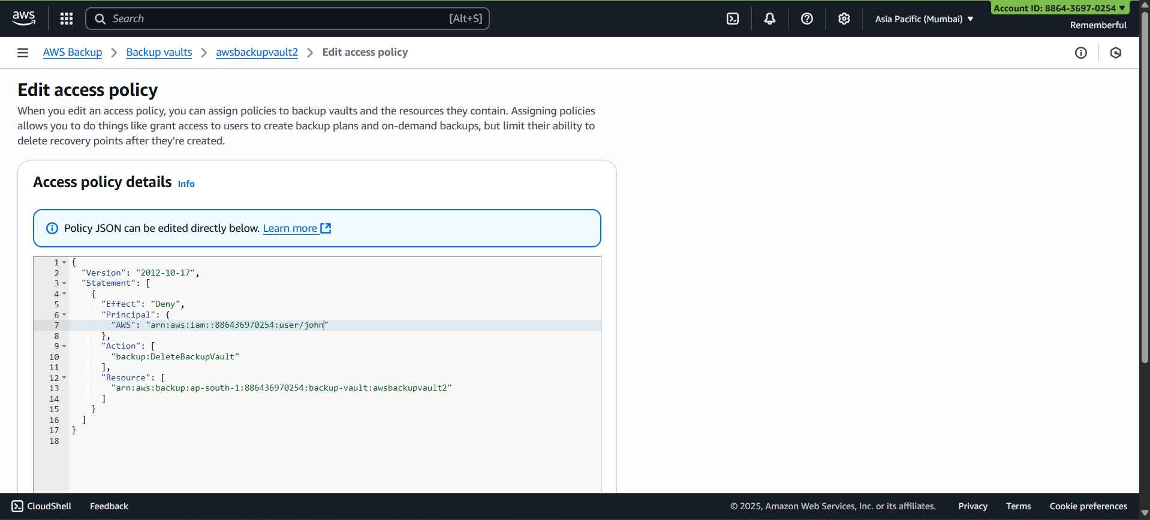
{
"Version": "2012-10-17",
"Statement": [
{
"Effect": "Deny",
"Principal": {
"AWS": "arn:aws:iam::886436970254:user/john"
},
"Action": [
"backup:DeleteBackupVault"
],
"Resource": [
"arn:aws:backup:ap-south-1:886436970254:backup-vault:awsbackupvault2"
]
}
]
}

Confirmation will occur:
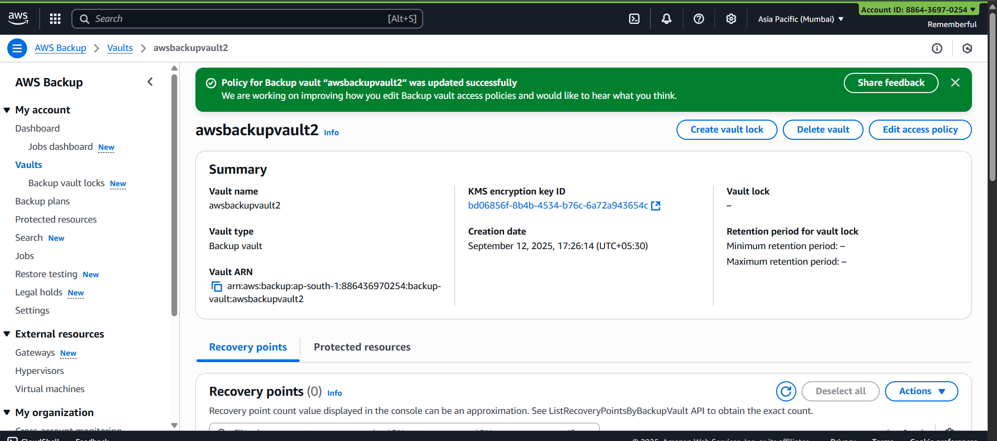
Now, sign in with the john as user:
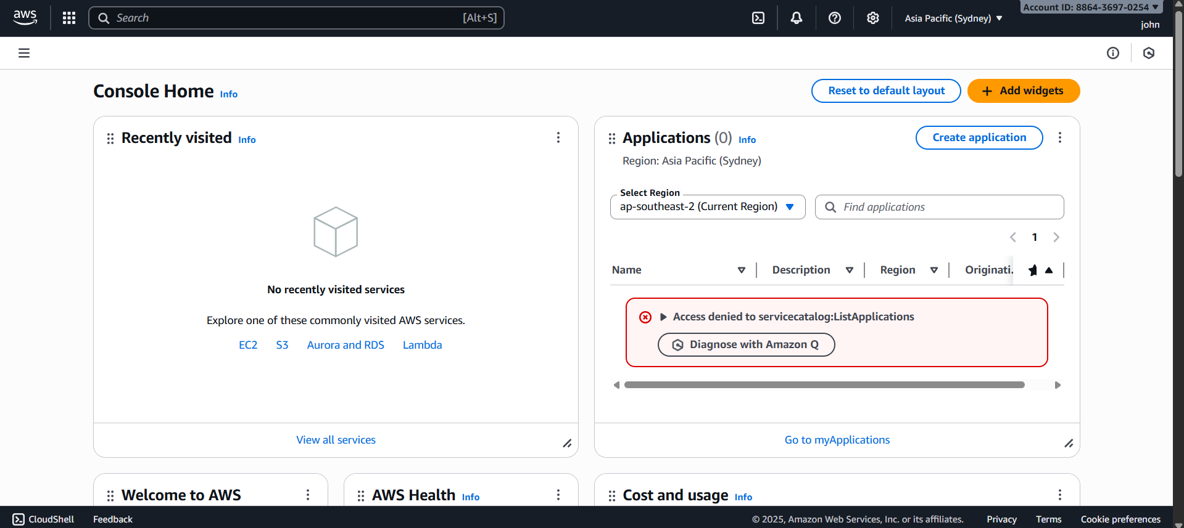
Look for AWS backup:
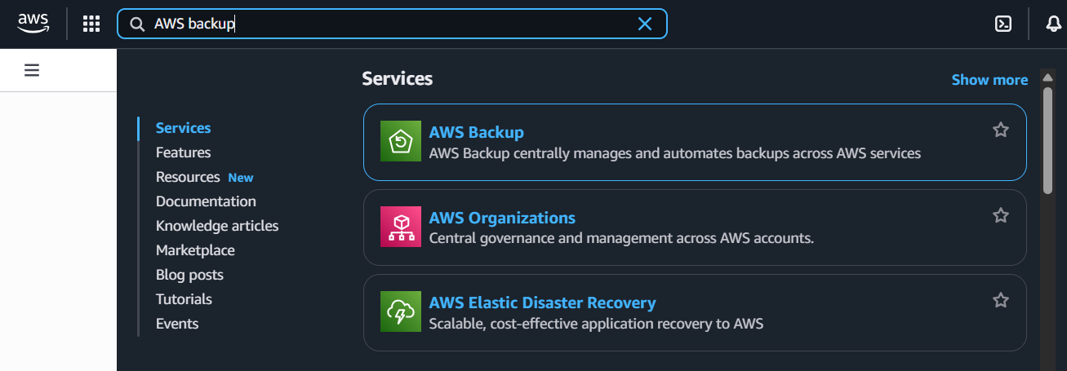
You will see that you can’t delete the awsbackupvault2.
--The End--

