Day 37
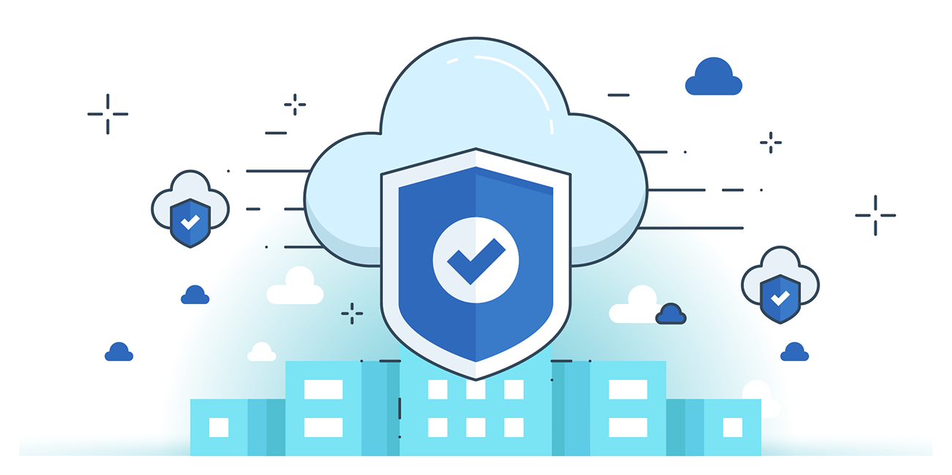

“CLOUD SECURITY”
Restricting access to S3 bucket object using cloudfront:
Steps:
Look for S3:
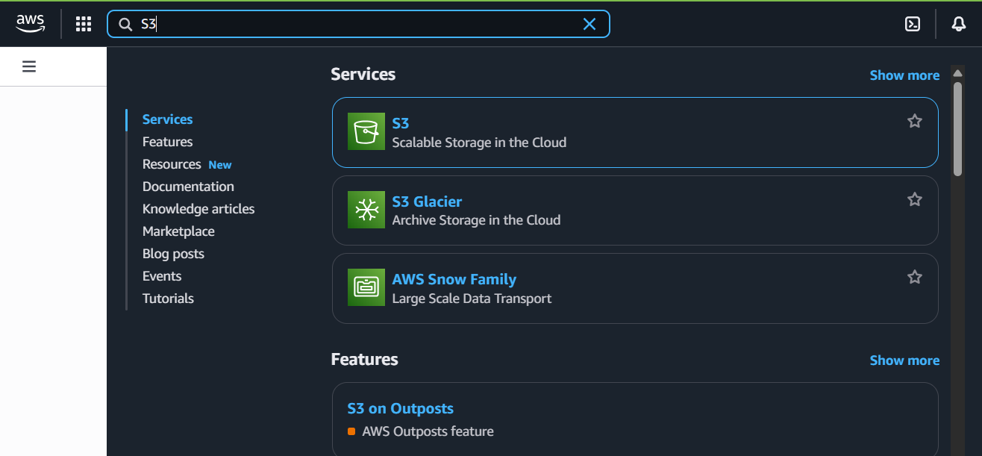
Following screen will appear:
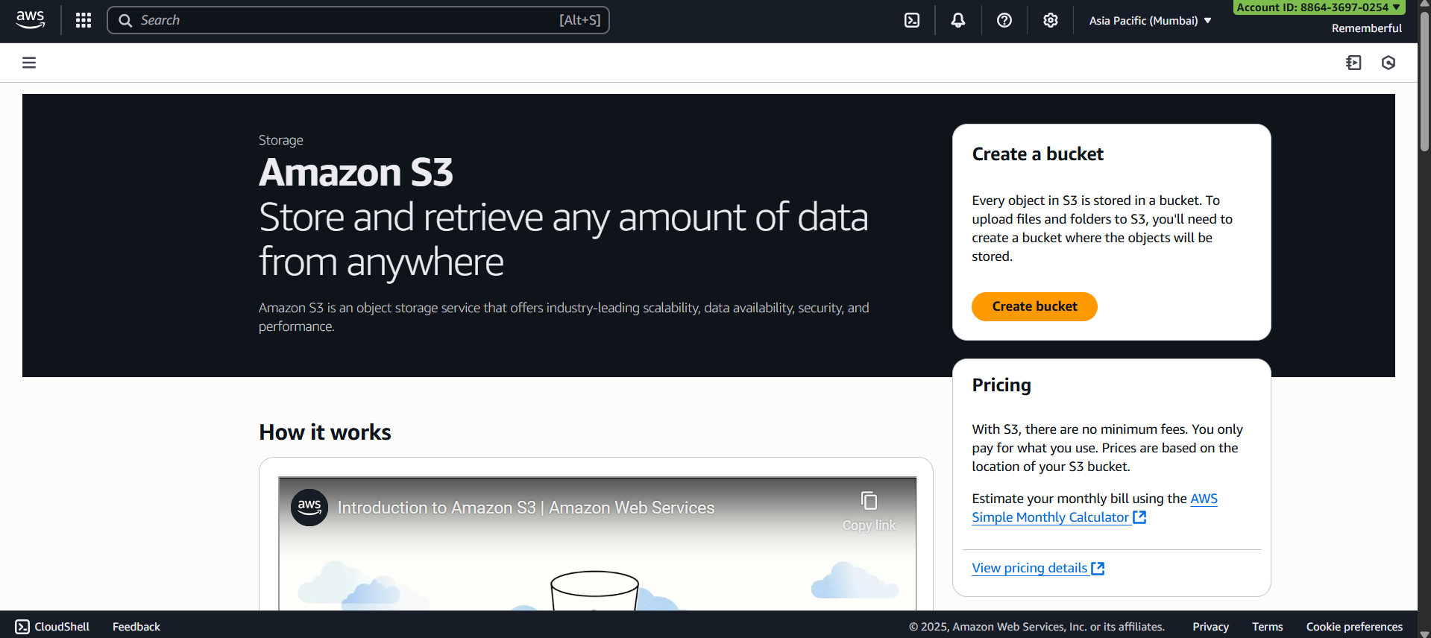

Click on “create bucket” button:
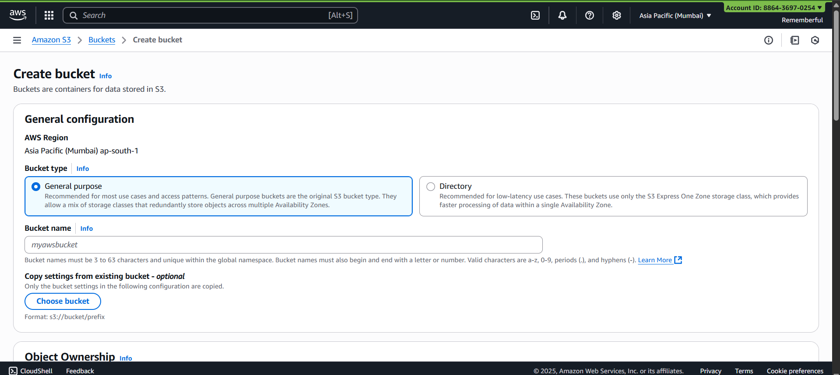
Create one bucket:
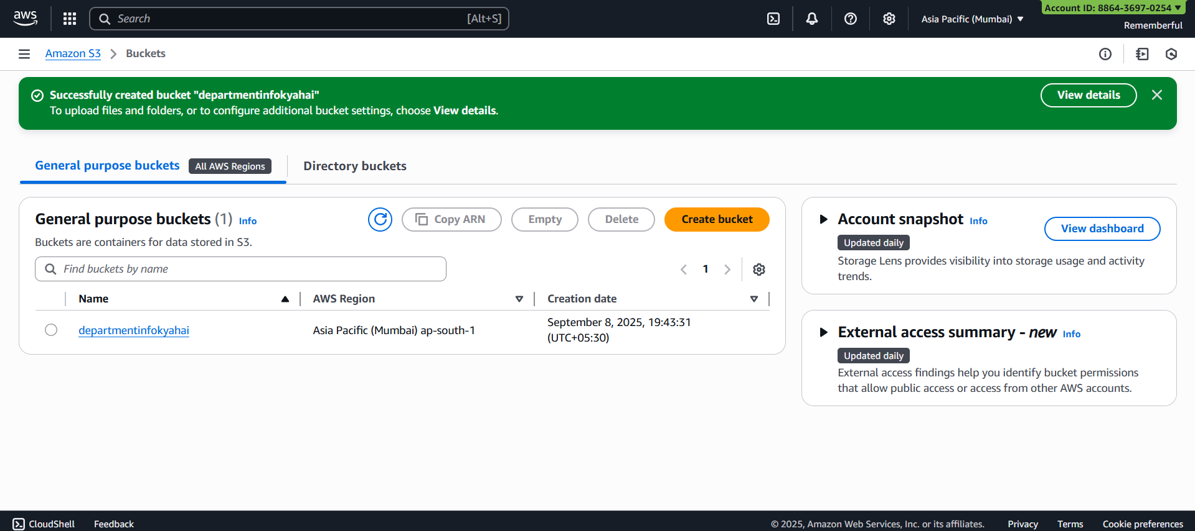
Open that bucket:
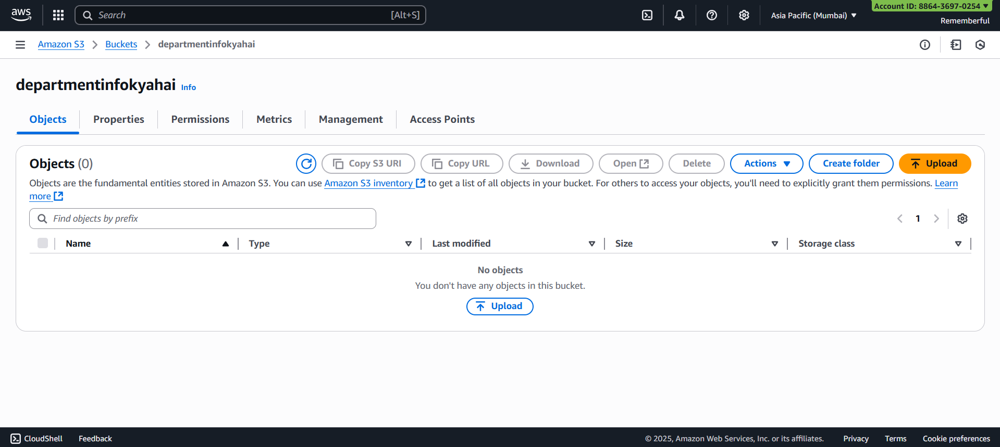
Now, click on the “upload” button:
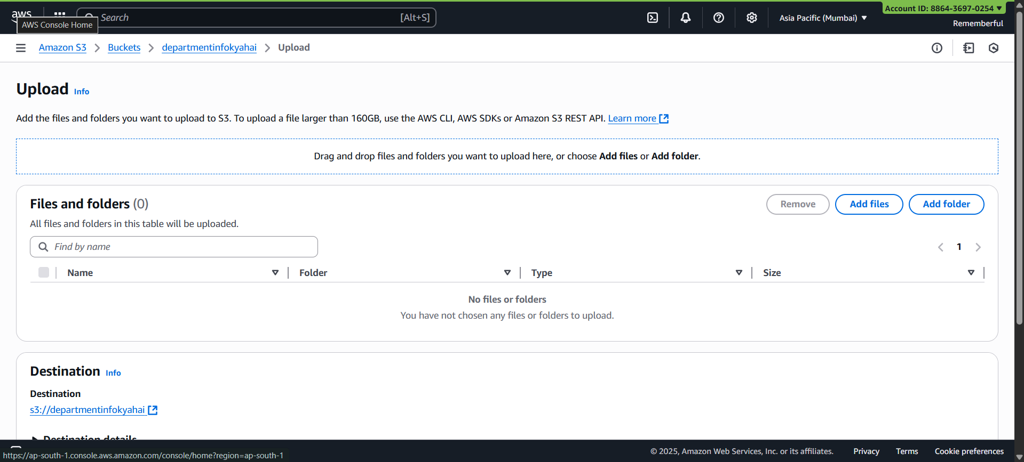

Click on “add files” and upload the index.html file:

It can be viewed there:
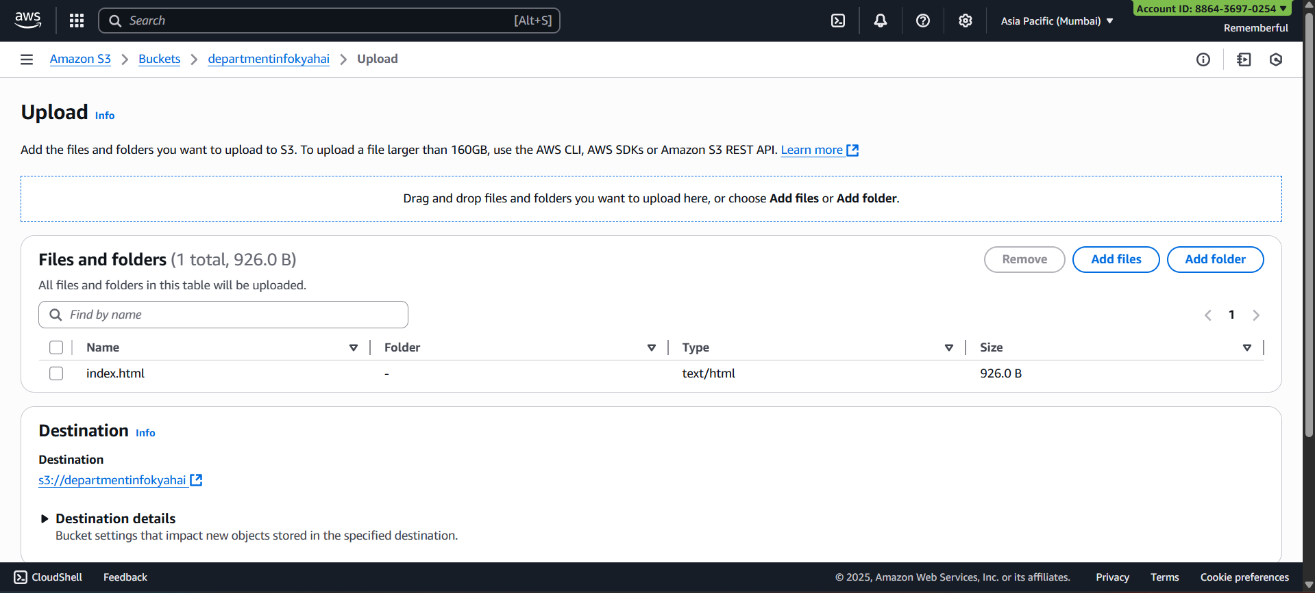

Click on the upload button to upload, following confirmation will occur:
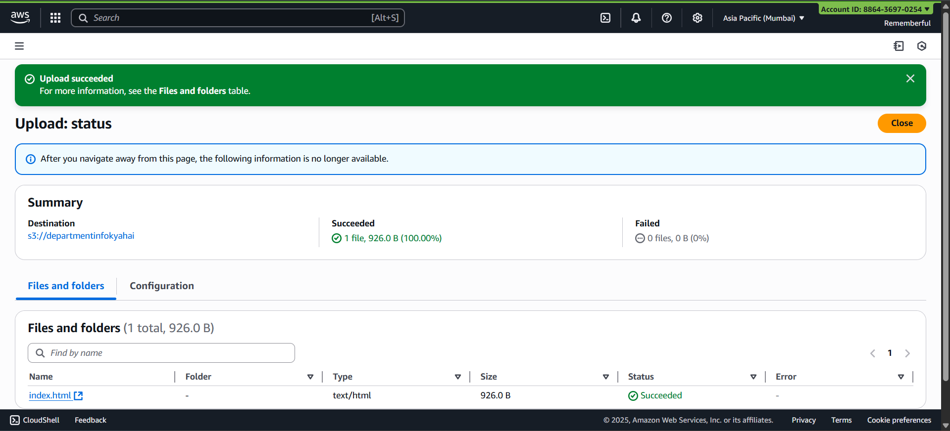
Now, open that index.html to get the properties of it:
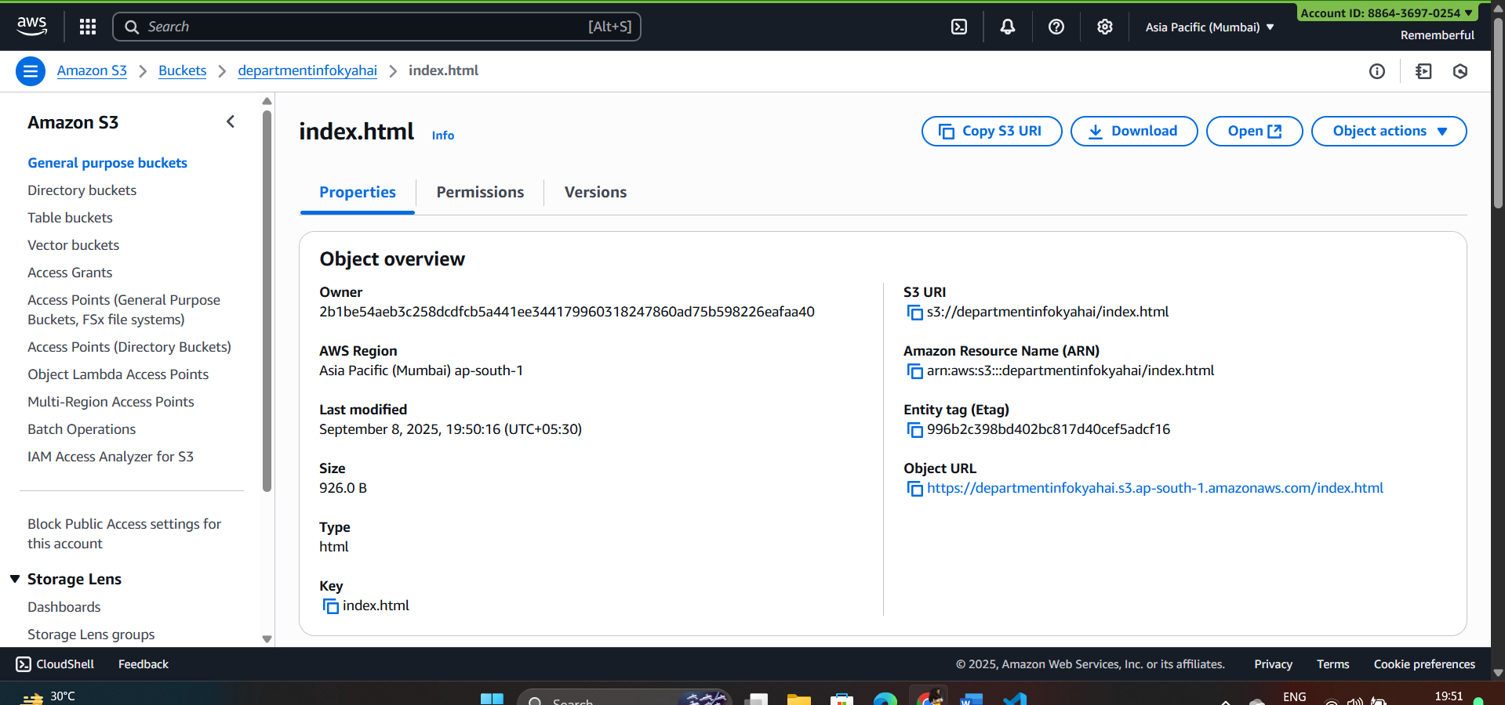

Click on the object url, following error page will occur as we don’t have public access for it:
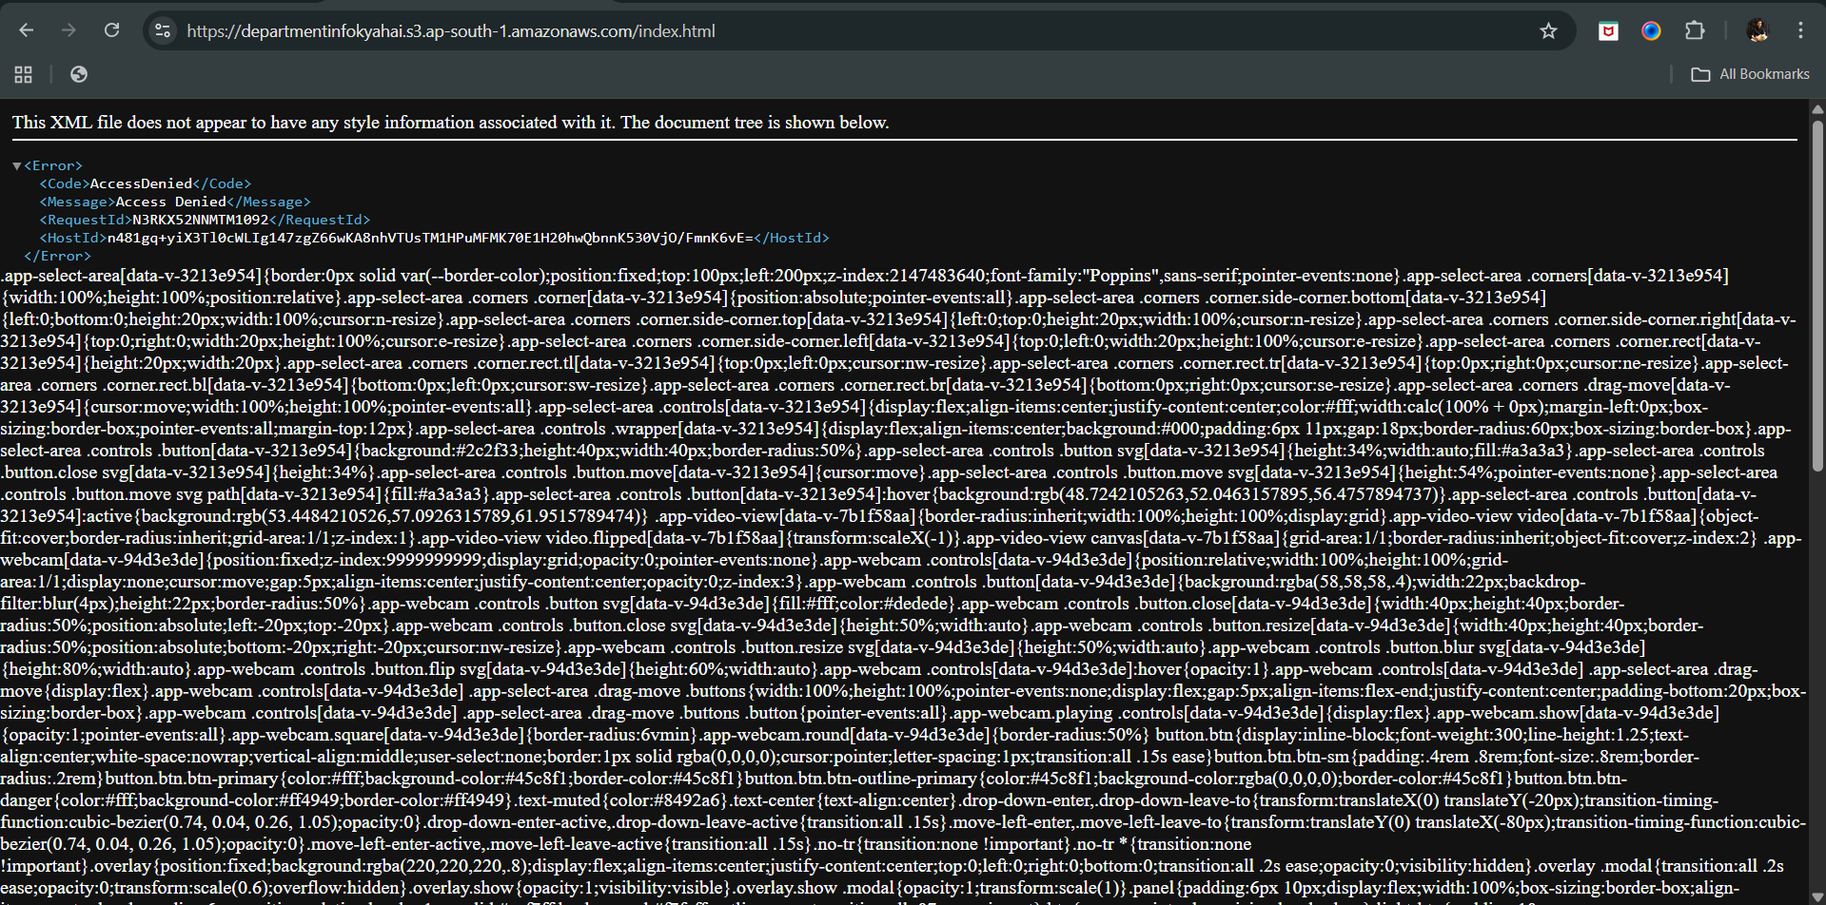
Now, look for cloudfront in the search bar:
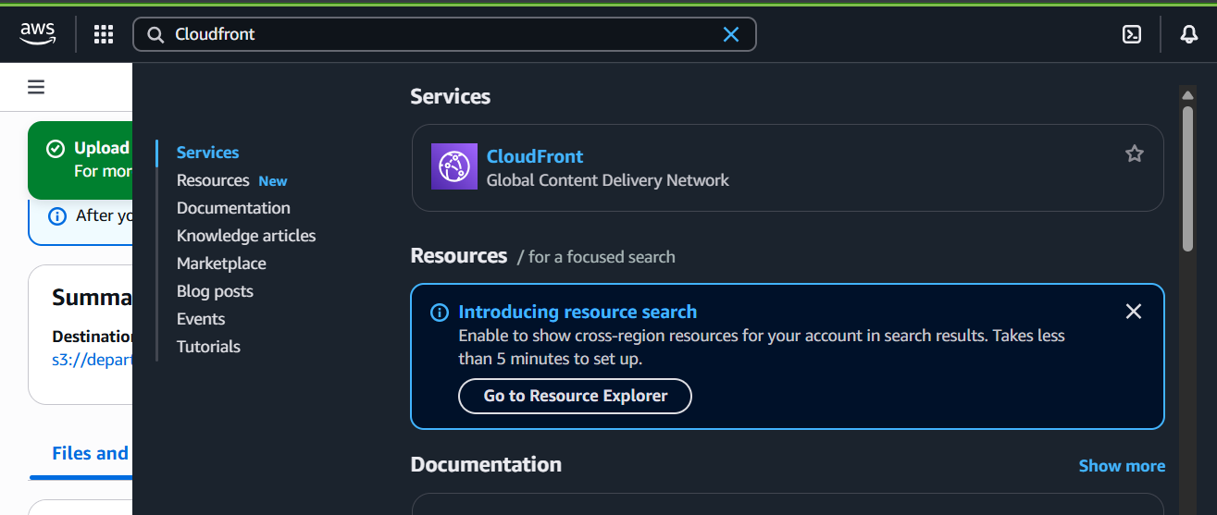

Following window will open:
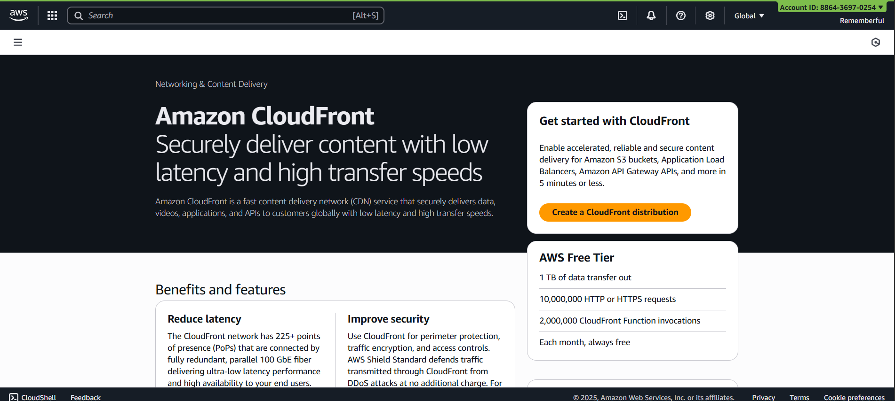
Click on “Create a CloudFront Distribution” button: following window will occur.
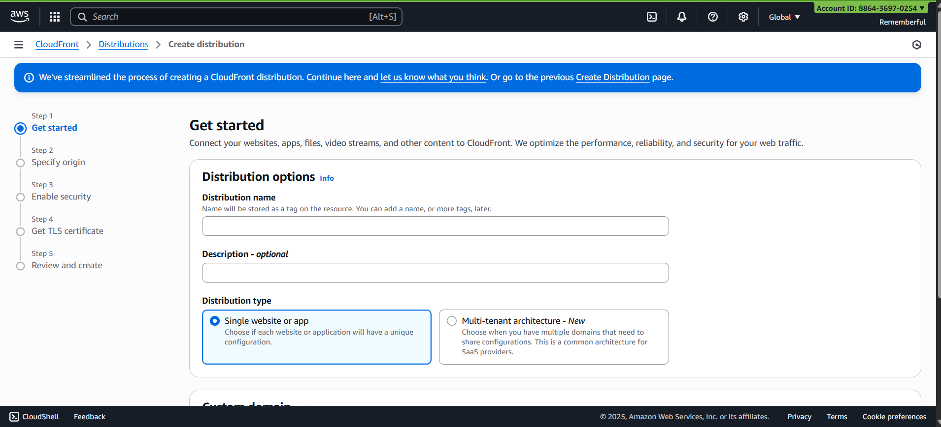
Make necessary changes and create, following confriamtion will occur:
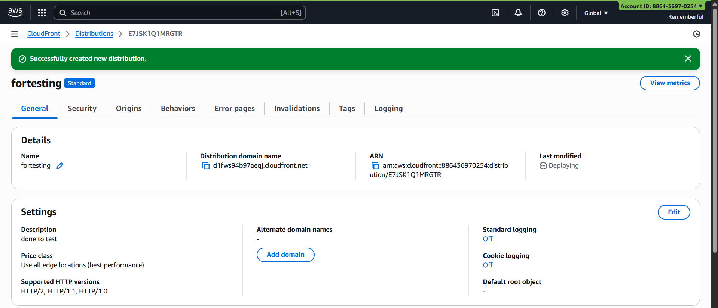
Go to the “distributions” section from the left panel:
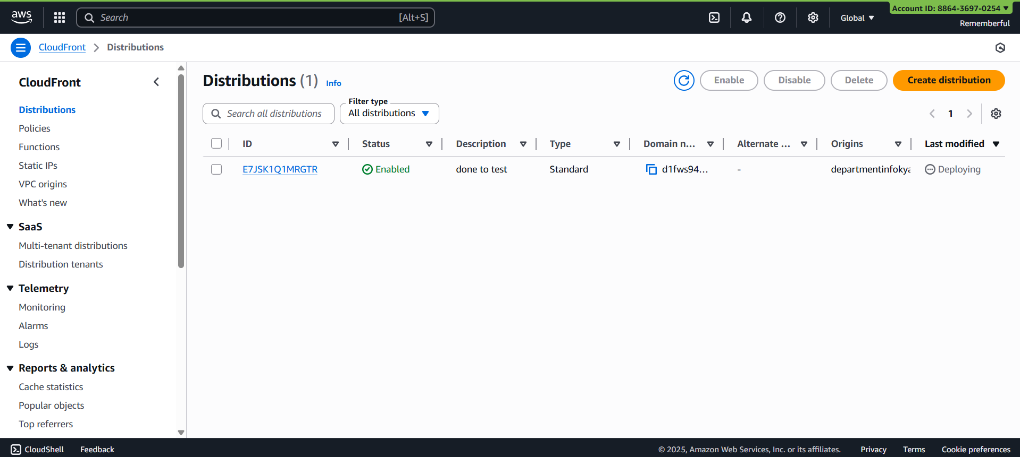
Click on the ID name to see the details:
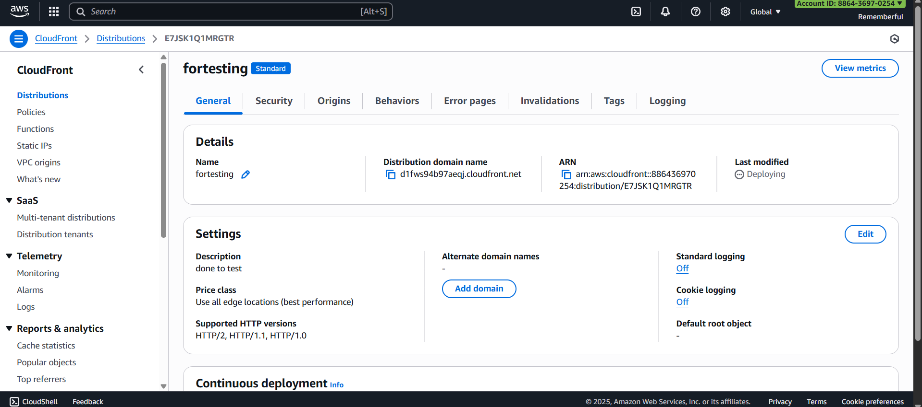
--The End--

