Day 52
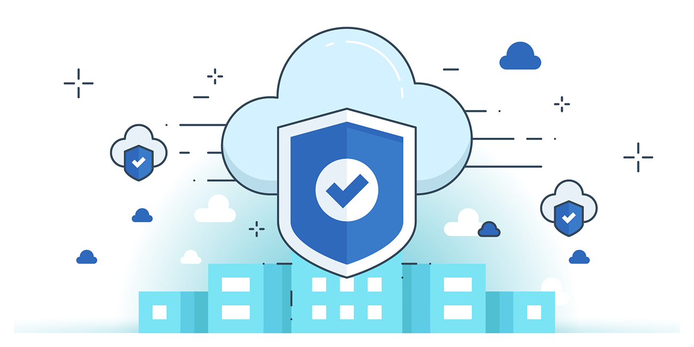

“CLOUD SECURITY”
What is Incident Response in Cloud:
It is the process of identifying intrusions or malicious activity in a cloud environment by analysing logs and using automated tools. It helps protect sensitive data, detect breaches early, and ensure compliance despite challenges like shared resources, multi-tenancy, and lack of visibility.
Importance of Cloud Incident Response (CIR):
- Confident Response: Provides clear instructions, roles, and guidelines to handle incidents without panic.
- Damage Mitigation: Helps quickly identify, contain, and remediate attacks to reduce financial and operational impact.
- Improves Cybersecurity: Reveals weaknesses and enables best practices for stronger defenses.
- Maintains Trust: Proper communication and response protect customer, investor, and partner confidence.
- Minimizes Downtime: Ensures faster recovery and continuity of operations.
How Cloud Incident Response (CIR) differs from Traditional IR:
- Governance: In cloud, data spans multiple regions/providers, making joint investigation harder vs. centralized traditional IR.
- Shared Responsibility: Security duties are split between provider, customer, and third parties, unlike traditional IR where the organization owns it end-to-end.
- Visibility: Cloud has limited visibility and dependency on provider tools, while traditional IR has full control over infrastructure and logs.

Cloud Incident Response (CIR) Framework
A CIR framework helps organizations mitigate risks and stay prepared for security and non-security incidents (e.g., DDoS, phishing, natural disasters, operational errors). It strengthens business continuity (BC) and disaster recovery (DR).
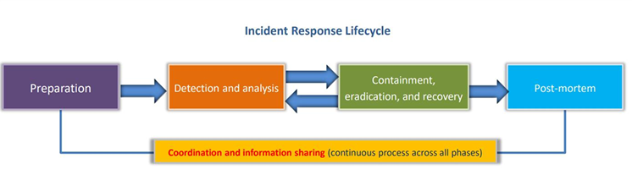
Cloud Incident Response (CIR): Best Practices
- Have an IR process ready before incidents occur.
- Create a joint IR plan with the CSP (Cloud Service Provider).
- Assess impact & prioritize risks quickly.
- Use the right tools for monitoring, forensics, and response.
- Regularly evaluate current security measures.
- Build a recovery plan and respond rapidly.
- Maintain a CMDB (Configuration Management Database) for cloud assets.
- Use diagrams to visualize architecture and incident flow.
- Communicate frequently with all stakeholders.

Security Orchestration, Automation, and Response (SOAR)
- SOAR = tools + software for handling incidents from a single interface.
- Security automation → automatically handles tasks (e.g., log searches, vulnerability scans).
- Security orchestration → connects tools and integrates systems for streamlined processes.
Key Benefits of SOAR:
- Streamlines automation, threat/vulnerability management, and incident response.
- Reduces alert fatigue by prioritizing and queuing alerts.
- Provides a single view of events for faster investigation.
- Integrates with SIEMs, firewalls, endpoints, etc.
- Cuts down false positives, repetitive tasks, and manual processes.
- Improves detection/response times (MTTD & MTTR).
--The End--

